SIG742 – MODERN DATA SCIENCE

END-TERM ASSIGNMENT REPORT



Submitted by,

Abhishek Manish (225167838)

Vishu Kukkar

Vishal Verma

PART 1

Environment Setup and Data Loading

Codework

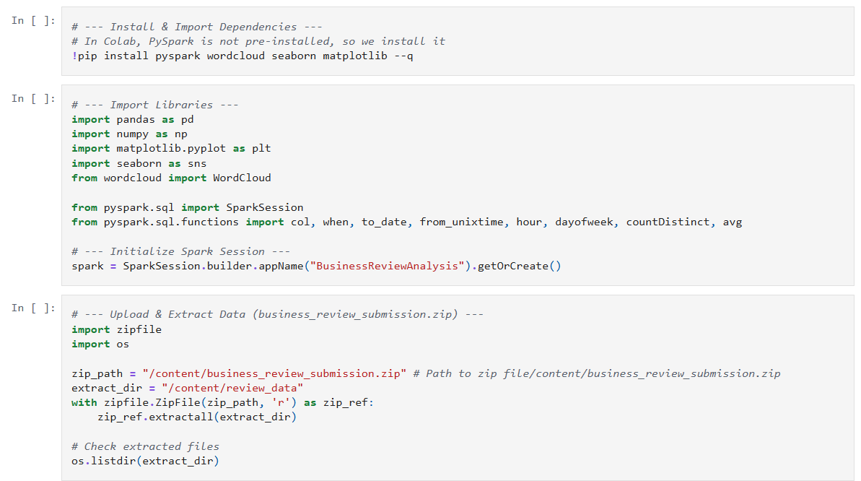

Output



Set Up Details And Data Loading Logic

Question 1.1

Codework a -

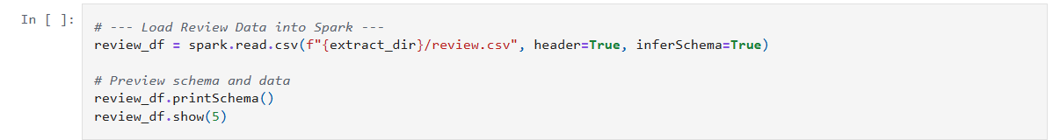

Output a -

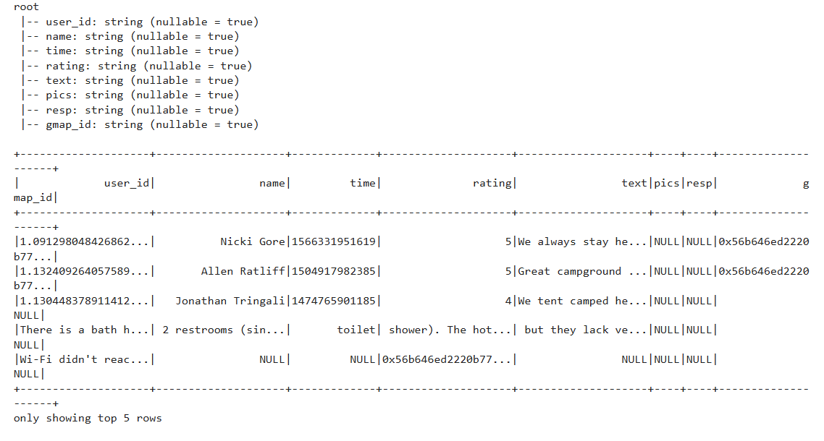

Codework b -

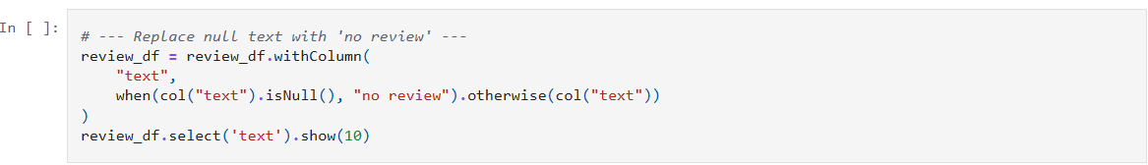

Output b -

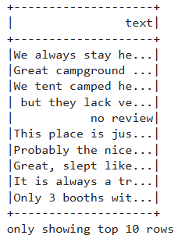

Detailed Logic Explanation for Codework Logic in Question 1.1