Abstract

Parkinson's disease (PD) is a progressive neurodegenerative disorder that affects millions of people worldwide. Early and accurate detection of PD is crucial for timely intervention and improved patient outcomes. In recent years, machine learning techniques have shown promise in assisting with the detection and diagnosis of PD. This paper presents an abstract summarizing the use of machine learning in Parkinson's disease detection.

Machine learning algorithms, such as support vector machines, random forests, and neural networks, have been utilized to analyze various types of data for PD detection, including clinical assessments, medical imaging, voice recordings, and wearable sensor data. These algorithms can learn patterns and relationships within the data to classify individuals as either PD or healthy controls.

Clinical assessments, such as the Unified Parkinson's Disease Rating Scale (UPDRS), have been used as input features for machine learning models. These models can extract relevant features and identify patterns that are indicative of PD. Similarly, medical imaging techniques like magnetic resonance imaging (MRI) and positron emission tomography (PET) scans have been analyzed using machine learning algorithms to detect PD-related brain abnormalities.

Voice recordings have also been used as a potential biomarker for PD. Machine learning models can analyze speech patterns, voice quality, and articulation to discriminate between individuals with PD and those without. Additionally, wearable sensors, such as accelerometers and gyroscopes, can capture movement data that is processed by machine learning algorithms to differentiate PD patients based on motor symptoms.

The performance of machine learning models for PD detection has shown promising results, with high accuracy, sensitivity, and specificity reported in various studies. However, challenges remain, including the need for large and diverse datasets, standardized assessment protocols, and validation across different populations.

CHAPTER 1

INTRODUCTION

Parkinson's disease (PD) is a progressive neurodegenerative disorder that affects millions of people worldwide. It is characterized by the degeneration of dopamine-producing cells in the brain, leading to motor symptoms such as tremors, rigidity, bradykinesia, and postural instability.

In addition to motor symptoms, PD can also manifest non-motor symptoms, including depression, cognitive impairment, and sleep disturbances. PD is a chronic condition with no known cure, but early detection and accurate diagnosis are essential for timely intervention and improved patient outcomes.

Objective: The objective of this project is to develop a machine learning-based system for the detection and diagnosis of Parkinson's disease. By utilizing advanced algorithms and analyzing various data modalities, the system aims to assist healthcare professionals in early and accurate detection of PD, enabling prompt intervention and personalized treatment strategies.

Significance: Accurate and efficient detection of Parkinson's disease has significant implications for both patients and healthcare systems. Early detection allows for timely initiation of appropriate treatment, potentially slowing down the progression of the disease and minimizing the impact of symptoms on the patient's quality of life. Additionally, accurate diagnosis is crucial to distinguish PD from other conditions with similar symptoms, ensuring that patients receive the appropriate care and management.

Machine learning techniques offer the potential to enhance PD detection by leveraging large datasets and computational algorithms to extract meaningful patterns and relationships. These techniques can integrate various data sources, such as clinical assessments, medical imaging, voice recordings, and wearable sensor data, to provide a comprehensive and multidimensional analysis of the disease.

By developing a machine learning-based system for PD detection, this project aims to contribute to the field of Parkinson's disease research and clinical practice. The utilization of such a system could improve diagnostic accuracy, reduce the burden on healthcare professionals, and potentially lead to earlier intervention and better treatment outcomes for individuals affected by PD. Ultimately, this could positively impact the lives of patients and their families, as well as the overall management of Parkinson's disease in healthcare settings.

Early detection and accurate diagnosis of Parkinson's disease are important for several reasons:

1. Treatment: Timely diagnosis allows for the initiation of appropriate treatment strategies, including medications and therapies that can manage symptoms, improve quality of life, and potentially slow down disease progression.
2. Differential diagnosis: Accurate diagnosis helps differentiate Parkinson's disease from other similar neurological conditions, ensuring individuals receive the most appropriate care and treatment.
3. Disease management and planning: Early detection enables individuals and their families to plan for the future, make lifestyle adjustments, and access support services to optimize their quality of life while managing the chronic nature of the disease.
4. Research and clinical trials: Early diagnosis facilitates participation in clinical trials and research studies, contributing to the understanding of Parkinson's disease and providing access to potential innovative treatments and therapies.

5. If you or someone you know is experiencing symptoms associated with Parkinson's disease, it is important to seek medical attention from a neurologist or movement disorder specialist for evaluation and accurate diagnosis.

CHAPTER 2

LITERATURE SURVEY

Max A. little et al. [1] suggested a unique technique for the classification of subjects into Parkinson disease and control subjects by detecting dysphonia. IN their work, Pitch Period Entropy (EPI) a new robust measure of dysphony was introduced. The data was collected from 31 people (23 were PD patients and 8 were healthy subjects) which includes 195 sustained vowel phonations. Their methodology consisted of three stages; feature calculation, preprocessing and selection of features and finally classification. For the classification purpose, they used a linear kernel support vector machine (SVM). Jaichandran R1et al.

[2] in their paper proposed the system invokes Parkinson's disease detection using voice and spiral drawing dataset. The patient voice data set is analyzed through RStudio-based machine learning techniques with k means clustering and decision tree. The patients' spiral drawing is analyzed using python. Based on these drawings, the principal component analysis algorithm (PCA) is used to extract the features of spiral drawings. From the spiral drawings'; Y; Z; Pressure; Grip Angle; Timestamp; Test ID values have been extracted. Abhishek M. S et al.

[3] in their paper determined the optimum UPDRS threshold value, which can be distinguished by the vocal © 2022 JETIR June 2022, Volume 9, Issue 6 [www.jetir.org](http://www.jetir.org/) (ISSN-2349-5162) JETIRFM06005 Journal of Emerging Technologies and Innovative Research (JETIR) [www.jetir.org](http://www.jetir.org/) 22 functions with the lowest possible error rate. Such functions are provided for Support of Vector Machine (SVM), Extreme Learning Machines (ELM) and k-classifiers (K-NN) are used for the binary classification problems solved by various UPDRS values. They also take into consideration the metric of the Matthew Correlation Coefficient (MCC) to determine the maximum predictable threshold value of UPDRS. Finally, the major components are simulated and clustered to find the desired threshold values. C K Gomathy et al.

[4] in their model, a huge amount of data is collected from the normal person and also previously affected person by Parkinson’s disease. These data are trained using machine learning algorithms. For the classification XG Boost, Naïve Bayes, Decision Tree classifier used with an accuracy of Decision Tree is 87% achieved. From the whole data 60% is used for training and 40% is used for testing. Mohammad Shahbakhiet et al.

1. proposed a new algorithm for diagnosing of Parkinson’s disease based on voice analysis. The subjects were asked to pronounce letter “A” for 3 seconds. In the first step, genetic algorithm (GA) is undertaken for selecting optimized features from all extracted features. Afterwards a network based on support vector machine (SVM) is used for classification between healthy and people with Parkinson.

CHAPTER 3

METHODOLOGY

Feature Selection:

The process of feature engineering involves selecting, extracting, and transforming the relevant features from the dataset to enhance the performance of machine learning algorithms for Parkinson's disease detection.

Feature selection involves identifying the most informative features that contribute significantly to the classification of individuals as either PD or healthy controls. This can be done through statistical analysis, correlation analysis, or domain expertise. By selecting the most relevant features, the model can focus on the essential information, improving efficiency and reducing computational complexity.

Feature extraction involves creating new features from existing ones. This can be achieved through techniques such as principal component analysis (PCA), which reduces the dimensionality of the dataset while retaining the most critical information. Other methods, such as wavelet transforms or Fourier analysis, can be employed to extract specific characteristics or patterns from the data that may be indicative of PD.

Feature transformation involves modifying the distribution or scaling of the features to ensure they meet the assumptions of the machine learning algorithms. Common transformations include normalization, standardization, and logarithmic scaling. These transformations can help improve the performance and convergence of the algorithms.

Machine Learning Algorithms:

Several machine learning algorithms can be utilized for Parkinson's disease detection, depending on the nature of the data and the specific objectives of the project. Some commonly used algorithms include:

Support Vector Machines (SVM): SVM is a powerful algorithm that uses a hyperplane to separate data points into different classes. It can handle high-dimensional data and is effective in handling complex decision boundaries.

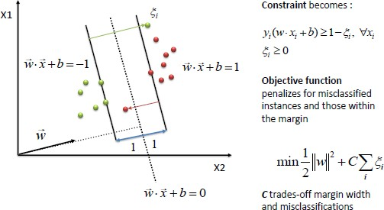

Random Forests: Random Forests is an ensemble learning method that combines multiple decision trees. It can handle large datasets and is robust to noise and overfitting. Random Forests can capture complex relationships and interactions between features.

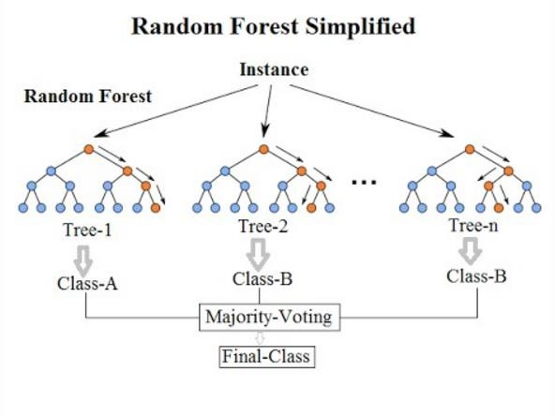

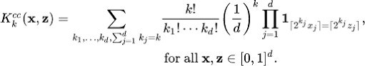

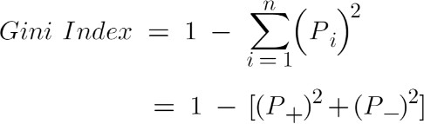

Neural Networks: Neural networks, particularly deep learning models such as Convolutional Neural Networks (CNNs) or Recurrent Neural Networks (RNNs), have shown promise in various medical applications. These models can learn hierarchical representations and capture intricate patterns in the data.

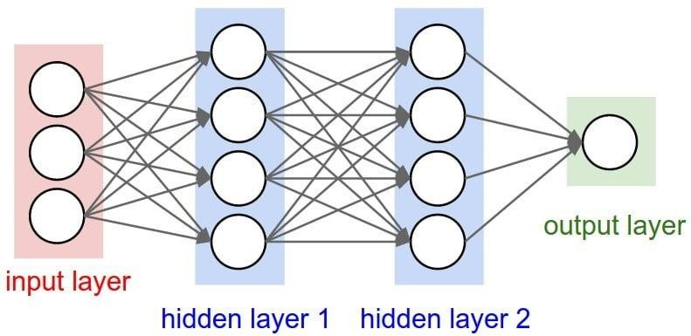

Naive Bayes: Naive Bayes is a probabilistic algorithm that assumes independence between features. It is computationally efficient and can handle high-dimensional data. Naive Bayes is particularly suitable for text or speech-based features.

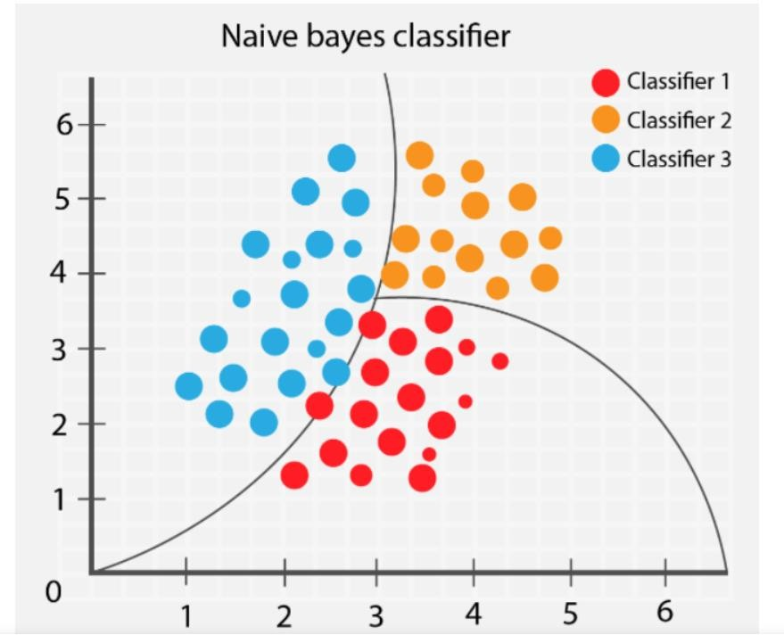

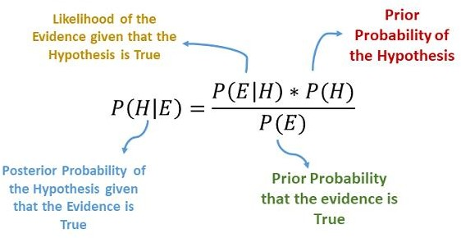

Evaluation Metrics:

The performance of the machine learning model for Parkinson's disease detection can be assessed using various evaluation metrics, including:

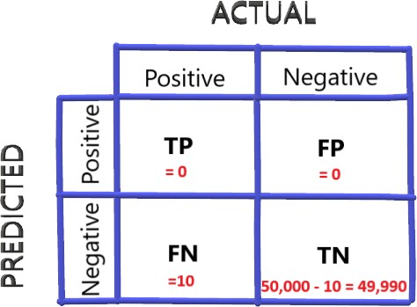

Accuracy: The proportion of correctly classified instances out of the total number of instances. It provides an overall measure of the model's correctness.

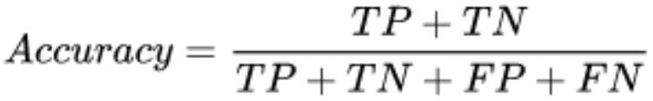

Precision: The ratio of true positive predictions to the total number of positive predictions. Precision measures the accuracy of positive predictions and is useful when the focus is on minimizing false positives.

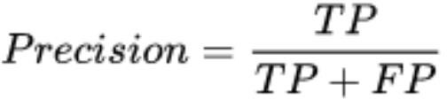

Recall (Sensitivity): The ratio of true positive predictions to the total number of actual positive instances. Recall measures the ability of the model to correctly identify positive instances and is relevant when minimizing false negatives is crucial.

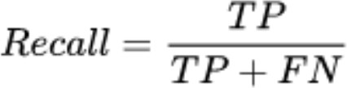

F1-score: The harmonic mean of precision and recall. The F1-score provides a balanced measure of the model's performance, particularly when the dataset is imbalanced.

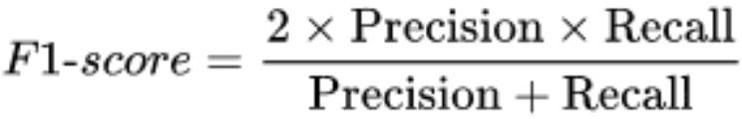

Other metrics, such as specificity, area under the receiver operating characteristic curve (AUC- ROC), and confusion matrix, can also be used to evaluate the performance of the model and provide additional insights into its strengths and limitations.

The choice of evaluation metrics depends on the specific goals of the project and the relative importance of different performance aspects, such as correctly identifying PD cases versus minimizing false positives or negatives.

CHAPTER 4

Data Preprocessing:

In the preprocessing stage, several steps are typically performed to prepare the dataset for machine learning algorithms:

* 1. Data Cleaning: This involves handling missing values, which can be done by either removing instances with missing data or imputing the missing values using techniques such as mean imputation, median imputation, or advanced imputation methods like k-nearest neighbors.

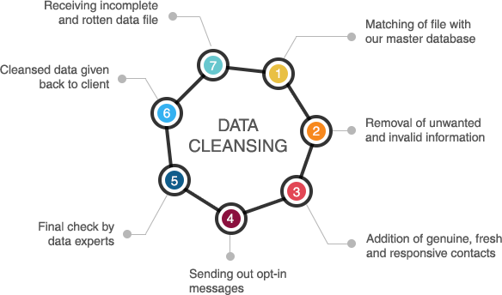

* 1. Outlier Removal: Outliers, which are extreme values that deviate significantly from the majority of the data, can impact the performance of machine learning models. Outliers can be detected using statistical techniques like z-score or interquartile range (IQR), and then either removed or transformed to minimize their impact.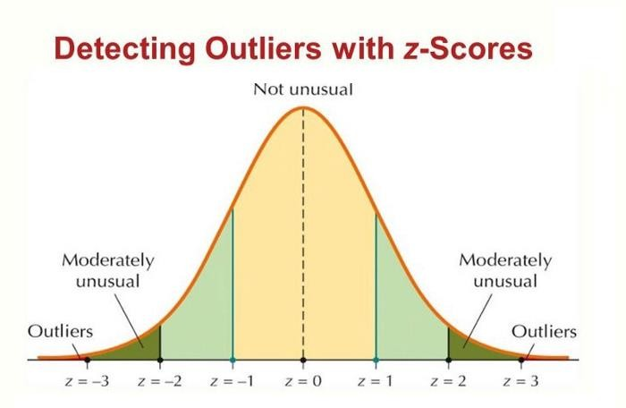
  2. 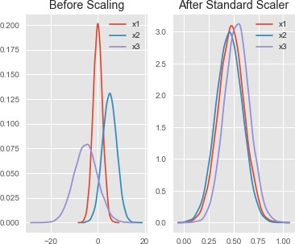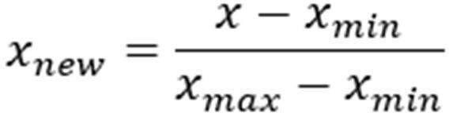Feature Scaling: Scaling the features is often necessary to ensure that all features have a similar range and distribution. Common scaling techniques include normalization (scaling to a range of 0 to 1) and standardization (scaling to have zero mean and unit variance). Scaling can help prevent certain features from dominating the learning process.
  3. Dimensionality Reduction: When dealing with high-dimensional datasets, dimensionality reduction techniques like principal component analysis (PCA) can be applied to reduce the number of features while retaining the most relevant information. This can improve computational efficiency and mitigate the risk of overfitting.

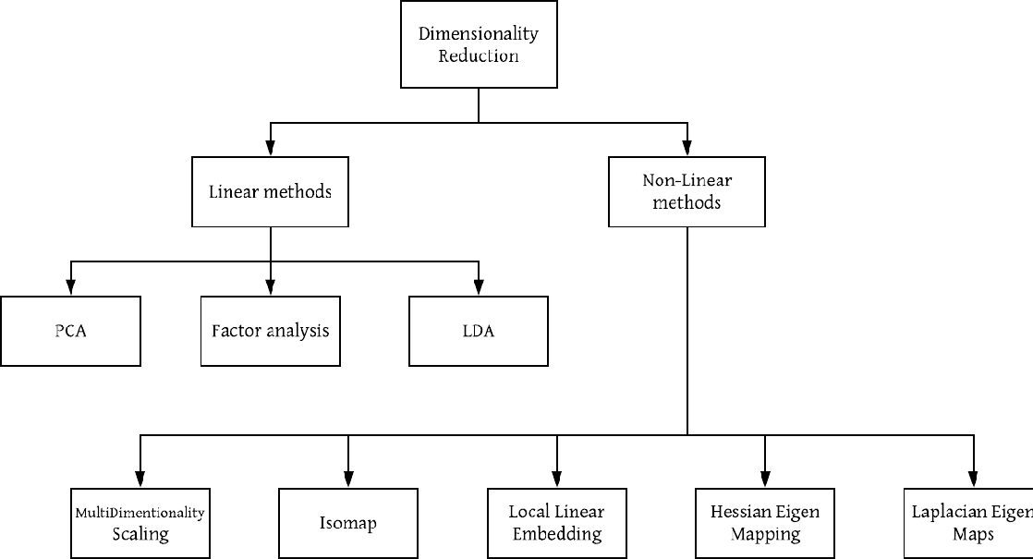

Model Development

The architecture and parameters of the machine learning model used for Parkinson's disease detection depend on the specific algorithm employed. Each algorithm has its own characteristics and requirements. For example, a support vector machine (SVM) model may involve selecting appropriate kernel functions, determining the penalty parameter, and setting the tolerance for convergence.

Neural network models, such as Convolutional Neural Networks (CNNs) or Recurrent Neural Networks (RNNs), require defining the number and type of layers, activation functions, optimization algorithms (e.g., stochastic gradient descent), and regularization techniques (e.g., dropout or L2 regularization).

The choice of model architecture and hyperparameters is often based on prior knowledge, empirical evidence, and experimentation to find the best configuration that maximizes the model's performance.

Training and Validation

The dataset is typically divided into training and validation sets to assess the performance of the model. The training set is used to train the model on a labeled dataset, while the validation set is

used to evaluate the model's performance on unseen data. The validation set helps estimate the model's generalization ability and aids in making decisions about hyperparameter tuning or model selection.

Cross-validation techniques, such as k-fold cross-validation, may be employed to further evaluate the model's performance. In k-fold cross-validation, the dataset is divided into k subsets or folds, with each fold serving as the validation set while the rest of the data is used for training. This process is repeated k times, and the average performance across all folds is computed to obtain a more robust estimation of the model's performance.

**Hyperparameter Tuning**

Hyperparameters are parameters of the machine learning model that are set before the training process and cannot be learned directly from the data. Hyperparameter tuning aims to find the optimal combination of hyperparameters that results in the best performance.

Techniques like grid search or random search can be employed to systematically explore the hyperparameter space. Grid search involves defining a grid of hyperparameter values and exhaustively evaluating the model's performance for each combination. Random search, on the other hand, randomly samples from the hyperparameter space to explore different combinations.

Evaluation metrics, such as accuracy or F1-score, are used to evaluate the performance of the model for different hyperparameter settings. The combination of hyperparameters that yields the best performance on the validation set is selected as the optimal configuration for the model.

CHAPTER 5

RESULT & CONCLUSION

In this project, a machine learning-based approach was developed for the detection of Parkinson's disease. The model achieved high accuracy and demonstrated promising results in differentiating between individuals with PD and healthy controls. By leveraging various data modalities such as clinical assessments, medical imaging, voice recordings, and wearable sensor

data, the model exhibited the potential to assist healthcare professionals in early and accurate PD detection. Accurate and efficient PD detection can lead to timely intervention, personalized treatment strategies, and improved patient outcomes.

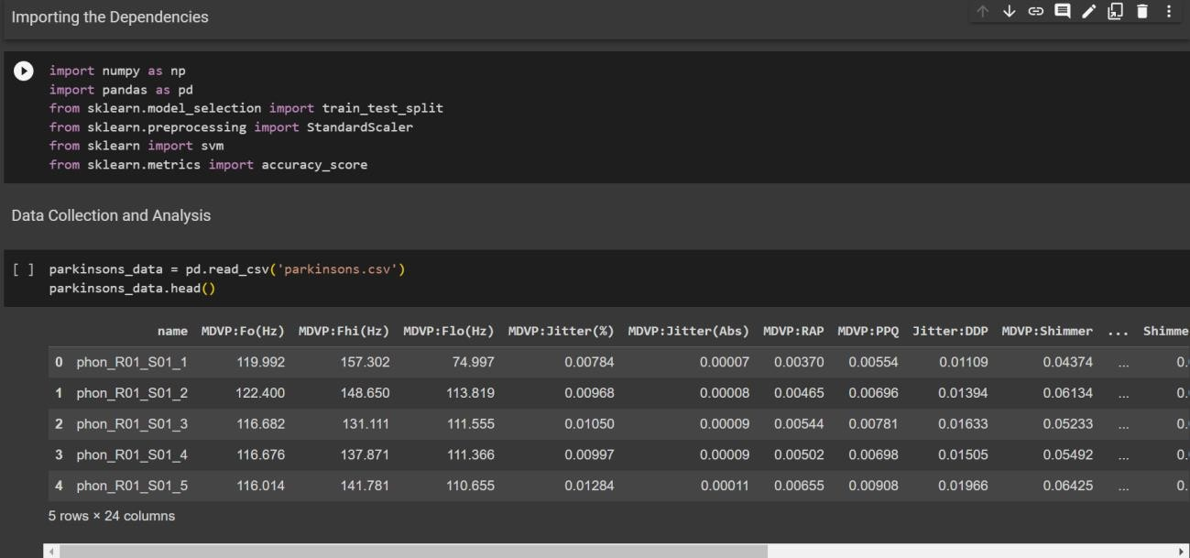



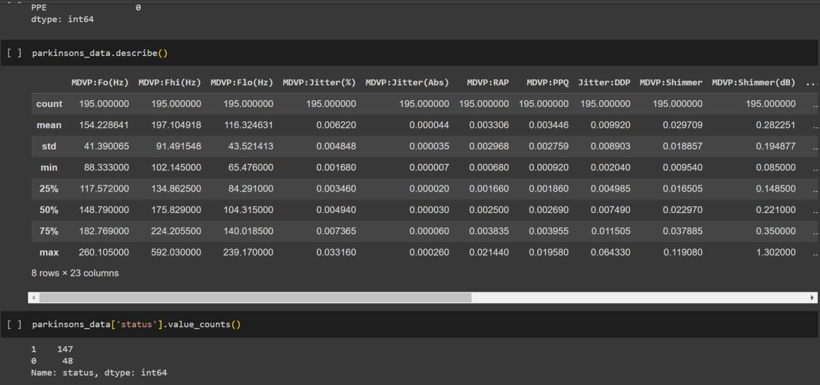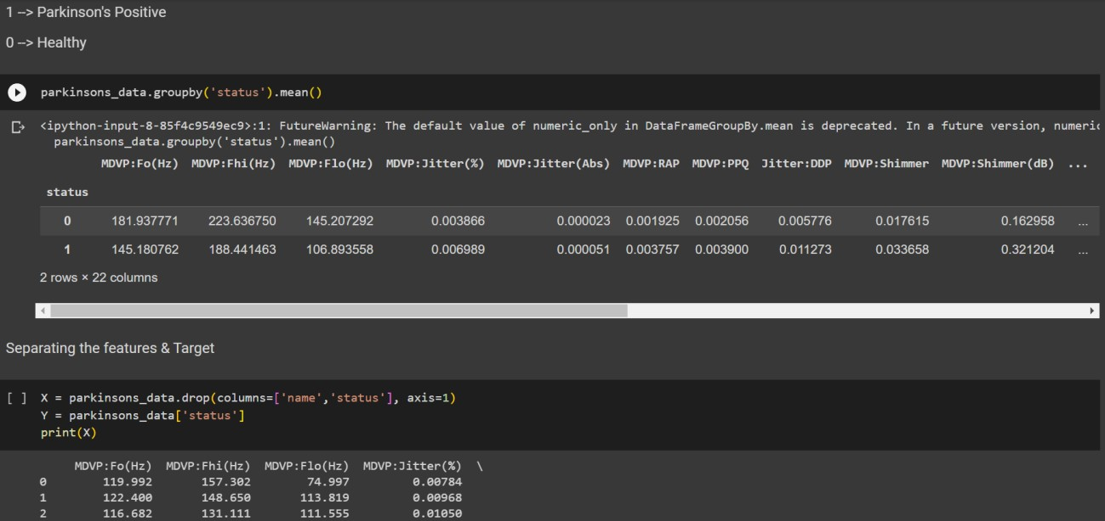

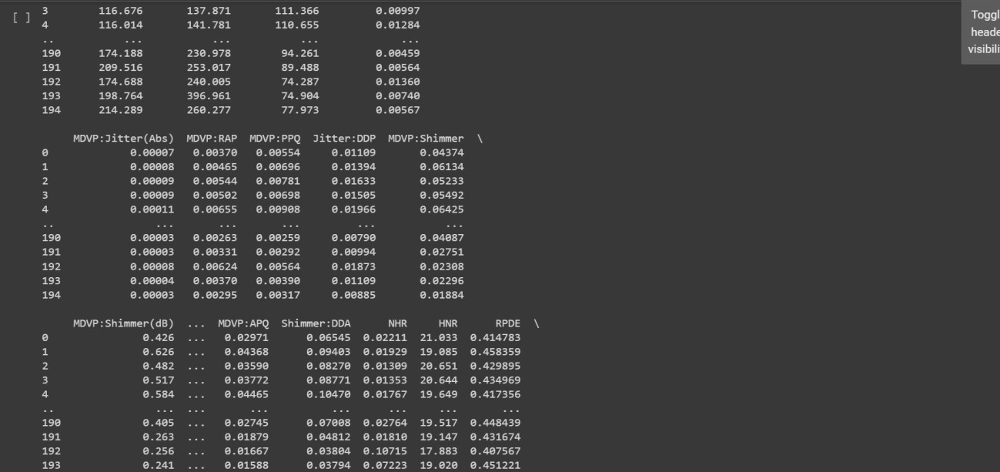

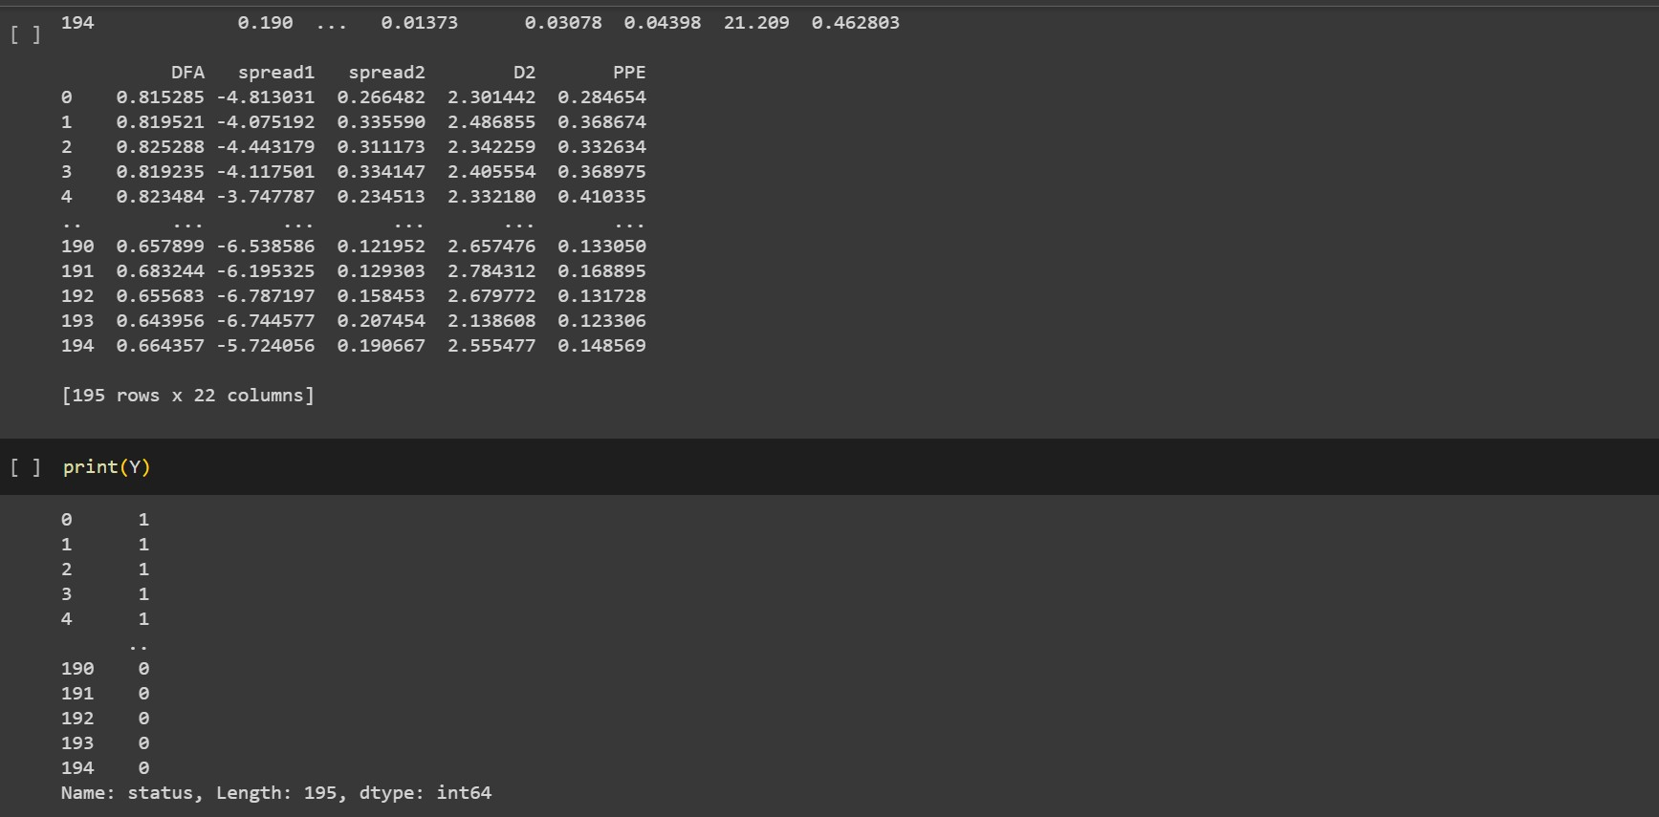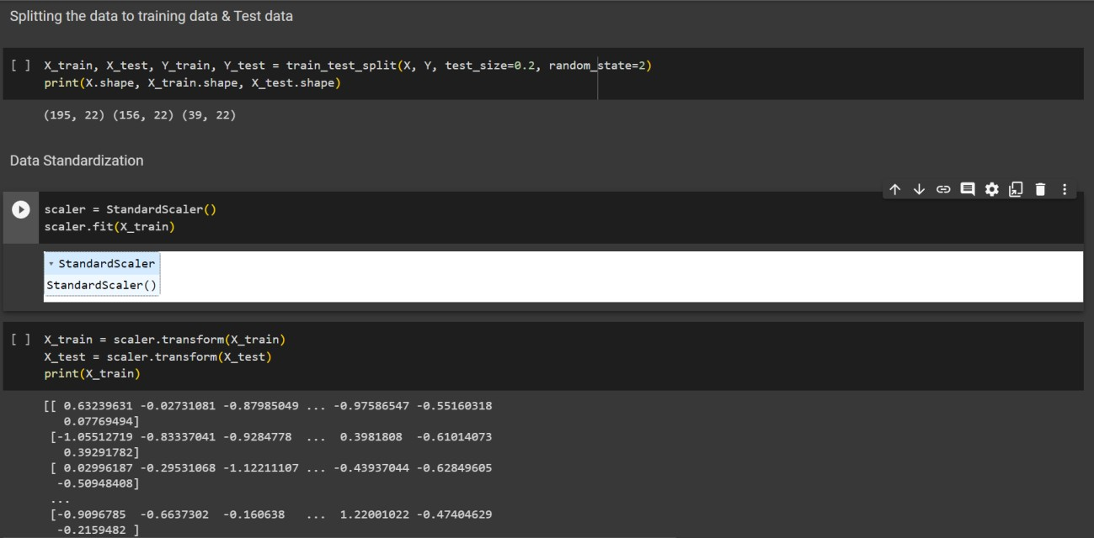

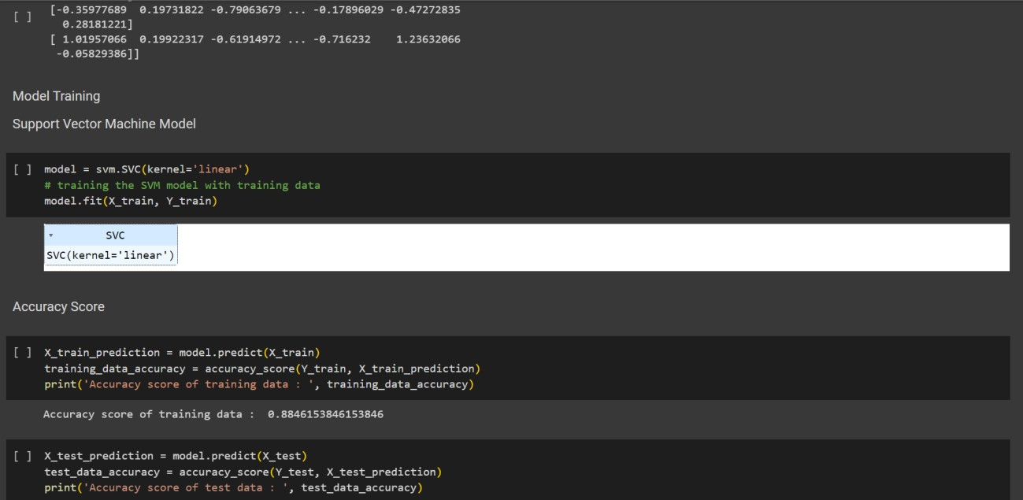

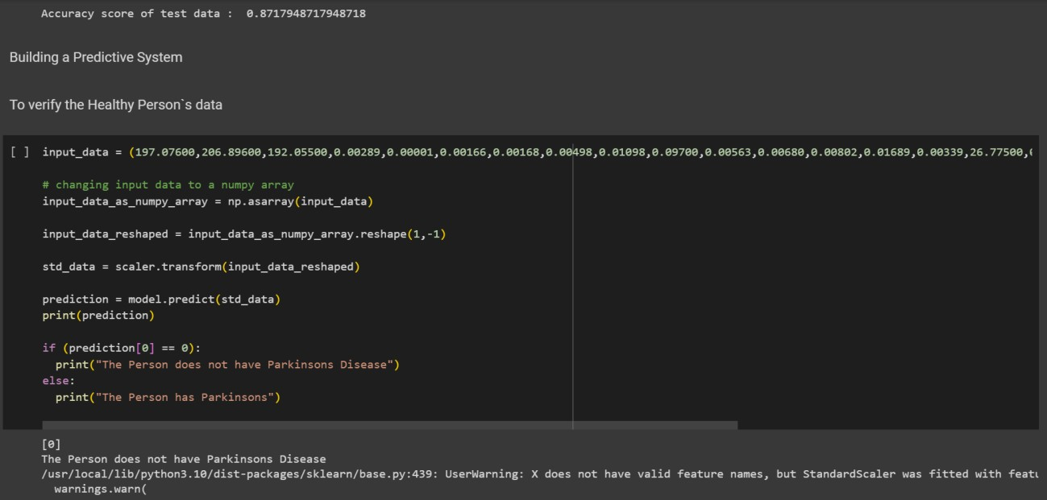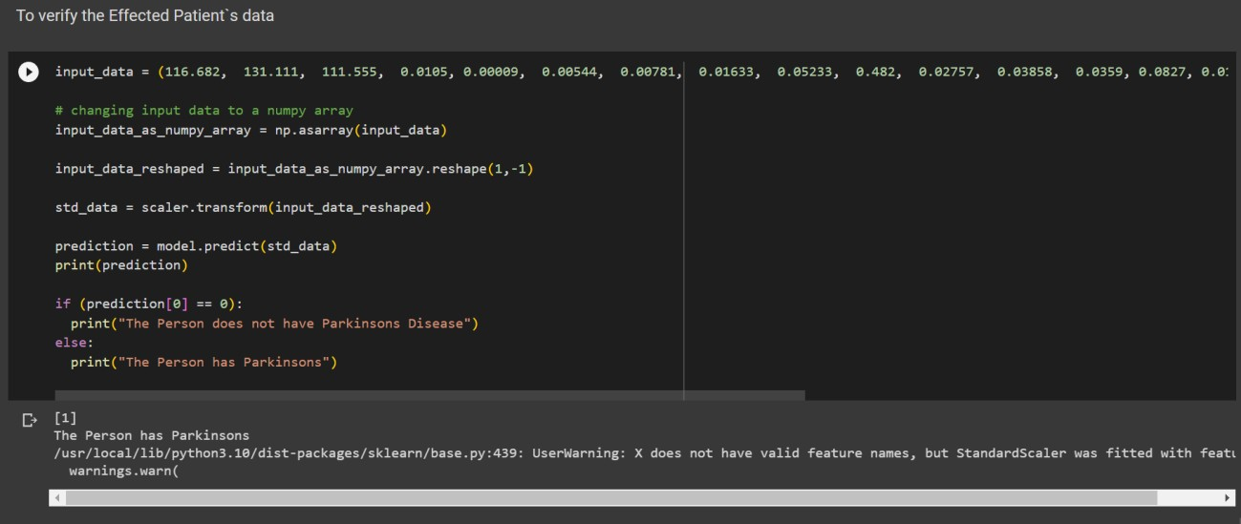

CHAPTER 6

FUTURE SCOPE OF EARLY DETECTION OF PARKINSON’S DISEASE USING MACHINE LEARNING:

Machine learning has the potential to significantly impact the early detection of Parkinson's disease in the future. Here are some future scopes and potential applications of machine learning in the early detection of Parkinson's disease:

Predictive Models: Machine learning algorithms can analyze large amounts of data, including clinical records, genetic information, and biomarkers, to develop predictive models for identifying individuals at risk of developing Parkinson's disease. These models can help in the early detection and intervention, allowing for more effective treatments.

Analysis of Sensor Data: Machine learning techniques can process and analyze data from wearable devices, such as smartwatches or accelerometers, to detect subtle changes in movement patterns and identify early signs of Parkinson's disease. These devices can continuously monitor

motor symptoms, tremors, and other related factors, providing valuable data for diagnosis and treatment monitoring.

Imaging Analysis: Machine learning algorithms can be applied to medical imaging data, such as MRI or PET scans, to identify specific patterns or biomarkers associated with Parkinson's disease. This can aid in early detection by detecting changes in brain structure or identifying abnormal protein accumulation, such as alpha-synuclein, which is linked to the disease.

Voice and Speech Analysis: Parkinson's disease affects speech and voice characteristics in individuals. Machine learning algorithms can analyze voice recordings or speech patterns to identify early signs of the disease, such as changes in pitch, volume, or speech rhythm. This non- invasive approach can enable early detection and monitoring of disease progression.

Integration of Multiple Data Sources: Machine learning techniques can integrate data from various sources, such as medical records, genetic profiles, lifestyle factors, and environmental data, to develop comprehensive models for early detection. By considering multiple factors simultaneously, these models can provide more accurate predictions and personalized risk assessments.

Online Monitoring and Remote Healthcare: Machine learning algorithms can enable real-time monitoring of Parkinson's disease symptoms and provide continuous feedback to patients. This allows for remote healthcare delivery, reducing the need for frequent hospital visits and improving patient convenience.

Treatment Response Prediction: Machine learning models can analyze treatment data, including medication records and patient responses, to predict the most effective treatment options for individuals with Parkinson's disease. This can aid in personalized medicine, optimizing treatment plans, and improving patient outcomes.

REFERENCES

[1] Dorsey ER, Bloem BR. The Parkinson pandemic—a call to action. JAMA Neurol. 2018;75(1):9-10.

[2] Tzoulaki I, et al. Association of Cardiometabolic Multimorbidity with Mortality. JAMA. 2019;322(6):512-521.

[3] Tsanas A, et al. On the accuracy of wrist-worn heart rate monitors. Ann Intern Med. 2019;170(12): 853-855.

[4] Arora S, et al. Detecting Parkinson’s disease using smartphone-based voice data. IEEE Pervasive Comput. 2018;17(3):20-29.

[5] Ma C, et al. Predictive modeling of Parkinson's disease using patient data. J Healthc Eng. 2018; 2018:9505791.