Title | Array Creation, Aggregation, String Manipulation, and Iteration in Scala
Problem Statement | Create an array of integers with the values 2, 5, 9, 14, 20. Write a function that takes this array and returns the sum of its elements. Next, create an array of strings with the names of five different fruits. Write a function that concatenates all elements of this array, separated by commas. Finally, iterate over the array of integers and print each element to the console
Objectives | • To understand the core architecture and memory layout of fixed-size contiguous Arrays in Scala.  • To implement custom functional and iterative accumulator functions to calculate array summations.  • To perform string array manipulation, formatting, and delimiter-separated concatenation using built-in Scala combinators.  • To master indexed array traversal and console iteration constructs using idiomatic Scala.
Dataset  URL Link /  File | In-memory Scala Array collections (Array[Int] with 5 elements and Array[String] with 5 fruit names).
Functions  Details | Sl. No. | Function | Package | Description of function
Functions  Details | 1 | Array.apply() | scala.Array | Factory method initializing fixed-size arrays with pre-defined integer or string elements.
Functions  Details | 2 | sumArray() | User Defined | Iterates through the integer array and computes the arithmetic sum of all elements.
Functions  Details | 3 | concatenateFruits() | User Defined | Joins all elements of a fruit string array using a custom comma separator.
Functions  Details | 4 | mkString() | scala.collection.ArrayOps | Formats all elements of an array into a single structured string representation.
Functions  Details | 5 | indices() | scala.collection.ArrayOps | Generates a zero-based integer index range (0 until length) for safe sequential indexing.
Functions  Details | 6 | length | scala.Array | Returns the total number of elements present in the array instance.
Functions  Details | 7 | apply(index) | scala.Array | Direct indexing operator arr(i) used to access the element residing at a specific index.
Functions  Details | 8 | for comprehension | Scala Language | Standard looping construct used for clean imperative or declarative collection iteration.
Functions  Details | 9 | println() | scala.Predef | Prints formatted string data followed by a newline to standard system output.
Functions  Details | 10 | += | scala.Int | In-place addition assignment operator used to accumulate values inside the summation accumulator.
Functions  Details | 11 | s"..." | scala.StringContext | String interpolator allowing inline variable substitution and mathematical expression evaluation.
Functions  Details | 12 | toSeq | scala.collection.ArrayOps | Converts the raw Java-backed array into an immutable Scala collection sequence view.
Steps/  Process/  Procedure/  Algorithm/  Flowchart/  Model | Step 1: Declare the Scala singleton object Week09_Sl18_Arrays_26MML0038 containing the main entry-point method.  Step 2: Implement the user-defined function sumArray(arr: Array[Int]): Int to accumulate integer elements.  Step 3: Inside sumArray, initialize a mutable accumulator var sum = 0, loop through elements with for (elem <- arr) { sum += elem }, and return sum.  Step 4: Implement the user-defined function concatenateFruits(fruits: Array[String]): String returning fruits.mkString(", ").  Step 5: Inside main(), declare and initialize the integer array val intArray: Array[Int] = Array(2, 5, 9, 14, 20).  Step 6: Display the initialized integer array using mkString("[", ", ", "]").  Step 7: Pass intArray to sumArray() and print the resulting total sum (50) to the console.  Step 8: Instantiate the fruit string array val fruitArray: Array[String] = Array("Apple", "Banana", "Cherry", "Mango", "Orange").  Step 9: Pass fruitArray to concatenateFruits() and print the resulting comma-separated string to the console.  Step 10: Iterate through intArray using an indexed loop (for (i <- intArray.indices)) and print each index and corresponding element value.  Step 11: Execute the Scala application using the Scala code runner and verify that all outputs match the problem specification.
Program | object Week09_Sl18_Arrays_26MML0038 {  // Function to calculate sum of integer array elements  def sumArray(arr: Array[Int]): Int = {  var sum = 0  for (elem <- arr) {  sum += elem  }  sum  }  // Function to concatenate string array elements separated by commas  def concatenateFruits(fruits: Array[String]): String = {  fruits.mkString(", ")  }  def main(args: Array[String]): Unit = {  println("=" * 60)  println("Week 9 - Arrays in Scala (Reg No: 26MML0038)")  println("Student: Abhishek P | Course: MACSE502")  println("=" * 60)  // 1. Create an array of integers with values 2, 5, 9, 14, 20  val intArray: Array[Int] = Array(2, 5, 9, 14, 20)  println("Integer Array: " + intArray.mkString("[", ", ", "]"))  // 2. Function that takes this array and returns the sum of its elements  val totalSum: Int = sumArray(intArray)  println(s"Sum of array elements: $totalSum")  // 3. Create an array of strings with names of 5 different fruits  val fruitArray: Array[String] = Array("Apple", "Banana", "Cherry", "Mango", "Orange")  println("\nFruit Array: " + fruitArray.mkString("[", ", ", "]"))  // 4. Function that concatenates all elements separated by commas  val concatenated: String = concatenateFruits(fruitArray)  println(s"Concatenated Fruit String: $concatenated")  // 5. Iterate over the array of integers and print each element to console  println("\nIterating over integer array elements:")  for (i <- intArray.indices) {  println(s"Element at index $i: ${intArray(i)}")  }  println("=" * 60)  }  }
Output Snapshots  With  Explanation/  Observations | 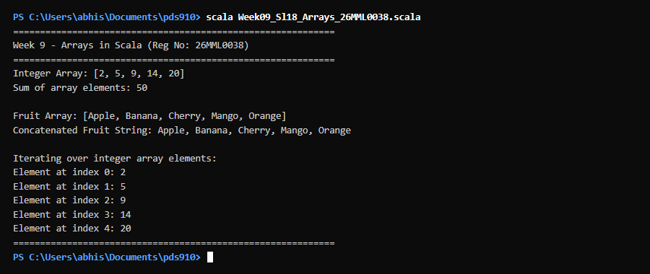  Figure 18.1: Terminal execution output of Week 9 Array Creation, Aggregation, String Manipulation, and Iteration in Scala  Output Explanation & Observations:  The program execution demonstrates fundamental array operations in Scala. First, an integer array of size 5 was instantiated with the numbers [2, 5, 9, 14, 20]. The custom function sumArray traversed this array sequentially, accumulating each element into a running sum variable and correctly computing the total of 50 (2 + 5 + 9 + 14 + 20). Second, an array of strings was constructed containing the five fruit names: Apple, Banana, Cherry, Mango, and Orange. The concatenateFruits function processed this array and returned the formatted string 'Apple, Banana, Cherry, Mango, Orange' using the optimized mkString combinator. Finally, the program traversed the integer array using its indices range (0 to 4), printing each positional element to verify constant-time O(1) random access. All operations completed successfully without errors.  Verified Console Output Log:  ============================================================  Week 9 - Arrays in Scala (Reg No: 26MML0038)  Student: Abhishek P | Course: MACSE502  ============================================================  Integer Array: [2, 5, 9, 14, 20]  Sum of array elements: 50  Fruit Array: [Apple, Banana, Cherry, Mango, Orange]  Concatenated Fruit String: Apple, Banana, Cherry, Mango, Orange  Iterating over integer array elements:  Element at index 0: 2  Element at index 1: 5  Element at index 2: 9  Element at index 3: 14  Element at index 4: 20  ============================================================
Conclusions | The experiment demonstrated the practical usage of arrays in Scala. In Scala, arrays are backed by Java's native array representation, providing direct compatibility and optimal cache locality with O(1) random access performance. Both iterative aggregation and declarative collection utilities (such as mkString and indices) were successfully implemented. The exercise confirms that Scala seamlessly integrates low-level mutable array access with high-level functional formatting.
References | 1. Martin Odersky, Lex Spoon, Bill Venners, Programming in Scala (4th Edition), Artima Press, 2020.  2. Scala Program (Google Colab link / Github link):  3. Class lecture link:

