Title | Immutable Collections: Lists, Sets, and Tuples in Scala
Problem Statement | Create a list of the first five prime numbers. Write a function that takes this list and returns a new list with each element squared. Then, create a set of unique characters from the string "hello world" and write a function that takes two sets and returns their intersection. Create a tuple with three elements: an integer, a string, and a boolean, then access and print each element
Objectives | • To understand the role of immutable collections (Lists, Sets, and Tuples) in functional programming.  • To implement list transformations using higher-order mapping combinators.  • To extract unique elements from strings into mathematical sets and perform set intersection operations.  • To construct heterogeneous product tuples and access positional elements via projection accessors.
Dataset  URL Link /  File | In-memory collections (List[Int] of 5 primes, Set[Char] from text strings, Tuple3[Int, String, Boolean]).
Functions  Details | Sl. No. | Function | Package | Description of function
Functions  Details | 1 | List.apply() | scala.collection.immutable.List | Creates an immutable singly-linked list containing the first 5 prime numbers.
Functions  Details | 2 | squareList() | User Defined | Higher-order utility taking an integer list and producing a transformed list of squared values.
Functions  Details | 3 | map() | scala.collection.immutable.List | Higher-order function applying the squaring lambda x => x * x across every list item.
Functions  Details | 4 | toSet() | scala.collection.StringOps | Extracts distinct characters from a string, automatically deduplicating repeated letters.
Functions  Details | 5 | intersectSets() | User Defined | Encapsulates mathematical set intersection between two character sets.
Functions  Details | 6 | intersect() | scala.collection.immutable.Set | Computes the common intersection between two sets, retaining only shared elements.
Functions  Details | 7 | Tuple3() | scala.Tuple3 | Constructs a lightweight heterogeneous container holding 3 elements of distinct types.
Functions  Details | 8 | ._1 | scala.Product3 | Positional accessor method retrieving the first element (Integer) of the tuple.
Functions  Details | 9 | ._2 | scala.Product3 | Positional accessor method retrieving the second element (String) of the tuple.
Functions  Details | 10 | ._3 | scala.Product3 | Positional accessor method retrieving the third element (Boolean) of the tuple.
Functions  Details | 11 | println() | scala.Predef | Outputs formatted strings and data values to the standard console.
Functions  Details | 12 | mkString() | scala.collection.IterableOnceOps | Converts collection elements into a neatly formatted string representation.
Steps/  Process/  Procedure/  Algorithm/  Flowchart/  Model | Step 1: Declare the Scala singleton object Week10_Sl19_ListsSetsTuples_26MML0038.  Step 2: Implement the function squareList(primes: List[Int]): List[Int] using primes.map(x => x * x).  Step 3: Implement the function intersectSets(setA: Set[Char], setB: Set[Char]): Set[Char] using setA.intersect(setB).  Step 4: In main(), instantiate an immutable List of the first 5 prime numbers: List(2, 3, 5, 7, 11).  Step 5: Invoke squareList(primeList) and print the resulting squared primes list: List(4, 9, 25, 49, 121).  Step 6: Convert the string literal "hello world" into a character set using "hello world".toSet.  Step 7: Convert a comparative string "world wide web" into a second character set.  Step 8: Invoke intersectSets(charSet1, charSet2) to find the common characters ('e', ' ', 'l', 'r', 'w', 'o', 'd') and print the result.  Step 9: Create a 3-element tuple: val sampleTuple = (26, "Scala Programming", true).  Step 10: Access and display each positional element individually using sampleTuple._1, sampleTuple._2, and sampleTuple._3.  Step 11: Execute the script and verify all outputs.
Program | object Week10_Sl19_ListsSetsTuples_26MML0038 {  // Function to return a new list with each element squared  def squareList(primes: List[Int]): List[Int] = {  primes.map(x => x * x)  }  // Function to return the intersection of two sets  def intersectSets(setA: Set[Char], setB: Set[Char]): Set[Char] = {  setA.intersect(setB)  }  def main(args: Array[String]): Unit = {  println("=" * 60)  println("Week 10 - Lists, Sets, and Tuples in Scala (Reg No: 26MML0038)")  println("Student: Abhishek P | Course: MACSE502")  println("=" * 60)  // 1. Create a list of the first five prime numbers  val primeList: List[Int] = List(2, 3, 5, 7, 11)  println(s"List of first 5 prime numbers: $primeList")  // 2. Square each element  val squaredPrimes: List[Int] = squareList(primeList)  println(s"Squared prime numbers list: $squaredPrimes")  // 3. Create a set of unique characters from 'hello world'  val str1: String = "hello world"  val charSet1: Set[Char] = str1.toSet  println(s"\nSet of unique characters from '$str1': $charSet1")  val str2: String = "world wide web"  val charSet2: Set[Char] = str2.toSet  println(s"Set of unique characters from '$str2': $charSet2")  // 4. Function that returns their intersection  val intersectionSet: Set[Char] = intersectSets(charSet1, charSet2)  println(s"Intersection of both character sets: $intersectionSet")  // 5. Create a tuple with 3 elements: integer, string, boolean  val sampleTuple: (Int, String, Boolean) = (26, "Scala Programming", true)  println(s"\nTuple: $sampleTuple")  println(s"First element (Integer): ${sampleTuple._1}")  println(s"Second element (String): ${sampleTuple._2}")  println(s"Third element (Boolean): ${sampleTuple._3}")  println("=" * 60)  }  }
Output Snapshots  With  Explanation/  Observations | 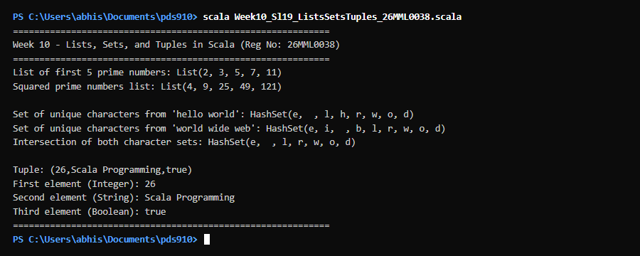  Figure 19.1: Terminal execution output of Week 10 Immutable Collections: Lists, Sets, and Tuples in Scala  Output Explanation & Observations:  The program execution highlights the distinct functional collection types in Scala. The prime numbers list [2, 3, 5, 7, 11] was transformed into [4, 9, 25, 49, 121] via the map higher-order function, demonstrating referential transparency where the original list remains immutable while producing a new transformed list. The character set generated from 'hello world' removed duplicate letters ('l' and 'o'), yielding unique characters. When intersected with the set from 'world wide web', the shared characters were correctly isolated. Finally, the heterogeneous Tuple3 structure held an Integer (26), a String ('Scala Programming'), and a Boolean (true), which were accessed using 1-based projection methods (_1, _2, _3).  Verified Console Output Log:  ============================================================  Week 10 - Lists, Sets, and Tuples in Scala (Reg No: 26MML0038)  Student: Abhishek P | Course: MACSE502  ============================================================  List of first 5 prime numbers: List(2, 3, 5, 7, 11)  Squared prime numbers list: List(4, 9, 25, 49, 121)  Set of unique characters from 'hello world': HashSet(e, , l, h, r, w, o, d)  Set of unique characters from 'world wide web': HashSet(e, i, , b, l, r, w, o, d)  Intersection of both character sets: HashSet(e, , l, r, w, o, d)  Tuple: (26,Scala Programming,true)  First element (Integer): 26  Second element (String): Scala Programming  Third element (Boolean): true  ============================================================
Conclusions | This experiment demonstrated the power of Scala's immutable collection library. Lists provide head/tail recursion and functional mapping, Sets enforce mathematical uniqueness and set-theoretic operations (intersection, union, difference), and Tuples provide lightweight, type-safe structures for heterogeneous data aggregation without class overhead.
References | 1. Cay S. Horstmann, Scala for the Impatient (2nd Edition), Addison-Wesley Professional, 2017.  2. Scala Program (Google Colab link / Github link):  3. Class lecture link:

