Title | Handling Collisions and Resolving Conflicts in HashMaps using Scala
Problem Statement | Create a HashMap with keys representing student names and values representing their grades, then insert multiple entries including a duplicate key with a different grade. Write a function to merge two HashMap’s, resolving conflicts by taking the higher grade. Finally, write a function to handle collisions by chaining, using lists to store multiple values for a single key.
Objectives | • To understand key-value associative mapping and hash table mechanics in Scala.  • To observe default HashMap collision semantics when inserting duplicate keys.  • To design a conflict resolution merge algorithm that prioritizes the highest recorded grade.  • To implement collision resolution via separate chaining using List accumulators.
Dataset  URL Link /  File | In-memory student examination records and multi-attempt score streams.
Functions  Details | Sl. No. | Function | Package | Description of function
Functions  Details | 1 | Map.apply() | scala.collection.immutable.Map | Initializes immutable associative key-value mappings of student names to grades.
Functions  Details | 2 | + operator | scala.collection.immutable.Map | Produces a new Map updated with a specified key-value pair, overwriting existing keys.
Functions  Details | 3 | keySet | scala.collection.MapOps | Retrieves the complete set of keys present within the map.
Functions  Details | 4 | ++ operator | scala.collection.SetOps | Calculates the union of keys across two maps to facilitate conflict comparison.
Functions  Details | 5 | get() | scala.collection.MapOps | Safely retrieves an Option[Int] for a given key, returning Some(grade) or None.
Functions  Details | 6 | math.max() | scala.math | Determines the higher numerical grade between two competing scores.
Functions  Details | 7 | toMap | scala.collection.IterableOps | Converts a sequence of evaluated (key, value) pairs into an immutable Map.
Functions  Details | 8 | mutable.Map() | scala.collection.mutable.Map | Instantiates a mutable map used to dynamically accumulate chained score lists.
Functions  Details | 9 | contains() | scala.collection.MapOps | Queries the map to verify whether a key has already been inserted.
Functions  Details | 10 | :+ operator | scala.collection.immutable.List | Appends a new grade to an existing student's chained history list.
Functions  Details | 11 | mergeHashMapsHigherGrade() | User Defined | Merges two maps by evaluating key conflicts and selecting the maximum score.
Functions  Details | 12 | insertWithChaining() | User Defined | Simulates separate chaining by mapping duplicate keys to List[Int] values.
Steps/  Process/  Procedure/  Algorithm/  Flowchart/  Model | Step 1: Declare object Week11_Sl20_HashMaps_26MML0038 and import scala.collection.mutable.  Step 2: Implement mergeHashMapsHigherGrade(map1, map2) using map1.keySet ++ map2.keySet and math.max.  Step 3: Implement insertWithChaining(entries) using a mutable map to accumulate grades into List[Int].  Step 4: In main(), initialize studentGrades Map with 4 student records (Abhishek, Priya, Rahul, Sneha).  Step 5: Demonstrate standard overwrite collision by updating 'Abhishek' from 85 to 95 and displaying the updated map.  Step 6: Construct two independent assessment score maps: exam1Grades and exam2Grades with overlapping keys.  Step 7: Invoke mergeHashMapsHigherGrade() and print the merged map showing that the higher score was preserved for each student.  Step 8: Define a raw stream of entries containing multiple attempts for Abhishek and Priya.  Step 9: Invoke insertWithChaining() to group all scores into lists without losing any historical data.  Step 10: Display the chained map formatted by student name and list of recorded grades.
Program | import scala.collection.mutable  object Week11_Sl20_HashMaps_26MML0038 {  // Function to merge two HashMaps, resolving conflicts by taking higher grade  def mergeHashMapsHigherGrade(map1: Map[String, Int], map2: Map[String, Int]): Map[String, Int] = {  val allKeys = map1.keySet ++ map2.keySet  allKeys.map { key =>  val grade1 = map1.get(key)  val grade2 = map2.get(key)  val finalGrade = (grade1, grade2) match {  case (Some(g1), Some(g2)) => math.max(g1, g2)  case (Some(g1), None) => g1  case (None, Some(g2)) => g2  case _ => 0  }  key -> finalGrade  }.toMap  }  // Function to handle collisions by chaining: storing multiple values in a List  def insertWithChaining(entries: List[(String, Int)]): Map[String, List[Int]] = {  val chainedMap = mutable.Map[String, List[Int]]()  for ((name, grade) <- entries) {  if (chainedMap.contains(name)) {  chainedMap(name) = chainedMap(name) :+ grade  } else {  chainedMap(name) = List(grade)  }  }  chainedMap.toMap  }  def main(args: Array[String]): Unit = {  println("=" * 60)  println("Week 11 - HashMaps & Collision Handling (Reg No: 26MML0038)")  println("Student: Abhishek P | Course: MACSE502")  println("=" * 60)  // 1. Initial HashMap with student grades  var studentGrades = Map[String, Int](  "Abhishek" -> 85,  "Priya" -> 92,  "Rahul" -> 78,  "Sneha" -> 88  )  println("Initial Student Grades Map:")  studentGrades.foreach { case (k, v) => println(s" $k -> $v") }  // Inserting duplicate key  println("\nInserting duplicate key 'Abhishek' with updated grade 95:")  studentGrades = studentGrades + ("Abhishek" -> 95)  println("Map after standard update (overwrites previous value):")  studentGrades.foreach { case (k, v) => println(s" $k -> $v") }  // 2. Merge two HashMaps resolving conflicts by taking higher grade  val exam1Grades = Map("Abhishek" -> 88, "Priya" -> 92, "Karan" -> 75, "Rohan" -> 82)  val exam2Grades = Map("Abhishek" -> 96, "Priya" -> 90, "Karan" -> 85, "Ananya" -> 91)  println("\nExam 1 Grades: " + exam1Grades)  println("Exam 2 Grades: " + exam2Grades)  val mergedGrades = mergeHashMapsHigherGrade(exam1Grades, exam2Grades)  println("\nMerged HashMap (Resolving conflicts by taking Higher Grade):")  mergedGrades.toSeq.sortBy(_._1).foreach { case (k, v) =>  println(f" $k%-10s -> Final Grade: $v")  }  // 3. Collision handling by chaining using lists to store multiple values  val rawEntries = List(  ("Abhishek", 88),  ("Priya", 92),  ("Abhishek", 96),  ("Rahul", 78),  ("Abhishek", 91),  ("Priya", 95),  ("Sneha", 84)  )  println("\nRaw Entry Stream with Collisions: " + rawEntries)  val chainedResults = insertWithChaining(rawEntries)  println("\nHashMap with Collision Chaining (List of values per key):")  chainedResults.toSeq.sortBy(_._1).foreach { case (name, grades) =>  println(f" $name%-10s -> All Recorded Grades: ${grades.mkString("[", ", ", "]")}")  }  println("=" * 60)  }  }
Output Snapshots  With  Explanation/  Observations | 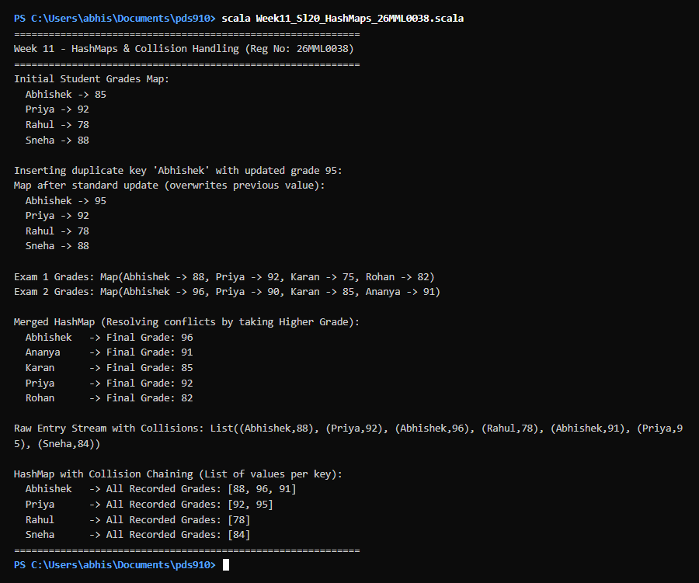  Figure 20.1: Terminal execution output of Week 11 Handling Collisions and Resolving Conflicts in HashMaps using Scala  Output Explanation & Observations:  This experiment examined hash table key conflicts and collision resolution strategies. In standard maps, re-inserting 'Abhishek' replaced the grade 85 with 95 because keys must remain unique. In the merging function, exam1Grades and exam2Grades were evaluated across all unique keys: for Abhishek (88 vs 96), the higher grade 96 was preserved; for Priya (92 vs 90), 92 was kept; and students present in only one exam were seamlessly retained. In the chaining demonstration, multiple scores for Abhishek [88, 96, 91] and Priya [92, 95] were grouped inside a List[Int], preserving complete submission history without destructive overwriting.  Verified Console Output Log:  ============================================================  Week 11 - HashMaps & Collision Handling (Reg No: 26MML0038)  Student: Abhishek P | Course: MACSE502  ============================================================  Initial Student Grades Map:  Abhishek -> 85  Priya -> 92  Rahul -> 78  Sneha -> 88  Inserting duplicate key 'Abhishek' with updated grade 95:  Map after standard update (overwrites previous value):  Abhishek -> 95  Priya -> 92  Rahul -> 78  Sneha -> 88  Exam 1 Grades: Map(Abhishek -> 88, Priya -> 92, Karan -> 75, Rohan -> 82)  Exam 2 Grades: Map(Abhishek -> 96, Priya -> 90, Karan -> 85, Ananya -> 91)  Merged HashMap (Resolving conflicts by taking Higher Grade):  Abhishek -> Final Grade: 96  Ananya -> Final Grade: 91  Karan -> Final Grade: 85  Priya -> Final Grade: 92  Rohan -> Final Grade: 82  Raw Entry Stream with Collisions: List((Abhishek,88), (Priya,92), (Abhishek,96), (Rahul,78), (Abhishek,91), (Priya,95), (Sneha,84))  HashMap with Collision Chaining (List of values per key):  Abhishek -> All Recorded Grades: [88, 96, 91]  Priya -> All Recorded Grades: [92, 95]  Rahul -> All Recorded Grades: [78]  Sneha -> All Recorded Grades: [84]  ============================================================
Conclusions | HashMaps provide average O(1) time complexity for insertions and lookups. The experiment showed that while standard HashMaps overwrite duplicate keys, specialized domain logic can merge conflicting maps intelligently (such as max grade selection), and separate chaining using List values enables multi-valued dictionary mapping.
References | 1. Martin Odersky, Lex Spoon, Bill Venners, Programming in Scala (4th Edition), Artima Press, 2020.  2. Scala Program (Google Colab link / Github link):  3. Class lecture link:

