Title | Advanced Functional Combinators: filter, map, flatMap, and foldLeft in Scala
Problem Statement | Create a list of integers from 1 to 10, then use filter to create a new list with only even numbers. Use map to create a new list where each element is multiplied by 3. Use flatMap to create a list of tuples where each integer is paired with its square. Finally, use foldLeft to calculate the product of all elements in the list.
Objectives | • To master higher-order functional collection combinators in Scala without imperative loops.  • To apply predicate filtering to extract even subsets of numeric collections.  • To transform data structures using unary mapping functions.  • To generate relational pair tuples using monadic flatMap transformations.  • To perform stateful sequential reductions across collections using curried foldLeft accumulators.
Dataset  URL Link /  File | In-memory numeric integer range (1 to 10).toList.
Functions  Details | Sl. No. | Function | Package | Description of function
Functions  Details | 1 | to() | scala.runtime.RichInt | Generates an inclusive numeric integer range from 1 to 10.
Functions  Details | 2 | toList | scala.collection.IterableOps | Converts the generated integer range into an immutable List.
Functions  Details | 3 | filter() | scala.collection.immutable.List | Applies the predicate lambda x => x % 2 == 0 to retain only even numbers.
Functions  Details | 4 | map() | scala.collection.immutable.List | Transforms each element x to x * 3 via a 1-to-1 transformation.
Functions  Details | 5 | flatMap() | scala.collection.immutable.List | Applies a function returning a collection and flattens the result into a list of tuples.
Functions  Details | 6 | foldLeft() | scala.collection.immutable.List | Accumulates elements from left to right using an initial seed and a binary function.
Functions  Details | 7 | % operator | scala.Int | Modulo arithmetic operator used to evaluate parity of integers.
Functions  Details | 8 | * operator | scala.Long | Multiplication operator used in scalar mapping and accumulator reduction.
Functions  Details | 9 | println() | scala.Predef | Outputs strings and formatted data to the standard console.
Functions  Details | 10 | foreach() | scala.collection.immutable.List | Iterates over tuples to produce structured console output.
Functions  Details | 11 | f"..." | scala.StringContext | Formatted string interpolator enabling printf-style column width alignment.
Functions  Details | 12 | stripMargin | scala.collection.StringOps | Strips leading whitespace margins from multi-line string templates.
Steps/  Process/  Procedure/  Algorithm/  Flowchart/  Model | Step 1: Declare object Week12_Sl21_Combinators_26MML0038.  Step 2: Generate an immutable List of integers from 1 to 10: val originalList = (1 to 10).toList.  Step 3: Apply filter(x => x % 2 == 0) to extract the even integers [2, 4, 6, 8, 10] into evenList.  Step 4: Apply map(x => x * 3) to scale each element by 3, yielding mappedList [3, 6, 9, 12, 15, 18, 21, 24, 27, 30].  Step 5: Apply flatMap(x => List((x, x * x))) to pair each integer with its square, producing flatMappedTuples.  Step 6: Display the generated list of (integer, square) pairs in a clean formatted column layout.  Step 7: Apply foldLeft(1L)((acc, elem) => acc * elem) on originalList to compute the product of all integers (10! = 3,628,800).  Step 8: Apply foldLeft(1L)(_ * _) on evenList to compute the product of even integers (3,840).  Step 9: Output and verify all results.
Program | object Week12_Sl21_Combinators_26MML0038 {  def main(args: Array[String]): Unit = {  println("=" * 60)  println("Week 12 - Advanced Functional Combinators (Reg No: 26MML0038)")  println("Student: Abhishek P | Course: MACSE502")  println("=" * 60)  // 1. Create a list of integers from 1 to 10  val originalList: List[Int] = (1 to 10).toList  println(s"Original List (1 to 10): $originalList")  // 2. Use filter to create a new list with only even numbers  val evenList: List[Int] = originalList.filter(x => x % 2 == 0)  println(s"Filtered List (Even numbers only): $evenList")  // 3. Use map to create a new list where each element is multiplied by 3  val mappedList: List[Int] = originalList.map(x => x * 3)  println(s"Mapped List (Each element multiplied by 3): $mappedList")  // 4. Use flatMap to create a list of tuples where each integer is paired with its square  val flatMappedTuples: List[(Int, Int)] = originalList.flatMap(x => List((x, x * x)))  println("\nFlatMapped List of Tuples (Element, Element^2):")  flatMappedTuples.foreach { case (n, sq) =>  println(f" Integer: $n%2d ==> Square: $sq%3d")  }  // 5. Use foldLeft to calculate the product of all elements in the list  val productOfAll: Long = originalList.foldLeft(1L)((acc, elem) => acc * elem)  println(s"\nProduct of all elements (1 to 10) using foldLeft: $productOfAll (10! = 3,628,800)")  // Product of even elements  val productOfEvens: Long = evenList.foldLeft(1L)(_ * _)  println(s"Product of even elements using foldLeft: $productOfEvens")  println("=" * 60)  }  }
Output Snapshots  With  Explanation/  Observations | 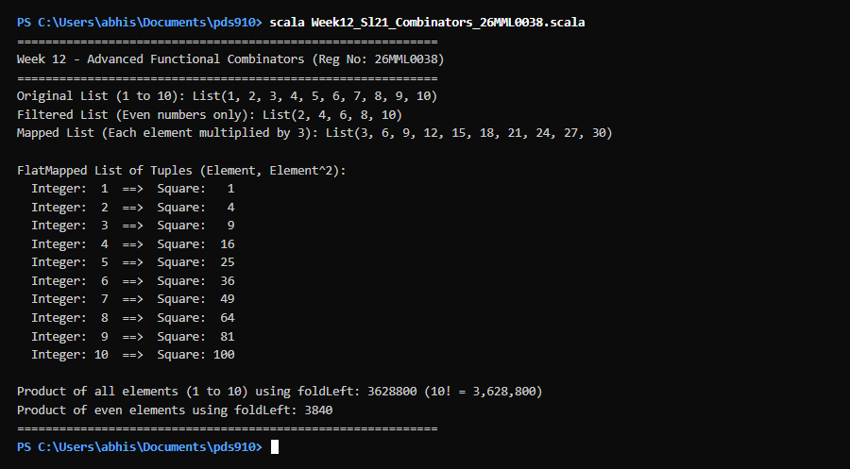  Figure 21.1: Terminal execution output of Week 12 Advanced Functional Combinators: filter, map, flatMap, and foldLeft in Scala  Output Explanation & Observations:  The program execution demonstrates the functional programming paradigm through four foundational combinators. filter inspected each element against x % 2 == 0, discarding odd numbers and retaining only [2, 4, 6, 8, 10]. map produced an exact 1-to-1 transformation, multiplying each element by 3 to yield [3, 6, ..., 30]. flatMap applied a 1-to-many function yielding a list of tuples [(1, 1), (2, 4), ..., (10, 100)] and flattened the nested structures into a single sequence. Finally, foldLeft accumulated the entire list starting from 1L, multiplying each element sequentially to calculate the exact factorial of 10 (3,628,800), demonstrating stateless reduction.  Verified Console Output Log:  ============================================================  Week 12 - Advanced Functional Combinators (Reg No: 26MML0038)  Student: Abhishek P | Course: MACSE502  ============================================================  Original List (1 to 10): List(1, 2, 3, 4, 5, 6, 7, 8, 9, 10)  Filtered List (Even numbers only): List(2, 4, 6, 8, 10)  Mapped List (Each element multiplied by 3): List(3, 6, 9, 12, 15, 18, 21, 24, 27, 30)  FlatMapped List of Tuples (Element, Element^2):  Integer: 1 ==> Square: 1  Integer: 2 ==> Square: 4  Integer: 3 ==> Square: 9  Integer: 4 ==> Square: 16  Integer: 5 ==> Square: 25  Integer: 6 ==> Square: 36  Integer: 7 ==> Square: 49  Integer: 8 ==> Square: 64  Integer: 9 ==> Square: 81  Integer: 10 ==> Square: 100  Product of all elements (1 to 10) using foldLeft: 3628800 (10! = 3,628,800)  Product of even elements using foldLeft: 3840  ============================================================
Conclusions | Advanced combinators form the engine of functional data engineering in Scala. By leveraging filter, map, flatMap, and foldLeft, developers write declarative, concise, and immutable data processing pipelines that avoid side-effects and are easily parallelizable.
References | 1. Dean Wampler, Alex Payne, Programming Scala (3rd Edition), O'Reilly Media, 2021.  2. Scala Program (Google Colab link / Github link):  3. Class lecture link:

