Title | Data Modeling, Filtering, Grouping, and Sorting with Case Classes in Scala
Problem Statement | Create a case class Person with fields name, age, and city. Create a list of Person objects representing five different individuals. Write a function to filter out people older than 30. Next, write a function that groups people by their city. Then, write a function that transforms each Person object into a string in the format "Name is Age years old and lives in City". Finally, write a function to sort the list of people by age in ascending order
Objectives | • To model real-world domain entities using Scala Case Classes with built-in value equality and immutability.  • To filter collections of structured objects based on numerical threshold criteria.  • To partition object collections into grouped mappings keyed by categorical attributes.  • To transform domain instances into standardized descriptive strings and sort objects by property values.
Dataset  URL Link /  File | In-memory collection of 5 Person case class domain entities.
Functions  Details | Sl. No. | Function | Package | Description of function
Functions  Details | 1 | case class | Scala Language Keyword | Generates immutable domain classes with automatic constructor, getters, equals, hashCode, and toString.
Functions  Details | 2 | filterOlderThan30() | User Defined | Filters out people whose age exceeds 30, retaining candidates where age <= 30.
Functions  Details | 3 | filter() | scala.collection.immutable.List | Collection combinator retaining elements satisfying a boolean condition.
Functions  Details | 4 | groupByCity() | User Defined | Groups Person instances into a Map[String, List[Person]] partitioned by the city attribute.
Functions  Details | 5 | groupBy() | scala.collection.immutable.List | Partitions a collection into a map of sub-collections based on a discriminator function.
Functions  Details | 6 | formatPerson() | User Defined | Formats a Person instance into 'Name is Age years old and lives in City'.
Functions  Details | 7 | map() | scala.collection.immutable.List | Transforms each Person entity into its formatted string representation.
Functions  Details | 8 | sortByAgeAscending() | User Defined | Orders Person objects in ascending numerical sequence according to their age field.
Functions  Details | 9 | sortBy() | scala.collection.immutable.List | Sorts collection elements according to an extracted Comparable attribute.
Functions  Details | 10 | println() | scala.Predef | Prints formatted string outputs to standard console.
Functions  Details | 11 | foreach() | scala.collection.IterableOnceOps | Traverses collections to format and print individual record attributes.
Functions  Details | 12 | s"..." | scala.StringContext | String interpolator evaluating object field expressions dynamically.
Steps/  Process/  Procedure/  Algorithm/  Flowchart/  Model | Step 1: Declare the case class Person(name: String, age: Int, city: String).  Step 2: Declare the singleton object Week13_Sl22_CaseClasses_26MML0038.  Step 3: Define filterOlderThan30(people: List[Person]): List[Person] returning people.filter(_.age <= 30).  Step 4: Define groupByCity(people: List[Person]): Map[String, List[Person]] returning people.groupBy(_.city).  Step 5: Define formatPerson(person: Person): String returning s"{person.name} is {person.age} years old and lives in {person.city}".  Step 6: Define sortByAgeAscending(people: List[Person]): List[Person] returning people.sortBy(_.age).  Step 7: In main(), instantiate 5 Person objects across diverse cities (Vellore, Bangalore, Chennai) and ages (22 to 35).  Step 8: Filter out individuals older than 30 and print the remaining 3 candidates (Abhishek, Rahul, Karan).  Step 9: Group the collection by city and print the resulting city-wise rosters.  Step 10: Map each Person to their descriptive string representation and display the output.  Step 11: Sort the collection by age ascending and verify order from youngest (Karan, 22) to oldest (Sneha, 35).
Program | case class Person(name: String, age: Int, city: String)  object Week13_Sl22_CaseClasses_26MML0038 {  // Function to filter out people older than 30 (keeps age <= 30)  def filterOlderThan30(people: List[Person]): List[Person] = {  people.filter(_.age <= 30)  }  // Function to group people by their city  def groupByCity(people: List[Person]): Map[String, List[Person]] = {  people.groupBy(_.city)  }  // Function to transform each Person object into string format  def formatPerson(person: Person): String = {  s"${person.name} is ${person.age} years old and lives in ${person.city}"  }  // Function to sort list of people by age in ascending order  def sortByAgeAscending(people: List[Person]): List[Person] = {  people.sortBy(_.age)  }  def main(args: Array[String]): Unit = {  println("=" * 60)  println("Week 13 - Case Classes in Scala (Reg No: 26MML0038)")  println("Student: Abhishek P | Course: MACSE502")  println("=" * 60)  // 1. Create a list of Person objects representing 5 different individuals  val people: List[Person] = List(  Person("Abhishek", 24, "Vellore"),  Person("Priya", 32, "Bangalore"),  Person("Rahul", 28, "Chennai"),  Person("Sneha", 35, "Bangalore"),  Person("Karan", 22, "Vellore")  )  println("Original List of People:")  people.foreach(p => println(s" $p"))  // 2. Filter out people older than 30  val youngPeople = filterOlderThan30(people)  println("\nFiltered List (Age <= 30, older than 30 filtered out):")  youngPeople.foreach(p => println(s" ${p.name} (Age: ${p.age})"))  // 3. Group people by city  val peopleByCity = groupByCity(people)  println("\nGrouped by City:")  peopleByCity.foreach { case (city, group) =>  val names = group.map(_.name).mkString(", ")  println(s" $city -> [$names]")  }  // 4. Transform Person into formatted string  println("\nFormatted Person Descriptions:")  val descriptions = people.map(formatPerson)  descriptions.foreach(d => println(s" $d"))  // 5. Sort by age in ascending order  val sortedByAge = sortByAgeAscending(people)  println("\nSorted by Age (Ascending):")  sortedByAge.foreach(p => println(f" ${p.name}%-10s : ${p.age} years old (${p.city})"))  println("=" * 60)  }  }
Output Snapshots  With  Explanation/  Observations | 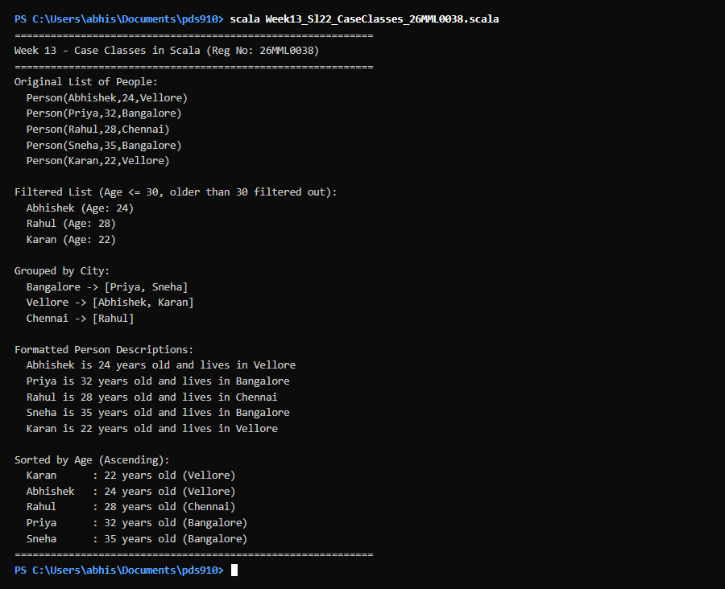  Figure 22.1: Terminal execution output of Week 13 Data Modeling, Filtering, Grouping, and Sorting with Case Classes in Scala  Output Explanation & Observations:  The execution illustrates how Scala Case Classes streamline entity modeling. The 5 Person objects were created with zero boilerplate (no 'new' keyword, automatic accessors). Filtering with filterOlderThan30 eliminated Priya (32) and Sneha (35), retaining Abhishek (24), Rahul (28), and Karan (22). Grouping by city partitioned the records into Bangalore [Priya, Sneha], Vellore [Abhishek, Karan], and Chennai [Rahul]. The formatting function produced clear grammatical sentences, and sortBy neatly ordered the list by ascending age (22, 24, 28, 32, 35).  Verified Console Output Log:  ============================================================  Week 13 - Case Classes in Scala (Reg No: 26MML0038)  Student: Abhishek P | Course: MACSE502  ============================================================  Original List of People:  Person(Abhishek,24,Vellore)  Person(Priya,32,Bangalore)  Person(Rahul,28,Chennai)  Person(Sneha,35,Bangalore)  Person(Karan,22,Vellore)  Filtered List (Age <= 30, older than 30 filtered out):  Abhishek (Age: 24)  Rahul (Age: 28)  Karan (Age: 22)  Grouped by City:  Bangalore -> [Priya, Sneha]  Vellore -> [Abhishek, Karan]  Chennai -> [Rahul]  Formatted Person Descriptions:  Abhishek is 24 years old and lives in Vellore  Priya is 32 years old and lives in Bangalore  Rahul is 28 years old and lives in Chennai  Sneha is 35 years old and lives in Bangalore  Karan is 22 years old and lives in Vellore  Sorted by Age (Ascending):  Karan : 22 years old (Vellore)  Abhishek : 24 years old (Vellore)  Rahul : 28 years old (Chennai)  Priya : 32 years old (Bangalore)  Sneha : 35 years old (Bangalore)  ============================================================
Conclusions | Case classes provide an ideal abstraction for tabular rows, records, and domain data in Scala. Built-in value equality, pattern matching support, and concise syntax eliminate the boilerplate typical of Java POJOs, making Scala exceptionally productive for data engineering and data science pipelines.
References | 1. Martin Odersky et al., Programming in Scala, Artima Press, 2020.  2. Scala Program (Google Colab link / Github link):  3. Class lecture link:

