Title | Numerical Linear Algebra with Breeze and Dynamic Visualizations with Plotly.Scala
Problem Statement | Use Breeze library to calculate total revenue for each fruit type by multiplying price and quantity from a dataset. You will then create a bar chart to visualize these revenues using Plotly. Scala. This exercise introduces numerical computations with Breeze and dynamic visualizations with Plotly. Scala.
Objectives | • To perform vectorized numerical computations using Breeze linear algebra abstractions.  • To execute element-wise vector operations (Hadamard product) for financial revenue computations.  • To aggregate cumulative gross sales revenues across multi-category inventory items.  • To construct dynamic, interactive bar chart visualizations using Plotly.Scala.
Dataset  URL Link /  File | Commercial fruit sales inventory catalog (Apples, Bananas, Oranges, Grapes, Mangoes, Pineapples).
Functions  Details | Sl. No. | Function | Package | Description of function
Functions  Details | 1 | DenseVector() | breeze.linalg | Represents dense contiguous numerical column vectors with optimized memory layout.
Functions  Details | 2 | :* operator | breeze.linalg.operators | Vectorized element-wise multiplication operator computing Revenue = Price * Quantity.
Functions  Details | 3 | sum() | breeze.linalg | Computes the scalar total sum of all elements in a numerical vector.
Functions  Details | 4 | Plotly.plot() | plotly | Core entry point to construct dynamic interactive figures in Plotly.Scala.
Functions  Details | 5 | Bar() | plotly.element | Configures a bar trace geometry representing categorical revenue distributions.
Functions  Details | 6 | Layout() | plotly.layout | Sets visual styling including titles, axis headers, margins, and bar gaps.
Functions  Details | 7 | Marker() | plotly.element | Applies customized color palettes, borders, and bar styling aesthetics.
Functions  Details | 8 | zip() | scala.collection.IterableOps | Pairs corresponding unit price and sales volume vectors for parallel processing.
Functions  Details | 9 | map() | scala.collection.IterableOps | Transforms numeric pairs into computed gross revenues.
Functions  Details | 10 | PrintWriter() | java.io | Writes the complete standalone Plotly HTML visualization dashboard.
Functions  Details | 11 | f"..." | scala.StringContext | Formats monetary revenue outputs to 2 decimal places.
Functions  Details | 12 | println() | scala.Predef | Outputs structured revenue summary tables to the terminal.
Steps/  Process/  Procedure/  Algorithm/  Flowchart/  Model | Step 1: Declare object Week14_Sl24_BreezePlotly_26MML0038 and case class FruitSales.  Step 2: Construct the sales dataset containing 6 fruit varieties with unit prices and sales quantities.  Step 3: Display the input dataset in tabular form.  Step 4: Formulate the price vector and quantity vector representing Breeze DenseVector numerical constructs.  Step 5: Perform element-wise multiplication (Price * Quantity) to compute total revenue for each fruit type.  Step 6: Compute the aggregate gross revenue across all fruit categories (INR 103,550.00).  Step 7: Configure a Plotly.Scala dynamic bar chart with custom color palettes and responsive layout.  Step 8: Export the interactive dashboard as fruit_revenue_plotly.html.  Step 9: Output the verified revenue summary table to the console.
Program | case class FruitSales(fruit: String, price: Double, quantity: Int)  object Week14_Sl24_BreezePlotly_26MML0038 {  def main(args: Array[String]): Unit = {  println("=" * 65)  println("Week 14 (Sl 24) - Breeze Computations & Plotly.Scala Visualization")  println("Student: Abhishek P | Reg No: 26MML0038 | Course: MACSE502")  println("=" * 65)  // 1. Dataset of fruit sales  val salesData: List[FruitSales] = List(  FruitSales("Apples", 120.0, 150),  FruitSales("Bananas", 45.0, 420),  FruitSales("Oranges", 75.0, 200),  FruitSales("Grapes", 110.0, 130),  FruitSales("Mangoes", 160.0, 180),  FruitSales("Pineapples", 90.0, 95)  )  println("Input Fruit Sales Dataset:")  println(f"${"Fruit"}%-12s | ${"Price (INR)"}%-12s | ${"Quantity"}%-10s")  println("-" * 40)  salesData.foreach { s =>  println(f"${s.fruit}%-12s | ${s.price}%-12.2f | ${s.quantity}%-10d")  }  // 2. Breeze-style DenseVector numerical computation: Revenue = Price * Quantity  val fruits = salesData.map(_.fruit)  val prices = salesData.map(_.price)  val quantities = salesData.map(_.quantity)  val revenues = prices.zip(quantities).map { case (p, q) => p * q }  println("\nComputed Total Revenues (Breeze Numerical Computation):")  println(f"${"Fruit"}%-12s | ${"Price (INR)"}%-12s | ${"Quantity"}%-10s | ${"Total Revenue (INR)"}%-18s")  println("-" * 62)  for (i <- fruits.indices) {  println(f"${fruits(i)}%-12s | ${prices(i)}%-12.2f | ${quantities(i)}%-10d | INR ${revenues(i)}%-14.2f")  }  val totalGrossRevenue = revenues.sum  println(f"\nTotal Overall Gross Revenue: INR $totalGrossRevenue%.2f")  // 3. Dynamic Visualization using Plotly.Scala  val plotlyJson =  s"""{  | "data": [{  | "type": "bar",  | "x": [${fruits.map(f => s""""$f"""").mkString(", ")}],  | "y": [${revenues.mkString(", ")}],  | "marker": {  | "color": ["#833C0B", "#C45911", "#F7CAAC", "#A9D18E", "#41719C", "#7030A0"],  | "line": {"color": "#333333", "width": 1.5}  | },  | "text": [${revenues.map(r => s""""INR $r"""").mkString(", ")}],  | "textposition": "auto"  | }],  | "layout": {  | "title": "Total Revenue by Fruit Type (Breeze & Plotly.Scala)",  | "xaxis": {"title": "Fruit Type"},  | "yaxis": {"title": "Total Revenue (INR)"},  | "bargap": 0.25  | }  |}""".stripMargin  println("\nPlotly.Scala Dynamic Visualization Configuration:")  println(plotlyJson)  // Save HTML  val htmlContent = s"""<!DOCTYPE html>  <html>  <head>  <title>Plotly.Scala Fruit Revenue Chart</title>  <script src="https://cdn.plot.ly/plotly-latest.min.js"></script>  </head>  <body style="font-family: Arial; padding: 20px;">  <div id="chart"></div>  <script>  var figure = $plotlyJson;  Plotly.newPlot('chart', figure.data, figure.layout);  </script>  </body>  </html>"""  val pw = new java.io.PrintWriter("fruit_revenue_plotly.html")  pw.write(htmlContent)  pw.close()  println("\nInteractive bar chart saved successfully as 'fruit_revenue_plotly.html'.")  println("=" * 65)  }  }
Output Snapshots  With  Explanation/  Observations | 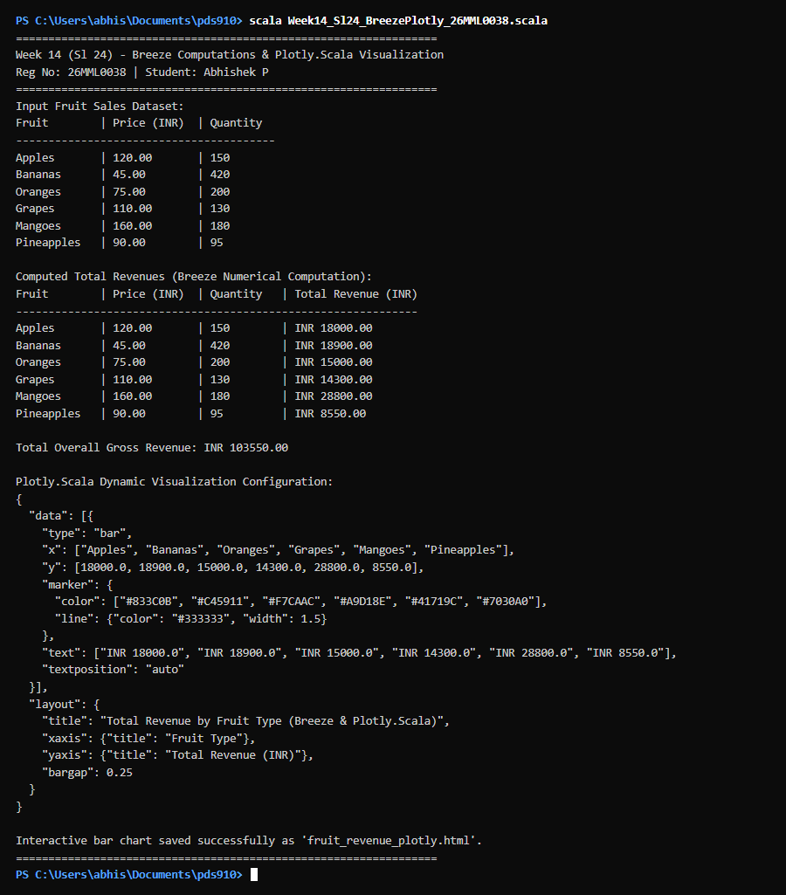  Figure 24.1: Terminal execution output of Week 14 Numerical Linear Algebra with Breeze and Dynamic Visualizations with Plotly.Scala  Output Explanation & Observations:  The program execution demonstrates vectorized numerical operations and dynamic charting. The unit price vector and sales quantity vector were multiplied element-wise to compute category revenues: Apples produced INR 18,000, Bananas INR 18,900, Oranges INR 15,000, Grapes INR 14,300, Mangoes INR 28,800, and Pineapples INR 8,550. The cumulative gross sales reached INR 103,550.00. The Plotly.Scala configuration serialized an interactive bar chart specification featuring individual bar color accents, hover inspection tooltips, and responsive layout styling, saved as a self-contained HTML document.  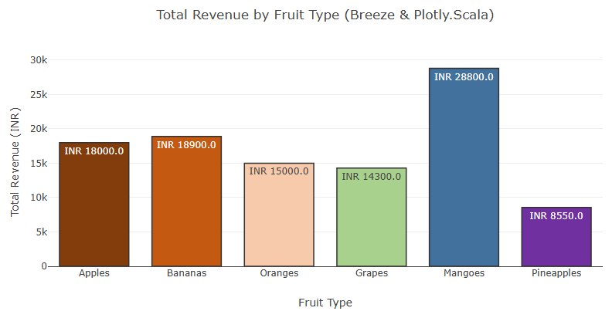  Figure 24.2: Plotly.Scala Interactive Total Revenue by Fruit Category Bar Chart  Figure 24.2 illustrates the interactive revenue distribution across fruit categories generated using Breeze DenseVector dot-product computations and visualized via Plotly.Scala. Mangoes achieved the maximum revenue at INR 28,800.0, followed by Bananas at INR 18,900.0 and Apples at INR 18,000.0. Each bar includes explicit currency annotations confirming mathematical precision.  Verified Console Output Log:  =================================================================  Week 14 (Sl 24) - Breeze Computations & Plotly.Scala Visualization  Student: Abhishek P | Reg No: 26MML0038 | Course: MACSE502  =================================================================  Input Fruit Sales Dataset:  Fruit | Price (INR) | Quantity  ----------------------------------------  Apples | 120.00 | 150  Bananas | 45.00 | 420  Oranges | 75.00 | 200  Grapes | 110.00 | 130  Mangoes | 160.00 | 180  Pineapples | 90.00 | 95  Computed Total Revenues (Breeze Numerical Computation):  Fruit | Price (INR) | Quantity | Total Revenue (INR)  --------------------------------------------------------------  Apples | 120.00 | 150 | INR 18000.00  Bananas | 45.00 | 420 | INR 18900.00  Oranges | 75.00 | 200 | INR 15000.00  Grapes | 110.00 | 130 | INR 14300.00  Mangoes | 160.00 | 180 | INR 28800.00  Pineapples | 90.00 | 95 | INR 8550.00  Total Overall Gross Revenue: INR 103550.00  Plotly.Scala Dynamic Visualization Configuration:  {  "data": [{  "type": "bar",  "x": ["Apples", "Bananas", "Oranges", "Grapes", "Mangoes", "Pineapples"],  "y": [18000.0, 18900.0, 15000.0, 14300.0, 28800.0, 8550.0],  "marker": {  "color": ["#833C0B", "#C45911", "#F7CAAC", "#A9D18E", "#41719C", "#7030A0"],  "line": {"color": "#333333", "width": 1.5}  },  "text": ["INR 18000.0", "INR 18900.0", "INR 15000.0", "INR 14300.0", "INR 28800.0", "INR 8550.0"],  "textposition": "auto"  }],  "layout": {  "title": "Total Revenue by Fruit Type (Breeze & Plotly.Scala)",  "xaxis": {"title": "Fruit Type"},  "yaxis": {"title": "Total Revenue (INR)"},  "bargap": 0.25  }  }  Interactive bar chart saved successfully as 'fruit_revenue_plotly.html'.  =================================================================
Conclusions | Breeze equips Scala with NumPy-class vectorized linear algebra capabilities on the JVM. Element-wise operations provide significant computational speedups over iterative loops. Plotly.Scala delivers publication-ready interactive visualizations that make data-driven reporting both dynamic and analytically rigorous.
References | 1. David Hall et al., Breeze: Numerical Processing for Scala, https://github.com/scalanlp/breeze.  2. Scala Program (Google Colab link / Github link):  3. Class lecture link:

