**Class Diagram**

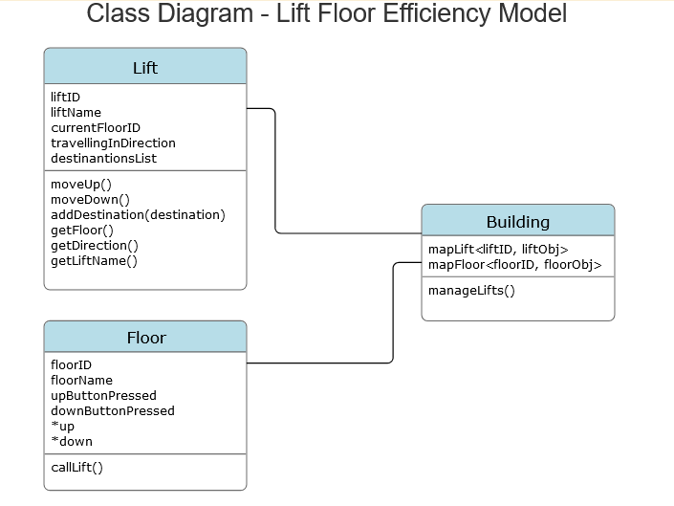

**E-R diagram**

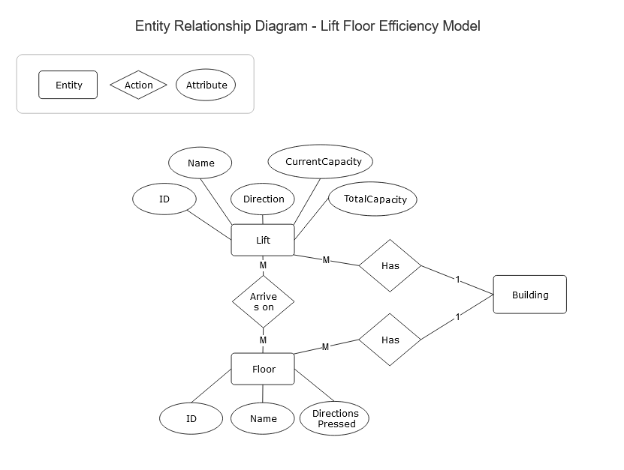

**SQL queries with outputs**

1. SELECT * from lift_data;

1|Lift 1|Up|0|10

2|Lift 2|Up|0|10

3|Lift 3|Down|0|10

4|Lift 4||0|10

1. SELECT * from floor_data;

1|Floor 1|Up

2|Floor 2|Up

3|Floor 3|Up/Down

4|Floor 4|Down

5|Floor 5|

6|Floor 6|

7|Floor 7|Up

8|Floor 8|

9|Floor 9|

10|Floor 10|Up/Down

11|Floor 11|

12|Floor 12|

13|Floor 13|

14|Floor 14|Down

1. SELECT l.liftName, f.floorName FROM lift_data as l, floor_data as f, lift_floor_map as lfm WHERE l.liftID = lfm.liftID AND lfm.floorID = f.floorID;

Lift 1|Floor 1

Lift 2|Floor 11

Lift 3|Floor 14

Lift 4|Floor 4

1. SELECT COUNT(liftID) from lift_floor_map GROUP BY floorID;

1

1

1

1