**Dependencies:**

1. Knowledge:
   1. Maps API
   2. OAuth
   3. Payment gateway API
2. Technologies:
   1. Frontend: React Native + React Material UI + Vite
   2. Backend: FastAPI
   3. Database Management: PostgreSQL
   4. Version Control System: GitHub
   5. Mock Screens: Figma
3. User Stories.
4. Technical Stories.

**Milestones:**

1. Database Structure defined.
2. Database Created.
3. Backend initialization.
4. Backend models and schemas created match the defined database.
5. Initial crud operations and data logic implementation.
6. Unit Test cases written for the data logic.
7. Unit Test cases written for the business logic.
8. OAuth Implementation.
9. Business Logic Implementation.
10. Exception Handling Implementation.
11. Documentation for every function.
12. Ensuring all test cases pass.
13. Frontend Initialization.
14. Unit Test Cases written for Frontend Components.
15. Unit Test Cases written for Frontend Helper Functions.
16. Frontend Implementation complete.
17. Integration Testing.
18. Demo.

**Project Gannt Chart:** 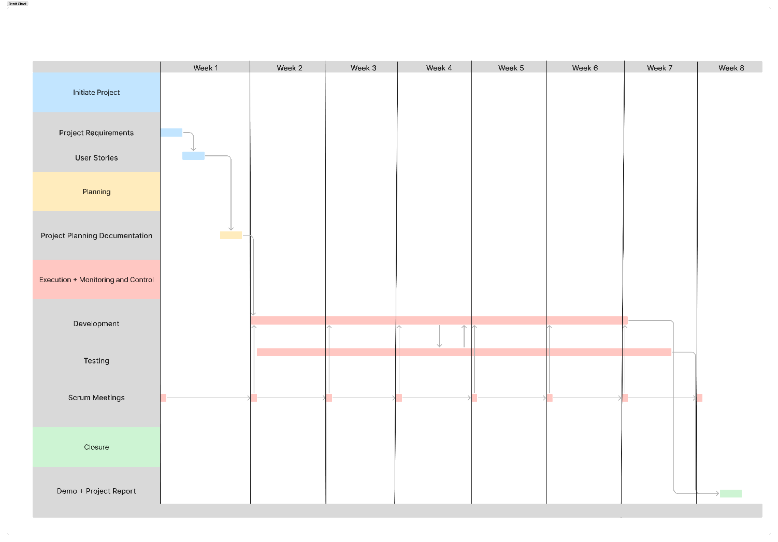

**Pradeep:**

1. Project Synopsis
2. User Stories
3. Test Cases for User Stories
4. Project Planning
5. Development
6. Testing

**Arjun:**

1. User Stories
2. Test cases for User Stories
3. Project Planning
4. Development
5. Testing

**Abhishek:**

1. Project Requirements
2. User Stories
3. Project Planning
4. Development
5. Testing