**CENTRAL UNIVERSITY OF HARYANA**

**Department of Computer Science & Engineering under SOET**



**C++ Programming Lab**

Write a program to show that the effect of default arguments can be alternatively achieved by overloading.

Submitted by

Abhishek Rao

Roll No- 191882

Submitted to

Mr. Anant Rajee Bara

Assistant Professor

Central University of Haryana (SOET)

**Program - 1:** Write a program to show that the effect of default arguments can be alternatively achieved by overloading.

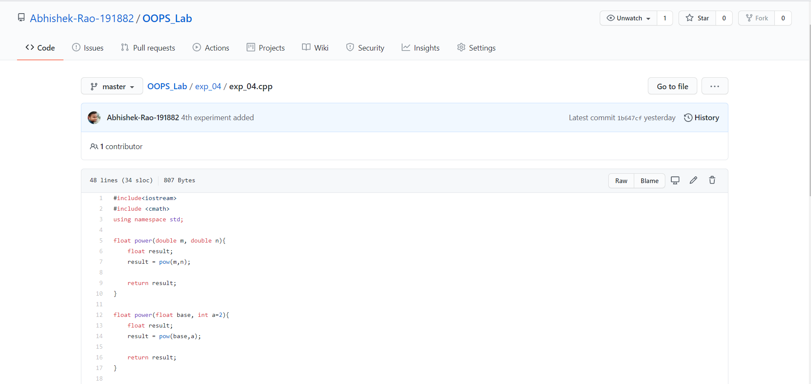**Code:**

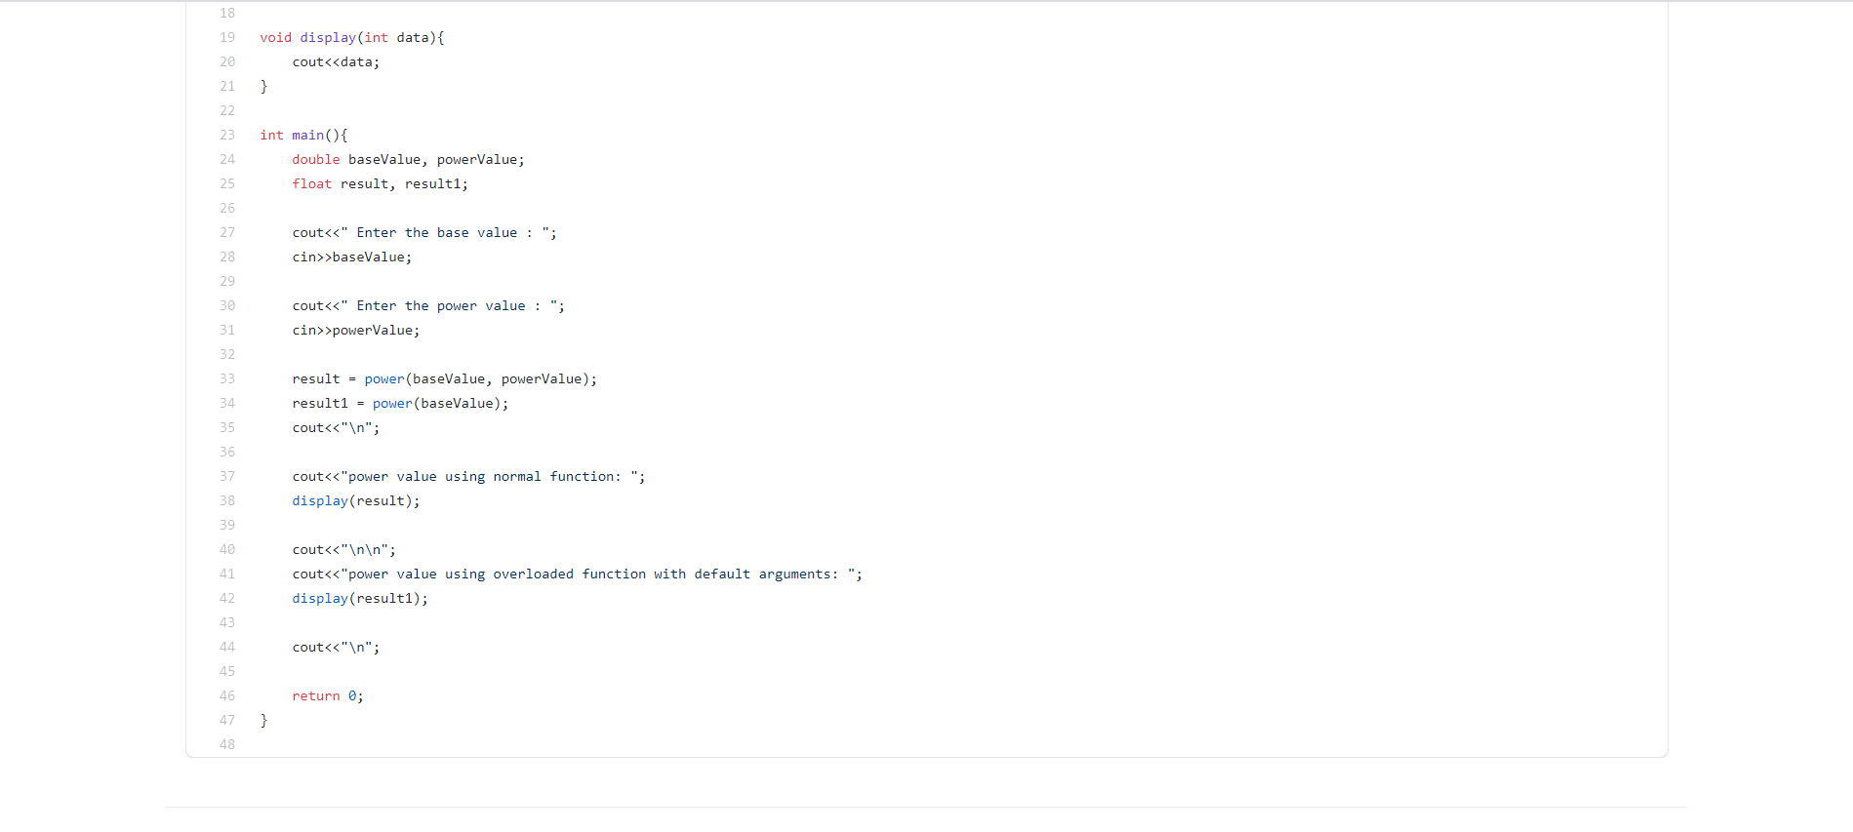**Output:**

