



**Object Oriented Programming using C++ Lab**

**Assignment - 03**

Submitted by

Name :- Abhishek Rao Roll no. :- 191882

Department :- B.tech Computer Science Engineering

Course :– OOPS Lab Course Code :- BT CS 405

Submitted to

Mr. Anant Rajee Bara

Assistant Professor

Department of Computer Science and Engineering

School of Engineering and Technology, Central University of Haryana

**Assignment - 03**

1. **Problem statement:**

Write a program to show that the effect of default arguments can be alternatively achieved by overloading.

1. **Code:**

#include<iostream>

#include <cmath>

using namespace std;

float power(double m, double n){

float result;

result = pow(m,n);

return result;

}

float power(float base, int a=2){

float result;

result = pow(base,a);

return result;

}

void display(int data){

cout<<data;

}

int main(){

double baseValue, powerValue;

float result, result1;

cout<<" Enter the base value : ";

cin>>baseValue;

cout<<" Enter the power value : ";

cin>>powerValue;

result = power(baseValue, powerValue);

result1 = power(baseValue);

cout<<"\n";

cout<<"power value using normal function: ";

display(result);

cout<<"\n\n";

cout<<"power value using overloaded function with default arguments: ";

display(result1);

cout<<"\n";

return 0;

}

**Screenshot of code after uploading on Github:**

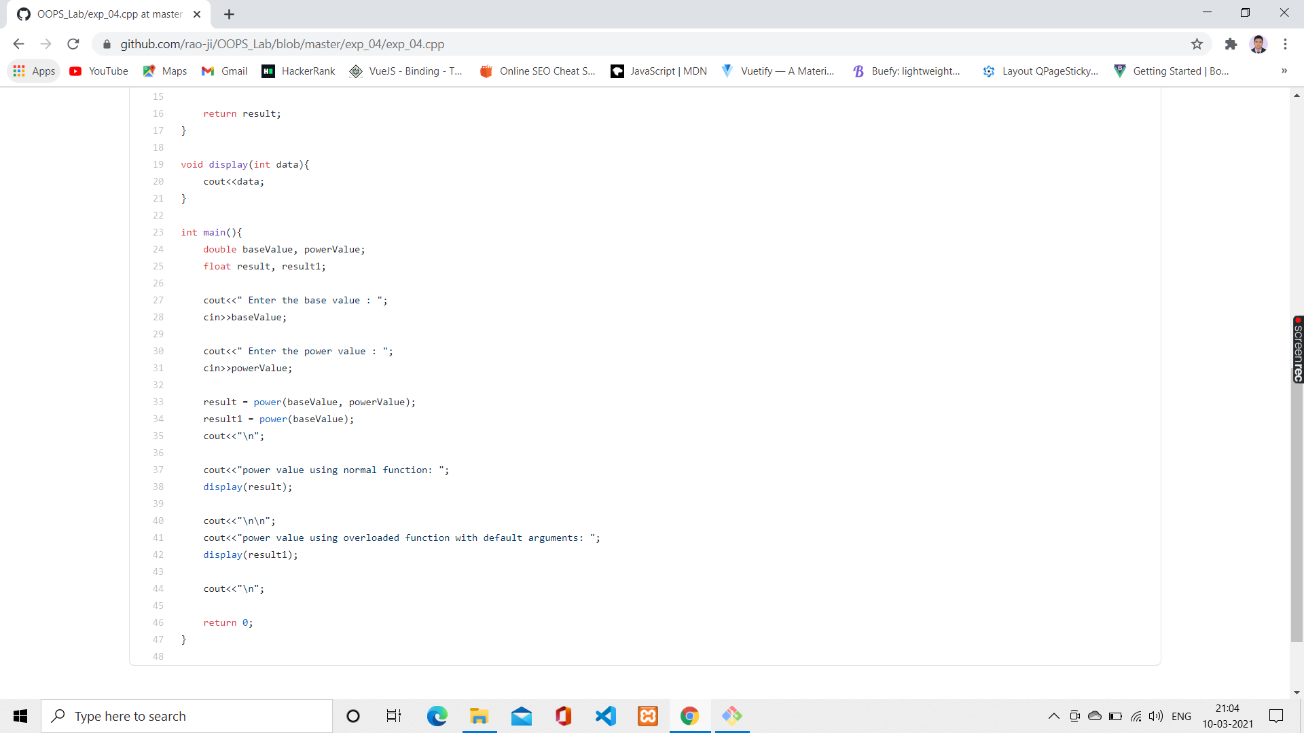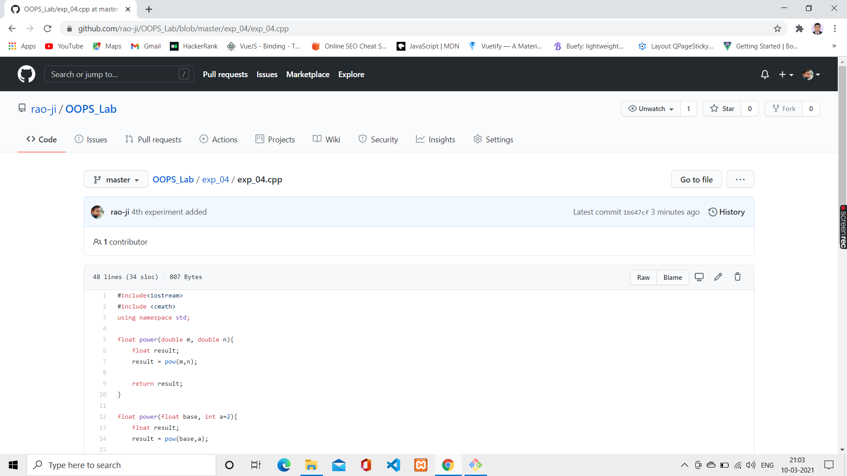

**Link of Github Repository:**

<https://github.com/rao-ji/OOPS_Lab/blob/master/exp_04/exp_04.cpp>

1. 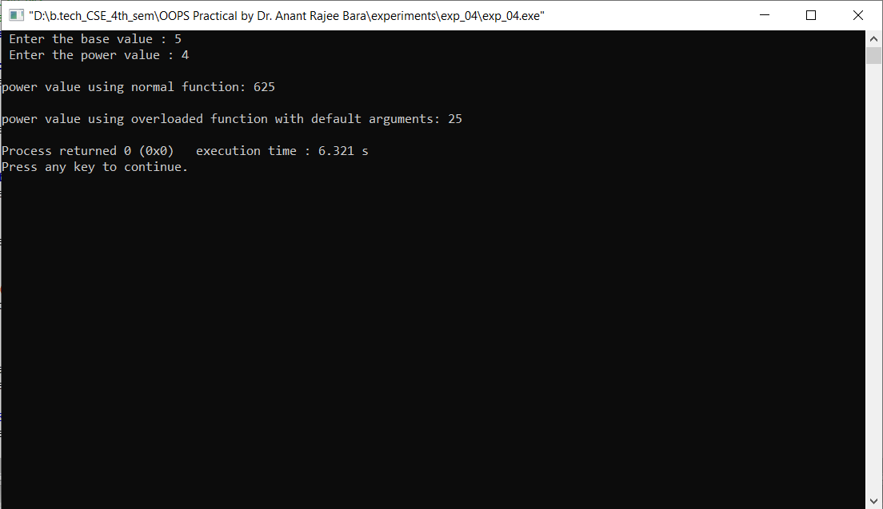**Output :**