**CENTRAL UNIVERSITY OF HARYANA**

**Department of Computer Science & Engineering under SOET**



**C++ Programming Lab**

Write a class STRING that can be used to store strings, add strings, equate strings, output strings.

Submitted by

Abhishek Rao

Roll No- 191882

Submitted to

Mr. Anant Rajee Bara

Assistant Professor

Central University of Haryana (SOET)

**Program - 6:** Write a class STRING that can be used to store string, add strings, equate string, output string.

**Code:**

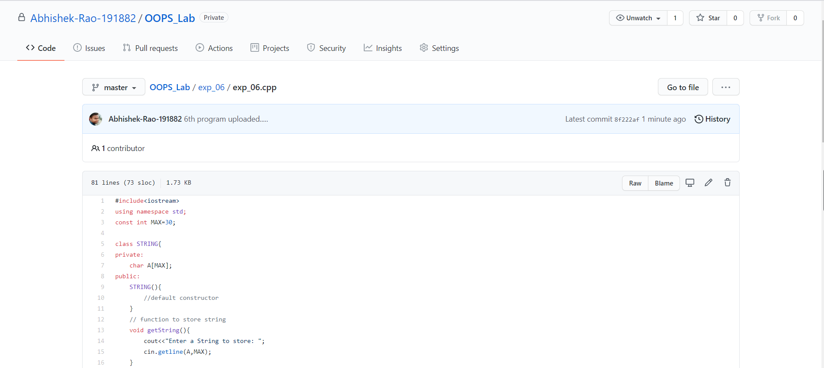

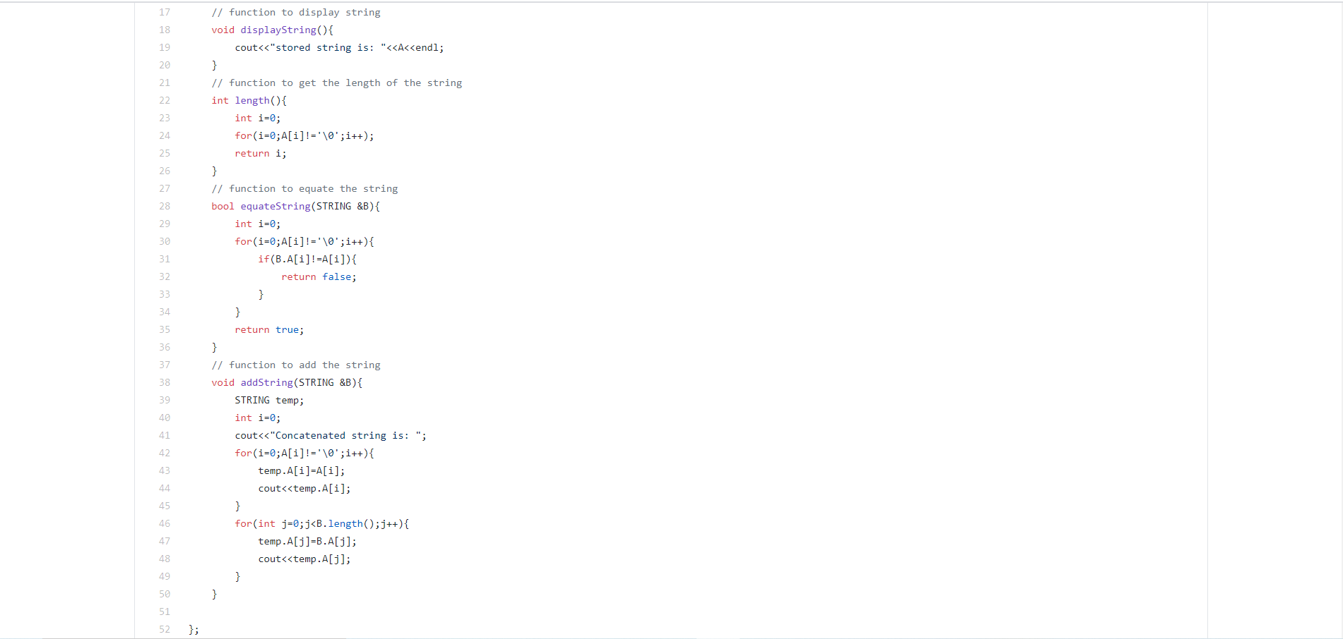

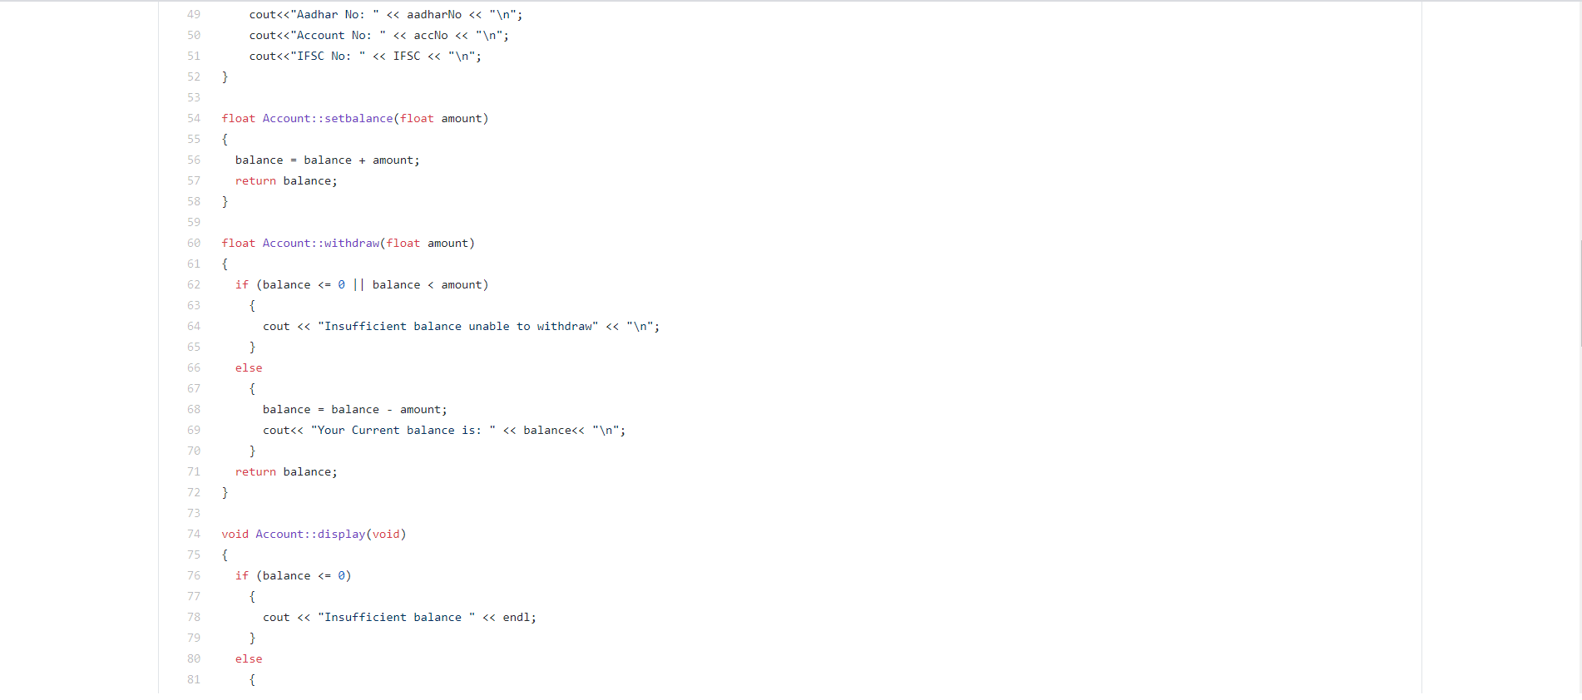

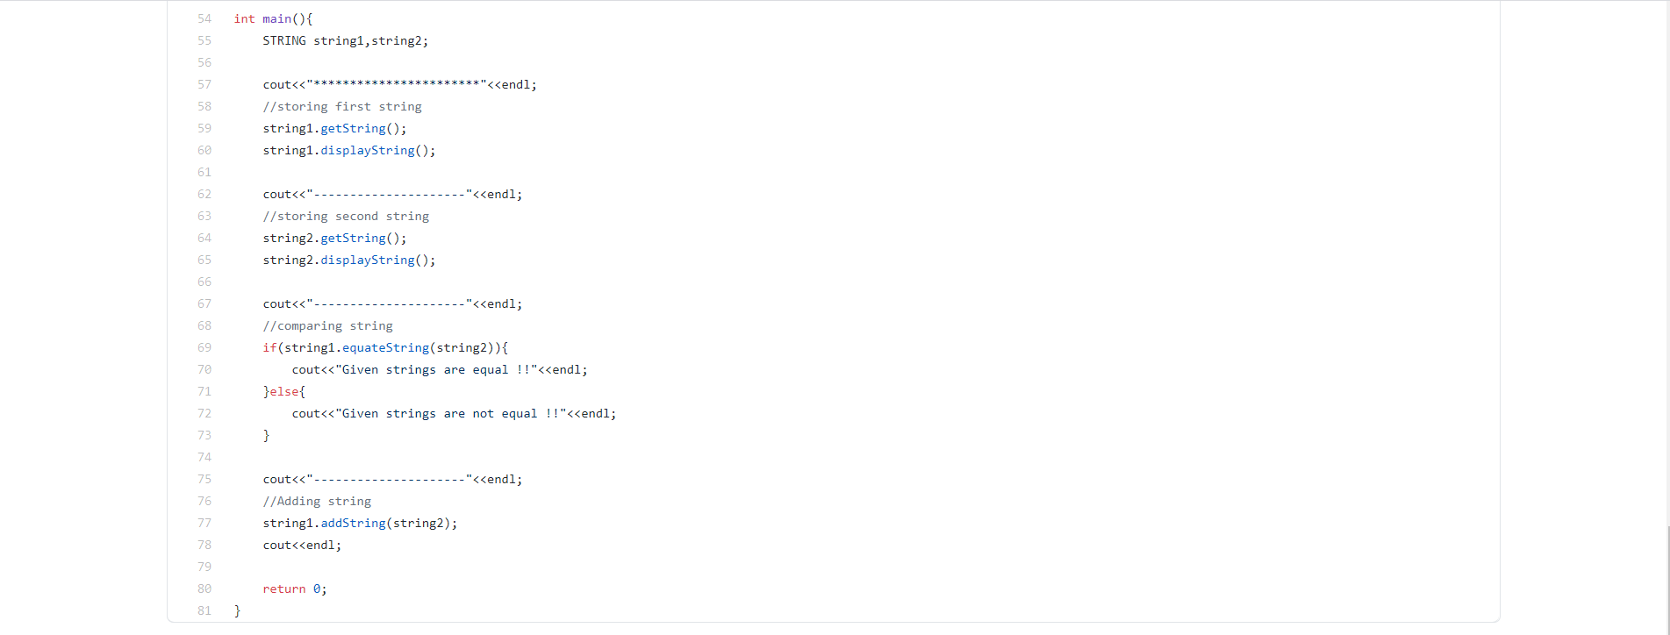

**Output:**

