Calculator App Using React Js

***Wireframe Documentation***

Firstpage

We have divided this Calculator App into Two Modes: -

1. First View is Light mode of Calculator .

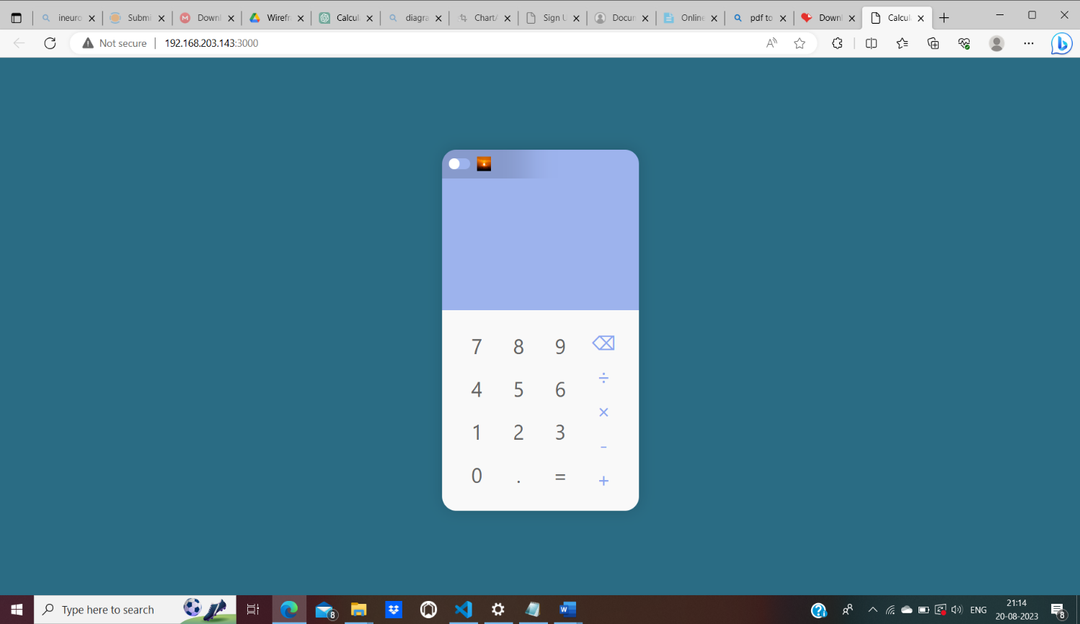

1. Second View is Dark Mode of Calculator

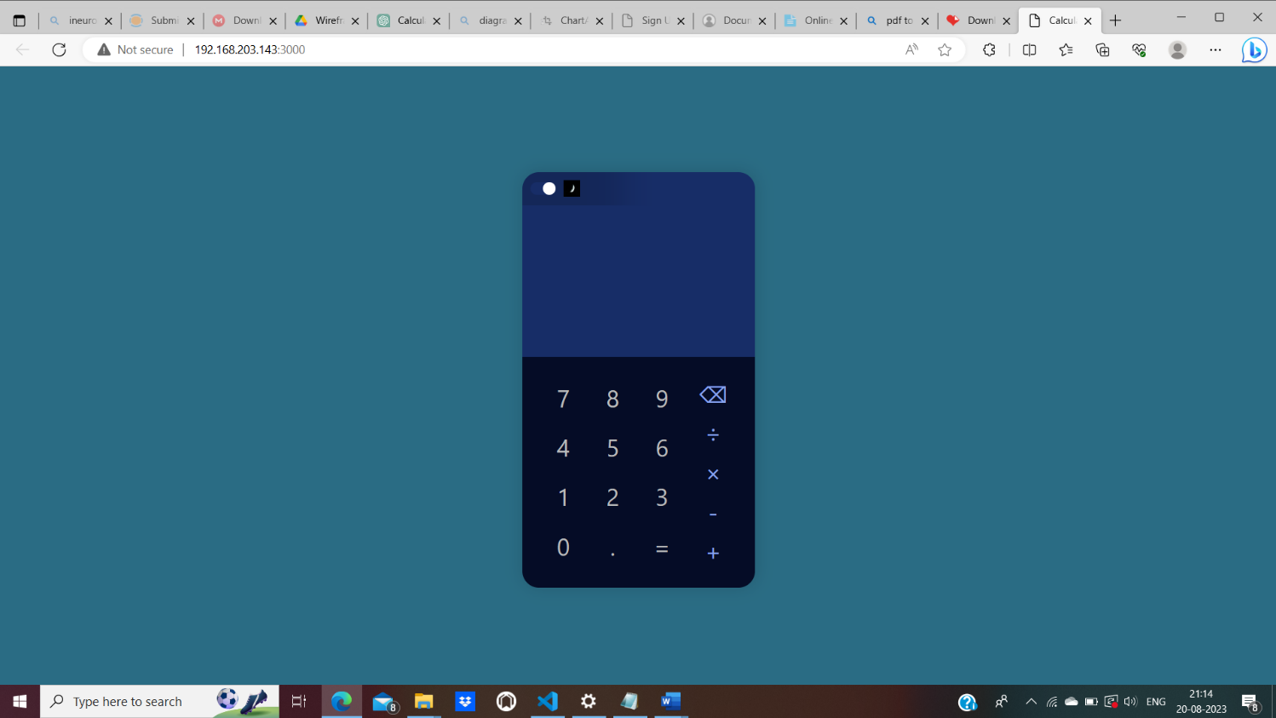

Based on User’s input, Calculator is performing Operation, on Calculator & it is showing results is below:

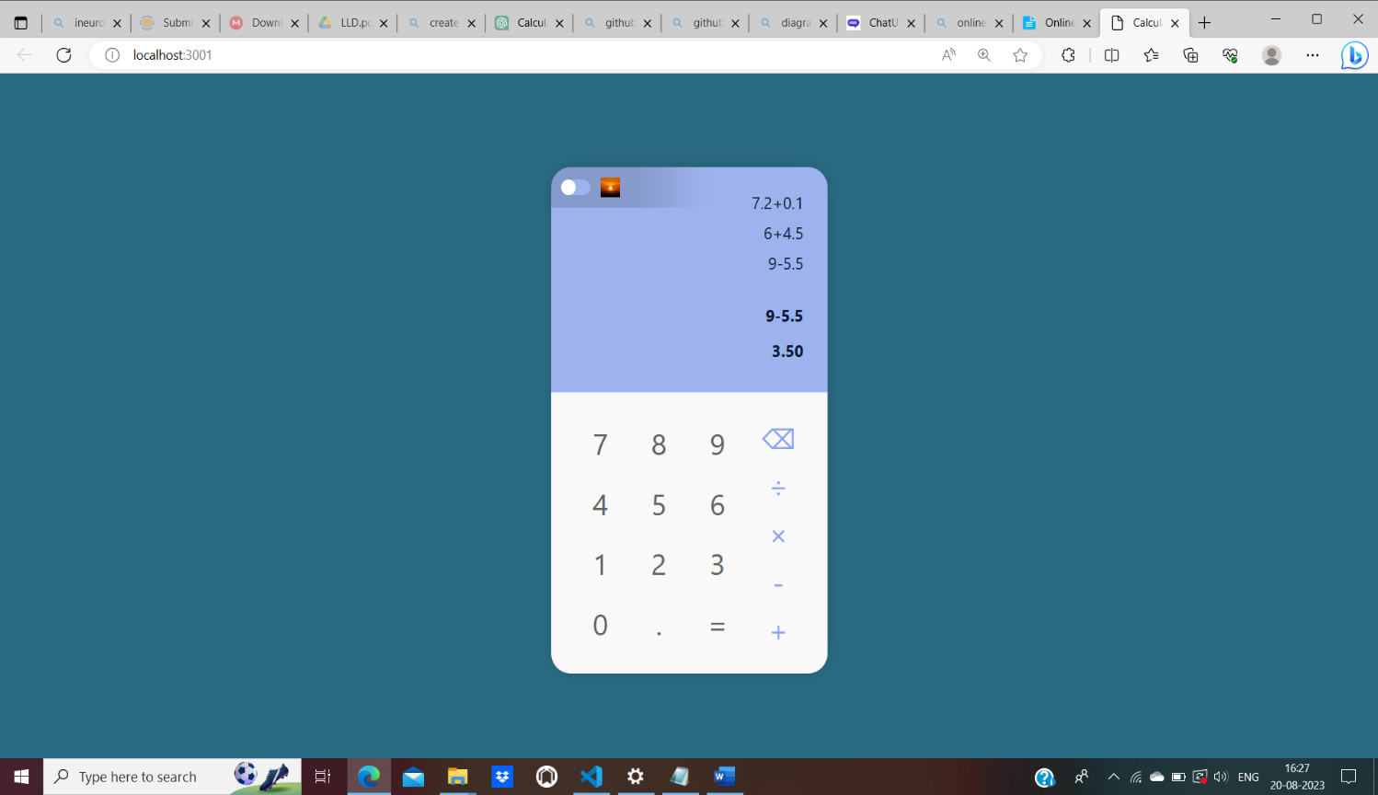

It is storing results in the above section.

