Project Proposal Synopsis

Academic Year 2026 to 2027

Team Details
S. No. | Roll Number | Name | Email | Contact Number
1 | 2361304 | Lokesh Singh Mehta (TL) | lokeshmehta1805@gmail.com | 8630842307
2 | 2361370 | Nitesh Singh Mahara | singhmaharachandan@gmail.com | 8077584833
3 | 2361280 | Krishna Mehta | ktm740092@gmail.com | 9193019243
4 | 2361025 | Abhishek Singh Rawat | abhishekpersona1402@gmail.com | 9411132560
Project Details
Title: Safar Himalaya
Technologies to be used: React.js, Node.js, Express.js, MongoDB, Razorpay
Brief Description of the Project (Point-wise):
MERN Stack Smart Tourism Platform:
Safar Himalaya is a MERN stack-based smart tourism platform designed to help travellers plan, explore, and manage trips across Himalayan destinations through one integrated system.
- Personalized Trip Recommendation:
The platform provides personalized trip recommendations based on the traveller’s budget, trip duration, interests, preferred season, and group type such as solo, family, or friends using a recommendation engine.
- Hotel Price Tracker:
Tracks accommodation prices in real time and notifies travellers of price drops, helping them book at the best possible rates.
- Network Dead Zone :
Shows travellers the areas along their route where mobile network coverage is weak or unavailable, helping them prepare for communication and emergencies.
- Bluetooth-Based Communication:
Lets group members exchange messages through Bluetooth mesh networking without internet access, helping maintain connectivity in remote trekking zones.
- SOS Button:
Provides a one-tap emergency alert that shares the traveller's live location with emergency contacts and is designed to work even in low- or no-network areas of the Himalayas.
- Trip with Friends :
Enables groups to plan trips together and automatically splits shared expenses such as hotels, cabs, and food among members.
- Weather-Based Alerts:
Sends real-time weather and hazard warnings, including landslides and heavy rain, for the traveller's route to help avoid unsafe conditions.
- Safe House:
Locates the nearest safe shelters or homestays during emergencies or bad weather, ensuring travellers always have a safe place to go.
- Three-Layer Architecture:
The platform is divided into three layers—Admin, Service Provider, and Traveller—where each layer has specific roles and access to relevant features

Whether compared with an existing system (give URL, link, or citation):
https://www.myswitzerland.com/en-in/
Whether discussed with a faculty member: Yes (Mr. Rahul Singh)
Whether the proposed work extends internship work: No
Previous work with the proposed technologies: Yes
Whether a preliminary DFD or ERD has been prepared: Yes

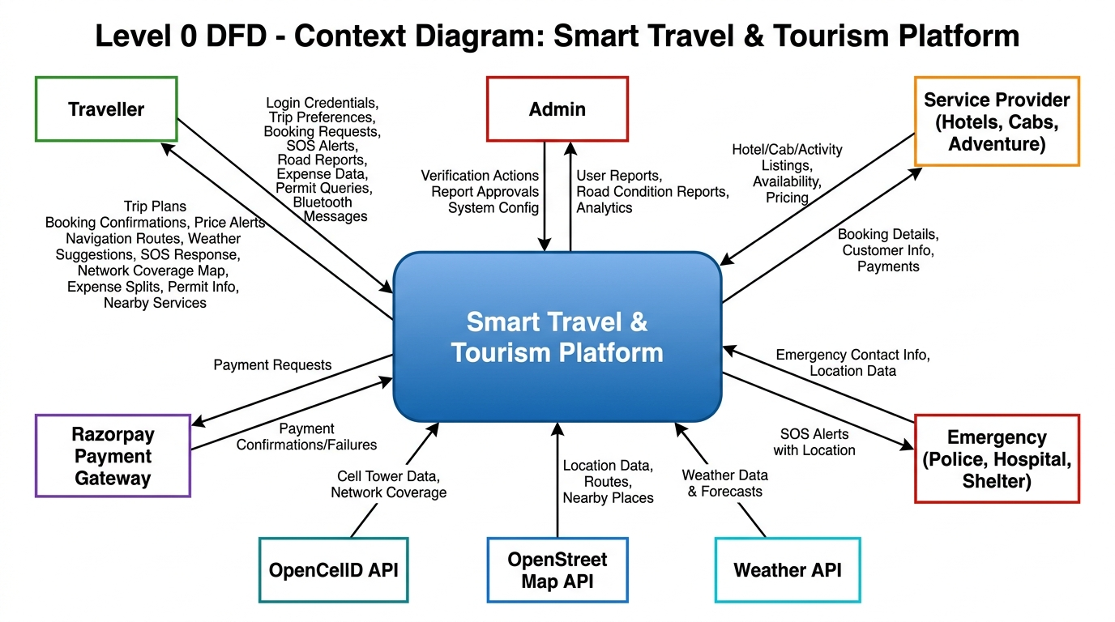

Planning Details
July 2026 to April 2027
Phase | From | To
Literature Survey | 15-07-2026 | 02-08-2026
Design | 03-08-2026 | 01-09-2026
Implementation-1 | 02-09-2026 | 31-10-2026
Implementation-2 | 01-11-2026 | 01-01-2027
Implementation-3 | 01-01-2027 | 01-01-2027
Testing | 04-03-2027 | 05-04-2027
Submission | 15 April 2027

Work Distribution Plan

Project ID: 13 |  |  | Team Leader: Lokesh Singh Mehta
Project Title: Safar Himalaya
S. No. | Module Name | Functionalities |  | Technologies Used | Team Member
1 | Traveller Portal | Trip Planner, Booking System, SOS Button, Payment Gateway |  | React.js, Node.js, Express.js, MongoDB, Razorpay | Lokesh Singh Mehta
2 | Service Provider Portal | Dynamic Pricing, Smart Booking, Multiple Services |  | React.js, Node.js, Express.js, MongoDB | Nitesh Singh Mahara
3 | Admin Portal | Verification, Admin Dashboard, Analytics |  | React.js, Node.js, Express.js, MongoDB | Abhishek Singh Rawat
4 | Traveller Portal | Booking History, Price Graph, Nearby Services |  | React.js, Node.js, Express.js, MongoDB | Krishna Mehta

Remember
- Permanent PROJECT ID would be provided only after acceptance of proposal.
- If more than one person is allocated on a module, it should be mentioned who is dealing with which functionalities of the module.
- Create this distribution PLAN in detail.
- Distribution of workload should be balanced among team members.

