A PROJECT ON

“ONLINE EXAMINATION PORTAL”

SUBMITTED IN
PARTIAL FULFILLMENT OF THE REQUIREMENT
FOR THE COURSE OF
DIPLOMA IN ADVANCED COMPUTING FROM CDAC

SUNBEAM INSTITUTE OF INFORMATION TECHNOLOGY
KARAD

SUBMITTED BY:

Bhagyashri Vilasrao Kale
Kajal Kailas Ghule
Ganesh Navanath Shinde
Tejas Sanjay Lakade

UNDER THE GUIDENCE OF:
Mr. Shubham Borle,
Faculty Member
Sunbeam Institute of Information Technology, KARAD.



CERTIFICATE

This is to certify that the project work under the title ‘Online Examination Portal’ is done by miss. Bhagyashri Vilasrao Kale, miss Kajal Kailas Ghule, Mr. Ganesh Navanath Shinde, Mr. Tejas Sanjay Lakade in partial fulfillment of the requirement for award of Diploma in Advanced Computing Course.

Mr. Shubham Borle
Project Guide Course Co-Coordinator

Date:

A PROJECT ON
Online Examination Portal
SUBMITTED IN
PARTIAL FULFILLMENT OF THE REQUIREMENT
FOR THE COURSE OF DIPLOMA IN ADVANCED COMPUTING FROM CDAC

SUNBEAM INSTITUTE OF INFORMATION TECHNOLOGY
Hinjawadi
SUBMITTED BY:
Bhagyashri Vilasrao Kale
Kajal Kailas Ghule
Ganesh Navanath Shinde
Tejas Sanjay Lakade
UNDER THE GUIDENCE OF:
Mr. Shubham Borle
Faculty Member
Sunbeam Institute of Information Technology, Pune

ACKNOWLEDGEMENT

A project usually falls short of its expectation unless aided and guided by the right persons at the right time. We avail this opportunity to express our deep sense of gratitude towards Mr. Nitin Kudale (Center Coordinator, SIIT, Pune) and Mr. Shubham Borle (Course Coordinator, SIIT ,Pune) .
We are deeply indebted and grateful to them for their guidance, encouragement and deep concern for our project. Without their critical evaluation and suggestions at every stage of the project, this project could never have reached its present form.
Last but not the least we thank the entire faculty and the staff members of Sunbeam Institute of Information Technology, Pune for their support.

Bhagyashri Vilasrao Kale
Kajal Kailas Ghule
Ganesh Navanath Shinde
Tejas Sanjay Lakade

DAC Sep 22 Batch,
SIIT Pune

INTRODUCTION TO PROJECT

The web based “Online Examination Portal” project is an attempt to stimulate the basic concepts of Examination Conduction. The system enables the candidate to do the things such as search for Company as per job preference and can give exam scheduled by Company for which the candidate has applied. Companies can post a job as per their requirements.
The system provides Candidates a Quick Search facility that provides them details of the jobs posted by companies and list of candidates applied for the job to the companies. To apply and post job you need to login into your account.
The system allows the Company to send an email to candidates that have applied for their job regarding their selection for the examination and the scheduled Date & time of the exam. The system will display all the candidates and companies to each other.
Here we provided quick search facility which displays number of vacancies available for particular company and for particular job. Based on vacancies and requirements the candidates can apply for the company.
Company will check for the candidates applied for the job they have posted. They will notify all Candidates regarding the update about the scheduling of exam, Company will conduct the exam and the candidates will appear for the exam. Based on the candidate’s performance in the examination the further decision will be taken by the company regarding their recruitment of the candidates.

2.REQUIREMENTS

2.1 FUNCTIONAL REQUIREMENTS

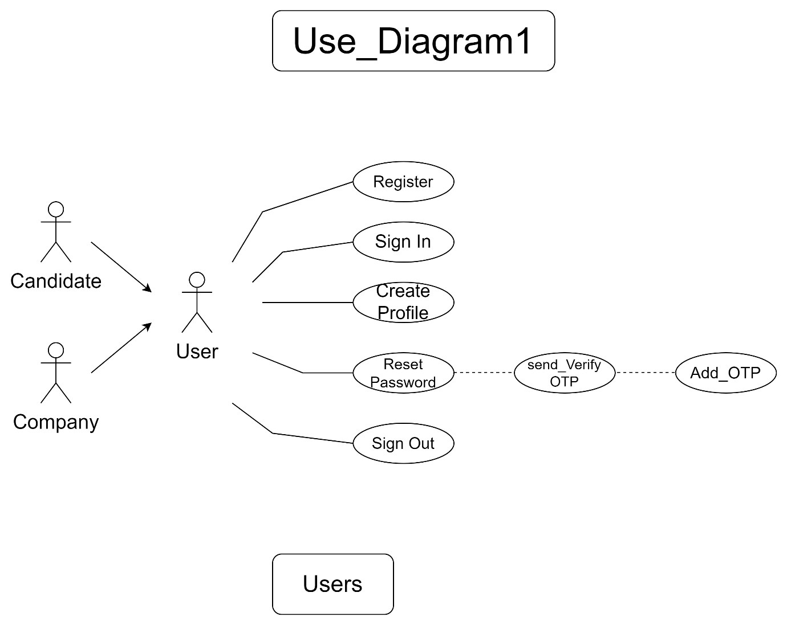
2.1 User

The Candidate and Company both will be called the ‘user’, will be presented with five common choices by the system, as the first step in the interaction between System and them. A user can choose one of these and his choice would be governed by whether he is a registered as Candidate or as a Company. The terms ‘registered candidate’ and ‘registered company’ are described below.
A candidate who has applied for the job or the company have already posted a job or conducted an exam regarding the recruitment earlier would have been given a user id and a password. This ‘personal information’ would be henceforth referred to as ‘profile’. Such a user with a profile in DB-user shall be called a ‘registered user’. A registered user can use the functioning by logging into the system.
A new user, on the other hand, would have to register himself with the system by providing personal information, with help of this new user will becomes a registered user.

2.2 Registration and creation of user profile

The system shall require a user to register, in order to carry out the Exam and Job application functionalities. It will ask the user for the following information at the least – a user name, an address, a city, a state, a pin code, an Email, a Mobile No, a password, a Confirm Password, Date of Birth, Gender, Highest Qualification – for the candidate. For company an additional detail such as Contact person, company website will be asked. The system will ask user it’s role at the time of Registration as well.
Based on the role chosen by the user the distribution is done internally. That is if user have selected
- Candidate Role
- Company Role
In case user choses a) option – user has registered himself as candidate he can search and see the jobs created by companies also, candidate can apply for the suitable jobs.
In case user chose b) option – user has registered himself as Company
He can post Jobs as per the requirement and can conduct exam.
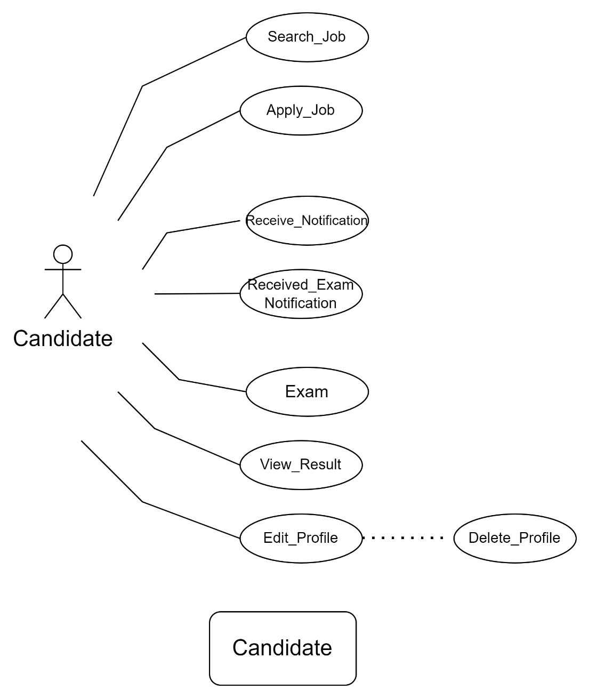

2.2.1 Search Job
The above mentioned is the functionality provided by system for the candidate only. Here candidate can search for the available jobs suitable for his profile that is academics and experience level.
2.2.2 Apply Job
Candidate can choose any job best suited for him and can apply for it.

2.2.3 Receive Notification
Once a candidate applies for a job, company posted that job will look for the candidate list and will send them all a notification regarding their selection for the examination.

2.2.4 Receive Exam Notification
Candidate selected for the examination will receive a notification regarding the exact date and time of the examination.

2.2.5 Appearing for Exam
Candidate can appear for the exam scheduled by the company.

2.2.6 View Result
Candidate can view result of the same examination he has given.

2.2.7 Edit / Delete Profile
Candidate can update/ delete his profile at any instant of time, after deletion the details of the profile will be deleted from the database and user will not be able to use the system.

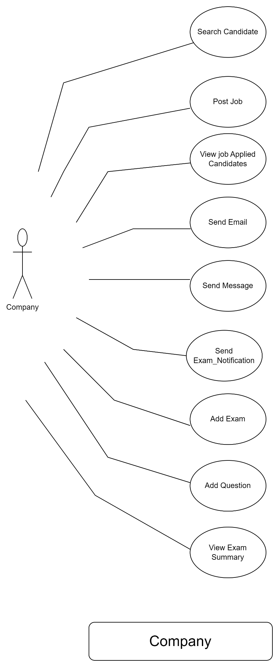
2.3.1 Search for Candidate
Company can post a job and ask for candidates to apply for it.
Company can view the list of candidates applied for the job. Company can also search for the candidate in their list.

2.3.2 Post Job
Company can post a job as per its requirement.

2.3.3. View Applied Candidate List
Company can view the detailed list of candidates applied to the job with their names, contact no, email id.

2.3.4. Send Email
Company can send email to the selected candidates based on the emails they have provided at the time of registration.

2.3.5. Send Message
Company can send Message to candidates regarding their exam schedule.

2.3.6. Send Exam Notification
Company can send an exam notification to the candidates prior to the scheduled exam date and time.

2.3.7. Add Exam
As per the requirement mentioned in the job , Company can schedule an exam with the difficulty as per the job requirement knowledge level, it might be easy, medium or difficult.

2.3.8. Add Question
Company can add specific questions to the exams, they are stored in the Database for time being and can be fetched and will be displayed to the candidate as the part of exam as and when scheduled.

2.3.9. View Exam summary
Company can view the summary of marks gained by the candidates and the top performers in the same exam, based on which they can take decision regarding the further recruitment process.

ADMIN :
Here no admin role is specified since, there will be direct communication between candidate and company and hence no middleware or third person involvement will be required.

  - NON FUNCTIONAL REQUIREMENTS

2.2.1 Interface
Go to Appendix B for user interfaces

2.2.2 Performance
- Number of Concurrent Users:
ARS shall be able to handle at least 1000 transactions/inquiries per
second
- Booking of Tickets:
The system is susceptible to any temporary server failure since it uses the strong feature of Struts 2 and Hibernate. Hence the examination will be continued even if the sever gets disconnected in between the examination.

2.2.3 Constraint
ARS shall be able to handle at least 1000 transactions/inquiries persecond

2.2.4 Other Requirements:
- Hardware Interfaces
The SPMS is expected to function on Intel PIII 900 MHz Processor equivalent or above, 128 MB RAM, 20 GB HDD.
- Software Interfaces
The SPMS shall work on MS Windows operating systems family (MS Windows 98, MS Windows NT Workstation, MS Windows 2000, MS Windows XP). It configures to work with Oracle database. This System works on Apache Tomcat server. It uses browser IE 5.0 & above. It uses IIS 5.0 server.

3. DESIGN

3.1 Database Design

The following table structures depict the database design.

Table1: Registration

Key Type/ Constraint | Column Name | Data Type | Length | Allow Null (1=Yes;0=No)
3 | UserID | Number | 4 | 0
0 | Name | Varchar | 70 | 0
0 | Address | Varchar | 45 | 0
0 | City | Varchar | 45 | 1
0 | State | Varchar | 45 | 1
0 | pin code | Varchar | 10 | 1
0 | mobile | Varchar | 15 | 1
0 | Email_id | Varchar | 30 | 1
0 | password | Varchar | 256 | 1
0 | DOB | DATE |  | 0
0 | gender | Char | 1 | 0
0 | Contact_person | Varchar | 70 | 0
0 | Comp_website | Varchar | 100 | 1
1 | role | Varchar | 45 | 0
1 | User_type | number |  | 0
0 | Qualification_details | Varchar | 100 | 0

Table2: User_Type

3 | Id | Number | 4 | 0
0 | userType | Varchar | 30 | 1

Table3: Notification

3 | ID | Number | 4 | 0
0 | User_id | Number |  | 1
0 | C_msg | Varchar | 45 | 1
0 | Msg_datetime | DateTime |  | 1

Table4: Question

3 | ID | Number | 4 | 0
3 | User_id | Number | 4 | 0
0 | Question | Varchar | 256 | 1
0 | Option_a | Varchar | 45 | 1
3 | Option_b | Varchar | 45 | 0
0 | Option_c | Varchar | 45 | 1
0 | Option_d | Varchar | 45 | 1
0 | Option_e | Varchar | 45 | 1
0 | Correct_ans | Varchar | 45 | 1
0 | X | Varchar | 45 | 1
0 | Y | Varchar | 45 | 1
0 | Z | Number | 4 | 1

Table5: ApplyJob

3 | Id | Number | 4 | 0
0 | User_id | Number | 4 | 0
3 | Job_id | Number | 4 | 0
0 | isApplied | TinyInt |  | 0
0 | ApplicationDate | Date |  | 1
0 | X | Varchar | 45 | 1

Table6:Post Job

3 | ID | Number | 4 | 0
0 | User-id | Number | 4 | 1
0 | Last_date | Date |  | 1
0 | Vacancy | Number | 4 | 1
0 | Skill | Varchar | 100 | 1
0 | Min_qualification | Varchar | 20 | 1
0 | Max_age | Number | 4 | 1
0 | Job_location | Varchar | 45 | 1
0 | Salary | Double |  | 1
0 | Working_hours | Number | 4 | 1
0 | Description | Varchar | 256 | 1

Table7:Result

3 | Id | Number | 4 | 0
0 | User_id | Number | 4 | 0
3 | ques_id | Number | 4 | 0
0 | Selected_ans | Varchar | 4 | 0
0 | X | Varchar | 45 | 1
0 | Y | Varchar | 45 | 1

Table8:Password_history

3 | Id | Number | 4 | 0
0 | User_id | Number | 4 | 0
3 | Old_Password | Varchar | 256 | 0
0 | Last_modified | Date |  | 0

Table9:OTP_details

3 | Id | Number | 4 | 0
0 | User_id | Number | 4 | 0
2 | Otp_code | Varchar | 6 | 0
0 | Generated_on | Date |  | 0
0 | Expiry_time | Date
0 | isVerified | TinyINT
0 | X | Varchar | 45 | 1
0 | Y | Varchar | 45 | 1

Table10:Exam

3 | Id | Number | 4 | 0
0 | User_id | Number | 4 | 0
3 | Ques_id | Number | 4 | 0
0 | Exam_OTP | Varchar | 6 | 0

E-R Diagram,Dataflow diagram and Class Diagram:

Go to Appendix A

4. CODING STANDARDS IMPLEMENTED

Naming and Capitalization
Below summarizes the naming recommendations for identifiers in Pascal casing is used mainly (i.e. capitalize first letter of each word) with camel casing (capitalize each word except for the first one) being used in certain circumstances.
Identifier | Case | Examples | Additional Notes
Class | Pascal | EmailOTP, AppUser, BaseEntity | Class names should be based on "objects" or "real things" and should generally be nouns. No ‘_’ signs allowed. Do not use type prefixes like ‘C’ for class.
Method | Camel | getDetails, sendEmail | Methods should use verbs or verb phrases.
Parameter | Camel | name, address | Use descriptive parameter names. Parameter names should be descriptive enough that the name of the parameter and its type can be used to determine its meaning in most scenarios.
Interface | Pascal with "I" prefix | applyJob | Do not use the ‘_’ sign

Comments
- Comment each type, each non-public type member, and each region declaration.
- Use end-line comments only on variable declaration lines. End-line comments are comments that follow code on a single line.
- Separate comments from comment delimiters (apostrophe) or // with one space.
- Begin the comment text with an uppercase letter.
- End the comment with a period.
- Explain the code; do not repeat it.

Appendix A

Class Diagram

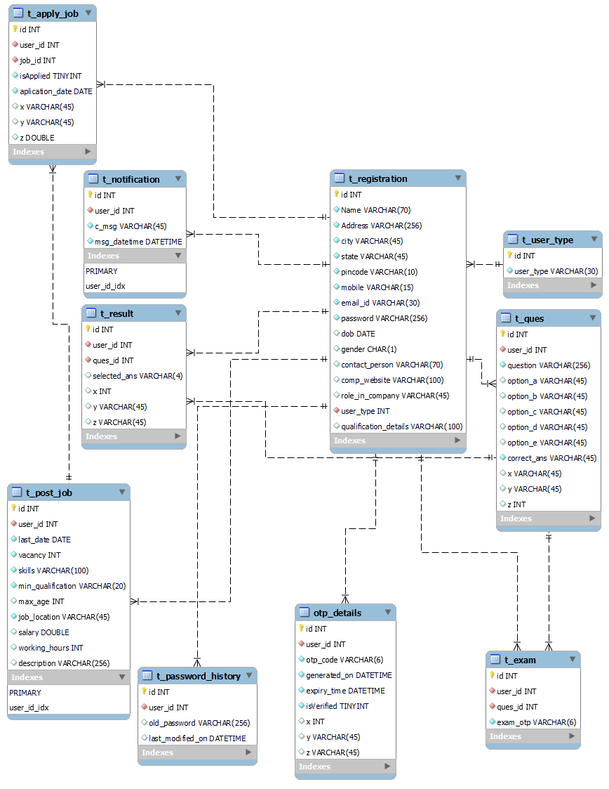

Appendix B

Registration Page
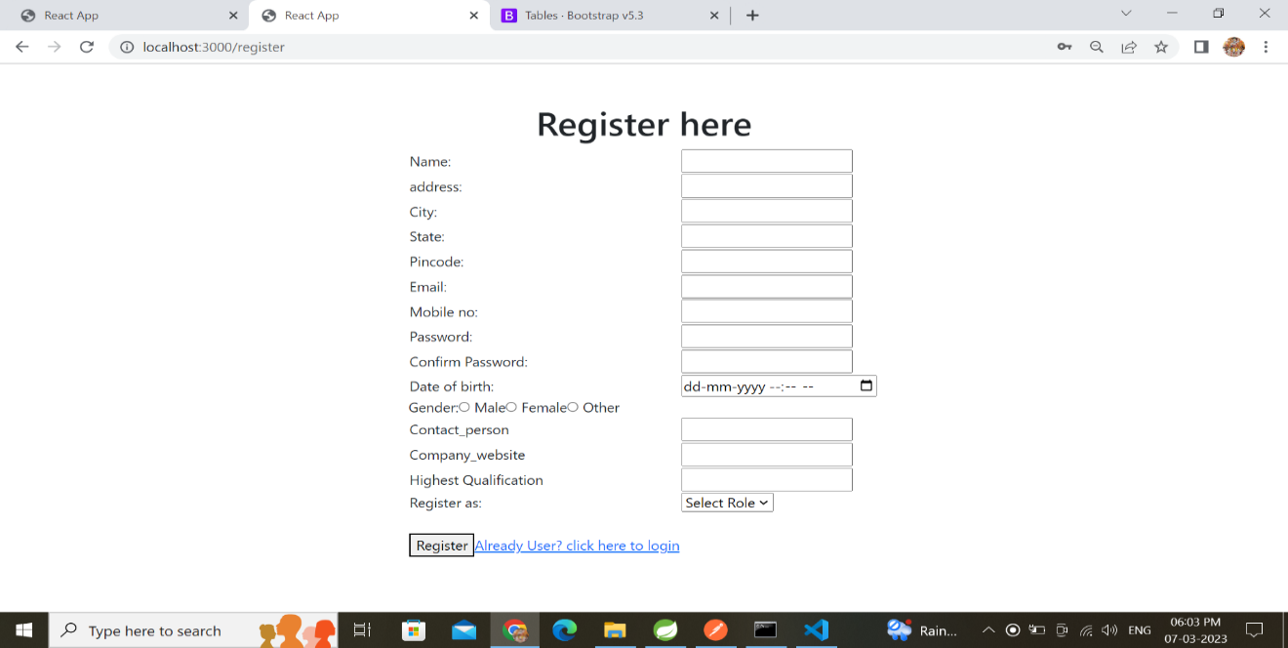

LoginPopup:

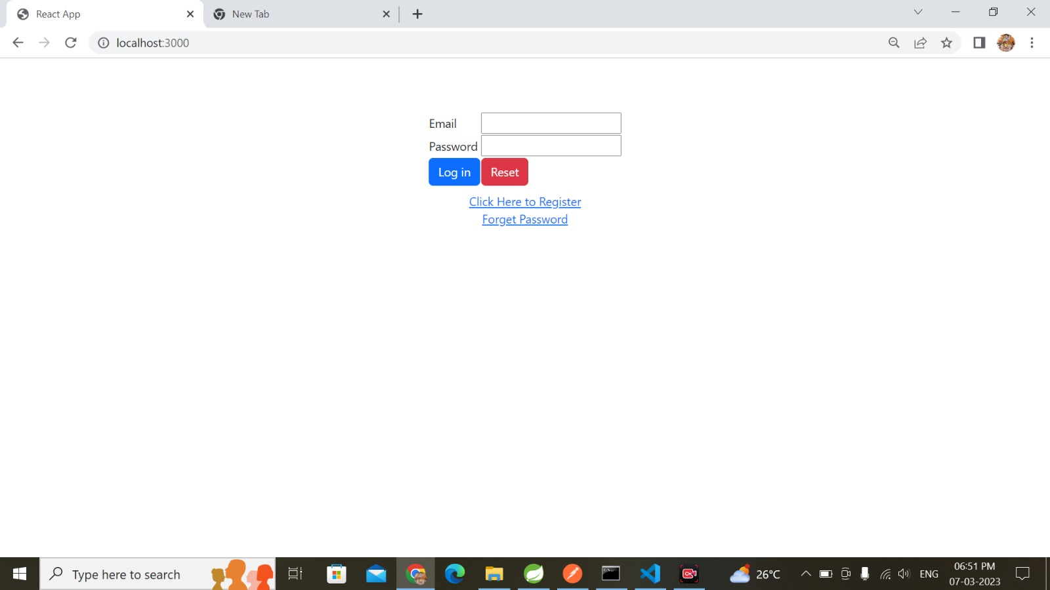

Search Company/Job:

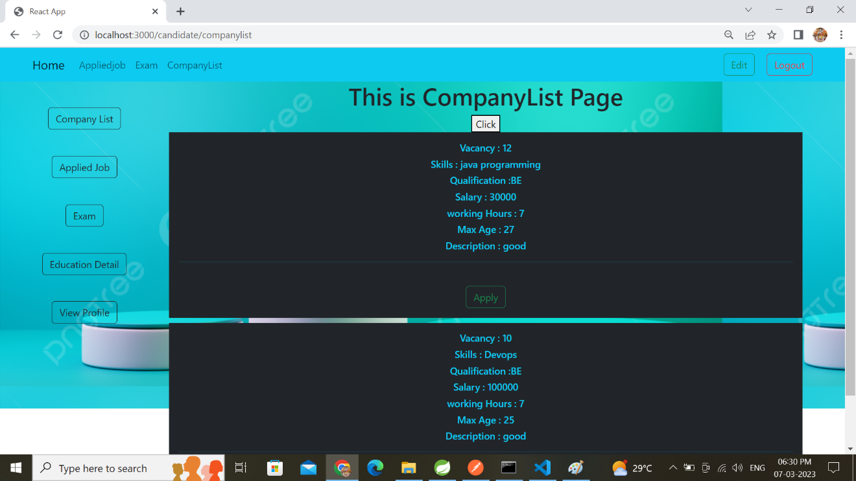

Apply Job:

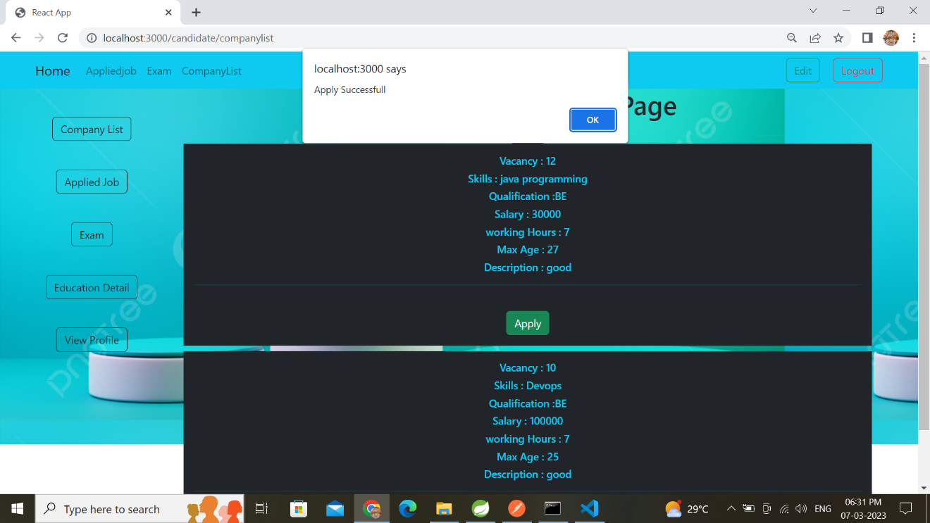

Edit Candidate Profile:
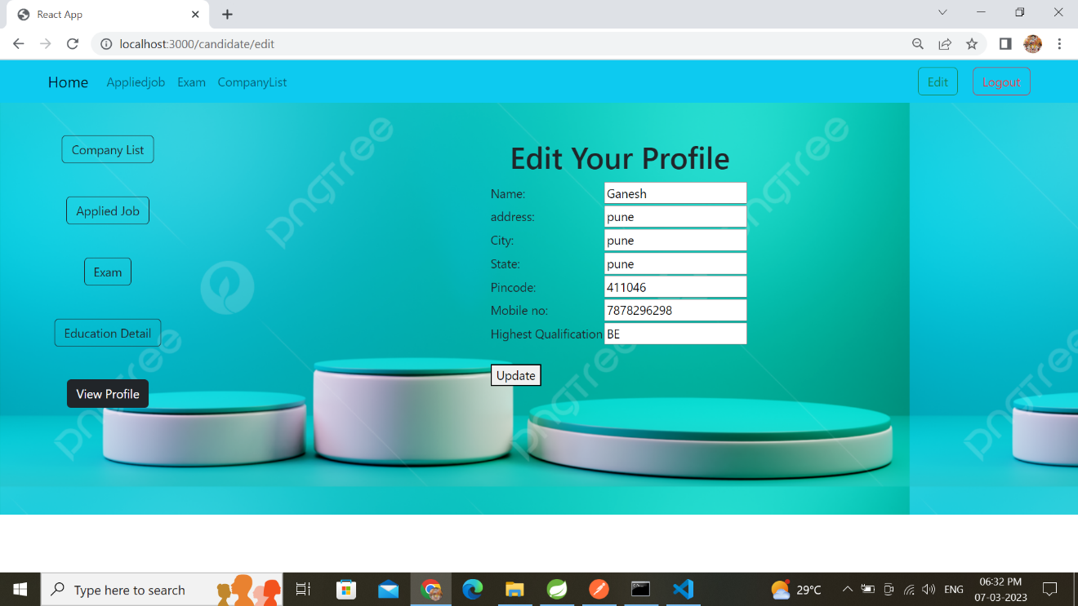

Update Question:

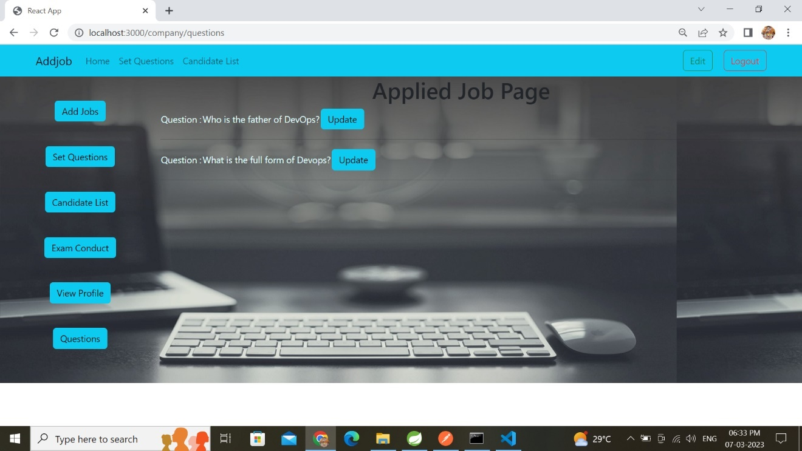

Update Question:

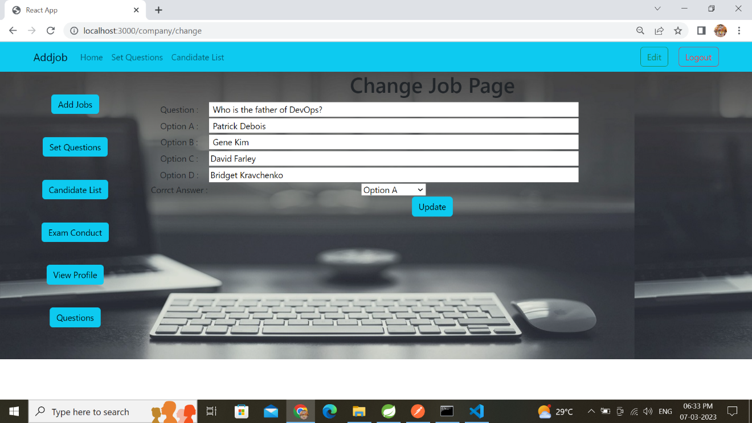

EditCompanyProfile:

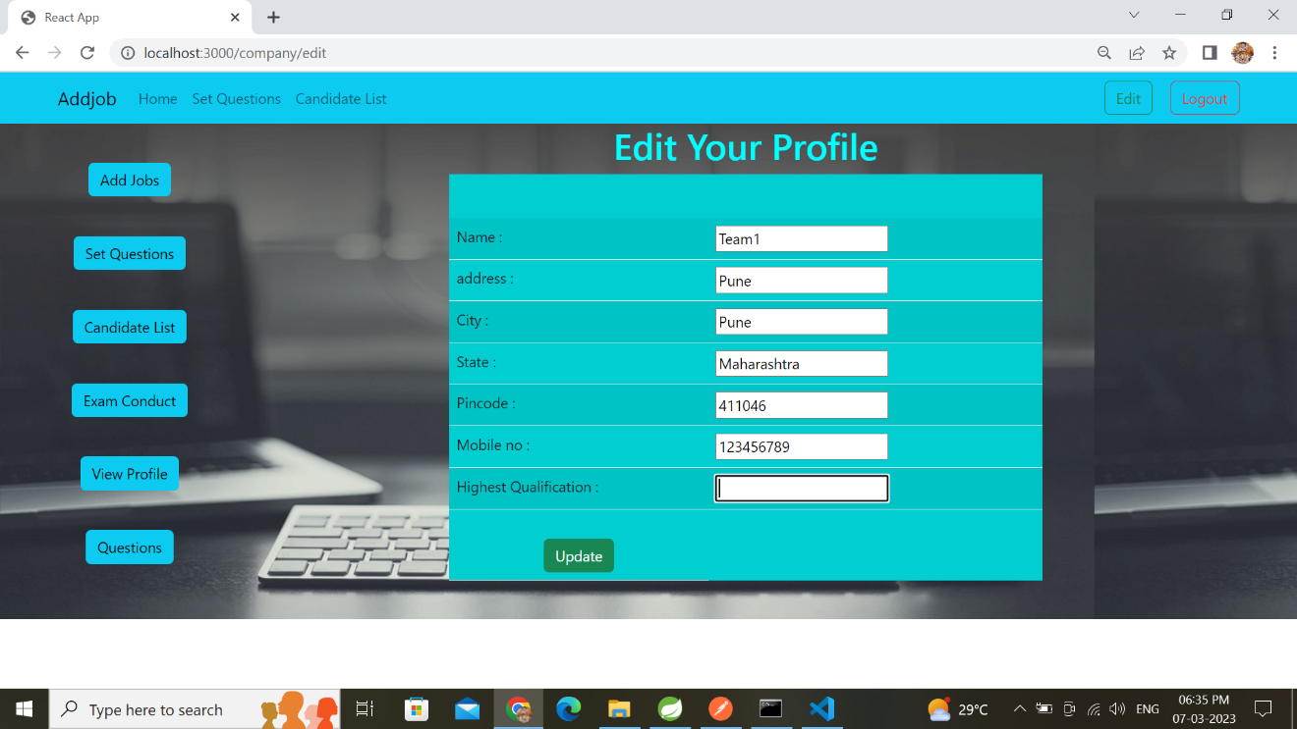

Add JOB:
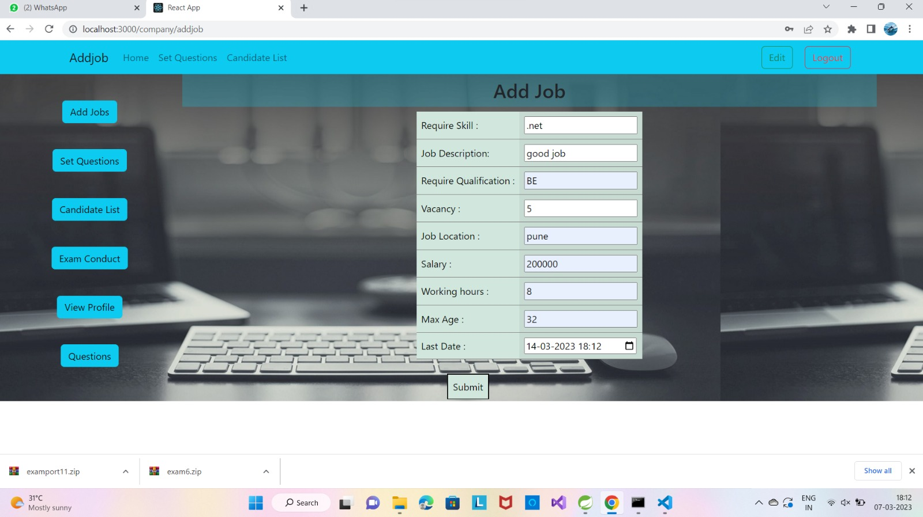

Set a Question:

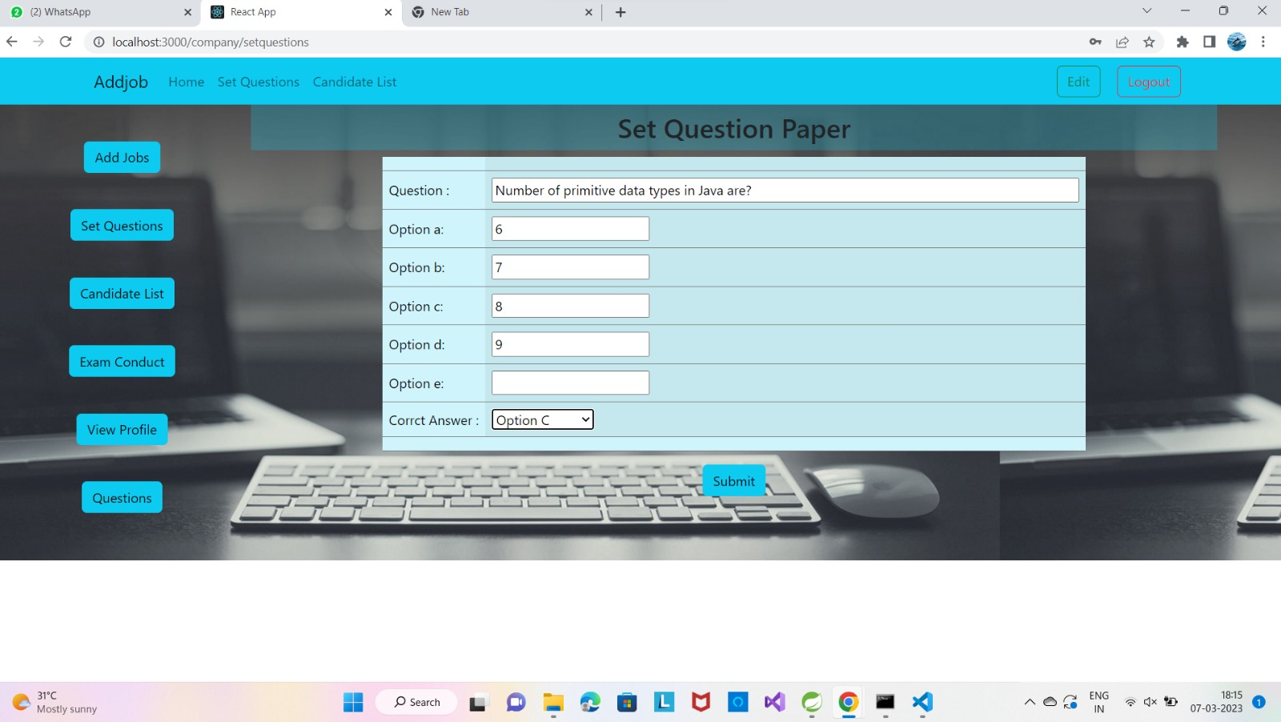

Set a Exam:

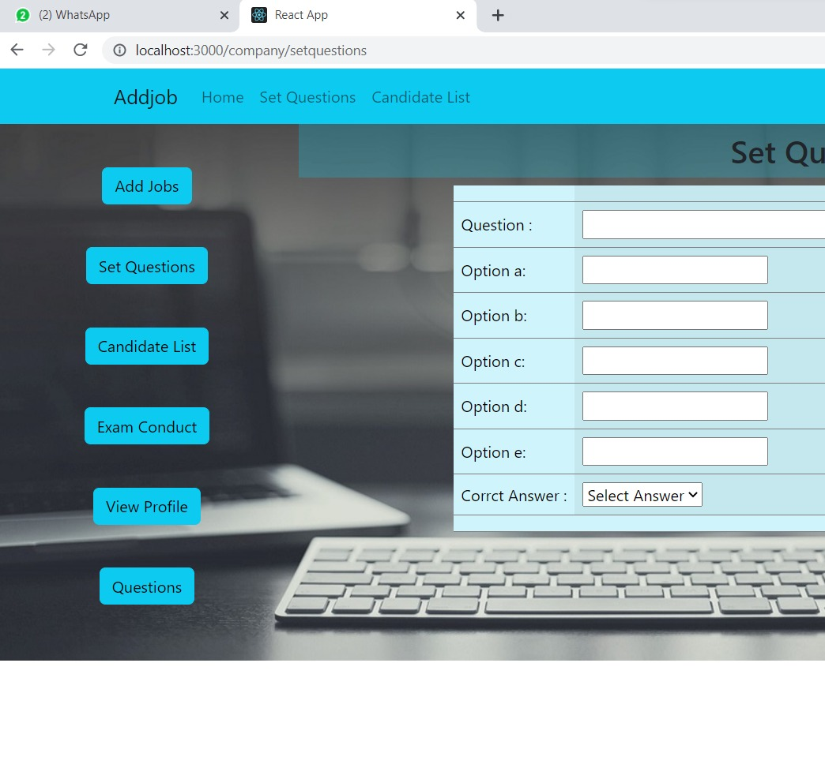

7.REFERENCES:

http://www.google.com

https://www.testportal.net/

https://www.conductexam.com/

https://www.yoctel.com/online-exam-website-portal

https://joinsuperset.com/student.html

https://www.speedexam.net/

https://exam.net/

