**Case Study Report**

1. **Location where most number of Funding is done.**

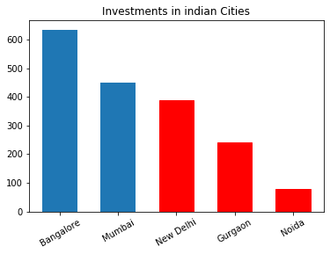

* Bars in Red colour representing cities of NCR.
* New Delhi is best among the NCR.
* Bangalore is best among all cities for getting investment for Startups.

**2.**  **Top 5 investors who have invested maximum number of times.**

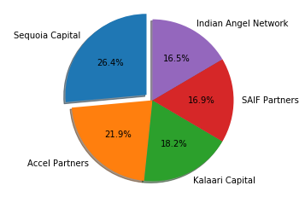

* Sequoia capital has maximum number of investments.

**3. Investors invested maximum number of times in different companies.**

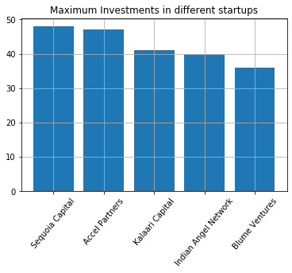

**4. Investment type is crowd funding & Seed funding(intial Investment).**

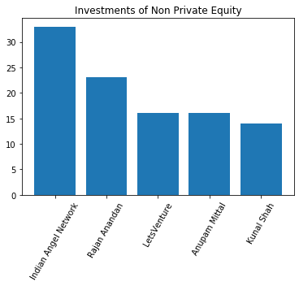

**5. Investment type is Private Equity.**

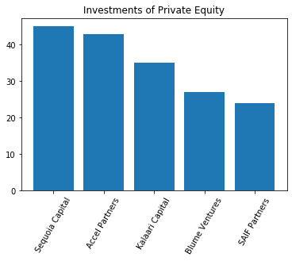

**Conclusion:-**

From the above figures and answers ,the analysis comes to the conclude that **Bangalore**

Is the best among all the cities to expect better investment and **Indian angel network** is best

Investor to start with. After that we can expect better investment from **Sequoia capitals** for investments.