VERIFACT AI

FAKE NEWS DETECTION AND
MISINFORMATION ANALYSIS USING
NATURAL LANGUAGE PROCESSING
A PROJECT REPORT
Submitted by
Abhishek Singh [RA2311003010759]
Rishabh Dhatrak [RA2311003010758]
Under the Guidance of
Dr. S. Saminathan
Assistant Professor
Department of Computing Technologies
in partial fulfillment of the requirements for the degree of
BACHELOR OF TECHNOLOGY
in
COMPUTER SCIENCE AND ENGINEERING
CORE


DEPARTMENT OF COMPUTING TECHNOLOGIES
COLLEGE OF ENGINEERING AND TECHNOLOGY
SRM INSTITUTE OF SCIENCE AND TECHNOLOGY
KATTANKULATHUR - 603 203
NOVEMBER 2026



SRM INSTITUTE OF SCIENCE AND TECHNOLOGY
KATTANKULATHUR - 603 203

BONAFIDE CERTIFICATE

Certified that 21CSP302L - Project report titled “VeriFact AI: Fake News Detection and Misinformation Analysis Using Natural Language Processing” is the bonafide work of “Abhishek Singh [RA2311003010759] and Rishabh Dhatrak [RA2311003010758]” who carried out the project work under my supervision. Certified further, that to the best of my knowledge the work reported herein does not form any other project report or dissertation on the basis of which a degree or award was conferred on an earlier occasion on this or any other candidate.

SIGNATURE | SIGNATURE
Dr. S. Saminathan  Assistant Professor  Faculty In-Charge  Department of Computing Technologies | Dr. Niranjana G  Head of Department  Department of Computing Technologies

ACKNOWLEDGEMENTS
We thank SRM Institute of Science and Technology, Kattankulathur, and the College of Engineering and Technology for the academic environment and facilities that supported this project.
We express our gratitude to Dr. Niranjana G, Head of Department, Department of Computing Technologies, for supporting the project work and its academic review.
We sincerely thank our guide, Dr. S. Saminathan, Assistant Professor, Department of Computing Technologies, for guidance during the development of VeriFact AI. The project brought together natural language processing, machine learning, application design, and experimental evaluation.
We thank the project coordinators, panel members, faculty advisors, and teaching staff for the course instruction and review process. The work provided an opportunity to connect language-processing concepts with a functioning analysis application.
We acknowledge the authors of WELFake and LIAR for making their research datasets available, and the maintainers of the open-source libraries used in the implementation. Their contributions enabled reproducible experimentation and the development of an inspectable NLP pipeline.
Finally, we thank our parents, family members, and friends for their encouragement and support throughout the project.
Abhishek Singh
Rishabh Dhatrak

ABSTRACT
VeriFact AI is a full-stack application for fake news detection and misinformation analysis using Natural Language Processing. It supports pasted English text, public article URLs, and text-based TXT/PDF documents. The system presents a statistical article assessment together with signed feature contributions, linguistic observations, extractive summaries, named entities, and candidate claims. A separate factual-verification status prevents a model estimate from being presented as independent proof.
The active pipeline uses word TF-IDF features, a linear Support Vector Machine, and sigmoid calibration. WELFake data preparation includes source-marker cleaning, exact-duplicate removal, approximate-duplicate grouping, and group-disjoint training, validation, calibration, and test partitions. The retained corpus contains 60,544 articles. On 12,110 held-out test articles, the model achieves 96.31% accuracy, 96.51% misleading-class precision, 94.99% recall, and 95.74% F1.
The frontend uses Next.js and TypeScript; the backend uses FastAPI, scikit-learn, spaCy, and SQLAlchemy. Session-owned history, report export, deletion, and an interactive NLP lab support practical inspection. Verification on 28 October 2026 passed 41 backend tests, 11 component tests, and eight browser workflows.
A separate diagnostic on 798 LIAR short claims achieves only 47.24% accuracy, demonstrating limited transfer beyond the article benchmark. The project therefore provides an explainable screening tool and learning environment, while leaving source verification and evidence assessment as distinct tasks. Future work includes source and temporal holdouts, contemporary Indian news evaluation, multilingual support, and evidence-grounded claim review.
Keywords: Natural Language Processing, fake news detection, TF-IDF, Support Vector Machine, calibration, explainability.

TABLE OF CONTENTS
ABSTRACT iv
TABLE OF CONTENTS v
LIST OF FIGURES vii
LIST OF TABLES viii
ABBREVIATIONS ix
INTRODUCTION 1
1.1 Introduction to Project 1
1.2 Problem Statement 2
1.3 Motivation 3
1.4 Sustainable Development Goal of the Project 4
LITERATURE SURVEY 5
2.1 Datasets for News and Claim Classification 5
2.2 Lexical Features and Linear Classification 6
2.3 Calibration and Semantic Representations 7
2.4 Linguistic Analysis and Application Technologies 8
SPRINT PLANNING AND EXECUTION METHODOLOGY 9
3.1 Sprint I 9
3.1.1 Objectives with User Stories of Sprint I 10
3.1.2 Functional Document 11
3.1.3 Architecture Document 12
3.1.4 Outcome of Objectives and Result Analysis 13
3.1.5 Sprint Retrospective 14

TABLE OF CONTENTS
3.2 Sprint II 15
3.2.1 Objectives with User Stories of Sprint II 15
3.2.2 Functional Document 16
3.2.3 Architecture Document 17
3.2.4 Outcome of Objectives and Result Analysis 19
3.2.5 Sprint Retrospective 20
RESULTS AND DISCUSSIONS 21
4.1 Project Outcomes 21
4.2 Discussion of Findings 26
CONCLUSION AND FUTURE ENHANCEMENT 27
5.1 Conclusion 27
5.2 Future Enhancement 28
REFERENCES 29
APPENDIX A CODING 31
APPENDIX B SCREENSHOTS 33

LIST OF FIGURES
Figure 3.1 Request and report architecture 12
Figure 3.2 Article training and inference pipeline 18
Figure 4.1 Confusion matrix for the article test partition 21
Figure B.1 Article assessment interface 33
Figure B.2 Model explanation interface 34
Figure B.3 Interactive NLP lab 35

LIST OF TABLES
Table 1.1 Problem requirements and implemented responses 2
Table 1.2 Proposed educational and information outcomes 4
Table 2.1 Datasets used in the project 5
Table 2.2 Literature and implementation synthesis 8
Table 3.1 Sprint scope and completion criteria 9
Table 3.2 Sprint I user stories and acceptance criteria 10
Table 3.3 Input and extraction contract 11
Table 3.4 Legacy LIAR experiment outcomes 13
Table 3.5 Sprint II user stories and acceptance criteria 15
Table 3.6 Article assessment policy 16
Table 3.7 Group-disjoint article partitions 17
Table 3.8 Validation search for the article SVM 19
Table 4.1 Full-test article classification metrics 21
Table 4.2 Confidence-filtered result reported separately 22
Table 4.3 Experimental results and their scope 23
Table 4.4 Backend test cases and observed outcomes 24
Table 4.5 Interface and browser verification on 28 October 2026 25
Table 5.1 Future work and proposed acceptance evidence 28

ABBREVIATIONS
Abbreviation | Expansion
AI | Artificial Intelligence
API | Application Programming Interface
BERT | Bidirectional Encoder Representations from Transformers
CSE | Computer Science and Engineering
ECE | Expected Calibration Error
F1 | Harmonic mean of precision and recall
LSH | Locality-Sensitive Hashing
NER | Named Entity Recognition
NLP | Natural Language Processing
ORM | Object-Relational Mapping
POS | Part of Speech
ROC-AUC | Area Under the Receiver Operating Characteristic Curve
SDG | Sustainable Development Goal
SSRF | Server-Side Request Forgery
SVM | Support Vector Machine
TF-IDF | Term Frequency–Inverse Document Frequency
URL | Uniform Resource Locator

CHAPTER 1

INTRODUCTION

1.1 Introduction to Project
VeriFact AI is a web application for fake news detection and misinformation analysis using Natural Language Processing. It accepts English news text, public article links, and text-based documents, then presents an article classification together with the words that influenced it. The application also exposes sentence summaries, named entities, grammatical annotations, candidate claims, and a saved analysis history. Its purpose is to help a reader inspect an article and decide what requires further verification.
The active classifier uses the WELFake article corpus [1]. After filtering and duplicate handling, 60,544 articles remain. A word TF-IDF representation feeds a linear Support Vector Machine, and a separate sigmoid calibration stage converts its decision score into class estimates. The model achieved 96.31% accuracy on 12,110 held-out articles. This result describes agreement with the benchmark labels; it does not establish the truth of an arbitrary article.
Earlier experiments used a binary subset of the LIAR short-claim dataset [2]. Their different task and lower transfer performance motivated the move to a full-article model. VeriFact therefore records the model version and evaluated domain alongside a prediction. The report distinguishes the active article classifier from the preserved LIAR experiments throughout the methodology and evaluation.
The implemented system combines a Next.js interface, a FastAPI service, scikit-learn models, a local spaCy pipeline, and SQLAlchemy persistence. Users can review extracted text before submitting it, inspect model contributions, return to saved reports, and delete their own records. Optional evidence search is a separate, consent-based feature. A persistent factual-status message states that an article has not been independently verified.
This project demonstrates the complete path from text preparation and supervised learning to a usable application. The principal outcome is a working, explainable screening system with reproducible benchmark artifacts and tested user workflows.

1.2 Problem Statement
Readers often encounter articles through forwarded messages, copied text, and aggregated news links. The original source and supporting evidence may be difficult to inspect from those entry points. A single numerical confidence score is especially easy to misread as proof. The engineering problem is to provide a useful screening result while making its evidence, uncertainty, and limitations visible.
The project addresses three connected requirements. It must obtain usable text from common inputs, apply a reproducible classifier, and explain the result without presenting learned word associations as verified facts. It must also keep submitted analyses accessible within the same browser session while preventing another session from reading or deleting them.
Table 1.1 Problem requirements and implemented responses
Requirement | Implemented response
Obtain readable article text | Editable URL and TXT/PDF extraction
Produce an inspectable estimate | TF-IDF, linear SVM and sigmoid calibration
Explain model behavior | Signed contributions from active model features
Communicate uncertainty | Input sufficiency checks and confidence threshold
Support further investigation | Exact claim excerpts and optional evidence retrieval
Preserve user control | Session-owned history, export and deletion

The input scope is English text. Direct text submission requires at least 12 words and permits up to 60,000 characters. Classification uses no more than the first 2,500 words. Inputs below 40 cleaned words or with insufficient vocabulary overlap receive a cautious assessment even when a preliminary class estimate can be computed.
The system does not determine truth by consulting a complete knowledge base. It is not a universal detector for all countries, languages, or breaking events. Its success criteria are correct software behavior, traceable model outputs, measured benchmark performance, and honest disclosure when supporting evidence is unavailable.

1.3 Motivation
The project is motivated by the need to connect NLP theory with an application that can be examined during a demonstration. Tokenization, lexical weighting, classification, lemmatization, entity recognition, and dependency parsing become easier to understand when a user can submit text and inspect the resulting annotations. VeriFact makes these operations visible rather than presenting only a final label.
Interpretability is a central design choice. A linear classifier permits a direct calculation of each active feature's contribution to the calibrated decision score. This makes it possible to show why a word or bigram affected a prediction and to identify suspicious shortcuts. For example, a date-related term may influence the result because of patterns in historical training data, without providing any evidence that the current article is false.
Another motivation is the difference between short claims and full articles. The legacy LIAR experiments operate on brief political statements. Users of the application also submit longer news reports, which provide a different distribution of vocabulary and context. Training on WELFake addresses that input mismatch, while a separate LIAR stress test makes the remaining transfer weakness measurable.
The interface is also intended to encourage careful reading. It shows the original submitted text, exact excerpts for candidate claims, and an extractive summary. Because summary sentences are copied from the article, readers can inspect their context. Language cues such as urgency are displayed separately from learned model contributions, reducing the chance that a sensational phrase will be presented as a factual contradiction.
From a software engineering perspective, the project provides experience with typed API contracts, asynchronous forms, extraction failures, database transactions, migrations, and automated tests. These concerns affect whether an NLP system is usable outside a notebook. The project therefore evaluates both classification performance and the complete path through submission, persistence, retrieval, and deletion.

1.4 Sustainable Development Goal of the Project
The project has an educational relationship to Sustainable Development Goal 4, Quality Education [3]. Its NLP lab allows students to inspect tokens, lemmas, parts of speech, entities, and grammatical dependencies. Its explanation interface also helps users distinguish a statistical association from supporting evidence. These features can support classroom discussion of digital information and responsible interpretation of machine learning outputs.
VeriFact also relates to Goal 16, particularly the emphasis on public access to information in target 16.10 [4]. The application encourages readers to examine an article's source, claims, and publication context before sharing it. Optional retrieval of published fact checks may provide relevant material for that review, although retrieval alone does not establish whether the submitted claim is supported or contradicted.
Table 1.2 Proposed educational and information outcomes
SDG relationship | Project contribution | Evaluation boundary
Goal 4 | Interactive NLP annotations and explanations | Learning gains have not been measured
Goal 16 | Claim inspection and source-checking prompts | No measured societal misinformation reduction
Responsible use | Visible uncertainty and separate factual status | Classifier remains vulnerable to dataset bias

These relationships describe intended contributions rather than demonstrated social impact. No user study has measured whether the application changes sharing behavior, improves media literacy, or reduces exposure to misinformation. Such claims would require a separate evaluation with participants, a defined comparison condition, and appropriate consent.
An educational deployment could ask students to inspect both correctly and incorrectly classified articles, explain the most influential features, and compare those features with external evidence. Assessment should reward recognition of uncertainty and source quality as well as the ability to read model metrics. This would make the project useful even when a classifier prediction is incorrect.

CHAPTER 2

LITERATURE SURVEY

2.1 Datasets for News and Claim Classification
WELFake [1] provides a corpus of full news articles assembled from several datasets. Its published distribution is suitable for studying article-level classification, but a merged corpus may preserve source, style, and topic patterns that make a benchmark easier than independent verification. The project consequently treats the inherited labels as training targets and reports the scope of the evaluation with every major performance claim.
LIAR [2] is a benchmark of short statements associated with graded truthfulness labels. The project's binary experiment keeps true and mostly-true statements in one class, and false and pants-fire statements in the other. Half-true and barely-true examples are excluded. This conversion creates a narrower binary task and should not be confused with the original six-class benchmark.
Table 2.1 Datasets used in the project
Dataset | Text unit | Project use | Main limitation
WELFake | News article | Active training and article test | Inherited labels and source/style effects
LIAR binary subset | Short political claim | Legacy models and transfer diagnostic | Excludes middle labels; different domain

The two datasets cannot support a direct before-and-after accuracy comparison because their inputs, labels, and test populations differ. The article classifier's strong WELFake score and weak LIAR transfer score show that calibration alone does not solve domain shift.
Exact duplicate removal and approximate grouping reduce overlap between training and testing. Source-disjoint and temporal evaluation remain necessary to establish stronger evidence of transfer.

2.2 Lexical Features and Linear Classification
TF-IDF represents text through weighted vocabulary features. Term frequency records how strongly a term appears in one document, while inverse document frequency reduces the relative importance of terms that occur across many training documents. The scikit-learn feature extraction documentation describes this representation and its sparse implementation [5]. In VeriFact, the vocabulary contains word unigrams and bigrams, so both individual words and short local phrases can influence the classifier.
A linear Support Vector Machine learns a separating decision function in that feature space. The scikit-learn SVM documentation explains the available linear classification implementation and regularization controls [6]. The project uses balanced class weights and compares C values of 0.5, 1, and 2. Validation macro-F1 selects the candidate; the held-out test set is reserved for the final selected configuration.
The deployment choice is attractive because inference uses sparse matrix operations and the feature weights can be inspected directly. The explanation is tied to the model actually loaded by the application. A positive signed contribution moves the calibrated score toward the misleading class, while a negative contribution moves it toward the credible class.
This transparency does not make the representation semantic evidence. A classifier may learn a publisher's phrasing, repeated political vocabulary, or historical dates. Removing obvious source markers reduces some shortcuts, but subtler associations remain. The interface therefore describes contributions as learned associations and retains a separate factual-verification status.
The active configuration uses sublinear term frequency, a minimum document frequency of 3, a maximum document frequency of 0.98, and a maximum of 140,000 features. These are project implementation choices recorded in the training pipeline. A fitted vocabulary is reused at inference, ensuring that submitted articles are represented in the same feature space as the training data.

2.3 Calibration and Semantic Representations
A raw SVM decision score is not itself a probability. Probability calibration fits a mapping between model scores and observed labels; the scikit-learn documentation describes sigmoid and other calibration approaches [7]. Guo et al. show why confidence quality requires separate attention from classification accuracy [8]. Their study concerns modern neural networks, while VeriFact applies the broader calibration principle to a linear article model.
The project fits sigmoid scaling on a dedicated group-disjoint calibration partition. Its calibration data are separate from both the training data used for model coefficients and the validation data used to choose C. The resulting probabilities remain estimates relative to the historical benchmark. They should not be interpreted as the probability that every factual assertion in an article is true.
BERT introduced a pretrained bidirectional transformer representation for language tasks [9]. Sentence-BERT adapts transformer representations for sentence-level embeddings and similarity [10]. These approaches provide relevant context for the project's earlier experiments with frozen MiniLM sentence embeddings. In those experiments, the encoder supplied features to a supervised linear classifier; the encoder weights were not fine-tuned.
The repository preserves six LIAR candidates covering word features, character features, and semantic-feature combinations. The selected calibrated challenger used word and character TF-IDF. Its retrospective test result did not exceed the earlier baseline. The report retains this negative result because a more elaborate feature set does not guarantee better generalization.
No trained BERT, DistilBERT, RNN, or LSTM model is claimed as part of the active release. A transformer adapter exists as an extension point, but an unevaluated adapter is not an experimental result. Future comparisons must use matched splits, comparable tuning budgets, and explicit data-leakage controls.

2.4 Linguistic Analysis and Application Technologies
The spaCy linguistic-feature documentation describes tokenization, part-of-speech tagging, morphology, lemmatization, dependency parsing, and named entities [11]. VeriFact exposes a trained local pipeline for these annotations. The annotations support inspection of language structure; they are separate from the article classifier's sparse features and can themselves contain errors.
FastAPI provides the Python API layer [12], while the Next.js App Router supports the web interface and its same-origin proxy [13]. SQLAlchemy supplies the object-relational persistence layer [14]. These components allow the trained pipeline to be connected to validation, saved reports, history filters, and a responsive application. Their use addresses system integration rather than changing the underlying definition of model accuracy.
The optional Google Fact Check Tools integration retrieves published fact-check material [15]. It requires server configuration and per-request consent. A retrieved item is related material, not an automatically proven match to a claim. The current project does not implement evidence entailment or a verified support-versus-contradiction decision.
Table 2.2 Literature and implementation synthesis
Area | Adopted approach | Remaining research question
Article screening | TF-IDF and calibrated linear SVM | Transfer to new sources and time periods
Semantic features | Frozen embeddings in legacy experiments | Benefit under matched article evaluation
Language inspection | Trained local spaCy annotations | Accuracy on varied writing styles
Evidence retrieval | Optional published fact-check search | Claim alignment and evidence entailment

The resulting research gap is practical and measurable: a useful application must communicate both what the classifier has learned and what it cannot establish. VeriFact addresses that gap through separate model, language, and evidence views. A source- and time-disjoint benchmark remains necessary before making stronger deployment claims.

CHAPTER 3

SPRINT PLANNING AND EXECUTION METHODOLOGY

3.1 Sprint I
The implementation is organized into two technical increments for this report. Sprint I covers the input-to-report application foundation, including the initial short-claim baseline, persistence, and a usable interface. Sprint II covers the full-article model, stronger data separation, calibrated explanations, richer linguistic inspection, and regression testing.
Table 3.1 Sprint scope and completion criteria
Increment | Scope | Completion evidence
Sprint I | Input validation, baseline analysis, stored reports, history | Working API routes, database models and frontend workflow
Sprint II | Article training, calibration, explanation, NLP lab, extraction fixes | Saved metrics, split manifest, model adapter and automated checks

Each increment is described through objectives and user stories, a functional document, an architecture document, outcomes, and a retrospective. This structure connects implementation choices to observable behavior. For example, a requirement to explain a prediction is complete only when the visible explanation comes from the active model and its displayed context can be inspected.
Model experimentation and software testing use different evidence. Held-out predictions measure agreement with dataset labels. Component, API, and browser tests verify behavior such as preserving a report after reload or rejecting a private URL. Passing those software tests does not establish classification accuracy on a new population.
The methodology also treats unavailable dependencies explicitly. Missing weights must not generate invented probabilities; missing evidence credentials must not produce fabricated sources. These failure states are part of the product contract and are covered by implementation and tests.

3.1.1 Objectives with User Stories of Sprint I
The first increment establishes a complete analysis workflow. The primary user is a reader or student who wants to submit English content, inspect a result, and return to it later. The stories below define success in terms of observable application behavior rather than interface appearance alone.
Table 3.2 Sprint I user stories and acceptance criteria
ID | User story | Acceptance criterion
S1-01 | As a reader, I want to submit article text | Valid content returns a report with an actual model version
S1-02 | As a reader, I want to review extracted content | URL or file text is editable before analysis
S1-03 | As a student, I want understandable outputs | Label, confidence, method and uncertainty are visible
S1-04 | As a user, I want to revisit reports | A saved report opens after page reload
S1-05 | As a user, I want control over my history | Search, filters and authorized deletion work
S1-06 | As a user, I want clear recovery from failure | Validation and extraction errors identify the next action

The input experience supports pasted text, a public URL, and a TXT or text-based PDF file. Validation occurs in the browser for immediate feedback and again in the API because a client can bypass browser checks. The API remains the authoritative boundary for accepted content and stored data.
Persistence is part of the story rather than an incidental implementation detail. A successful response must correspond to a committed report that the same session can retrieve. A failed database transaction must not be presented as a saved analysis. History and dashboard values are derived from actual stored records.
The sprint also establishes accessible navigation and usable empty states. A new session must have a clear route to the analyzer; a mobile user must be able to open the navigation menu and reach the same core functions.

3.1.2 Functional Document
The analysis form sends a typed request to the backend through the Next.js proxy. The backend normalizes text, validates its limits, obtains the session identity, invokes analysis services, and commits the result. The response includes an identifier used by the results route. Navigation follows that returned identifier rather than a simulated local result.
Table 3.3 Input and extraction contract
Input or limit | Required behavior
Pasted text | At least 12 words; maximum 60,000 characters
Headline | Optional; maximum 300 characters
URL | Public HTTP or HTTPS on permitted ports
Upload | TXT or unencrypted text-based PDF; maximum 5 MB
PDF | At most 50 pages; extraction in a time-limited process
Unsupported input | Clear error and usable correction path

URL extraction is a review operation. It obtains article content and source attribution, then lets the reader inspect and correct the extracted text. If a publisher blocks access or the content cannot be extracted, the interface offers a paste-text fallback. The project does not claim support for scanned PDF OCR or unrestricted access to paywalled material.
Analysis results contain the submitted text, model assessment, confidence when available, model version, language observations, candidate claims, and evidence status. Exact character offsets connect highlights and excerpts to the cleaned text returned by the API. This reduces ambiguity when the same word occurs more than once.
History retrieval is session-scoped and paginated. Users may search headline text, filter by assessment label, sort chronologically, and delete individual or all owned reports. JSON export and browser print support preserve the visible analysis for later examination. Anonymous session storage does not provide cross-device accounts or recovery.

3.1.3 Architecture Document
The frontend separates presentation components from typed API access. The analyzer handles form state and extraction review; the results view renders the returned report; history and dashboard components request stored records and aggregates. TanStack Query manages remote data state, while React Hook Form and Zod support form validation.
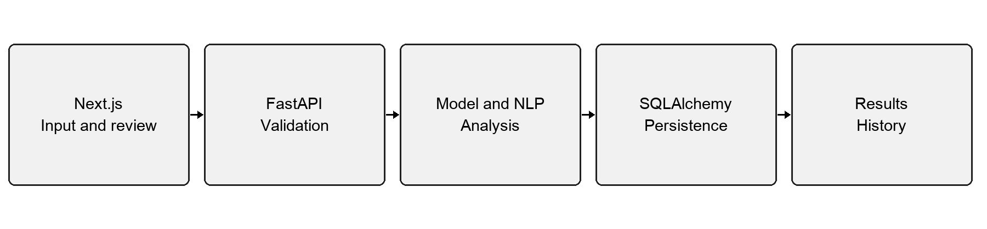
Figure 3.1 Request and report architecture
FastAPI routes validate transport inputs and enforce session ownership. Service modules orchestrate extraction, model inference, linguistic processing, and evidence retrieval. The machine-learning layer provides a classifier interface and shared preprocessing. SQLAlchemy models and sessions handle relational storage, with Alembic migrations recording schema changes.
The browser communicates through a same-origin proxy. Backend-only values, including evidence credentials and session signing secrets, remain outside public frontend variables. Original article content is rendered as text instead of executable HTML. The request lifecycle keeps input validation, inference, and persistence as distinct operations with explicit failure states.
The local database is SQLite, allowing the project to run without a separate database service. A PostgreSQL configuration is available, but the demonstrated workflow and automated integration tests use SQLite. Database portability does not imply that every remote deployment configuration has been verified.
The architecture supports later model replacement by recording versioned predictions in each saved report. An older report remains interpretable after the active model changes because it retains the version that produced its result.

3.1.4 Outcome of Objectives and Result Analysis
The application foundation supports submission, persisted results, history, deletion, and dashboard statistics. The backend's analysis, insight, claim, and evidence records provide a structured representation of each report. The frontend can reload the saved identifier and render its stored contents. These outcomes establish the system pathway needed to evaluate later model improvements through the same interface.
The initial LIAR baseline used TF-IDF with logistic regression. On the retained 798-example binary test subset, its accuracy was 66.29%, precision 60.00%, recall 61.95%, and F1 60.96% for the misleading class. These figures are retained as a legacy result. They concern short historical political claims and are not an article benchmark.
Table 3.4 Legacy LIAR experiment outcomes
Model | Test accuracy | Misleading F1 | Interpretation
Initial TF-IDF logistic baseline | 66.29% | 60.96% | Legacy reference result
Calibrated word and character challenger | 63.66% | 53.53% | Selected on validation; lower test result

The calibrated challenger used out-of-fold training scores for sigmoid calibration. Its test Brier score improved relative to its own uncalibrated score, but its discrimination did not surpass the initial baseline on the reused test set. The experiment therefore illustrates that calibration quality and classification accuracy are distinct dimensions.
The repository documents the comparison as retrospective. Because the test set had already been used for the baseline report, it should not be represented as a newly untouched benchmark for a broad claim of progress. The preserved experiment remains useful for explaining validation selection and the limits of transferring short-claim models to complete news articles.

3.1.5 Sprint Retrospective
The first increment established that correct model integration requires more than loading weights. The application must maintain preprocessing consistency, identify the loaded model, validate returned fields, and distinguish unavailable outputs from low confidence. A model-free execution path still provides language observations while clearly stating that classification is unavailable.
The short-claim model also exposed a mismatch between the original training task and the user's article workflow. The earlier operating policy could withhold predictions for longer content. This protected against unsupported scope but limited the usefulness of full-article submission. The next increment therefore focused on an article dataset and an article-specific inference policy rather than merely relaxing an input check.
Extraction behavior was another practical constraint. A successful HTTP response may contain a JavaScript shell, navigation text, or a blocked-content message instead of an article. Editable review and explicit failure messages were necessary to prevent accidental analysis of the wrong content. Those lessons informed the public MSN feed and structured-data fallbacks added later.
Session ownership and deletion required tests at the API boundary. Hiding another report in the interface would be insufficient if its identifier could still be retrieved directly. The integration suite checks retrieval and deletion using separate sessions and checks tampered session cookies and wrong origins.
The main improvement carried forward was a stricter separation of outputs: statistical prediction, linguistic observations, and retrieved evidence. The software should make each method inspectable and preserve uncertainty rather than blend the outputs into a single unsupported credibility score. This separation also made regression tests more precise because each output has an identifiable source and contract.

3.2 Sprint II

3.2.1 Objectives with User Stories of Sprint II
The second increment aligns the model with full-article inputs and makes its decisions easier to inspect. It introduces article data preparation, group-disjoint partitions, validation-selected SVM training, separate calibration, and a clearer explanation interface. It also expands the NLP lab and extraction regression coverage.
Table 3.5 Sprint II user stories and acceptance criteria
ID | User story | Acceptance criterion
S2-01 | As a reader, I want a full article assessed | Long articles receive the active article-model response
S2-02 | As a reviewer, I want reproducible metrics | Metrics match the loaded model and saved evaluation
S2-03 | As a student, I want to inspect influential terms | Signed contributions reconstruct the calibrated score
S2-04 | As a reader, I want factual status kept clear | Not independently verified remains visible
S2-05 | As a student, I want to explore grammar | Entities, lemmas, POS and dependencies are available
S2-06 | As a user, I want public MSN links handled | Extracted article text reaches review and analysis

Completion requires numerical and behavioral evidence. The trained artifact must have matching metrics, the split manifest must show no group overlap, and an analysis must expose the actual model version. The browser workflow must also distinguish benchmark accuracy from performance on a different domain.
The explanation panel provides model-feature, language-cue, and NLP-walkthrough views. Its acceptance criterion is methodological clarity: lexical cues cannot be silently added to the learned classifier score, and a feature contribution cannot be presented as evidence of factual falsity.
The sprint keeps backward compatibility for stored reports. New linguistic and article-scope fields are optional where necessary so older records can still be displayed without being re-scored or assigned a new model identity.

3.2.2 Functional Document
The article classifier returns Likely Credible, Potentially Misleading, or Needs Further Verification. The last assessment is used when confidence or input sufficiency is inadequate. All three remain screening assessments. The response separately exposes a factual status of Not independently verified and describes the domain covered by evaluation.
Table 3.6 Article assessment policy
Condition | Displayed behavior
Adequate input and maximum probability at least 0.65 | Class-based screening assessment
Maximum probability below 0.65 | Needs Further Verification
Fewer than 40 cleaned words | Cautious preliminary assessment
Vocabulary coverage below 0.20 | Cautious preliminary assessment
More than 2,500 words | First 2,500 classified; truncation warning

The feature panel shows up to fourteen influential active terms. Selecting a term presents its direction and source context when an exact textual match exists. The displayed bars are scaled relative to the largest shown absolute contribution. They are not separate probabilities and should not be summed as percentages.
The NLP lab returns annotations and extractive summaries without creating an analysis-history record. Users can inspect lemmas, grammatical heads, dependency labels, and named entities. Summary sentences remain exact excerpts. Topics are derived from recurring noun lemmas rather than generated factual descriptions.
Optional evidence lookup requires server enablement, credentials, and request-specific consent. When any prerequisite is absent or retrieval fails, the system reports the appropriate unavailable state. It does not generate substitute sources. The interface also offers investigation actions that help users search exact candidate claims while keeping their verification status explicit.

3.2.3 Architecture Document

Data Preparation and Partitioning
The WELFake downloader verifies the distributed file checksum before preparation. The raw CSV contains 72,134 records. The loader filters missing or short bodies, applies shared source-marker cleaning, removes exact duplicates and conflicting duplicates, and groups approximate duplicates. The retained corpus contains 60,544 articles in 59,424 groups.
The numeric label mapping requires an explicit audit. The dataset description reverses the mapping supported by the distributed CSV class counts and Reuters-tagged records. The project uses CSV label 0 for real and label 1 for fake, with count and source checks recorded in its model card. This interpretation is documented rather than hidden in the training code.
Table 3.7 Group-disjoint article partitions
Partition | Articles | Purpose
Training | 36,325 | Fit vocabulary and classifier
Validation | 6,054 | Select C using macro-F1
Calibration | 6,055 | Fit sigmoid probability mapping
Test | 12,110 | Evaluate the selected calibrated model

Ten stratified group folds are assigned using seed 42. Six folds form training, one validation, one calibration, and two testing. Identical titles or 80-word leads and MinHash LSH matches are kept within the same group. The saved manifest permits an overlap check across partitions.
Approximate grouping reduces leakage but cannot prove that every paraphrase has been detected. The split is not source-disjoint or time-disjoint. These limits matter because news datasets can share recurring publishers, topics, and styles even after duplicate texts have been separated.

Model Training and Inference
The training pipeline fits TF-IDF only on the training articles. Each SVM candidate uses the same partition design and balanced class weights. Validation macro-F1 selects C, with ROC-AUC as the tie breaker. The chosen value is C=2. Test labels do not select the candidate, fit the calibrator, or adjust the fixed confidence threshold.
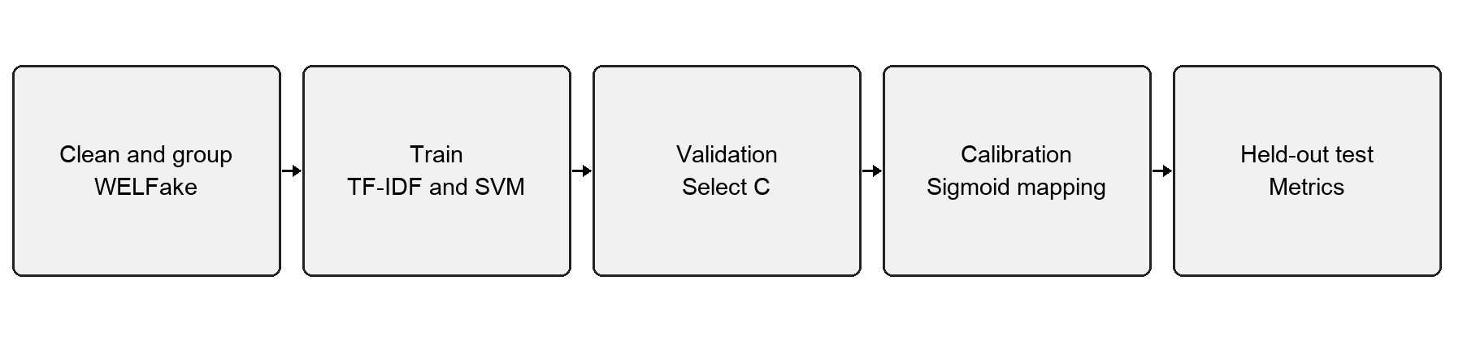
Figure 3.2 Article training and inference pipeline
At inference, shared cleaning removes obvious publisher strings, URLs, datelines, reporting credits, and media markers. The fitted vectorizer transforms the cleaned article, the SVM calculates a decision score, and the calibrator produces the misleading-class estimate. The complementary estimate represents the credible class.
For a feature j, the signed contribution is its TF-IDF value multiplied by the SVM coefficient and calibration slope. The sum of those contributions, together with the transformed intercept, reconstructs the calibrated logit. This identity is tested against the model output. The resulting explanation is mathematically linked to the decision function rather than generated as a plausible narrative.
The trained bundle stores the vectorizer, classifier, calibrator, metadata, and matching evaluation data. The API rejects stale evaluation information when model identity does not match. Existing reports preserve their original version so a model upgrade does not silently rewrite the interpretation of earlier analyses.

3.2.4 Outcome of Objectives and Result Analysis
The active article model achieves 96.31% full-test accuracy on the WELFake partition. Misleading-class precision is 96.51%, recall is 94.99%, and F1 is 95.74%. All headline metrics include low-confidence test examples. Conditional performance after a confidence filter is reported separately to avoid presenting a selected subset as the full benchmark.
Table 3.8 Validation search for the article SVM
C | Validation accuracy | Validation macro-F1 | Selection
0.5 | 95.80% | 95.73% | Candidate
1.0 | 95.97% | 95.90% | Candidate
2.0 | 95.99% | 95.92% | Selected

The separate calibration partition improves the recorded test Brier score from 0.07798 for the stored pre-calibration comparison to 0.02778 after calibration. The result supports the value of the fitted score mapping on this benchmark. It does not demonstrate calibration under a new publisher, country, or time distribution.
The product now provides a numerical article assessment for full reports while retaining cautious treatment of short or unfamiliar text. The old 160-word political-claim restriction no longer suppresses long-article results. The interface keeps the evaluated-domain limitation and factual status visible beside the model output.
The extraction changes also support public MSN article content through its public feed when the initial response is a JavaScript shell. Regression coverage checks structured-data fallback, plain text, redirects, and access errors. A browser test covers extraction, review, prediction, and persisted results for the supplied public MSN link.

3.2.5 Sprint Retrospective
The article release improved alignment between the input workflow and the training task. Its evaluation also made the remaining domain limitation more visible: the same model achieved only 47.24% accuracy on 798 LIAR short claims. The appropriate conclusion is that the model works well on its article benchmark and transfers poorly to this diagnostic population.
The label audit was a significant methodological lesson. Public dataset descriptions can contain inconsistencies, and a training pipeline should not treat a numeric label as self-explanatory. Class totals, source-tagged records, saved mappings, and assertions help make interpretation reviewable. A documented mapping is necessary for every reported confusion matrix and class-specific metric.
The explanation interface demonstrated the value of exact model contributions. It exposed cases in which a familiar term or date influenced a prediction for reasons unrelated to the truth of an article. Showing those associations lets a reviewer question the learned decision rather than accept a confident label without inspection.
The sprint also showed the limits of automated testing. A passing browser test confirms that the interface displays a result and preserves its disclosures. It does not confirm that the result is factually correct. Software tests, benchmark evaluation, and independent claim verification must remain distinct parts of the evaluation process.
Future work should prioritize a trustworthy evaluation population before adding model complexity. New articles should be divided by source and time, with reliable claim-level evidence where possible. Interface improvements should continue to make uncertainty actionable, while new evidence capabilities should require explicit evaluation of claim matching and entailment rather than treating retrieved keywords as proof.

CHAPTER 4

RESULTS AND DISCUSSIONS

4.1 Project Outcomes

Performance Evaluation
The selected calibrated model was evaluated on 12,110 group-held-out WELFake articles. The saved evaluation artifact records 6,816 credible-class and 5,294 misleading-class examples. Its confusion matrix contains 11,663 correct predictions and 447 errors. The benchmark accuracy is therefore 11,663 divided by 12,110, or 96.31%.
Table 4.1 Full-test article classification metrics
Metric | Value
Accuracy | 96.31%
Misleading-class precision | 96.51%
Misleading-class recall | 94.99%
Misleading-class F1 | 95.74%
Macro-F1 | 96.24%
ROC-AUC | 0.9939
Brier score | 0.0278

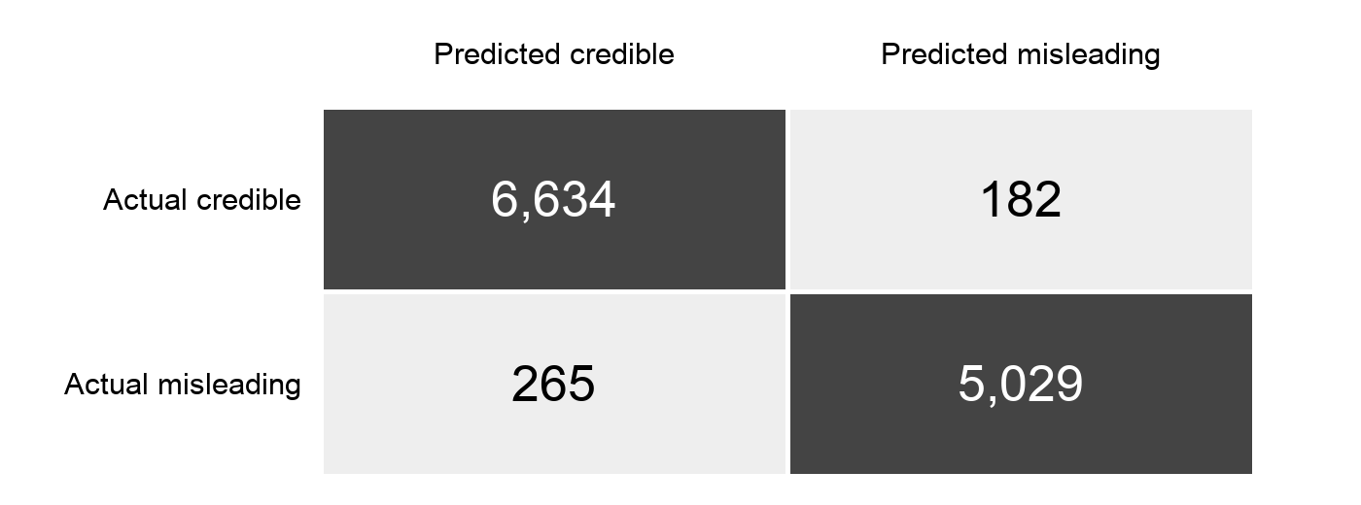
Figure 4.1 Confusion matrix for the article test partition
Rows in Figure 4.1 represent the inherited dataset labels and columns represent predicted classes. The matrix is a measure of dataset-label agreement. No confidence-based exclusions are applied to these counts.

Error Analysis and Calibration
The model incorrectly classified 182 credible-labeled articles as misleading and 265 misleading-labeled articles as credible. For the misleading class, precision measures the share of predicted misleading examples carrying that label, while recall measures the share of all misleading-labeled examples recovered by the classifier. Their imbalance is visible in the larger false-negative count.
The recorded accuracy interval is approximately 95.96% to 96.63%. This interval describes sampling uncertainty for the evaluated test population. It does not account for all effects of inherited labeling error, source overlap, or a new deployment distribution. A narrow interval around a benchmark score should therefore not be used to claim universal reliability.
Table 4.2 Confidence-filtered result reported separately
Measure | Result
Maximum-class threshold | 0.65
Accepted test articles | 11,766 of 12,110
Coverage | 97.16%
Accuracy among accepted articles | 97.41%
Conditional accuracy interval | 97.10% to 97.68%

The filtered result answers a different question from full-test accuracy. It estimates agreement only among examples passing the confidence filter. Its scope is confidence-only evaluation; the deployed system also considers text length and vocabulary sufficiency. The filtered metric must not replace the full-test score in the abstract or conclusion.
The calibrated model has an expected calibration error of approximately 0.0072 in the stored evaluation. This provides a useful benchmark diagnostic, but the binning scheme and dataset affect the value. A separate reliability study is needed for contemporary Indian news and any other target population before interpreting confidence as a well-calibrated estimate there.

Comparisons and Domain Transfer
The project contains several valid results that answer different experimental questions. Comparing them requires keeping their datasets, feature configurations, and evaluation history visible. A higher score on a different dataset cannot establish that one model is universally more capable than another.
Table 4.3 Experimental results and their scope
Experiment | Test population | Accuracy | Scope
Legacy logistic baseline | 798 LIAR claims | 66.29% | Short-claim reference
Calibrated lexical challenger | 798 LIAR claims | 63.66% | Retrospective comparison
Active calibrated SVM | 12,110 WELFake articles | 96.31% | Main article benchmark
Active SVM transfer diagnostic | 798 LIAR claims | 47.24% | Different task and domain

The transfer diagnostic was not pooled into WELFake results or used to tune the article model. Its low accuracy shows that the article benchmark cannot be treated as a guarantee for isolated political statements. The diagnostic also has balanced accuracy of about 50.90%, close to a non-discriminating result for that population.
The earlier semantic candidates used frozen MiniLM embeddings with lexical features. The selected challenger still relied on word and character TF-IDF and did not improve the reused test score. These findings support careful validation rather than selecting a model because its architecture sounds more advanced.
Current Indian news accuracy has not been measured. A contemporary MSN article can receive a strong model estimate while remaining factually unverified. The interface therefore states the domain limitation in the results view and keeps related evidence, linguistic observations, and class estimates distinguishable.

Backend Testing Results
The backend suite was rerun on 28 October 2026. All 41 tests passed in an isolated temporary SQLite database. The suite exercises trained inference, API behavior, extraction defenses, linguistic spans, persistence, and unavailable states. Parameterized cases account for the difference between the number of test functions and the final executed-test count.
Table 4.4 Backend test cases and observed outcomes
Test area | Expected behavior | Outcome
Text and language validation | Invalid, empty or oversized content is rejected | Passed
Article inference | Active weights produce actual estimates and version | Passed
Contribution consistency | Features plus intercept reconstruct model score | Passed
Short content | No definitive class for inadequate article text | Passed
Split manifest | No duplicate group crosses partitions | Passed
Report lifecycle | Submit, retrieve, aggregate and delete correctly | Passed
Session isolation | Other sessions cannot access owned reports | Passed
Cookie and origin checks | Tampering and wrong origin are rejected | Passed

These tests provide evidence of implementation correctness for the specified cases. They do not prove resistance to every possible misuse or replace model evaluation. The isolated database ensures the checks do not delete or contaminate a user's existing analysis history.
The suite also verifies that missing model weights cannot serve stale metrics. Evaluation artifacts must match the loaded model after configuration changes.

Extraction and Frontend Testing Results
The extraction tests check both usable public content and failure conditions. They include private-address rejection, mixed DNS answers, connection pinning, redirects to private hosts, public MSN extraction, JSON-LD fallback, and explicit access errors. File tests cover permitted text/PDF input and invalid or unsupported uploads.
Table 4.5 Interface and browser verification on 28 October 2026
Test group | Executed | Result
Frontend component tests | 11 | All passed
Browser workflows | 8 | All passed
Backend tests | 41 | All passed

The component tests cover short-content validation, input tabs, unsupported documents, request errors, navigation to the returned report ID, editable URL extraction, a paste-text fallback, uncertainty display, navigation, and explanation context. The run emitted a React act warning in the mobile-navigation test, although all assertions passed. This warning is a test-synchronization issue to address in maintenance.
The eight browser workflows cover the complete saved-report lifecycle; mobile layout and theme; feature/context explanations; an urgency example; public MSN extraction; NLP-lab annotations without history persistence; long-article analysis; and separate presentation of article-benchmark and cross-domain results. Browser screenshots from these workflows are included in Appendix B.
The browser run used separate local test services and a temporary database. The public MSN workflow was a live integration check at the time of execution; an external publisher may later change its content or availability. Mocked extractor regressions provide a more controlled check of expected response handling.

4.2 Discussion of Findings
The evaluation supports two conclusions. First, the application implements a complete and tested article-analysis workflow with model-linked explanations. Second, the active model separates inherited labels effectively within the WELFake benchmark but does not establish dependable factual verification across domains. Both conclusions are necessary to describe the project accurately.
Source-marker cleaning and duplicate grouping improve experimental discipline. However, publishers may still differ in syntax, topic selection, article length, and writing style. A linear model can learn those differences even when a publisher's name is removed. Source and temporal holdouts are needed to estimate how strongly the current result depends on those remaining patterns.
The output design is useful because it exposes rather than conceals this limitation. Users can inspect contributing terms and their article context, read the text used by the model, and see the factual-verification status separately. The interface does not claim that an emotionally worded sentence proves misinformation, or that a model contribution is a contradiction from an external source.
There are also operational limits. The system is English-only, scanned PDF OCR is absent, and anonymous cookie-scoped history cannot be recovered across devices. The evidence integration requires configuration and consent. A production deployment would require additional operational work, including shared rate limiting, secure hosting, retention policy, and deployment-specific testing.
No latency benchmark or controlled usability study is reported. The working demonstration and automated workflow completion show functionality, but they do not quantify user learning, long-term reliability, or social impact. Those are appropriate future evaluation targets once a representative deployment population and measurable acceptance criteria have been defined.

CHAPTER 5

CONCLUSION AND FUTURE ENHANCEMENT

5.1 Conclusion
VeriFact AI implements fake news and misinformation screening as an inspectable NLP application. Users can submit English article text, extract public URLs or text-based documents, examine a model assessment, inspect influential features and language annotations, and manage saved reports. The implementation connects a trained model to a typed API, persistent storage, and a responsive interface.
The active article pipeline combines source-aware text cleaning, word TF-IDF, a linear SVM, and sigmoid calibration. Its training and evaluation use separate group-disjoint partitions. On 12,110 held-out WELFake articles, it achieved 96.31% accuracy and 95.74% misleading-class F1. These results are supported by saved metrics, test predictions, and a partition manifest.
The project also documents a substantial limitation. The same model achieved 47.24% accuracy on a separate set of 798 LIAR short claims. This diagnostic shows why a strong article-benchmark score must remain attached to its evaluated population. The application consequently retains uncertainty disclosures and a separate Not independently verified status for every article assessment.
Software verification supports the delivered workflow. The current run passed 41 backend tests, 11 frontend component tests, and eight browser workflows. The checks cover input validation, extraction, trained inference, contribution consistency, session ownership, stored results, mobile interaction, and the display of methodological limitations.
The project's contribution is a reproducible, explainable screening baseline and a practical learning environment for NLP. Its value lies in making model behavior and its limits available for inspection. Stronger real-world claims will require representative data, independent evidence evaluation, and controlled studies of how readers interpret and use the outputs.

5.2 Future Enhancement
The highest-priority extension is a more representative evaluation design. Articles should be collected with reliable source and publication-time metadata, with publishers and later time periods held out during evaluation. Independently reviewed labels would help distinguish factual misinformation from publisher-level or inherited corpus labels.
Table 5.1 Future work and proposed acceptance evidence
Enhancement | Proposed evidence of completion
Source and temporal holdouts | Published split rules and disjointness audit
Contemporary Indian news evaluation | Independently labeled test set and class metrics
Evidence-grounded claim review | Evaluated retrieval, claim matching and entailment
Multilingual support | Language-specific data, calibration and error analysis
OCR for scanned documents | Extraction quality tests and editable text review
Contextual model comparison | Matched splits, tuning budget and transfer evaluation
User study | Measured understanding of confidence and factual status

Model enhancements should be judged against a fixed, auditable evaluation protocol. Fine-tuning a transformer may help with context, but it also introduces new computational and leakage risks. A comparison should include precision, recall, calibration, resource use, and domain transfer rather than reporting accuracy alone.
Evidence retrieval could be extended into a claim-centric review pipeline. Such a system would identify a claim, retrieve relevant passages, assess whether they address the same entities and time period, and evaluate support or contradiction. Human review would remain valuable for disputed or incomplete evidence.
Operational improvements include authenticated accounts, retention controls, shared rate limiting, and deployment monitoring. These should be introduced only with clearly specified ownership and privacy behavior. The present anonymous-session model remains suitable for local demonstration and course evaluation.

REFERENCES
[1] Verma, P. K., Agrawal, P., and Prodan, R., WELFake Dataset for Fake News Detection in Text Data, version 0.1, Zenodo, 2021. https://zenodo.org/records/4561253
[2] Wang, W. Y., “Liar, Liar Pants on Fire”: A New Benchmark Dataset for Fake News Detection, Proceedings of the 55th Annual Meeting of the Association for Computational Linguistics, Volume 2, pp. 422–426, 2017. https://aclanthology.org/P17-2067/
[3] United Nations Department of Economic and Social Affairs, Sustainable Development Goal 4: Quality Education. https://sdgs.un.org/goals/goal4 (accessed 28 October 2026).
[4] United Nations Department of Economic and Social Affairs, Sustainable Development Goal 16: Peace, Justice and Strong Institutions. https://sdgs.un.org/goals/goal16 (accessed 28 October 2026).
[5] scikit-learn Developers, Feature Extraction, scikit-learn User Guide. https://scikit-learn.org/stable/modules/feature_extraction.html (accessed 28 October 2026).
[6] scikit-learn Developers, Support Vector Machines, scikit-learn User Guide. https://scikit-learn.org/stable/modules/svm.html (accessed 28 October 2026).
[7] scikit-learn Developers, Probability Calibration, scikit-learn User Guide. https://scikit-learn.org/stable/modules/calibration.html (accessed 28 October 2026).
[8] Guo, C., Pleiss, G., Sun, Y., and Weinberger, K. Q., On Calibration of Modern Neural Networks, Proceedings of the 34th International Conference on Machine Learning, PMLR 70, pp. 1321–1330, 2017. https://proceedings.mlr.press/v70/guo17a.html

REFERENCES
[9] Devlin, J., Chang, M.-W., Lee, K., and Toutanova, K., BERT: Pre-training of Deep Bidirectional Transformers for Language Understanding, Proceedings of NAACL-HLT, pp. 4171–4186, 2019. https://aclanthology.org/N19-1423/
[10] Reimers, N., and Gurevych, I., Sentence-BERT: Sentence Embeddings using Siamese BERT-Networks, Proceedings of EMNLP-IJCNLP, pp. 3982–3992, 2019. https://aclanthology.org/D19-1410/
[11] Explosion, Linguistic Features, spaCy Usage Documentation. https://spacy.io/usage/linguistic-features (accessed 28 October 2026).
[12] FastAPI, FastAPI Documentation. https://fastapi.tiangolo.com/ (accessed 28 October 2026).
[13] Vercel, Next.js Documentation. https://nextjs.org/docs (accessed 28 October 2026).
[14] SQLAlchemy Authors, SQLAlchemy ORM, SQLAlchemy 2.0 Documentation. https://docs.sqlalchemy.org/en/20/orm/ (accessed 28 October 2026).
[15] Google, Fact Check Tools API, Google for Developers. https://developers.google.com/fact-check/tools/api (accessed 28 October 2026).

Project Reproducibility Materials
Implementation and result provenance are recorded in the project's README.md, docs/ARTICLE-MODEL.md, docs/ARCHITECTURE.md, docs/API.md, docs/SYLLABUS.md, and docs/IMPROVEMENT-REPORT.md. The active evaluation is stored in backend/artifacts/articles/metrics.json, with split-manifest.json and test-predictions.json providing numerical audit records. The model evaluation was generated on 26 October 2026; the software-test results in this report were rerun on 28 October 2026.

APPENDIX A

CODING

A.1 Shared article preprocessing
The following excerpt is taken from backend/app/ml/article_features.py. The same cleaning function is used by training and inference.
"""Shared, source-scrubbed article features used at training and inference."""

import re
from app.ml.preprocessing import clean_text

def article_text(text: str) -> str:
text = clean_text(text).lower()
# Remove easy publisher identifiers and URL/byline artifacts in BOTH classes.
text = re.sub(r"https?://\S+|www\.\S+", " ", text)
text = re.sub(r"^.{0,90}?\((?:reuters|ap|afp)\)\s*[-–—:]?", " ", text)
text = re.sub(
r"\b(?:reuters|associated press|getty images|image copyright|read more|click here|subscribe now)\b",
" ",
text,
)
text = re.sub(r"\[(?:video|photos?|audio)\]", " ", text)
text = re.sub(
r"\b(?:reporting by|editing by|additional reporting by)\b[^\n.]{0,250}",
" ",
text,
)
return " ".join(text.split()[:2500])

A.2 Article inference and contributions
The following excerpt from backend/app/ml/article_classifier.py shows the score, calibration, input-sufficiency policy, and signed model contributions.
def predict(self, text: str) -> dict:
cleaned = article_text(text)
words = tokens(cleaned)
original_words = len(tokens(text))
x = self.vectorizer.transform([cleaned])
logit = float(self.model.decision_function(x)[0])
risk = float(self.calibrator.predict_proba([[logit]])[0, 1])
confidence = max(risk, 1 - risk)
coverage = sum(w in self.vectorizer.vocabulary_ for w in words) / max(
1, len(words)
)
adequate = len(words) >= self.metadata["min_words"] and coverage >= 0.20
uncertain = not adequate or confidence < self.metadata["threshold"]
label = (
"Needs Further Verification"
if uncertain
else ("Potentially Misleading" if risk >= 0.5 else "Likely Credible")
)
# Exact additive calibrated-logit contributions, not generated rationales.
slope = float(self.calibrator.coef_[0, 0])
row = x.tocsr()
weighted = row.data * self.model.coef_[0, row.indices] * slope
order = np.argsort(np.abs(weighted))[::-1][:14]
names = self.vectorizer.get_feature_names_out()
features = [
{
"term": str(names[row.indices[k]]),
"contribution": round(float(weighted[k]), 6),
"direction": "misleading" if weighted[k] > 0 else "credible",
}
for k in order
]

APPENDIX B

SCREENSHOTS
The report displays a trained model assessment and the separate factual-verification status. This view comes from the long-article browser test and uses demonstration text.
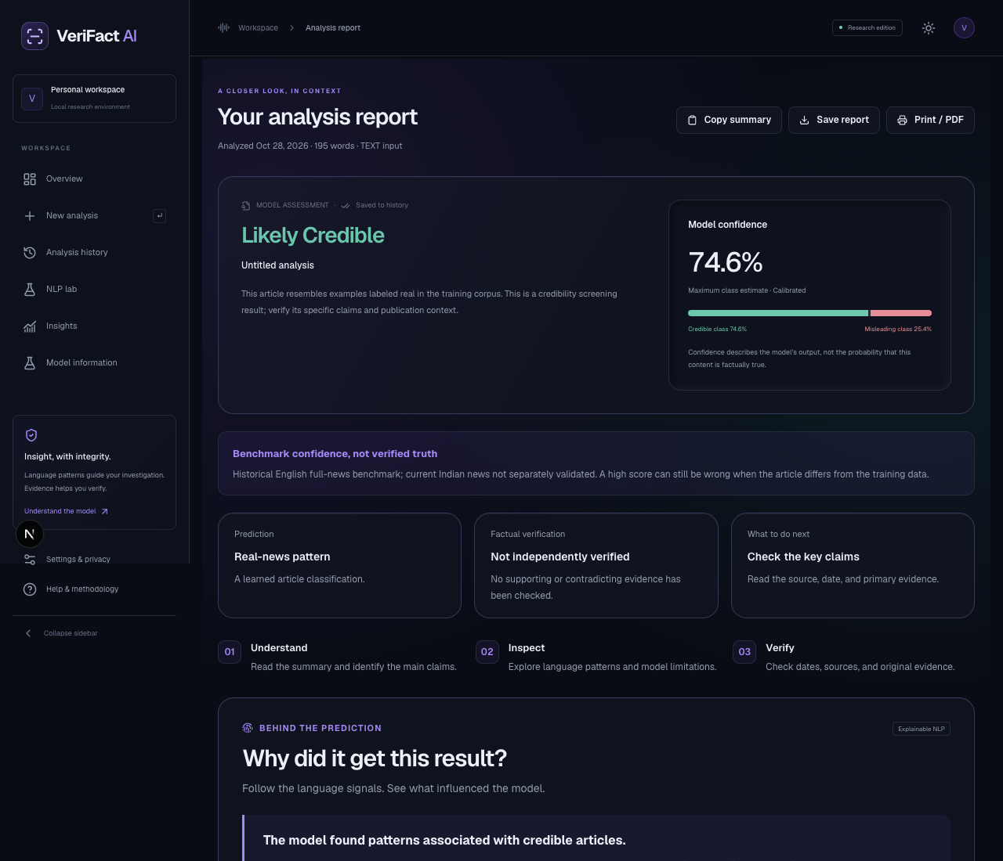
Figure B.1 Article assessment interface
Captured during the successful browser test run on 28 October 2026. Upper portion of the full report.

APPLICATION SCREENSHOTS
Actual signed feature contributions can be inspected alongside their direction and source context. This screenshot was captured by the explanation browser workflow.
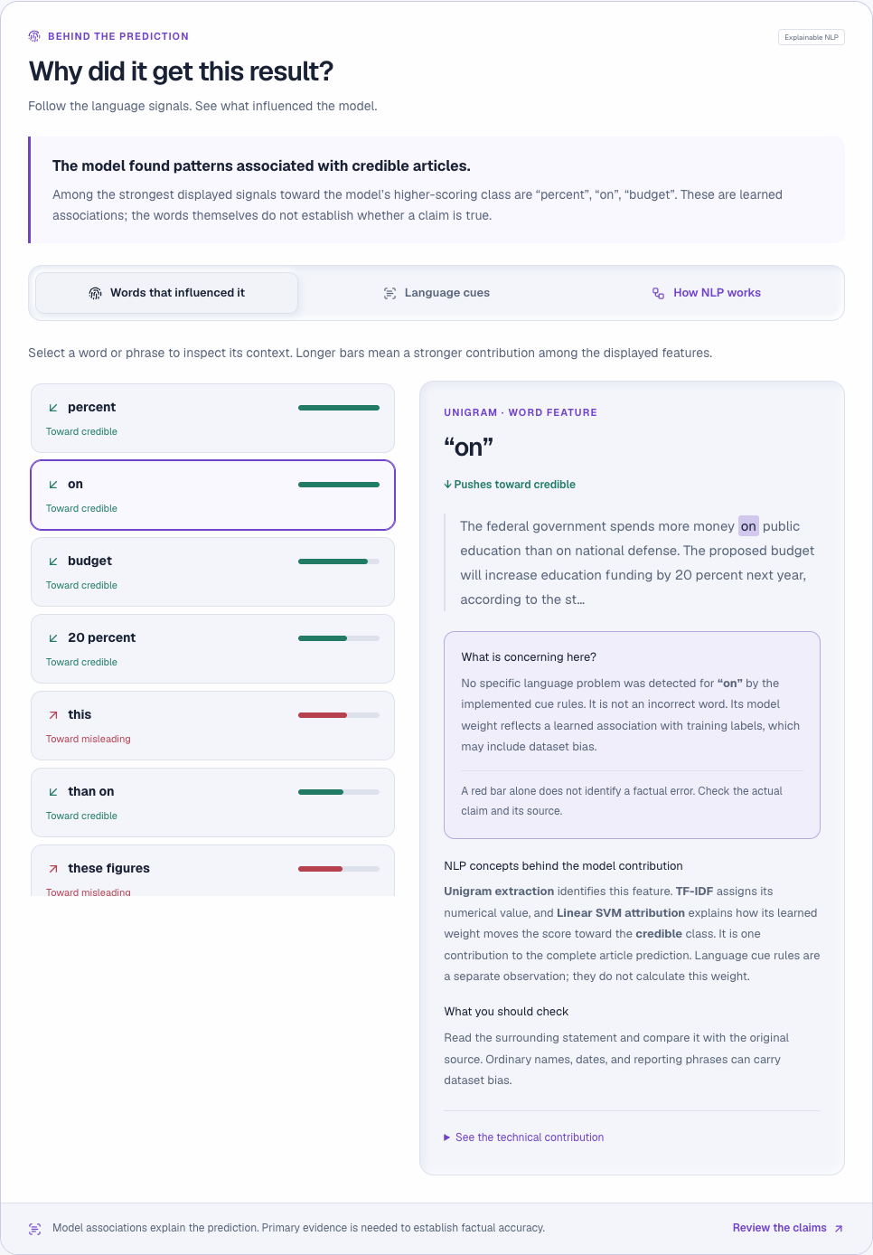
Figure B.2 Model explanation interface
Captured during the successful browser test run on 28 October 2026.

APPLICATION SCREENSHOTS
The NLP lab displays an extractive summary, named entities, and exploration controls for the fictional example. The workflow verifies that using the lab does not create a history record.

Figure B.3 Interactive NLP lab
Captured during the successful browser test run on 28 October 2026.

