Assignment-1 â€” Basic User Management
-----------------------------------
Create a user named devuser1.
Create three users:
developer1
developer2
developer3
Verify that all three users were created.
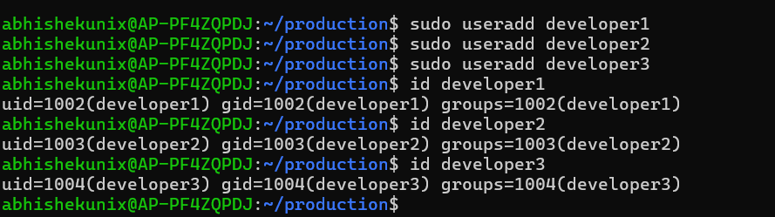

Delete developer3.
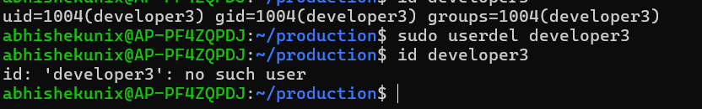
Create a user named tester1.
Change the username tester1 to qauser1.
Delete qauser1.
Create a user named admin1 and verify its UID and primary group.
admin1:x:1004:1005::/home/admin1:/bin/sh
Primary group : 1005
UID : 1004

Assignment-2 â€” Group Management:
-------------------------------
Create the following groups:
developers
testers
admins
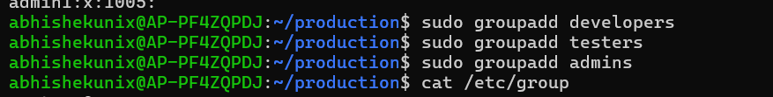
Verify that the groups were created.
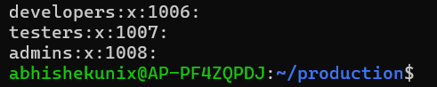
Rename the group testers to qa.
Delete the admins group.
Create a new group called operations.
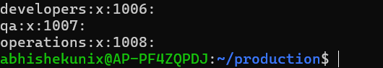
Assignment-3 â€” Add Users to Groups:
----------------------------------
Create these users:
john
alice
bob
Add john and alice to the developers group.
Add bob to the qa group.
Add bob to the developers group without removing his existing group memberships.
Verify the group memberships of all three users.

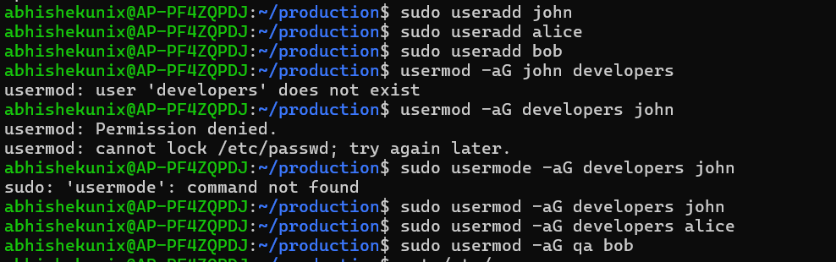
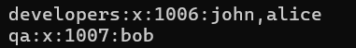
Remove alice from the developers group.
Verify that alice is no longer a member of developers.
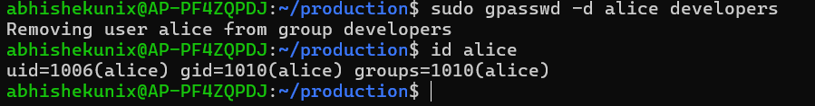

Assignment-4 â€” File Ownership:
-----------------------------
Create a directory:
/project

Create three files inside it:
/project/app.conf
/project/app.log
/project/deploy.sh

Change the owner of app.conf to john.
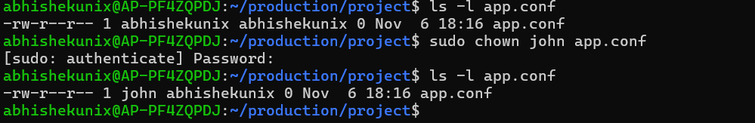

Change the owner and group of app.log to:
alice:developers

Change the group ownership of deploy.sh to developers.
Verify the ownership and group of all three files.
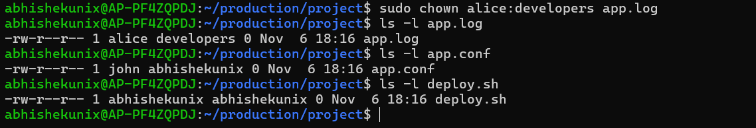

Assignment-5 â€” File Permissions:
-------------------------------
Set the permissions of app.conf to:
rw-r-----
Set the permissions of app.log to:
rw-r--r--
Set the permissions of deploy.sh to:
rwxr-x---
Verify the permissions using ls -l.

Convert the following symbolic permissions into numeric permissions:
rwxr-x---
rw-r-----
rwxrwxr-x
r--r--r--

Convert the following numeric permissions into symbolic permissions:
755 drwx- r-x-r-x
644 -rw-r—r--
750 drwx-r-x----
700 drwx--------

