**Topics: Descriptive Statistics and Probability**

1. Look at the data given below. Plot the data, find the outliers and find out $μ, σ, σ^{2}$

|  |  |
| --- | --- |
| **Name of company** | **Measure X** |
| Allied Signal | 24.23% |
| Bankers Trust | 25.53% |
| General Mills | 25.41% |
| ITT Industries | 24.14% |
| J.P.Morgan & Co. | 29.62% |
| Lehman Brothers | 28.25% |
| Marriott | 25.81% |
| MCI | 24.39% |
| Merrill Lynch | 40.26% |
| Microsoft | 32.95% |
| Morgan Stanley | 91.36% |
| Sun Microsystems | 25.99% |
| Travelers | 39.42% |
| US Airways | 26.71% |
| Warner-Lambert | 35.00% |

* The following is the outlier in the boxplot: Morgan Stanley 91.36%
* measure_x.describe()
* **Mean** = 33.271333
* **Standard deviation** = 16.945401
* measure_x.var()
* **Variance** = 287.1466123809524

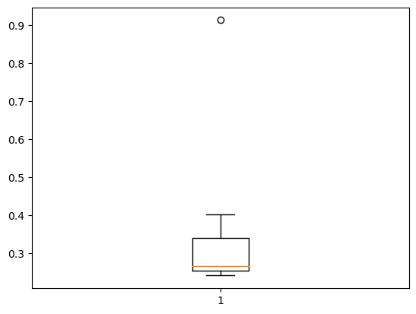

In the above graph we can say that there 1 outlier in data at 0.9= (Morgan Stanley-91.36% )



Answer the following three questions based on the box-plot above.

1. What is inter-quartile range of this dataset? (please approximate the numbers) In one line, explain what this value implies.

* Q1=5 ,Q3=12,Q2=median Value
* IQR=Q3-Q1

=12-5=7

This value shows that Q1(25% data ) is between 0 to 5 and Q3 (75% dta) is from 0 to 12.

The minimum value is 0 and maximum value is 19.

One outlier is present in data i.e on 25th.

1. What can we say about the skewness of this dataset?

* it is left – skewed data. More data on left side and median is towards Q1.

1. If it was found that the data point with the value 25 is actually 2.5, how would the new box-plot be affected?

* In that case there is no outlier in dataset.
* And the data of this boxplot is normally distributed and the median is slightly moved towards middle.



Answer the following three questions based on the histogram above.

1. Where would the mode of this dataset lie?

* Between 4-8

1. Comment on the skewness of the dataset.

* It is Right – skewed data . Mean>Median>mode
* Data is more towards left and has an outlier on 25th data point

1. Suppose that the above histogram and the box-plot in question 2 are plotted for the same dataset. Explain how these graphs complement each other in providing information about any dataset.

* The boxplot is used for displaying data in standardized way and Histogram is used for to show the frequency distribution in each class occur in dataset.
* This both are used for finding outliers in data set
* To find skewness and variance of dataset.
* This above both plot shows that outliers in data and data is left-skewed data.

1. AT&T was running commercials in 1990 aimed at luring back customers who had switched to one of the other long-distance phone service providers. One such commercial shows a businessman trying to reach Phoenix and mistakenly getting Fiji, where a half-naked native on a beach responds incomprehensibly in Polynesian. When asked about this advertisement, AT&T admitted that the portrayed incident did not actually take place but added that this was an enactment of something that “could happen.” Suppose that one in 200 long-distance telephone calls is misdirected. What is the probability that at least one in five attempted telephone calls reaches the wrong number? (Assume independence of attempts.)

* **Ans:  IF** 1 in 200 long-distance telephone calls are getting misdirected.
* probability of call misdirecting   = 1/200

Probability of call not Misdirecting = 1-1/200 = 199/200

**The** probability for at least one in five attempted telephone calls reaches the wrong number

Number of Calls = 5

n = 5,p = 1/200, q = 199/200

* P(x) = at least one in five attempted telephone calls reaches the wrong number
* P(x) = ⁿCₓ pˣ qⁿ⁻ˣ
* P(x) = (nCx) (p^x) (q^n-x)
* P(1) = (5C1) (1/200)^1 (199/200)^5-1
* P(1) = 0.0245037

1. Returns on a certain business venture, to the nearest $1,000, are known to follow the following probability distribution

|  |  |
| --- | --- |
| x | P(x) |
| -2,000 | 0.1 |
| -1,000 | 0.1 |
| 0 | 0.2 |
| 1000 | 0.2 |
| 2000 | 0.3 |
| 3000 | 0.1 |
|  |  |

E(X) =Sum X.*P(X) | E(X^2) =X^2*P(X)

-200 | 400000

-100 | 100000

0 | 0

200 | 200000

600 | 1200000

300 | 900000

Total: 800 | 2800000

1. What is the most likely monetary outcome of the business venture?

* The most likely monetary outcome of the business venture is 2000$As for 2000$ the probability is 0.3 which is maximum as compared to others

1. Is the venture likely to be successful? Explain

* Yes, the probability that the venture will make more than 0 or a profit

**p(x>0)+p(x>1000)+p(x>2000)+p(x=3000) = 0.2+0.2+0.3+0.1 = 0.8** this states that there is a good 80% chances for this venture to be making a profit

1. What is the long-term average earning of business ventures of this kind? Explain

* The long term average is expected value =Sum(X*p(X))=800 which mean on average
* The returns will be +800

1. What is the good measure of the risk involved in a venture of this kind? Compute this measure

* The good measure of the risk involved in a venture of this kind depends on the Variability in the distribution. Higher Variance means more chances of risk
* Var (X) = E(X^2) –(E(X))^2
* = 2800000 – 800^2
* = 2160000