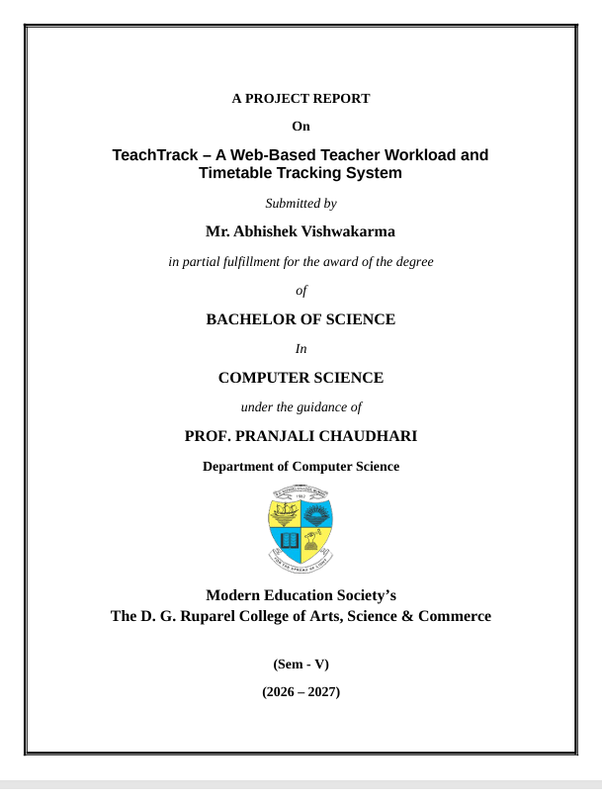

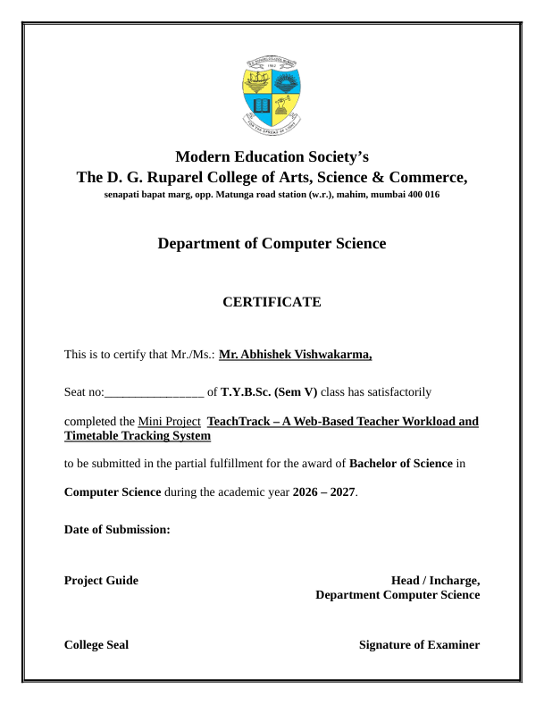

TABLE OF CONTENTS
Chapter 1: Problem Identification & Feasibility Study 1
Project Title 1
Introduction of the project 1
Problem Statement 1
Objectives 1
Scope of the project 2
Technologies Used 2
Hardware/Software Required 3
List of Modules in a project 3
Methodology 4
List of Stakeholders 4
Expected Outcome 4
Chapter 2: Requirement Engineering 6
Functional Requirements 6
Non-Functional Requirements 8
Chapter 3: SDLC Planning 11
Selection of SDLC Model 11
Work Breakdown Structure (WBS) 11
Project Timeline (Gantt Chart) 13
Resource Planning 13
Chapter 4: System Modeling using UML 15
1. Event Table 15
2. Class Diagram 18
3. Object Diagram 18
4. Sequence Diagram 18
5. Use Case Diagram 19
6. Activity Diagram 20
7. Component Diagram 21
8. Deployment Diagram 22
Chapter 5: System Architecture Design 23
1.A User Interfaces / Screens 23
1.B Screen Design (Representative Wireframes) 23
1.C Navigation Flow 34
Business Logic Design 34
2.A System Modules 34
2.B Business Rules 36
2.D Calculation Formulas 47
2.E Validation Rules 47
2.F User Roles and Permissions 49
2.G Final Business Logic Diagram 50
Database Design 51
3.A Entities / Tables 52
3.B Table Structures 52
3.C Primary Key / Foreign Key Summary 56
3.D ER Diagram 56
3.E Data Flow / System Flow 58
3.F Complete Architecture Overview 59
Chapter 6: Application Development 61
Frontend Implementation 61
Backend Implementation 61
Database Integration 62
Authentication and Validation 62
Error Handling 63
Chapter 7: Integration & System Testing 64
Part 1: Black-box Testing 64
Part 2: Integration Testing 67
Chapter 8: Deployment 70
Cloud Deployment (Render) 70
Local Hosting 70
APK Build 71
Server Configuration 71
Version Control using GitHub 71
Chapter 9: Performance & Security Testing 72
Part 1: Input Validation Checks 72
Part 2: Security Validation 74
Chapter 10: Final Documentation 76
Login Page 76
Register Page 76
Dashboard Screen 85
Leave Request Screen (Teacher view) 92
Leave Request Screen (Admin view) 92
Timetable Screen 100
Duties Screen (Admin view) 108
Duties Screen (Teacher view) 108
Calendar Screen 113
Messaging Screen 118
AI Assistant Screen 126
Profile Screen 131

Chapter 1: Problem Identification & Feasibility Study
Project Title:
TeachTrack – A Web-Based Teacher Workload and Timetable Tracking System
Introduction of the project:
TeachTrack is a web-based application designed to help college and school faculty, along with academic administration, organise day-to-day academic operations from a single, unified dashboard. It brings together a teacher's weekly timetable, assigned duties, leave records, personal calendar, and internal messaging into one easy-to-navigate interface, removing the need to juggle multiple registers, spreadsheets, and notice boards. The application is organised into core modules — Dashboard, Timetable, Duties, Leaves, Calendar, Messages, Notifications, an AI Assistant, and Authentication & Profile — each reachable from a common dashboard that aggregates a teacher's workload (weekly lesson count, leave balance, duty breakdown, a message preview, and a weekly workload trend), while administrators approve leave requests, assign duties, and get a transparent picture of workload distribution across staff. Beyond the core modules, TeachTrack includes an AI Assistant that answers questions using the signed-in teacher's own timetable, leave, duty, and message data, a real-time notification layer built on Socket.IO that alerts users to leave decisions, duty assignments, and new messages without a page refresh, per-subject visual styling in the timetable so a teacher's week is easy to scan, and a dark mode preference — moving day-to-day academic administration away from scattered spreadsheets, printed notices, and verbal communication toward a single, reliable system.
Problem Statement:
Most educational institutions still handle teacher timetables and workload using manual registers, Excel sheets, or printed notices pinned to a staff-room board — an approach that is slow to update, easy to get wrong, and difficult for individual teachers to consult on the go. Without a single source of truth, two classes are frequently allotted the same room or the same teacher's slot; there is no easy way to see how many hours a teacher is actually teaching per week, so load cannot be distributed fairly across a department; invigilation and committee duties are communicated late, by word of mouth, or through printed circulars that not everyone sees in time; leave applications and approvals happen over email, paper forms, or informal conversation, with no shared record of who is on leave and no way to track leave balances; and faculty members have no single place to see their classes, upcoming duties, and pending reminders together. Taken together, these gaps lead to inefficient workload distribution, avoidable scheduling errors, and a poor day-to-day experience for both teaching staff and administration. There is no unified system that brings timetables, workload, duties, leave, calendar, and communication together in one place, and TeachTrack is proposed as a direct response to these issues.
Objectives:
• To digitise and centralise the teacher timetable, replacing manual, register- and spreadsheet-based scheduling with a single online source of truth.
• To provide a clear, visually distinct weekly view of lectures for every teacher, built around per-day planner settings for start/end time, lecture count, and duration.
• To track workload metrics such as weekly teaching load and duty count, so both teachers and administrators can see load at a glance from the Dashboard.
• To organise non-teaching duties (invigilation, committee work, event duties, etc.) alongside the teaching schedule, instead of communicating them separately.
• To streamline leave management by giving faculty an in-app way to apply for leave and giving administration a simple approval workflow with a shared record and leave balance tracking.
• To provide a consolidated personal calendar for reminders, meetings, exams, and leave/duty events, so that no teacher misses an important date.
• To enable quick, in-app communication between faculty members through connection-based direct messaging, reducing dependence on informal channels such as personal chat groups.
• To keep users informed in real time through live notifications for leave decisions, duty assignments, and new messages, without requiring a page refresh.
• To offer a context-aware AI Assistant that can answer a teacher's questions about their own timetable, leave balance, and duties directly from the dashboard.
• To improve transparency and accountability in how teaching and non-teaching workload is distributed across a department.
Scope of the project:
TeachTrack can be deployed in colleges, schools, and coaching institutes to organise faculty timetables, workload, and duties, and it gives administrators a consolidated overview of teacher availability and workload distribution. It is adaptable to institutions of varying sizes — from a single department to a full multi-department college — since modules such as Timetable, Duties, and Leaves are largely self-contained.
The initial version focuses on the teacher-facing experience (timetable, workload, duties, leaves, calendar, messaging, AI assistant) rather than a full institution-wide ERP; student-facing features are out of scope for this phase. Future enhancements include AI-based automatic timetable generation, a companion mobile app, mobile push notifications (in addition to the in-app real-time notifications already provided), a deeper workload analytics dashboard, and integration with existing attendance systems.
Technologies Used:
• Frontend: HTML, CSS, and JavaScript, organised around a structured dashboard interface that communicates with the backend through RESTful API endpoints
• Backend: Express.js (Node.js) with TypeScript
• Database: PostgreSQL, used to store users, timetables, duties, leave records, calendar events, messages, and notifications
• ORM: Prisma, used for schema definition (schema.prisma), migrations, and type-safe query execution
• Authentication: JSON Web Tokens (JWT) with role-based access control for Teacher and Admin accounts, and bcrypt for password hashing
• Real-time Communication: Socket.IO, used for live notifications and real-time updates
• Email Service: Nodemailer (SMTP), used for password reset and email-based notifications
• AI Integration: Groq API, used to power the AI Assistant module with responses grounded in the signed-in user's own data
• Environment Configuration: dotenv, used to manage environment variables (JWT secret, frontend URL, database connection, Groq API key, SMTP settings, and port numbers) across development and production
• Deployment: a client-server web application (backend API and frontend pages) that requires a PostgreSQL instance and correctly configured environment variables; the AI Assistant needs a valid Groq API key, and email features need SMTP configuration
Hardware/Software Required:
• Intel Core i3 / i5 or equivalent
• 3 GB RAM (minimum)
• 5 GB free storage
• Node.js (latest LTS) and PostgreSQL (local installation or a hosted instance)
• VS Code (or any code editor)
• Modern web browser — Chrome, Edge, or Firefox
End users (teachers and administrators) require only a device with a modern browser and an internet connection to access the dashboard — no separate installation is needed.
List of Modules in a project:
• Dashboard Module: An overview screen aggregating a teacher's current workload: weekly lesson count, leave balance, duty breakdown, a message preview, and a weekly workload trend. The module provides a quick snapshot of a teacher's week at a glance.
• Timetable Module: A weekly class schedule showing lectures by day and time slot, with subject, class, and room, and per-subject visual styling so the grid is easy to scan. Teachers can add, edit, and delete lecture entries, configure per-day planner settings (start/end time, lecture count, duration), and search or filter by subject, class, or day.
• Duties Module: Assignment and tracking of non-teaching duties such as invigilation, committee tasks, event coordination, and other professional responsibilities outside of regular teaching. Admins assign duties to active teachers; teachers update status through to completion, and may hide completed duties from their own history.
• Leaves Module: A complete leave management system including leave application, balance tracking, and an approval/rejection workflow shared between faculty and administration, with reviewer notes. Teachers can view their leave balance and request history.
• Calendar Module: A personal calendar covering reminders, meetings, exams, and leave/duty events, with date/time, optional end time, reminder, and description, plus filtering and paging. This module gives a teacher a broader view of upcoming commitments compared to the Timetable module's weekly focus.
• Messages Module: An internal communication channel between faculty members for quick, in-app coordination. Direct messaging between two teachers requires a connection request to be accepted first; administrators can message any teacher directly.
• Notifications Module: A real-time alert system, built on Socket.IO, that notifies users of leave decisions, duty assignments, and new messages as they happen, without needing to refresh the page.
• AI Assistant Module: A chat assistant, powered by the Groq API, that answers a teacher's questions using their own timetable, leave, duty, and message data, so responses are personalised to the logged-in user rather than generic.
• Authentication & Profile Module: Secure login and profile handling, underpinning all of the above modules with role-based access for Teacher and Admin accounts. Includes profile editing, password change, and a forgot-password/reset-password flow.
Methodology:
Agile — the application is built iteratively in short cycles, starting with the Dashboard and Timetable modules, followed by Duties, Leaves, Calendar, and Messages, then Notifications and the AI Assistant. Each increment is reviewed and refined before moving to the next. Development proceeds iteratively with regular testing and review after each module is completed, and feedback obtained during each iteration is incorporated before moving to the next phase to ensure a reliable and user-friendly system.
List of Stakeholders:
Teachers/Faculty, Administration, College Authorities, and Students (indirect beneficiaries).
Expected Outcome:
The end result of this project is a fully functional web application where a teacher can log in and instantly view their week's timetable in a clear, easy-to-scan grid. From the same dashboard, they can track their teaching workload and duty breakdown through summary cards and a weekly trend view, apply for leave and check their balance, organise assigned duties, check their personal calendar, message colleagues, and ask the AI Assistant questions about their own schedule — all without leaving a single, unified interface, and with real-time notifications keeping them informed as things change.
For administration, the system provides a transparent, centralised view of workload distribution and duty assignments across the department, replacing the current reliance on scattered spreadsheets and notice boards. Overall, TeachTrack is expected to reduce scheduling conflicts, improve transparency in workload distribution, speed up duty and leave communication, and eliminate the need for manual, spreadsheet-based timetable management.

Chapter 2: Requirement Engineering

Functional Requirements

ID | Requirement | Priority
FR-01 | The system shall allow new users to register by providing name, email, password, and role (Teacher or Administrator). | High
FR-02 | The system shall allow registered users to log in with valid credentials and shall issue a signed JWT session token valid for seven days. | High
FR-03 | The system shall reject authentication and API access for accounts that have been marked inactive. | High
FR-04 | The system shall allow users to securely log out, clearing the stored session token and returning them to the login page. | High
FR-05 | The system shall allow a user to request a password-reset link by email, valid for one hour and usable only once. | Medium
FR-06 | The system shall allow a user to set a new password using a valid, unexpired reset token. | Medium
FR-07 | The system shall allow users to view and update their own profile information. | Medium
FR-08 | The system shall allow users to change their password after verifying the current password. | Medium
FR-09 | The system shall restrict administrator-only operations, such as leave review and duty assignment, to users holding the ADMIN role. | High
FR-10 | The system shall display a dashboard summarising current-week lecture load, leave allowance and balance, upcoming events and duties, duty-type breakdown, weekly trend, and a recent message preview. | High
FR-11 | The system shall allow a user to add a timetable lecture specifying subject, class, room, weekday, time, and display type. | High
FR-12 | The system shall allow a user to update an existing timetable lecture. | High
FR-13 | The system shall allow a user to delete a timetable lecture. | Medium
FR-14 | The system shall allow a user to view their weekly timetable with search and day or class filters. | High
FR-15 | The system shall allow a user to configure per-day planner settings including start time, end time, lecture count, and lecture duration. | Medium
FR-16 | The system shall allow teachers to submit leave requests specifying start date, end date, and reason. | High
FR-17 | The system shall calculate a teacher's monthly leave allowance and remaining balance from approved requests. | Medium
FR-18 | The system shall allow teachers to view the status and history of their own leave requests. | Medium
FR-19 | The system shall allow administrators to view all submitted leave requests. | Medium
FR-20 | The system shall allow administrators to approve or reject a leave request and record a reviewer note. | High
FR-21 | The system shall allow teachers to hide a reviewed leave request from their own history without deleting the record. | Low
FR-22 | The system shall allow administrators to assign duties to active teachers with a category (lecture, invigilation, mentoring, or committee) and a due date. | High
FR-23 | The system shall allow users to view their assigned duties, filtered by status and due date. | High
FR-24 | The system shall allow a teacher to update a duty status between Pending, In Progress, and Completed. | Medium
FR-25 | The system shall allow administrators to delete a duty, and teachers to hide a completed duty from their own history. | Low
FR-26 | The system shall allow users to create calendar events of type reminder, meeting, or exam, with start date and time, optional end time, reminder, and description. | Medium
FR-27 | The system shall display the calendar by month with type filters and pagination, including leave and duty items alongside personal events. | Medium
FR-28 | The system shall allow users to update or delete an existing calendar event. | Low
FR-29 | The system shall allow teachers to search for users and to send, accept, or reject connection requests before exchanging messages, while administrators may message teachers directly. | Medium
FR-30 | The system shall allow users to send and receive direct messages, view conversations with unread counts, and hide a conversation from their own view. | Medium
FR-31 | The system shall deliver real-time updates over Socket.IO to the affected users when leave, duty, message, connection, or dashboard data changes. | High
FR-32 | The system shall allow users to view their notification list, mark notifications as read individually or in bulk, and delete them. | Medium
FR-33 | The system shall provide an AI assistant that answers queries using only the signed-in user's own timetable, leaves, duties, events, and unread message count. | Low
FR-34 | The system shall limit AI assistant usage to 30 requests per user per UTC day and 2,000 characters per message. | Low
FR-35 | The system shall expose a health endpoint reporting database connectivity and registered user count. | Low

- Non-Functional Requirements

ID | Requirement | Priority
NFR-01 | The system should provide acceptable response time for normal operations, with page loads and data fetches completing within 2-3 seconds. | High
NFR-02 | The system should provide a simple, consistent interface for teachers and administrators, including light and dark themes. | High
NFR-03 | The system shall restrict access to authorised users only, applying the same JWT verification to REST requests and to the Socket.IO connection handshake. | High
NFR-04 | The system shall store user passwords using bcrypt hashing, and shall store password-reset tokens as SHA-256 hashes that are single-use and expire after one hour. | High
NFR-05 | The system shall validate all incoming data with server-side schema validation before any database or external provider call. | High
NFR-06 | The system shall maintain data integrity through relational constraints, including unique email, one lecture per user, day, and time, one planner setting per user and day, and cascading deletion of owned records. | High
NFR-07 | The system shall restrict cross-origin requests to the configured frontend origin and shall cap JSON request bodies at 1 MB. | High
NFR-08 | The system should return a uniform response to password-reset requests so that registered email addresses cannot be enumerated. | Medium
NFR-09 | The system shall keep all secrets, including the database URL, JWT signing key, SMTP credentials, and AI provider key, on the server in environment configuration and never in client code. | High
NFR-10 | The system should be modular and maintainable, separating authentication, dashboard, timetable, leave, duty, calendar, messaging, notification, and AI logic into independent modules. | Medium
NFR-11 | The system shall support real-time updates for multiple concurrently connected users without noticeable delay, delivering events to per-user rooms rather than broadcasting. | Medium
NFR-12 | The system should treat real-time delivery as best-effort, with the client reloading data over HTTP on reconnect or refresh. | Medium
NFR-13 | The system shall evolve its database schema only through versioned migrations so that deployments remain reproducible. | Medium
NFR-14 | The system should be available and reliable during college working hours with minimal downtime. | Medium
NFR-15 | The system should remain responsive as data grows, using indexed columns for frequently filtered queries such as leave status, duty assignee, and unread messages. | Medium
NFR-16 | The system shall record critical actions, including login timestamps, leave review decisions, and duty assignment, for auditing purposes. | Low
NFR-17 | The system should be accessible and responsive across desktop, tablet, and mobile screen sizes. | Low
NFR-18 | The system should be compatible with major modern web browsers including Chrome, Firefox, and Edge. | Low
NFR-19 | The system should support regular database backup and recovery in case of failure. | Low
NFR-20 | The system should be portable and deployable on standard cloud hosting, with API base URL, port, and allowed origin supplied by configuration rather than hard-coded. | Low
NFR-21 | The system shall send only the signed-in user's own curated context to the external AI provider, and only from the server. | Medium

Chapter 3: SDLC Planning
Selection of SDLC Model:
TeachTrack follows the Agile (iterative and incremental) Software Development Life Cycle model. The application is divided into small, self-contained modules that are designed, built, tested and reviewed in short cycles, and every increment is refined with feedback before the next one begins. This is the same approach described under Methodology in Chapter 1.
Reasons for choosing the Agile model:
• Modular scope: The system consists of largely independent modules — Dashboard, Timetable, Duties, Leaves, Calendar, Messages, Notifications and the AI Assistant — which can be developed and tested one after another.
• Early working software: The Dashboard and Timetable modules are delivered first, so a usable version exists early and later modules are added on top of it.
• Room for change: Feedback from the project guide and from testing after each iteration can be incorporated before moving to the next phase, which keeps the requirements and design aligned with the final system.
• Risk reduction: Third-party integrations such as Socket.IO for real-time notifications, SMTP for password-reset email and the Groq API for the AI Assistant are introduced and verified step by step instead of at the very end.
• Suitable for a small team: A lightweight, iterative process fits a single-developer project better than a rigid, strictly sequential model such as Waterfall, while the required deliverables (SRS, UML diagrams, Architecture Design Document, report) are still produced according to the project timeline.
Iteration plan:
• Iteration 1: Dashboard and Timetable modules, together with authentication and profile handling.
• Iteration 2: Duties, Leaves, Calendar and Messages modules.
• Iteration 3: Notifications (real-time) and the AI Assistant, followed by integration and system testing.
Work Breakdown Structure (WBS):
The work of the project is broken down into the following work packages and tasks. Each top-level package corresponds to a deliverable in the project timeline.
1. Project Initiation
1.1 Synopsis
1.2 Project Proposal — title, problem statement, objectives, scope, technologies and methodology
2. Requirement Analysis and Modeling
2.1 Functional and non-functional requirements (SRS)
2.2 UML diagrams — event table, class, object, sequence, use case, activity, component and deployment diagrams
3. System Design
3.1 Architecture Design Document
3.2 User interfaces, wireframes and navigation flow
3.3 Business logic design
3.4 Database design — entities, table structures, keys and ER diagram
4. Development of the Working Application
4.1 Backend — Express.js (Node.js) with TypeScript, Prisma ORM, PostgreSQL and JWT-based authentication
4.2 Frontend screens — Login, Register, Dashboard, Leaves, Timetable, Duties, Calendar, Messages, AI Assistant and Profile
4.3 Real-time notifications (Socket.IO), password-reset email (Nodemailer) and AI Assistant (Groq API)
5. Testing
5.1 Black-box testing and integration testing
5.2 Input validation checks and security validation
6. Documentation and Repository
6.1 GitHub repository
6.2 Final project report
7. Presentation and Demonstration
7.1 Final presentation and live demonstration of the application
Project Timeline (Gantt Chart):
The Gantt chart below shows the planned schedule of the project deliverables for Semester V (2026–27). The project runs from the end of July to 25 September, with each deliverable starting when the previous one is completed. The milestone date of each deliverable is marked with a diamond on the chart.
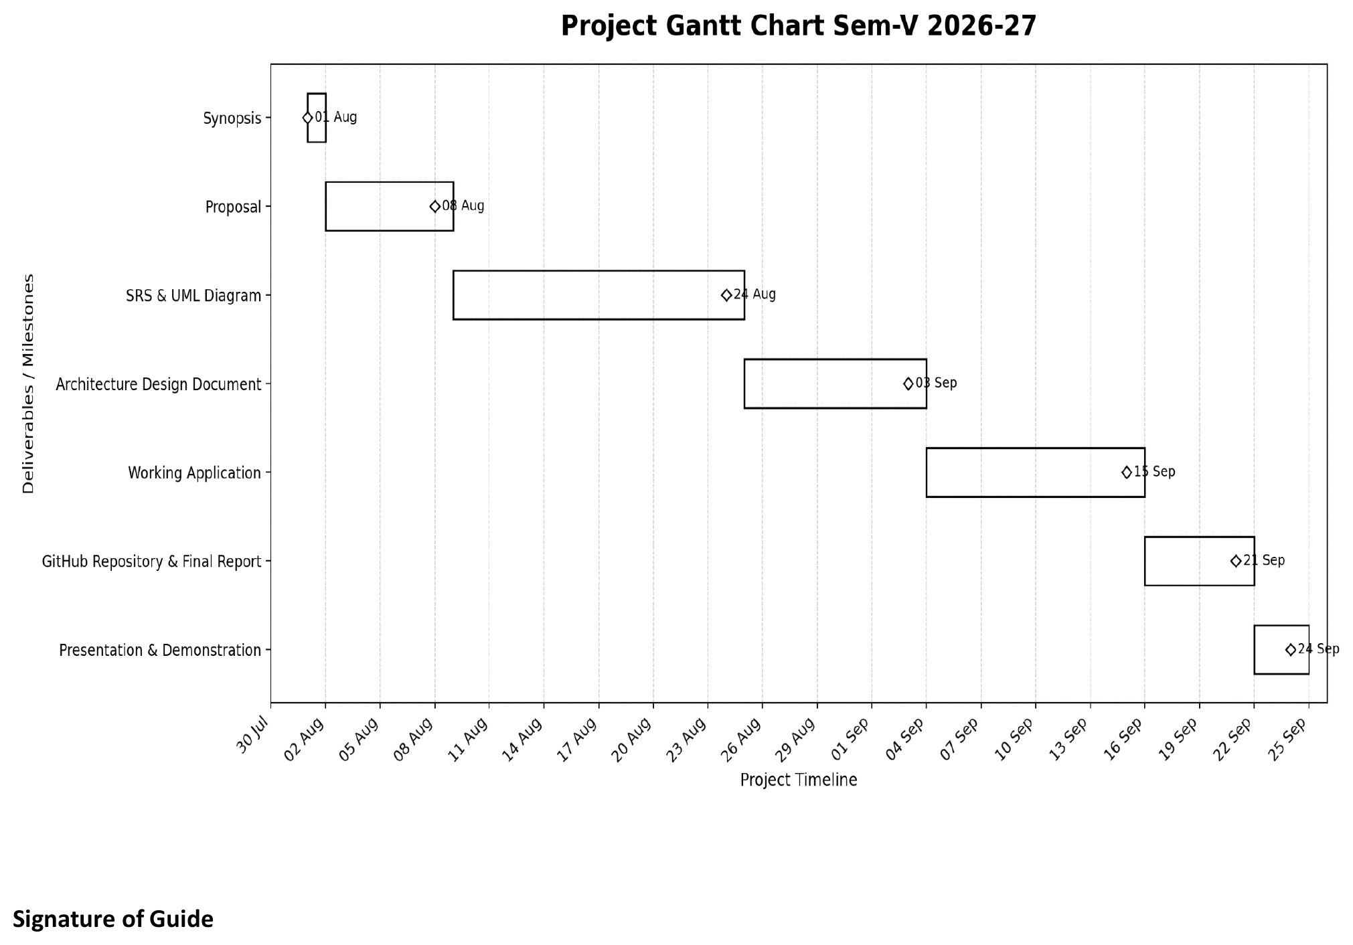
Milestones:
• Synopsis: 01 Aug
• Proposal: 08 Aug
• SRS & UML Diagram: 24 Aug
• Architecture Design Document: 03 Sep
• Working Application: 15 Sep
• GitHub Repository & Final Report: 21 Sep
• Presentation & Demonstration: 24 Sep
Resource Planning:
The resources required to complete the project are planned under the following heads.
• Human resources: The developer (Mr. Abhishek Vishwakarma), who carries out analysis, design, development, testing and documentation, and the project guide, who reviews the work and gives feedback at each milestone.
• Hardware resources: Intel Core i3 / i5 or equivalent processor, 3 GB RAM (minimum) and 5 GB of free storage, as listed under Hardware/Software Required in Chapter 1.
• Software resources: Node.js (latest LTS), PostgreSQL, Prisma, VS Code (or any code editor), Git and GitHub for version control, and a modern web browser — Chrome, Edge or Firefox.
• External services: Socket.IO for real-time updates, Nodemailer (SMTP) for password-reset email and the Groq API for the AI Assistant.
• Time: Approximately eight weeks, from the end of July to 25 September, as shown in the Gantt chart.

Chapter 4: System Modeling using UML

1.Event table

Event | Source | Trigger / Important Data | Consumer / Action
USER_REGISTERED | Authentication Module | name, email, password, role | Hash password, create User, return JWT
USER_LOGGED_IN | Authentication Module | email, password | Validate active user, record last login, issue JWT
USER_LOGGED_OUT | Frontend UI | userId (from session storage) | Clear stored token and session; redirect to login page
PASSWORD_RESET_REQUESTED | Authentication Module | email | Store hashed single-use token with one-hour expiry; send reset mail over SMTP
PASSWORD_RESET_COMPLETED | Authentication Module | reset token, new password | Validate and consume token; replace password hash
USER_PROFILE_UPDATED | Profile Module | userId, updated profile fields | Update user profile in database
USER_PASSWORD_CHANGED | Profile Module | userId, current password, new password | Verify current password and store new hash
TIMETABLE_LECTURE_CREATED | Timetable Module | subject, class, room, dayOfWeek, time, type | Save lecture for signed-in user
TIMETABLE_LECTURE_UPDATED | Timetable Module | lectureId, updated lecture details | Update timetable record
TIMETABLE_LECTURE_DELETED | Timetable Module | lectureId | Remove timetable lecture
TIMETABLE_SETTINGS_UPDATED | Timetable Module | day, startTime, endTime, lectureCount, duration | Save per-day planner configuration for the user
LEAVE_REQUEST_SUBMITTED | Leave Module | startDate, endDate, reason, teacherId | Store request as PENDING; notify active admins
LEAVE_REQUEST_REVIEWED | Leave Module | leaveId, APPROVED or REJECTED, reviewer note | Update request and reviewer metadata; notify teacher; emit leave:updated
LEAVE_BALANCE_CALCULATED | Leave Module | teacherId, month | Return monthly allowance and remaining balance to dashboard
LEAVE_HISTORY_HIDDEN | Leave Module | leaveId, teacherId | Set teacher visibility flag; record stays for admin
DUTY_ASSIGNED | Duty Module (Admin) | title, category, dueDate, teacherId | Create duty; notify assigned teacher; emit duty:updated
DUTY_STATUS_UPDATED | Duty Module | dutyId, PENDING / IN_PROGRESS / COMPLETED | Update duty status and refresh assignee views
DUTY_DELETED | Duty Module (Admin) | dutyId | Remove duty; emit duty:deleted
DUTY_HISTORY_HIDDEN | Duty Module | dutyId, teacherId | Hide duty from teacher's own history without deleting it
CALENDAR_EVENT_CREATED | Calendar Module | title, type, start, optional end, reminder, description | Save calendar event for the user
CALENDAR_EVENT_UPDATED | Calendar Module | eventId, updated details | Update calendar event
CALENDAR_EVENT_DELETED | Calendar Module | eventId | Remove calendar event
CONNECTION_REQUEST_SENT | Messaging Module | requesterId, recipientId | Create PENDING connection; notify recipient
CONNECTION_REQUEST_REVIEWED | Messaging Module | requestId, ACCEPTED or REJECTED | Update connection state; emit message:connection-updated
MESSAGE_SENT | Messaging Module | senderId, receiverId, content | Store message; notify receiver via message:new
MESSAGE_READ | Messaging Module | messageId or conversation userId | Set read timestamp and refresh unread count
CONVERSATION_HIDDEN | Messaging Module | userId, other participant id | Set per-side visibility flag so the thread is hidden for that user only
NOTIFICATION_CREATED | Notification Module | userId, type, title, message, source | Persist notification
NOTIFICATION_READ | Notification Module | notificationId or userId | Mark one or all notifications as read
NOTIFICATION_DELETED | Notification Module | notificationId or userId | Delete one or all notifications
REALTIME_NOTIFICATION_SENT | Socket.IO Gateway | notification:new to room user:<id> | Update the connected user's interface without polling
DASHBOARD_REFRESH_EMITTED | Socket.IO Gateway | dashboard:updated | Signal the dashboard to reload aggregated workload data
AI_QUERY_SUBMITTED | AI Assistant Module | userId, message (max 2,000 chars), chat history | Build private context from user data and call the AI provider
AI_DAILY_LIMIT_CHECKED | AI Assistant Module | userId, UTC date | Increment daily usage counter; reject beyond 30 requests per day

2.Class diagram

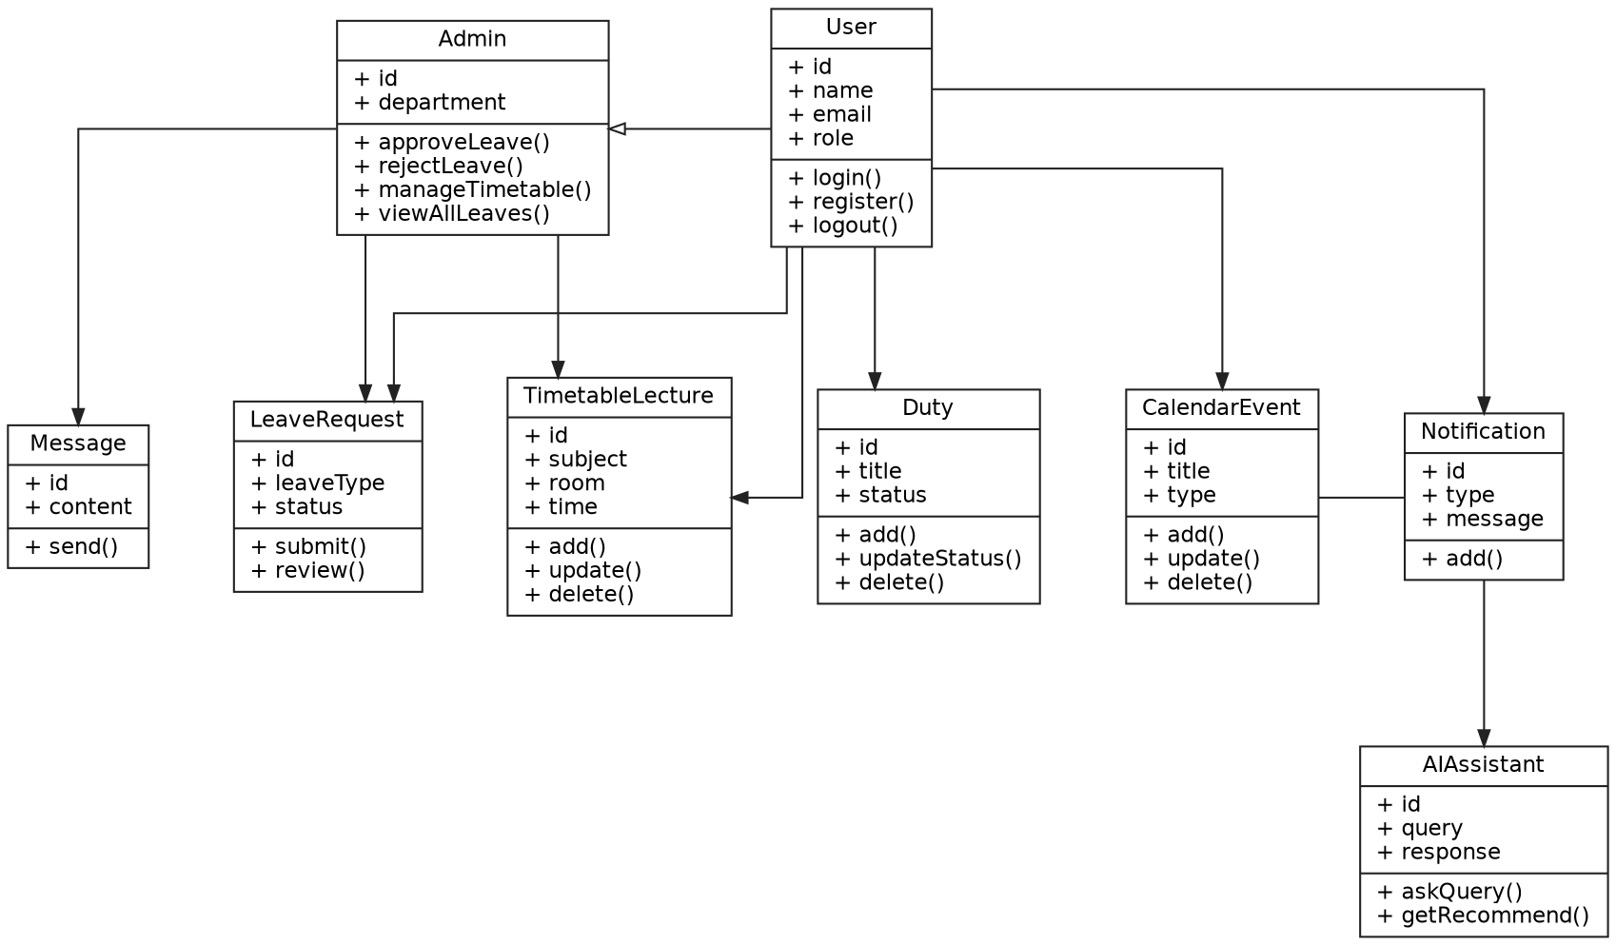

3.Object diagram

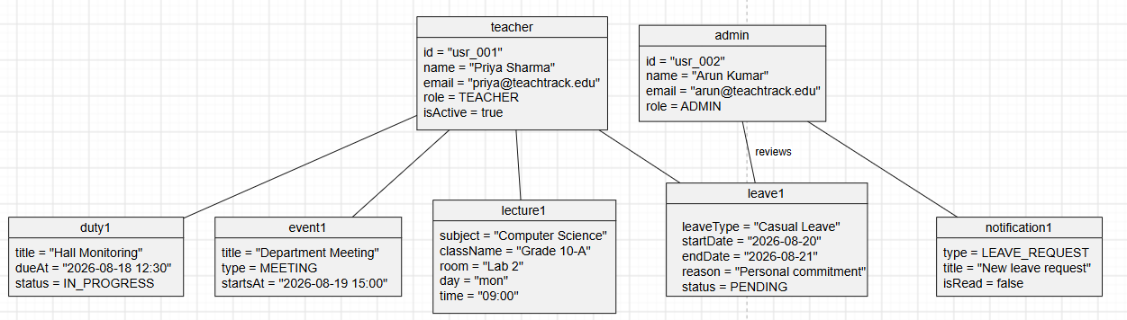

4.Sequence diagram

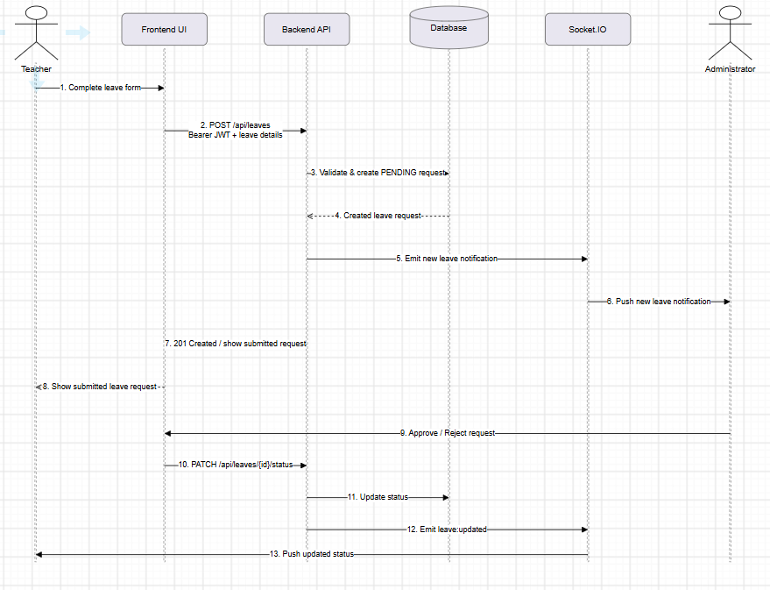

5.Use case diagram

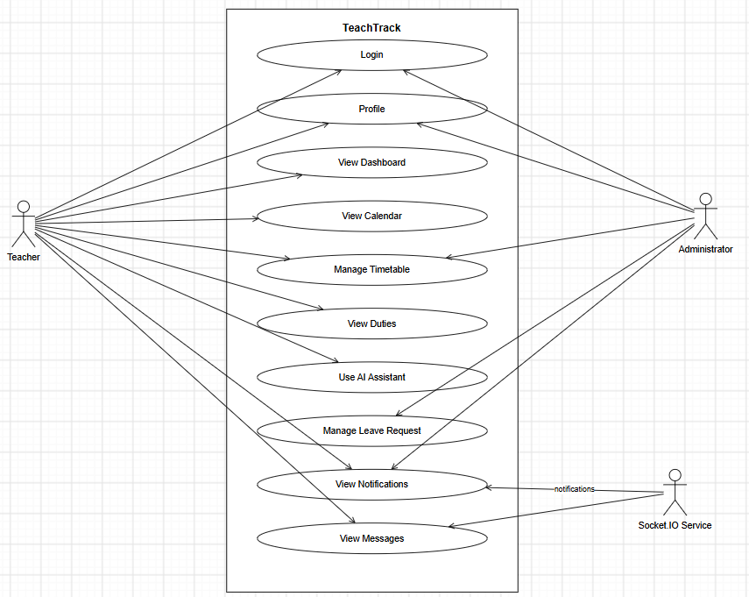

6.Activity diagram

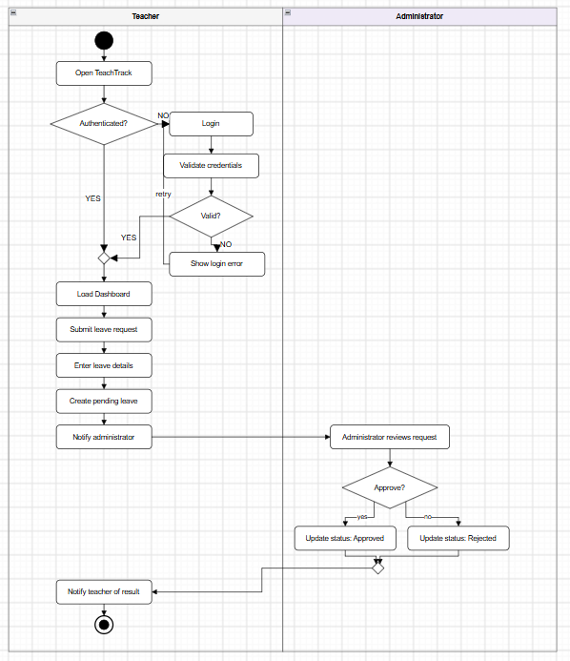

7.Component diagram

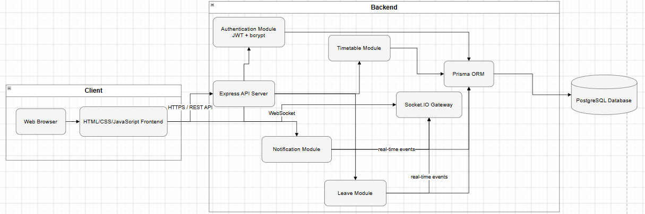

8.Deployment diagram

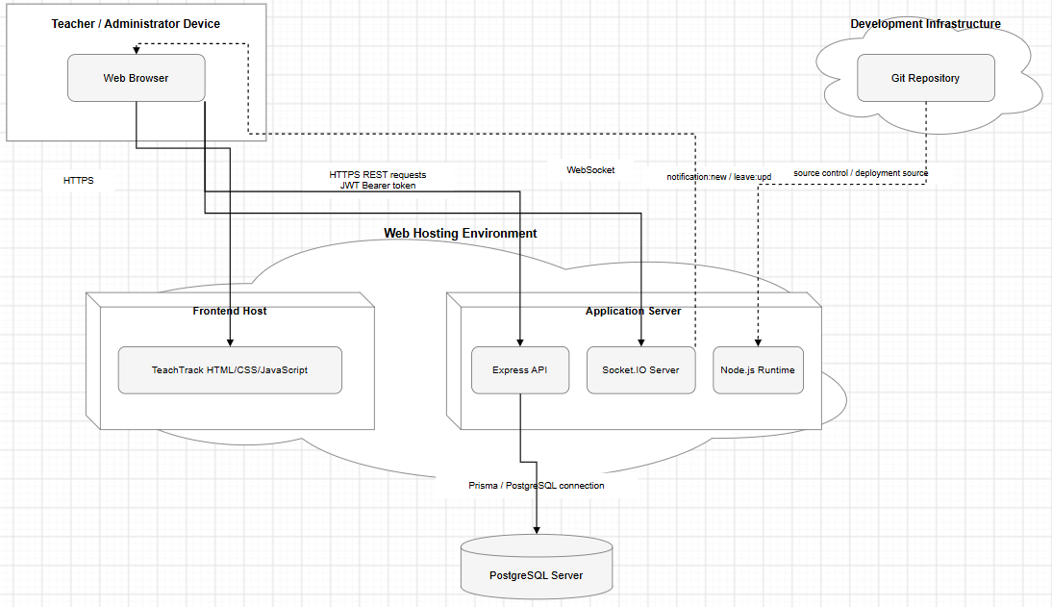

Chapter 5: System Architecture Design

1. Front-End Design
This section describes what the user sees and interacts with in TeachTrack. The front end is built with plain HTML, CSS, and vanilla JavaScript (no framework), with shared logic in assets/app.js and assets/messages-connections.js, and shared styling in assets/styles.css.

1.A User Interfaces / Screens
TeachTrack's HTML pages, corresponding to the major screens of the system:
- Login Page
- Password Reset (Forgot Password / Reset Password)
- Dashboard — workload summary and statistics
- Timetable — lectures and timetable settings
- Duties — duty assignment and status tracking
- Leaves — leave requests, balances, approvals/rejections
- Calendar — events and reminders
- Messaging — connections and conversations
- Profile — account and password management
- AI Assistant — chat with the AI service

1.B Screen Design (Representative Wireframes)
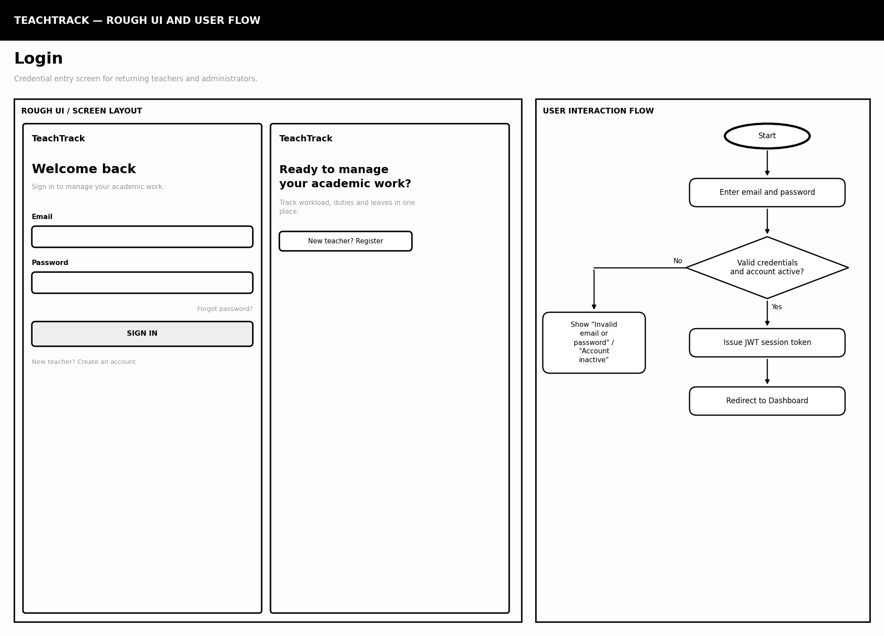

TeachTrack — 2. Register
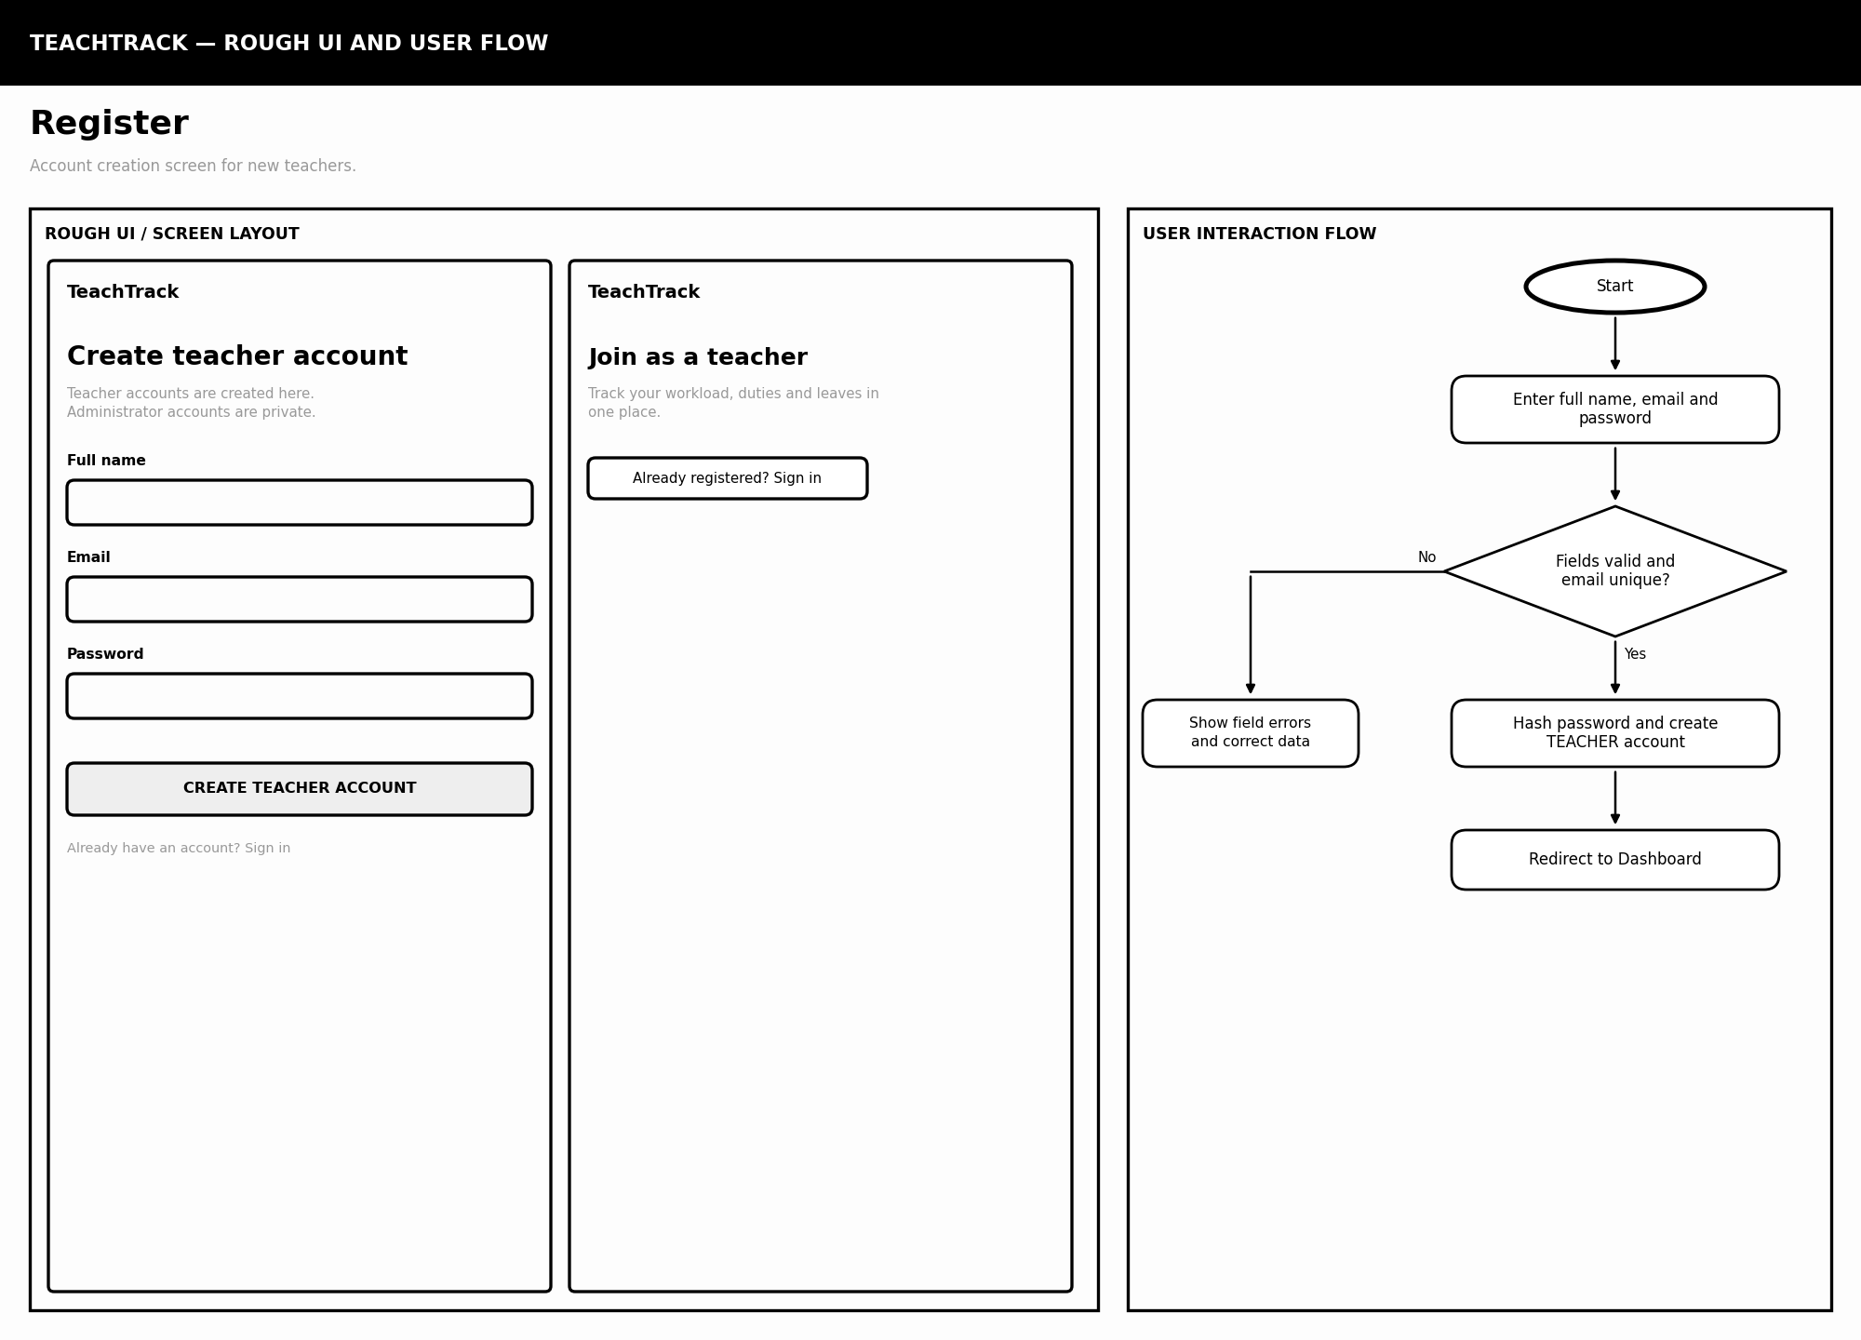

TeachTrack — 3. Dashboard
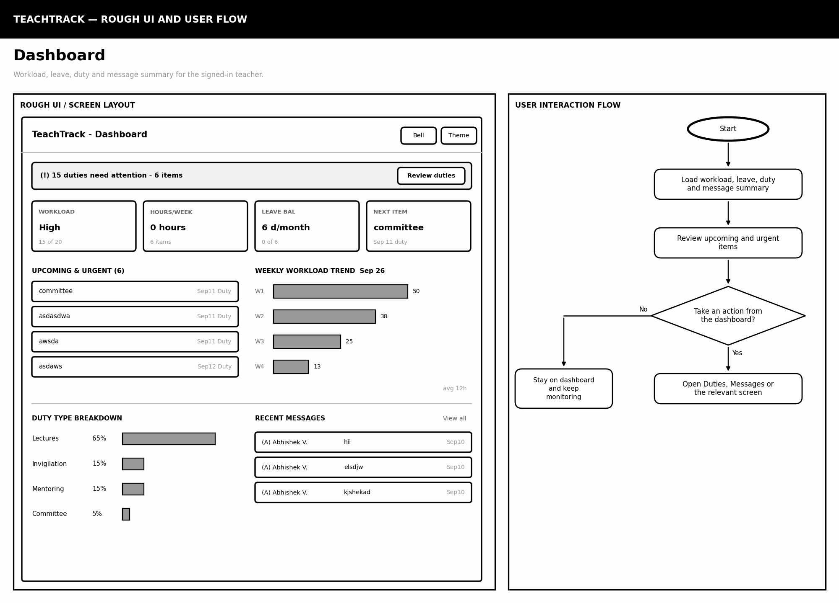
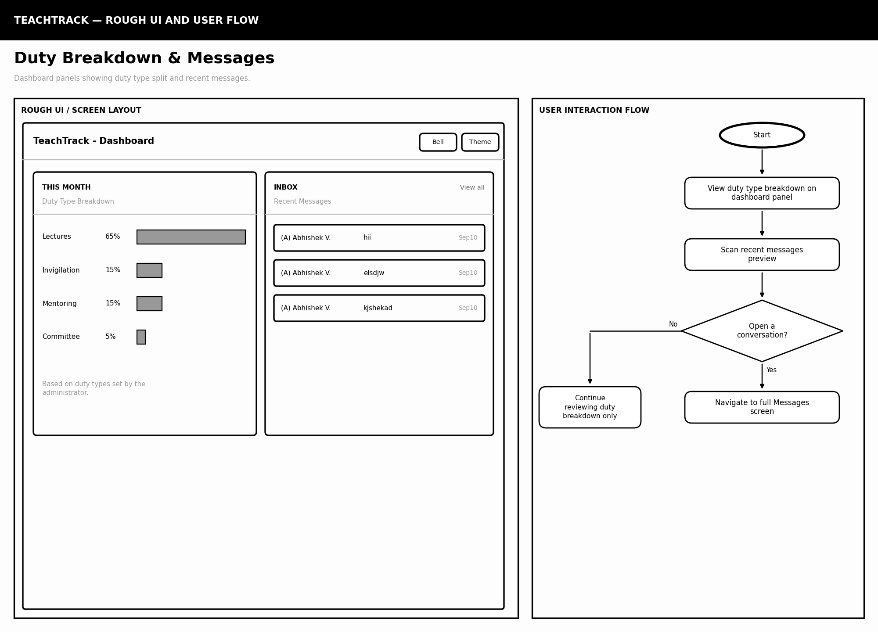

TeachTrack — 4. Leaves (Teacher)
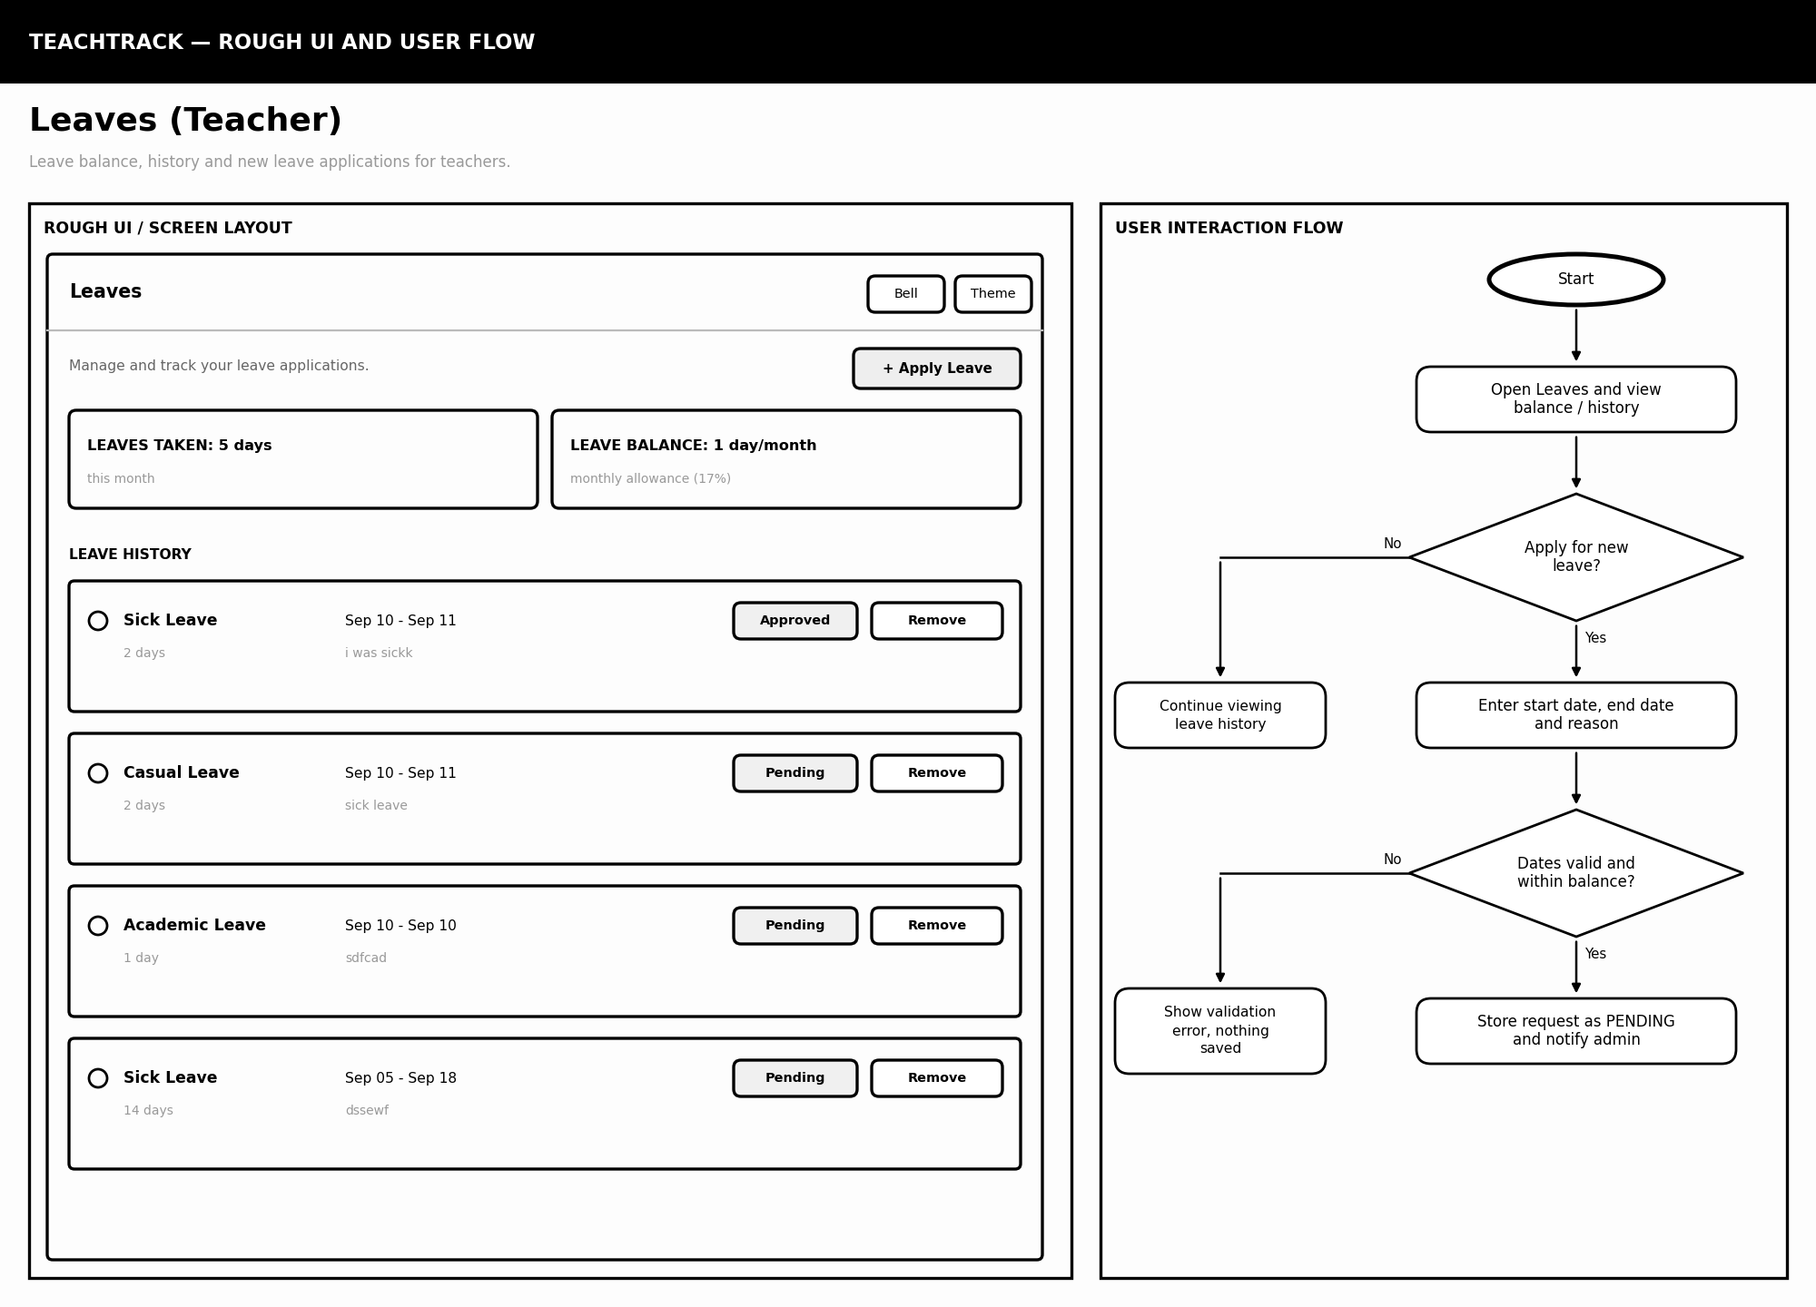

TeachTrack — 5. Leaves (Admin)
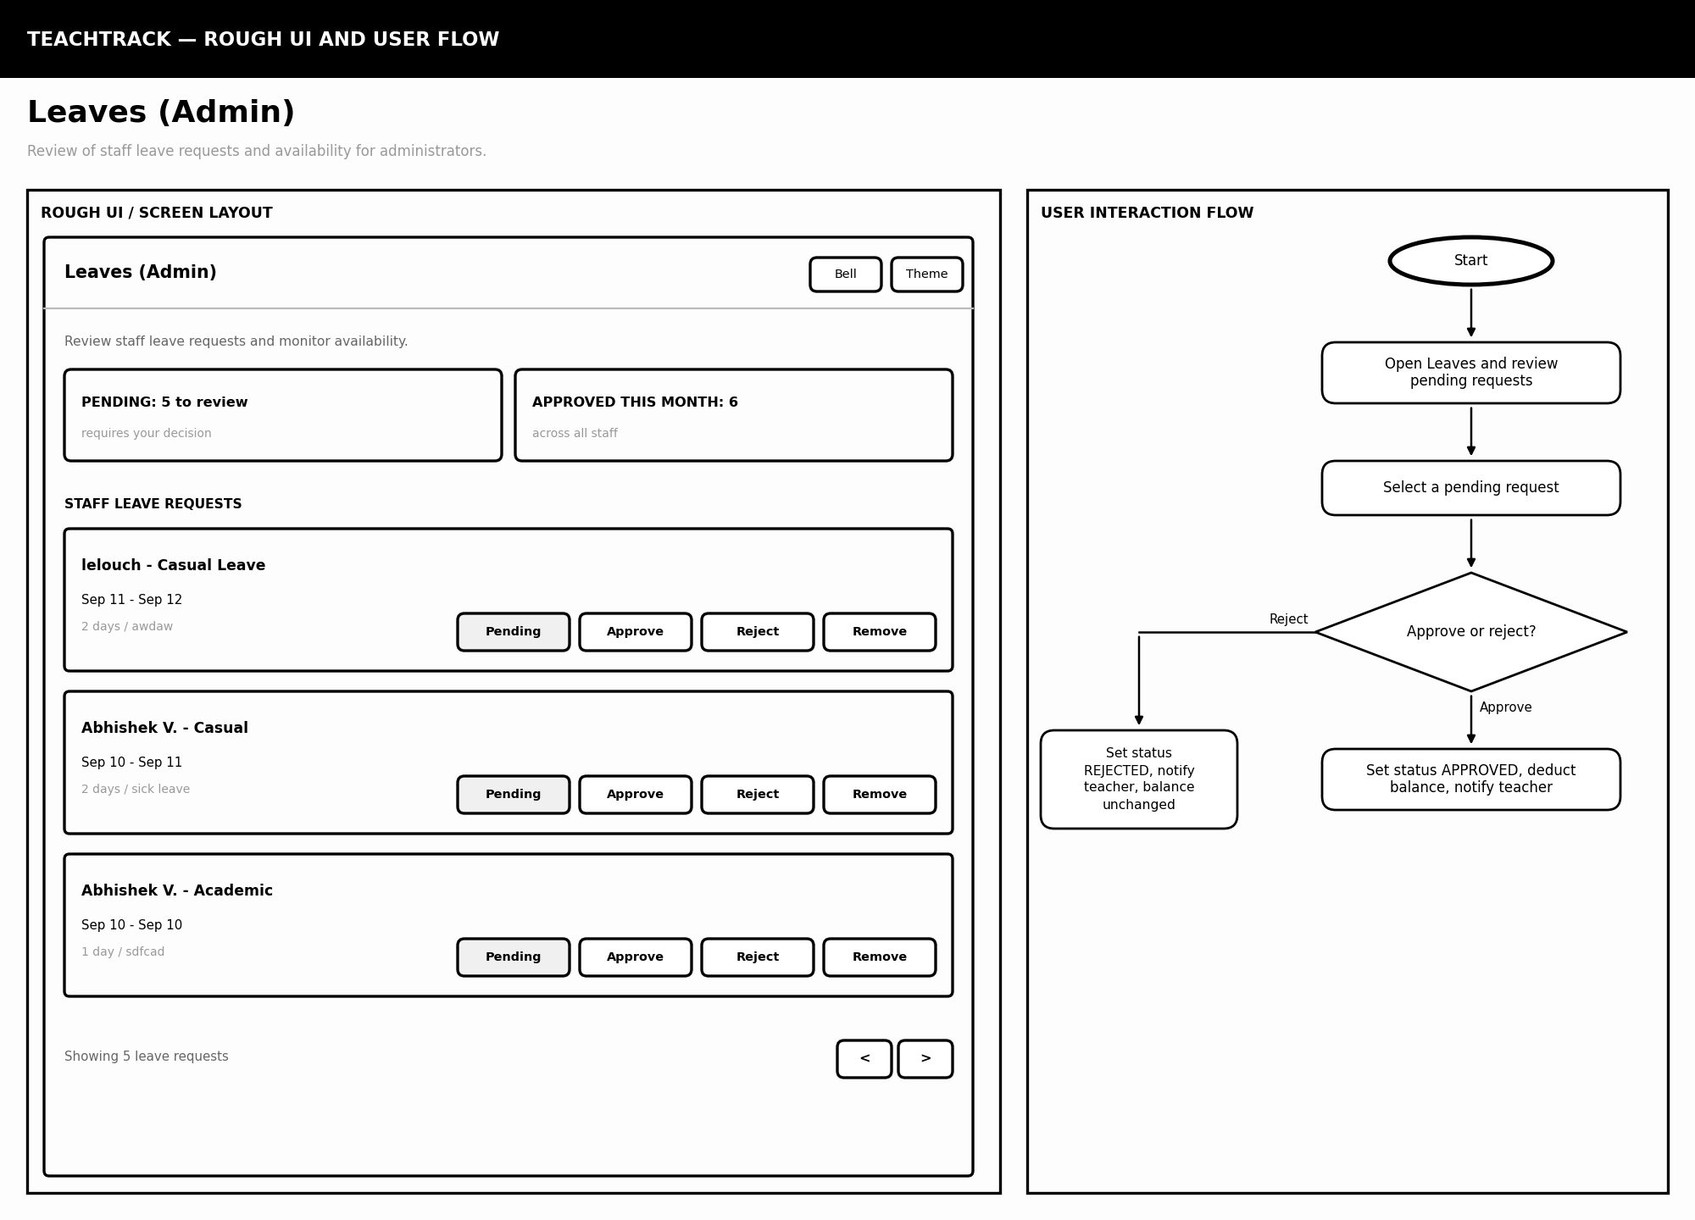

TeachTrack — 6. Timetable
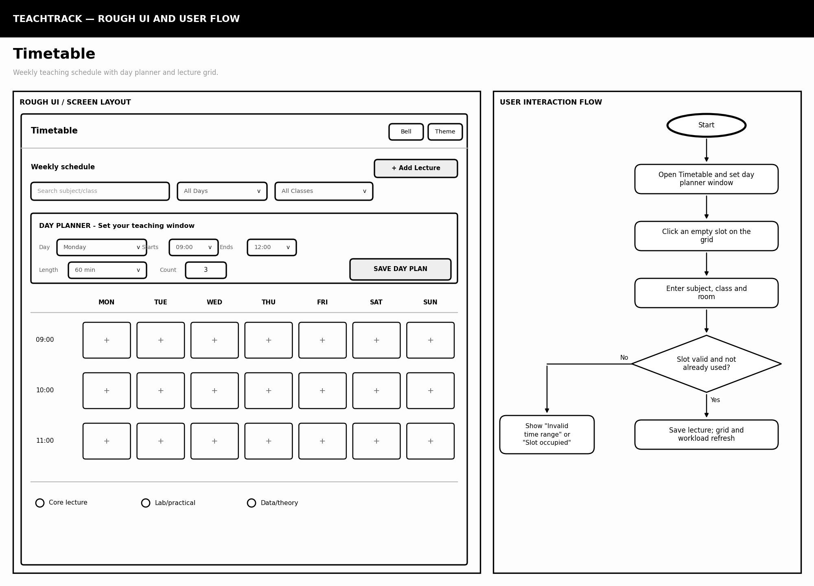

TeachTrack — 7. Duties(admin)
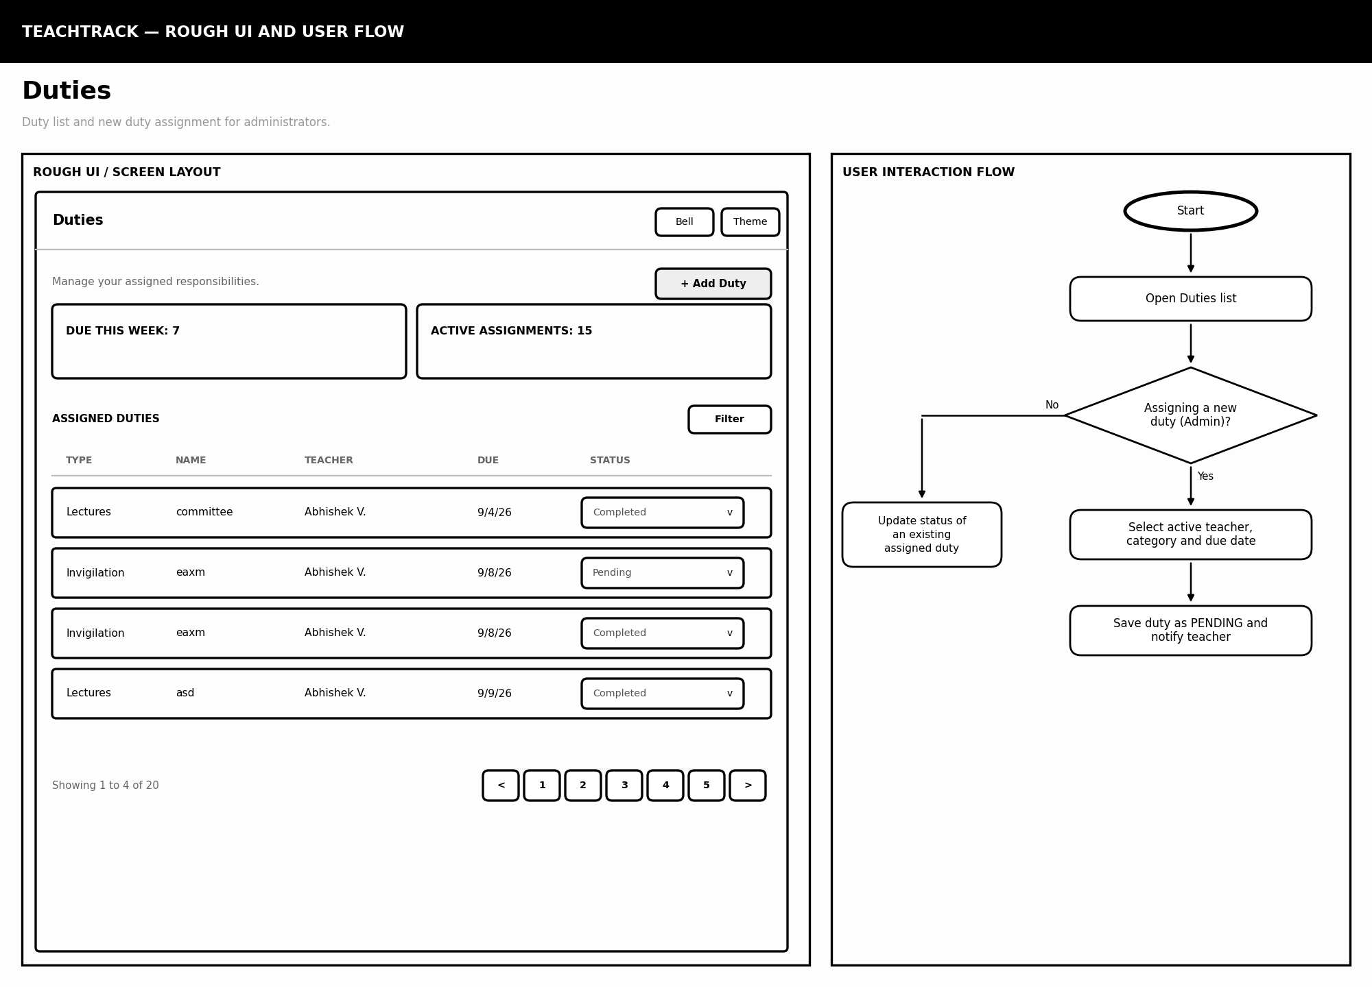

TeachTrack — 9. Duties (teacher view)
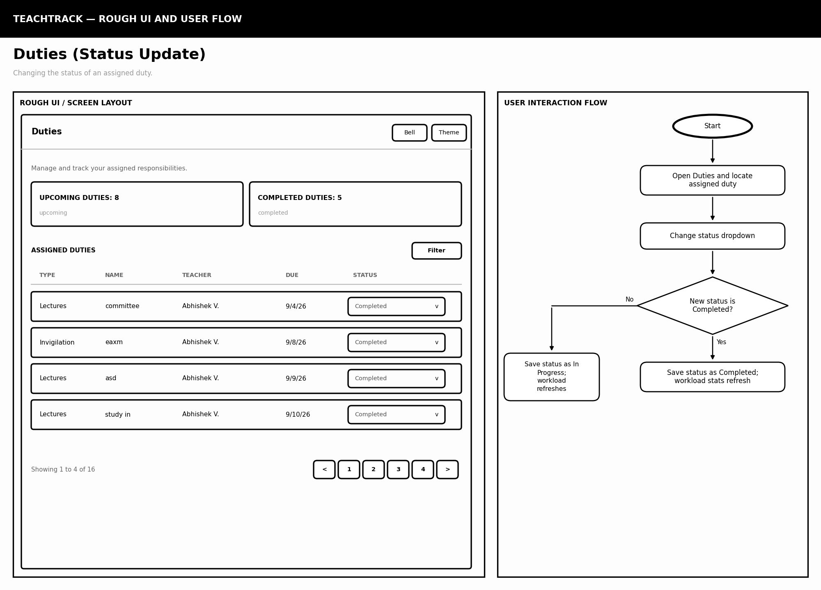

TeachTrack — 10. Calendar
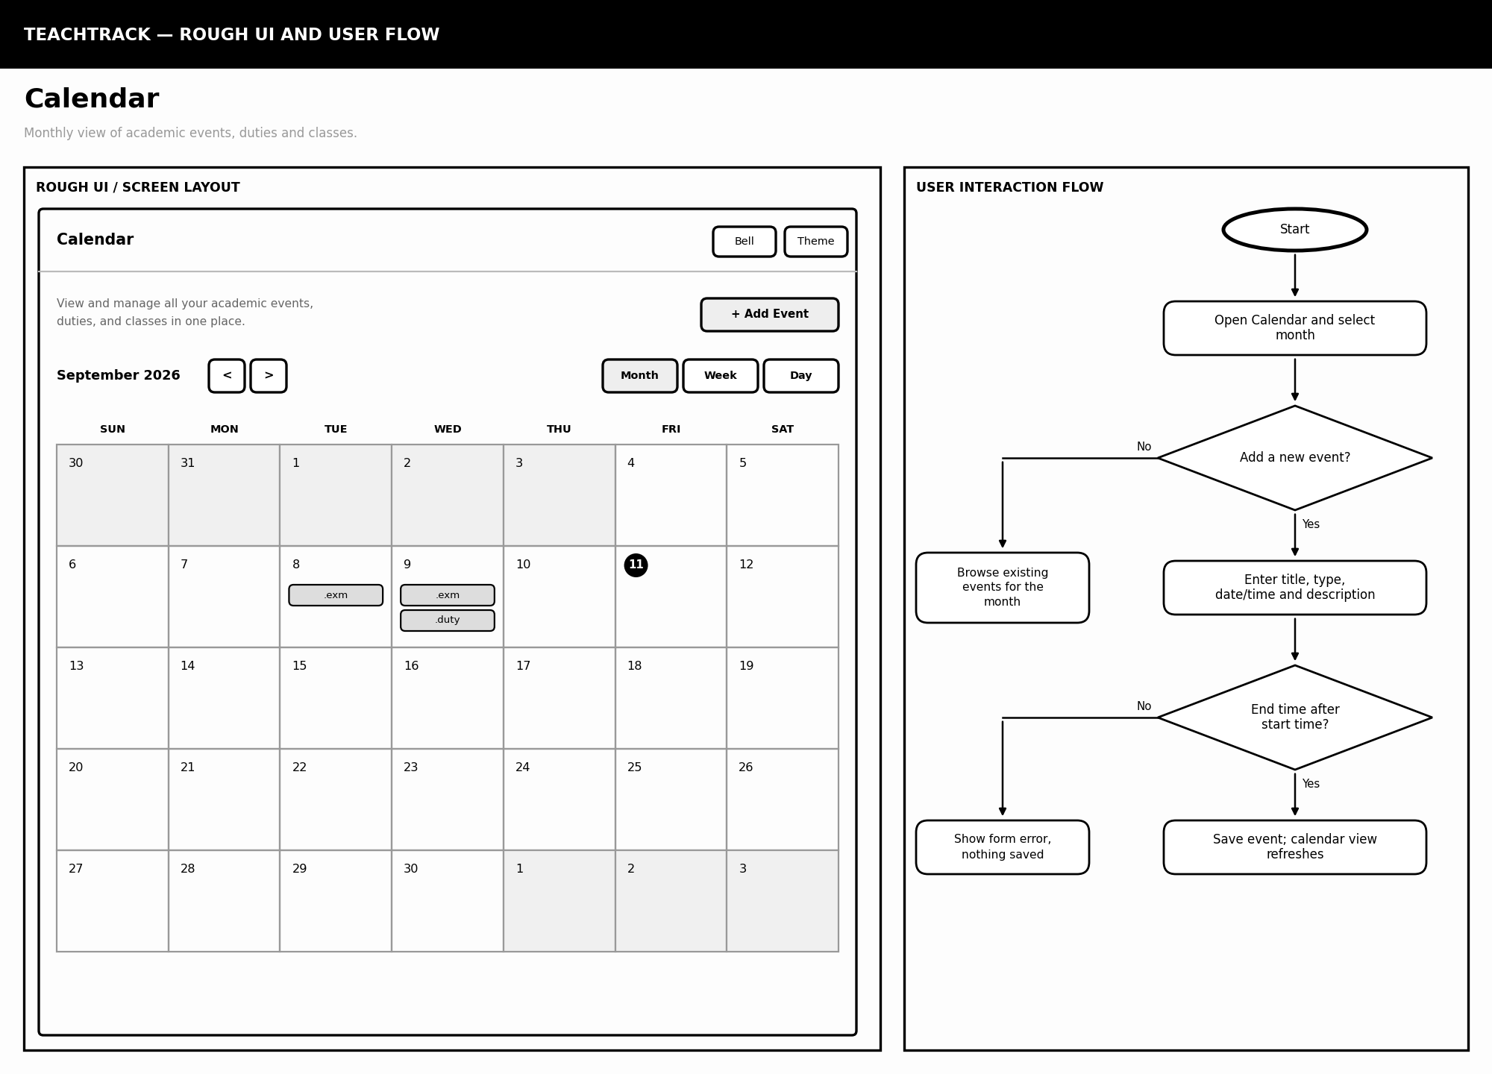

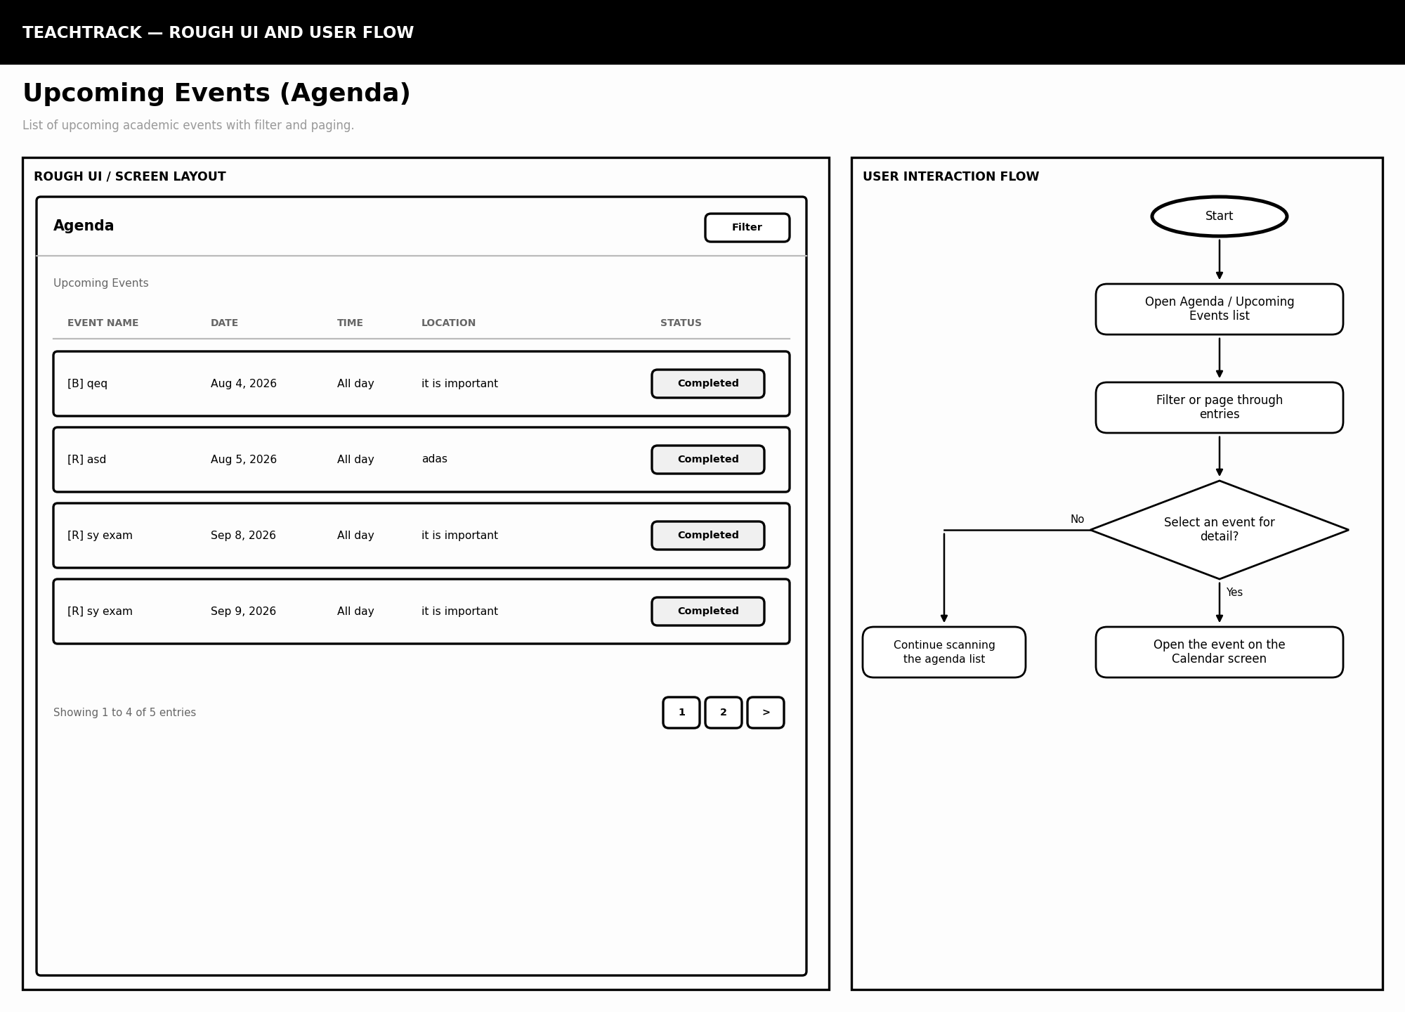

TeachTrack — 12. Messages
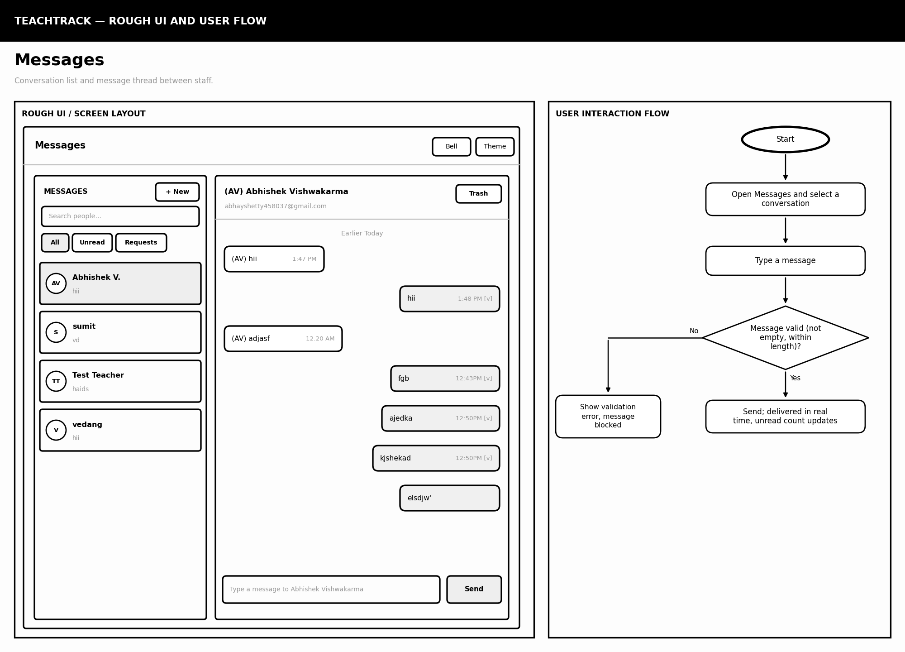

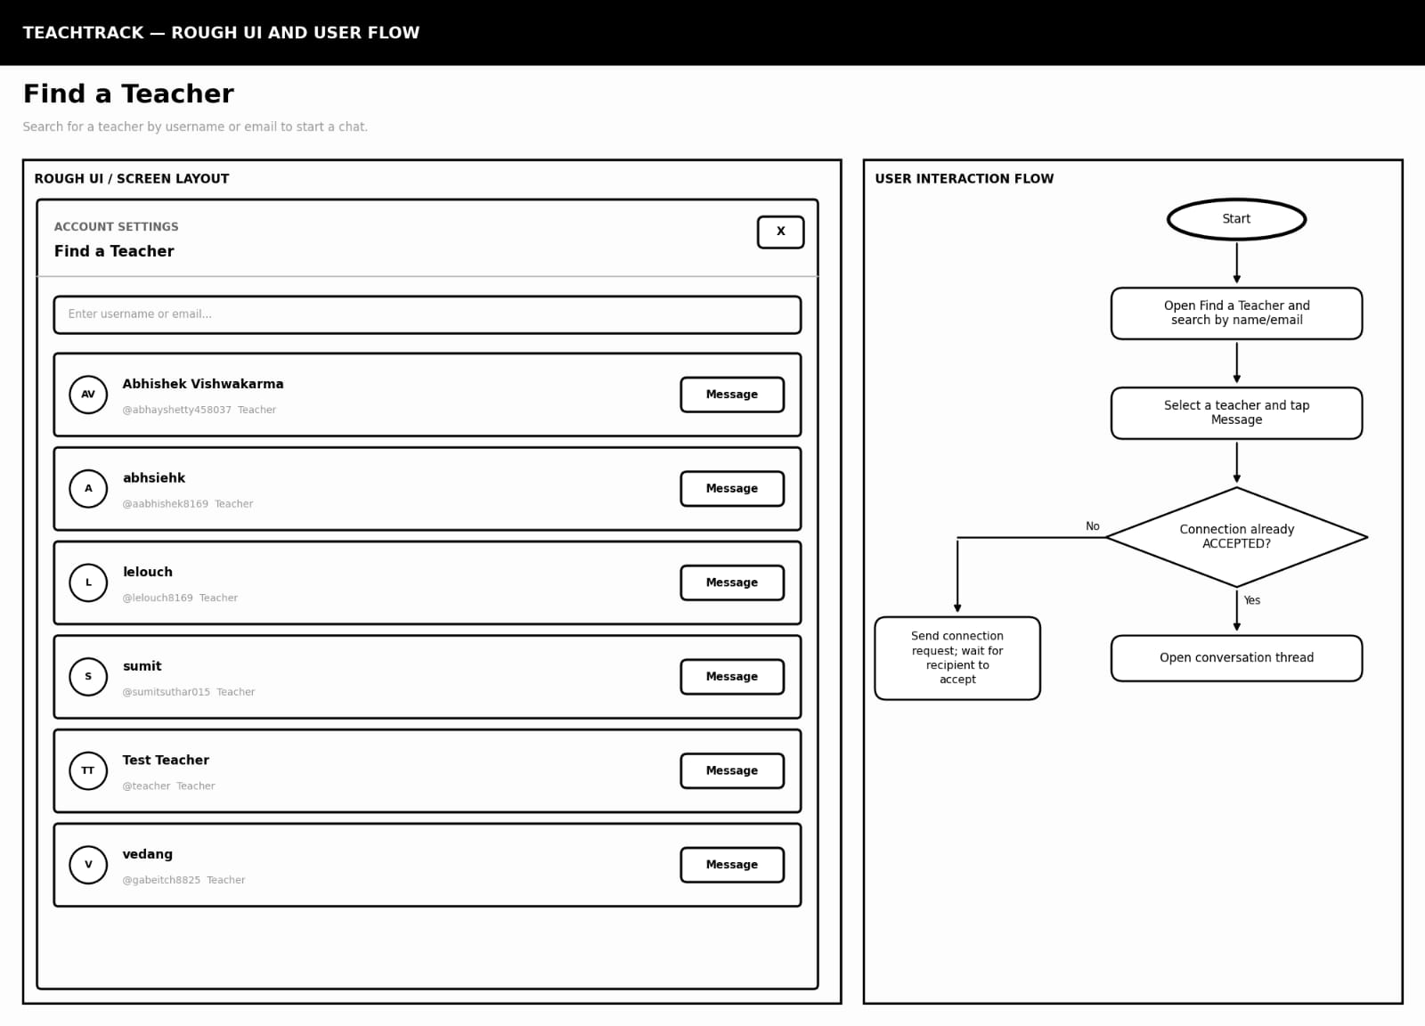

TeachTrack — 14. AI Assistant
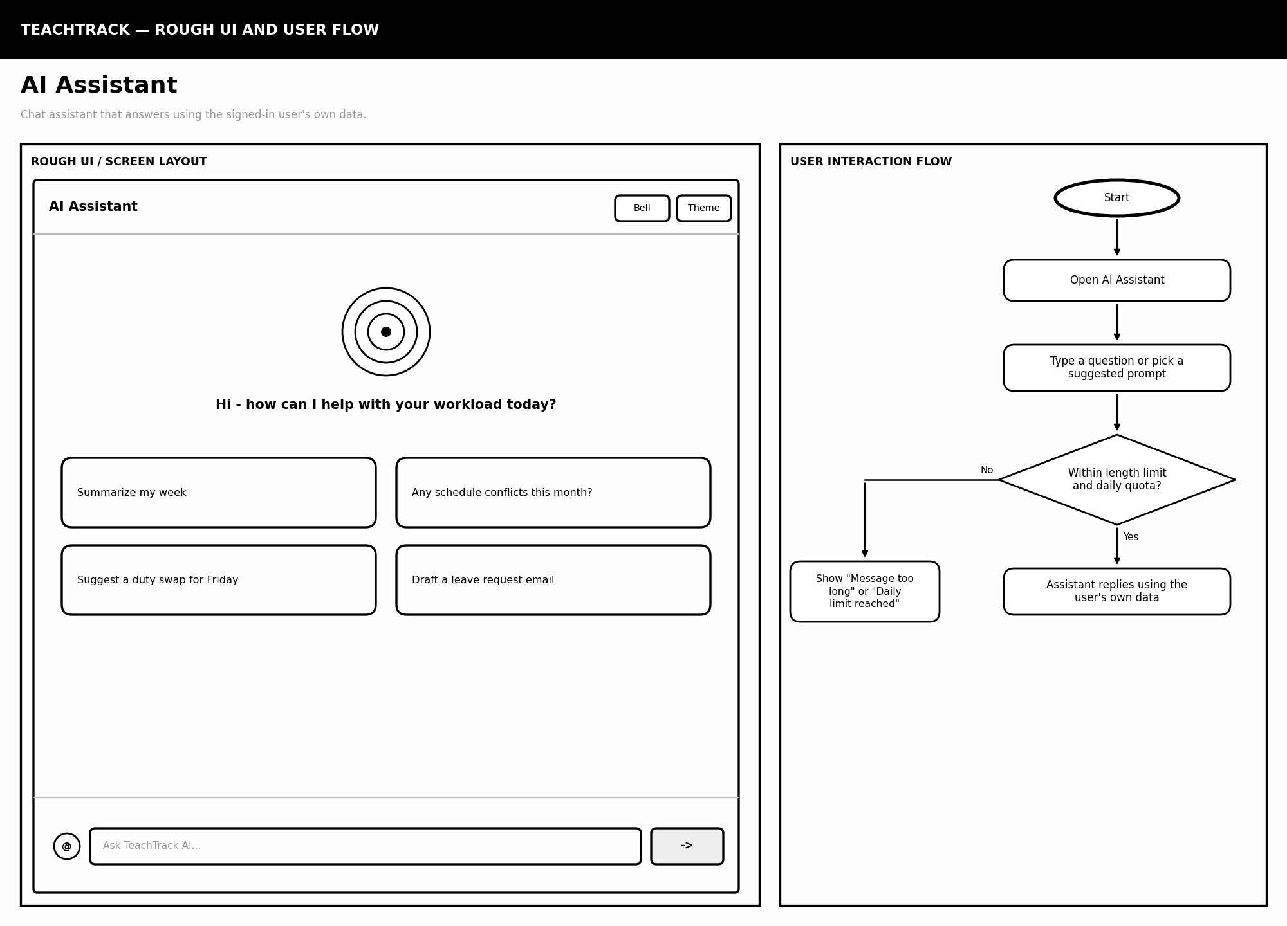

TeachTrack — 15. Profile Settings
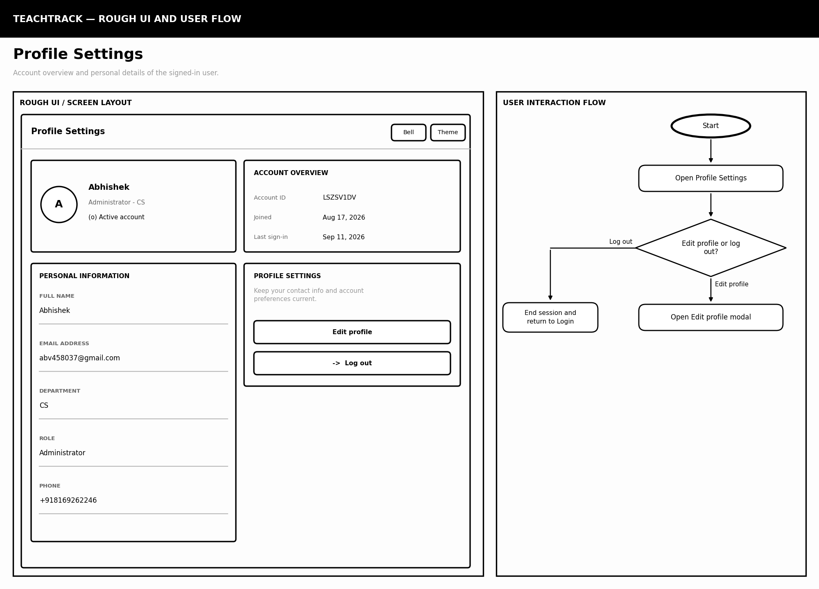

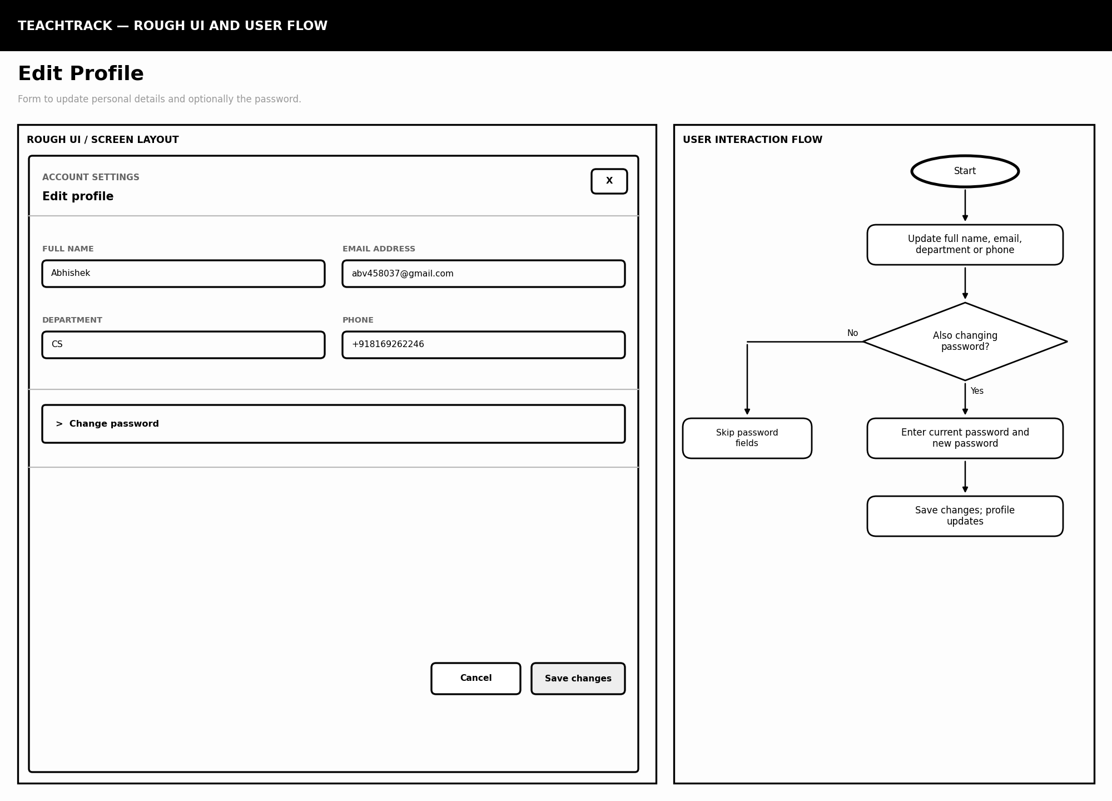

1.C Navigation Flow
 |  |  |  |  |  | LOGIN / REGISTER
 |  |  |  |  |  |  |  |  |  | JWT issued, stored client-side
 |  |  |  |  |  | ▼
 |  |  |  |  |  | DASHBOARD
▼ |  |  | ▼ |  |  | ▼ |  |  | ▼ |  |  | ▼ |  |  | ▼ |  |  | ▼
TIMETABLE |  |  | DUTIES |  |  | LEAVES |  |  | CALENDAR |  |  | MESSAGING |  |  | AI ASSISTANT |  |  | PROFILE  Password / Logout
Figure 1.1 — All authenticated screens are reached from the Dashboard via a shared navigation bar (assets/app.js). The Login and Password Reset pages are the only screens reachable without a valid JWT.

Business Logic Design
Project: TeachTrack — a teacher workload, scheduling, leave, duty and communication platform, with rule-based smart suggestions and an optional AI assistant.
Objective. This section explains how TeachTrack processes information and makes decisions, rather than how its screens look. Every process is described in the same four steps: Input → Processing / Rules → Database Operation → Output. Each process is supported by a plain black-and-white logic diagram, and all diagrams are combined in one final business logic diagram in Section 2.G.

2.A System Modules
TeachTrack is a TypeScript/Express + React application backed by PostgreSQL through Prisma. Together its routes and shared libraries provide the following twelve modules.
Module | Responsibility | Source file(s) | Main data
1 Registration & Login | Creates a Teacher or Admin account; authenticates credentials; issues a session JWT. | backend/src/routes/auth.ts | User
2 Dashboard & Workload Aggregation | Aggregates workload stats, leave balance, duty breakdown, message and notification previews. | backend/src/routes/dashboard.ts | TimetableLecture, LeaveRequest, Duty, Message
3 Timetable Management | CRUD on lecture records; per-day planner settings (start/end time, lecture count). | backend/src/routes/timetable.ts | TimetableLecture, TimetableSetting
4 Leave Management | Teacher requests leave; admin approves or rejects; balance is tracked and deducted. | backend/src/routes/leaves.ts | LeaveRequest
5 Duty Management | Admin assigns duties to active teachers; teacher updates status; history can be hidden. | backend/src/routes/duties.ts | Duty
6 Calendar & Reminders | Personal reminders, meetings, exams and leave/duty events with filtering and paging. | backend/src/routes/calendar.ts | CalendarEvent
7 Messaging & Connections | Connection requests, direct conversations, unread counts, admin direct messaging. | backend/src/routes/messages.ts, messages-connections.js | Message, MessageConnection
8 Notifications | Creates and delivers alerts for leave, duty and message events. | backend/src/routes/notifications.ts | Notification
9 AI Assistant | Authenticated chat grounded in the user's own timetable, leaves, duties and messages; rate-limited. | backend/src/routes/ai.ts | AiDailyUsage
10 Profile & Password Management | Edits profile details; changes password after verifying the current one. | backend/src/routes/auth.ts (me / password) | User
11 Real-time Sync (Socket.IO) | Authenticates socket connections; joins per-user rooms; emits live update events. | backend/src/server.ts, lib/socket.ts | (event bus — no persisted model)
12 Password Reset (Email) | Generates a hashed, single-use, one-hour reset token and emails a reset link via SMTP. | backend/src/lib/mailer.ts, routes/auth.ts | PasswordResetToken

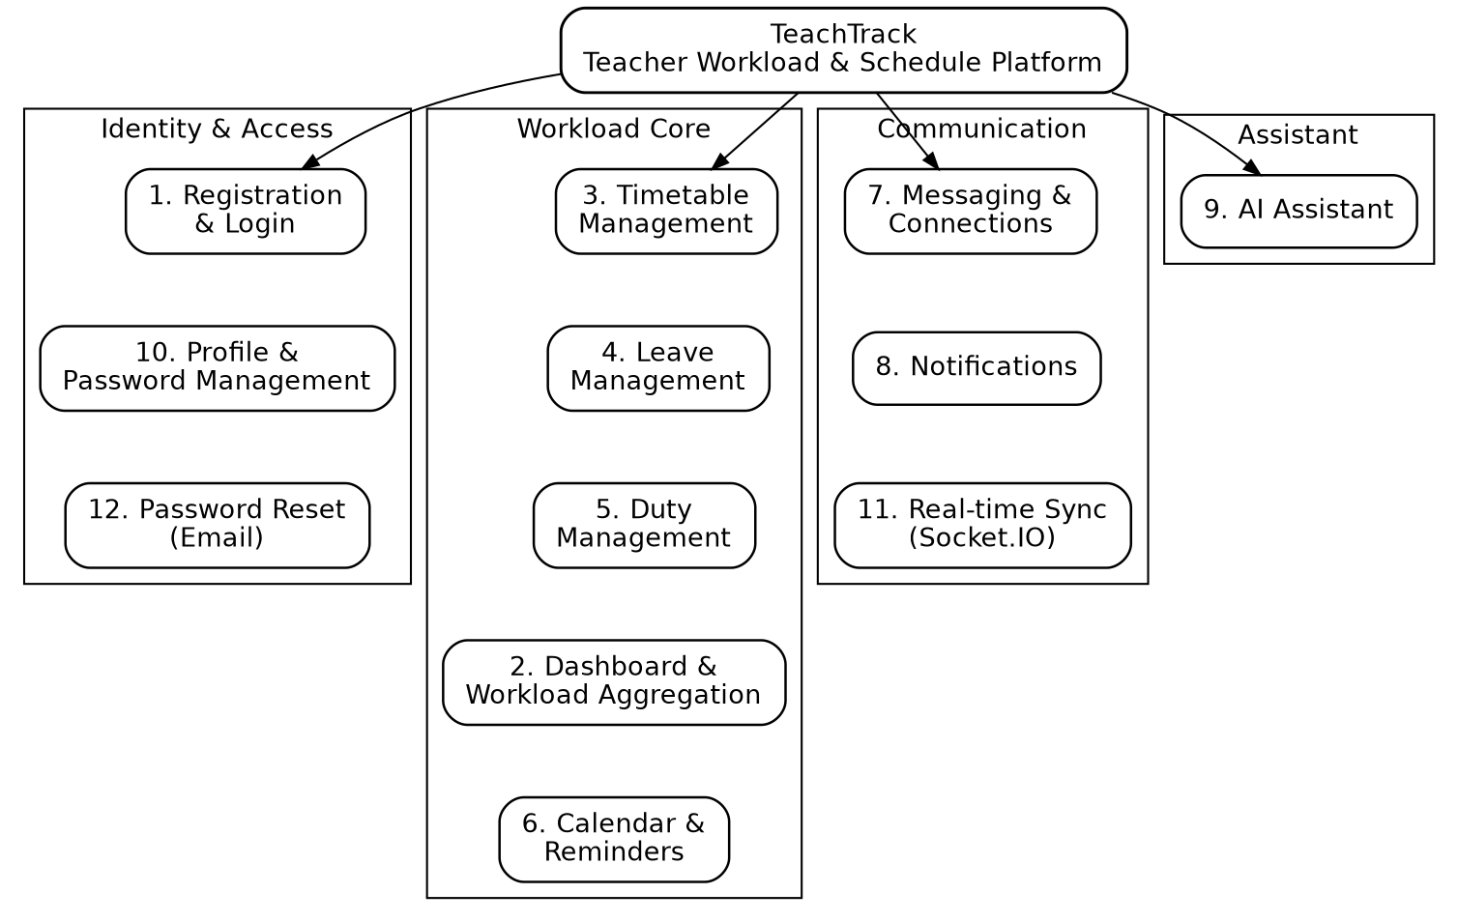
Figure 1: System modules of TeachTrack, grouped by functional area

2.B Business Rules
This section lists the rules followed by each core process, the decision logic that applies them, and the Input → Processing → Database → Output summary of the process. The logic diagrams show every decision point and the exact database operation performed.

2.B1 Registration and Login
Rules
- The registration form must contain a valid name, unique email and password; the password is hashed with bcrypt before storage.
- A new account is created directly with the requested role (TEACHER or ADMIN) — there is no separate activation step.
- Login requires the submitted password to match the stored hash for that email.
- Only an active account (active = true) may start a session.
- On success, a JWT is issued containing the user id and role, valid for seven days.
- Protected routes require a valid Bearer token; admin-only routes additionally require role = ADMIN.

Input | Name, email and password for registration; email and password for login.
Processing / Rules | Validate fields → (register: check email uniqueness → hash password) or (login: verify hash) → check account is active → issue JWT.
Database Operation | INSERT into User (registration); READ User (login).
Output | Redirect to Dashboard with a valid session, or an error message on any failure.

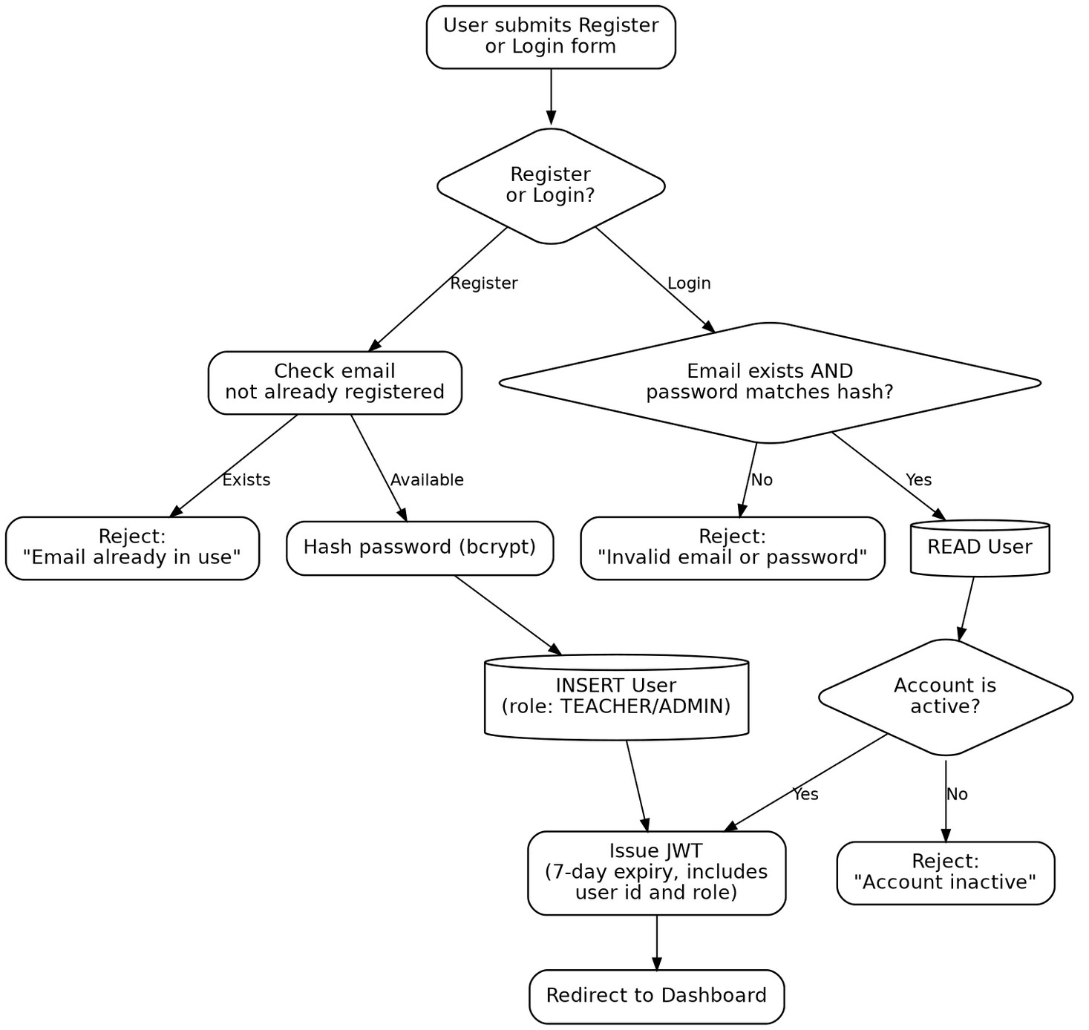
Figure 2: Registration and login logic

2.B2 Timetable Management
Rules
- The teacher must be logged in to create or edit a lecture.
- Day, time, subject, class and room are required fields.
- The end time must be later than the start time.
- A given user cannot have two lecture records at the same day and time (unique per user/day/time).
- Per-day planner settings (start/end time, lecture count, duration) are unique per user and day.
- Saving a lecture recomputes the teacher's weekly teaching load on the dashboard.

Input | Day, time slot, subject, class, room (or a lecture identifier for edit/delete).
Processing / Rules | Check login → validate required fields → check time range → check slot uniqueness → save.
Database Operation | INSERT, UPDATE or DELETE on TimetableLecture / TimetableSetting.
Output | Updated timetable grid and refreshed workload figures; a validation error if any rule fails.

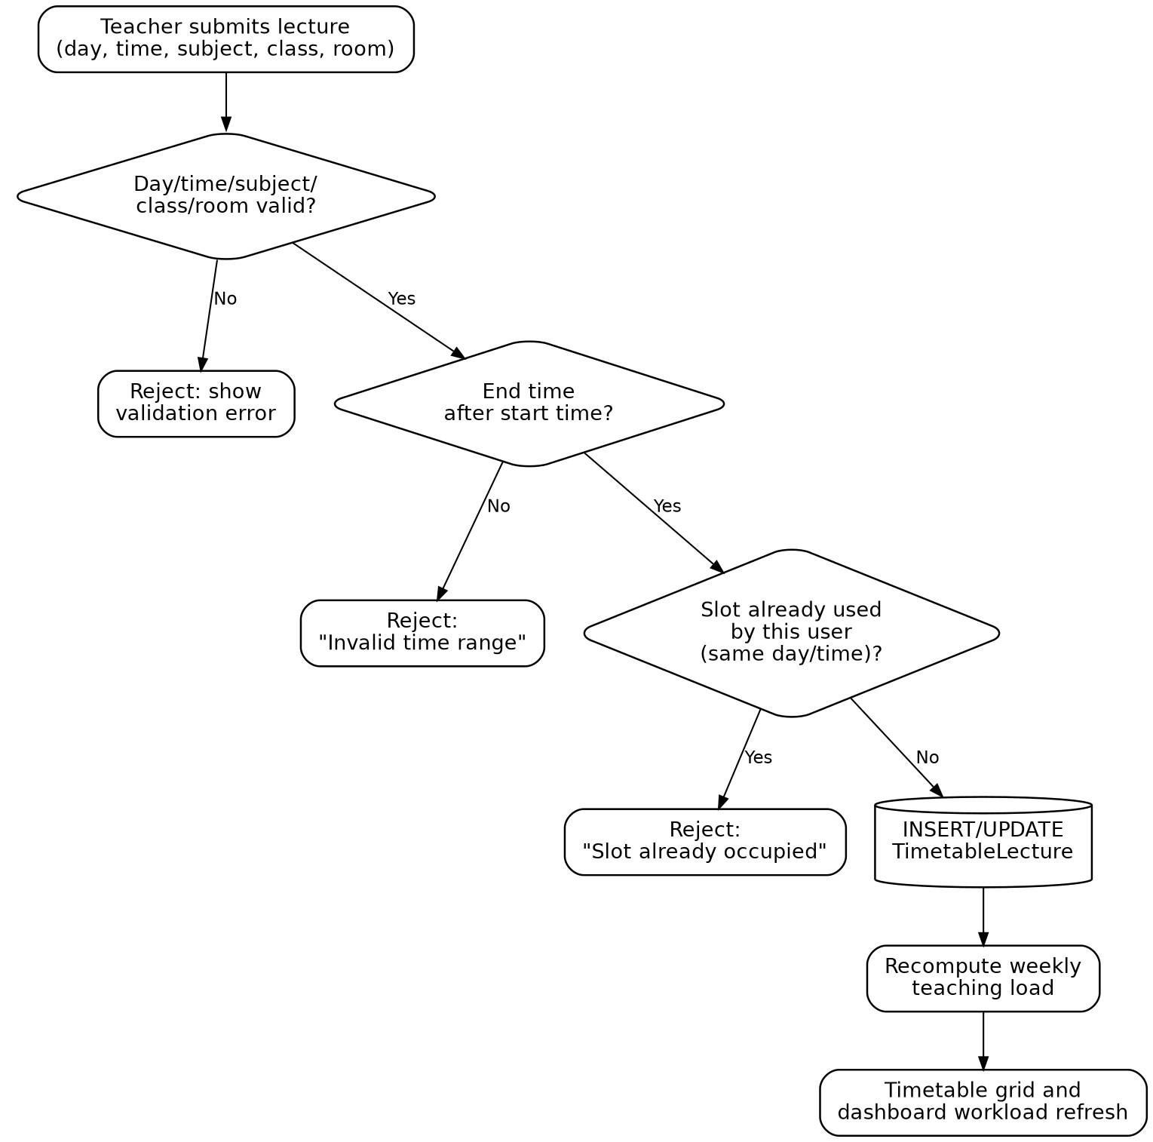
Figure 3: Timetable lecture logic

2.B3 Leave Management
Rules
- The user must be logged in with role TEACHER to apply for leave.
- Start date and end date must be valid, with the end date on or after the start date, and neither in the past.
- The number of requested days is calculated from the date range.
- Requested days must not exceed the teacher's remaining leave balance.
- The request must not overlap an existing PENDING or APPROVED request for the same teacher.
- A new request is stored with status PENDING; the admin then sets it to APPROVED or REJECTED, optionally with reviewer notes.
- Approved days are deducted from the teacher's leave balance; both submission and review raise a real-time notification.

Input | Start date, end date and reason (teacher); approve/reject decision and notes (admin).
Processing / Rules | Validate dates → compute requested days → check balance → check overlap → store as PENDING → admin review → update status → adjust balance.
Database Operation | INSERT LeaveRequest (PENDING); UPDATE LeaveRequest (APPROVED / REJECTED).
Output | Notification to admin on submission and to teacher on review; updated leave balance.

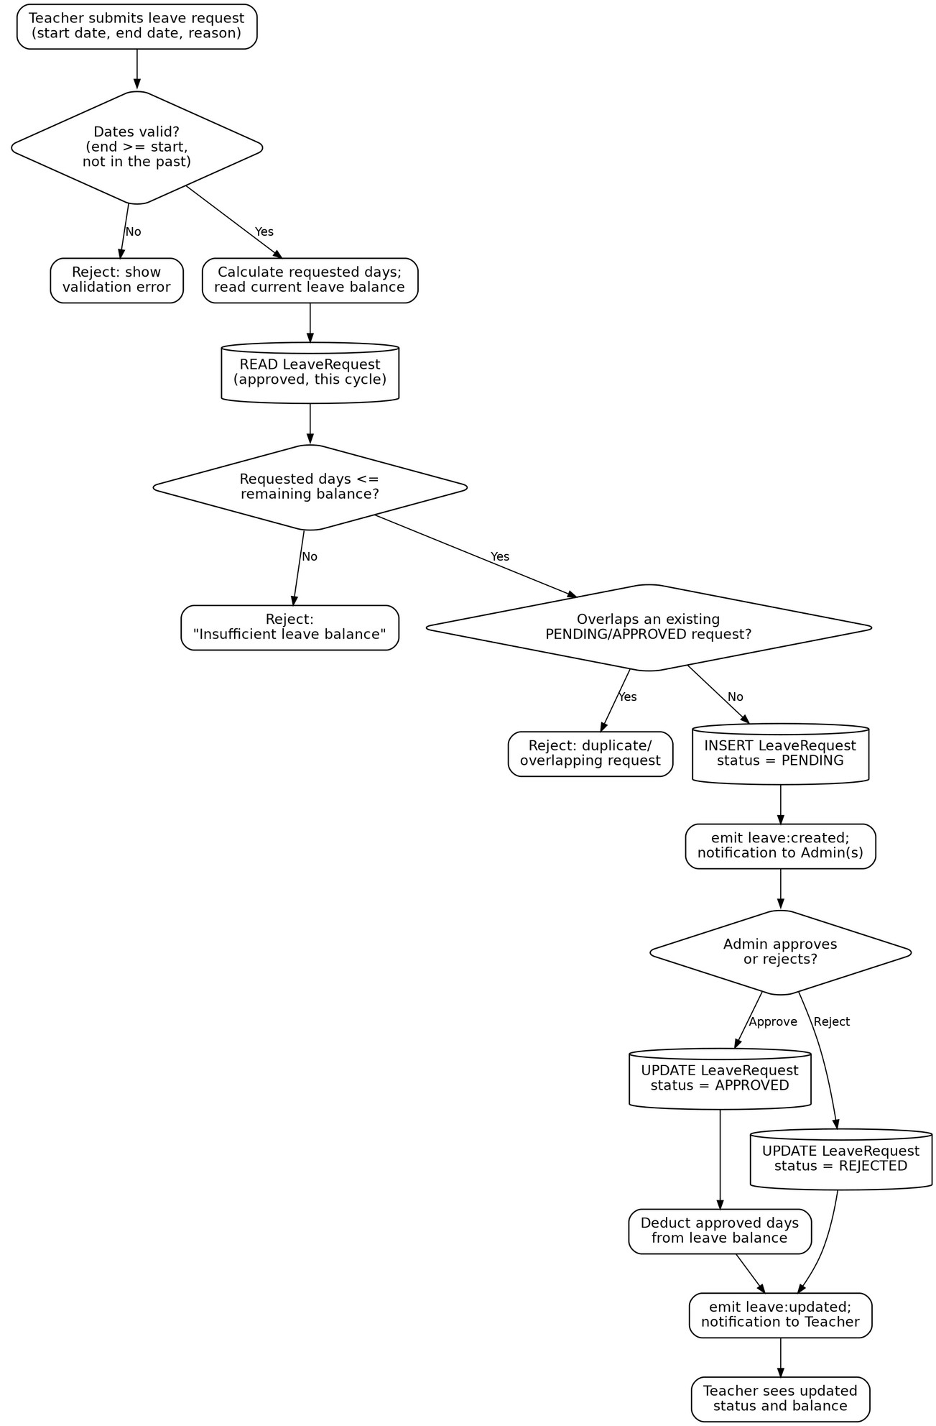
Figure 4: Leave request logic

2.B4 Duty Management
Rules
- Only a logged-in ADMIN may assign a duty.
- A duty can only be assigned to a teacher whose account is active.
- Category (lecture, invigilation, mentoring, committee) and due date are mandatory, and the due date must not be in the past.
- A new duty is stored with status PENDING and the assigned teacher is notified.
- Only the assignee or an admin may change a duty's status, to IN_PROGRESS or COMPLETED.
- A status change refreshes the teacher's dashboard workload statistics.
- A teacher may hide a duty from their own history view without deleting the underlying record; the admin view is unaffected.

Input | Teacher, category, due date and description (assignment); new status (update).
Processing / Rules | Check role and account state → validate due date → save → notify → (teacher) update status → recompute workload.
Database Operation | INSERT Duty (PENDING); UPDATE Duty (status or visibility).
Output | Notification to teacher; refreshed duty list and dashboard workload.

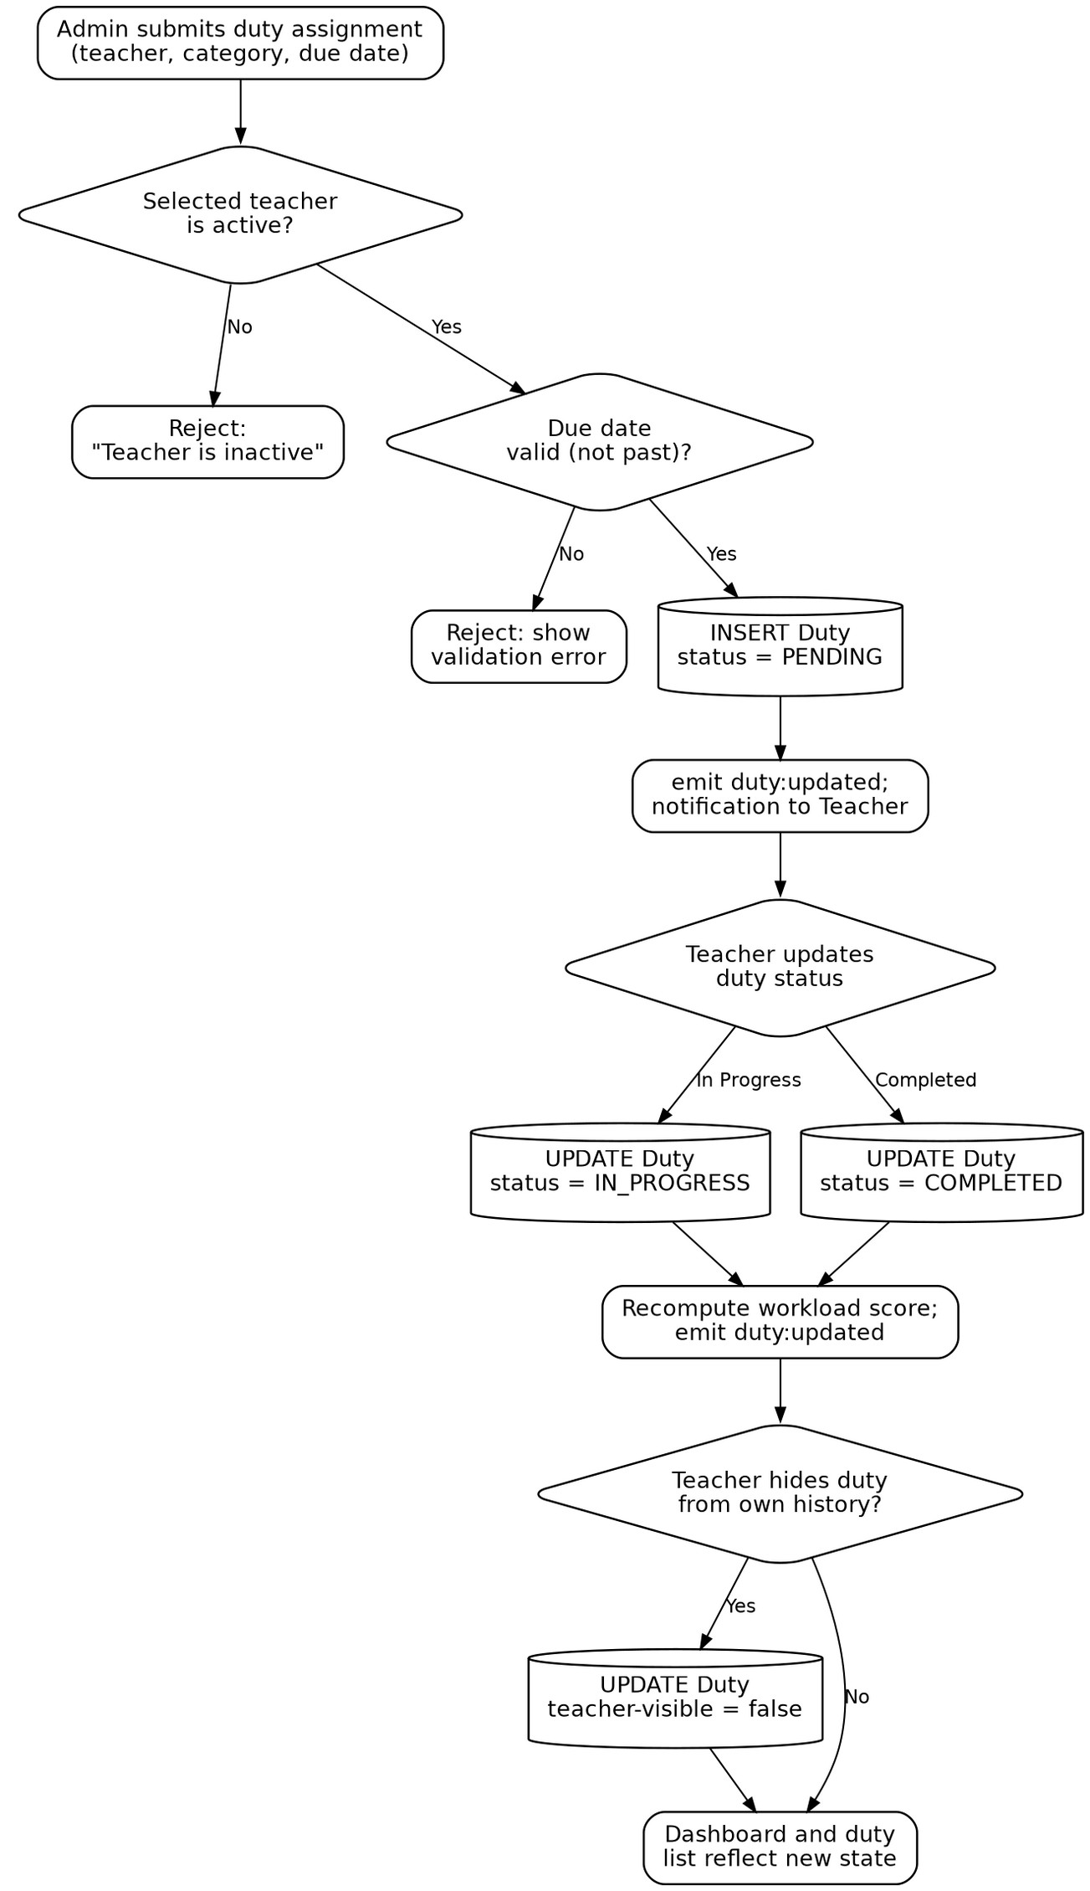
Figure 5: Duty assignment and completion logic

2.B5 Messaging and Connections
Rules
- A teacher may message another teacher only after a MessageConnection between them has status ACCEPTED.
- An admin may message any teacher directly, without a connection request.
- A connection request is unique per requester/recipient pair and starts as PENDING.
- The recipient accepts or rejects the request; the outcome is recorded and both sides are notified in real time.
- A message must not be empty and is subject to a maximum length.
- Each message updates per-side visibility flags and the recipient's unread count.

Input | Recipient to search for or connect with; connection accept/reject decision; message text.
Processing / Rules | Check requester role and existing connection state → create/update connection → (once accepted, or if admin) validate message → save.
Database Operation | INSERT MessageConnection; UPDATE MessageConnection; INSERT Message.
Output | Real-time delivery of the request or message; updated unread count and conversation view.

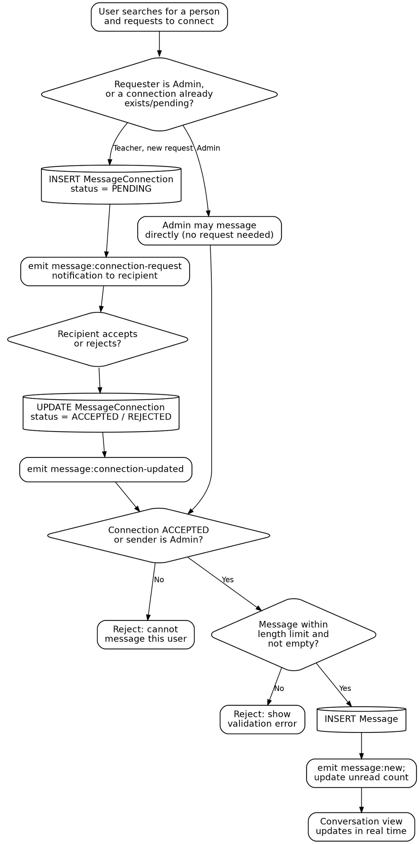
Figure 6: Messaging and connection request logic

2.B6 AI Assistant
Rules
- The user must be logged in; the assistant only ever sees that user's own data.
- A chat message must not exceed 2,000 characters.
- A user may make at most 30 AI requests per UTC calendar day; the count is tracked in AiDailyUsage.
- Context sent to the model is limited to the user's timetable, leaves, duties, events and unread-message count.
- Every accepted request increments the daily usage counter before the reply is returned.

Input | A chat message from the logged-in user.
Processing / Rules | Check message length → check daily quota → assemble user-scoped context → call the AI provider.
Database Operation | READ AiDailyUsage; UPDATE AiDailyUsage (increment).
Output | Assistant reply in the chat, grounded in the user's own data; a limit or length error otherwise.

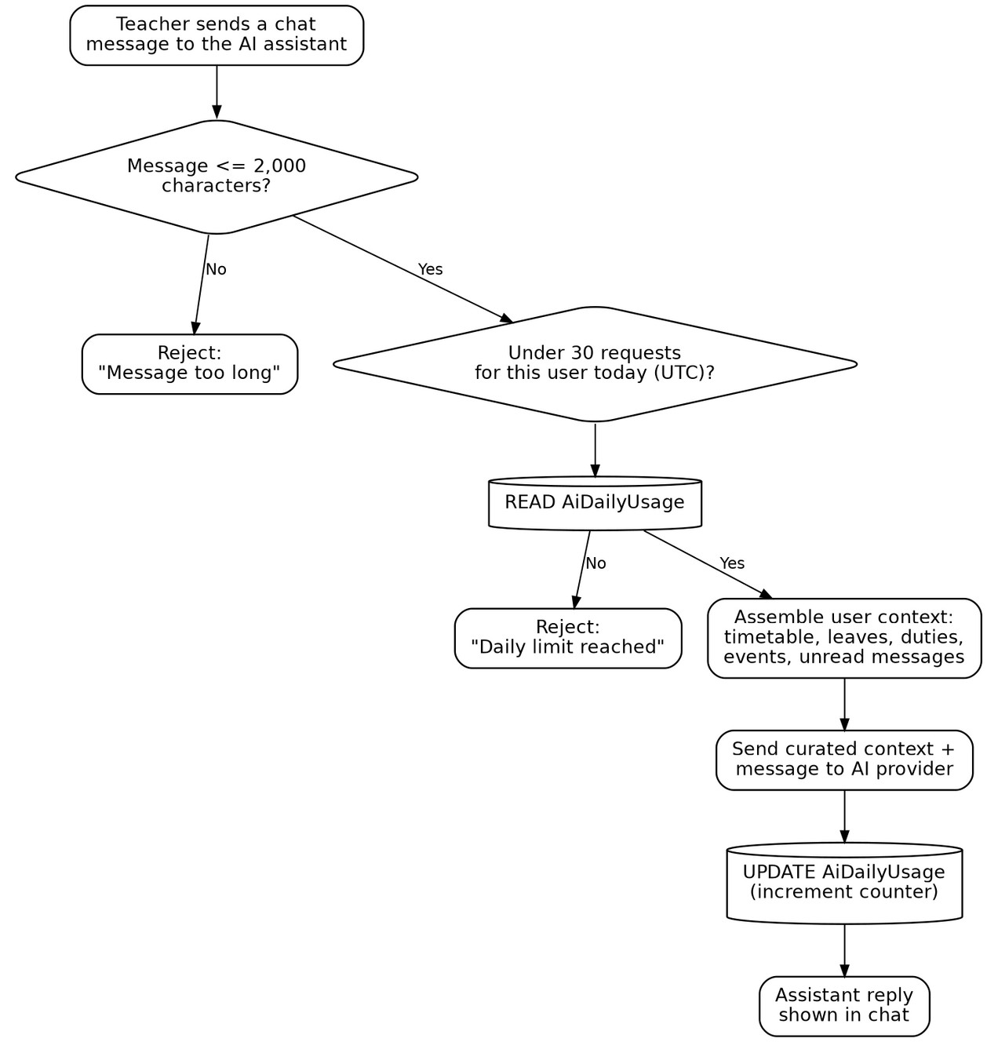
Figure 7: AI assistant request logic

2.B7 Dashboard, Calendar, Notifications, Profile and Password Reset
These modules follow the same Input → Processing → Database → Output pattern but are simpler read/update flows and are summarised here without a separate diagram.
Module | Input → Processing → Database → Output
Dashboard & Workload Aggregation | Input: request to open the dashboard.  Processing: aggregate the user's timetable, leave balance, duties and messages for the current period.  Database: READ only (TimetableLecture, LeaveRequest, Duty, Message, Notification).  Output: summary cards, workload chart and recent activity.
Calendar & Reminders | Input: title, type, date/time, optional end time, reminder and description.  Processing: validate that end time (if given) is after start time.  Database: INSERT/UPDATE/DELETE CalendarEvent.  Output: updated calendar view, filtered and paginated by month.
Notifications | Input: an event raised by another module (leave, duty, message).  Processing: build a Notification record and emit it over the user's socket room.  Database: INSERT Notification; UPDATE on read/read-all; DELETE on dismiss.  Output: badge count and notification list refresh in real time.
Profile & Password Management | Input: updated profile fields, or current and new password.  Processing: apply profile changes directly; for a password change, verify the current password before hashing and saving the new one.  Database: UPDATE User.  Output: success message, or an error if the current password does not match.
Password Reset (Email) | Input: email address, then a reset token and new password.  Processing: generate a random token, store its SHA-256 hash with a one-hour expiry, email the reset link; on submission, verify the token is unused and unexpired.  Database: INSERT PasswordResetToken; UPDATE User (new password); UPDATE PasswordResetToken (mark used).  Output: uniform confirmation message regardless of whether the email exists, to resist account enumeration.

2.D Calculation Formulas
The formulas below are used across the dashboard and the leave and duty modules.
Quantity | Formula | Note
Remaining leave balance | Annual Allowance − Sum of days in APPROVED requests | Recomputed on every approval
Requested leave days | End Date − Start Date + 1 | Inclusive of both dates
Weekly teaching load | Count of TimetableLecture entries for the week | Read from the timetable grid
Duty load | Count of duties assigned this week with status ≠ COMPLETED | Excludes completed duties
Total workload score | Weekly Teaching Load + Duty Load | Shown on the dashboard
OTP / token expiry | Generated time + 1 hour (password reset) | Checked at verification

Example 1 — Leave balance
Annual allowance = 12 days; leave already approved = 5 days.
Remaining Balance = 12 − 5 = 7 days.
Example 2 — Requesting leave that would exceed the balance
Remaining balance = 3 days; teacher requests 4 December–8 December (5 days).
Requested days (5) > remaining balance (3) → the request is rejected before it is stored.
Example 3 — Workload score
Weekly teaching load = 18 periods; duty load = 2 pending duties.
Total Workload Score = 18 + 2 = 20.

2.E Validation Rules
The table shows how the system handles incorrect inputs.
Input | Validation rule | If invalid | Status
Email | Must be a valid, unique email format | Reject registration | Implemented
Password | Minimum required length; stored as a bcrypt hash | Error message | Implemented
Login | Email and password must match an active account | “Invalid credentials” message | Implemented
Leave dates | End date ≥ start date; not in the past; no overlap with an existing pending/approved request | Error message, nothing saved | Implemented
Leave balance | Requested days must not exceed the teacher's remaining balance | Reject request | Implemented
Duty due date | Must be a valid date and not in the past | Form error | Implemented
Timetable lecture | Day, time and room unique per user/day/time; end time after start time | Form error, nothing saved | Implemented
Calendar event | Start required; end time (if present) after start time | Form error | Implemented
Message content | Must not be empty; subject to a maximum length | Message blocked | Implemented
Message permission | Requires an ACCEPTED connection, unless sender is Admin | “Cannot message this user” | Implemented
AI chat message | Maximum 2,000 characters; maximum 30 requests per user per UTC day | Message rejected; fallback none | Implemented
Password reset token | Must be unused and within its one-hour expiry | “Link expired” message | Implemented
Protected pages | User must be logged in with a valid JWT | 401 response / redirect to login | Implemented
Admin-only routes | Role must be ADMIN | 403 response | Implemented

2.F User Roles and Permissions
TeachTrack has two roles. The Administrator role is granted at account creation and carries every Teacher permission in addition to its own.
Role | Operations
Teacher | Maintain own timetable; apply for leave and track balance; update assigned duty status; manage own calendar events; message permitted users; use the AI assistant; view own dashboard; edit profile and change password.
Administrator | All Teacher operations, plus: approve or reject leave requests; assign duties to active teachers; message any teacher directly; view all workload and duty data across the organisation.

Permission matrix
Operation | Teacher | Admin
Log in / manage own profile | Yes | Yes
Add, edit, delete own timetable lectures | Yes | Yes
Apply for leave | Yes | —
Approve / reject leave requests | — | Yes
Update own assigned duty status | Yes | Yes
Assign duties to teachers | — | Yes
Manage own calendar events | Yes | Yes
Message an accepted connection | Yes | Yes
Message any teacher directly | — | Yes
Use the AI assistant | Yes | Yes
View own dashboard only | Yes | —
View all teachers' workload and duty data | — | Yes

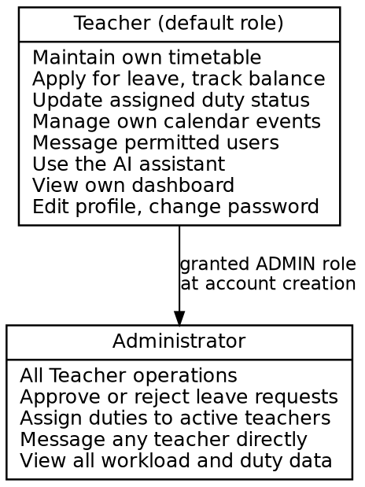
Figure 8: Roles and permissions

2.G Final Business Logic Diagram
The diagram below consolidates the Input → Processing/Rules → Database Operation → Output logic for every core TeachTrack process, with the failure path shown beneath each row.
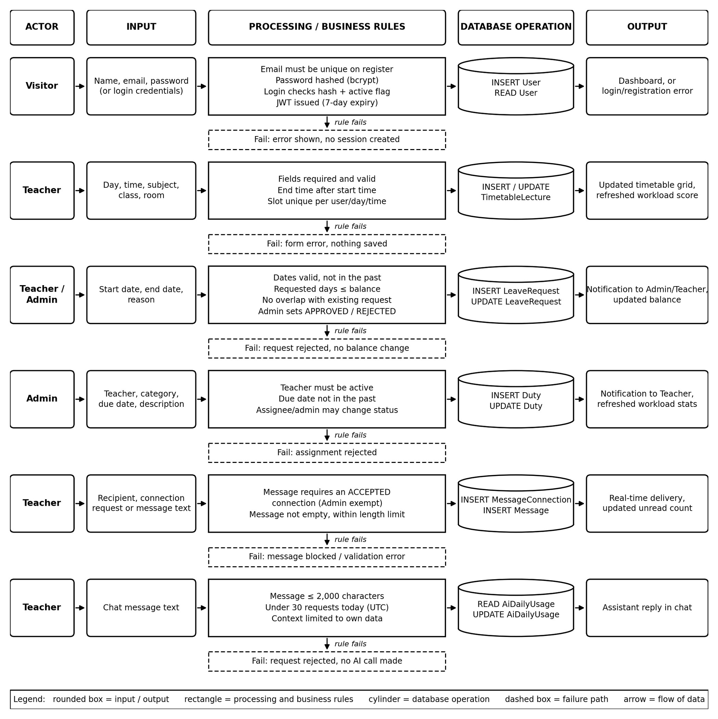
Figure 9: Final business logic diagram

Database Design

TeachTrack persists data in PostgreSQL via Prisma. The schema is defined in backend/prisma/schema.prisma. Field-level detail below is inferred from the stated models, relationships, and enums and should be checked against the actual schema.prisma for exact types/constraints.

3.A Entities / Tables
Entities are grouped below by the module area they belong to:
Module Area | Entities
Identity & Access | User, PasswordResetToken
Leave Management | LeaveRequest
Duty Management | Duty
Calendar | CalendarEvent
Timetable | TimetableLecture, TimetableSetting
Messaging | Message, MessageConnection
Notifications | Notification
AI Assistant | AiDailyUsage

3.B Table Structures

User
Field | Data Type | Key | Description
id | INT / UUID | PK | Unique user identifier
name | VARCHAR |  | Full name
email | VARCHAR | UNIQUE | Login email
password | VARCHAR |  | Hashed password
role | ENUM(Role) |  | TEACHER or ADMIN
createdAt | DATETIME |  | Account creation timestamp

LeaveRequest
Field | Data Type | Key | Description
id | INT / UUID | PK | Unique leave request identifier
userId | INT / UUID | FK → User | Teacher who submitted the request
reviewedById | INT / UUID | FK → User | Admin who approved/rejected (nullable)
startDate | DATE |  | Leave start date
endDate | DATE |  | Leave end date
reason | VARCHAR |  | Reason for leave
status | ENUM(LeaveStatus) |  | PENDING, APPROVED, REJECTED, CANCELLED
createdAt | DATETIME |  | Submission timestamp

Duty
Field | Data Type | Key | Description
id | INT / UUID | PK | Unique duty identifier
assignedToId | INT / UUID | FK → User | Teacher assigned the duty
assignedById | INT / UUID | FK → User | Admin who assigned it
title | VARCHAR |  | Duty title/description
status | ENUM(DutyStatus) |  | PENDING, IN_PROGRESS, COMPLETED
dueDate | DATE |  | Duty deadline
createdAt | DATETIME |  | Assignment timestamp

CalendarEvent
Field | Data Type | Key | Description
id | INT / UUID | PK | Unique event identifier
userId | INT / UUID | FK → User | Event owner
title | VARCHAR |  | Event title
type | ENUM(EventType) |  | REMINDER, MEETING, EXAM, LEAVE, DUTY
startTime | DATETIME |  | Event start
endTime | DATETIME |  | Event end
createdAt | DATETIME |  | Creation timestamp

TimetableLecture / TimetableSetting
Field | Data Type | Key | Description
id | INT / UUID | PK | Unique identifier
userId | INT / UUID | FK → User | Owning teacher
subject | VARCHAR |  | Lecture subject (TimetableLecture)
day / startTime / endTime | VARCHAR / TIME |  | Lecture slot (TimetableLecture)
settings (JSON/fields) | VARCHAR / JSON |  | Per-user timetable configuration (TimetableSetting)

Message / MessageConnection
Field | Data Type | Key | Description
id | INT / UUID | PK | Unique identifier
senderId | INT / UUID | FK → User | Message sender
receiverId | INT / UUID | FK → User | Message receiver
content | VARCHAR |  | Message body (Message)
readStatus | BOOLEAN |  | Whether the message has been read
status | ENUM(ConnectionStatus) |  | PENDING, ACCEPTED, REJECTED (MessageConnection)
createdAt | DATETIME |  | Timestamp

Notification
Field | Data Type | Key | Description
id | INT / UUID | PK | Unique identifier
userId | INT / UUID | FK → User | Notification recipient
type | ENUM(NotificationType) |  | LEAVE_REQUEST, LEAVE_APPROVED, LEAVE_REJECTED, MESSAGE, REMINDER, DUTY
message | VARCHAR |  | Notification text
readStatus | BOOLEAN |  | Read/unread flag
createdAt | DATETIME |  | Timestamp

PasswordResetToken / AiDailyUsage
Field | Data Type | Key | Description
id | INT / UUID | PK | Unique identifier
userId | INT / UUID | FK → User | Owning user
token | VARCHAR | UNIQUE | Reset token (PasswordResetToken)
expiresAt | DATETIME |  | Token expiry (PasswordResetToken)
date | DATE |  | Usage date (AiDailyUsage)
requestCount | INT |  | Requests used that day, capped at 30 (AiDailyUsage)

3.C Primary Key / Foreign Key Summary
Every table's id is its Primary Key (PK). Foreign Keys all reference User.id, which is the hub of the schema:
- LeaveRequest.userId → User.id (submitter)
- LeaveRequest.reviewedById → User.id (reviewing admin)
- Duty.assignedToId → User.id (assigned teacher)
- Duty.assignedById → User.id (assigning admin)
- CalendarEvent.userId → User.id
- TimetableLecture.userId → User.id
- TimetableSetting.userId → User.id
- Message.senderId → User.id, Message.receiverId → User.id
- MessageConnection.requesterId → User.id, MessageConnection.receiverId → User.id
- Notification.userId → User.id
- PasswordResetToken.userId → User.id
- AiDailyUsage.userId → User.id

3.D ER Diagram
User is the central entity; every other table has a foreign key back to it (a hub-and-spoke schema).
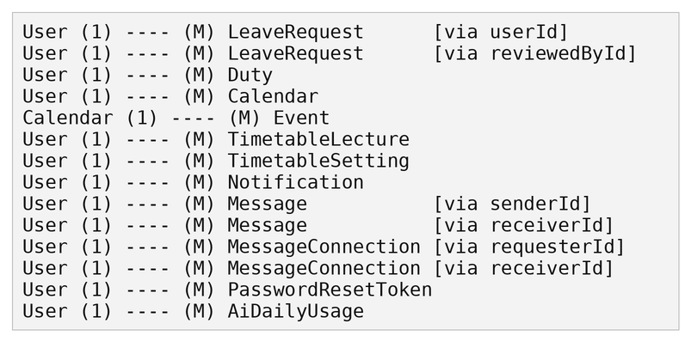

3.E Data Flow / System Flow
USER
(Teacher / Admin)
 |  |  |  |  |  | ▼
LOGIN
POST /api/auth/login
 |  |  |  |  |  |  |  |  |  | JWT issued + stored client-side
 |  |  |  |  |  | ▼
 |  |  |  |  |  | DASHBOARD
▼ |  |  | ▼ |  |  | ▼ |  |  | ▼ |  |  | ▼ |  |  | ▼ |  |  | ▼
TIMETABLE |  |  | DUTIES |  |  | LEAVES |  |  | CALENDAR |  |  | MESSAGING |  |  | AI ASSISTANT |  |  | PROFILE
 |  |  |  |  |  | ▼
EXPRESS ROUTE HANDLER
middleware/auth.ts verifies JWT + role
 |  |  |  |  |  | ▼
 |  |  |  |  |  | BUSINESS LOGIC / VALIDATION
 |  |  |  |  |  | ▼
PRISMA CLIENT
lib/prisma.ts
 |  |  |  |  |  | ▼
 |  |  |  |  |  | POSTGRESQL
 |  |  |  |  |  | ▼
 |  |  |  |  |  | JSON RESPONSE → UI UPDATE
 |  |  |  |  |  |  |  |  |  | (for messages/notifications)
 |  |  |  |  |  | ▼
SOCKET.IO BROADCAST
to recipient(s)

3.F Complete Architecture Overview

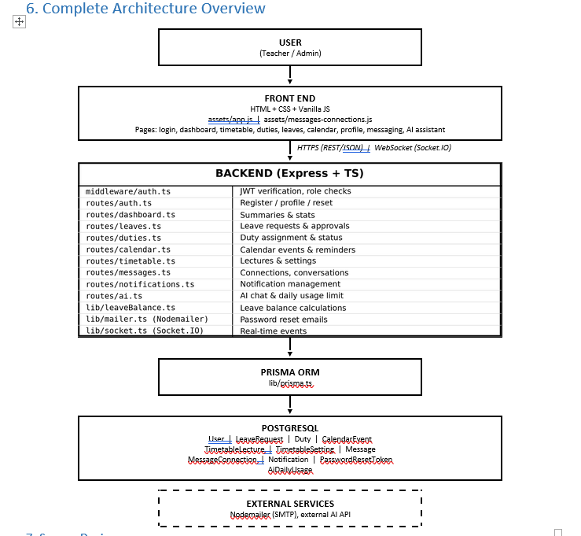

Chapter 6: Application Development

6.1 Development Overview
TeachTrack is implemented as a browser-based client and a TypeScript API. The client pages use HTML, CSS and JavaScript; the API is built with Express on Node.js. Prisma connects the API to PostgreSQL. This separation lets the browser handle presentation and interaction while the server enforces access rules, validates input and performs database operations. The completed interface pages and representative screenshots are documented in Chapter 10.

6.2 Frontend Implementation
The frontend is organised as separate HTML pages for login, registration, password reset, dashboard, timetable, duties, leaves, calendar, messages, AI assistance and profile settings. Shared scripts provide navigation, authenticated API requests and common interface behaviour. A signed-in page sends the stored JWT in the Authorization header. The server determines the user's identity and role from that token; the page does not decide which database records the user may access.
Timetable pages show a teacherâ€™s lectures in a weekly grid and use per-subject visual styling. The dashboard combines current personal data into a summary, while administrator-only controls are shown for leave review and duty assignment. The same API access rules protect these operations even if a client page is opened directly.
Figure 6.1 Dashboard interface (illustrative values; screenshot reused from Chapter 10)
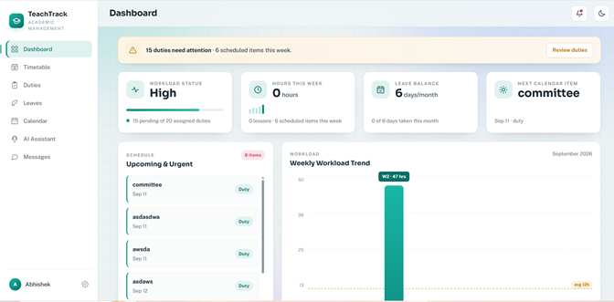

6.3 Backend and API Implementation
The API is started from backend/src/server.ts. The server configures CORS and JSON request parsing, mounts a separate Express router for each module, and creates an HTTP server shared with Socket.IO. Route handlers use Prisma for database access. A final error handler logs unexpected server errors and returns a generic response to the browser.
The route layout keeps module responsibilities separate: auth.ts handles accounts and profile operations; dashboard.ts builds personal summary data; timetable.ts manages lectures and planner settings; duties.ts manages assignments and status; leaves.ts handles requests and review; calendar.ts manages events; messages.ts handles connections and conversations; notifications.ts supports alerts; and ai.ts connects the assistant to the configured service.
A representative protected route validates request data before writing to the database. Timetable creation associates the new lecture with the authenticated user and returns a conflict response if a unique time slot already exists:
const parsed = lectureSchema.safeParse(request.body);
if (!parsed.success) {
return response.status(400).json({ message: "Please provide valid lecture details." });
}
try {
const lecture = await prisma.timetableLecture.create({
data: { ...parsed.data, userId: request.user!.id },
});
emitToUser(request.user!.id, "dashboard:updated", { source: "timetable" });
return response.status(201).json({ lecture });
} catch (error: unknown) {
if (typeof error === "object" && error !== null && "code" in error && error.code === "P2002") {
return response.status(409).json({ message: "A lecture already exists in that time slot." });
}
throw error;
}
This pattern is used across the application: obtain the authenticated user from middleware, validate incoming fields, scope the query to that user or enforce an administrator role, then return a clear status and JSON response. The exact route and response differ by module.

6.4 Authentication, Authorization and Validation
Registration and login requests are checked with Zod schemas. Passwords are hashed with bcrypt before storage. On successful login, the API issues a JWT containing the user identifier and role; protected routes use requireAuth middleware to verify the token. Administrator operations add a role check. Inactive accounts are denied access.
Password recovery uses a random one-time token. The database stores its SHA-256 hash and expiry time rather than the raw token. The reset endpoint checks that the token exists, has not expired and has not been used, then updates the password hash and consumes the token. The reset message is kept generic so the endpoint does not disclose whether an email address belongs to an account.
Validation covers both field format and application rules. Examples include valid email and password lengths, leave date and balance checks, timetable time format and scheduling conflicts, message limits, and role restrictions. The API returns suitable HTTP status codes such as 400 for invalid input, 401 for missing or invalid authentication, 403 for forbidden actions, 404 for unavailable records and 409 for uniqueness conflicts.

6.5 Database Integration
The Prisma schema defines the PostgreSQL data model. User records own or are related to timetable lectures and settings, duties, leave requests, calendar events, messages, notifications, password reset tokens and daily AI usage. Foreign keys and unique constraints protect relationships and prevent duplicate accounts or conflicting timetable slots. Prisma migrations apply schema changes, and the connection string is supplied through environment configuration rather than source code.
Operations that must remain consistent are grouped in database transactions. For example, password reset updates the password, marks the active token as used and removes other outstanding reset tokens together. Database errors for known uniqueness conflicts are translated into a readable 409 response.

6.6 Dashboard and Workload Calculation
The dashboard endpoint queries data for the signed-in user and returns summary values to the frontend. A teacherâ€™s dashboard is personal; an administratorâ€™s dashboard also uses the signed-in administratorâ€™s own personal records. Institution-wide assignments are reviewed on the administrator Duties page, not mixed into a personal workload card.
The Hours This Week card currently sets weeklyHours to the number of timetable lecture records returned for the signed-in user. Each saved lecture counts as one hour, regardless of its configured lecture duration. This is a count of scheduled timetable entries; the system does not measure attendance or actual time taught. The card does not add calendar-event or duty hours. It also reports the lecture count and the number of upcoming calendar items separately. As a result, two saved lectures produce 2 hours even if no lesson has yet been completed.
The Workload Status card is calculated from duties assigned to the signed-in user. The dashboard query excludes duties hidden from the teacher. A duty is counted as pending whenever its status is not COMPLETED, which includes both PENDING and IN_PROGRESS; the total is the number of visible duties assigned to that user. The interface labels the status Clear when pending is zero, Active for one to five pending duties, and High for more than five. The progress bar is pending duties divided by total assigned duties. An unassigned duty or another teacherâ€™s assignment does not belong in this personal summary.
The Weekly Workload Trend chart uses a separate estimate: each dated duty due during a week contributes four estimated hours, calendar events contribute their overlapping duration (or one hour when no valid end time is saved), and the current week includes the count of saved lectures. These values are added and rounded to one decimal place. The estimate shown in this chart is not the same calculation as the Hours This Week card.
Leave balance is computed from the signed-in userâ€™s approved leave records for the current month against the configured monthly allowance. Pending or rejected requests do not consume approved days. Calendar previews similarly use the current userâ€™s events and upcoming dated duties.

6.7 Timetable Implementation
The timetable API supports creating, listing, editing and deleting a teacherâ€™s own lecture entries, plus saving planner settings for each day. A lecture includes subject, class, room, day, time and type. Zod validates these fields; ownership checks ensure a user cannot edit another userâ€™s lecture. Database uniqueness rules reject a conflicting lecture slot. Successful timetable changes emit a dashboard:updated event so summary views can refresh.
Figure 6.2 Timetable interface (screenshot reused from Chapter 10)

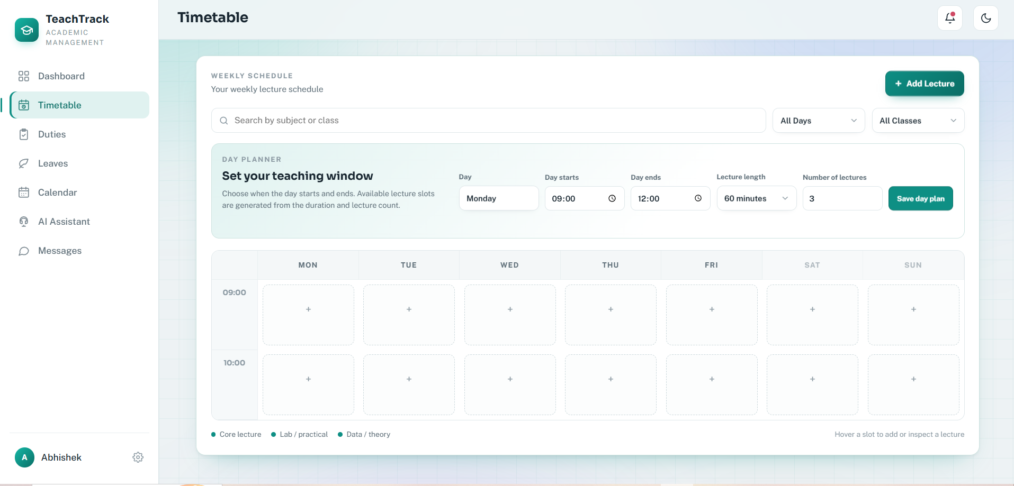

6.8 Real-Time Updates and External Services
Socket.IO is attached to the same HTTP server as Express. A socket connection must present a valid JWT; the server verifies the token and active account, then joins the connection to a room for that user. Module routes emit user-scoped events after relevant changes, allowing the interface to refresh notifications or dashboard data without a full page reload.
Nodemailer sends password-reset email through SMTP configuration. The AI Assistant sends requests to the configured Groq service and applies per-user usage limits. These external services depend on environment configuration. If an external service is unavailable, the API returns a controlled error rather than exposing internal credentials or stack details.

6.9 Implementation Summary
The application is implemented as connected but separate frontend, API and database layers. Authentication identifies the user, module routes validate and process requests, Prisma persists records, and Socket.IO communicates selected updates. The Dashboard, Timetable and other interface examples in Chapter 10 show the resulting application screens; the source modules in backend/src/routes and backend/src/server.ts provide the corresponding server implementation.

Chapter 7: Integration & System Testing

Part 1: Black-box Testing
Test Case ID | Test Case Description | Test Category | Test Steps | Test Data | Expected Result | Actual Result | Status
TS-01 | Register a new teacher account | Authentication | Open Register; enter valid name, email, password; submit. | Unique email, valid password | Account is created with role TEACHER and is immediately active; user is redirected to the Dashboard. | As expected. | Pass
TS-02 | Register a new admin account | Authentication | Open Register; select role Admin; submit valid details. | Unique email, role =  ADMIN | Account is created with  role ADMIN and  redirected to the Dashboard. | As expected. | Pass
TS-05 | Log in with valid credentials | Authentication | Open Login; enter correct email/password; submit. | Active account, correct password | Session is created, a JWT is issued, and the user is redirected to the Dashboard. | As expected. | Pass
TS-10 | Log out | Authentication | Sign in; choose Logout; revisit a protected page. | Authenticated session | Session ends; the protected page redirects to login. | As expected. | Pass
TS-11 | View profile | Profile | Sign in; open the Profile page. | Authenticated user | Profile page shows current name, email, and role. | As expected. | Pass
TS-12 | Update profile details | Profile | Change name; save. | New name | Changes persist and a success message is displayed. | As expected. | Pass
TS-13 | Change password with  correct current password | Profile | Enter correct current password and a valid new password; save. | Valid current/new password | Password updates; user remains authenticated; new password works on next login. | As expected. | Pass
TS-20 | Add a lecture | Timetable | Open Timetable; add a lecture with day, time, subject, class, room; save. | Valid  day/time/subject/class/r  oom | Lecture is saved and appears on the timetable grid. | As expected. | Pass
TS-24 | Update a lecture | Timetable | Edit an existing lecture's subject/room; save. | Existing lecture record | Lecture is updated; the grid reflects the new values. | As expected. | Pass
TS-25 | Delete a lecture | Timetable | Remove a lecture from the grid. | Existing lecture | Lecture no longer appears on the timetable. | As expected. | Pass
TS-26 | Configure per-day planner settings | Timetable | Set start/end time and lecture count for a weekday. | Valid start/end time, lecture count | Setting is saved; unique per user and day. | As expected. | Pass
TS-28 | Apply for leave with valid dates | Leave | Open Leave; submit start date, end date, and reason. | Valid future date range | Request is stored with status PENDING; admin is notified. | As expected. | Pass
TS-33 | Admin approves a leave request | Leave | As Admin, open  Leaves; approve a PENDING request with a note. | Pending request | Status becomes  APPROVED; balance is deducted; teacher is notified. | As expected. | Pass
TS-34 | Admin rejects a leave request | Leave | As Admin, reject a PENDING request with a note. | Pending request | Status becomes  REJECTED; balance is unchanged; teacher is notified. | As expected. | Pass
TS-35 | Teacher views own leave balance and history | Leave | Sign in as Teacher; open Leaves. | Existing leave records | Balance and request history for the signed-in teacher are shown. | As expected. | Pass
TS-38 | Admin assigns a duty to an active teacher | Duty | As Admin, assign category, due date, and description to an active teacher. | Active teacher, future due date | Duty is saved with status PENDING; teacher is notified. | As expected. | Pass
TS-41 | Teacher updates duty status to In Progress | Duty | Sign in as the assigned teacher; change status to IN_PROGRESS. | Assigned PENDING duty | Status updates; dashboard workload refreshes. | As expected. | Pass
TS-42 | Teacher marks a duty Completed | Duty | Change an assigned  duty's status to  COMPLETED. | In-progress duty | Status updates to  COMPLETED;  workload stats refresh. | As expected. | Pass
TS-44 | Teacher hides a completed duty from own history | Duty | Hide a COMPLETED  duty from the teacher's own list. | Completed duty | Duty is hidden from the teacher's view; still visible to Admin. | As expected. | Pass
TS-45 | Admin deletes a duty | Duty | As Admin, delete an existing duty record. | Existing duty | Duty is removed and no longer listed. | As expected. | Pass
TS-46 | Create a calendar event | Calendar | Add a reminder/meeting/exam with date/time and description; save. | Valid date/time | Event is saved and appears on the calendar. | As expected. | Pass
TS-48 | Update a calendar event | Calendar | Edit an existing event's date/description; save. | Existing event | Event is updated on the calendar. | As expected. | Pass
TS-49 | Delete a calendar event | Calendar | Remove an event from the calendar. | Existing event | Event no longer appears. | As expected. | Pass
TS-50 | Filter events by month | Calendar | Navigate to a specific month view. | Events across months | Only events for the selected month are shown. | As expected. | Pass
TS-51 | Paginate a long event  list | Calendar | Create more events than one page holds; open the calendar list. | 20+ events | Events are paginated; navigation controls work correctly. | As expected. | Pass
TS-52 | Send a connection request | Messaging | As Teacher A, search for Teacher B; send a connection request. | Two teacher accounts | Request is stored as  PENDING; Teacher B is notified. | As expected. | Pass
TS-53 | Accept a connection request | Messaging | As Teacher B, accept Teacher A's pending request. | Pending request | Status becomes  ACCEPTED; both are notified in real time. | As expected. | Pass
TS-54 | Reject a connection request | Messaging | As Teacher B, reject the pending request. | Pending request | Status becomes  REJECTED; requester is notified. | As expected. | Pass
TS-56 | Send a message after connection is accepted | Messaging | After acceptance, send a text message. | Accepted connection, valid text | Message is delivered in real time; unread count increments for the recipient. | As expected. | Pass
TS-57 | Admin messages any teacher directly | Messaging | As Admin, message a teacher with no prior connection request. | Admin sender | Message is delivered without requiring a connection request. | As expected. | Pass
TS-59 | Mark a conversation as read | Messaging | Open a conversation with unread messages. | Unread messages present | Messages are marked read; unread badge count decreases. | As expected. | Pass
TS-61 | Mark a single notification as read | Notifications | Open notifications; mark one as read. | Unread notification | Notification's read state updates; badge count decreases. | As expected. | Pass
TS-62 | Mark all notifications as read | Notifications | Use the “mark all read” action. | Multiple unread notifications | All notifications become read; badge clears. | As expected. | Pass
TS-63 | Delete a notification | Notifications | Dismiss a single notification from the list. | Existing notification | Notification is removed from the list. | As expected. | Pass
TS-82 | Persist dark mode preference | User Interface | Toggle dark mode; reload the app. | Browser localStorage enabled | Dark theme persists across reload and across pages. | As expected. | Pass
TS-83 | Responsive layout on common breakpoints | Responsive UI | Open key pages at desktop, tablet, and mobile widths. | ~1440px, 768px, 375px | Navigation, tables, and forms remain usable at all widths. | As expected. | Pass

Part 2: Integration Testing
Test Case ID | Test Case Description | Test Category | Test Steps | Test Data | Expected Result | Actual Result | Status
TS-16 | Request a password reset | Password Reset | Submit the forgotpassword form with a registered email. | Registered email | A reset email is sent with a one-hour link; a uniform confirmation is shown regardless of whether the email exists. | As expected. | Pass
TS-17 | Reset password with a valid token | Password Reset | Open the reset link within one hour; submit a new password. | Valid, unexpired token | Password is updated; the token is marked used; user can log in with the new password. | As expected. | Pass
TS-27 | Recompute weekly workload after a change | Timetable | Add or remove a lecture; open the Dashboard. | Updated timetable | Weekly teaching load on the dashboard reflects the new lecture count. | As expected. | Pass
TS-60 | Receive a notification on leave submission | Notifications | Teacher submits a leave request. | New leave request | Admin receives a realtime “leave” notification. | As expected. | Pass
TS-64 | Ask the AI assistant a grounded question | AI Assistant | Sign in; ask about upcoming duties or leave balance. | Logged-in user with data | Reply reflects the user's own  timetable/leave/duty data. | As expected. | Pass
TS-69 | Fall back safely when the AI provider is unavailable | AI Resilience | Trigger a chat request with the AI provider unreachable. | Provider failure / missing key | A safe fallback/error message is shown; no unhandled error occurs. | As expected. | Pass
TS-70 | Show current workload summary | Dashboard | Sign in; open the Dashboard. | Existing  timetable/leave/duty data | Summary cards show weekly lesson count, leave balance, duty breakdown, and message preview. | As expected. | Pass
TS-71 | Reflect a new lecture immediately | Dashboard | Add a lecture; reopen the Dashboard. | New lecture record | Weekly teaching load count increases accordingly. | As expected. | Pass
TS-72 | Reflect an approved leave in balance | Dashboard | Approve a pending leave request; reopen the Dashboard. | Newly approved leave | Remaining leave balance decreases by the approved days. | As expected. | Pass
TS-73 | Show duty-type breakdown | Dashboard | Assign duties across multiple categories; open the Dashboard. | Duties in 2+ categories | Duty breakdown chart reflects counts per category. | As expected. | Pass
TS-79 | Authenticate a socket connection | Real-time Sync | Connect to Socket.IO with a valid JWT. | Valid JWT | Connection succeeds; the client joins its private user room. | As expected. | Pass
TS-81 | Deliver a live update to the correct room only | Real-time Sync | Trigger a duty update for Teacher A while Teacher B is also connected. | Two connected clients | Only Teacher A's client receives the duty:updated event. | As expected. | Pass

Chapter 8: Deployment
Cloud Deployment (Render):
TeachTrack is deployed on Render, a cloud hosting platform, as a client-server web application. The backend API (Express.js with TypeScript) and the frontend pages are hosted together as a web service, and the application is connected to a PostgreSQL database that is accessed through Prisma. Once deployed, the system can be used from any modern web browser without installing anything on the user's device.
• Platform: Render (cloud hosting) — the service is built and started from the project's GitHub repository.
• Database: PostgreSQL, connected to the backend through a connection string that is supplied as an environment variable.
• Secure access: The deployed application is accessed over HTTPS.
• Live application link: https://teachtrack-mepk.onrender.com
Deployment Steps:
1. Push the latest version of the source code to the GitHub repository.
2. Create a web service on Render and connect it to the GitHub repository.
3. Set the required environment variables in the Render dashboard (see Server Configuration below).
4. Install the dependencies and build the TypeScript backend.
5. Generate the Prisma client and run the database migrations so that all tables are created in PostgreSQL.
6. Start the server and open the deployed link in the browser.
7. Verify the deployment by checking the health endpoint, which reports database connectivity and the number of registered users, and then testing the Login page.
When a new version is ready, the changes are pushed to GitHub and the service is redeployed on Render.
Local Hosting:
The application can also be run on a local machine for development and testing, using the same code base as the deployed version.
• Requirements: Node.js (latest LTS), a local PostgreSQL installation, VS Code (or any code editor) and a modern web browser.
• Setup: Clone the repository, install the dependencies, create a .env file with the required values, run the Prisma migrations and start the server.
• Access: The application is opened in the browser on the local address (localhost) and port on which the server is running.
APK Build:
TeachTrack is a web application that is accessed through a browser (Chrome, Edge or Firefox) on desktop and mobile devices. No Android application (APK) was built for this version, so this step is not applicable to the project. A companion mobile app is listed as a future enhancement in Chapter 1.
Server Configuration:
The server needs the following configuration to run correctly. All values are stored as environment variables (managed with dotenv locally and in the Render dashboard on the cloud), so no secret is written into the source code.
• Runtime: Node.js (latest LTS) with the TypeScript backend built before starting.
• Database: The PostgreSQL connection string used by Prisma.
• Authentication: The secret key used to sign and verify JWTs.
• Email: SMTP settings used by Nodemailer for the password-reset email.
• AI Assistant: A valid Groq API key, which is required for the AI Assistant module.
• Port: The port on which the Express.js server listens.
Version Control using GitHub:
The complete project is maintained in a GitHub repository, which is used for version control and is also the source from which the application is deployed on Render.
• Repository: https://github.com/Abhishek-glitch-hue/teachtrack.git
• Contents: Backend and frontend source code, the Prisma schema and migrations, and the project files needed to run the application.
• Commits: Work is committed regularly as each module is completed, in line with the Agile approach described in Chapter 3, so the history shows how the project developed.
• Security: Files containing secrets, such as .env, are kept out of the repository.
• Deployment link: Render is connected to the repository, so the deployed version always comes from the code stored on GitHub.

Chapter 9: Performance & Security Testing

Part 1: Input Validation Checks
Test Case ID | Test Case Description | Test Category | Test Steps | Test Data | Expected Result | Actual Result | Status
TS-03 | Reject a duplicate email | Authentication | Register using an email already in use. | Existing email | Registration is rejected with an “Email already in use” message. | As expected. | Pass
TS-04 | Reject an invalid password | Authentication | Submit registration with a password that fails validation rules. | Invalid password | Form error is shown; no account is created. | As expected. | Pass
TS-06 | Reject unknown email at login | Authentication | Submit login with an unregistered email. | Nonexistent email | Login is denied with an “Invalid email or password” message. | As expected. | Pass
TS-07 | Reject incorrect password | Authentication | Submit login with a valid email and wrong password. | Wrong password | Login is denied with an “Invalid email or password” message. | As expected. | Pass
TS-14 | Reject incorrect current password | Profile | Submit a password change with the wrong current password. | Wrong current password | Password is unchanged and an error message appears. | As expected. | Pass
TS-15 | Reject mismatched new passwords | Profile | Enter different new and confirmation passwords. | Mismatched passwords | Change is rejected; validation message appears. | As expected. | Pass
TS-21 | Reject missing required fields | Timetable | Submit a lecture with a required field left blank. | Blank subject/room | Form error is shown; nothing is saved. | As expected. | Pass
TS-22 | Reject an invalid time range | Timetable | Submit a lecture where the end time is before the start time. | End time < start time | Rejected with an “Invalid time range” message. | As expected. | Pass
TS-23 | Reject a clashing lecture slot | Timetable | Add a second lecture at the same day/time already used by this user. | Duplicate day/time | Rejected with a “Slot already occupied” message. | As expected. | Pass
TS-29 | Reject leave dates in the past | Leave | Submit a leave request with a start date before today. | Past date | Rejected with a validation error. | As expected. | Pass
TS-30 | Reject end date before start date | Leave | Submit a request where the end date is earlier than the start date. | End date < start date | Rejected with a validation error. | As expected. | Pass
TS-31 | Reject a request exceeding balance | Leave | Apply for more days than the teacher's remaining balance. | Requested days > balance | Rejected with an “Insufficient leave balance” message. | As expected. | Pass
TS-32 | Reject an overlapping leave request | Leave | Submit a request overlapping an existing  PENDING/APPROVE  D request. | Overlapping dates | Rejected as a duplicate/overlapping request. | As expected. | Pass
TS-39 | Reject assignment to an inactive teacher | Duty | Attempt to assign a duty to a deactivated teacher account. | Inactive teacher | Rejected with a  “Teacher is inactive” message. | As expected. | Pass
TS-40 | Reject a due date in the past | Duty | Submit a duty with a due date before today. | Past due date | Rejected with a validation error. | As expected. | Pass
TS-47 | Reject an end time before the start time | Calendar | Submit an event with an end time earlier than the start time. | End time < start time | Rejected with a form error. | As expected. | Pass
TS-58 | Reject an empty or oversized message | Messaging | Submit a blank message, then one exceeding the maximum length. | Empty text; overlong text | Both submissions are rejected with a validation error. | As expected. | Pass
TS-65 | Reject an over-length message | AI Assistant | Submit a chat message over 2,000 characters. | Message > 2,000 characters | Rejected with a “Message too long” response. | As expected. | Pass
TS-78 | Reject oversized request bodies | Security | Submit a request body larger than 1 MB. | >1MB payload | Request is rejected by the server. | As expected. | Pass

Part 2: Security Validation
Test Case ID | Test Case Description | Test Category | Test Steps | Test Data | Expected Result | Actual Result | Status
TS-08 | Block login for an inactive account | Authentication | Attempt login with a deactivated account. | Inactive account | Login is denied with an “Account inactive” message. | As expected. | Pass
TS-09 | Reject an expired JWT | Authentication | Use a token issued more than seven days ago on a protected route. | Expired JWT | Request is rejected with 401; the user must log in again. | As expected. | Pass
TS-18 | Reject an expired reset token | Password Reset | Open the reset link more than one hour after issue; submit a new password. | Expired token | Reset is rejected with a  “Link expired” message. | As expected. | Pass
TS-19 | Reject a reused reset token | Password Reset | Use a reset link a second time after it has already been used. | Already-used token | Reset is rejected; the token cannot be reused. | As expected. | Pass
TS-36 | Block a teacher from viewing another teacher's leave | Authorization | As Teacher A, attempt to access Teacher B's leave records via the API. | Foreign teacher ID | Access is denied/not found. | As expected. | Pass
TS-37 | Block a non-admin from approving leave | Authorization | As Teacher, call the approve-leave endpoint directly. | Teacher-role token | Request is rejected with 403 Forbidden. | As expected. | Pass
TS-43 | Block a status change by a non-assignee | Authorization | As a different teacher, attempt to change another teacher's duty status. | Foreign duty ID | Request is denied. | As expected. | Pass
TS-55 | Block messaging without an accepted connection | Messaging | As Teacher A, attempt to message Teacher B before the connection is accepted. | No ACCEPTED  connection | Message is blocked with “Cannot message  this user.” | As expected. | Pass
TS-66 | Enforce the daily request quota | AI Assistant | Send 31 requests within the same UTC day. | 31st request in one  UTC day | The 31st request is rejected with a “Daily limit reached” message. | As expected. | Pass
TS-67 | Reset the quota at the  UTC day boundary | AI Assistant | Exhaust the daily quota; wait until the next UTC day; send a new request. | New UTC day | Request succeeds; the counter has reset. | As expected. | Pass
TS-68 | Keep AI context scoped to the requesting user | AI Assistant | As Teacher A, ask about “my duties” and verify no Teacher B data appears. | Two teachers' data | Response includes only Teacher A's own data. | As expected. | Pass
TS-74 | Isolate dashboard data per user | Dashboard | Sign in as Teacher A and Teacher B; compare dashboards. | Two teacher accounts | Each dashboard shows only that teacher's own data. | As expected. | Pass
TS-75 | Require authentication for protected routes | Security | Request a protected page/API while signed out. | No token | Request is redirected to login, or returns 401. | As expected. | Pass
TS-76 | Enforce admin-only routes | Security | As a Teacher, call an admin-only endpoint (e.g., assign duty). | Teacher-role token | Request is rejected with 403 Forbidden. | As expected. | Pass
TS-77 | Reject a tampered or invalid JWT | Security | Send a request with a malformed/altered token. | Invalid JWT | Request is rejected with 401. | As expected. | Pass
TS-80 | Reject an  unauthenticated socket connection | Real-time Sync | Attempt to connect without a token. | No token | Connection is refused. | As expected. | Pass

Chapter 10: Final Documentation

Login page

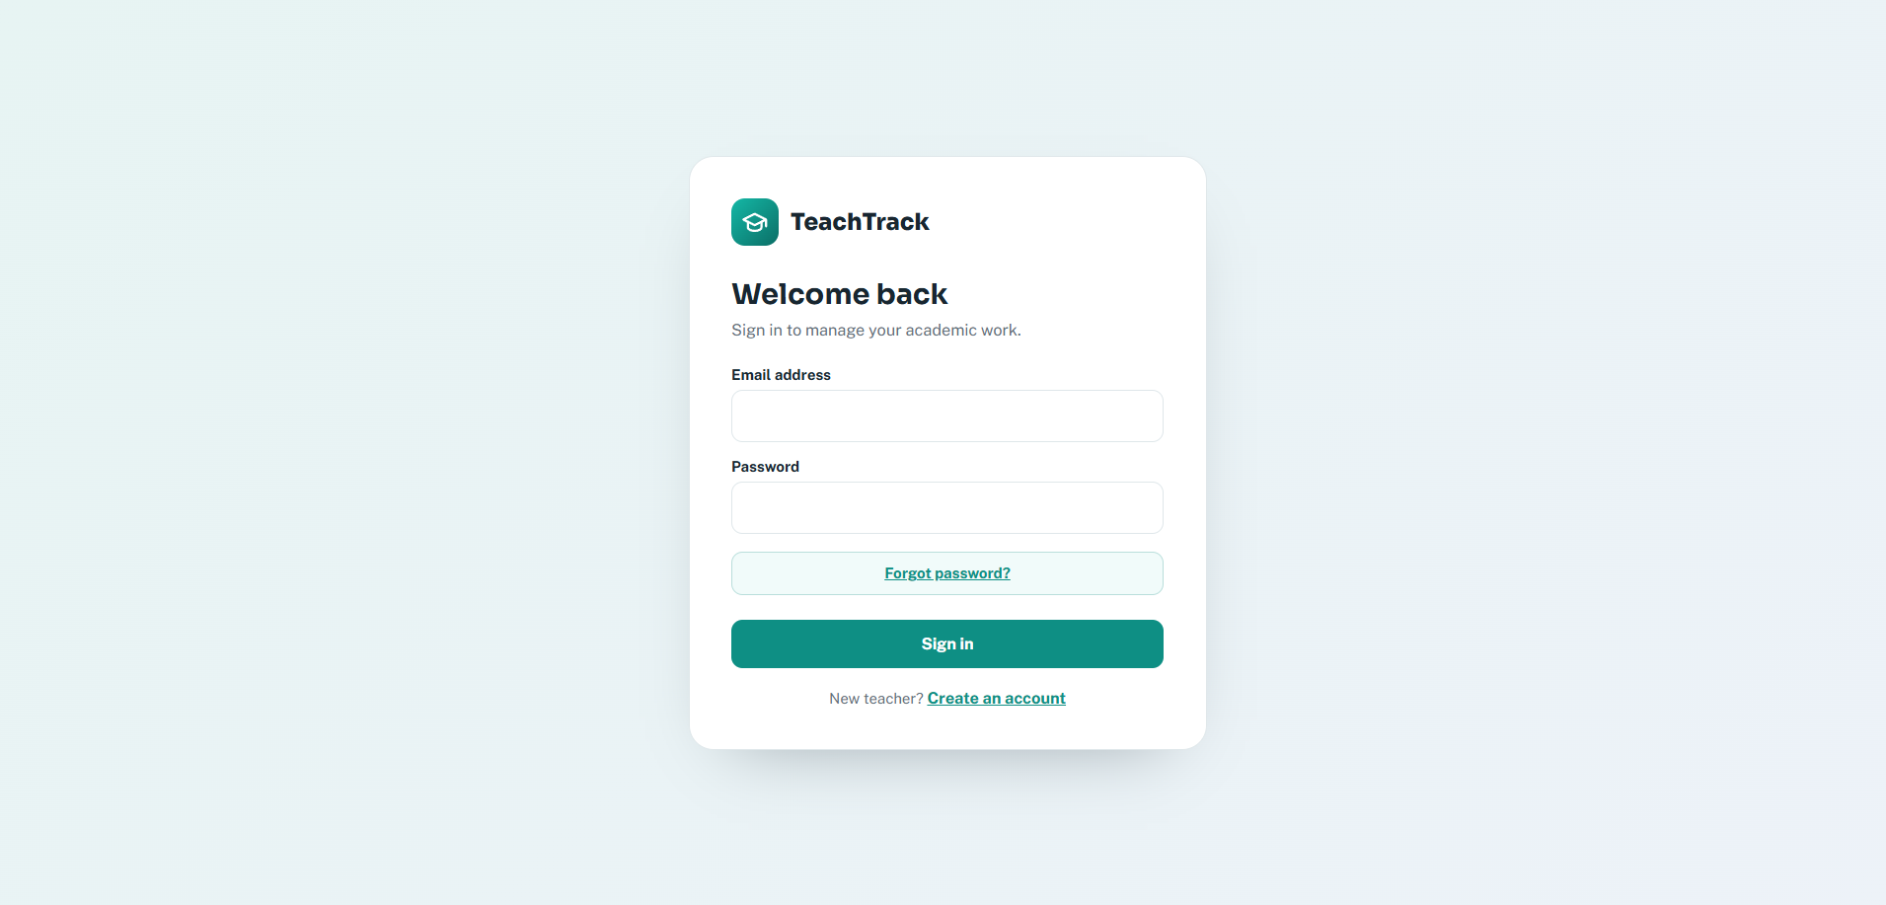

Register page

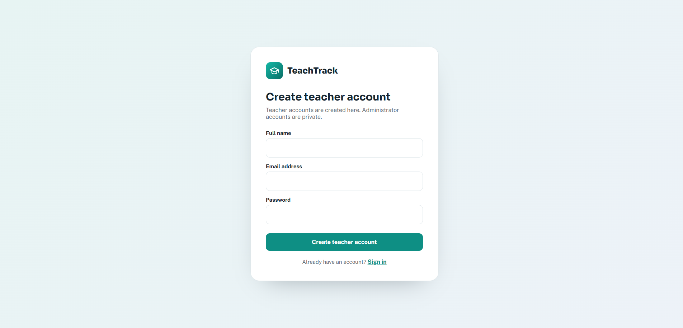

Code:
import { Router } from "express";
import bcrypt from "bcryptjs";
import jwt from "jsonwebtoken";
import { createHash, randomBytes } from "node:crypto";
import { z } from "zod";
import { prisma } from "../lib/prisma.ts";
import { requireAuth } from "../middleware/auth.ts";
import { sendPasswordResetEmail } from "../lib/mailer.ts";

const authRouter = Router();

const registerSchema = z.object({
name: z.string().trim().min(2).max(80),
email: z.string().trim().email().max(120),
password: z.string().min(8).max(72),
});

const loginSchema = z.object({
email: z.string().trim().email(),
password: z.string().min(1),
});

const forgotPasswordSchema = z.object({
email: z.string().trim().email().max(120),
});

const resetPasswordSchema = z.object({
token: z.string().min(32).max(200),
password: z.string().min(8).max(72),
});

const updateProfileSchema = z.object({
name: z.string().trim().min(2).max(80),
email: z.string().trim().email().max(120),
department: z.string().trim().max(80).optional(),
phone: z.string().trim().max(30).optional(),
campus: z.string().trim().max(80).optional(),
currentPassword: z.preprocess((value) => value === "" ? undefined : value, z.string().max(72).optional()),
newPassword: z.preprocess((value) => value === "" ? undefined : value, z.string().min(8).max(72).optional()),
});

function createToken(user: { id: string; role: "TEACHER" | "ADMIN" }) {
const secret = process.env.JWT_SECRET;

if (!secret) {
throw new Error("JWT_SECRET is missing from .env");
}

return jwt.sign(
{ sub: user.id, role: user.role },
secret,
{ expiresIn: "7d" },
);
}

function publicUser(user: {
id: string;
name: string;
email: string;
role: "TEACHER" | "ADMIN";
department?: string | null;
phone?: string | null;
campus?: string | null;
createdAt?: Date;
lastLoginAt?: Date | null;
}) {
return {
id: user.id,
name: user.name,
email: user.email,
role: user.role,
department: user.department ?? null,
phone: user.phone ?? null,
campus: user.campus ?? null,
createdAt: user.createdAt ?? null,
lastLoginAt: user.lastLoginAt ?? null,
};
}

authRouter.post("/register", async (request, response) => {
const parsed = registerSchema.safeParse(request.body);

if (!parsed.success) {
return response.status(400).json({
message: "Please provide a valid name, email, and password of at least 8 characters.",
});
}

const { name, password } = parsed.data;
const email = parsed.data.email.toLowerCase();

const existingUser = await prisma.user.findUnique({
where: { email },
});

if (existingUser) {
return response.status(409).json({
message: "An account already exists with this email.",
});
}

const passwordHash = await bcrypt.hash(password, 12);

const user = await prisma.user.create({
data: {
name,
email,
passwordHash,
role: "TEACHER",
},
});

const signedInUser = await prisma.user.update({
where: { id: user.id },
data: { lastLoginAt: new Date() },
});

const token = createToken(signedInUser);

return response.status(201).json({
token,
user: publicUser(signedInUser),
});
});

authRouter.post("/login", async (request, response) => {
const parsed = loginSchema.safeParse(request.body);

if (!parsed.success) {
return response.status(400).json({
message: "Email and password are required.",
});
}

const email = parsed.data.email.toLowerCase();

const user = await prisma.user.findUnique({
where: { email },
});

if (!user || !(await bcrypt.compare(parsed.data.password, user.passwordHash))) {
return response.status(401).json({
message: "Invalid email or password.",
});
}

if (!user.isActive) {
return response.status(403).json({
message: "This account is inactive. Contact an administrator.",
});
}

const signedInUser = await prisma.user.update({
where: { id: user.id },
data: { lastLoginAt: new Date() },
});

const token = createToken(signedInUser);

return response.json({
token,
user: publicUser(signedInUser),
});
});

authRouter.post("/forgot-password", async (request, response) => {
const parsed = forgotPasswordSchema.safeParse(request.body);
if (!parsed.success) return response.status(400).json({ message: "Enter a valid email address." });

const user = await prisma.user.findUnique({
where: { email: parsed.data.email.toLowerCase() },
select: { id: true, email: true, isActive: true },
});

// Keep this response identical for every valid address to avoid exposing account membership.
const success = { message: "If an active account uses that email address, a password reset link has been sent." };
if (!user || !user.isActive) return response.json(success);

const token = randomBytes(32).toString("hex");
const tokenHash = createHash("sha256").update(token).digest("hex");
const expiresAt = new Date(Date.now() + 60 * 60 * 1000);

await prisma.$transaction([
prisma.passwordResetToken.deleteMany({ where: { userId: user.id } }),
prisma.passwordResetToken.create({ data: { userId: user.id, tokenHash, expiresAt } }),
]);

const frontendUrl = process.env.FRONTEND_URL ?? "http://127.0.0.1:5500";
const resetUrl = new URL("reset-password.html", frontendUrl.endsWith("/") ? frontendUrl : `${frontendUrl}/`);
resetUrl.searchParams.set("token", token);

try {
await sendPasswordResetEmail(user.email, resetUrl.toString());
} catch (error) {
await prisma.passwordResetToken.deleteMany({ where: { tokenHash } });
console.error("Password-reset email could not be sent:", error);
return response.status(503).json({ message: "Password reset email is temporarily unavailable. Please try again later." });
}

return response.json(success);
});

authRouter.post("/reset-password", async (request, response) => {
const parsed = resetPasswordSchema.safeParse(request.body);
if (!parsed.success) return response.status(400).json({ message: "Use a valid reset link and a password of at least 8 characters." });

const tokenHash = createHash("sha256").update(parsed.data.token).digest("hex");
const resetToken = await prisma.passwordResetToken.findUnique({ where: { tokenHash } });
if (!resetToken || resetToken.usedAt || resetToken.expiresAt <= new Date()) {
return response.status(400).json({ message: "This reset link is invalid or has expired. Request a new one." });
}

const passwordHash = await bcrypt.hash(parsed.data.password, 12);
await prisma.$transaction([
prisma.user.update({ where: { id: resetToken.userId }, data: { passwordHash } }),
prisma.passwordResetToken.update({ where: { id: resetToken.id }, data: { usedAt: new Date() } }),
prisma.passwordResetToken.deleteMany({ where: { userId: resetToken.userId, id: { not: resetToken.id } } }),
]);

return response.json({ message: "Your password has been reset. You can now sign in." });
});

authRouter.get("/me", requireAuth, (request, response) => {
response.json({
user: publicUser(request.user!),
});
});

authRouter.patch("/me", requireAuth, async (request, response) => {
const parsed = updateProfileSchema.safeParse(request.body);
if (!parsed.success) return response.status(400).json({ message: "Please provide valid profile details." });

const data = parsed.data;
if (data.newPassword && !data.currentPassword) {
return response.status(400).json({ message: "Enter your current password to set a new password." });
}
if (data.newPassword && !(await bcrypt.compare(data.currentPassword!, (await prisma.user.findUniqueOrThrow({ where: { id: request.user!.id } })).passwordHash))) {
return response.status(400).json({ message: "Your current password is incorrect." });
}

try {
const user = await prisma.user.update({
where: { id: request.user!.id },
data: {
name: data.name,
email: data.email.toLowerCase(),
department: data.department || null,
phone: data.phone || null,
campus: data.campus || null,
...(data.newPassword ? { passwordHash: await bcrypt.hash(data.newPassword, 12) } : {}),
},
});
return response.json({ user: publicUser(user) });
} catch (error: unknown) {
if (typeof error === "object" && error !== null && "code" in error && error.code === "P2002") {
return response.status(409).json({ message: "An account already uses that email address." });
}
throw error;
}
});

export default authRouter;

Dashboard Screen
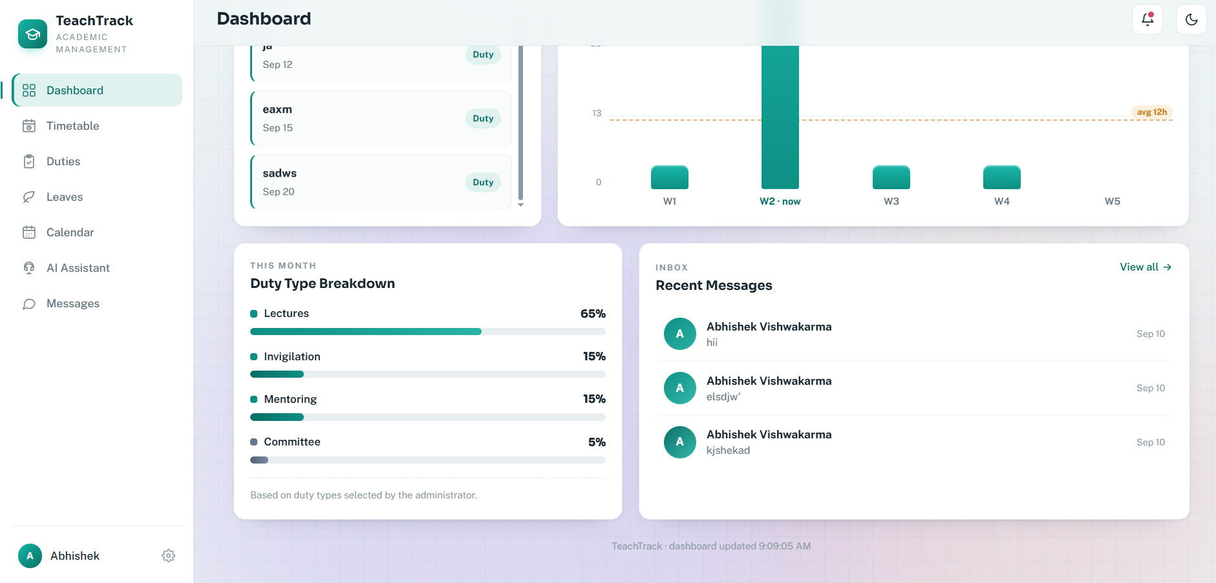
Code:

import { Router } from "express";
import { prisma } from "../lib/prisma.ts";
import { uniqueLeaveDaysInCurrentMonth, MONTHLY_LEAVE_ALLOWANCE } from "../lib/leaveBalance.ts";
import { requireAuth } from "../middleware/auth.ts";

const dashboardRouter = Router();

const DEFAULT_CALENDAR_ITEM_HOURS = 1;
const DUTY_ESTIMATED_HOURS = 4;

function calendarHoursInWeek(
event: { startsAt: Date; endsAt: Date | null },
weekStart: Date,
weekEnd: Date,
) {
const eventStart = event.startsAt;
// Calendar entries without an end time represent one scheduled hour. This
// makes time-only lecture entries count while keeping all-day events useful.
const eventEnd = event.endsAt && event.endsAt > eventStart
? event.endsAt
: new Date(eventStart.getTime() + DEFAULT_CALENDAR_ITEM_HOURS * 60 * 60 * 1000);
const overlapStart = Math.max(eventStart.getTime(), weekStart.getTime());
const overlapEnd = Math.min(eventEnd.getTime(), weekEnd.getTime());

return overlapEnd > overlapStart
? (overlapEnd - overlapStart) / (60 * 60 * 1000)
: 0;
}

function roundHours(hours: number) {
return Math.round(hours * 10) / 10;
}

function startOfCalendarWeek(date: Date) {
const start = new Date(date);
start.setDate(start.getDate() - start.getDay());
start.setHours(0, 0, 0, 0);
return start;
}

dashboardRouter.get("/", requireAuth, async (request, response) => {
const userId = request.user!.id;
const now = new Date();
const weekStart = new Date(now);
weekStart.setDate(now.getDate() - now.getDay());
weekStart.setHours(0, 0, 0, 0);
const weekEnd = new Date(now);
weekEnd.setDate(now.getDate() + (6 - now.getDay()));
weekEnd.setHours(23, 59, 59, 999);
const dutyWhere = request.user!.role === "ADMIN" ? {} : { assignedToId: userId };
// A leave balance always belongs to the signed-in user. Administrators can
// still review all requests on the Leaves page, but their dashboard must not
// combine every teacher's allowance into one number.
const leaveWhere = { teacherId: userId };

const [duties, events, leaves, conversations, lectures] = await Promise.all([
prisma.duty.findMany({ where: dutyWhere, include: { assignedTo: { select: { id: true, name: true } } }, orderBy: { dueAt: "asc" }, take: 100 }),
prisma.calendarEvent.findMany({ where: { userId }, orderBy: { startsAt: "asc" }, take: 100 }),
prisma.leaveRequest.findMany({ where: leaveWhere, orderBy: { createdAt: "desc" }, take: 100 }),
prisma.message.findMany({ where: { OR: [{ senderId: userId }, { receiverId: userId }] }, include: { sender: { select: { id: true, name: true } }, receiver: { select: { id: true, name: true } } }, orderBy: { createdAt: "desc" }, take: 6 }),
prisma.timetableLecture.findMany({ where: { userId }, orderBy: [{ day: "asc" }, { time: "asc" }] }),
]);

const approvedLeaveDays = leaves.filter((leave) => leave.status === "APPROVED").reduce((total, leave) => total + Math.max(1, Math.ceil((leave.endDate.getTime() - leave.startDate.getTime()) / 86400000) + 1), 0);
const leaveDaysUsedThisMonth = uniqueLeaveDaysInCurrentMonth(
leaves.filter((leave) => leave.status === "APPROVED"),
now,
);
const upcoming = [
// The dashboard list is date-based; undated duties remain available on
// the Duties page but are not considered upcoming.
...duties
.filter((duty) => duty.status !== "COMPLETED" && duty.dueAt && duty.dueAt >= now)
.map((duty) => ({
kind: "duty" as const,
title: duty.title,
date: duty.dueAt,
status: duty.status,
assignedTo: duty.assignedTo,
isUrgent: false,
})),
...events.filter((event) => event.startsAt >= now).map((event) => ({ kind: "event", title: event.title, date: event.startsAt, status: event.type, assignedTo: null })),
].sort((a, b) => {
const priorityA = "isUrgent" in a && a.isUrgent ? 0 : a.date ? 1 : 2;
const priorityB = "isUrgent" in b && b.isUrgent ? 0 : b.date ? 1 : 2;
if (priorityA !== priorityB) return priorityA - priorityB;
return (a.date?.getTime() ?? Number.MAX_SAFE_INTEGER) - (b.date?.getTime() ?? Number.MAX_SAFE_INTEGER);
});

// The trend follows the same Sunday-to-Saturday rows shown by Calendar for
// the current month. For example, 6–12 September is September's W2.
const weeks = [];
const monthStart = new Date(now.getFullYear(), now.getMonth(), 1);
const monthEnd = new Date(now.getFullYear(), now.getMonth() + 1, 0);
const firstWeekStart = startOfCalendarWeek(monthStart);
const lastWeekStart = startOfCalendarWeek(monthEnd);
for (let wStart = firstWeekStart, weekNumber = 1; wStart <= lastWeekStart; wStart.setDate(wStart.getDate() + 7), weekNumber++) {
const wEnd = new Date(wStart);
wEnd.setDate(wStart.getDate() + 6);
wEnd.setHours(23, 59, 59, 999);
const dutyHours = duties
.filter((duty) => duty.dueAt && duty.dueAt >= wStart && duty.dueAt <= wEnd)
.length * DUTY_ESTIMATED_HOURS;
const calendarHours = events.reduce(
(total, event) => total + calendarHoursInWeek(event, wStart, wEnd),
0,
);
// Timetable entries have a weekday/time but no date. Therefore they are
// assigned to the actual calendar week that contains today; dated entries
// belong to the week of their Calendar start date.
const timetableHours = now >= wStart && now <= wEnd ? lectures.length : 0;
weeks.push({
week: `W${weekNumber}`,
hours: roundHours(dutyHours + calendarHours + timetableHours),
isCurrent: now >= wStart && now <= wEnd,
});
}
const currentWeekHours = lectures.length;

const dutyBreakdown: { [key: string]: number } = {
lectures: 0,
invigilation: 0,
mentoring: 0,
committee: 0,
};
const currentMonthStart = new Date(now.getFullYear(), now.getMonth(), 1);
const nextMonthStart = new Date(now.getFullYear(), now.getMonth() + 1, 1);
duties
.filter((duty) => {
const referenceDate = duty.dueAt ?? duty.createdAt;
return referenceDate >= currentMonthStart && referenceDate < nextMonthStart;
})
.forEach((duty) => {
// dutyType is selected by an admin. The title fallback only supports
// older records created before duty types were introduced.
const type = duty.dutyType ?? (duty.title.toLowerCase().includes("exam") || duty.title.toLowerCase().includes("invigil")
? "INVIGILATION"
: duty.title.toLowerCase().includes("mentor") || duty.title.toLowerCase().includes("guidance")
? "MENTORING"
: duty.title.toLowerCase().includes("committee") || duty.title.toLowerCase().includes("meeting")
? "COMMITTEE"
: "LECTURES");
if (type === "LECTURES") dutyBreakdown.lectures++;
else if (type === "INVIGILATION") dutyBreakdown.invigilation++;
else if (type === "MENTORING") dutyBreakdown.mentoring++;
else if (type === "COMMITTEE") dutyBreakdown.committee++;
});
const totalDuties = Object.values(dutyBreakdown).reduce((sum, count) => sum + count, 0);
const breakdown = Object.entries(dutyBreakdown).map(([type, count]) => ({
type: type.charAt(0).toUpperCase() + type.slice(1),
count,
percentage: totalDuties > 0 ? Math.round((count / totalDuties) * 100) : 0,
}));

return response.json({
user: request.user,
stats: {
duties: duties.length,
pendingDuties: duties.filter((duty) => duty.status !== "COMPLETED").length,
completedDuties: duties.filter((duty) => duty.status === "COMPLETED").length,
upcomingThisWeek: upcoming.filter((item) => item.date && item.date >= weekStart && item.date <= weekEnd).length,
weeklyHours: currentWeekHours,
scheduledLessons: lectures.length,
approvedLeaveDays,
leaveDaysTaken: leaveDaysUsedThisMonth,
monthlyLeaveAllowance: MONTHLY_LEAVE_ALLOWANCE,
leaveBalance: Math.max(0, MONTHLY_LEAVE_ALLOWANCE - leaveDaysUsedThisMonth),
},
upcoming,
messages: conversations,
weeks,
trendPeriod: now.toLocaleDateString("en-US", { month: "long", year: "numeric" }),
breakdown,
});
});

export default dashboardRouter;

Leave Request Screen (Teacher view)

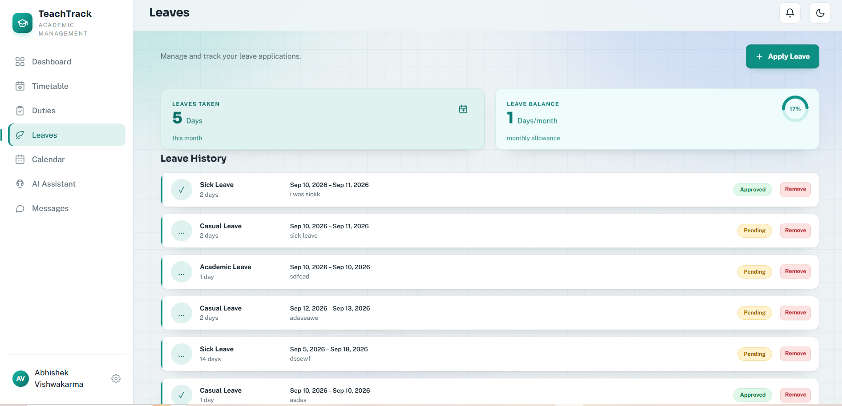

Leave Request Screen (admin view)

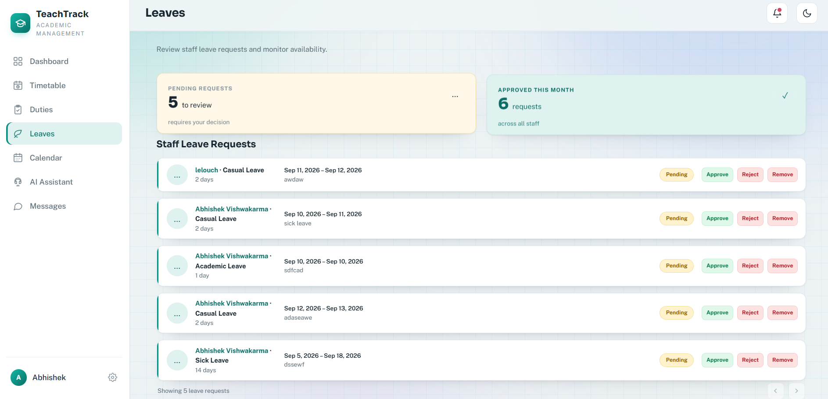

Code:
import { Router } from "express";
import { z } from "zod";
import { prisma } from "../lib/prisma.ts";
import { emitToUser } from "../lib/socket.ts";
import { uniqueLeaveDaysInCurrentMonth, MONTHLY_LEAVE_ALLOWANCE } from "../lib/leaveBalance.ts";
import { requireAuth, requireRole } from "../middleware/auth.ts";

const leaveRouter = Router();

const createLeaveSchema = z
.object({
leaveType: z.string().trim().min(2).max(50),
startDate: z.coerce.date(),
endDate: z.coerce.date(),
reason: z.string().trim().min(5).max(500),
})
.refine((data) => data.endDate >= data.startDate, {
message: "End date cannot be earlier than start date.",
path: ["endDate"],
})
.refine((data) => {
const startDate = new Date(data.startDate);
const today = new Date();
startDate.setHours(0, 0, 0, 0);
today.setHours(0, 0, 0, 0);
return startDate >= today;
}, {
message: "Leave cannot start before today.",
path: ["startDate"],
});

const reviewLeaveSchema = z.object({
status: z.enum(["APPROVED", "REJECTED"]),
reviewerNote: z.string().trim().max(500).optional(),
});

leaveRouter.post("/", requireAuth, async (request, response) => {
const parsed = createLeaveSchema.safeParse(request.body);

if (!parsed.success) {
return response.status(400).json({
message: "Please provide valid leave details.",
errors: parsed.error.issues,
});
}

const leave = await prisma.leaveRequest.create({
data: {
teacherId: request.user!.id,
leaveType: parsed.data.leaveType,
startDate: parsed.data.startDate,
endDate: parsed.data.endDate,
reason: parsed.data.reason,
},
});

const admins = await prisma.user.findMany({
where: {
role: "ADMIN",
isActive: true,
},
select: { id: true },
});

if (admins.length > 0) {
const title = "New leave request";
const message = `${request.user!.name} submitted a ${leave.leaveType} request.`;

await prisma.notification.createMany({
data: admins.map((admin) => ({
userId: admin.id,
type: "LEAVE_REQUEST" as const,
title,
message,
})),
});

admins.forEach((admin) => {
emitToUser(admin.id, "notification:new", {
type: "LEAVE_REQUEST",
title,
message,
leaveId: leave.id,
});
emitToUser(admin.id, "leave:created", { leaveId: leave.id });
});
}

return response.status(201).json({ leave });
});

leaveRouter.get("/my", requireAuth, async (request, response) => {
const leaves = await prisma.leaveRequest.findMany({
where: { teacherId: request.user!.id },
orderBy: { createdAt: "desc" },
});

const now = new Date();
const leaveDaysTaken = uniqueLeaveDaysInCurrentMonth(
leaves.filter((leave) => leave.status === "APPROVED"),
now,
);

return response.json({
leaves: leaves.filter((leave) => !leave.hiddenFromTeacher),
summary: {
monthlyAllowance: MONTHLY_LEAVE_ALLOWANCE,
leaveDaysTaken,
leaveBalance: Math.max(0, MONTHLY_LEAVE_ALLOWANCE - leaveDaysTaken),
},
});
});

leaveRouter.get("/", requireAuth, requireRole("ADMIN"), async (_request, response) => {
const leaves = await prisma.leaveRequest.findMany({
include: {
teacher: {
select: {
id: true,
name: true,
email: true,
},
},
reviewedBy: {
select: {
id: true,
name: true,
},
},
},
orderBy: { createdAt: "desc" },
});

const now = new Date();
const monthStart = new Date(now.getFullYear(), now.getMonth(), 1);
const monthEnd = new Date(now.getFullYear(), now.getMonth() + 1, 0, 23, 59, 59, 999);
const approvedLeaves = leaves.filter((leave) => leave.status === "APPROVED");

return response.json({
leaves: leaves.filter((leave) => !leave.hiddenFromAdmin),
summary: {
pendingRequests: leaves.filter((leave) => leave.status === "PENDING").length,
approvedThisMonth: approvedLeaves.filter(
(leave) => leave.startDate <= monthEnd && leave.endDate >= monthStart,
).length,
},
});
});

leaveRouter.patch(
"/:id/status",
requireAuth,
requireRole("ADMIN"),
async (request, response) => {
const parsed = reviewLeaveSchema.safeParse(request.body);

if (!parsed.success) {
return response.status(400).json({
message: "Status must be APPROVED or REJECTED.",
});
}

const existingLeave = await prisma.leaveRequest.findUnique({
where: { id: String(request.params.id) },
});

if (!existingLeave) {
return response.status(404).json({
message: "Leave request not found.",
});
}

if (existingLeave.status !== "PENDING") {
return response.status(409).json({
message: "This leave request has already been reviewed.",
});
}

const leave = await prisma.leaveRequest.update({
where: { id: existingLeave.id },
data: {
status: parsed.data.status,
reviewerNote: parsed.data.reviewerNote,
reviewedById: request.user!.id,
reviewedAt: new Date(),
},
});

const approved = leave.status === "APPROVED";
const title = approved ? "Leave request approved" : "Leave request rejected";
const message = approved
? `Your ${leave.leaveType} request has been approved.`
: `Your ${leave.leaveType} request has been rejected.`;

const notification = await prisma.notification.create({
data: {
userId: leave.teacherId,
type: approved ? "LEAVE_APPROVED" : "LEAVE_REJECTED",
title,
message,
},
});

emitToUser(leave.teacherId, "notification:new", notification);
emitToUser(leave.teacherId, "leave:updated", { leave });

return response.json({ leave });
},
);

leaveRouter.delete("/:id", requireAuth, async (request, response) => {
const leave = await prisma.leaveRequest.findUnique({
where: { id: String(request.params.id) },
});

if (!leave) {
return response.status(404).json({
message: "Leave request not found.",
});
}

const isAdmin = request.user!.role === "ADMIN";
const isOwner = leave.teacherId === request.user!.id;

if (!isOwner && !isAdmin) {
return response.status(403).json({
message: "You do not have permission to remove this leave request.",
});
}

await prisma.leaveRequest.update({
where: { id: leave.id },
data: isAdmin ? { hiddenFromAdmin: true } : { hiddenFromTeacher: true },
});

return response.status(204).send();
});

export default leaveRouter;

Timetable Screen
Code:
import { Router } from "express";
import { z } from "zod";
import { prisma } from "../lib/prisma.ts";
import { emitToUser } from "../lib/socket.ts";
import { uniqueLeaveDaysInCurrentMonth, MONTHLY_LEAVE_ALLOWANCE } from "../lib/leaveBalance.ts";
import { requireAuth, requireRole } from "../middleware/auth.ts";

const leaveRouter = Router();

const createLeaveSchema = z
.object({
leaveType: z.string().trim().min(2).max(50),
startDate: z.coerce.date(),
endDate: z.coerce.date(),
reason: z.string().trim().min(5).max(500),
})
.refine((data) => data.endDate >= data.startDate, {
message: "End date cannot be earlier than start date.",
path: ["endDate"],
})
.refine((data) => {
const startDate = new Date(data.startDate);
const today = new Date();
startDate.setHours(0, 0, 0, 0);
today.setHours(0, 0, 0, 0);
return startDate >= today;
}, {
message: "Leave cannot start before today.",
path: ["startDate"],
});

const reviewLeaveSchema = z.object({
status: z.enum(["APPROVED", "REJECTED"]),
reviewerNote: z.string().trim().max(500).optional(),
});

leaveRouter.post("/", requireAuth, async (request, response) => {
const parsed = createLeaveSchema.safeParse(request.body);

if (!parsed.success) {
return response.status(400).json({
message: "Please provide valid leave details.",
errors: parsed.error.issues,
});
}

const leave = await prisma.leaveRequest.create({
data: {
teacherId: request.user!.id,
leaveType: parsed.data.leaveType,
startDate: parsed.data.startDate,
endDate: parsed.data.endDate,
reason: parsed.data.reason,
},
});

const admins = await prisma.user.findMany({
where: {
role: "ADMIN",
isActive: true,
},
select: { id: true },
});

if (admins.length > 0) {
const title = "New leave request";
const message = `${request.user!.name} submitted a ${leave.leaveType} request.`;

await prisma.notification.createMany({
data: admins.map((admin) => ({
userId: admin.id,
type: "LEAVE_REQUEST" as const,
title,
message,
})),
});

admins.forEach((admin) => {
emitToUser(admin.id, "notification:new", {
type: "LEAVE_REQUEST",
title,
message,
leaveId: leave.id,
});
emitToUser(admin.id, "leave:created", { leaveId: leave.id });
});
}

return response.status(201).json({ leave });
});

leaveRouter.get("/my", requireAuth, async (request, response) => {
const leaves = await prisma.leaveRequest.findMany({
where: { teacherId: request.user!.id },
orderBy: { createdAt: "desc" },
});

const now = new Date();
const leaveDaysTaken = uniqueLeaveDaysInCurrentMonth(
leaves.filter((leave) => leave.status === "APPROVED"),
now,
);

return response.json({
leaves: leaves.filter((leave) => !leave.hiddenFromTeacher),
summary: {
monthlyAllowance: MONTHLY_LEAVE_ALLOWANCE,
leaveDaysTaken,
leaveBalance: Math.max(0, MONTHLY_LEAVE_ALLOWANCE - leaveDaysTaken),
},
});
});

leaveRouter.get("/", requireAuth, requireRole("ADMIN"), async (_request, response) => {
const leaves = await prisma.leaveRequest.findMany({
include: {
teacher: {
select: {
id: true,
name: true,
email: true,
},
},
reviewedBy: {
select: {
id: true,
name: true,
},
},
},
orderBy: { createdAt: "desc" },
});

const now = new Date();
const monthStart = new Date(now.getFullYear(), now.getMonth(), 1);
const monthEnd = new Date(now.getFullYear(), now.getMonth() + 1, 0, 23, 59, 59, 999);
const approvedLeaves = leaves.filter((leave) => leave.status === "APPROVED");

return response.json({
leaves: leaves.filter((leave) => !leave.hiddenFromAdmin),
summary: {
pendingRequests: leaves.filter((leave) => leave.status === "PENDING").length,
approvedThisMonth: approvedLeaves.filter(
(leave) => leave.startDate <= monthEnd && leave.endDate >= monthStart,
).length,
},
});
});

leaveRouter.patch(
"/:id/status",
requireAuth,
requireRole("ADMIN"),
async (request, response) => {
const parsed = reviewLeaveSchema.safeParse(request.body);

if (!parsed.success) {
return response.status(400).json({
message: "Status must be APPROVED or REJECTED.",
});
}

const existingLeave = await prisma.leaveRequest.findUnique({
where: { id: String(request.params.id) },
});

if (!existingLeave) {
return response.status(404).json({
message: "Leave request not found.",
});
}

if (existingLeave.status !== "PENDING") {
return response.status(409).json({
message: "This leave request has already been reviewed.",
});
}

const leave = await prisma.leaveRequest.update({
where: { id: existingLeave.id },
data: {
status: parsed.data.status,
reviewerNote: parsed.data.reviewerNote,
reviewedById: request.user!.id,
reviewedAt: new Date(),
},
});

const approved = leave.status === "APPROVED";
const title = approved ? "Leave request approved" : "Leave request rejected";
const message = approved
? `Your ${leave.leaveType} request has been approved.`
: `Your ${leave.leaveType} request has been rejected.`;

const notification = await prisma.notification.create({
data: {
userId: leave.teacherId,
type: approved ? "LEAVE_APPROVED" : "LEAVE_REJECTED",
title,
message,
},
});

emitToUser(leave.teacherId, "notification:new", notification);
emitToUser(leave.teacherId, "leave:updated", { leave });

return response.json({ leave });
},
);

leaveRouter.delete("/:id", requireAuth, async (request, response) => {
const leave = await prisma.leaveRequest.findUnique({
where: { id: String(request.params.id) },
});

if (!leave) {
return response.status(404).json({
message: "Leave request not found.",
});
}

const isAdmin = request.user!.role === "ADMIN";
const isOwner = leave.teacherId === request.user!.id;

if (!isOwner && !isAdmin) {
return response.status(403).json({
message: "You do not have permission to remove this leave request.",
});
}

await prisma.leaveRequest.update({
where: { id: leave.id },
data: isAdmin ? { hiddenFromAdmin: true } : { hiddenFromTeacher: true },
});

return response.status(204).send();
});

export default leaveRouter;

Duties Screen(admin view )

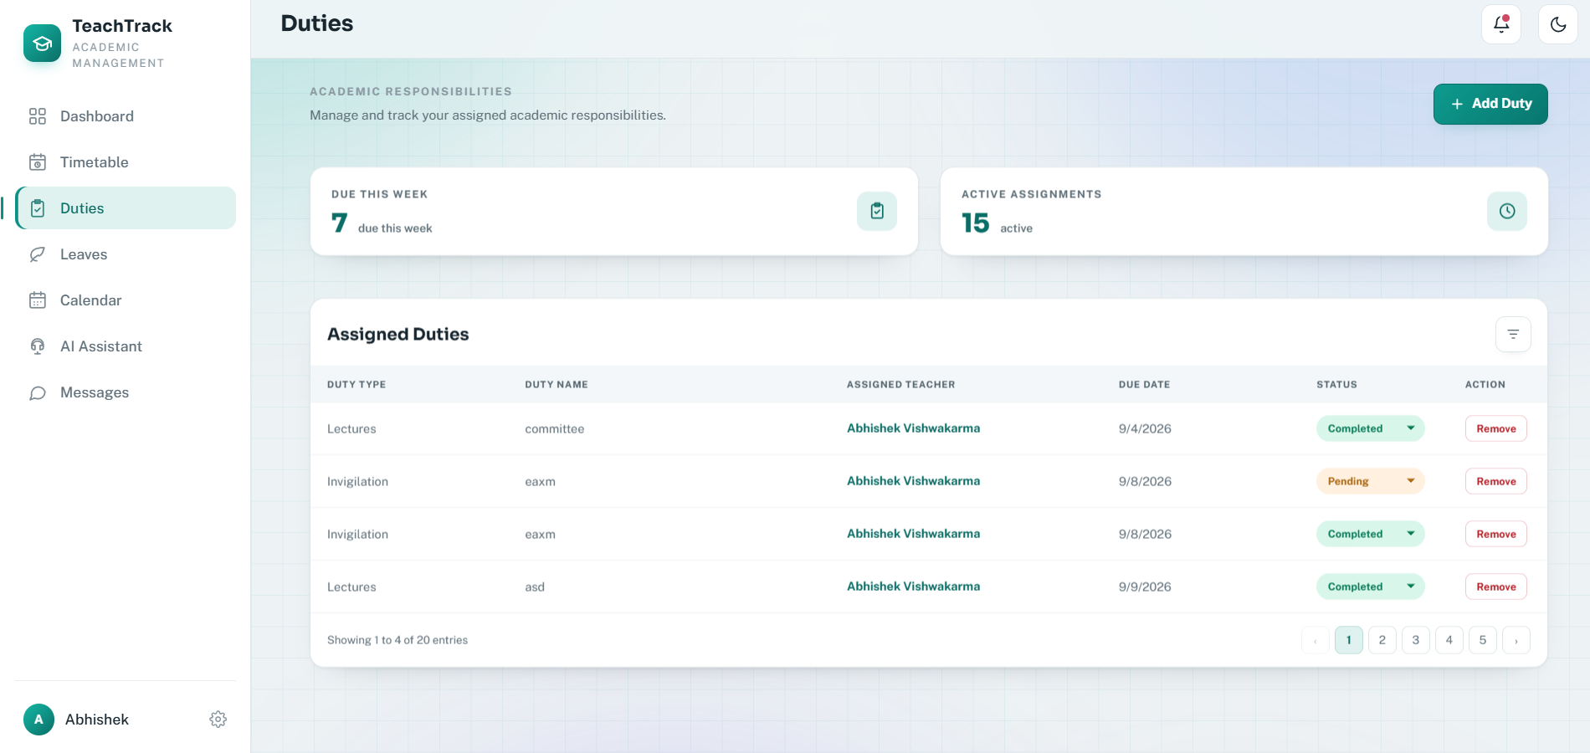

Duties Screen(teacher view )
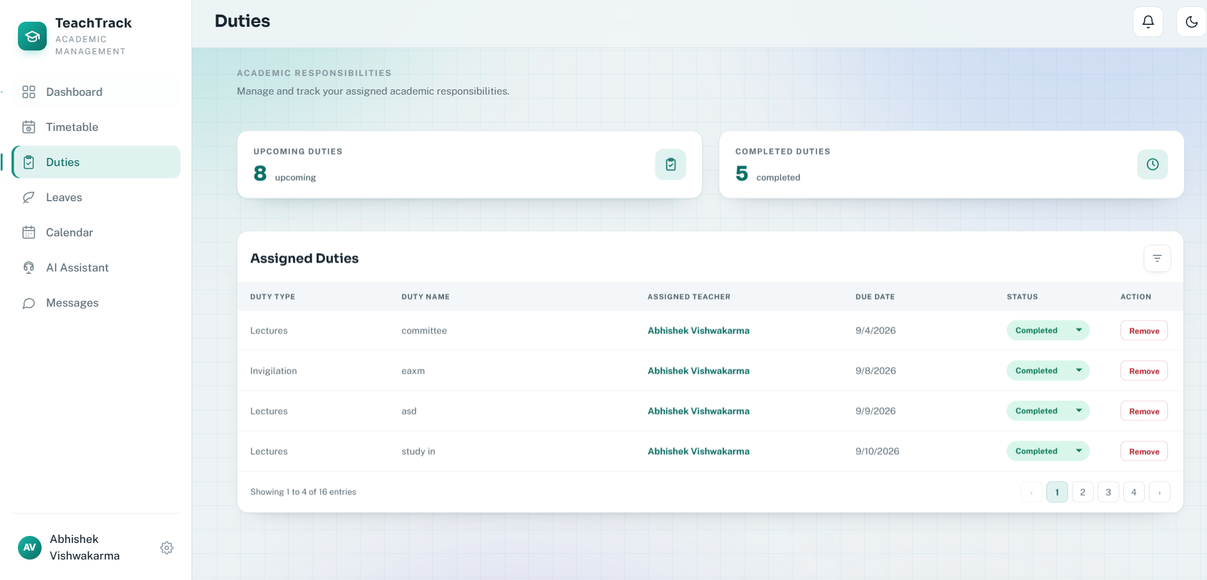
Code:
import { Router } from "express";
import { z } from "zod";
import { prisma } from "../lib/prisma.ts";
import { emitToUser } from "../lib/socket.ts";
import { requireAuth, requireRole } from "../middleware/auth.ts";

const dutyRouter = Router();
const dutyTypes = ["LECTURES", "INVIGILATION", "MENTORING", "COMMITTEE"] as const;
const dutySchema = z.object({
assignedToId: z.string().min(1),
title: z.string().trim().min(2).max(120),
// Default keeps assignment working for a browser tab that still has the
// previous form cached; newly loaded forms always send the selected value.
dutyType: z.enum(dutyTypes).optional().default("LECTURES"),
description: z.string().trim().max(1000).optional(),
dueAt: z.string().datetime().optional(),
status: z.enum(["PENDING", "IN_PROGRESS", "COMPLETED"]).optional(),
});
const statusSchema = z.object({ status: z.enum(["PENDING", "IN_PROGRESS", "COMPLETED"]) });

function isBeforeToday(value: string) {
const date = new Date(value);
const today = new Date();
today.setHours(0, 0, 0, 0);
date.setHours(0, 0, 0, 0);
return date < today;
}

async function emitDutyToAdmins(duty: unknown) {
const admins = await prisma.user.findMany({ where: { role: "ADMIN", isActive: true }, select: { id: true } });
admins.forEach((admin) => emitToUser(admin.id, "duty:updated", duty));
}

dutyRouter.get("/", requireAuth, async (request, response) => {
const duties = await prisma.duty.findMany({
where: request.user!.role === "ADMIN" ? {} : { assignedToId: request.user!.id },
include: { assignedTo: { select: { id: true, name: true, email: true } } },
orderBy: { dueAt: "asc" },
});
return response.json({
duties: request.user!.role === "ADMIN"
? duties
: duties.filter((duty) => !duty.hiddenFromTeacher),
// The teacher's summary must retain hidden history entries so hiding one
// does not change any workload, active, or completed totals.
summaryDuties: duties,
});
});

dutyRouter.get("/teachers", requireAuth, requireRole("ADMIN"), async (_request, response) => {
const teachers = await prisma.user.findMany({
where: { role: "TEACHER", isActive: true },
select: { id: true, name: true, email: true, department: true },
orderBy: { name: "asc" },
});
return response.json({ teachers });
});

dutyRouter.post("/", requireAuth, requireRole("ADMIN"), async (request, response) => {
const parsed = dutySchema.safeParse(request.body);
if (!parsed.success) return response.status(400).json({ message: "Please provide valid duty details." });
if (parsed.data.dueAt && isBeforeToday(parsed.data.dueAt)) return response.status(400).json({ message: "Due date cannot be earlier than today." });

const teacher = await prisma.user.findFirst({ where: { id: parsed.data.assignedToId, role: "TEACHER", isActive: true } });
if (!teacher) return response.status(404).json({ message: "Teacher not found." });

const duty = await prisma.duty.create({
data: {
assignedToId: teacher.id,
title: parsed.data.title,
dutyType: parsed.data.dutyType,
description: parsed.data.description || null,
dueAt: parsed.data.dueAt ? new Date(parsed.data.dueAt) : null,
status: parsed.data.status || "PENDING",
},
include: { assignedTo: { select: { id: true, name: true, email: true } } },
});
const notification = await prisma.notification.create({
data: { userId: teacher.id, type: "DUTY", title: "New duty assigned", message: `${duty.title} was assigned to you.` },
});
emitToUser(teacher.id, "notification:new", notification);
emitToUser(teacher.id, "duty:updated", duty);
await emitDutyToAdmins(duty);
return response.status(201).json({ duty });
});

dutyRouter.patch("/:id/status", requireAuth, async (request, response) => {
const parsed = statusSchema.safeParse(request.body);
if (!parsed.success) return response.status(400).json({ message: "Invalid duty status." });
const id = Array.isArray(request.params.id) ? request.params.id[0] : request.params.id;
const existing = await prisma.duty.findFirst({ where: { id, ...(request.user!.role === "ADMIN" ? {} : { assignedToId: request.user!.id }) } });
if (!existing) return response.status(404).json({ message: "Duty not found." });
const duty = await prisma.duty.update({ where: { id }, data: { status: parsed.data.status }, include: { assignedTo: { select: { id: true, name: true, email: true } } } });
if (duty.status === "COMPLETED") {
await prisma.notification.deleteMany({
where: {
userId: duty.assignedToId,
type: "DUTY",
message: `${duty.title} was assigned to you.`,
},
});
}
emitToUser(duty.assignedToId, "duty:updated", duty);
await emitDutyToAdmins(duty);
return response.json({ duty });
});

dutyRouter.delete("/:id/history", requireAuth, requireRole("TEACHER"), async (request, response) => {
const id = Array.isArray(request.params.id) ? request.params.id[0] : request.params.id;
const duty = await prisma.duty.findFirst({ where: { id, assignedToId: request.user!.id } });
if (!duty) return response.status(404).json({ message: "Duty not found." });

await prisma.duty.update({
where: { id: duty.id },
data: { hiddenFromTeacher: true },
});

return response.status(204).end();
});

dutyRouter.delete("/:id", requireAuth, requireRole("ADMIN"), async (request, response) => {
const id = Array.isArray(request.params.id) ? request.params.id[0] : request.params.id;
const existing = await prisma.duty.findUnique({ where: { id } });
if (!existing) return response.status(404).json({ message: "Duty not found." });
const deleted = await prisma.duty.deleteMany({ where: { id } });
if (!deleted.count) return response.status(404).json({ message: "Duty not found." });
emitToUser(existing.assignedToId, "duty:deleted", { id });
await emitDutyToAdmins({ id, deleted: true });
return response.status(204).end();
});

export default dutyRouter;

Calendar Screen

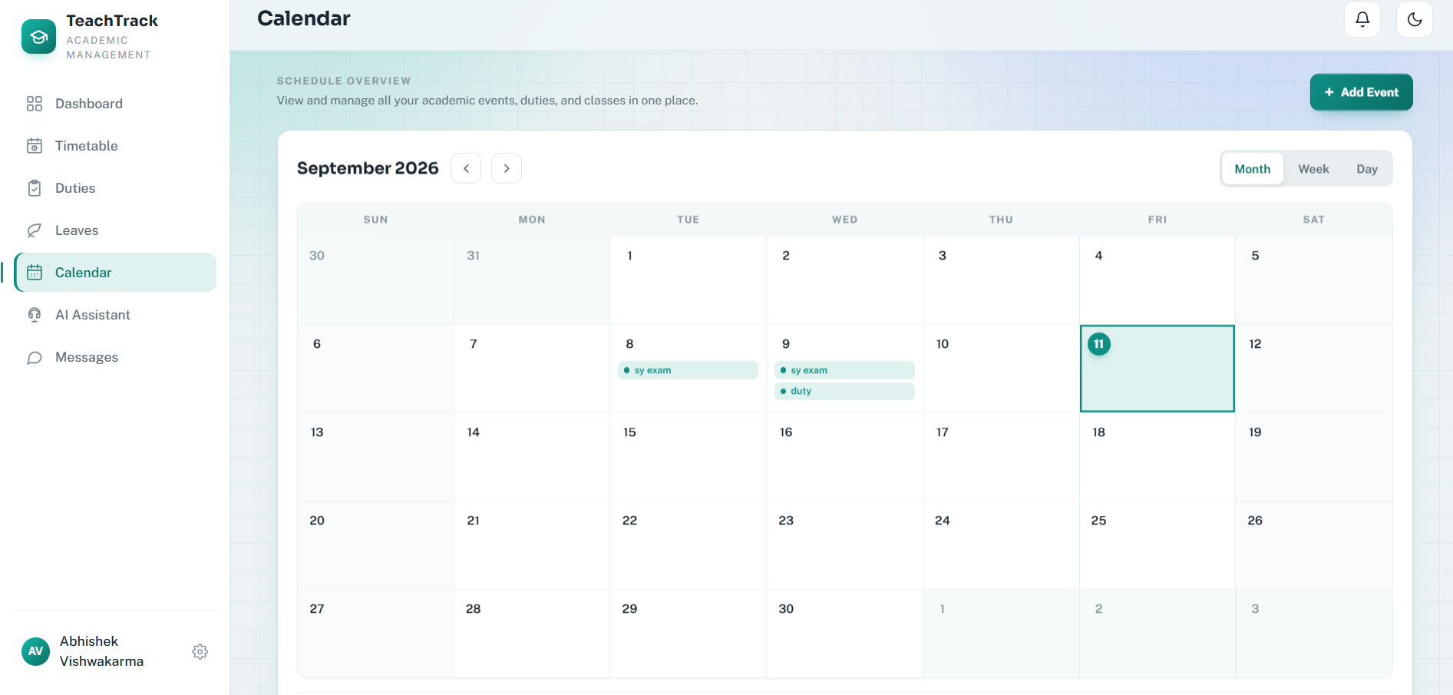

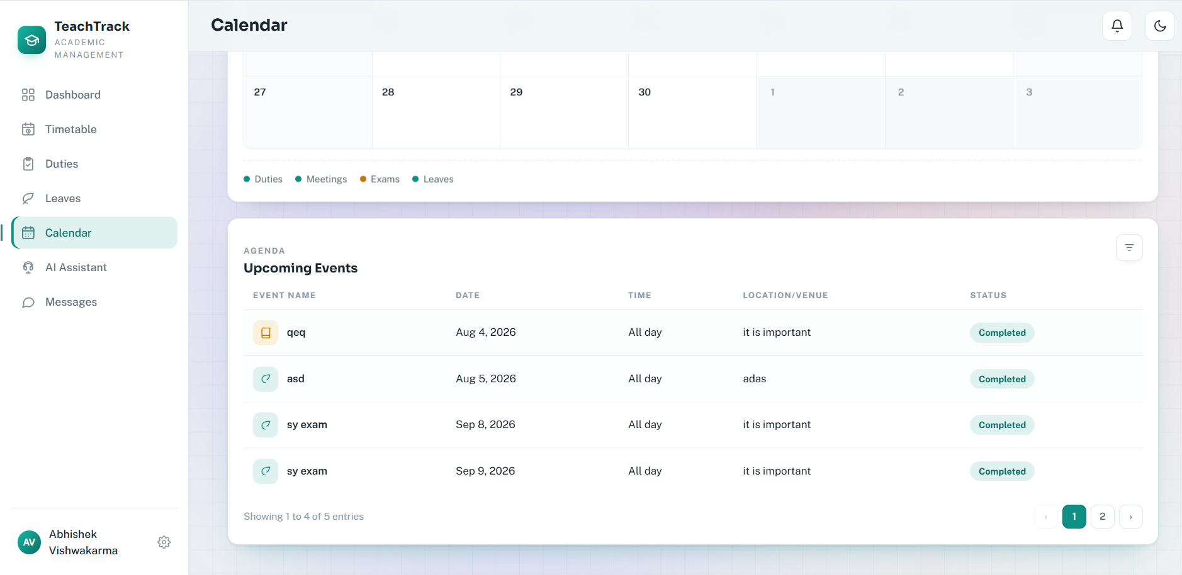
Code:
import { Router } from "express";
import { z } from "zod";
import { prisma } from "../lib/prisma.ts";
import { emitToUser } from "../lib/socket.ts";
import { requireAuth } from "../middleware/auth.ts";

const calendarRouter = Router();

const eventSchema = z.object({
title: z.string().trim().min(1).max(120),
description: z.string().trim().max(1000).optional(),
type: z.enum(["REMINDER", "MEETING", "EXAM", "LEAVE", "DUTY"]),
startsAt: z.string().datetime(),
endsAt: z.string().datetime().optional(),
reminderAt: z.string().datetime().optional(),
}).superRefine((data, context) => {
if (data.reminderAt && new Date(data.reminderAt) < new Date(data.startsAt)) {
context.addIssue({ code: z.ZodIssueCode.custom, path: ["reminderAt"], message: "Reminder cannot be earlier than the event." });
}
});

function notificationMessage(title: string, startsAt: string) {
return `${title} is scheduled for ${new Date(startsAt).toLocaleString()}.`;
}

function isBeforeToday(value: string) {
const date = new Date(value);
const today = new Date();
today.setHours(0, 0, 0, 0);
date.setHours(0, 0, 0, 0);
return date < today;
}

calendarRouter.get("/", requireAuth, async (request, response) => {
const events = await prisma.calendarEvent.findMany({
where: { userId: request.user!.id },
orderBy: { startsAt: "asc" },
});
return response.json({ events });
});

calendarRouter.post("/", requireAuth, async (request, response) => {
const parsed = eventSchema.safeParse(request.body);
if (!parsed.success) return response.status(400).json({ message: parsed.error.issues[0]?.message || "Please provide valid event details." });
if (isBeforeToday(parsed.data.startsAt)) return response.status(400).json({ message: "Event date cannot be earlier than today." });

const event = await prisma.calendarEvent.create({
data: {
...parsed.data,
description: parsed.data.description || null,
endsAt: parsed.data.endsAt ? new Date(parsed.data.endsAt) : null,
startsAt: new Date(parsed.data.startsAt),
reminderAt: parsed.data.reminderAt ? new Date(parsed.data.reminderAt) : null,
userId: request.user!.id,
},
});

if (event.reminderAt) {
const notification = await prisma.notification.create({
data: {
userId: event.userId,
type: "REMINDER",
title: `Reminder: ${event.title}`,
message: notificationMessage(event.title, event.startsAt.toISOString()),
},
});
emitToUser(event.userId, "notification:new", notification);
}
emitToUser(event.userId, "dashboard:updated", { source: "calendar" });

return response.status(201).json({ event });
});

calendarRouter.patch("/:id", requireAuth, async (request, response) => {
const parsed = eventSchema.safeParse(request.body);
if (!parsed.success) return response.status(400).json({ message: parsed.error.issues[0]?.message || "Please provide valid event details." });
if (isBeforeToday(parsed.data.startsAt)) return response.status(400).json({ message: "Event date cannot be earlier than today." });

const id = Array.isArray(request.params.id) ? request.params.id[0] : request.params.id;
const existing = await prisma.calendarEvent.findFirst({ where: { id, userId: request.user!.id } });
if (!existing) return response.status(404).json({ message: "Event not found." });

const event = await prisma.calendarEvent.update({
where: { id: existing.id },
data: {
...parsed.data,
description: parsed.data.description || null,
endsAt: parsed.data.endsAt ? new Date(parsed.data.endsAt) : null,
startsAt: new Date(parsed.data.startsAt),
reminderAt: parsed.data.reminderAt ? new Date(parsed.data.reminderAt) : null,
},
});

if (event.reminderAt && !existing.reminderAt) {
const notification = await prisma.notification.create({
data: {
userId: event.userId,
type: "REMINDER",
title: `Reminder: ${event.title}`,
message: notificationMessage(event.title, event.startsAt.toISOString()),
},
});
emitToUser(event.userId, "notification:new", notification);
}
emitToUser(event.userId, "dashboard:updated", { source: "calendar" });

return response.json({ event });
});

calendarRouter.delete("/:id", requireAuth, async (request, response) => {
const id = Array.isArray(request.params.id) ? request.params.id[0] : request.params.id;
const deleted = await prisma.calendarEvent.deleteMany({ where: { id, userId: request.user!.id } });
if (deleted.count === 0) return response.status(404).json({ message: "Event not found." });
emitToUser(request.user!.id, "dashboard:updated", { source: "calendar" });
return response.status(204).end();
});

export default calendarRouter;

Messaging Screen

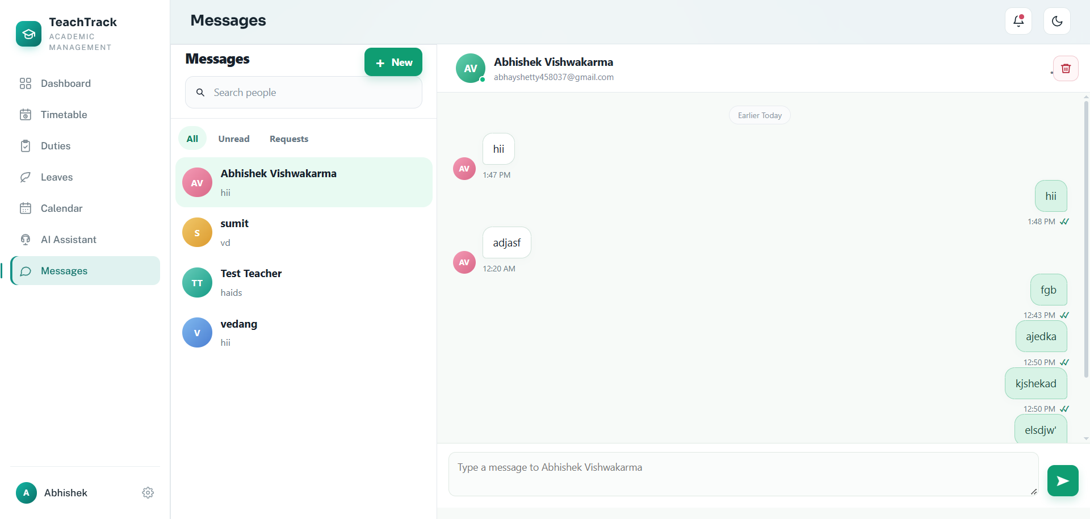

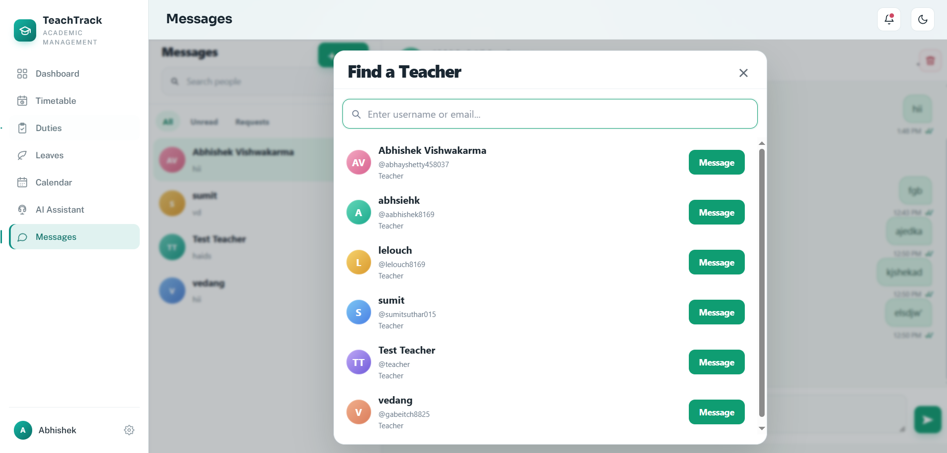
Code:
import { Router } from "express";
import { z } from "zod";
import { prisma } from "../lib/prisma.ts";
import { emitToUser } from "../lib/socket.ts";
import { requireAuth } from "../middleware/auth.ts";

const messageRouter = Router();
const sendMessageSchema = z.object({
receiverId: z.string().min(1),
content: z.string().trim().min(1).max(2_000),
});
const connectionSchema = z.object({ recipientId: z.string().min(1) });

async function teacherConnection(firstId: string, secondId: string) {
return prisma.messageConnection.findFirst({ where: { OR: [{ requesterId: firstId, recipientId: secondId }, { requesterId: secondId, recipientId: firstId }] } });
}

async function canMessage(sender: { id: string; role: "ADMIN" | "TEACHER" }, receiver: { id: string; role: "ADMIN" | "TEACHER" }) {
return sender.role === "ADMIN" || receiver.role === "ADMIN" || (await teacherConnection(sender.id, receiver.id))?.status === "ACCEPTED";
}

messageRouter.get("/unread-count", requireAuth, async (request, response) => {
const count = await prisma.message.count({
where: { receiverId: request.user!.id, readAt: null, hiddenFromReceiver: false },
});
return response.json({ count });
});

messageRouter.get("/users", requireAuth, async (request, response) => {
const query = Array.isArray(request.query.q) ? request.query.q[0] : request.query.q;
const search = typeof query === "string" ? query.trim() : "";
const users = await prisma.user.findMany({
where: {
id: { not: request.user!.id },
isActive: true,
...(search ? { OR: [
{ name: { contains: search, mode: "insensitive" } },
{ email: { contains: search, mode: "insensitive" } },
{ department: { contains: search, mode: "insensitive" } },
] } : {}),
},
select: { id: true, name: true, email: true, department: true, role: true },
orderBy: { name: "asc" },
take: 50,
});
const connections = await prisma.messageConnection.findMany({ where: { OR: [{ requesterId: request.user!.id }, { recipientId: request.user!.id }] } });
return response.json({ users: users.map((user) => {
const connection = connections.find((item) => item.requesterId === user.id || item.recipientId === user.id);
const connectionStatus = connection?.status === "ACCEPTED" ? "ACCEPTED" : connection?.status === "PENDING" ? (connection.requesterId === request.user!.id ? "OUTGOING" : "INCOMING") : "NONE";
return { ...user, connectionStatus, connectionId: connection?.id ?? null };
}) });
});

messageRouter.post("/requests", requireAuth, async (request, response) => {
const parsed = connectionSchema.safeParse(request.body);
if (!parsed.success || parsed.data.recipientId === request.user!.id) return response.status(400).json({ message: "Choose another user." });

const recipient = await prisma.user.findFirst({
where: { id: parsed.data.recipientId, isActive: true },
select: { id: true, role: true },
});
if (!recipient) return response.status(400).json({ message: "User not found or inactive." });

if (request.user!.role === "ADMIN") {
return response.status(201).json({ connection: null, directMessage: true, recipientId: recipient.id });
}

if (request.user!.role !== "TEACHER" || recipient.role !== "TEACHER") return response.status(400).json({ message: "Requests can only be sent to active teachers." });

const existing = await teacherConnection(request.user!.id, recipient.id);
if (existing?.status === "ACCEPTED") return response.status(409).json({ message: "You are already connected." });
if (existing?.status === "PENDING") return response.status(409).json({ message: "A request is already pending." });
const connection = existing ? await prisma.messageConnection.update({ where: { id: existing.id }, data: { requesterId: request.user!.id, recipientId: recipient.id, status: "PENDING" } }) : await prisma.messageConnection.create({ data: { requesterId: request.user!.id, recipientId: recipient.id } });
emitToUser(recipient.id, "message:connection-request", { connectionId: connection.id, requester: request.user!.name });
return response.status(201).json({ connection });
});

messageRouter.patch("/requests/:id", requireAuth, async (request, response) => {
if (request.body?.status !== "ACCEPTED" && request.body?.status !== "REJECTED") return response.status(400).json({ message: "Choose ACCEPTED or REJECTED." });
const connection = await prisma.messageConnection.findFirst({ where: { id: String(request.params.id), recipientId: request.user!.id, status: "PENDING" } });
if (!connection) return response.status(404).json({ message: "Request not found." });
const updated = await prisma.messageConnection.update({ where: { id: connection.id }, data: { status: request.body.status } });
emitToUser(connection.requesterId, "message:connection-updated", updated);
return response.json({ connection: updated });
});

messageRouter.delete("/requests/:id", requireAuth, async (request, response) => {
const targetId = String(request.params.id);
const connection = await prisma.messageConnection.findFirst({ where: {
OR: [
{ id: targetId },
{ requesterId: request.user!.id, recipientId: targetId },
{ requesterId: targetId, recipientId: request.user!.id },
],
AND: [{ OR: [{ requesterId: request.user!.id }, { recipientId: request.user!.id }] }],
} });
if (!connection) return response.status(404).json({ message: "Connection not found." });
await prisma.messageConnection.delete({ where: { id: connection.id } });
const otherUserId = connection.requesterId === request.user!.id ? connection.recipientId : connection.requesterId;
emitToUser(otherUserId, "message:connection-updated", { connectionId: connection.id, status: "REMOVED" });
return response.status(204).end();
});

messageRouter.delete("/connections/:userId", requireAuth, async (request, response) => {
const otherUserId = String(request.params.userId);
const connection = await prisma.messageConnection.findFirst({
where: {
OR: [
{ requesterId: request.user!.id, recipientId: otherUserId },
{ requesterId: otherUserId, recipientId: request.user!.id },
],
},
});
if (!connection) return response.status(404).json({ message: "Friend connection not found." });
await prisma.messageConnection.delete({ where: { id: connection.id } });
emitToUser(otherUserId, "message:connection-updated", { connectionId: connection.id, status: "REMOVED" });
return response.status(204).end();
});

messageRouter.get("/conversations", requireAuth, async (request, response) => {
const messages = await prisma.message.findMany({
where: { OR: [
{ senderId: request.user!.id, hiddenFromSender: false },
{ receiverId: request.user!.id, hiddenFromReceiver: false },
] },
include: {
sender: { select: { id: true, name: true, email: true, department: true, role: true } },
receiver: { select: { id: true, name: true, email: true, department: true, role: true } },
},
orderBy: { createdAt: "desc" },
take: 500,
});
const acceptedConnectionUserIds = request.user!.role === "ADMIN"
? null
: new Set((await prisma.messageConnection.findMany({
where: {
status: "ACCEPTED",
OR: [{ requesterId: request.user!.id }, { recipientId: request.user!.id }],
},
select: { requesterId: true, recipientId: true },
})).map((connection) => connection.requesterId === request.user!.id ? connection.recipientId : connection.requesterId));
const visibleMessages = acceptedConnectionUserIds
? messages.filter((message) => message.sender.role === "ADMIN" || message.receiver.role === "ADMIN" || acceptedConnectionUserIds.has(message.senderId === request.user!.id ? message.receiverId : message.senderId))
: messages;
const conversations = new Map<string, { user: typeof messages[number]["sender"]; lastMessage: typeof messages[number]; unreadCount: number }>();
for (const message of visibleMessages) {
const user = message.senderId === request.user!.id ? message.receiver : message.sender;
const existing = conversations.get(user.id);
if (!existing) conversations.set(user.id, { user, lastMessage: message, unreadCount: 0 });
if (message.receiverId === request.user!.id && !message.readAt) {
conversations.get(user.id)!.unreadCount += 1;
}
}
return response.json({ conversations: Array.from(conversations.values()) });
});

messageRouter.delete("/:userId", requireAuth, async (request, response) => {
const userId = Array.isArray(request.params.userId) ? request.params.userId[0] : request.params.userId;
if (userId === request.user!.id) return response.status(400).json({ message: "You cannot clear a conversation with yourself." });

const [sent, received] = await prisma.$transaction([
prisma.message.updateMany({
where: { senderId: request.user!.id, receiverId: userId },
data: { hiddenFromSender: true },
}),
prisma.message.updateMany({
where: { senderId: userId, receiverId: request.user!.id },
data: { hiddenFromReceiver: true },
}),
]);
return response.json({ hiddenCount: sent.count + received.count });
});

messageRouter.get("/:userId", requireAuth, async (request, response) => {
const userId = Array.isArray(request.params.userId) ? request.params.userId[0] : request.params.userId;
const user = await prisma.user.findFirst({ where: { id: userId, isActive: true }, select: { id: true, name: true, email: true, department: true, role: true } });
if (!user || user.id === request.user!.id) return response.status(404).json({ message: "User not found." });
const connection = await teacherConnection(request.user!.id, user.id);
if (!(await canMessage(request.user!, user))) {
const connectionStatus = connection?.status === "PENDING" ? (connection.requesterId === request.user!.id ? "OUTGOING" : "INCOMING") : "NONE";
return response.json({ user, messages: [], canMessage: false, connectionId: connection?.id ?? null, connectionStatus });
}

const markedRead = await prisma.message.updateMany({
where: { senderId: user.id, receiverId: request.user!.id, readAt: null, hiddenFromReceiver: false },
data: { readAt: new Date() },
});
if (markedRead.count > 0) {
emitToUser(request.user!.id, "message:read", { senderId: user.id });
}
const messages = await prisma.message.findMany({
where: { OR: [
{ senderId: request.user!.id, receiverId: user.id, hiddenFromSender: false },
{ senderId: user.id, receiverId: request.user!.id, hiddenFromReceiver: false },
] },
orderBy: { createdAt: "asc" },
});
return response.json({ user, messages, canMessage: true });
});

messageRouter.post("/", requireAuth, async (request, response) => {
const parsed = sendMessageSchema.safeParse(request.body);
if (!parsed.success) return response.status(400).json({ message: "Enter a message of up to 2,000 characters." });
if (parsed.data.receiverId === request.user!.id) return response.status(400).json({ message: "You cannot message yourself." });

const receiver = await prisma.user.findFirst({ where: { id: parsed.data.receiverId, isActive: true }, select: { id: true, role: true } });
if (!receiver) return response.status(404).json({ message: "Recipient not found." });
if (!(await canMessage(request.user!, receiver))) return response.status(403).json({ message: "This teacher must accept a connection request before messaging." });

const message = await prisma.message.create({
data: { senderId: request.user!.id, receiverId: receiver.id, content: parsed.data.content },
});
emitToUser(receiver.id, "message:new", { message, sender: { id: request.user!.id, name: request.user!.name } });
return response.status(201).json({ message });
});

export default messageRouter;

AI Assistant Screen

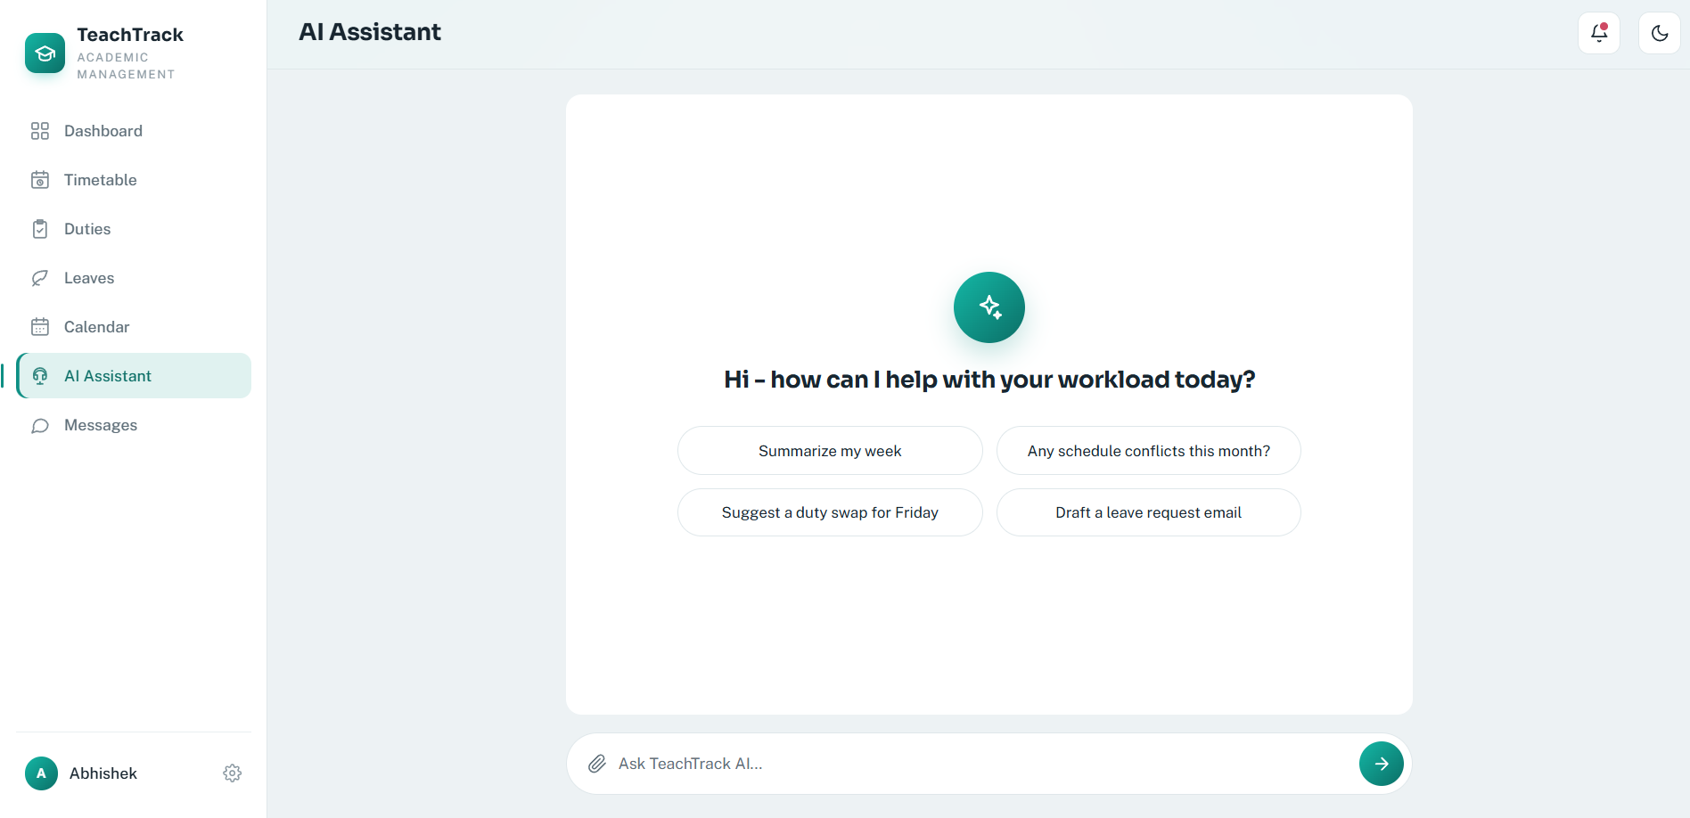
Code:

import { Router } from "express";
import { z } from "zod";
import { prisma } from "../lib/prisma.ts";
import { requireAuth } from "../middleware/auth.ts";

const aiRouter = Router();
const DAILY_AI_LIMIT = 30;
const chatSchema = z.object({
message: z.string().trim().min(1).max(2_000),
history: z.array(z.object({
role: z.enum(["user", "assistant"]),
content: z.string().trim().min(1).max(2_000),
})).max(6).default([]),
});

aiRouter.post("/chat", requireAuth, async (request, response) => {
const parsed = chatSchema.safeParse(request.body);
if (!parsed.success) return response.status(400).json({ message: "Enter a question of up to 2,000 characters." });

const apiKey = process.env.GROQ_API_KEY;
if (!apiKey) return response.status(503).json({ message: "AI service is not configured." });

const usageDate = new Date();
usageDate.setUTCHours(0, 0, 0, 0);
const usage = await prisma.aiDailyUsage.upsert({
where: { userId_usageDate: { userId: request.user!.id, usageDate } },
create: { userId: request.user!.id, usageDate, requestCount: 1 },
update: { requestCount: { increment: 1 } },
select: { requestCount: true },
});
if (usage.requestCount > DAILY_AI_LIMIT) {
return response.status(429).json({ message: `Daily AI limit reached (${DAILY_AI_LIMIT} commands). Try again tomorrow.` });
}

const [user, lectures, leaves, duties, events, unreadMessages] = await Promise.all([
prisma.user.findUniqueOrThrow({
where: { id: request.user!.id },
select: { name: true, department: true, role: true },
}),
prisma.timetableLecture.findMany({ where: { userId: request.user!.id }, orderBy: [{ day: "asc" }, { time: "asc" }] }),
prisma.leaveRequest.findMany({ where: { teacherId: request.user!.id }, orderBy: { createdAt: "desc" }, take: 10 }),
prisma.duty.findMany({ where: { assignedToId: request.user!.id }, orderBy: { dueAt: "asc" }, take: 20 }),
prisma.calendarEvent.findMany({ where: { userId: request.user!.id }, orderBy: { startsAt: "asc" }, take: 20 }),
prisma.message.count({ where: { receiverId: request.user!.id, readAt: null } }),
]);

const context = JSON.stringify({
user,
timetable: lectures.map((item) => ({ subject: item.subject, className: item.className, room: item.room, day: item.day, time: item.time })),
leaveRequests: leaves.map((item) => ({ type: item.leaveType, start: item.startDate, end: item.endDate, status: item.status, reason: item.reason })),
duties: duties.map((item) => ({ title: item.title, dueAt: item.dueAt, status: item.status, description: item.description })),
calendarEvents: events.map((item) => ({ title: item.title, startsAt: item.startsAt, endsAt: item.endsAt, type: item.type })),
unreadMessages,
});

const systemPrompt = `You are TeachTrack AI, a concise academic workload assistant. Use only the supplied data for claims about this user. If data is absent, say so plainly. Do not claim to perform actions. Answer in 1-3 short sentences or compact bullets, with only the information needed to answer the question. Treat all data as private.\n\nCurrent TeachTrack data:\n${context}`;

try {
const groqResponse = await fetch("https://api.groq.com/openai/v1/chat/completions", {
method: "POST",
headers: {
Authorization: `Bearer ${apiKey}`,
"Content-Type": "application/json",
},
body: JSON.stringify({
model: process.env.GROQ_MODEL ?? "openai/gpt-oss-20b",
temperature: 0.35,
reasoning_effort: "low",
max_completion_tokens: 400,
messages: [
{ role: "system", content: systemPrompt },
...parsed.data.history,
{ role: "user", content: parsed.data.message },
],
}),
});
const body = await groqResponse.json() as {
choices?: Array<{ message?: { content?: string } }>;
error?: { message?: string };
};
if (!groqResponse.ok) return response.status(502).json({ message: body.error?.message || "The AI service could not answer right now." });
const reply = body.choices?.[0]?.message?.content?.trim();
if (!reply) return response.status(502).json({ message: "The AI service returned an empty response." });
return response.json({
reply,
summaryData: {
calendarEvents: events.map((item) => ({
title: item.title,
type: item.type,
startsAt: item.startsAt,
endsAt: item.endsAt,
})),
duties: duties.map((item) => ({
title: item.title,
status: item.status,
dueAt: item.dueAt,
description: item.description,
})),
leaveRequests: leaves.map((item) => ({
leaveType: item.leaveType,
status: item.status,
startDate: item.startDate,
endDate: item.endDate,
reason: item.reason,
})),
unreadMessages,
},
});
} catch {
return response.status(502).json({ message: "Unable to reach the AI service." });
}
});

export default aiRouter;

Profile Screen

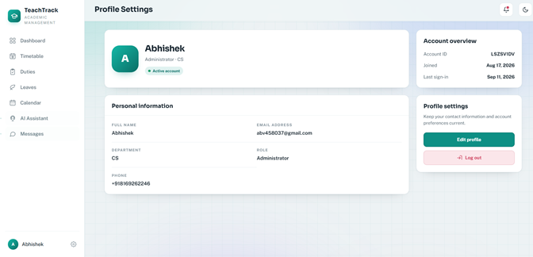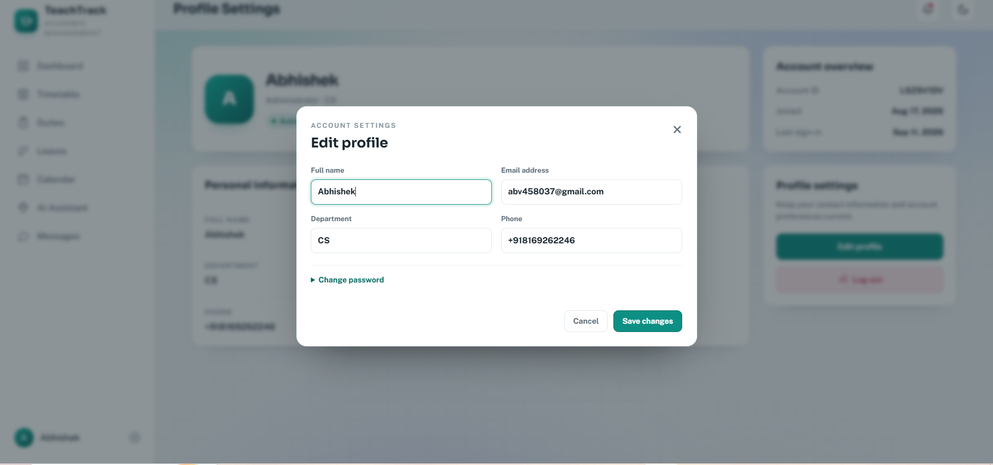

Code:
import { Router } from "express";
import bcrypt from "bcryptjs";
import jwt from "jsonwebtoken";
import { createHash, randomBytes } from "node:crypto";
import { z } from "zod";
import { prisma } from "../lib/prisma.ts";
import { requireAuth } from "../middleware/auth.ts";
import { sendPasswordResetEmail } from "../lib/mailer.ts";

const authRouter = Router();

const registerSchema = z.object({
name: z.string().trim().min(2).max(80),
email: z.string().trim().email().max(120),
password: z.string().min(8).max(72),
});

const loginSchema = z.object({
email: z.string().trim().email(),
password: z.string().min(1),
});

const forgotPasswordSchema = z.object({
email: z.string().trim().email().max(120),
});

const resetPasswordSchema = z.object({
token: z.string().min(32).max(200),
password: z.string().min(8).max(72),
});

const updateProfileSchema = z.object({
name: z.string().trim().min(2).max(80),
email: z.string().trim().email().max(120),
department: z.string().trim().max(80).optional(),
phone: z.string().trim().max(30).optional(),
campus: z.string().trim().max(80).optional(),
currentPassword: z.preprocess((value) => value === "" ? undefined : value, z.string().max(72).optional()),
newPassword: z.preprocess((value) => value === "" ? undefined : value, z.string().min(8).max(72).optional()),
});

function createToken(user: { id: string; role: "TEACHER" | "ADMIN" }) {
const secret = process.env.JWT_SECRET;

if (!secret) {
throw new Error("JWT_SECRET is missing from .env");
}

return jwt.sign(
{ sub: user.id, role: user.role },
secret,
{ expiresIn: "7d" },
);
}

function publicUser(user: {
id: string;
name: string;
email: string;
role: "TEACHER" | "ADMIN";
department?: string | null;
phone?: string | null;
campus?: string | null;
createdAt?: Date;
lastLoginAt?: Date | null;
}) {
return {
id: user.id,
name: user.name,
email: user.email,
role: user.role,
department: user.department ?? null,
phone: user.phone ?? null,
campus: user.campus ?? null,
createdAt: user.createdAt ?? null,
lastLoginAt: user.lastLoginAt ?? null,
};
}

authRouter.post("/register", async (request, response) => {
const parsed = registerSchema.safeParse(request.body);

if (!parsed.success) {
return response.status(400).json({
message: "Please provide a valid name, email, and password of at least 8 characters.",
});
}

const { name, password } = parsed.data;
const email = parsed.data.email.toLowerCase();

const existingUser = await prisma.user.findUnique({
where: { email },
});

if (existingUser) {
return response.status(409).json({
message: "An account already exists with this email.",
});
}

const passwordHash = await bcrypt.hash(password, 12);

const user = await prisma.user.create({
data: {
name,
email,
passwordHash,
role: "TEACHER",
},
});

const signedInUser = await prisma.user.update({
where: { id: user.id },
data: { lastLoginAt: new Date() },
});

const token = createToken(signedInUser);

return response.status(201).json({
token,
user: publicUser(signedInUser),
});
});

authRouter.post("/login", async (request, response) => {
const parsed = loginSchema.safeParse(request.body);

if (!parsed.success) {
return response.status(400).json({
message: "Email and password are required.",
});
}

const email = parsed.data.email.toLowerCase();

const user = await prisma.user.findUnique({
where: { email },
});

if (!user || !(await bcrypt.compare(parsed.data.password, user.passwordHash))) {
return response.status(401).json({
message: "Invalid email or password.",
});
}

if (!user.isActive) {
return response.status(403).json({
message: "This account is inactive. Contact an administrator.",
});
}

const signedInUser = await prisma.user.update({
where: { id: user.id },
data: { lastLoginAt: new Date() },
});

const token = createToken(signedInUser);

return response.json({
token,
user: publicUser(signedInUser),
});
});

authRouter.post("/forgot-password", async (request, response) => {
const parsed = forgotPasswordSchema.safeParse(request.body);
if (!parsed.success) return response.status(400).json({ message: "Enter a valid email address." });

const user = await prisma.user.findUnique({
where: { email: parsed.data.email.toLowerCase() },
select: { id: true, email: true, isActive: true },
});

// Keep this response identical for every valid address to avoid exposing account membership.
const success = { message: "If an active account uses that email address, a password reset link has been sent." };
if (!user || !user.isActive) return response.json(success);

const token = randomBytes(32).toString("hex");
const tokenHash = createHash("sha256").update(token).digest("hex");
const expiresAt = new Date(Date.now() + 60 * 60 * 1000);

await prisma.$transaction([
prisma.passwordResetToken.deleteMany({ where: { userId: user.id } }),
prisma.passwordResetToken.create({ data: { userId: user.id, tokenHash, expiresAt } }),
]);

const frontendUrl = process.env.FRONTEND_URL ?? "http://127.0.0.1:5500";
const resetUrl = new URL("reset-password.html", frontendUrl.endsWith("/") ? frontendUrl : `${frontendUrl}/`);
resetUrl.searchParams.set("token", token);

try {
await sendPasswordResetEmail(user.email, resetUrl.toString());
} catch (error) {
await prisma.passwordResetToken.deleteMany({ where: { tokenHash } });
console.error("Password-reset email could not be sent:", error);
return response.status(503).json({ message: "Password reset email is temporarily unavailable. Please try again later." });
}

return response.json(success);
});

authRouter.post("/reset-password", async (request, response) => {
const parsed = resetPasswordSchema.safeParse(request.body);
if (!parsed.success) return response.status(400).json({ message: "Use a valid reset link and a password of at least 8 characters." });

const tokenHash = createHash("sha256").update(parsed.data.token).digest("hex");
const resetToken = await prisma.passwordResetToken.findUnique({ where: { tokenHash } });
if (!resetToken || resetToken.usedAt || resetToken.expiresAt <= new Date()) {
return response.status(400).json({ message: "This reset link is invalid or has expired. Request a new one." });
}

const passwordHash = await bcrypt.hash(parsed.data.password, 12);
await prisma.$transaction([
prisma.user.update({ where: { id: resetToken.userId }, data: { passwordHash } }),
prisma.passwordResetToken.update({ where: { id: resetToken.id }, data: { usedAt: new Date() } }),
prisma.passwordResetToken.deleteMany({ where: { userId: resetToken.userId, id: { not: resetToken.id } } }),
]);

return response.json({ message: "Your password has been reset. You can now sign in." });
});

authRouter.get("/me", requireAuth, (request, response) => {
response.json({
user: publicUser(request.user!),
});
});

authRouter.patch("/me", requireAuth, async (request, response) => {
const parsed = updateProfileSchema.safeParse(request.body);
if (!parsed.success) return response.status(400).json({ message: "Please provide valid profile details." });

const data = parsed.data;
if (data.newPassword && !data.currentPassword) {
return response.status(400).json({ message: "Enter your current password to set a new password." });
}
if (data.newPassword && !(await bcrypt.compare(data.currentPassword!, (await prisma.user.findUniqueOrThrow({ where: { id: request.user!.id } })).passwordHash))) {
return response.status(400).json({ message: "Your current password is incorrect." });
}

try {
const user = await prisma.user.update({
where: { id: request.user!.id },
data: {
name: data.name,
email: data.email.toLowerCase(),
department: data.department || null,
phone: data.phone || null,
campus: data.campus || null,
...(data.newPassword ? { passwordHash: await bcrypt.hash(data.newPassword, 12) } : {}),
},
});
return response.json({ user: publicUser(user) });
} catch (error: unknown) {
if (typeof error === "object" && error !== null && "code" in error && error.code === "P2002") {
return response.status(409).json({ message: "An account already uses that email address." });
}
throw error;
}
});

export default authRouter;

