nDrive design description
Version 0.3

Contents
nDrive core design 4
1. Subsystems description 4
1.1. Networking 4
1.2. Signal subsystem 5
1.3. Sync subsystem 5
1.4. FS Watcher 5
1.5. Mapper 5
1.6. Merging subsystem 5
1.7. Control subsystem 5
1.8. Monitoring subsystem 6
1.9. Notification subsystem 6
1.10. DB Manager 6
2. Technologies and resource cost 6
3. Merging client changes with server changes 7
4. Client actions handling sequence 9
4. Server side merging process 10

Revision History
Date | Version | Description | Author
30/11/2010 | 0.1 | Initial version | Alexey Polkanov, Kirill Kazakov, Anton Alferov
01/12/2010 | 0.2 | Added technologies and resource using table | Alexey Polkanov, Kirill Kazakov, Anton Alferov
03/12/2010 | 0.3 | Sequence diagrams added | Alexey Polkanov, Kirill Kazakov, Anton Alferov

nDrive core design
Subsystem decomposition of nDrive syncing system is shown on figure below.
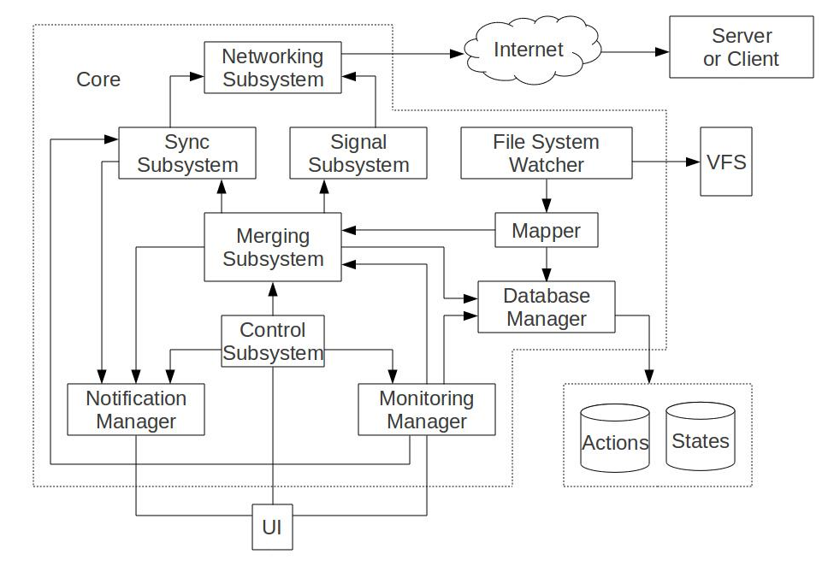
Fig. 1. nDrive subsystem decomposition

1. Subsystems description

1.1. Networking
The subsystem serves transferring of binary data over the network. It
a) detects network availability (if network is up, if direct connection is allowed, if proxy supports HTTPS etc.)
b) wraps/unwraps signal and synchronization data into/from SSL
c) tunnels signal and synchronization data over HTTPS
d) (de)multiplexes HTTPS-tunneled data

1.2. Signal subsystem
The subsystem (de)serializes object states and sends/receives them over network. So it implements Object State Protocol (OSP).

1.3. Sync subsystem
The subsystem deals with files/directories, calculate and send file deltas, sends/receives them over network, applies deltas to update files. So it implements File Partial Synchronization Protocol (FPSP).

1.4. FS Watcher
This subsystem is responsible for file system events monitoring such as operations with files and folders (create, remove, copy, move, rename, edit (for files) ). Watcher prepares structures (structured events) based on those file system events. These structured events are sent to the Mapper to provide subsequent processing.
Underlying realization of the subsystem depends on a particular platform but the interface of it is the same on all platforms.

1.5. Mapper
The mapper accepts structured events from the FS Watcher and maps them to Object States. As a particular Object State has been created it is sent to the Merging subsystem. Also it is sent to the Database Manager to reflect last FS changes there.

1.6. Merging subsystem
In terms of the nDrive core design, merging is a process of merge of Object State tables. For instance, when client reads the server version of the table it has to merge two tables to update its own.
The merging process is not just merging of tables. It also reflects all changes of table in the file system (i.e. downloading new files, creating folders, copying, moving, applying diffs and so on) if changes were received from the Server, and sends all changes to the Server if changes are appeared on the Client. Sending changes to the Server includes sending files and diffs if required.
The subsystem uses appropriate transport subsystems for sending and receiving data.

1.7. Control subsystem
Control subsystem purpose is to manage all parameters that can be customized. Also all interactive action that user take part in have to be done throw it.
Its responsibilities are:
- - Conflicts resolution;
- - Network settings;
- - Sharing;
- - etc.

1.8. Monitoring subsystem
Monitor subsystem requests to all other subsystem for any status parameters. If user want to know some actual information about syncing, network connection, etc. the monitor subsystem is responsible for requesting for them.

1.9. Notification subsystem
Notification subsystem is responsible for notification for any events that can be happened. It has event listeners and event dispatchers. When any subsystem dispatches the event all listeners got it.

1.10. DB Manager
DB Manager contains all database requests wrappers. Different DBMS has different DB Manager with the same interface. So the only change that has to be done for changing DBMS is changing DB Manager. It is supposed to use SQLite for client side and Postgre SQL for server side.

2. Technologies and resource cost
Subsystem | Technologies | Resource using (if it is significant)
Networking | C++, boost::asio, Linux API and POSIX (server side) | Network, CPU (SSL encoding/decoding)
Sync | C++, boost, parts of rsync, probably some crypto libraries (investigation required) | CPU (checksum and signature calc), hard drive IO
Signal | C++, boost | -
FS Watcher | c++, boost, inotify/dnotify (Linux), WinApi (Windows), FSEvents (Mac OS) | ? (investigation required)
Mapper | C++, boost | CPU (signature calculating)
Merging | C++, boost | -
Control | C++, boost | -
Monitor | C++, boost | -
Notifier | C++, boost | -
DB Manager | C++, boost, sqlite3(client), Postgre API (server) | Memory (for caching)
UI | C++, Qt4 | -

3. Merging client changes with server changes
The merging process has to be done after client moves from offline state to the online. It consists of two steps:
- Downloading file system objects table from the server and applying all server chages
- Apply all client changes that was done in offline mode.
The whole process is shown on the Fig. 2.
If connection breaks at some point the system just start the process again. Only the changes that weren’t committed before connection fail have to be done after connection recovering.
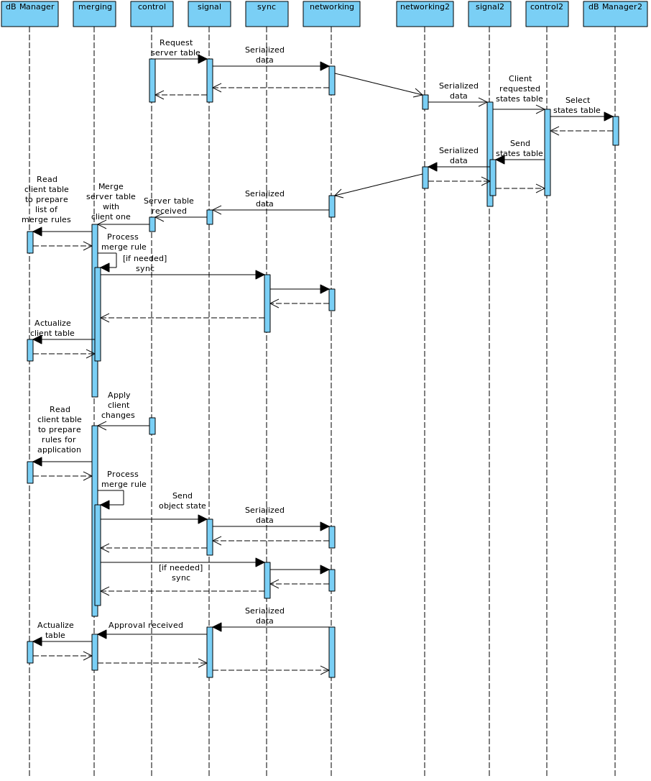
Fig. 2. Merging process

4. Client actions handling sequence
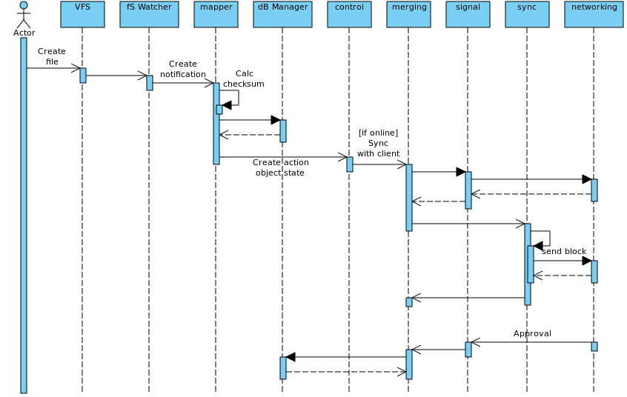
Fig. 3. Add/Modify action handling

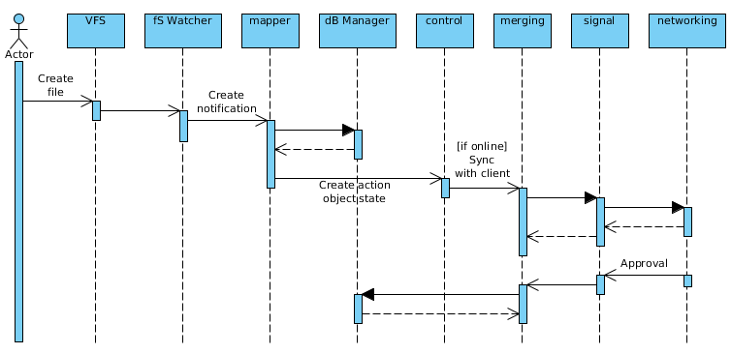
Fig. 4. Move/Rename/Delete action handling
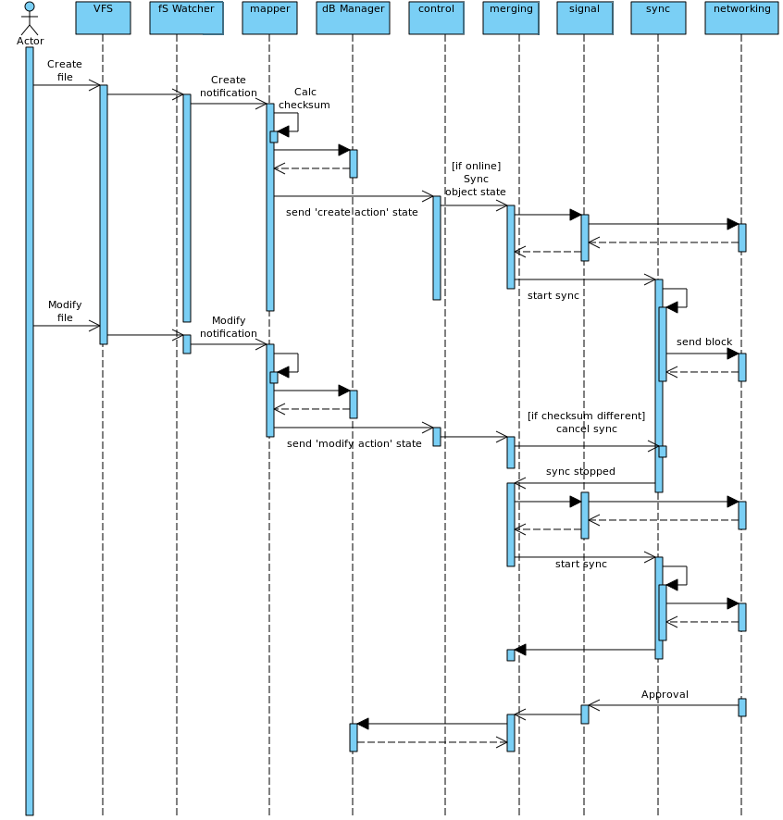
Fig. 5. Handling modification during syncing case

4. Server side merging process
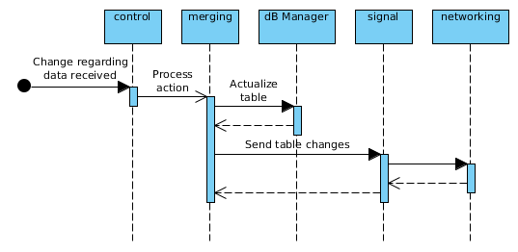
Fig.6. Changes processing at server side

5. Syncing process
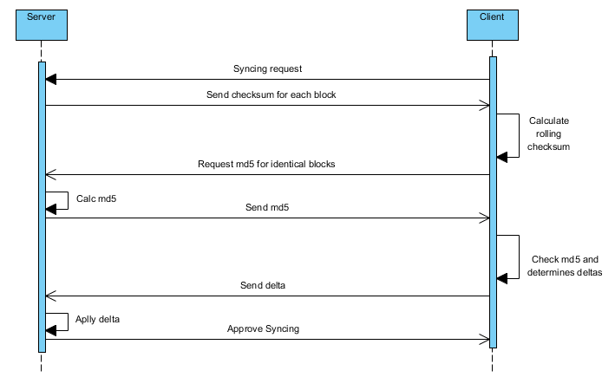
Fig. 7. Syncing changed file from client side
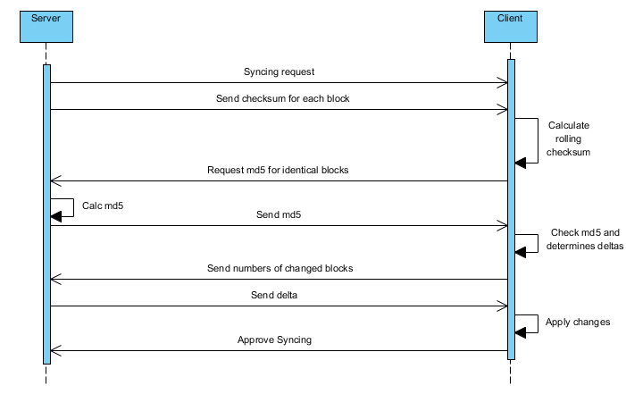
Fig. 8. Syncing changed file from server side

