nDrive requirements specification
Version 0.2

Contents
1. General purpose 4
2. Synchronization 4
2.1. Main Idea 4
2.2. File table 5
2.3. File system monitoring 6
2.4. File system actions 7
2.4.1. “Add” action 8
2.4.2. “Delete” action 9
2.4.3. “Move” action 10
2.4.4. “Copy” action 10
2.4.5. “Rename” action 11
2.4.6. “Edit” action 12
. 2.5. Remote Access 12
2.5.1. Any changes in file system on client side handling 12
2.5.2. Adding new record to action list 14
2.5.3. Action list processing 14
2.5.4. Connecting to the server 14
2.6. Direct Access (RDP) 15
2.7. Conflicts resolving 15
2.8. Versioning 16
2.9. Resuming uploading 16
2.10. Restrictions 16
3. Folder sharing 16
3.1. Overview 16
3.2. Do share 16
3.3. Get share 17
4. Refreshing 17
5. Network access 17
6. Graphics User Interface 17
6.1. Credentials window 17
6.2. Settings window 18
6.2.1. Shares accepting settings 18
6.2.2. Conflict auto resolving settings (don't sure, do we need it) 18
6.2.3. Notification settings 18
6.3. Monitoring window 18
6.3.1. Connection status 18
6.3.2. Shares manipulation monitoring 18
6.3.3. Synchronization monitoring 18
6.4. Shares window 18
6.4.1. Adding/removing share 19
6.4.2. Show shares 19
6.5. Conflicts window 19
6.6. Notification area icon 19
6.6.1. Animation 19
6.6.2. Notifications 19
6.7. Graphics environment context menu integration 19
6.8. No special UI for files and folder manipulation 20
6.9. History window 20
7. OS support 20

Revision History
Date | Version | Description | Author
19/11/2010 | 0.1 | Initial version | Alexey Polkanov, Kirill Kazakov, Anton Alferov
26/11/2010 | 0.2 | Removed GIT connected logic. Added file sync behavior description etc. | Alexey Polkanov, Kirill Kazakov, Anton Alferov

General purpose
The main purpose of the nDrive solution is to sync files between different network places. Each user has access to only own files and files that were shared for him.

The whole system displayed bellow (Fig.1).

Storage server
(Active)
DRDB
Linux
Storage server
(Passive)
DRDB
Linux
Terminal servers
Terminal servers
Terminal servers
LAN

Remote
sync

RDP

LDAP Authentication Server (Active Directory)
Client
(Windows, Linux, MAC, Android, Symbian, etc.)

Fig. 1. The system structure

So there are two ways to access for the nDrive folder:
- From terminal server directly by LAN;
- From client remote device throw wide area network.

The terminal servers are based on Windows Server OS that can accept RDP connections from the clients. Throw RDP user gets access to any services and software installed on the terminal servers. Also he has access to his nDrive storage throw local area network using UNC path.
Storage server is Linux based server. It has replication with hot swap support. The server side nDrive daemon commits all changes directly in the storage. For direct access by LAN all storages are accessible by SMB protocol.

2. Synchronization

2.1. Main Idea
The main idea is since any changes happen in one of synchronized points they should appear in the all other synchronized points as soon as possible. If the changes were made locally in offline mode, they will be sent to the server and synchronized just after connection appears.
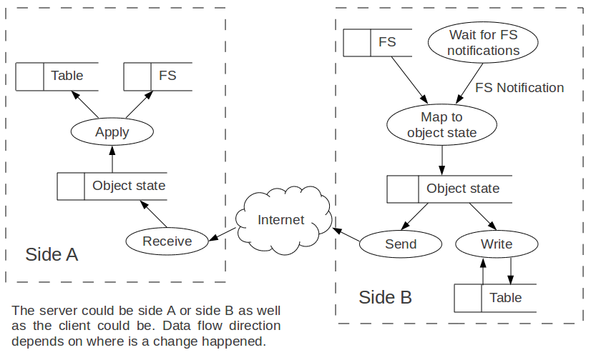

2.2. Object State Table
Both client and server have special table with the current states of all monitored objects (files and directories). Since the table has a row per an object one row describes Object State and the table is named as Object State Table. Object state record consists of the following fields:
ID | Unique identifier of the synchronized object
Name | Name of the shared object in the file system
ParentId | Identifier of the parent directory; zero means “on the root”
Version | Version number. It helps to determine where the latest version of the file. Also it can be useful for versioning and rollback
Checksum | Checksum of the file. If two files have equal checksums these files are considered as the same.
Example:

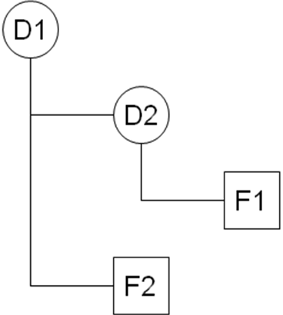

ID | Name | Parent ID | Version | Checksum
1 | D1 | 0 | 1
2 | F2 | 1 | 1 | 68643674
3 | D2 | 1 | 1
4 | F1 | 3 | 1 | 10289345

2.3. File system monitoring
Different file systems in different OS can be monitored for changes using different way (WinAPI for Windows, inotify/dnotify for GNU/Linux, FSEvents for Mac OS X). If we don’t have the way to get asynchronous notification about changes we can monitor file system journal or files content. In any case the following notification should be:
- Add file or directory
- Delete file or directory
- File modification
- Move file or directory
So we have one notification interface for each file system and different native implementation. Monitoring process is shown at figure below:

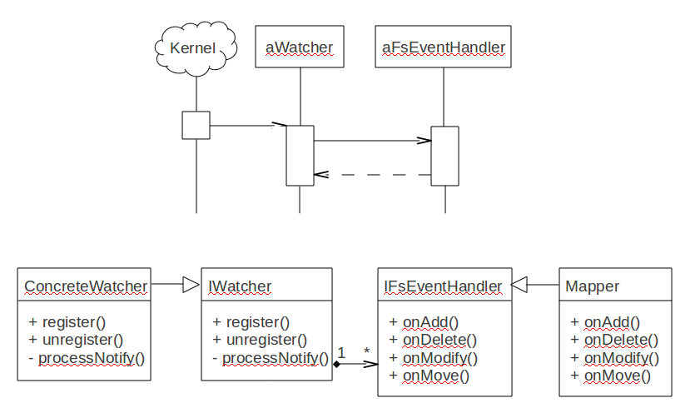

2.4. File system actions

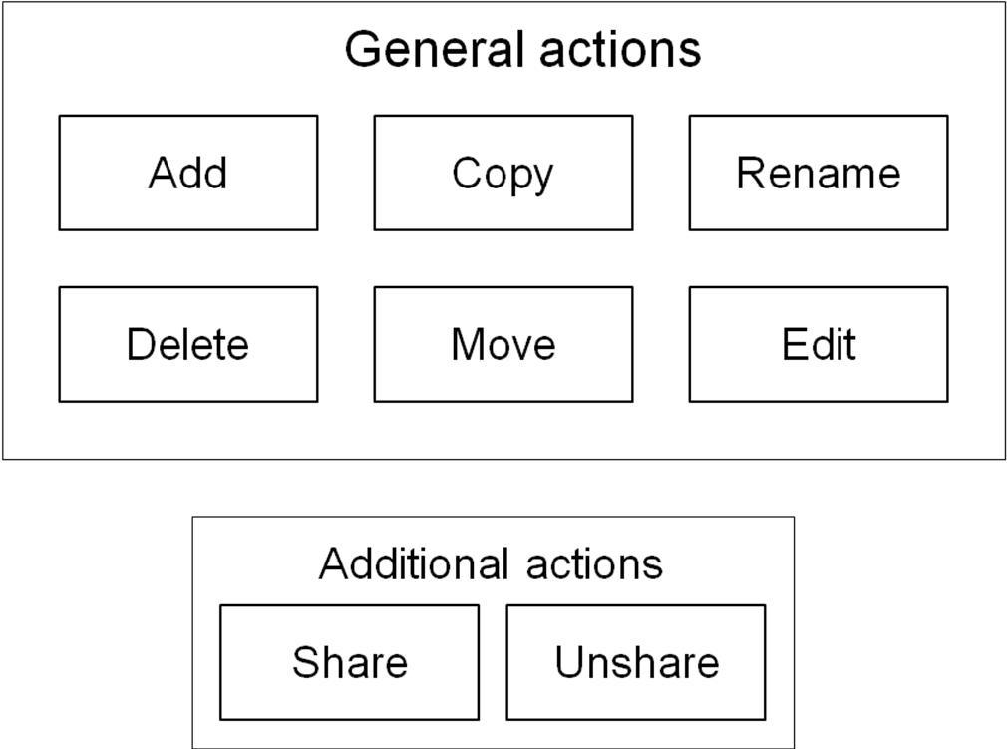

2.4.1. “Add” action

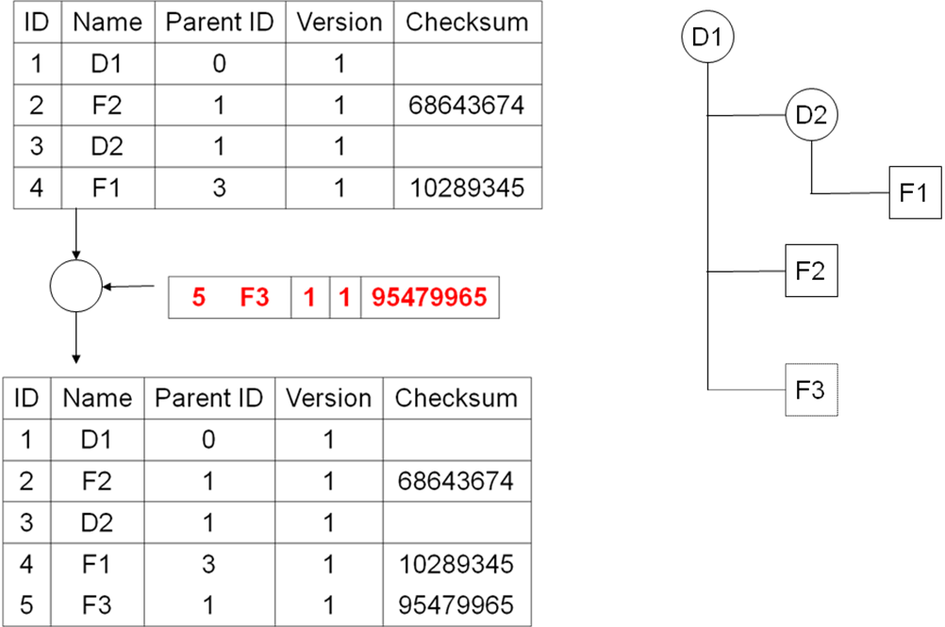

2.4.2. “Delete” action

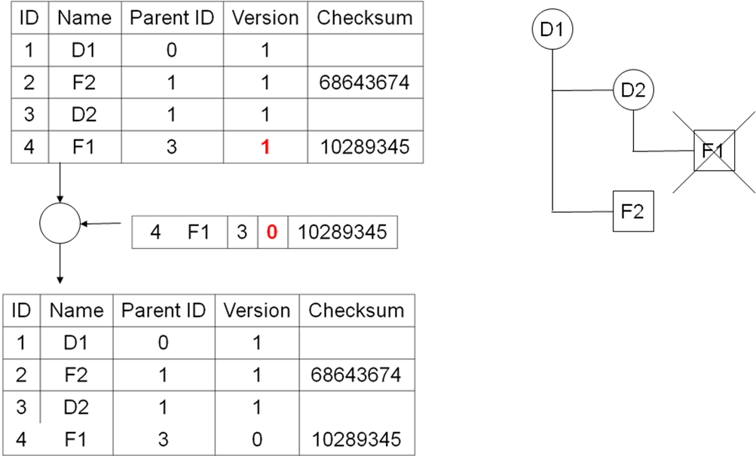

2.4.3. “Move” action

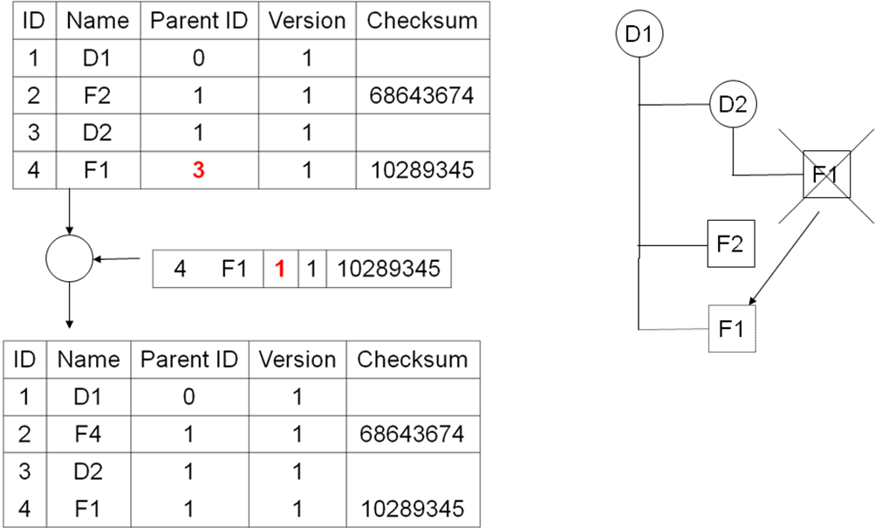

2.4.4. “Copy” action

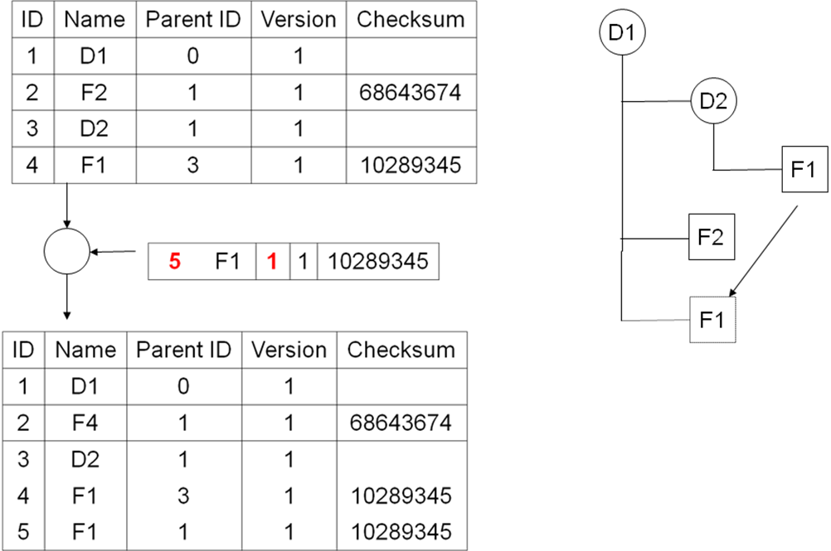

2.4.5. “Rename” action

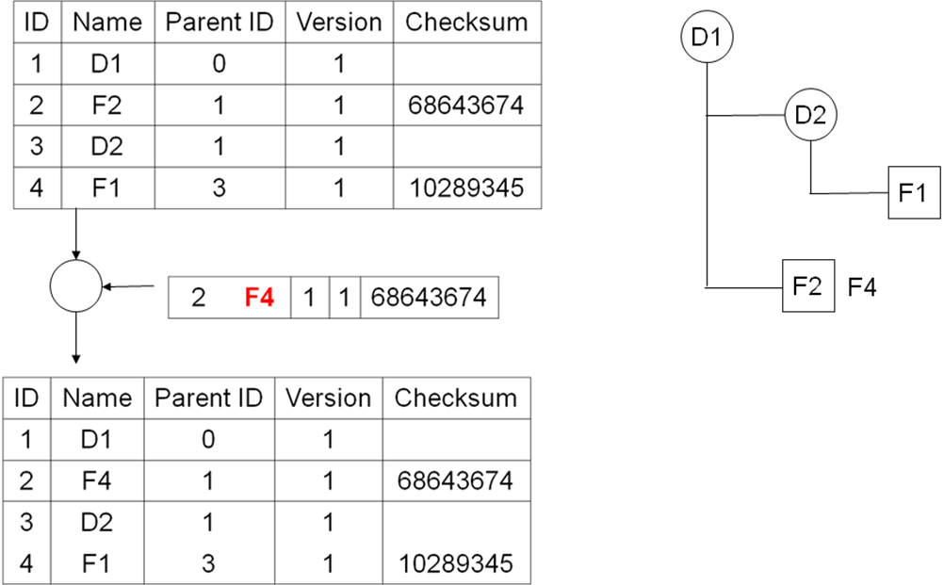

2.4.6. “Edit” action
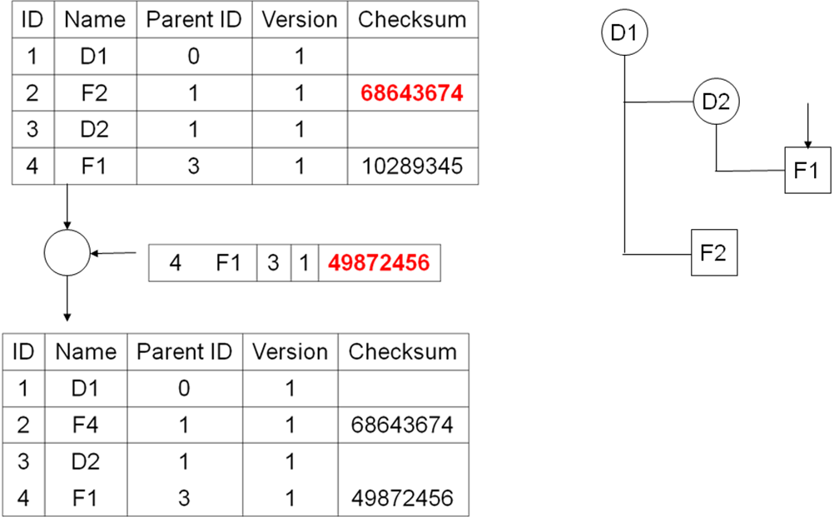

. 2.5. Remote Access
For the remote access user should install nDrive client and specify the path to the local copy of his storage. Special nDrive service will start and establish connection with the server.

There is ability for partial synching. If the client has not enough space or just don’t want to get all data from master storage he can get only the folders tree and select what he wants to download.

2.5.1. Any changes in file system on client side handling

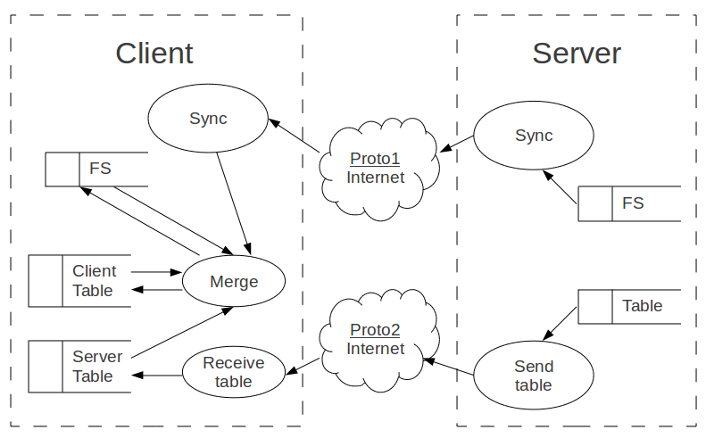
The file system change that can be notified by File System:
- Add file or directory
- Delete file or directory
- File modification
- Move file or directory
These actions can be mapped to the following actions:

File system notification | Client side event | Handling
Adding file or directory | Adding file or directory | - Checksum calculating 2  - Create new table record  - Put record to the action list
Adding file or directory | Copying file1
Delete file or directory | Delete file or directory | - Changing table record (changing version to 0)  - Put record to the action list
File modification | File modification | - Checksum calculating  - Preparing table record (changing checksum)  - Put record to the action list
Moving file or directory | Moving file or directory | - Preparing table record (changing parent id)  - Put record to the action list
Moving file or directory | Renaming file or directory | - Preparing table record (changing Name)  - Put record to the action list
¹There is no need to detect coping directory because we detect coping all the files it includes and directory creation.
² Not acceptable for directories

2.5.2. Adding new record to action list
If there is no record with the same id or file name and parent id (for new files id is unknown) new record just added to the action list. If we delete the file that exists in the server we move this action to the end of the list.
If the record id exists there are three ways of handling it:
- Replace it by new one
- Add new record.
- Remove existing record
The second way can be used in the case when existing record is modifying of new added file that is the copy of any existing files.
The third way we use if new action is rollback of existing action (e.g. adding the same file that was removed).
In other cases the existing record is replaced by new one. If more than one record exist the last replaces by new.

2.5.3. Action list processing
The action lists processes by one record in the order that exists in this list. When record starts processing it becomes locked. If some changes happen with the file, it’s syncing have to be rejected and restarts.
Action processing order:
- Action locked on the client
- Action sends to server. If the file is locked on the server now clients reject the action and go to the next action.
- Server do something and sync data with client if there is necessity
- During the syncing server side file is locked for modification
- After syncing has finished server modifies its table and send client ACK
- Client moves record from action table to main table.

2.5.4. Connecting to the server
When the client has connected to the server it gets file table and compares it with its file table and action table. If there is the change on server in the file that was changed on client too it means that conflict appears. In the other case client finds all differences between its table and server table and apply them one by one using the same method as for action list processing (see the table below).

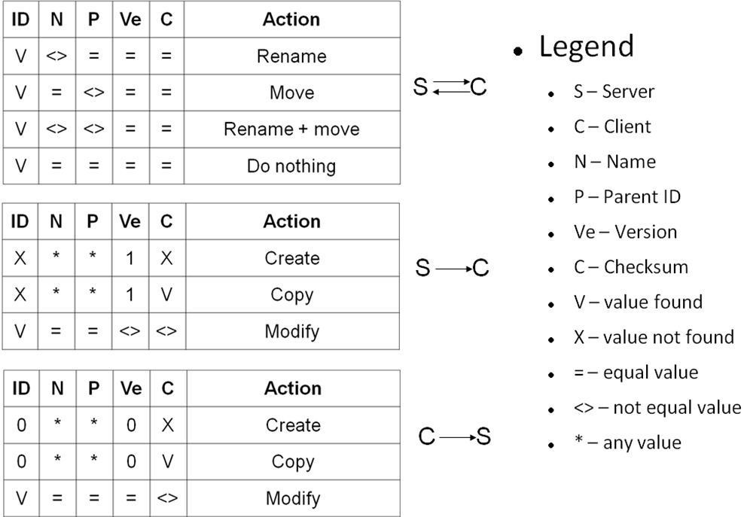

After uploading all changes from server client downloads its local changes (see action list processing).

2.6. Direct Access (RDP)
Client can use direct access to his storage throw the remote desktop on terminal server. He should use UNC path to open his storage that placed on Linux based Storage server. If he does some changes they are committed automatically by nDrive daemon running on the Storage server

2.7. Conflicts resolving
Conflicts appear in the case when there are some not pulled changes in the server and some local changes in one moment. In this case there are three options for user:
- Replace storage copy by his local copy;
- Replace his local copy by the storage copy;
- Rename local copy and save separately in the storage.

2.8. Versioning
System supports versioning. The number of stored versions can be limited.

2.9. Resuming uploading
System supports continue data transferring after network fails and appears again.

2.10. Restrictions
Using synchronized files directly at the server by remote desktop is caused by some restrictions and cases where behavior may be not friendly for user.
- When any remote client uploads its changes to the server the file is locked for writing and can’t be edited by anybody throw RDP.
- In other side when any file on server side is opened directly by the program that locks it (e.g. MS Word) remote client can’t upload its changes to the server. Also we can’t do any with parent directories.
- Warning! When any file on server side is opened directly by the program that doesn’t lock it (e.g. notepad) the client can upload his new version. But the changes obviously doesn’t appear in the program where this file is opened and can be rewritten and lost if the file will be saved on the server.

Folder sharing

Overview
File sharing allows one user to give access for any folder to another user or group of users.
Each user has a table that contains following information:
- Share folder address
- Share folder path in local copy
- Synchronization status
Client gets this table from Web service and if one of the records hasn’t been processed yet it process it (see 3.3.).

Do share
File sharing gives an ability to allow other users to see specialized folders from your storage.
Sharing the folder is doing in follow way:
- Created request to the Web service passing email of the target user and the folder that we want to share.
- For local access in the target user storage the symbolic link to the shared folder created.
Special rights added to the corresponding folder in the Storage server file system.
- For the remote access the shared folder becomes …. (????)

Get share
New share checked automatically by server notification. When new share detected by client side it suggests user to accept it and download all its content to the computer or reject downloading its content. There is an ability to accept rejected share and download content later.

Networking
Remote access to the Nivio storage uses some different protocols:
- HTTPS (web services)
- Object State Protocol (OSP)
- File Partial Syncronization Protocol (FPSP)

4.1. Server
Web services are hosted on another server so we do not have to care of them.
Really users do not want to transmit their files through insecure channel and we should use SSL to encrypt metadata and file content. So we have secure versions of our two protocols – OSPS and FPSPS accordingly.
Many users go to the Internet through a firewall or/and a proxy that allows the HTTP and HTTPS only. Because HTTP is unsecure nDrive client should be able to use HTTPS-tunneled versions of our two protocols – OSPT and FPSPT. Our server deals with both of them using the same port so we should provide some meta protocol xSPT which joins OSPT and FPSPT but does not mix them.
So our server listens these ports
- on port 443 as HTTPS and deals with xSPT
- on port XXX as SSL/TCP and deals with OSPS
- on port YYY as SSL/TCP and deals with FPSPS

4.2. Client
nDrive client uses web services from time to time and does not keep connection to a host provides web services. On the contrary nDrive client keeps permanent connection to our server provides xSPT, OSPS, and FPSPS. This connections means the client is online at the moment.

5. Graphics User Interface

5.1. Credentials window
The window should provide two input fields to make user able to type his user name and password. There also should be a check box to be able to save password and login automatically next time.

5.2. Settings window
This window should allow to manipulate with settings which are listed below.

5.2.1. Shares accepting settings
User can decide how to accept new personal shares, for example he can decide to automatically accept it if its size is under some condition. Or he can decide to do it unconditionally.

5.2.2. Conflict auto resolving settings (don't sure, do we need it)
User can decide to resolve conflicts automatically with one of the proposed ways (we should to investigate more on ways which git offers, and to filter them).

5.2.3. Notification settings
There number of notifications are supposed to be appeared, so user probably don't need them all. Thats why there should be an ability to turn particular notifications on/off.

5.3. Monitoring window
This window should reflect the state or progress of the process and actions listed below.

5.3.1. Connection status
Connection status reflects is we offline or online. In case of the offline status there could be a reason of the last connection lost and information about reconnection attempts (countdown or time left to the next connection attempt, manual connection attempt button).

5.3.2. Shares manipulation monitoring
All the time when user creates or deletes the shares this process should be monitored in this area. Progress, success results, errors and probably something else.

5.3.3. Synchronization monitoring
This area reflects the synchronization process in the same ways as with the shares: progress, success results, errors and so on.

5.4. Shares window
This window should allow manipulating with the user's shares.

5.4.1. Adding/removing share
User can share any synchronized folder with all users or with the some particular user.
He probably can share any folder on his disk which was not synchronized so far as well. In this case folder becomes in sync automatically first.
The above is also applicable for the share removing with the one exclusion: removing the share does not remove synchronization automatically. Such behavior could be as option.

5.4.2. Show shares
This part should show all the accepted and pending shares from other users, shares from this user and the public share.
The interface should provide navigation elements to be able to open those shares for browsing on a local disk if shares are available here or on the web if not.

5.5. Conflicts window
This window show all the conflicts which are appeared during the synchronization and shows the ways how to resolve them. User should be able to select from the proposed ways on how to resolve particular conflict.
It probably could be also an ability to apply some rule for all or some selected conflicts.

5.6. Notification area icon
The notification area icon should reflect the activity of the system in a simple way.

5.6.1. Animation
The icon should be changed and be animated on a synchronization process.
It should show special icons for unsynchronized, synchronizing and synchronized states.
It also should show a special icon when waiting the user to resolve the problem (accept the share or resolve conflict).

5.6.2. Notifications
The next notifications could be appeared during the system working:
- online
- offline
- somebody shared a folder with you
- conflict(s) appeared

5.7. Graphics environment context menu integration
Some features should be available from the every place while user working with his files, so the nDrive solution's own menu should be integrated into the graphics environment context menu.
So the following items should be appeared in that menu:
- make current folder synchronized/unsynchronized
- share/unshare folder with/from somebody or with/from everybody
- show the folder status if it is under some synchronization process

5.8. No special UI for files and folder manipulation
The solution should not provide some special UI for manipulating with files and folders to make them synchronized. That process should be transparent for the user to make him able to use the file manager he prefers. One thing he should to do explicitly is to mark some root folder synchronized.

5.9. History window
This window should show the number of last N actions which user was doing. As those actions are processing on files user should have ability to rollback particular files up to N steps back.

6. OS support
The following OS have to be supported on client side:
- Windows
- Linux
- MAC OS
- Android
- Symbian
- BlackBerry (without synchronization)

