Create three Instances
--abhiJenMaster
--abhiJenSlave1
--abhiJenSlave2

--abhiJenMaster Instance serves as the master Instance and the Remaining two Instances are the Slave instances.

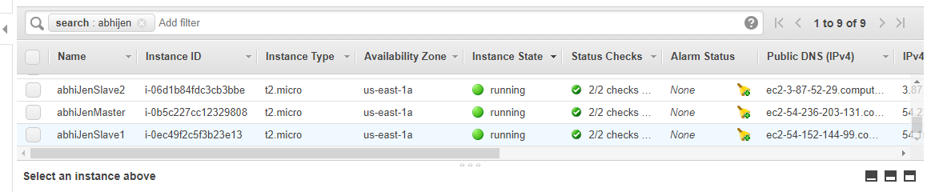

--Allow SSH(22), HTTP(80) and port 8080 in the Inbound Rules of the Security Groups of the Above Instances.

--Generate a KeyGen Pair in the Master Instance

-- [ec2-user@ip-172-31-83-224 ~]$ ssh-keygen -t rsa

--Paste the Public Key in the Authorized_Keys file in the 2 slave Instances

--Install Jenkins on the Master Instance

--[ec2-user@ip-172-31-83-224 ~]$ sudo wget -O /etc/yum.repos.d/jenkins.repo http://pkg.jenkins.io/redhat/jenkins.repo

--[ec2-user@ip-172-31-83-224 ~]$ sudo rpm --import https://pkg.jenkins.io/redhat/jenkins.io.key

--[ec2-user@ip-172-31-83-224 ~]$ sudo yum install jenkins -y

--[ec2-user@ip-172-31-83-224 ~]$ sudo service jenkins start
Starting jenkins (via systemctl): [ OK ]

--Install Java On all the 3 Instances

--$ sudo yum install jre

--Install Git On all the 3 Instances

--$ sudo yum install git

--Open Jenkins and and Add the Two Slave Nodes to the Master Node by adding the Private key of the Master into those..

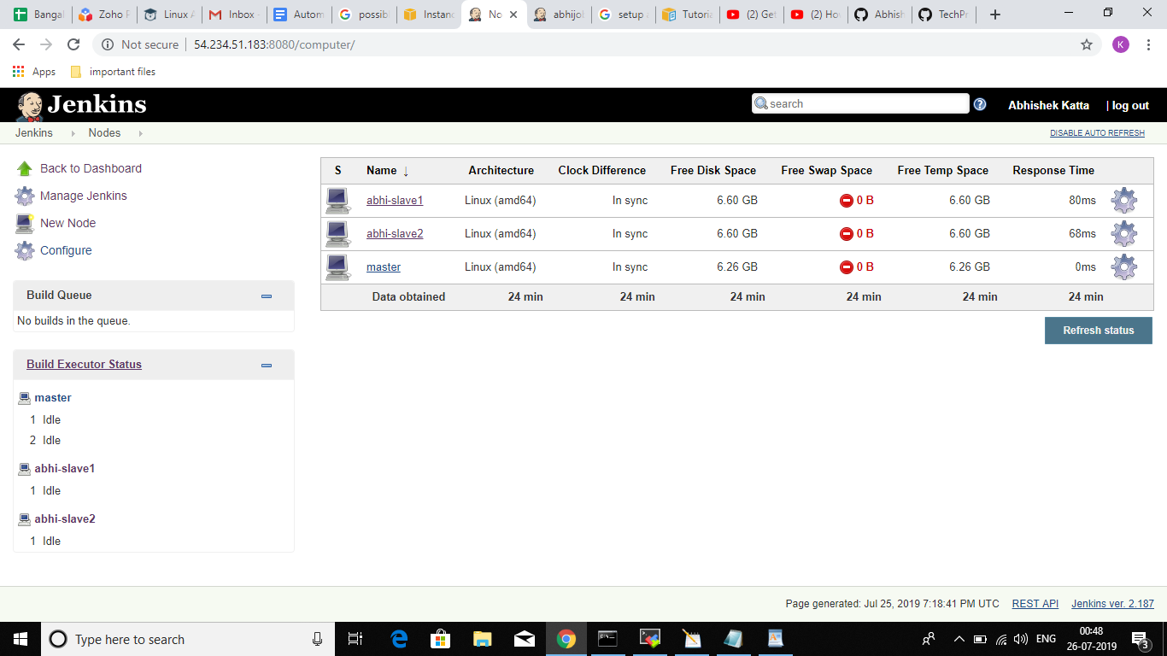

--Now Create Two Jobs
- abhi-Job-a
- abhi-job-b

--In abhi-Job-a , in the build Step we give the repository from which we need to fetch the File

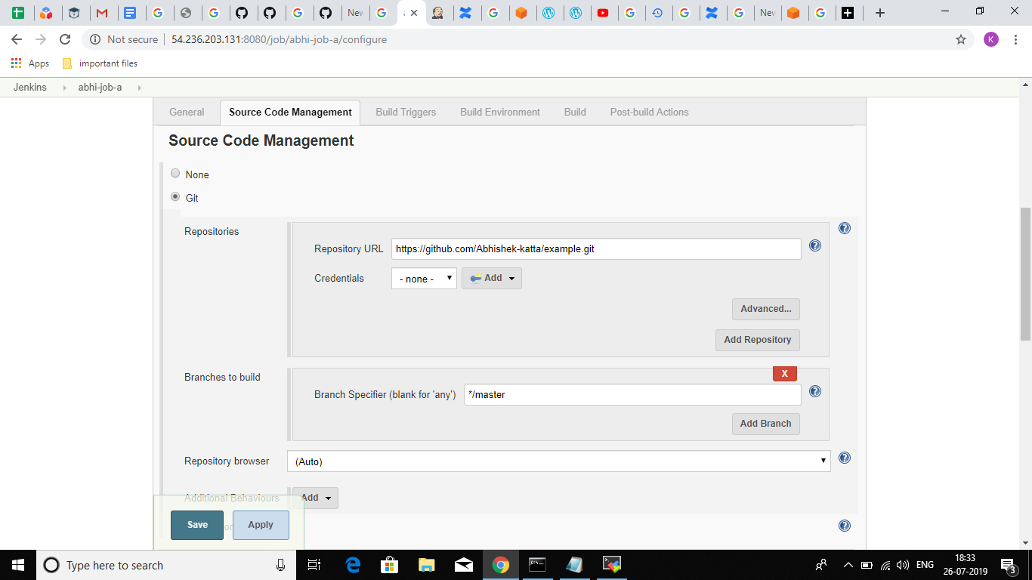

--Configure the 2nd Job i.e abhi-Job-b in such a way that it gets triggered after the job a has been finished and it adds the file obtained from job a to a Bucket in the Deploy Step.

--here is the config of abhi-job-2

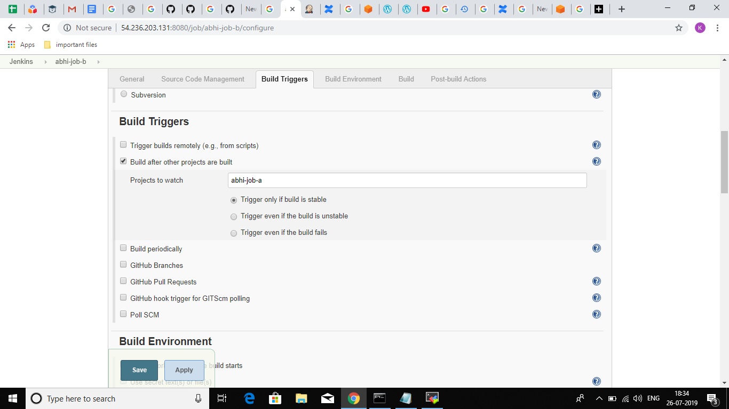

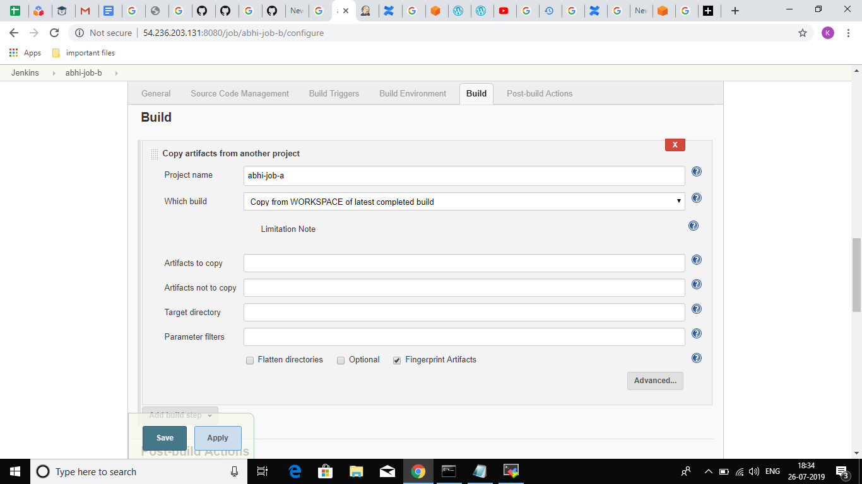

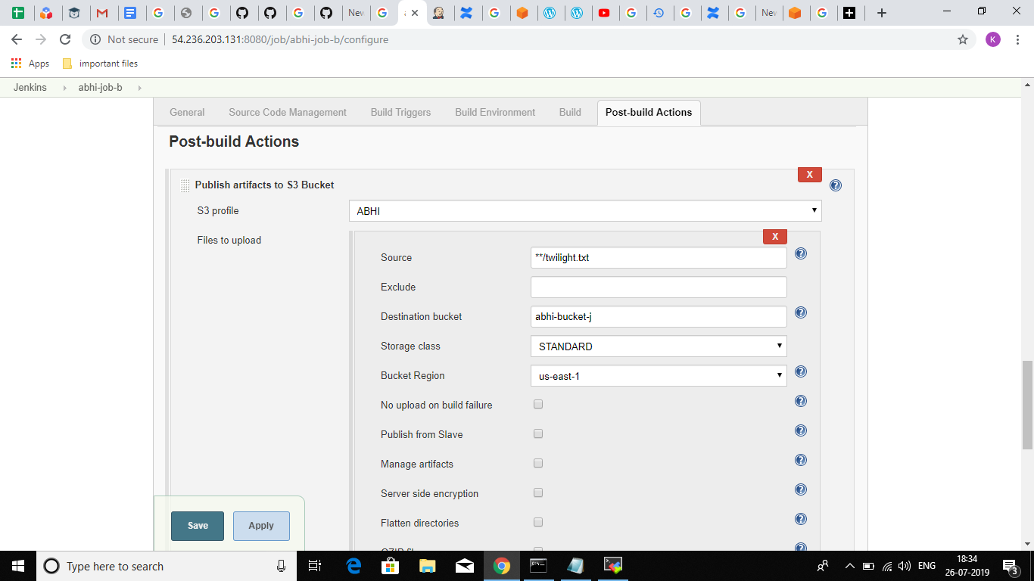

--build the job1

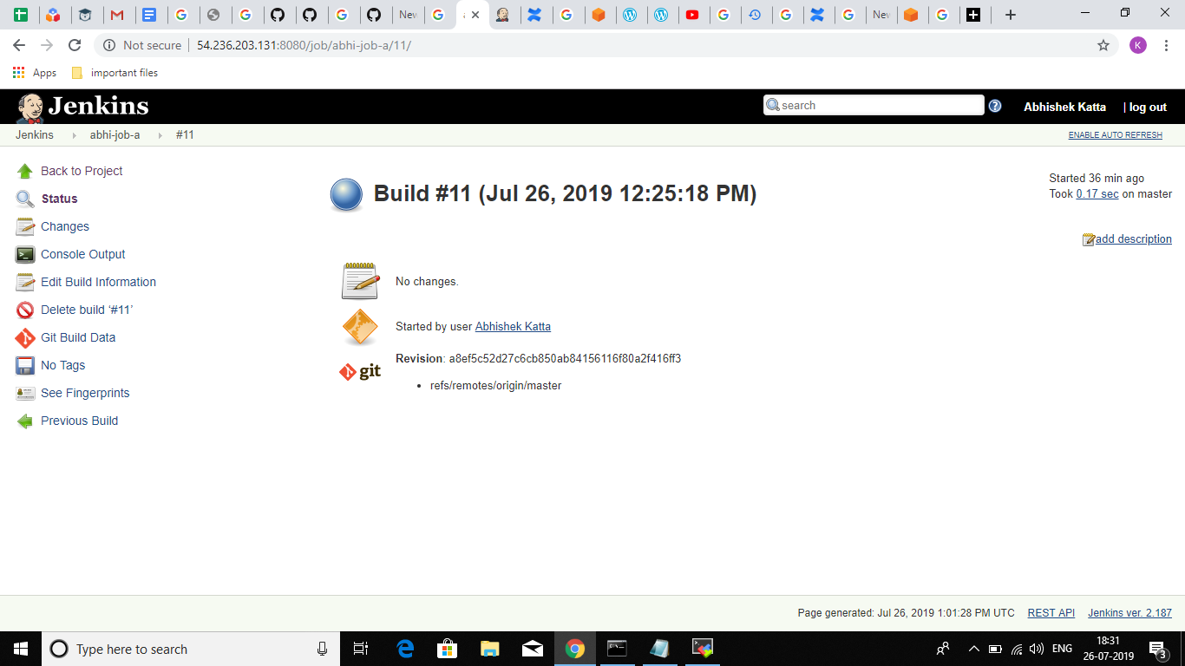

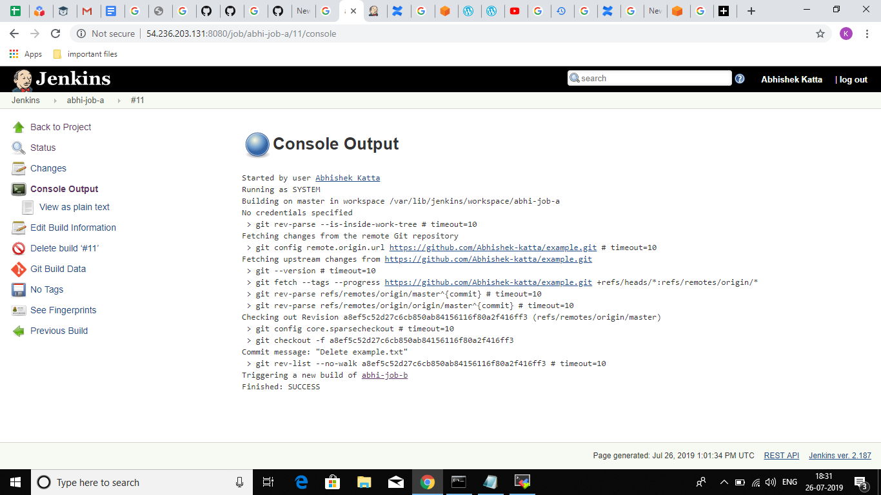

--Now the next process in the pipeline.. job 2 gets built..

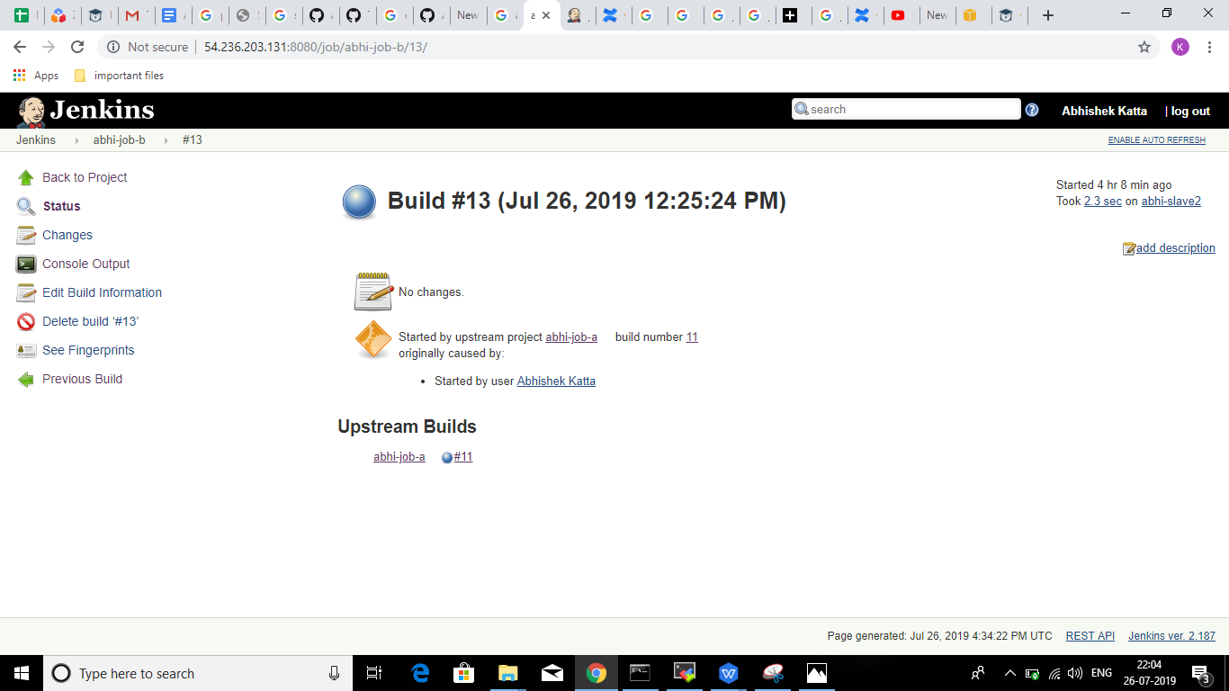

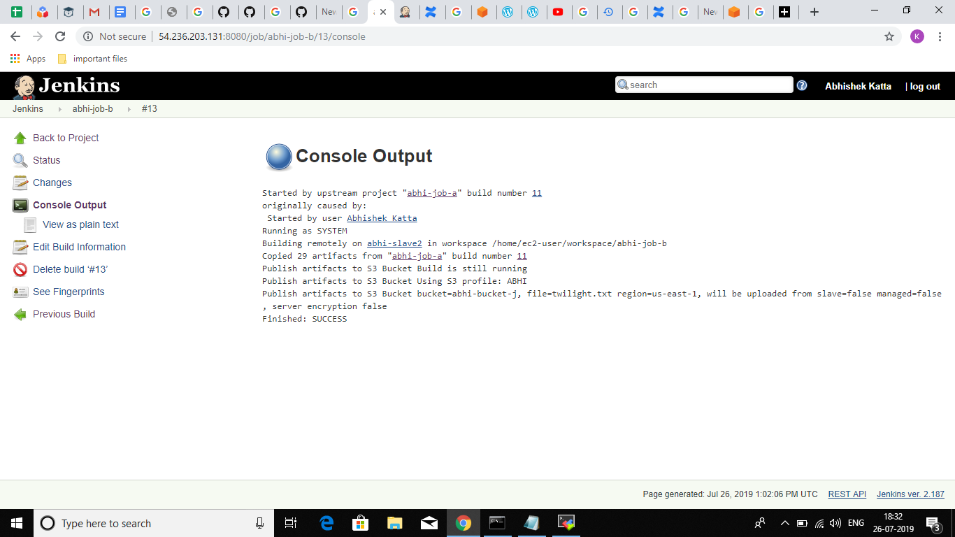

--So after this let’s checkout the bucket..

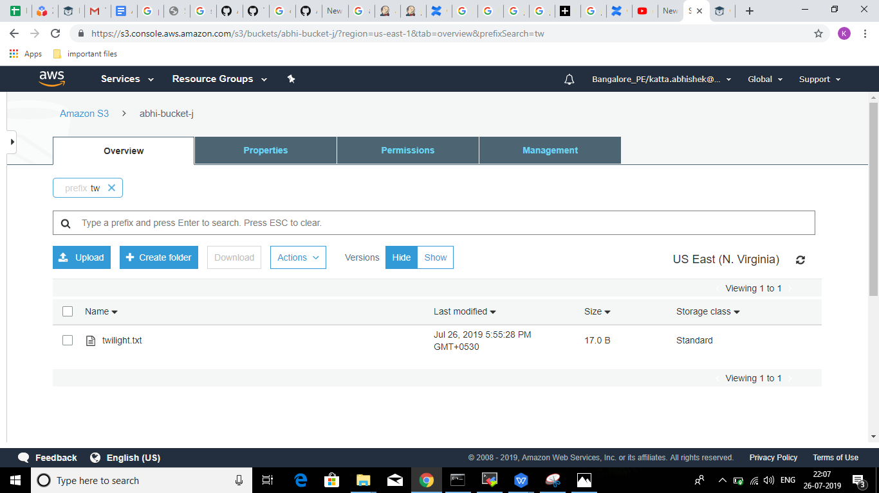

And so we have Successfully Setup a Jenkins ecosystem with one master and two slave nodes and setup a pipeline which in build step fetches a file from git repository and in the deploy step pushes it to a bucket..

