-- Create an EC2 Instance, “AbhiTF” and Install Terraform in it Using the Following Commands..

--sudo yum install -y zip unzip (if these are not installed)
--Wget https://releases.hashicorp.com/terraform/0.9.8/terraform_0.9.8_linux_amd64.zip
--unzip terraform_0.9.8_linux_amd64.zip
--sudo mv terraform /usr/local/bin/
Check Terraform Version--
-- terraform --version

Create Three Files--
-ec2.tf--which consists of the code to create the EC2-Instance
-variables.tf--in which we declare all the variables
-terraform.tfvars--in which we give the variable values.

Here is the ec2.tf--
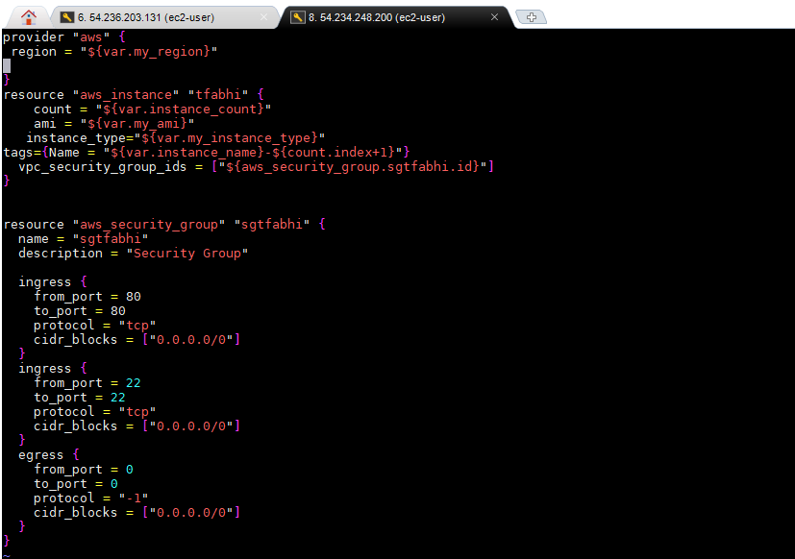

Here is the variables.tf pic--
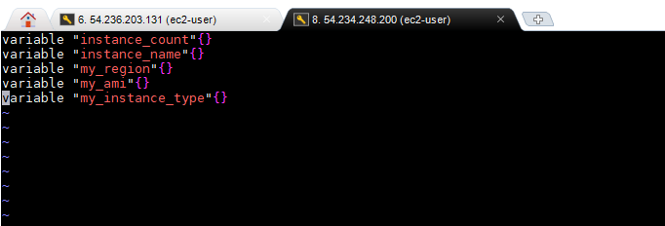

Here is the terraform.tfvars pic--
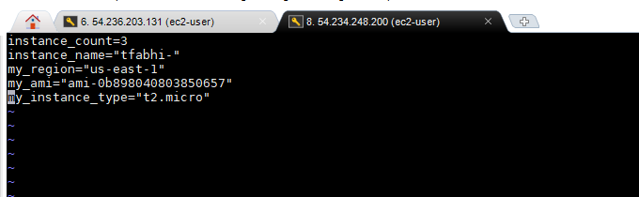

--$ terraform init--terraform will get initialized

--$ terraform plan-- it will show the plan

--$ terraform apply--it will apply the above plan and create the ec2 instances..

------------------Here is a pic of the created ec2 Instances---------

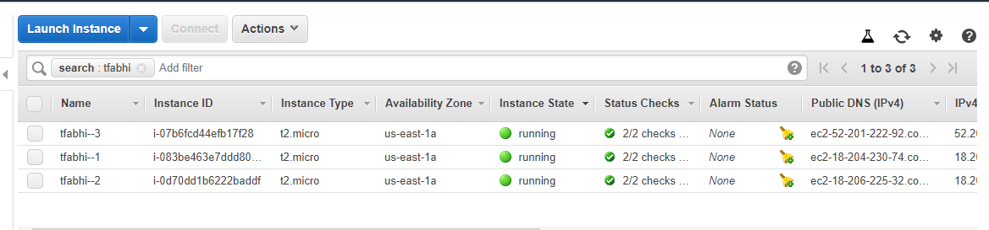

Here is the SG of these Instances

