A & B.
1.Create an EC2 Instance “AbhiNginxDockerLi” and SSH into it.

2.Update the installed packages and package cache on the Instance..
-- $ sudo yum update -y

3.Install Docker in the Instamce..
--$ sudo yum install docker -y

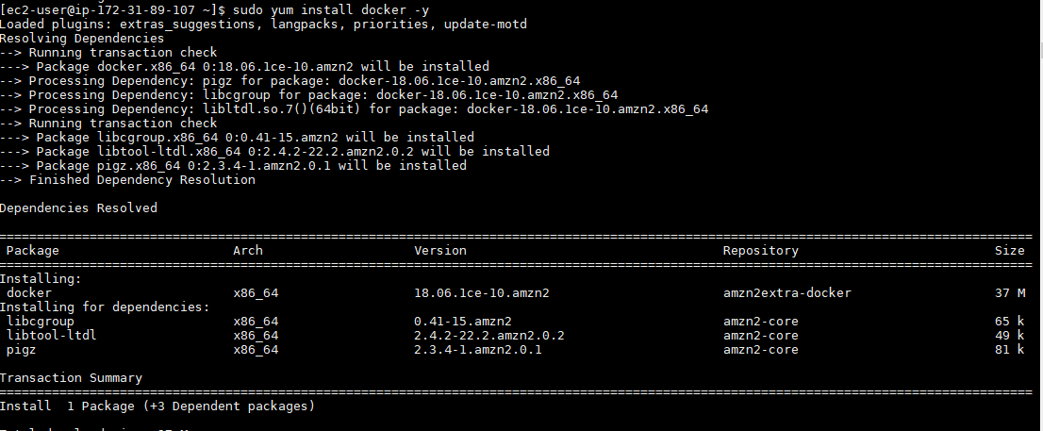

- Start the Docker service
--$ sudo service docker start

5.Add the ec2-user to the docker group so you can execute Docker commands without using sudo.
--$ sudo usermod -a -G docker ec2-user

Log out and log back in again to pick up the new docker group permissions.

6.Now Create the DockerFile
--$vi Dockerfile

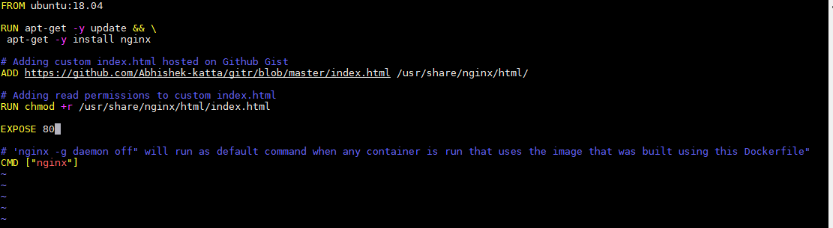

- Build the Docker image from your Dockerfile
-- $ docker build -t abhitest .

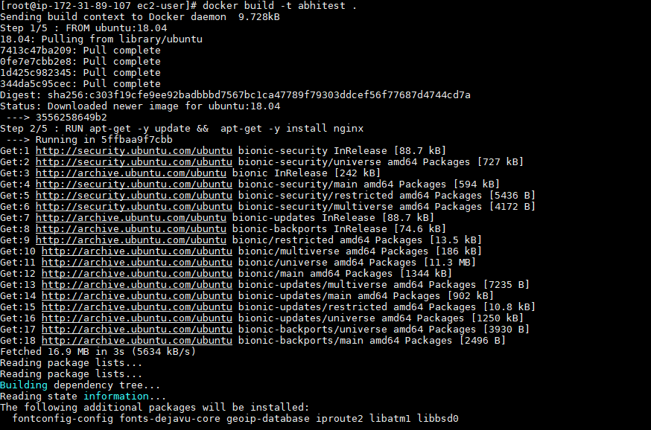
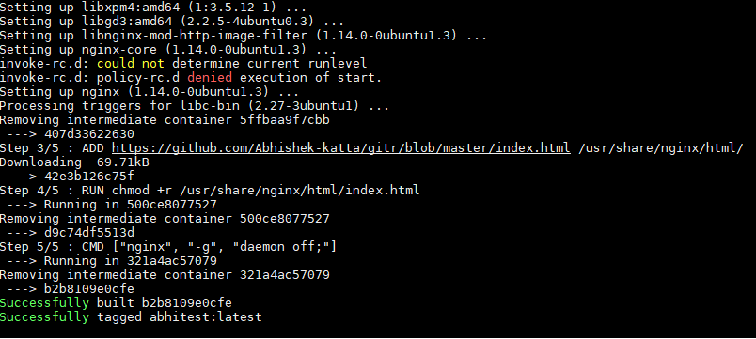

8.Run the newly built image. The -p 80:80 option maps the exposed port 80 on the container to port 80 on the host system
--$ docker run -t -i -p 80:80 hello-world

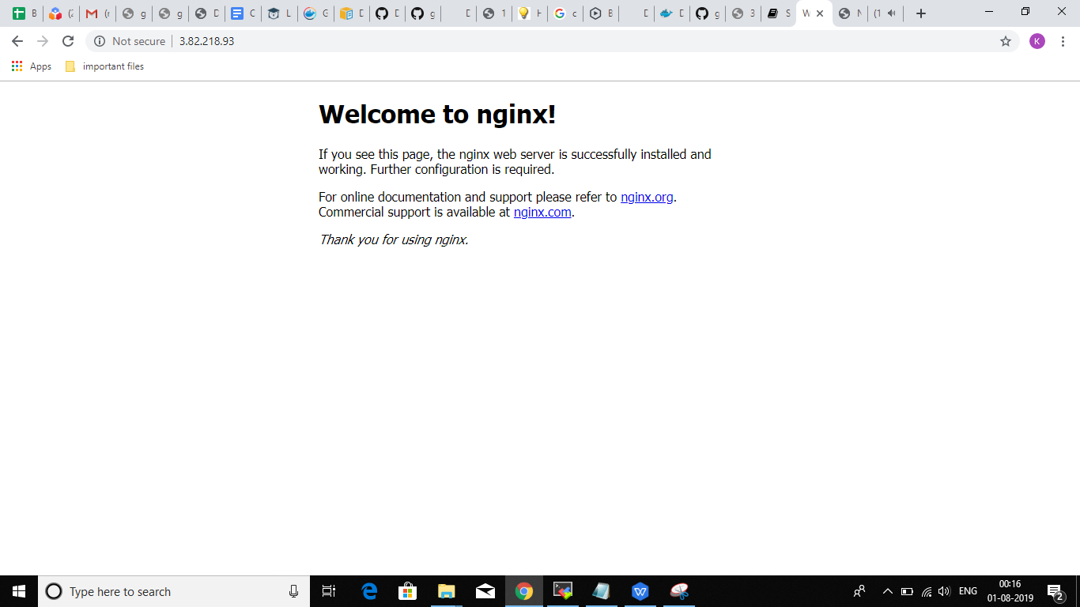

- & D.

--Publishing port 8080
--In the Dockerfile add the Below Line
EXPOSE 8080

And then -- $ docker build -t abhitest .
And then -- $ docker run -t -i -p 8080:8080 hello-world

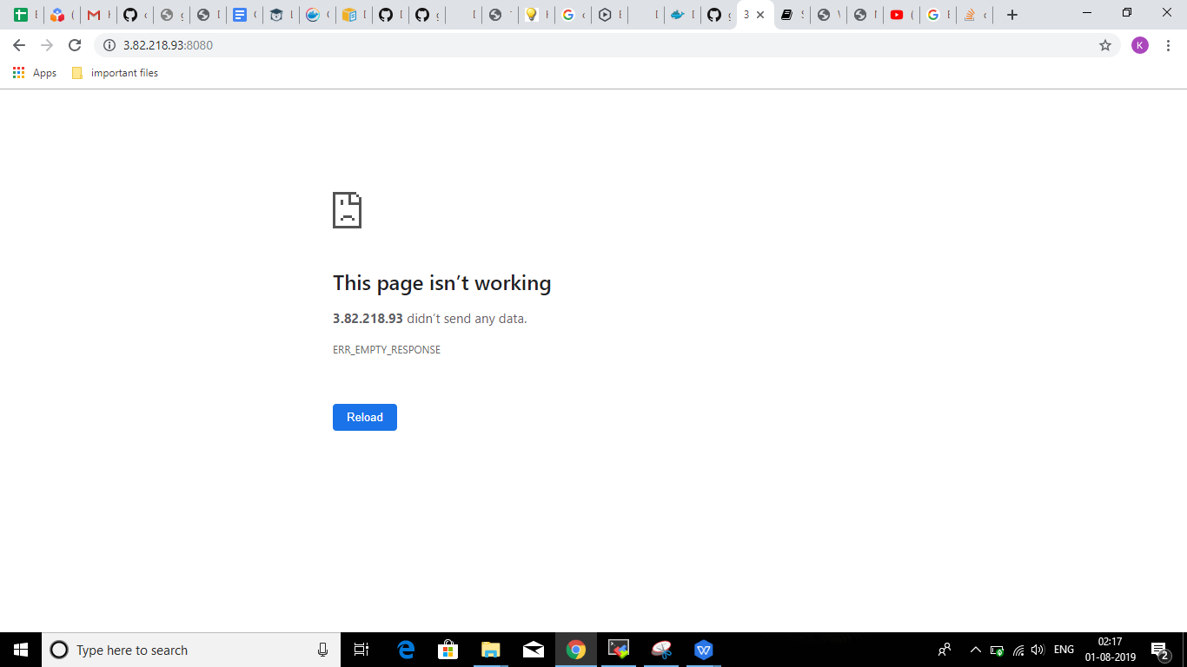

E.
- Executing Bash and Installing Nano
[root@ip-172-31-89-107 ec2-user]# --$ docker exec -it c51755df0e31 /bin/bash

root@c51755df0e31:/# sudo yum install nano -y

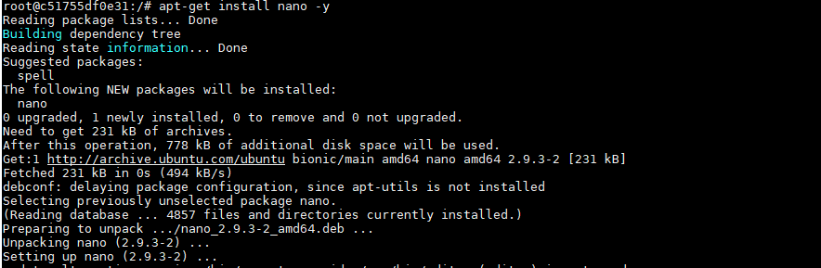

F.
--Pushing it to Docker Hub

We need to create a Docker Hub Account and Create a Repository..
My Repository Name is testrep

--$ docker login
Enter Username : abhishekkatta143
Enter Password : ************

--Tag the Image and then Push it to the Above Mentioned Repository
--$ docker tag 6053c91f2e40 abhishekkatta143/testrep:taggesh
--$ docker push abhishekkatta143/testrep:taggesh

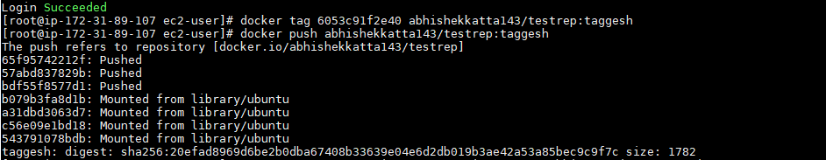

--Pushing Image to the ECR..

[root@ip-172-31-89-107 ec2-user]# aws ecr create-repository --repository-name abhi-repository --region us-east-1

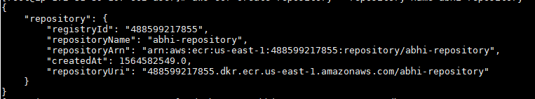

--Run the aws ecr get-login --no-include-email command to get the docker loginauthentication command string for your registry.

[root@ip-172-31-89-107 ec2-user]# aws ecr get-login --no-include-email --region us-east-1
--we will get a very big credential and then will be loggen in..

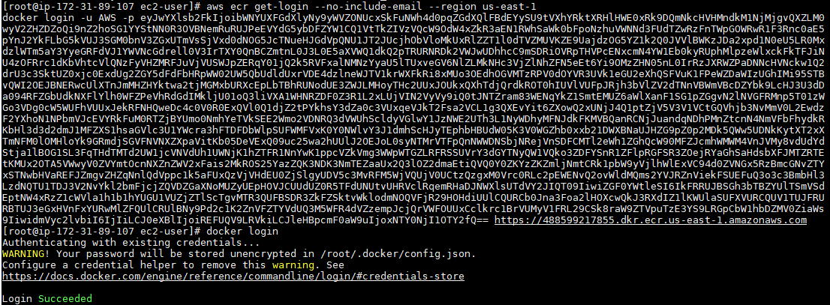

--Tag the Image..

[root@ip-172-31-89-107 ec2-user]# docker tag 6053c91f2e40 488599217855.dkr.ecr.us-east-1.amazonaws.com/abhi-repository

--Push the Image to the ECR

[root@ip-172-31-89-107 ec2-user]# docker push 488599217855.dkr.ecr.us-east-1.amazonaws.com/abhi-repository

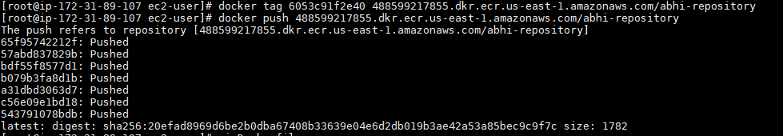

--Pushing image to GCR:

--Install gcloud sdk on the EC2 instance.

--Give the Instance the Permissions to Access the GCR

--Tag the Image with registry name
-- $ docker tag imageid gcr.io/pe-training/gcrpushabhi

--Push the image into the GCR
-- $ docker push gcr.io/pe-training/gcrpushabhi

