--Create an EC2 UBUNTU Instance and SSH into it.

--Install Docker and Docker-Compose in it.
--$ sudo apt install docker.io
--$ sudo apt install docker-compose -y

--Start the Docker Service.
--$ sudo service Docker start

--Make a Directory named “abhi”
--$ mkdir abhi

--$ cd abhi

--Create 4 files in the Present Directory
-Dockerfile
-app.py
-requirements.txt
-docker-compose.yaml

--Here is Dockerfile

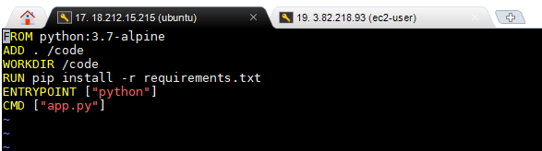

--Here is the app.py

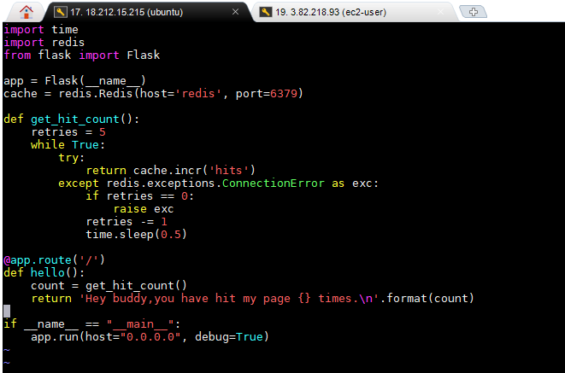

--Here is the docker-compose.yaml

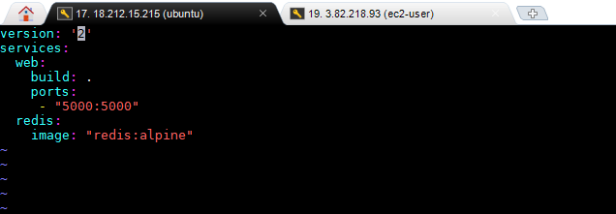

--Here is the requirements.txt

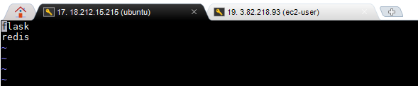

--Run the Docker- Compose

--$ docker-compose up
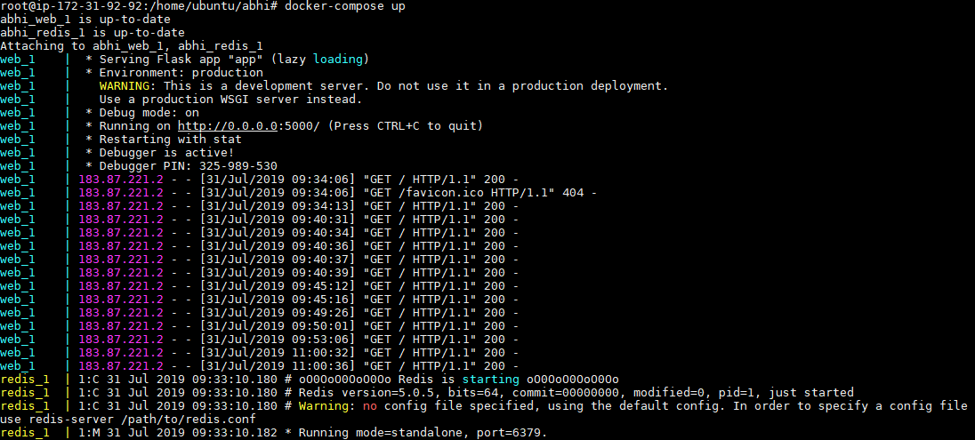

--Here is the Output when we Hit the Page

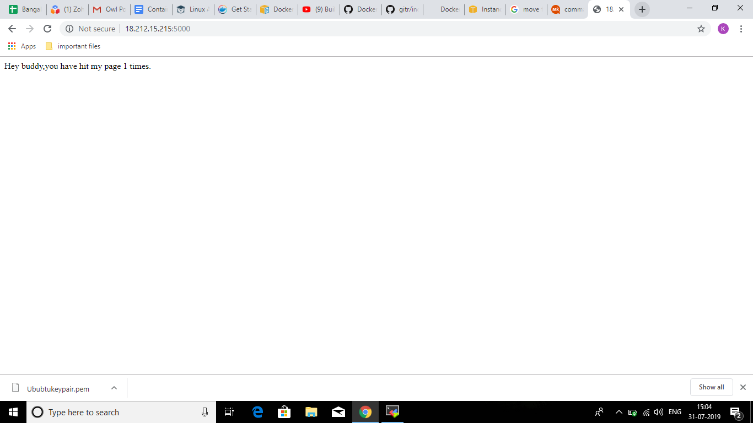

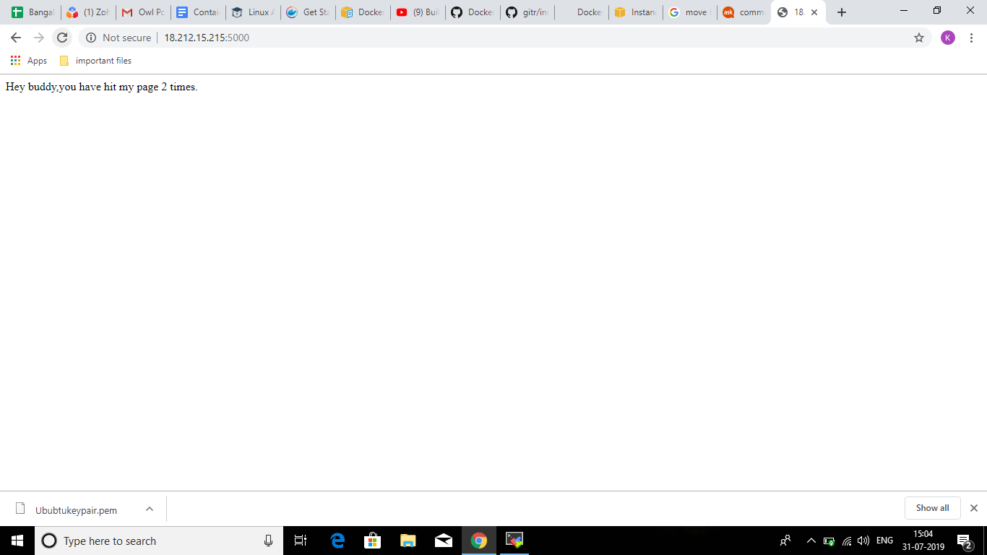

--So with each hit the Page Counter Increments.

