Question - 2 (2)
--In this Method..

We added a bind mount for the web service. The new volumes key mounts the project directory (current directory, '.') on the host to /code inside the container, allowing us to modify the code on the fly, without having to rebuild the image.

So now the new docker-compose.yaml file will be like

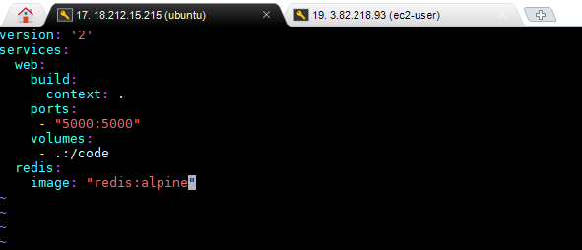

So if there are any changes, the following Shows up..

...
web_1 | * Detected change in '/code/app.py', reloading
web_1 | * Restarting with stat
web_1 | * Debugger is active!
web_1 | * Debugger PIN: 147-007-146

--Stop the docker-compose
--$ docker-compose down.

