--Create A Private Instance i.e an Instance which doesnt have an External IP Address.

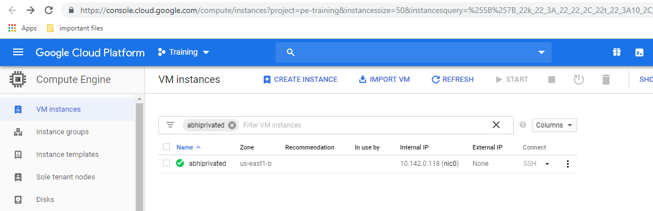

--Create a Public Instance

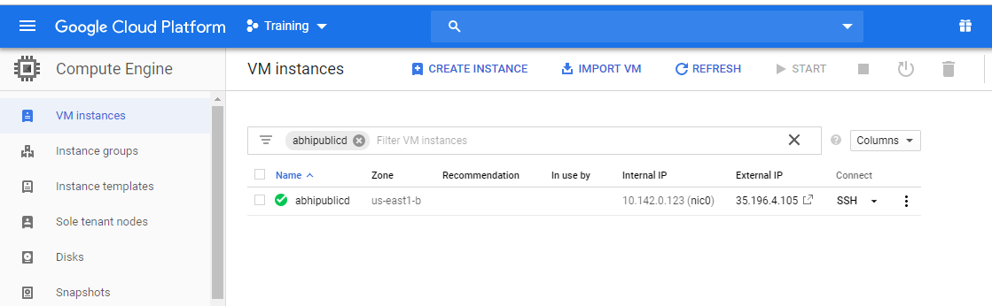

Create a Nat Gateway and while Creating a Nat Gateway we will get an option to create a router..enter a router name and associate it with the VPC and the Region in which the Private instance is Created.

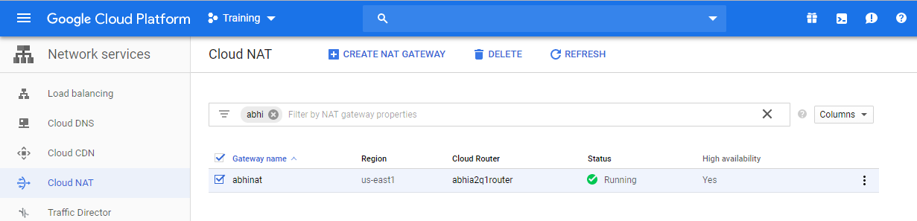

----Now ssh From the Public Instance

----From the Public Instance ssh the Private Instance

----We will Enter the Private Instance now.

----Ping Google From the Private Instance..and it works!!
