--Create an Instance with the following Startup Script which Installs Apache Server in the Instance.

Here is the Startup Code For it..

#! /bin/bash
apt-get update
apt-get install -y apache2
cat <<EOF > /var/www/html/index.html <html><body><h1>Abhishek Katta</h1> </body></html>
EOF

--Now Open the External IP Address of the Instance in a Web Browser Say Google Chrome Tab.
--It Displays the User Name.

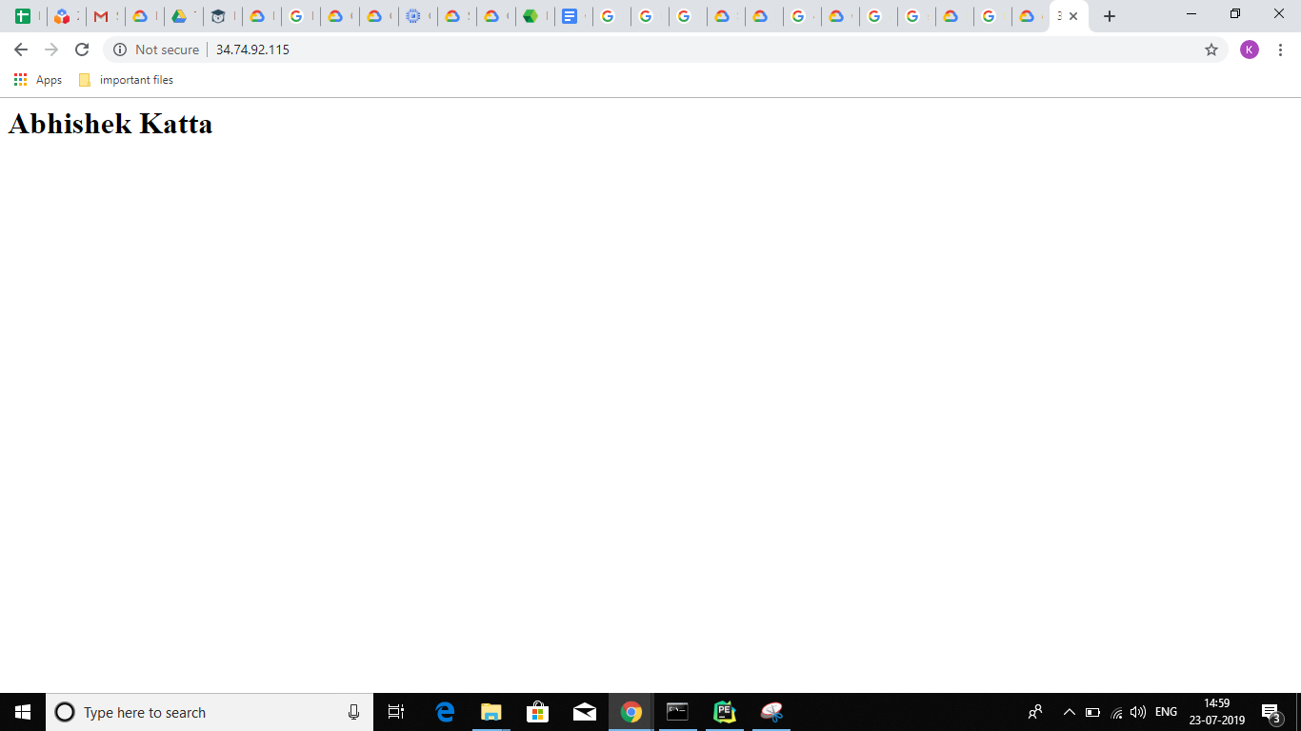

--Now Stop the Instance using Gcloud SDK CLI..

gcloud compute instances stop abhiserverinstance

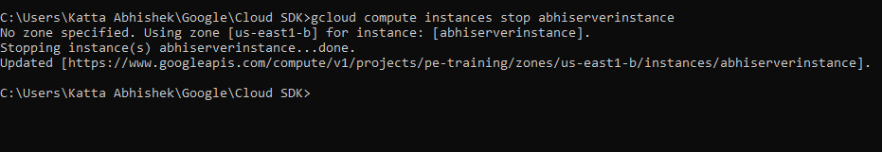

--Now Start the INstance

gcloud compute instances start abhiserverinstance

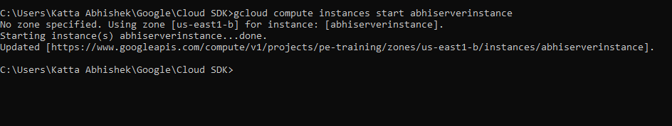

__ Now Check if the Server is working or not By opening the now Created External IP Address in Google Chrome New Tab.

--Now here is the the log file of the server startup.

