--Create A Bucket in the Cloud Storage --> abhibucket01

--Create A Cloud Function which gets Triggered if an Object is Added to the Above Bucket and if the Added Object in the Bucket is an Image then the Cloud Function Detects the Objects From the Images.

Here is the Code of the Cloud Function

from google.cloud import vision
from google.cloud.vision import types

class MyError(Exception):
pass

def detect_labels(uri):
client = vision.ImageAnnotatorClient()
image = vision.types.Image()
image.source.image_uri = uri
response = client.label_detection(image=image)
labels = response.label_annotations
print('Labels:')
print(labels)

for label in labels:
print(label.description)

def hello_gcs(event, context):
formats = ["image/jpeg", "image/png", "image/gif", "image/bmp", "image/webp", "image/x-icon", "application/pdf", "image/tiff"]
file_name = event['name']
file_type = event['contentType']
uri_path = "gs://abhibucket01/" + file_name
try:
if file_type not in formats:
Raise Error
detect_labels(uri_path)
except Error:
print(“the File is not in the Image Format”)

--Now View the LOgs of the Cloud Function in Which we get the Objects in the Given IMage

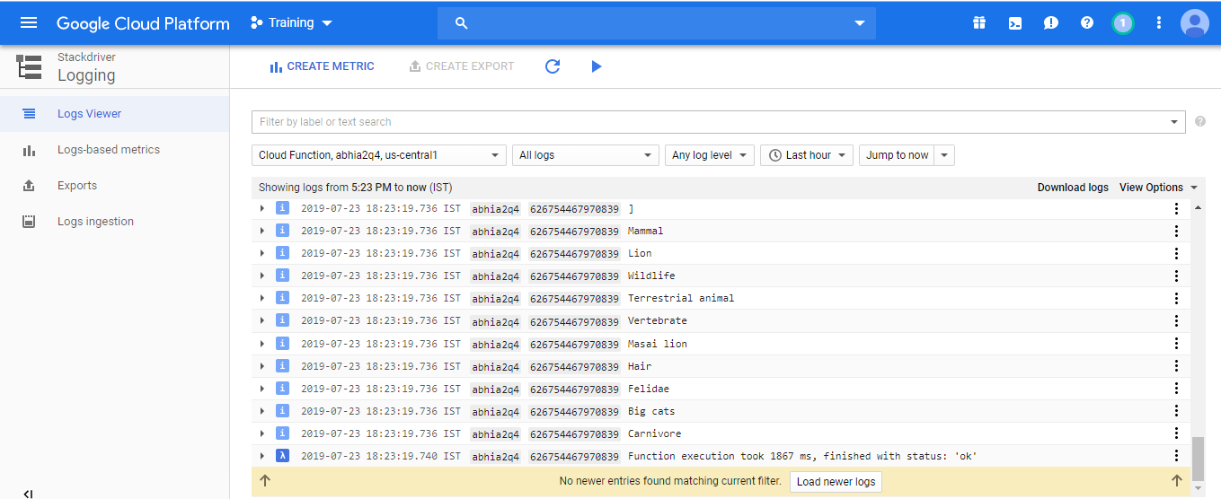

--Here is the Bucket View

