E-Commerce Sales Analytics & Forecasting
Capstone Project Report
Dataset: Sample - Superstore (Kaggle) — 9,994 e-commerce orders, 2014–2017.
Source link: https://www.kaggle.com/datasets/vivek468/superstore-dataset-final

1. Project Overview
This project analyzes historical e-commerce order data from a US-based retailer to answer a core business question: what is driving sales and profit performance today, and what should the business do next? Rather than presenting raw numbers, the analysis is organized the way a business owner or executive would consume it — starting from an executive summary, moving into sales and customer detail, and ending in a concrete, forward-looking action plan.
The workflow follows: raw data → cleaning → exploratory analysis → key performance indicators (KPIs) → a forecasting model → a business narrative of fact, insight, opportunity, risk, and action.

2. Data Cleaning
The raw dataset (9,994 rows, 21 columns) required the following cleaning steps before analysis:
- Parsed Order Date and Ship Date from text into proper date fields.
- Removed exact duplicate rows.
- Dropped rows with an unparseable order date.
- Removed rows with zero or negative Sales/Quantity (data entry errors).
- Engineered helper fields: Order Month, Order Year, and Profit Margin (Profit ÷ Sales).
After cleaning, all 9,994 rows passed validation with no missing values in any column used for analysis.

3. Key Performance Indicators (KPIs)
Six candidate KPIs were considered (revenue, orders, customers, average order value, profit, and growth %). The three highlighted below best represent overall business health without overwhelming the reader:
KPI | Value
Total Revenue | $2,297,200.86
Total Profit | $286,397.02
Total Orders | 5,009
Total Customers | 793
Average Order Value | $458.61
Latest Month-over-Month Growth | -29.2%

4. Sales & Product Analysis

4.1 Executive Overview: Monthly Revenue Trend
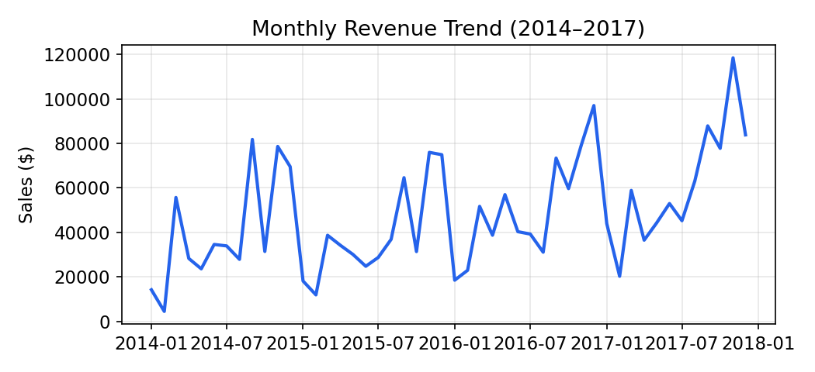
Revenue shows a clear seasonal pattern with year-end peaks, consistent with typical US retail seasonality.

4.2 Sales & Profit by Category
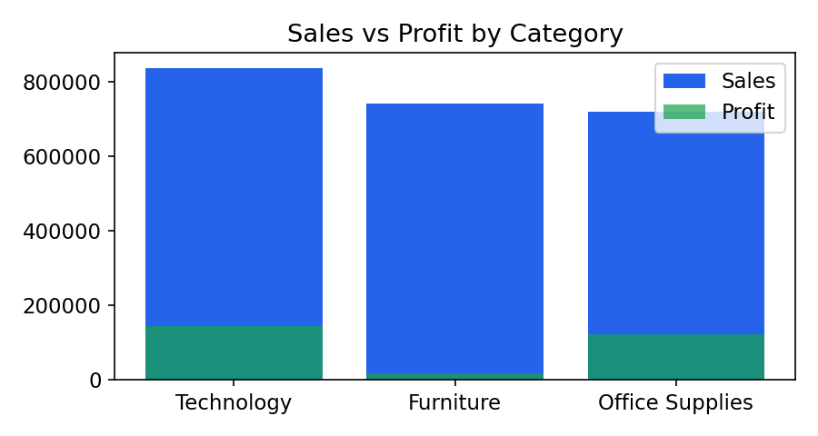
Category | Sales | Profit
Technology | $836,154 | $145,455
Furniture | $741,999 | $18,451
Office Supplies | $719,047 | $122,491

Insight: Furniture generates revenue comparable to Technology and Office Supplies but produces dramatically less profit — a strong signal of margin erosion, likely from discounting.

4.3 Sales by Region
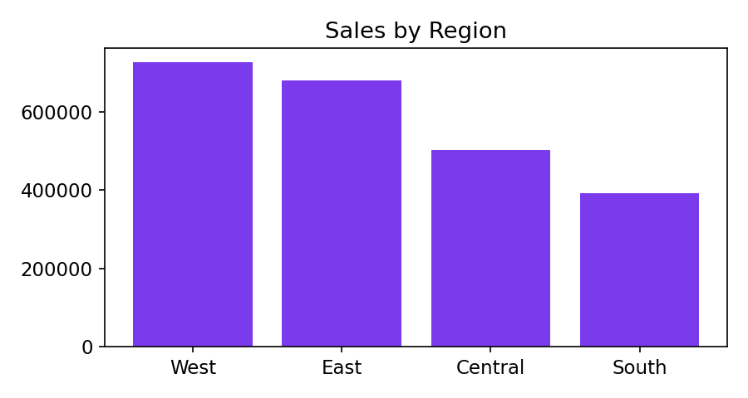
The West and East regions together account for the majority of revenue and profit, while the South lags on both dimensions.

5. Customer & Risk Analysis

5.1 Top Customers
The top 10 customers by total sales range from roughly $12,000 to $25,000 in lifetime purchases, representing a valuable, concentrated segment worth retention investment.

5.2 Churn Risk
Using a simple recency rule (no order placed in the last 6+ months relative to the most recent order date in the dataset), 199 of 793 customers (about 25%) are flagged as churn risk. This is a significant share of the customer base and warrants a proactive retention response.

6. Forecasting Model
A Linear Regression model was trained on monthly aggregated sales using two lag features (prior month, two months prior) and a month-of-year feature to capture seasonality. The data was split 80/20 in time order (never shuffled, since this is a time series) to evaluate the model honestly on unseen future months.
KPI | Value
MAE (Mean Absolute Error) | $17,471
RMSE (Root Mean Squared Error) | $22,661
R² (holdout set) | 0.10
The modest R² reflects the short history available (48 months) and the simplicity of the model, which was chosen deliberately for transparency over accuracy. The forecast below should be read as a directional guide, not a precise prediction.
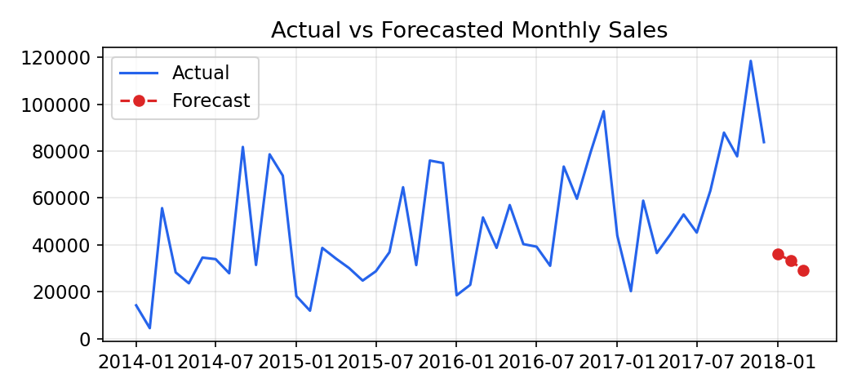
Month | Forecasted Sales
January 2018 | $36,062
February 2018 | $33,278
March 2018 | $29,066

7. Business Narrative: Fact → Insight → Opportunity → Risk → Action

Fact
Furniture generates high revenue but low profit; a subset of regions and customers drive most value; a quarter of customers are at churn risk.

Insight
Discount-heavy categories are quietly eroding margin, and customer value is concentrated rather than evenly spread — losing top customers would disproportionately hurt revenue.

Opportunity
Electronics/Technology outperforms on margin; increasing focus (marketing spend, inventory, promotions) on Technology and top-performing regions (West, East) can grow profit faster than revenue alone.

Risk
199 customers show high churn risk, and continued heavy discounting on Furniture threatens overall profitability even as revenue looks healthy.

Action
- Launch a targeted retention offer for high-value, at-risk customers identified in Section 5.2.
- Review and tighten discount policy on Furniture sub-categories to protect margin.
- Shift a portion of marketing budget toward Technology and the West/East regions.
- Re-run the forecast model monthly as new data arrives to keep the Q1 sales plan current.

8. Project Files
- ecommerce_sales_analytics.py — single Python file: data cleaning, EDA, KPI computation, forecasting model, and Streamlit dashboard.
- requirements.txt — Python library dependencies.
- README.md — overview and run instructions.
- E-Commerce_Sales_Analytics_Report.docx — this document.
- GitHub repository — hosts all of the above (link submitted separately).

