Answer 1

first=input("enter first name :")
last=input("enter last name :")
print(last,first)
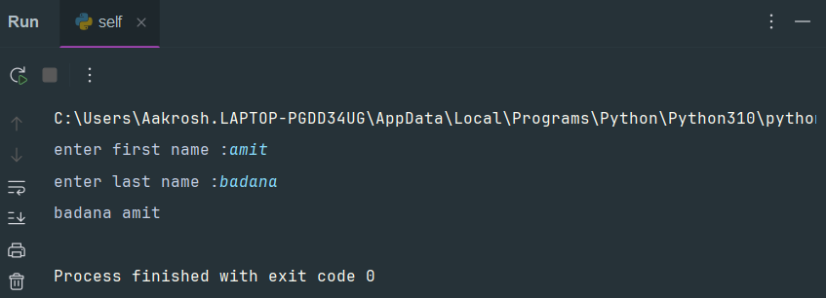

Answer 2
import calendar
y=int(input("enter year:"))
m=int(input("enter month:"))
print(calendar.month(y,m))

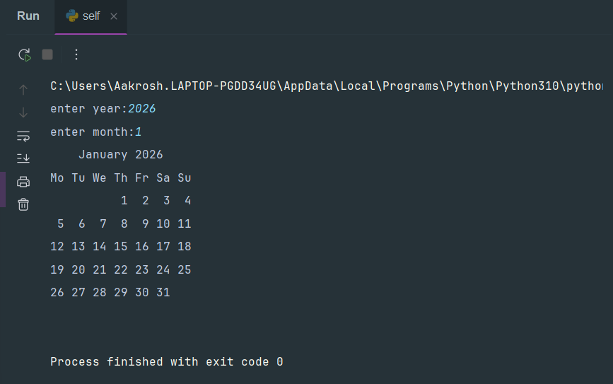

Answer 3
from datetime import date
d1=date(2015,7,2)
d2=date(2015,8,12)
diff=d2-d1
print(diff.days,"days")

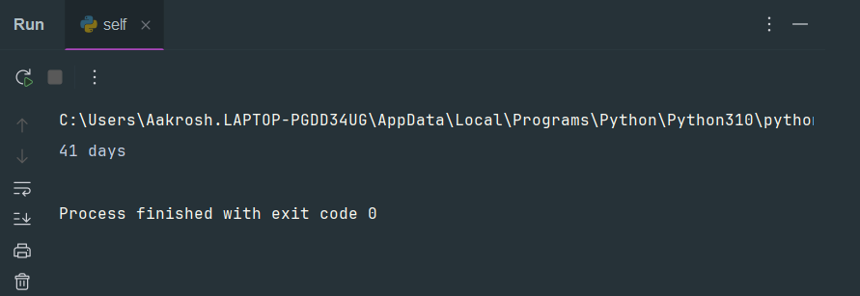

Answer 4

ch=input("enter the character :")
if ch in "aeiouAEIOU":
print("its a vowel")
else:
print("entered character is not a vowel")

