

STUCRA COMBINED WORK

REPORT



By - Abhishek Kumar

RESEARCH INTERNS

|  |  |
| --- | --- |
| **ASSIGNMENT AND TOPIC NAME** | **INDIVIDUAL/GROUP** |
| ASSIGNMENT - 1  **TOPIC** - METAVERSE | INDIVIDUAL |
| ASSIGNMENT - 2  **TOPIC** - AUTAMATION IN ELECTRIC VEHICLES | GROUP |
| ASSIGNMENT - 3  **TOPIC** - JWST | GROUP |
| ASSIGNMENT - 4  **TOPIC** - BLOCKCHAIN TECHNOLOGY | INDIVIDUAL |

**Content**

**Assignment - 1**

**Research by Abhishek Kumar , IIIT Bhopal**

**Topic:- METAVERSE**

**Introduction**

* METAVERSE, has been coined with the combination of prefix “meta” along with “universe, describes a hypothetical synthetic environment linked to the physical world.IMG_256

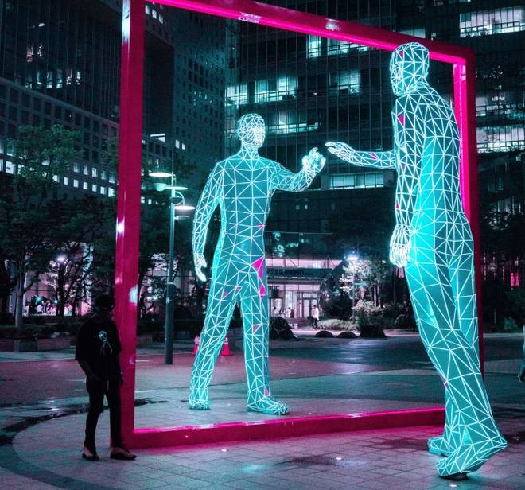

Source: Unsplash.com

IMG_256IMG_256

* It make use of multiple elements of technology such as virtual reality(VR), augmented reality(AR) and mixed reality(MR) .
* Metaverse enable its users to work, play creating contents in a game and distribute the contents around the world, stay connected with friends through everything from concerts and conferences to virtual trips around to the world.
* As the metaverse scene in Snow Crash, it helps project the duality of the real world and a copy of digital environments. Duality can be achieved in three sequential stages, namely (I) digital twins, (II) digital natives, and eventually (III) co-existence of physical-virtual reality or namely the surreality.
* According to mark Zuckerberg, the CEO of Facebook (Meta), it could take 5 to 10 years before its key features become mainstream. Also, metaverse is the successor of mobile Internet where people can do more than what they do now on the Internet.

**Some Uses and facts**

* **Meta** - Meta sees the future to a virtual world where digital avatars connect through work, travel or entertainment using VR headsets.
* **Microsoft** - Microsoft along with its plans for bringing mixed-reality including holograms and virtual avatars to Microsoft Teams in 2022, working with U.S. Army to help for his soldiers to train, rehearse and fight in .
* **Fortnite** - Tim Sweeney, CEO of Fortnite, has said, "It’s no secret that Epic is invested in building the metaverse."

**Concerns For User**

* Information privacy is unsafe as the companies involved in it most likely collect users’ personal information through wearable devices and user interactions.
* Addiction, when used over prolonged period of time, is another concern for user which might result in increase of mental and physical disorder such as depression, anxiety, and obesity.

Resources:-

1. <https://en.wikipedia.org/wiki/Metaverse>
2. <https://www.usatoday.com/story/tech/2021/11/10/metaverse-what-is-it-explained-facebook-microsoft-meta-vr/6337635001/>
3. <https://www.researchgate.net/publication/355172308_All_One_Needs_to_Know_about_Metaverse_A_Complete_Survey_on_Technological_Singularity_Virtual_Ecosystem_and_Research_Agenda>

**Assignment - 2**

**AUTOMATION IN ELECTRIC VEHICLES**

**Introduction:**

* In recent years, the world has seen leaps and bounds in various tech-related fields, with one of the biggest being AI (Artificial Intelligence).
* Paired with a drive to reduce demand pressure on non-renewable sources of energy, the next step becomes clear: Automation in Electric Vehicles.

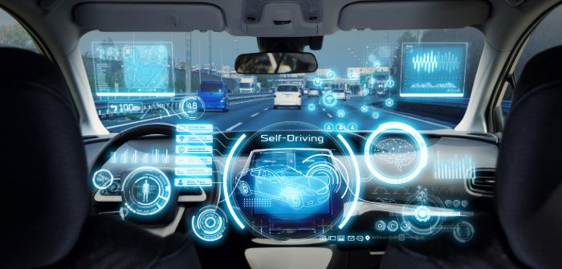

Image Source: <https://www.google.com/url?sa=i&url=https%3A%2F%2Fwww.autonomousvehicleinternational.com%2Fopinion%2Fautonomous-vehicles-at-night.html&psig=AOvVaw1I5M0hsPoWzCUTVEhS3698&ust=1641980973449000&source=images&cd=vfe&ved=0CAsQjRxqFwoTCKjMz_y1qfUCFQAAAAAdAAAAABAX>

* Developments in both respective fields (self-driving and electric-run) have taken place for many years, and an overview of the aforementioned serves well to provide context for their combination.
* Although electric vehicles were present throughout the 20th century, it wasn’t until the 2000 release of the Toyota Prius that demand for electric vehicles began to take off, spurred on by rising carbon prices and climate change speculation.
* Since then, various companies have broken into the electric vehicle industry, the most notable of which being Tesla.
* Following this, electric cars have grown in popularity, with over 2 million units being sold in 2019, representing almost 3 per cent of the total cars on the road.
* Similar to electric vehicles, autonomous vehicles saw some progress throughout the 20th century, but the 2010s saw the evolution of commercial road-based vehicles, with the leading example being, again, Tesla and their Autopilot program.

The market for pursuing disruptive technologies in autonomous vehicles is estimated to be upwards of a trillion dollars. This can be pinpointed to a number of reasons:

1. Those who seek access to electric vehicles and automation prefer both features in the same vehicle
2. The fact that electric vehicles use less moving parts make it more streamlined to implement autonomous features, by minimizing the correlation needed between hardware and software. Furthermore, this allows for more technological equipment (used for automation) to be added to the vehicle without causing them to become too heavy to operate on the road.
3. Automation leads to more efficient driving, combating the issue of limited driving range as seen in traditional electric vehicles.

**How Tesla Communicates With Hardware And Software ?**

* For every working device, it needs some relation between the hardware and the software. Like Tesla, it uses most of the communication of the system through the powerful hardware and by using the fastest and latest software available.
* At this stage, Tesla uses its own API for unlocking,locking, for checking odometers, etc. This software communicates directly with the car.
* If you want to lock your car, and you do not need to search for any keys, just take the phone and press the unlock button. This total works with the software of receiving technology that is embedded in the cars itself.
* Tesla uses the Smartcar API. This Smartcar API provides the RESTful service about the location of the car, and details of the car within less time.

**Smartcar API:**

* Smartcar API is a software that is especially designed to handle the API’s. It mostly uses programming languages like Python,Node.js etc.
* With this Smartcar API’s you can lock and unlock the car.
* Also used for checking the battery status,location,speed and problems. This is all done by the system that notes the data of every hardware component like sensors and batteries, and will share the information with the local system that is present in the car. And the data in the car is uploaded by using the Real time data bases.
* With the help of an application, we can see the details of the car and it’s utilities that are necessary.
* It Also Provides us with good privacy security and consistency.

**Benefits of automation in Electric Vehicles:**

The benefits include:

1- **Greater Road Safety** - Automation can help reduce the number of crashes on our roads. Higher levels of automation can have the potential to reduce risky and dangerous driver behaviors. The greatest promise may be reducing the devastation of impaired driving, drugged driving, unbelted vehicle occupants, speeding, and distraction.

2- **Greater Independence** - Full automation offers more personal freedom. People with disabilities would be capable of self-sufficiency, and highly automated vehicles can help them live the life they want. These vehicles can also enhance independence for seniors.

3- **Saving Money** - Automated driving systems could reduce our expenditure on vehicles. They can help avoid the costs of crashes, including medical bills, lost work time, and vehicle repair. Fewer crashes may reduce the costs of insurance. Also, we could use rechargeable batteries to reduce the cost even more.

4- **Environment friendly**- The air pollution can be reduced to a great extent with Electric cars. These cars use batteries that do not emit emissions like the internal combustion engines. Even due to having less or no sound, these vehicles help in reducing noise pollution as well.

**Tesla as an example:**

**1. Features of existing model Y Tesla Electric car**

* Capable of carrying 5-7 passengers at a time. Each second row seat can be folded flatly making it comfortable for keeping luggage, furniture, etc. with liftgate also making loading and unloading easy.
* Completely free from finding gas stations as it runs completely on electricity being rechargeable.
* 15 inch touchscreen display to control various things on the dashboard.
* Can reach the acceleration of 60mph in 3.5s with its maximum speed of 155mph
* 360 degree of visibility all around the car
* 12 Ultrasonic sensors to detect and prevent any possible collision.
* Offers some amount of autonomous Autopilot technology, front and rear sensors, adaptive cruise control, emergency brake assist.

**2. Expected Future Tesla Electric Car**

* Total of eight cameras provide 360 degree vision around the car with a maximum range of 250 meters.
* We need to just tell the car where to go, otherwise it will look at our calendar and take us there as the assumed destination.
* When we reach the destination, we need to simply step out at the entrance and the car will itself enter parking mode and search the proper spot and park itself. And back to us again on some fingertips of clicks.
* Hardware 3 onboard computer processes more than 40 times the data compared to its previous generation system. This computer runs the neural network developed by Tesla itself and provides a view of the world that a driver alone cannot access.
* Tesla’s first concern is to ensure safety through various new features like airbags.
* Navigating on Autopilot suggests lane changes to optimize our route. It also steers itself toward highway interchanges and exits when about to reach its destination.
* Includes ‘Automatic Emergency Braking’ to detect objects that may affect the car and applies brakes accordingly.
* Also warns the driver of side and front collisions if it seems

**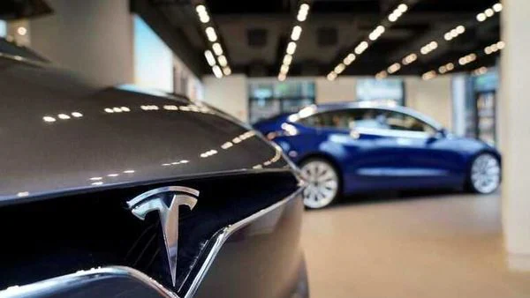**

Image Source - <https://auto.hindustantimes.com/auto/news/tesla-s-self-driving-ambitions-get-a-reboot-all-you-need-to-know-and-understand-41603332379610.html>

**CONCLUSION**

* The [environmental impact](https://www.conserve-energy-future.com/current-environmental-issues.php) of an electric car is zero, which means we’re reducing our [carbon footprint](https://www.conserve-energy-future.com/StepsReduceCarbonFootPrint.php) and positively affecting the economy.
* Companies like Nissan and Tesla are working on great electric models with an outstanding amount of benefits for people who decide to invest.
* Electric cars are gradually increasing on roads, which means less pollution, less particulate matter, and less noise.

Therefore, it is a great advancement in the field of vehicles.

**SOURCES**

<https://www.cmu.edu/news/stories/archives/2020/july/electric-autonomous-vehicles.html>

<https://www.pwc.co.uk/services/sustainability-climate-change/insights/autonomous-electric-vehicles.html>

<https://www.energy.gov/articles/history-electric-car>

<https://www.iea.org/reports/global-ev-outlook-2020>

<https://www.lord.com/blog/electronics/how-electric-vehicles-are-driving-growth-of-autonomous-vehicles>

<https://www.bmu.edu.in/social/future-of-electric-vehicles-in-india/>

<https://coalitionforfuturemobility.com/benefits-of-self-driving-vehicles/>

<https://www.tesla.com/autopilot>

<https://www.researchgate.net/publication/307551419_MODERN_ELECTRIC_CARS_OF_TESLA_MOTORS_COMPANY>

<https://www.eeweb.com/automation-and-electric-vehicles-evs-for-the-next-future/>

<https://www.conserve-energy-future.com/advantages-and-disadvantages-of-electric-cars.php>

**Approved By:**

**Vineeth,**

**IT Innovation Administrator**

**Assignment - 3**

**JAMES WEBB SPACE TELESCOPE**

***(JWST)***

***Introduction:***

**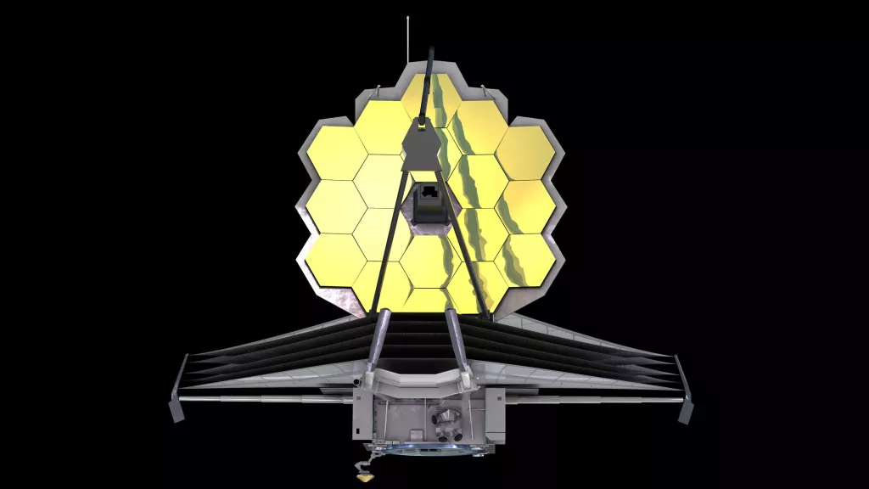**

**Image Source: <https://www.space.com/21925-james-webb-space-telescope-jwst.html>**

* The James Webb Space Telescope, often known as Webb or JWST, is a massive, space-based observatory with infrared wavelengths as its primary focus.
* It will add to and expand on the Hubble Space Telescope's discoveries.
* It will cover a wider range of wavelengths and have significantly better sensitivity.
* NASA, the European Space Agency (ESA), and the Canadian Space Agency have collaborated on this project.
* The telescope is named after NASA Administrator James E. Webb, who served from 1961 to 1968 and was a key figure in the Apollo programme.
* It was launched on Dec 25, 2021, from ESA's launch site at Kourou in French Guiana, on an Ariane 5 ECA rocket. This is a specialised rocket which is designed to take satellites and other payloads into transfer or low-Earth orbit.
* The JWST is the largest space observatory ever built. Its gigantic sunshield base measures a massive 22m by 12m.
* Using its infra-red telescope, the JWST observatory will examine objects over 13.6 billion light-years away.
* It is designed to provide improved [infrared](https://en.wikipedia.org/wiki/Infrared) resolution and sensitivity over others, viewing objects up to 100 times fainter than the faintest objects detectable by Hubble. This will enable a broad range of investigations across the fields of [astronomy](https://en.wikipedia.org/wiki/Astronomy) and [cosmology](https://en.wikipedia.org/wiki/Cosmology).
* The $10 billion James Webb Space Telescope — largest and most powerful space science telescope — will probe the cosmos to uncover the history of the universe from the [Big Bang](https://www.space.com/25126-big-bang-theory.html) to alien planet formation and beyond.

***Mission and goals:***

* The James Webb Space Telescope is an unprecedented mission that is on the precipice of seeing the light from the first galaxies and discovering the mysteries of our universe.
* **Goals of designing it:**
* observe farther into the universe than ever before
* search for the first stars and galaxies created after the Big Bang
* better understand how planets, stars and galaxies are born and evolve over time
* explore distant worlds and study our solar system
* determine the potential for life on planets around other stars.

***Architecture:***

**Key Facts:-**

* From its base, the entire telescope structure reaches around 26 feet (almost 8 metres).
* The bottom of the telescope structure has a yellow fixture that is designed to keep the bottom of the tower secure until the telescope structure is placed on the spacecraft.
* There are a total of **18 hexagonal mirrors** which make up Webb's 21-foot (6.5 meter) diameter "primary mirror."
* The backplane is the telescope's "spine," and it's responsible for keeping the mirrors and instruments steady when the telescope is peering into deep space, as well as keeping them stationary so that crisp images may be obtained.
* The backplane will also be carrying telescope optics and instruments weighing 7,500 pounds (2400 kg).

***Observatory view of JWST***

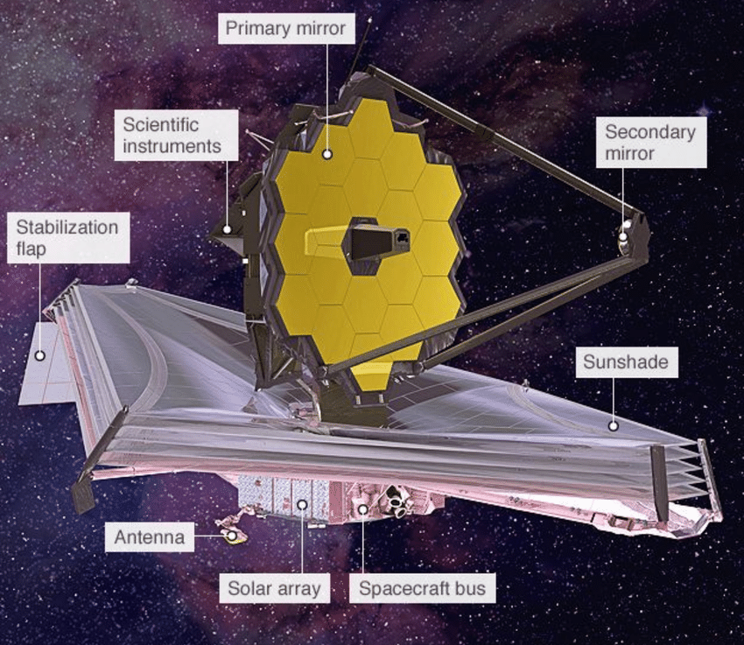

***Isometric view of JWST***

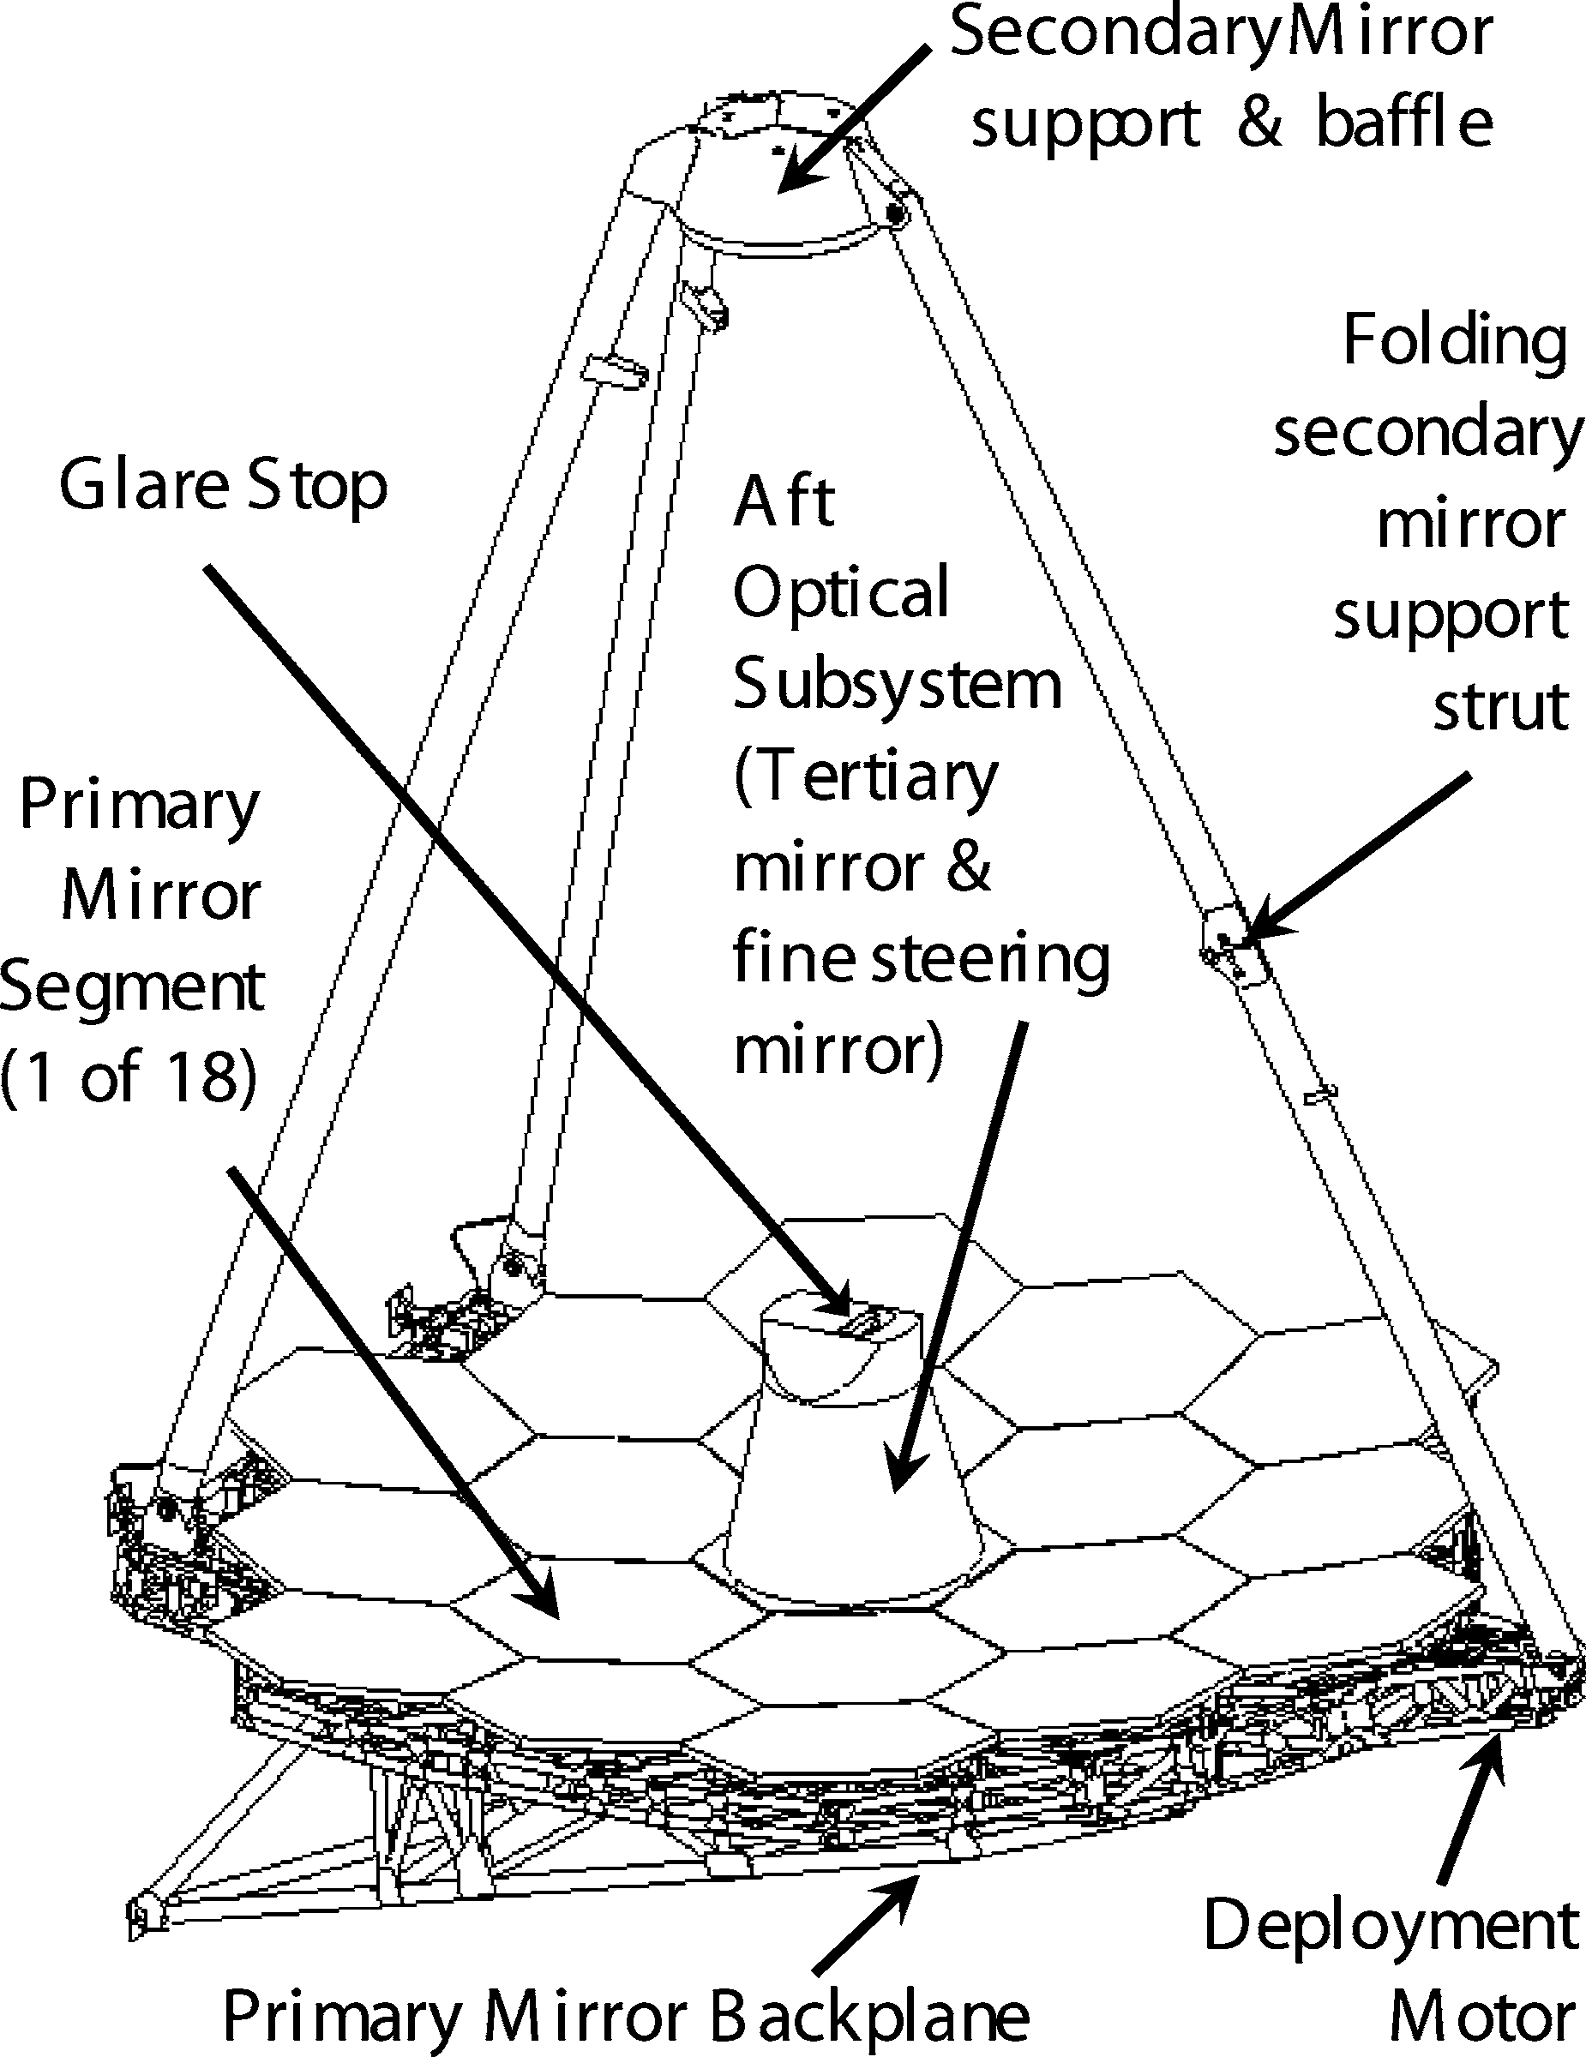

*Image source:*- researchgate.net

***Different Components/Parts of JWST***

1. **Optical Telescope Element:-**

* Three-mirror anastigmat of f/20 design
* Fine steering mirror (FSM) to provide line-of-sight stabilization of less than 7*.*3 milliarcsec
* Four separate deployments
* Semirigid, adjustable hexagonal mirror segments and graphite composite backplane structure

1. **Primary mirror:-**

* 25 m2  of total collecting area
* Basically, it deploys in two steps (2-chord fold).
* 18 semirigid hexagonal segments with set-and-monitor wavefront control actuators
* Beryllium is used as mirror segment material

1. **Secondary Mirror:-**

* Tripod configuration for supporting structure
* Deployment using a single redundant actuator
* Semirigid optic with 6 degrees of freedom alignment

1. **Aft optics:-**

* Fixed baffle contains tertiary mirror and FSM

1. **ISIM(Integrated Science Instrument Module):-**

* Simple semikinematic mount;
* Have 8 m2 of thermal radiator area, and 19.9 m3 volume.
* Contains all science instruments and fine guidance sensor

1. **Tower:-**

* Integral 1 Hz passive vibration isolators
* Isolates the telescope from spacecraft both thermally and vibrationally.

1. **Sunshield :-**

* Five-layer groove radiator design which reduces solar energy to tens of milliwatt
* Folded around telescope during launch
* Has been Sized (∼19.5 m × 11.4 m) and shaped to limit solar radiation induced momentum buildup.

1. **Spacecraft bus:-**

* Chandra-based attitude control subsystem
* Two-axis gimbaled high-gain Earth-pointing antenna with omnis, Ka and S band
* 471 Gb solid-state recorder to store 2 days of science and engineering data
* Propellant for more than 10 years.

***Working Of JWST:***

**Step 1**:- When an Ariane 5 rocket is detonated, the telescope folded inside the payload bay separates from its launch vehicle, resulting in Solar Array Deployment.

**Step 2**:- Sunshield pallets would be deployed on the third day of deployment.

**Step 3**:- The tower containing the instrumental package is then moved to the site where it will be used, allowing it to begin its operations. Generally on the fourth day of deployment, this action takes place.

**Step 4**:- The flap would assist the telescope in stabilising itself when the sun exerted solar pressure on the big sun screen.

**Step 5**:- Then special covers would release the tennis sized sun shields.

**Step 6**:- The sun shield would be strained to divide five layers once it is opened.

**Step 7**:- On the 10th day of deployment, a support system for the smaller secondary mirror would be set up.

**Step 8**:- The mirror's side panels would be extended on the 13th day of deployment. And the telescope would begin observing celestial bodies.

**Comparison Between The James Webb Space Telescope With Other Telescopes:**

* The James Webb Space Telescope has a broad field of view. As a result, even the distant planets, such as Neptune and Uranus, can be seen clearly.
* The Hubble telescope, which has been circulating since 1990, pales in comparison. Hubble's telescope has a diameter ranging around 2.4 metres in diameter. This Webb is about the size of a tennis court and is large enough to send a rocket into space.
* It's a mirror ranging from 6.5meters.
* Unlike other telescopes, this one can detect infrared light that is invisible to the naked eye. It has more advantages than any previous telescopic system in history.

This JWST is capable of producing infrared radiation visible to the human eye.

**Advantages Of James Webb Space Telescope:**

* Until today, this has been the world's largest and most advanced telescope.
* These are unquestionably larger than earthbound telescopes. Until now, the James Webb space telescope has been restricted to usage by astronomy centres and space agencies around the world, such as NASA, ISRO, and others.
* The research along the several planets can be examined well with the space and telegraphic issues. We don’t need any cameras or powerful equipment for the research of the planets.
* Cost for the equipment’s and funding for the space organisations can be reduced for the space examination crafts and cameras.
* Space waste or the waste materials in the planets can be reduced and the failure rate for the space crafts can be reduced for the lower cost.
* This James Webb Space Telescope can increase the research opportunities for space organisations across the globe. The planetary research can be reduced for the extent using the James Webb Space Telescope. This can increase the opportunities across the global issues and the global marketing cost can be decreased.

**Dis-Advantages Of James Webb Space Telescope:**

* Making such kind of heavy equipment can lead to the heavy usage of the materials and increase the pollution and marketing of the product.
* Mostly the funding becomes a very tactical way that too launching in this covid session in the world can impact a lot of education and financial issues of the government.
* The wastage and the plastic pollution of the world is getting increased and yes, if it fails the amount of products and wastage that is produced cannot be fixed and tied in the nation.
* The big space organisations are taking support from the various and multi national space organisations, this can lead to the collaboration in one way and can raise conflict issues when it comes to the final work.
* ·        The maintenance for this telescope is very expensive. Maintaining this telescope and requiring a close examination for this telescope at every second is very essential. With invalid and poor maintenance can lead to adverse effects on the global funding and environment.

***Conclusion:***

* The National Academy of Science has designated JWST as NASA's top investment priority for space astronomy this decade.
* It is a form of worldwide cooperation and collaboration that thrives on a philosophy of clear, centralised administration and strong systems engineering.
* As of now, the team has demonstrated the viability of all major technologies, including lightweight active optics and image-based wavefront sensing and control.
* The JWST project is continuing to meet all its milestones as it transitions to Phase C development with Northrop Grumman as the prime contractor.

Thousands of scientists and engineers from across the United States, Canada, and Europe will be touched and inspired by JWST, not to mention astronomers all around the world, whose discoveries using JWST may likely revolutionise the way we understand ourselves and our place in the universe.

***References:***

<https://www.asc-csa.gc.ca/eng/satellites/jwst/about.asp>

[https://www.jwst.nasa.gov/content/about/faqs/faq.html#whatis](https://www.jwst.nasa.gov/content/about/faqs/faq.html" \l "whatis)

<https://www.space.com/21925-james-webb-space-telescope-jwst.html>

<https://en.wikipedia.org/wiki/James_Webb_Space_Telescope>

<https://www.sciencefocus.com/space/james-webb-space-telescope/>

<https://www.nasa.gov/feature/goddard/nasas-james-webb-space-telescope-structure-stands-tall>

<https://www.jagranjosh.com/general-knowledge/nasas-james-webb-space-telescope-working-explained-1640604512-1>

<https://www.researchgate.net/publication/225939669_The_James_Webb_Space_Telescope>

**Assignment - 4**

**BLOCKCHAIN TECHNOLOGY**

*Introduction:-*

Blockchain is a data-storage technology that records data in such a way that it is highly difficult, if not impossible, to change, hack, or trick the system.

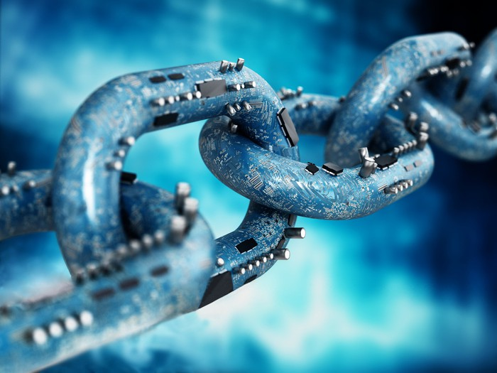

Image Source:- Fool.com

* Blockchain technology was introduced as a mechanism to verify that document timestamps could not be modified, by two great mathematicians, Staurt Haber and W.Scott in the year 1991.
* It is well-known and highly used for its role in cryptocurrency systems such as Bitcoin.
* The purpose of blockchain is to enable the recording and distribution of digital data without the ability to change or delete it.
* Blockchain, unlike traditional databases, separates data into interconnected blocks. When a block is added to the system, it is assigned a precise timestamp.
* Each block in this chain contains a large number of transactions, and as soon as any new transaction occurs on the blockchain, a record of that

transaction must be added to each participant's ledger.

* In the case of Bitcoin, blockchain is used in a decentralised fashion, meaning that all users collectively control it rather than any single person or group of people, and that no single person or group of people may misuse it.
* The transactions are recorded using an immutable (cannot be modified) cryptographic signature in this form of DLT(Distributed Ledger Technology). 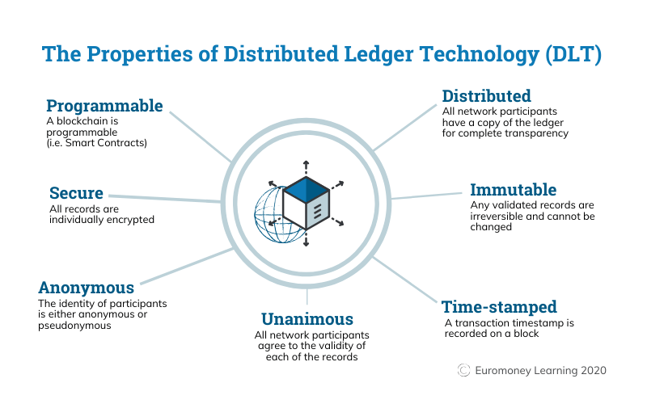

Image source:- Euromoney

*Purpose of being developed*

* Many attempts to generate digital money have been made in the past, but they have all failed.
* The question of trust was always there in all of the cases. There is no guarantee that if someone establishes a new currency, he will not generate money for himself or take money from others.
* Finally, Bitcoin's Blockchain database solved this issue because no one is in charge in blockchain; it is run by the people that utilise it. It also prevents them from making any more edits.

*Application:-*

1. Money transfer:- Utilizing blockchain technology for money transfer is

less expensive and faster than using an existing money transfer, especially in cross-border transactions. Even in the current banking system of the United States, money transfers between accounts can take several days, but a blockchain transaction can be completed in a matter of minutes.

1. Financial exchanges:- A decentralised cryptocurrency exchange that has grown significantly in recent years can also use blockchain for exchanges, allowing for faster and less expensive transactions because these changes do not require investors to deposit their assets, giving them more control and security.
2. Lending loans at cheaper rates:- Blockchain also enables other events, like as service payments, margin calls, collateral releases, and so on, to be triggered/happen automatically. As a result, loan processing is both faster and less expensive, allowing lenders to offer loans at lower rates.
3. Insurance:- Using smart contracts on a blockchain speeds up the process of receiving money for claimants. Also, keep detailed records of all claims, which can assist you avoid filing duplicate claims for the same event.
4. Real Estate:- Real estate transactions necessitate a large amount of documentation to be completed. However, with the use of blockchain technology, real estate transactions may be made more secure and accessible, as well as the verification and transfer of ownership can be made easier.
5. Secure personal Information:-It also keeps our data safe and provides secure access when needed.
6. Voting:-If our personal identity numbers, such as voter ID numbers, are stored on the blockchain, we may cast ballots with a few clicks on our phones, computers, neighbouring cafes, and other devices, reducing both the cost and time spent administering elections.
7. Government Benefits:-All of the government's schemes can be correctly employed and fraud can be avoided if we preserve our identities on a

blockchain, since people can receive funding and other advantages directly on their own systems, as is the case with the Pradhanmantri Awas Yojna.

1. Securely share medical Information:- If doctors, medical professionals, and patients all come together on the blockchain platform, patients will receive the best care possible; additionally, medical records will be pulled in a timely manner, and treatment will be provided as needed; otherwise, many patients will become more serious as a result of not receiving treatment on time.
2. Artist Royalties:-If artists' financial information is made available on the blockchain platform, music and film files released over the internet can ensure that they get rewarded for their efforts. It can also help to decrease piracy because blockchain prevents the same material from being duplicated.
3. Cybersecurity:- Blockchain offers end-to-end encryption and anonymity, as well as eliminating the risk of a single point of failure and hacking.
4. Big Data:- Since Blockchain is immutable in nature it can be used for storing big data.
5. IoT:- Blockchain can be also used to track the locations of our orders like in zomato, swiggy, etc. and also tracking assets.

*Current Scenario:-*

# Wedding:-According to Timesnownews.com, the title "Pune couple becomes India's first to hold blockchain wedding with a digital priest and NFT" demonstrates that people can get married using blockchain technology.

1. Covid-19:- It was being used to simplify the clinical trial processes for vaccines and drugs, raise public awareness, for fundraising activities, track donations, and as a reliable data tracker.

*Pros and Cons of Blockchain*

* Pros
* Because there is no human involvement in verification, accuracy has improved.
* It is also less expensive because there is no need to ask or allow any other third party to verify.
* Due to decentralisation, it is more difficult to interfere with blockchain transactions.
* All blockchain transactions are secure, private, and efficient.
* Isolated transactions because it doesn’t reveal a person’s identity but only a public key.
* Cons
* Transactions per second are low.
* Data storage limitations may occur
* Technology cost which includes costs of mining bitcoin, electricity bills, etc.
* Illegal trading and activity on the blockchain network can be done by unauthorized users

*Conclusion:-*

* If applied correctly, Blockchain Technology can be revolutionary.
* It will make life easier and safer by altering the way we store data and safeguard the transactions we conduct on a regular basis.
* Every transaction is recorded in a permanent and unchangeable way using blockchain technology.
* If Bitcoin and other cryptocurrencies are utilised today, it is only because of blockchain technology.
* Fraud, hacking, data theft, and information loss are all nearly impossible with this digital ledger.

*References*

<https://www.fool.com/investing/stock-market/market-sectors/financials/blockchain-stocks/blockchain-applications/>

<https://www.ncbi.nlm.nih.gov/pmc/articles/PMC7549424/>

<https://www.euromoney.com/learning/blockchain-explained/what-is-blockchain>

<https://www.investopedia.com/terms/b/blockchain.asp>