Project Report: Student Marks & Performance Analyser

1. Title Page

Student Marks & Performance Analyser
A Python-based Text User Interface (TUI) Application

Submitted by
Sl. No. | Student Name | Roll No. | Registration No.
1 | Satyajit Pati | BWU/BCC/25/085
2 | Soyel Rana Halder | BWU/BCC/25/086
3 | Sk Sayan Hasan | BWU/BCC/25/087
4 | Rituraj Das | BWU/BCC/25/088
5 | Shrijeeta Paul | BWU/BCC/25/089
6 | Abhishek Kumar Mistry | BWU/BCC/25/090

Programme and Semester
Course | PYTHON FOR ENGINEERING ESSENTIALS LAB
Faculty Name | Dr. Suparna Panchanan
Academic Session | 2026-2027
Semester | 3rd
Year | 2nd
Program | B.Tech. CSE CYS
Department | CSE CSDS

2. Abstract
The Student Marks & Performance Analyser is a menu-driven Python application that lets a teacher enter marks for several subjects and instantly analyse the performance of a class. It was developed because calculating totals, percentages, grades and class statistics by hand is slow and error-prone.
Main features:
- Entry of marks for different subjects with input validation.
- Automatic calculation of total marks, percentage and grade.
- Highest and lowest marks in every subject and overall.
- Class average, identification of students who need improvement, and a result summary.
The program is written in Python 3 using only the standard library, with a plain text user interface. The expected outcome is a fast, accurate and easy-to-use tool that turns raw marks into meaningful results.

3. Introduction
Schools and colleges evaluate students in many subjects, and teachers must compute totals, percentages and grades and then compare students with the rest of the class. Doing this manually for a whole class is repetitive and mistakes are common.
There is a clear need for a small, reliable tool that automates these calculations. The proposed solution is a console application in which the user enters the subjects and each student’s marks once, after which every result is generated by the program.
Python is well suited to this task because of its readable syntax and built-in data structures. Dictionaries store each student’s subject marks, lists store subject names, and built-in functions such as sum(), max() and min() perform the analysis. No external library is required.

4. Problem Statement
Manual processing of student marks is time-consuming and makes it difficult to calculate totals, percentages and grades accurately, to find the highest and lowest scorers, and to identify students who need improvement. Therefore, a Python-based system is proposed to automate mark entry and performance analysis.

5. Objectives
- To develop a simple, user-friendly Python application with a text-based menu.
- To allow marks to be entered for different subjects with validation.
- To automate the calculation of total marks, percentage and grade.
- To find the highest and lowest marks and the class average.
- To identify students who need improvement.
- To generate a clear result summary of the whole class.

6. Scope of the Project
What the system can do: accept marks for up to 10 subjects, calculate total, percentage and grade, find highest and lowest marks, compute class and subject averages, list weak students and display a result summary.
Who can use it: teachers, class coordinators and students, with no programming knowledge needed.
Type of data: student names (text) and subject marks (numbers between 0 and 100).
Possible future extensions: saving records to a file or database, exporting reports to CSV/PDF, editing or deleting individual students, and a graphical interface.
Not included: permanent storage (data is lost on exit), user login, graphical interface, and per-subject pass criteria other than a single pass mark.

7. Flowchart
The flowchart below shows the working of the program from start to exit.
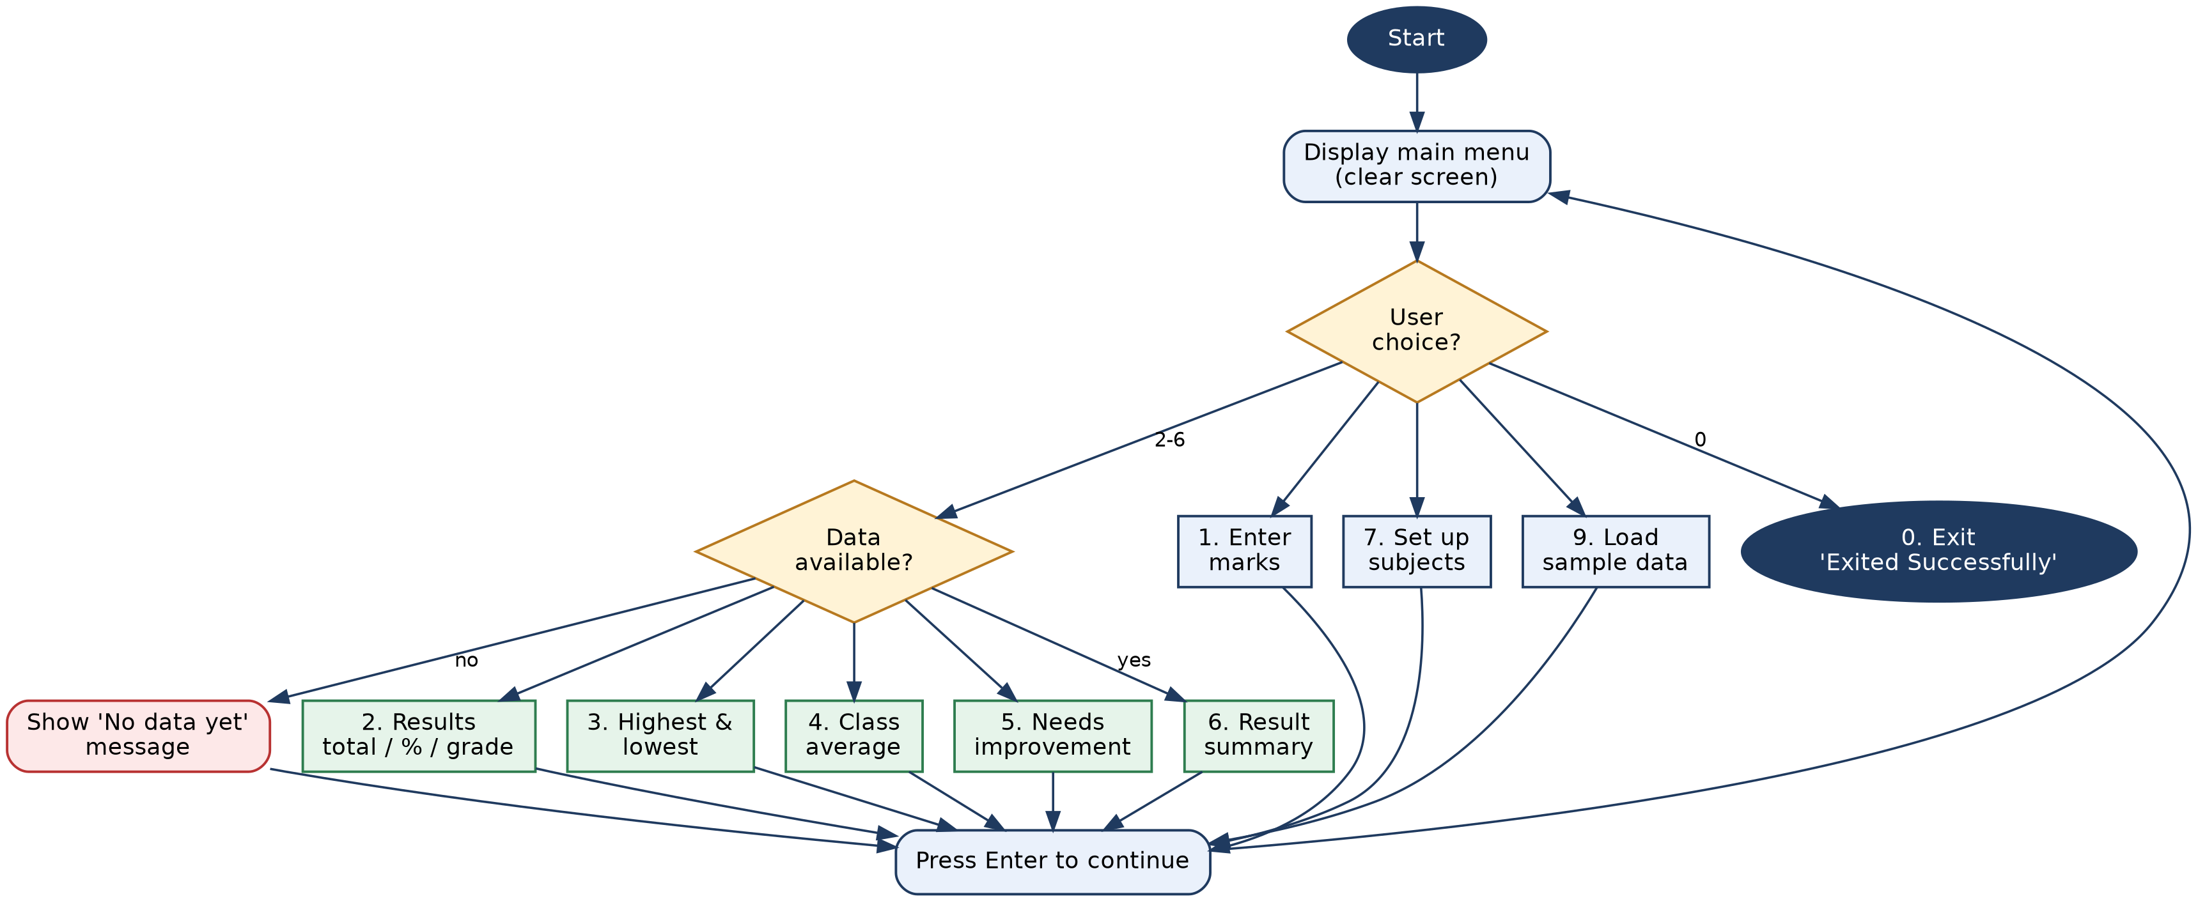
Figure 1: Flowchart of the Student Marks & Performance Analyser

8. Implementation / Python Code
The program is organised into helper functions, calculation functions and one function for each menu option. Key parameters are MAX_MARKS = 100, PASS_MARK = 40 and IMPROVE_BELOW = 50. The grade scale is A+ (90 and above), A (80), B (70), C (60), D (50), E (40) and F (below 40). The complete source code is given below.

from os import system, name as os_name

WIDTH = 72
MAX_MARKS = 100
PASS_MARK = 40
IMPROVE_BELOW = 50

subjects = []
students = {}

def clear_screen():
system("cls" if os_name == "nt" else "clear")

def line(ch="="):
print(ch * WIDTH)

def title(text):
clear_screen()
line()
print(text.center(WIDTH))
line()

def ask_number(prompt, low, high):
while True:
raw = input(prompt).strip()
try:
value = float(raw)
except ValueError:
print(" ! Please enter a number.")
continue
if low <= value <= high:
return value
print(f" ! Value must be between {low} and {high}.")

def pause():
input("\nPress Enter to continue...")

def need_data():
if not subjects or not students:
print("\n ! No data yet. Enter marks first (option 1) or load sample data (option 9).")
return False
return True

def total(name):
return sum(students[name].values())

def percentage(name):
return total(name) / (MAX_MARKS * len(subjects)) * 100

def grade(pct):
if pct >= 90: return "A+"
if pct >= 80: return "A"
if pct >= 70: return "B"
if pct >= 60: return "C"
if pct >= 50: return "D"
if pct >= PASS_MARK: return "E"
return "F"

def failed_subjects(name):
return [s for s, m in students[name].items() if m < PASS_MARK]

def class_average():
return sum(percentage(n) for n in students) / len(students)

def needs_improvement(name):
return percentage(name) < IMPROVE_BELOW or bool(failed_subjects(name))

def setup_subjects():
global subjects
title("SET UP SUBJECTS")
if students:
print("Changing subjects will erase all existing student records.")
if input("Continue? (y/n): ").strip().lower() != "y":
return
students.clear()
count = int(ask_number("How many subjects? ", 1, 10))
subjects = []
for i in range(1, count + 1):
while True:
name = input(f" Subject {i} name: ").strip().title()
if name and name not in subjects:
subjects.append(name)
break
print(" ! Name must be non-empty and unique.")
print("\nSubjects saved:", ", ".join(subjects))

def enter_marks():
if not subjects:
setup_subjects()
if not subjects:
return
title("ENTER MARKS")
print(f"Marks are out of {MAX_MARKS}. Leave the name blank to stop.\n")
while True:
name = input("Student name: ").strip().title()
if not name:
break
if name in students:
print(f" ({name} already exists - marks will be overwritten)")
marks = {}
for sub in subjects:
marks[sub] = ask_number(f" {sub:<15}: ", 0, MAX_MARKS)
students[name] = marks
print(f" Saved {name}: total {total(name):g}, {percentage(name):.1f}%, "
f"grade {grade(percentage(name))}\n")

def show_all_results():
title("ALL STUDENT RESULTS")
header = f"{'Name':<14}{'Total':>8}{'%':>8}{'Grade':>7} Marks"
print(header)
line("-")
for name in sorted(students):
pct = percentage(name)
marks = " ".join(f"{m:g}" for m in students[name].values())
print(f"{name:<14}{total(name):>8g}{pct:>8.1f}{grade(pct):>7} {marks}")
line("-")
print("Subject order:", ", ".join(subjects))

def highest_lowest():
title("HIGHEST AND LOWEST MARKS")
print(f"{'Subject':<15}{'Highest':<24}{'Lowest':<24}")
line("-")
for sub in subjects:
hi = max(students, key=lambda n: students[n][sub])
lo = min(students, key=lambda n: students[n][sub])
print(f"{sub:<15}{hi + ' (' + format(students[hi][sub], 'g') + ')':<24}"
f"{lo + ' (' + format(students[lo][sub], 'g') + ')':<24}")
line("-")
top = max(students, key=total)
bottom = min(students, key=total)
print(f"Overall topper : {top} with {total(top):g} marks")
print(f"Overall lowest : {bottom} with {total(bottom):g} marks")

def show_average():
title("CLASS AVERAGE")
for sub in subjects:
avg = sum(students[n][sub] for n in students) / len(students)
bar = "#" * int(avg / MAX_MARKS * 40)
print(f"{sub:<15}{avg:>6.1f} {bar}")
line("-")
print(f"Class average percentage: {class_average():.2f}% "
f"(grade {grade(class_average())})")

def show_improvement():
title("STUDENTS NEEDING IMPROVEMENT")
print(f"Criteria: overall < {IMPROVE_BELOW}% or any subject < {PASS_MARK} marks\n")
found = False
for name in sorted(students):
if needs_improvement(name):
found = True
weak = failed_subjects(name)
note = f"weak in: {', '.join(weak)}" if weak else "low overall score"
print(f" * {name:<14}{percentage(name):>6.1f}% {note}")
if not found:
print(" Great news - every student is meeting the standard!")

def summary():
title("RESULT SUMMARY")
total_students = len(students)
passed = [n for n in students if not failed_subjects(n)]
grades = {}
for n in students:
g = grade(percentage(n))
grades[g] = grades.get(g, 0) + 1
top = max(students, key=total)

print(f"Students : {total_students}")
print(f"Subjects : {', '.join(subjects)}")
print(f"Passed all : {len(passed)} "
f"({len(passed) / total_students * 100:.0f}%)")
print(f"Need improvement: {sum(needs_improvement(n) for n in students)}")
print(f"Class average : {class_average():.2f}%")
print(f"Topper : {top} ({percentage(top):.1f}%)")
print("\nGrade distribution:")
for g in ["A+", "A", "B", "C", "D", "E", "F"]:
print(f" {g:<3}{'*' * grades.get(g, 0)} {grades.get(g, 0) or ''}")

def load_sample():
global subjects
subjects = ["Maths", "Science", "English", "History"]
students.clear()
students.update({
"Asha": dict(zip(subjects, [92, 88, 95, 90])),
"Ben": dict(zip(subjects, [45, 38, 60, 52])),
"Chitra": dict(zip(subjects, [76, 81, 70, 68])),
"Dev": dict(zip(subjects, [30, 42, 55, 35])),
"Esha": dict(zip(subjects, [64, 59, 72, 66])),
})
print("\nSample data for 5 students loaded.")

MENU = """
1. Enter marks for students
2. View results (total, percentage, grade)
3. Highest and lowest marks
4. Class average
5. Students who need improvement
6. Result summary
7. Set up / change subjects
9. Load sample data
0. Exit
"""

def main():
while True:
title("STUDENT PERFORMANCE ANALYSER")
print(MENU)
choice = input("Choose an option: ").strip()

if choice == "1":
enter_marks()
elif choice == "7":
setup_subjects()
elif choice == "9":
load_sample()
elif choice == "0":
print("\nExited Successfully")
break
elif choice in {"2", "3", "4", "5", "6"}:
if need_data():
{"2": show_all_results, "3": highest_lowest, "4": show_average,
"5": show_improvement, "6": summary}[choice]()
else:
print("\n ! Invalid option.")
pause()

if __name__ == "__main__":
try:
main()
except (KeyboardInterrupt, EOFError):
print("\n\nExited.")

9. Input and Output
The screenshots below were captured from the actual execution of the program.
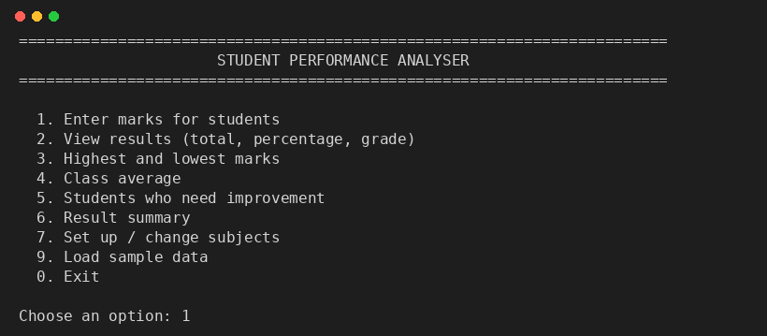
Figure 2: Main menu
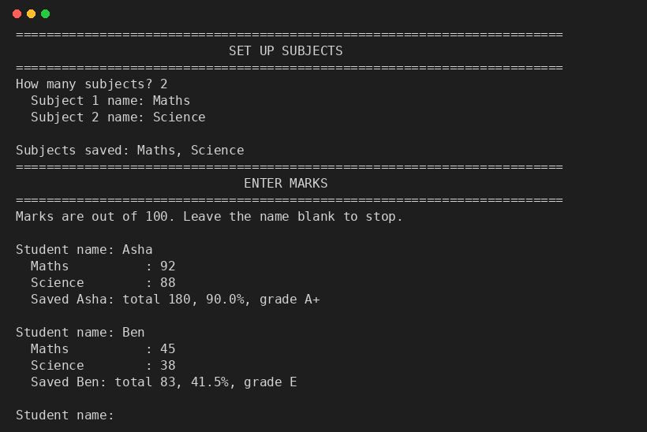
Figure 3: Setting up subjects and entering marks (option 1)
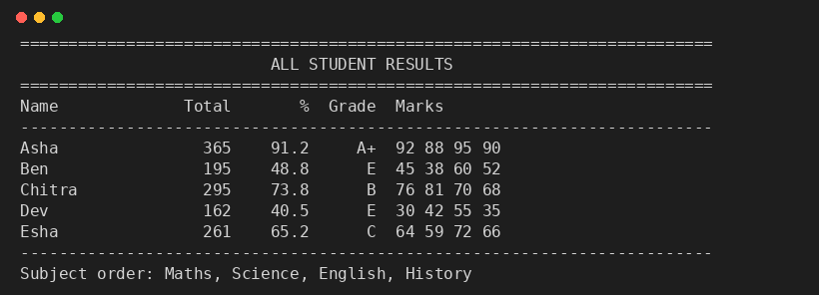
Figure 4: Total, percentage and grade for each student (option 2)
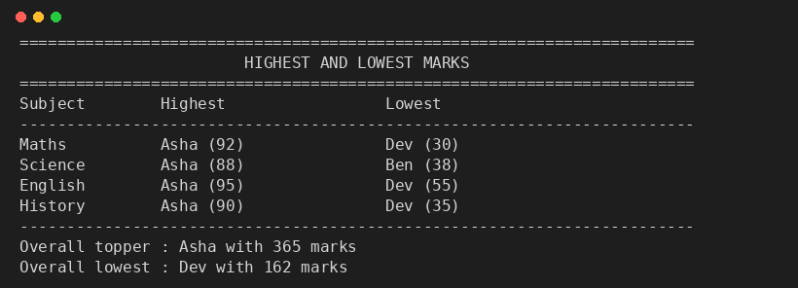
Figure 5: Highest and lowest marks (option 3)
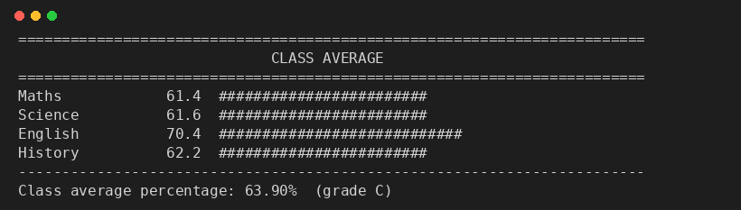
Figure 6: Class average (option 4)
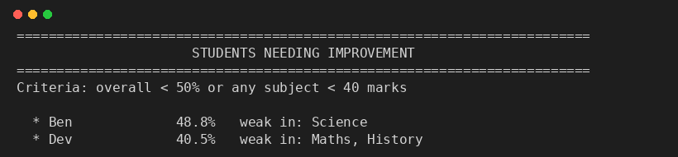
Figure 7: Students who need improvement (option 5)
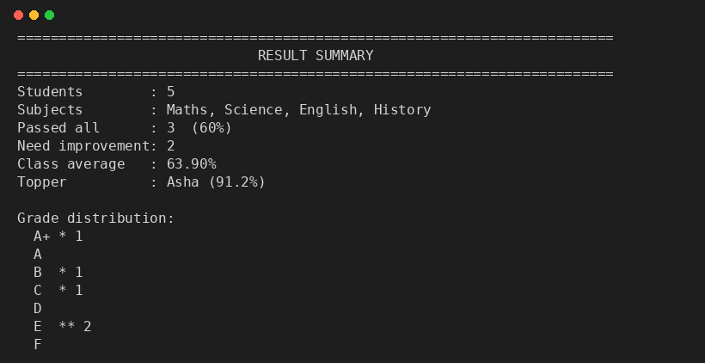
Figure 8: Result summary (option 6)

10. Results and Discussion
The program was tested with the built-in sample data of five students and four subjects (Maths, Science, English and History). The results were verified against manual calculation.
Observation | Result
Class average | 63.90% (grade C)
Topper | Asha (91.2%, grade A+)
Students passing all subjects | 3 of 5 (60%)
Students needing improvement | 2 (Ben and Dev)

Ben scored 48.8% overall and failed Science, while Dev scored 40.5% and failed Maths and History. Both were correctly flagged. Invalid inputs such as letters or marks above 100 were rejected with a message and the user was asked again, so incorrect data cannot enter the system. The screen is cleared before each page, which keeps the interface tidy. The main limitation is that data is kept in memory only.

11. Conclusion
The Student Marks & Performance Analyser meets all the required features: entering marks, calculating total, percentage and grade, finding the highest and lowest marks, computing the class average, identifying students who need improvement and displaying a result summary. It replaces slow manual calculation with a fast, accurate and easy-to-use tool built using only standard Python. In the future it can be extended with file storage, report export and a graphical interface.

