Functional Specification Document (FDS)
Generated by: H, Arya | Date: 2026-05-25

Document Control
| Version | Date | Author | Approval Status |
|---------|------------|-----------------|--------------------|
| 1.0 | 2023-10-30 | [Your Name] | Draft |

Executive Summary
The FreshBasket mobile application aims to provide customers with a convenient platform to order groceries directly from their mobile devices. The application will facilitate the browsing of products, management of shopping carts, and secure payment processing, while allowing store managers to oversee incoming orders and inventory. With a user-friendly interface and robust features, the app seeks to enhance the grocery shopping experience for users in Hyderabad.

Introduction
Purpose

Business Context
Project Background
FreshBasket aims to improve its service offering by launching a mobile application that allows customers to order groceries online, catering to the increasing demand for digital grocery services.
Business Needs
The need for a mobile platform arises from changing consumer behaviors and the necessity for FreshBasket to remain competitive in the grocery retail market.
Objectives
To provide a seamless grocery ordering experience.
To enable secure and efficient payment processing.
To facilitate effective order management for store managers.
Expected Benefits
Enhanced customer satisfaction and retention.
Increased sales through online orders.
Improved operational efficiency for inventory management.

Stakeholder Analysis
Stakeholder | Role | Responsibilities | Interests
Customers | End Users | Order groceries via mobile app | Usability, convenience
Store Managers | Admin Users | Manage orders and inventory | Order visibility, efficiency
IT Team | Development/Support | Build and maintain the application | Technical success
Marketing Team | Promotion | Promote the app to customers | Customer engagement
Business Analysts | Requirement Gathering | Gather and document requirements | Clear documentation

System Overview Diagram
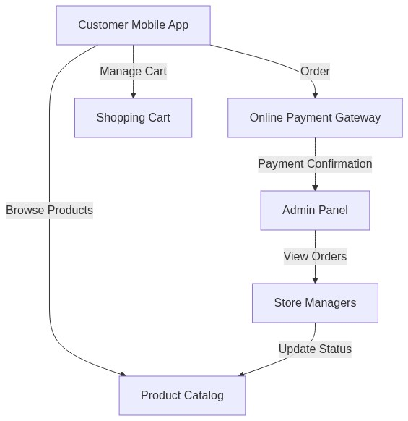
mermaid

Functional Requirements
Performance: The app must load product pages within 3 seconds.
Security: Must implement OTP-based authentication for secure user login.
Scalability: The app should support up to 10,000 simultaneous users.
Usability: The app must be user-friendly for customers who may not be tech-savvy.

User Workflows
Customer Ordering Workflow
• Customer opens the app.
• Customer browses the product catalog.
• Customer adds items to the cart.
• Customer selects a delivery time slot.
• Customer proceeds to payment.
• Customer completes the order.
Store Manager Order Management Workflow
• Store manager logs into the admin panel.
• Store manager views incoming orders.
• Store manager updates order status.
• Store manager manages inventory.

Feature Specifications
Feature: Product Catalog
Inputs: User request for products.
Outputs: List of available products.

Data Requirements
Field Name | Data Type | Validation Rules | Format
ProductID | Integer | Must be unique | Numeric
ProductName | String | Must not be empty | Alphanumeric
Price | Decimal | Must be greater than 0 | Numeric
Quantity | Integer | Must be non-negative | Numeric
OrderID | Integer | Must be unique | Numeric
UserID | Integer | Must correspond to registered user | Numeric

Business Rules
The app will only support orders from the five specified FreshBasket stores in Hyderabad.
Customers must authenticate using OTP for secure access.
Store managers must have distinct access rights to manage orders and inventory.

Non-Functional Requirements
Not enough detail provided in requirements.

User Interface Requirements
Screen Layouts: The app will have a home screen, product catalog, cart screen, and payment screen.
Navigation Flow: Users can navigate between the catalog, cart, and checkout with a bottom navigation bar.
UI Behavior: The app must provide feedback upon actions (e.g., item added to cart).

Integration Points
Payment Gateway: Integration with a secure online payment service.
Inventory Management System: Real-time updates on product availability.
User Authentication Service: For OTP generation and verification.

Assumptions & Constraints
Assumptions: Customers are more comfortable with OTP login than email-based authentication.
Constraints: The app must comply with local regulations regarding online payments and data privacy.

Risks & Mitigation
Risk | Likelihood | Impact | Mitigation Strategy
Technical challenges in app development | Medium | High | Use agile development practices and regular testing.
Low user adoption | Medium | High | Implement a marketing strategy to promote the app.
Security breaches | Low | High | Employ strong security protocols and regular audits.

Acceptance Criteria
The app must allow users to successfully place an order.
Users must be able to navigate the product catalog without issues.
The payment process must be completed without errors.
Store managers must be able to view and manage orders.

Traceability Matrix
User Story | Functional Requirement
As a customer, I want to order groceries. | FR-001
As a customer, I want to browse products. | FR-002
As a customer, I want to manage my cart. | FR-003
As a customer, I want to choose delivery time. | FR-004
As a customer, I want to pay securely. | FR-005
As a user, I want to log in securely. | FR-006
As a store manager, I want to view orders. | FR-007
As a store manager, I want to update order status. | FR-008

Appendices
Glossary
OTP: One-Time Password.
SKU: Stock Keeping Unit.
Acronyms
FDS: Functional Design Specification.
BRD: Business Requirements Document.
References
[FreshBasket Business Requirements Document](#)
[Industry Standards for Mobile Application Development](#)
---

Workflow Diagram
