Technical Design Specification (TDS)
new
Date: 2026-05-25
Prepared By: H, Arya
Source A2A Card: fds_a2a_card_new.json
Source FDS: C:\Users\harya\Desktop\new 1\Transcripts_final\Transcripts\projects\new\fds\FDS_20260525_112457.docx

1. Document Control
Version: 1.0
Status: Draft
Generated On: 2026-05-25 11:29:06
Generated From: fds_a2a_card_new.json

2. User Experience
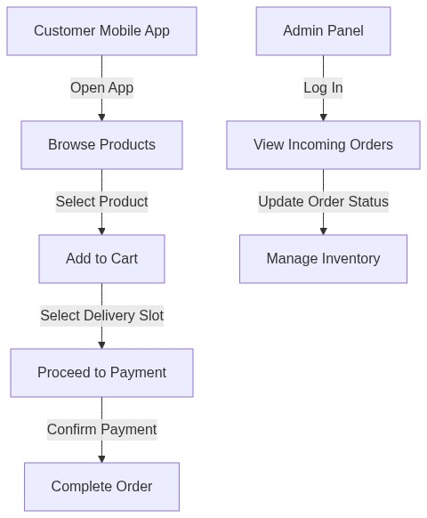

3. Functional Features
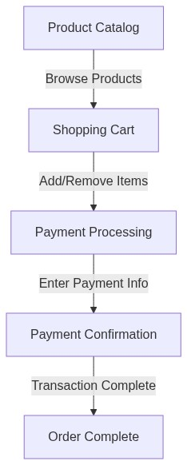

4. Data Architecture
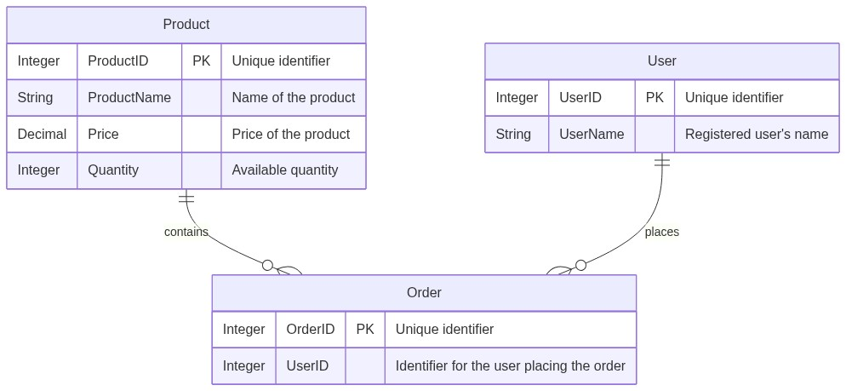

5. Integration Points
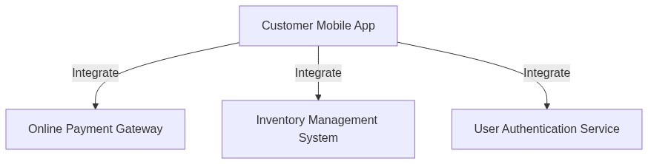

6. Security Protocols
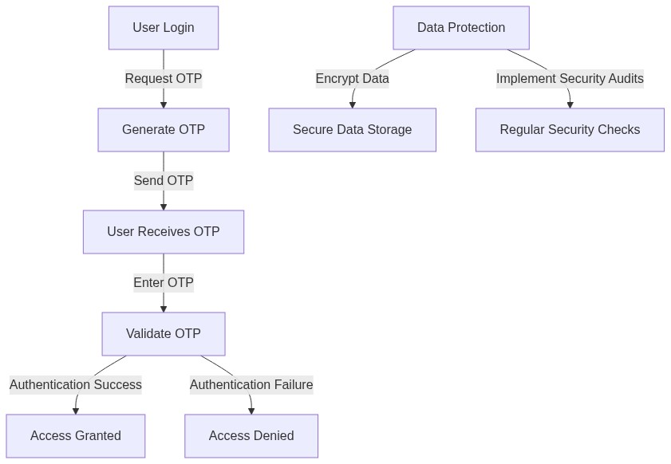

7. Business Rules
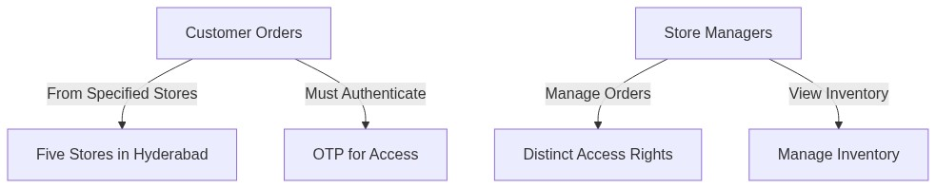

8. Requirement Pseudocode
Requirement Pseudocode
Flow: Customer Login
Inputs: userId, password
Preconditions: userId and password must be provided
Steps:
FUNCTION login(userId, password)
IF userId EXISTS IN database AND password IS VALID THEN
otp = generateOTP(userId)
sendOTP(userId, otp)
RETURN "OTP sent to registered mobile number"
ELSE
RETURN "Invalid credentials"
Postconditions: User receives OTP
Error Paths:
IF userId NOT FOUND THEN
RETURN "User not found"
IF password IS INVALID THEN
RETURN "Incorrect password"
Flow: OTP Verification
Inputs: userId, enteredOTP
Preconditions: User must have requested OTP
Steps:
FUNCTION verifyOTP(userId, enteredOTP)
storedOTP = getStoredOTP(userId)
IF enteredOTP EQUALS storedOTP THEN
markUserAsAuthenticated(userId)
RETURN "Login successful"
ELSE
RETURN "Invalid OTP"
Postconditions: User is authenticated
Error Paths:
IF storedOTP IS NULL THEN
RETURN "OTP not generated or expired"
Flow: Browse Product Catalog
Inputs: userId
Preconditions: User must be logged in
Steps:
FUNCTION browseProducts(userId)
products = fetchAvailableProducts()
IF products IS NOT EMPTY THEN
RETURN products
ELSE
RETURN "No products available"
Postconditions: User receives a list of products
Error Paths:
IF products NOT FOUND THEN
RETURN "Error fetching products"
Flow: Add Item to Cart
Inputs: userId, productId, quantity
Preconditions: userId must be logged in, productId must exist
Steps:
FUNCTION addToCart(userId, productId, quantity)
IF productExists(productId) THEN
cartItem = createCartItem(productId, quantity)
addItemToUserCart(userId, cartItem)
RETURN "Item added to cart"
ELSE
RETURN "Product not found"
Postconditions: Item is added to the user's cart
Error Paths:
IF quantity IS LESS THAN 1 THEN
RETURN "Invalid quantity"
Flow: Process Payment
Inputs: userId, paymentDetails
Preconditions: User must have items in the cart
Steps:
FUNCTION processPayment(userId, paymentDetails)
IF cartIsNotEmpty(userId) THEN
paymentResult = initiatePayment(paymentDetails)
IF paymentResult IS SUCCESS THEN
clearUserCart(userId)
RETURN "Payment successful, order placed"
ELSE
RETURN "Payment failed"
ELSE
RETURN "Cart is empty"
Postconditions: Payment is processed
Error Paths:
IF paymentDetails ARE INVALID THEN
RETURN "Invalid payment details"

