Infosys Springboard Virtual Internship 6.0 Completion Report

Team Details
Batch Number: 11
Start date: 29 December 2025
Names: <All Interns, names only>
Internship Duration: 8 Weeks

1. Project Title
FOODTRENDS UNDERSTANDING CUSTOMER PREFERENCES IN FACEBOOK

2. Project Objective
The objective of this project is to analyze customer discussions related to food on Facebook and identify emerging food trends using data analytics and Natural Language Processing techniques. The project aims to extract meaningful insights from large volumes of social media data and survey responses.
The key objectives include:
- Collect food-related data from Facebook posts, comments, and reactions.
- Perform sentiment analysis to understand customer opinions about different food items.
- Extract frequently mentioned food keywords to identify popular and emerging trends.
- Combine social media insights with survey responses to obtain structured customer preference data.
- Develop an interactive Power BI dashboard that visually presents food trends, sentiment patterns, and engagement metrics for easy interpretation.
The overall goal is to help food brands, researchers, and marketers understand public sentiment and customer preferences in the food industry.

3. Project description in detail
The Food Trend Analysis on Facebook project focuses on analyzing large-scale social media discussions to understand customer preferences and emerging trends in the food and beverage industry. The project collects unstructured data from Facebook, including posts, comments, reactions, and timestamps, using Apify scraping tools. In addition, structured data was gathered through an online survey to capture demographic information and food preferences from users. The combined dataset consists of more than 62,000 Facebook records and around 3,900 survey responses, providing a comprehensive dataset for analysis. The collected data was cleaned and preprocessed by removing duplicate records, handling missing values, standardizing timestamps, and preparing textual data for further analysis.
After preprocessing, Natural Language Processing techniques were applied to extract insights from the textual data. Sentiment analysis using the VADER model was used to classify comments and feedback into positive, neutral, or negative sentiments, allowing the identification of public opinion toward different food items. Keyword extraction was performed to detect frequently mentioned foods and emerging trends across posts and discussions. The processed data was then organized into a structured data model and integrated into a Power BI dashboard to visualize trends, sentiment patterns, and engagement metrics. These visualizations enable stakeholders to explore food trends interactively and gain insights that can support marketing strategies, product development, and consumer research.

4. Timeline Overview
Week | Activities Planned | Activities Completed
Week 1 | Data collection and understanding the dataset | Collected feedback data and studied the dataset
Week 2 | Data cleaning and preprocessing | Removed missing values and cleaned the data
Week 3 | Preparing data for sentiment analysis | Tokenization and stop word removal
Week 4 | Sentiment analysis | Classified feedback into positive, negative, and neutral
Week 5 | Product feature analysis | Analyzed feedback based on product features
Week 6 | Dashboard creation | Created performance dashboard
Week 7 | User segmentation | Grouped users based on feedback behavior
Week 8 | Final analysis and insights | Generated insights and summary report

5a. Key Milestones
Milestone | Description | Date Achieved
Project Kickoff | Started the project “Food Brand Understand Customer Trends” and understood objectives, tools, and data sources. | 29-DEC-25
Prototype/First Draft | Collected survey, social media, and review data. Cleaned and structured the dataset for analysis. | 14-FEB-26
Mid-Term Review | Implemented sentiment analysis to classify feedback into positive, neutral, and negative and created initial visualizations. | 20-FEB-26
Final Submission | Developed product insights, customer segmentation, and strategy dashboards in Power BI. | 28-FEB-26
Presentation | Presented the final dashboard, insights, and recommendations based on customer feedback trends. | 05-MAR-26

5b. Project execution details
The project execution involved several stages starting from data collection to visualization.
- Initially, large-scale Facebook data was scraped using Apify tools by providing Facebook page URLs. This resulted in a dataset containing posts, comments, engagement metrics, and timestamps.
- Next, a survey was conducted to collect structured data related to customer preferences, demographics, and food consumption patterns.
- After data collection, preprocessing steps were applied to clean and standardize the datasets. Duplicate entries and irrelevant columns were removed, missing values were handled, and text data was prepared for NLP processing.
- Natural Language Processing techniques were then applied to analyze textual data. Sentiment analysis was performed using the VADER model to determine whether comments expressed positive, neutral, or negative opinions. Keyword extraction techniques were used to identify frequently mentioned food items and topics.
- The cleaned and processed data was then structured into a multidimensional data model that allowed efficient querying and filtering.
- Finally, an interactive Power BI dashboard was developed to visualize insights such as trending foods, sentiment patterns, and engagement statistics. This dashboard allows users to explore trends over time and understand customer preferences more effectively.

6. Snapshots / Screenshots

Code Snapshots:

Sentiment Analysis
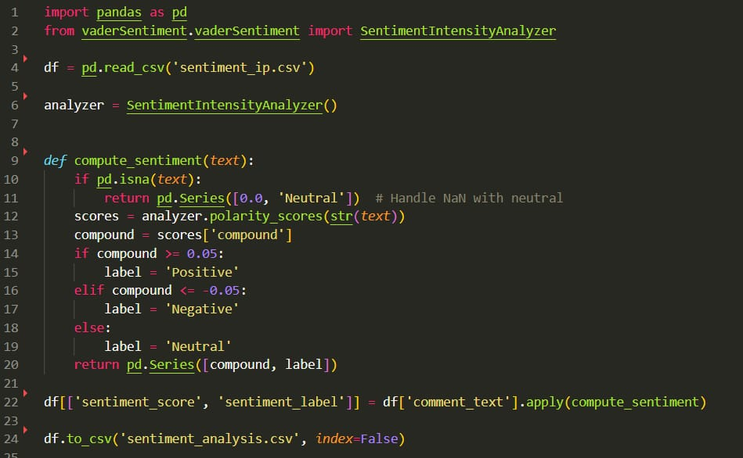

Keyword Extraction:
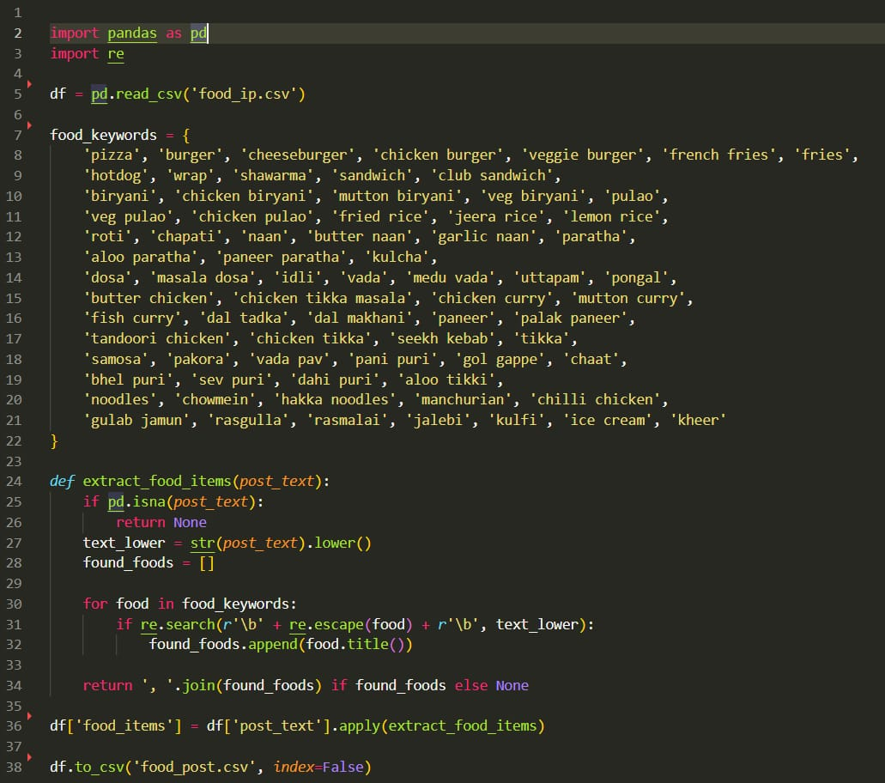

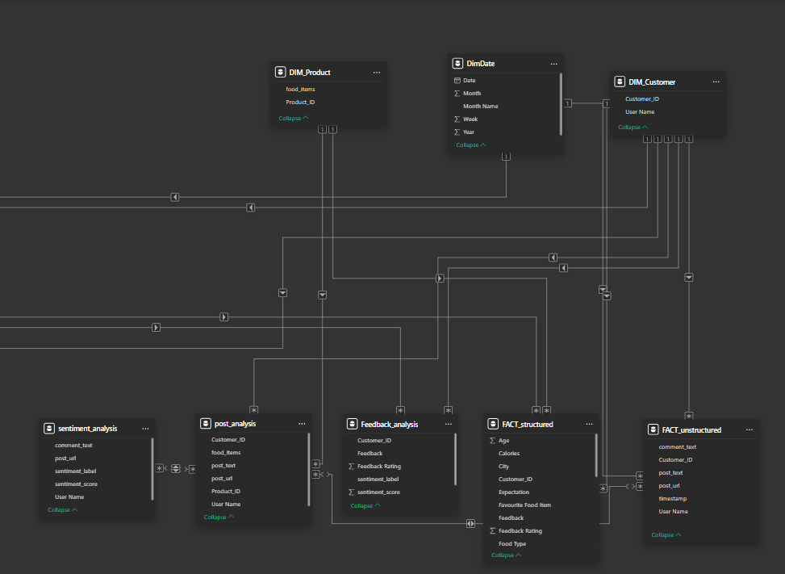
Model View:

Dashboards:
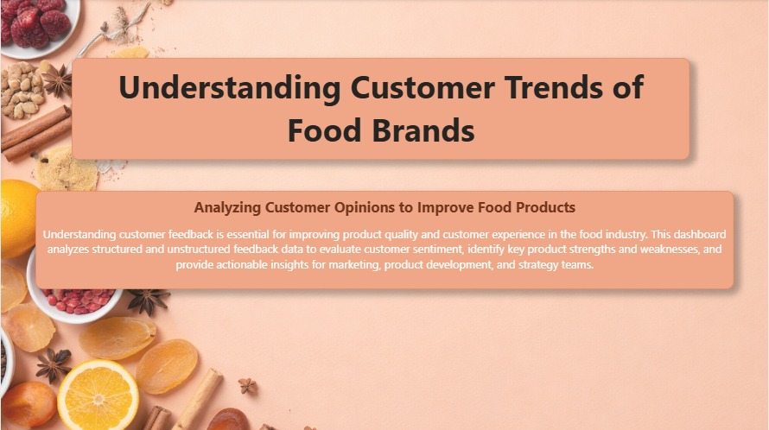

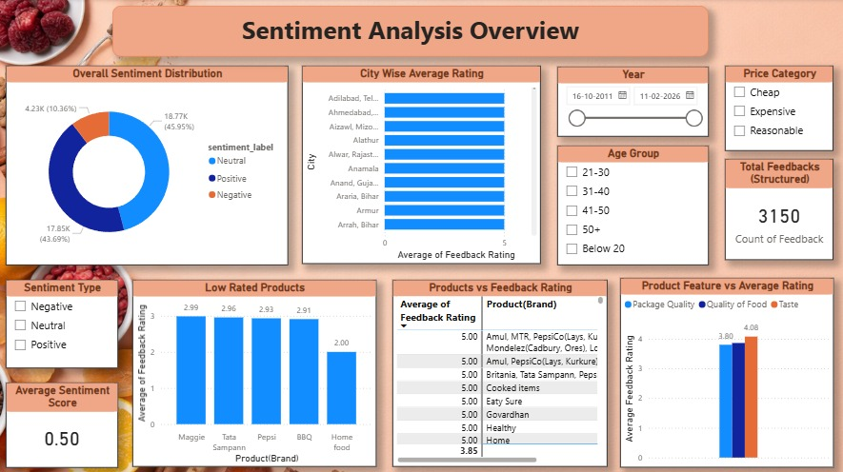
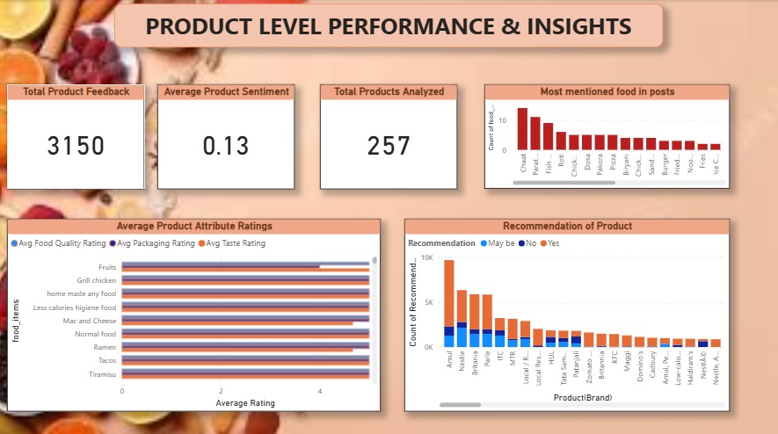

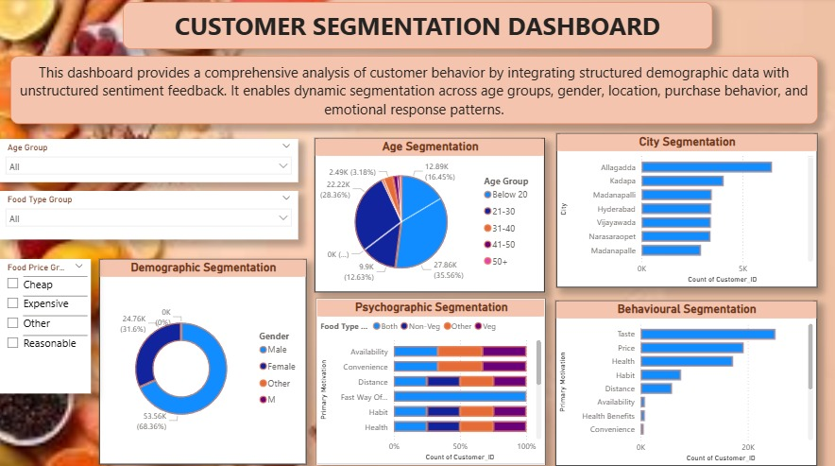

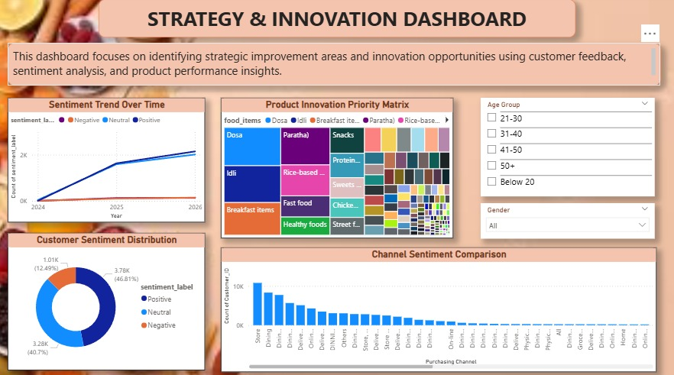

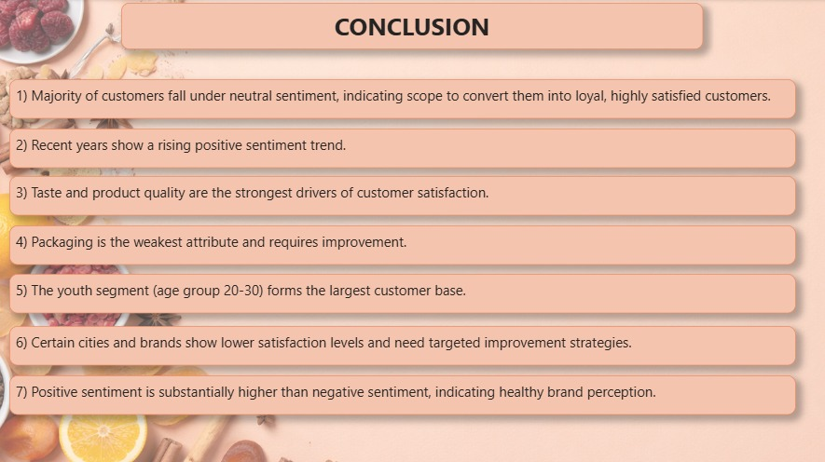

7. Challenges Faced
During the implementation of the Food Trend Analysis project, several challenges were encountered:
Large Volume of Unstructured Data
Facebook comments and posts contained slang, emojis, and inconsistent text formats, making preprocessing and NLP analysis difficult.
Data Noise
Social media data included irrelevant comments and spam which had to be filtered during the cleaning process.
Sentiment Classification Accuracy
Some comments contained sarcasm or mixed opinions, making accurate sentiment classification challenging.
Data Integration
Combining structured survey data with unstructured social media data required proper schema design and transformation.

8. Learnings & Skills Acquired
This project helped develop several technical and analytical skills.
- Data Collection & Web Scraping – Learned how to collect large datasets using Apify scraping tools.
- Data Cleaning & Preprocessing – Gained experience handling noisy and incomplete datasets.
- Natural Language Processing – Implemented sentiment analysis and keyword extraction techniques.
- Data Modeling – Learned to structure data for efficient analytical queries.
- Power BI Visualization – Developed interactive dashboards for trend analysis.
- Data Storytelling – Learned to convert raw data into meaningful insights for decision making.

9. Testimonials from team
The project provided valuable practical exposure to real-world data analysis and teamwork. Team members collaborated effectively in different phases such as data collection, cleaning, NLP processing, and dashboard development. The internship experience helped strengthen both technical knowledge and collaborative skills.

10. Conclusion
The Food Trend Analysis project successfully demonstrated how large-scale social media data can be transformed into actionable insights using data analytics and NLP techniques.
By analyzing over 62,000 Facebook records and 3,900 survey responses, the project identified trending food topics, customer sentiment patterns, and engagement behaviors. The final Power BI dashboard enables users to explore these insights interactively.
Overall, the internship project provided hands-on experience in data analytics, NLP, and visualization, strengthening the foundation for future work in data science and business intelligence.

11. Acknowledgements
We are truly grateful to Infosys for giving us this opportunity. We are very thankful to the mentor for their continuous support and mentorship throughout this project. Their guidance, patience, and expertise have played a major role in shaping our technical and professional growth. Thank you for always encouraging us and helping us succeed.

