Abhishek Satbhai (001587689)

**Program Structures & Algorithms**

**Fall 2021**

**Assignment No. 1**

* **Task**

1. **Find relationship between n steps and d (Euclidean distance)**
2. **Implement the code for random walk experiment**
3. **Run all unit test correctly**
4. **Run experiment at least for 6 values of n steps and for at least 10 times per experiment**

* **Relationship Conclusion:**

**After experimenting relationship between N steps and D.**

**I came to conclusion that:-**

**D ∝ √ N – ( 1 / 2 √N ) ) + C**

Where:-

D is Mean of Euclidean Distance

N is number of steps

C is the constant

* **Evidence to support the conclusion:**

1. **Output**

**N steps from range (10 to 100) and multiple of 10 for 30 number of experiment for each step**

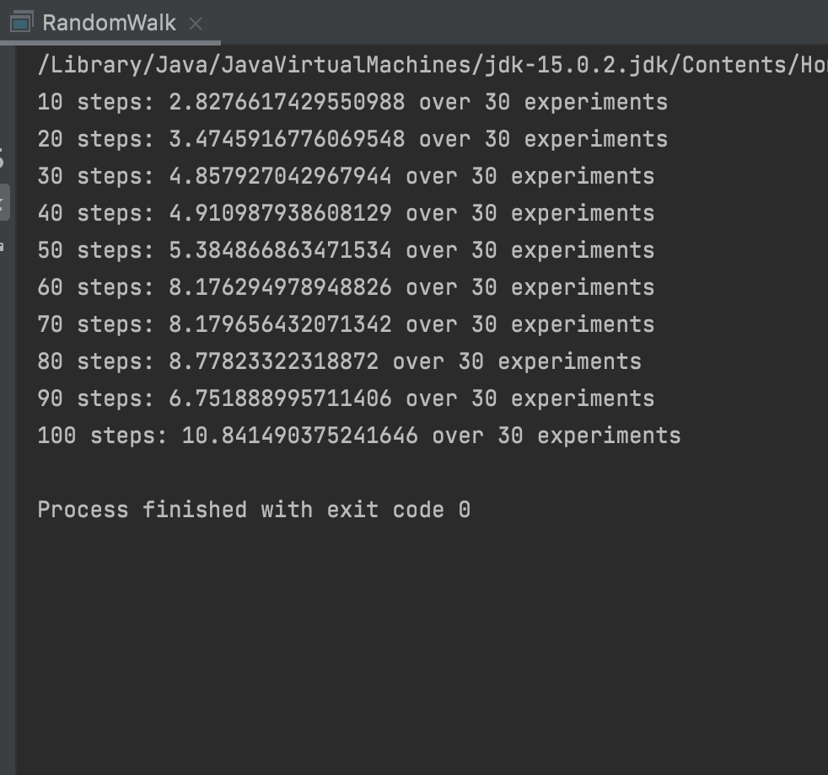

**N steps from range ( 1 to 15 ) for 30 number of experiment for each step**

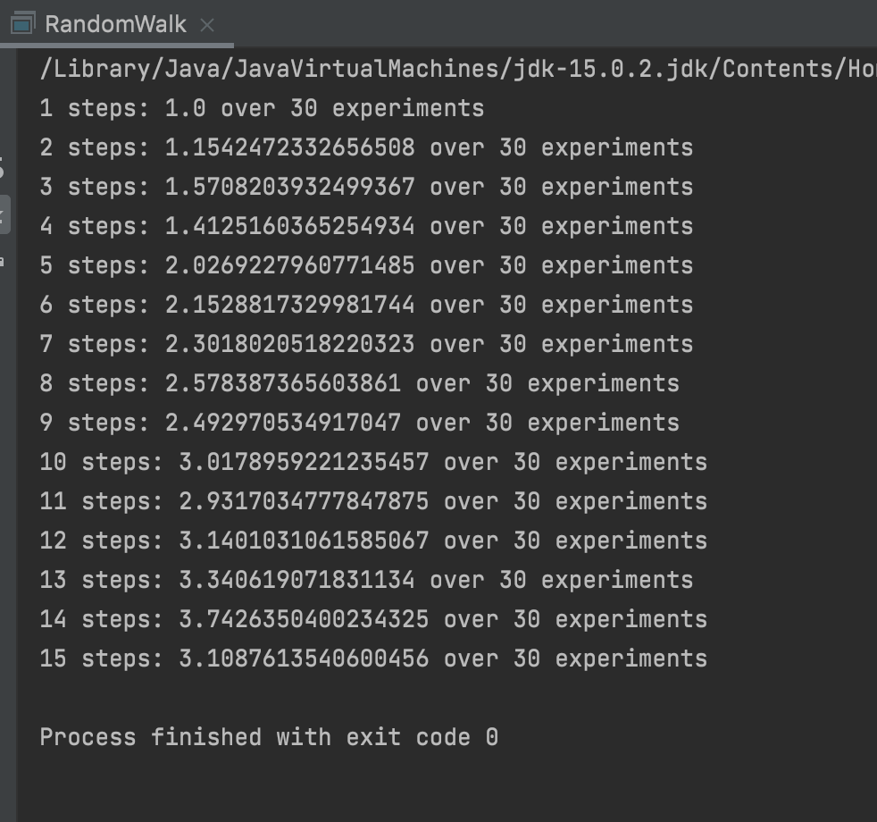

1. **Graphical Representation**

**Graph for N Steps ranges from (1 to 15)**

|  |  |  |  |  |
| --- | --- | --- | --- | --- |
|  | Mean distance | Number of experiments | Sqrt of N | Sqrt N - 1/(2* sqrt n) |
| 1 | 1 | 30 | 1 | 0.5 |
| 2 | 1.154247233 | 30 | 1.414213562 | 1.060660172 |
| 3 | 1.570820393 | 30 | 1.732050808 | 1.443375673 |
| 4 | 1.412516037 | 30 | 2 | 1.75 |
| 5 | 2.026922796 | 30 | 2.236067977 | 2.01246118 |
| 6 | 2.152881733 | 30 | 2.449489743 | 2.245365598 |
| 7 | 2.301802052 | 30 | 2.645751311 | 2.456769075 |
| 8 | 2.578387366 | 30 | 2.828427125 | 2.651650429 |
| 9 | 2.492970535 | 30 | 3 | 2.833333333 |
| 10 | 3.017895922 | 30 | 3.16227766 | 3.004163777 |
| 11 | 2.931703478 | 30 | 3.31662479 | 3.165869118 |
| 12 | 3.140103106 | 30 | 3.464101615 | 3.319764048 |
| 13 | 3.340619072 | 30 | 3.605551275 | 3.466876226 |
| 14 | 3.74263504 | 30 | 3.741657387 | 3.608026766 |
| 15 | 3.108761354 | 30 | 3.872983346 | 3.743883901 |

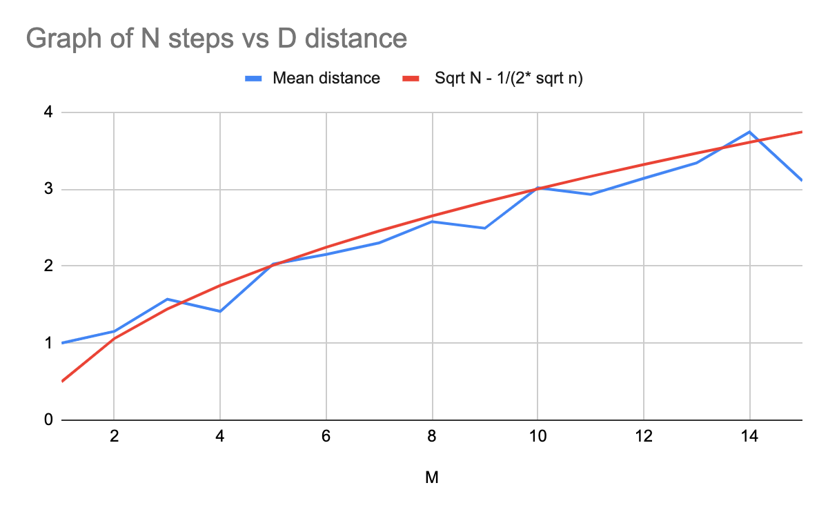

**Graph for N steps ranges (0 to 100) and multiple of 10**

|  |  |  |  |  |
| --- | --- | --- | --- | --- |
| N Steps | Mean distance | Number of experiments | Sqrt of N | Sqrt N - 1/(2* sqrt N) |
| 10 | 2.827661743 | 30 | 3.16227766 | 3.004163777 |
| 20 | 3.474591678 | 30 | 4.472135955 | 4.360332556 |
| 30 | 4.857927043 | 30 | 5.477225575 | 5.385938482 |
| 40 | 4.910987939 | 30 | 6.32455532 | 6.245498379 |
| 50 | 5.384866863 | 30 | 7.071067812 | 7.000357134 |
| 60 | 8.176294979 | 30 | 7.745966692 | 7.68141697 |
| 70 | 8.179656432 | 30 | 8.366600265 | 8.306838835 |
| 80 | 8.778233223 | 30 | 8.94427191 | 8.888370211 |
| 90 | 6.751888996 | 30 | 9.486832981 | 9.434128353 |
| 100 | 10.84149038 | 30 | 10 | 9.95 |

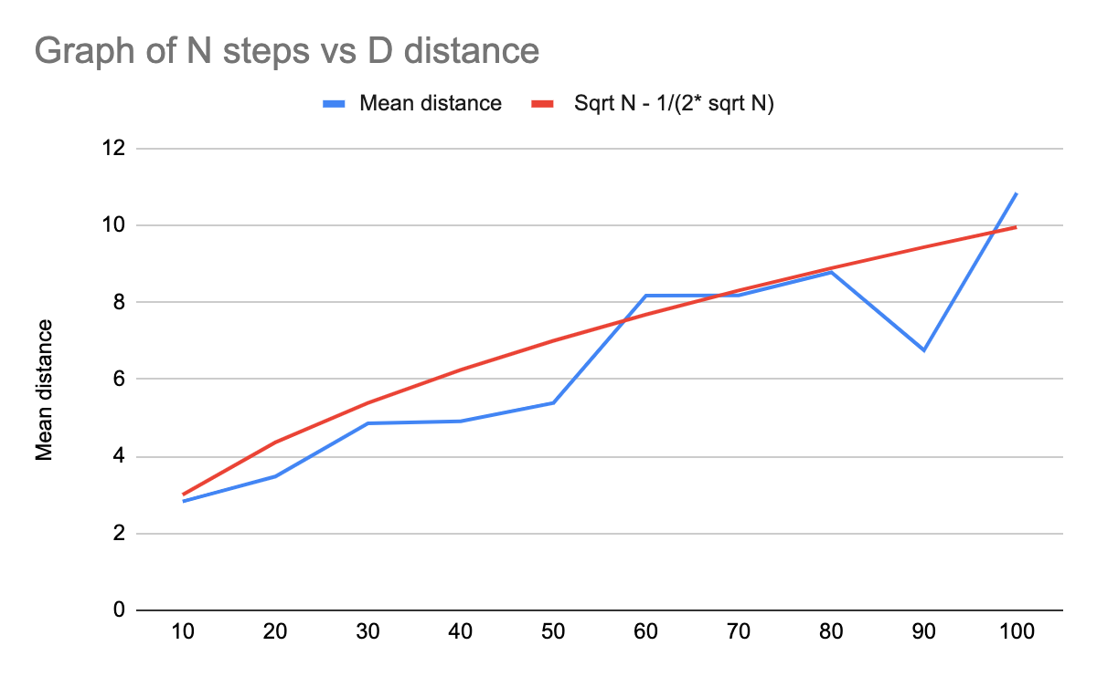

* **Unit tests result:(Snapshot of successful unit test run)**

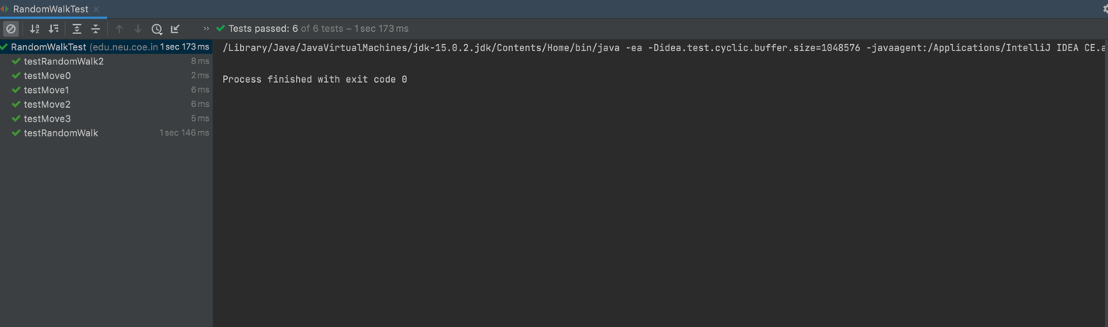

Code with changes :-

1.Added code to move() function:-

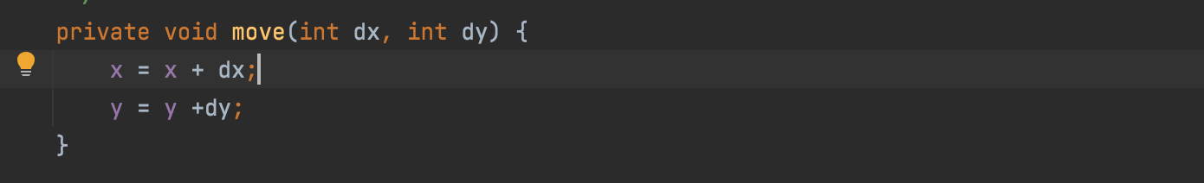

2.Added code to randomwalk() function:-

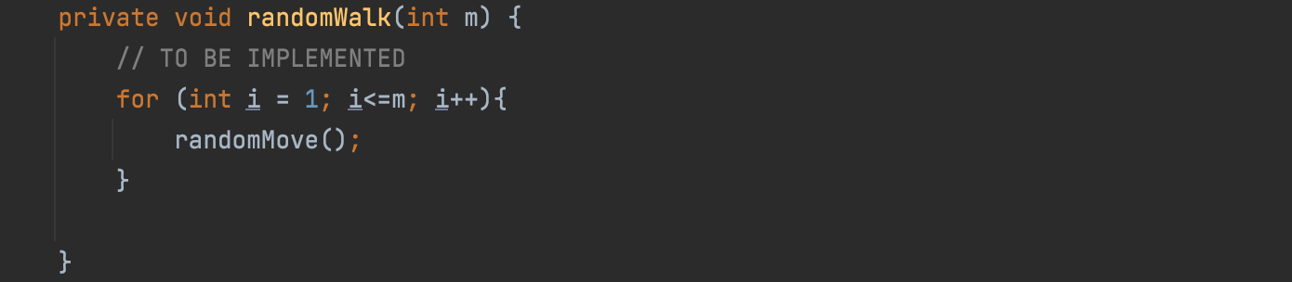

1. Added code to distance() function:-

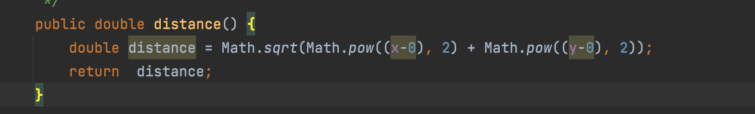

4.Modified main function to run for different values of m :-

