Abhishek Satbhai (001587689)

**Program Structures & Algorithms**

**Fall 2021**

**Assignment No. 3**

**Task:**

1. **Implement Quick Union**
2. **Pass All Test cases for UF_HWQUPC.java**
3. **Then generates random pairs of integers between 0 and n-1,**
4. **Show Evidence of run**
5. **Determine the relationship between the number of objects (*n*) and the number of pairs (*m*) generated**

**Part 1.**

**Added code below to implement quick union**

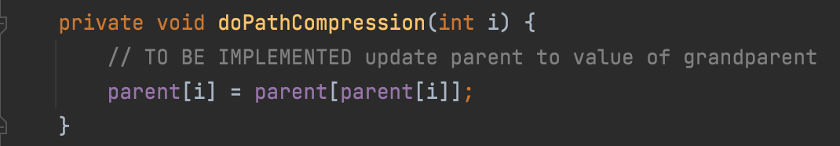

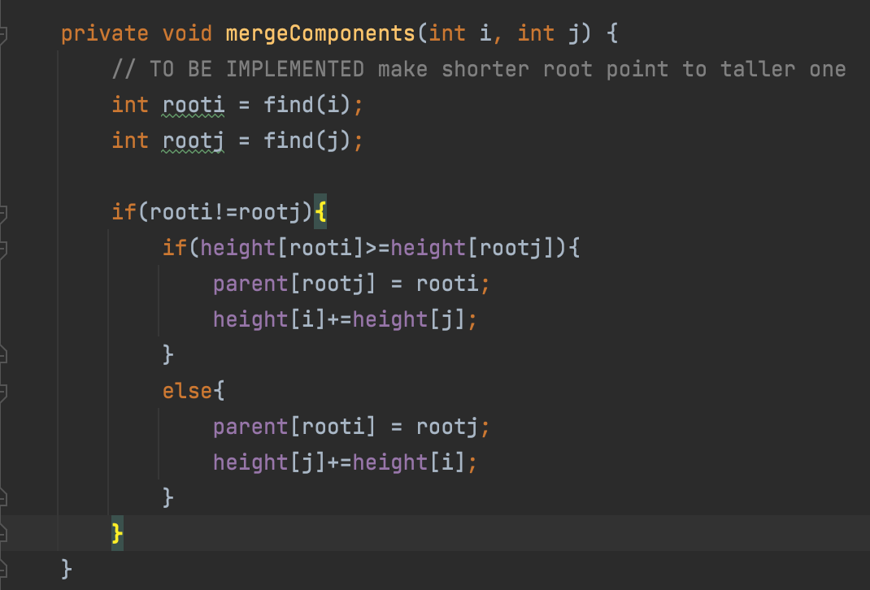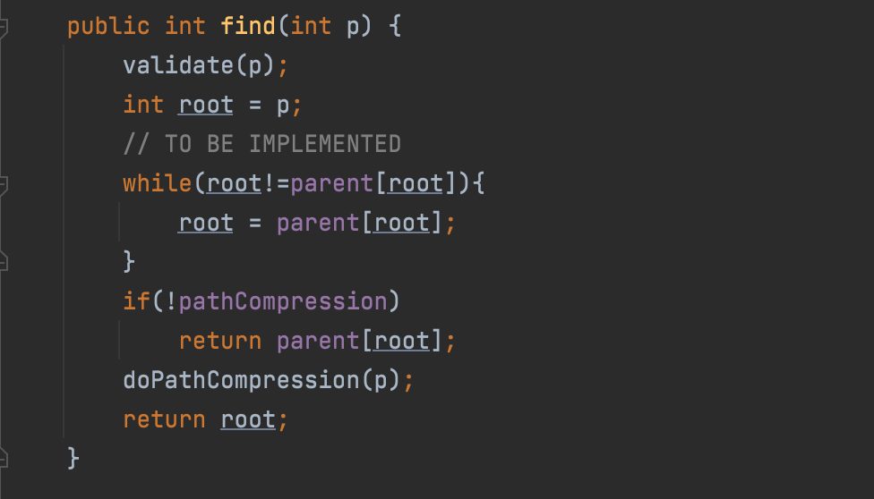

**Part 2:**

**Pass All Test cases for UF_HWQUPC.java**

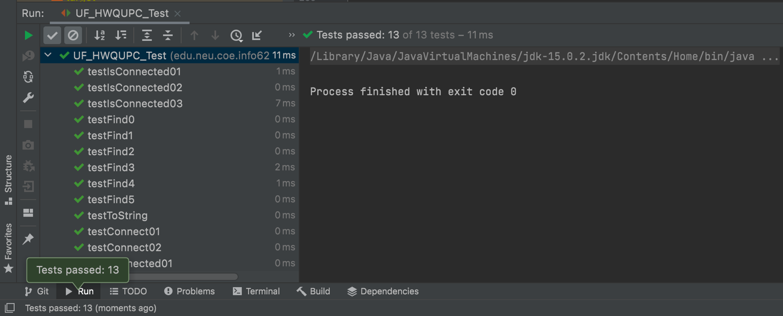

**Part 3:**

**Built Ufind.java class to generate random pair and count number of connection**

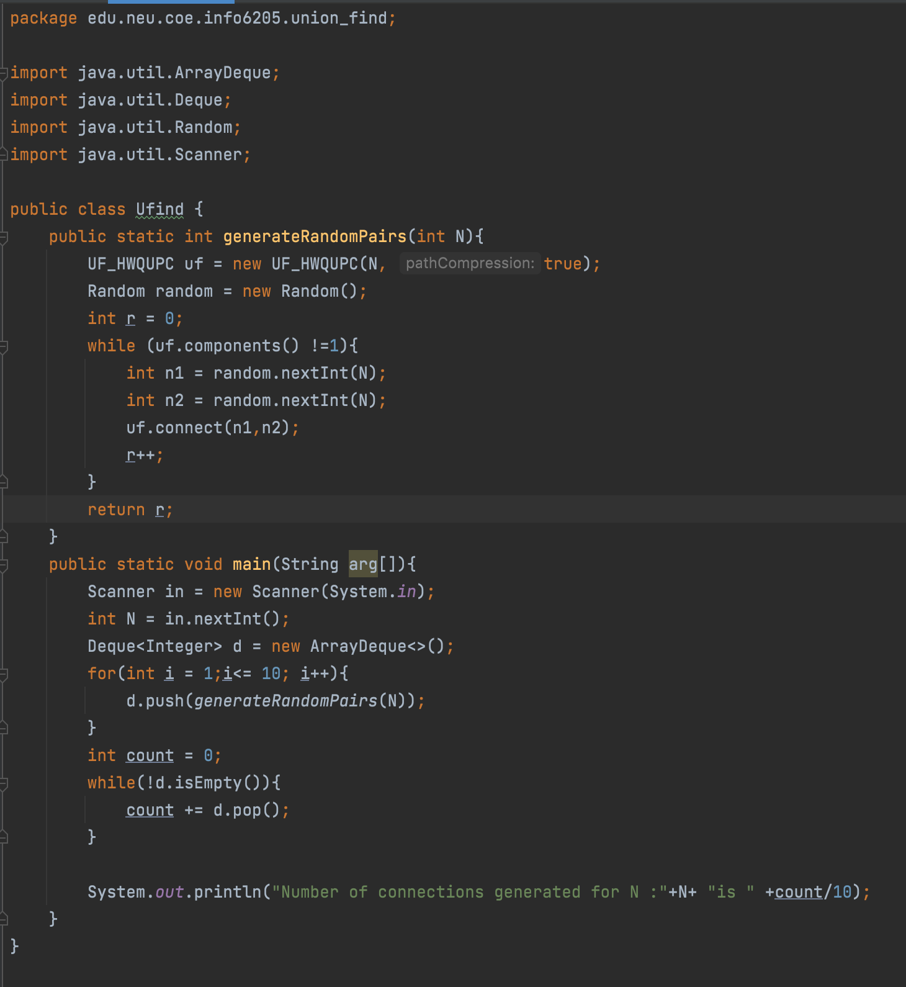

**Part 4 Output :**

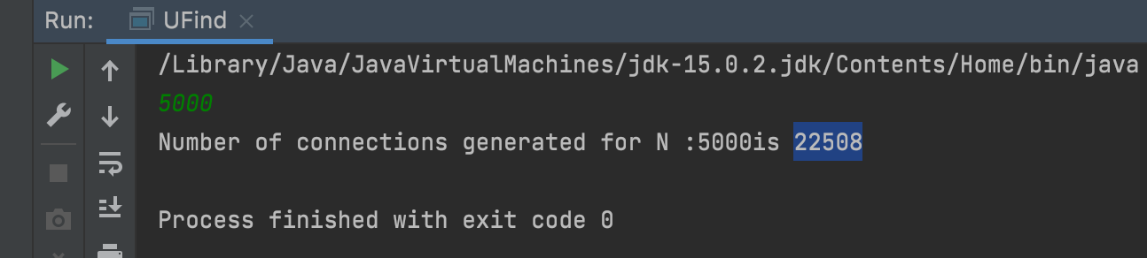

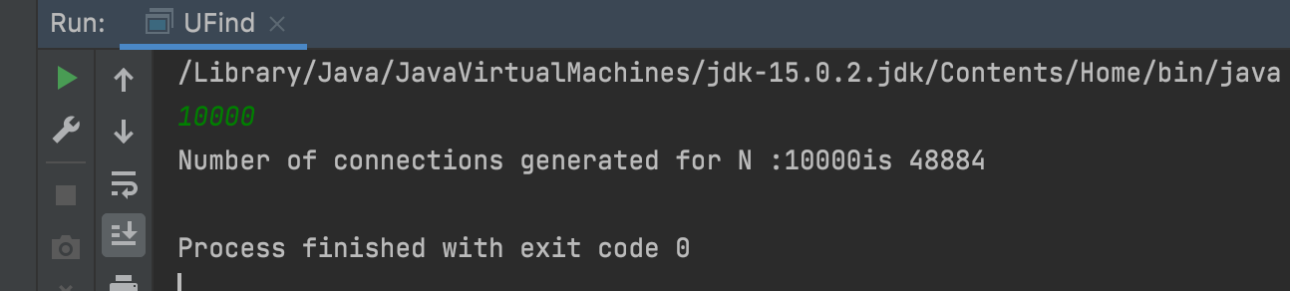

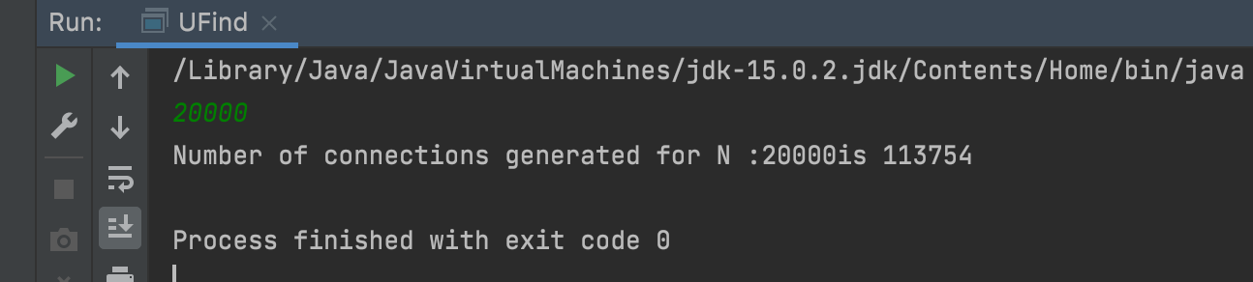

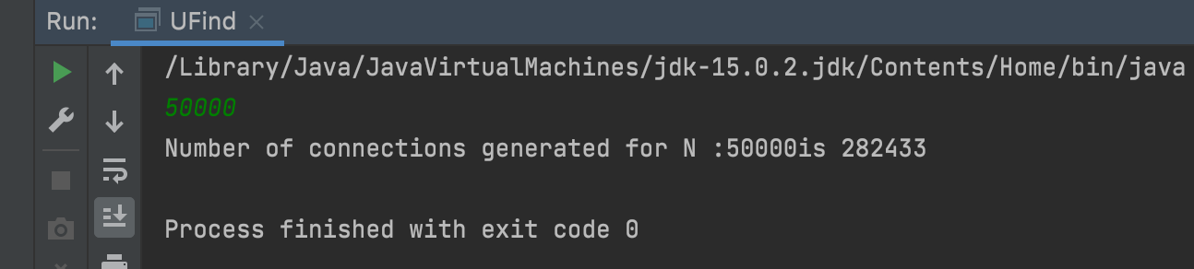

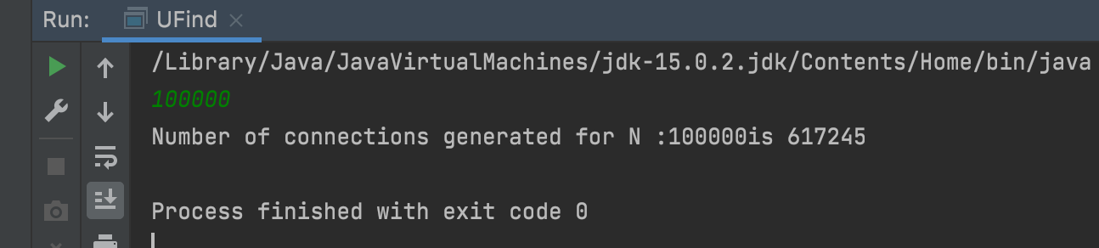

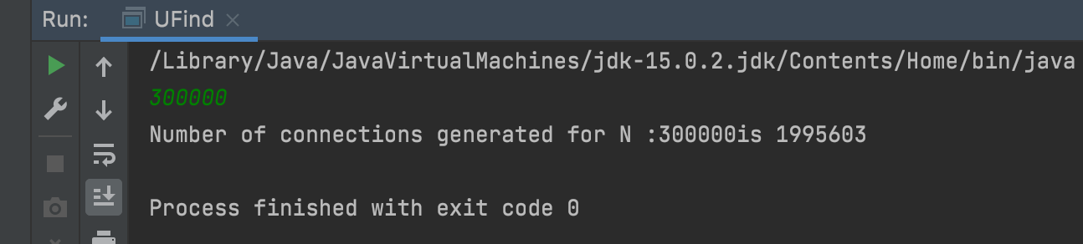

**Part 5:**

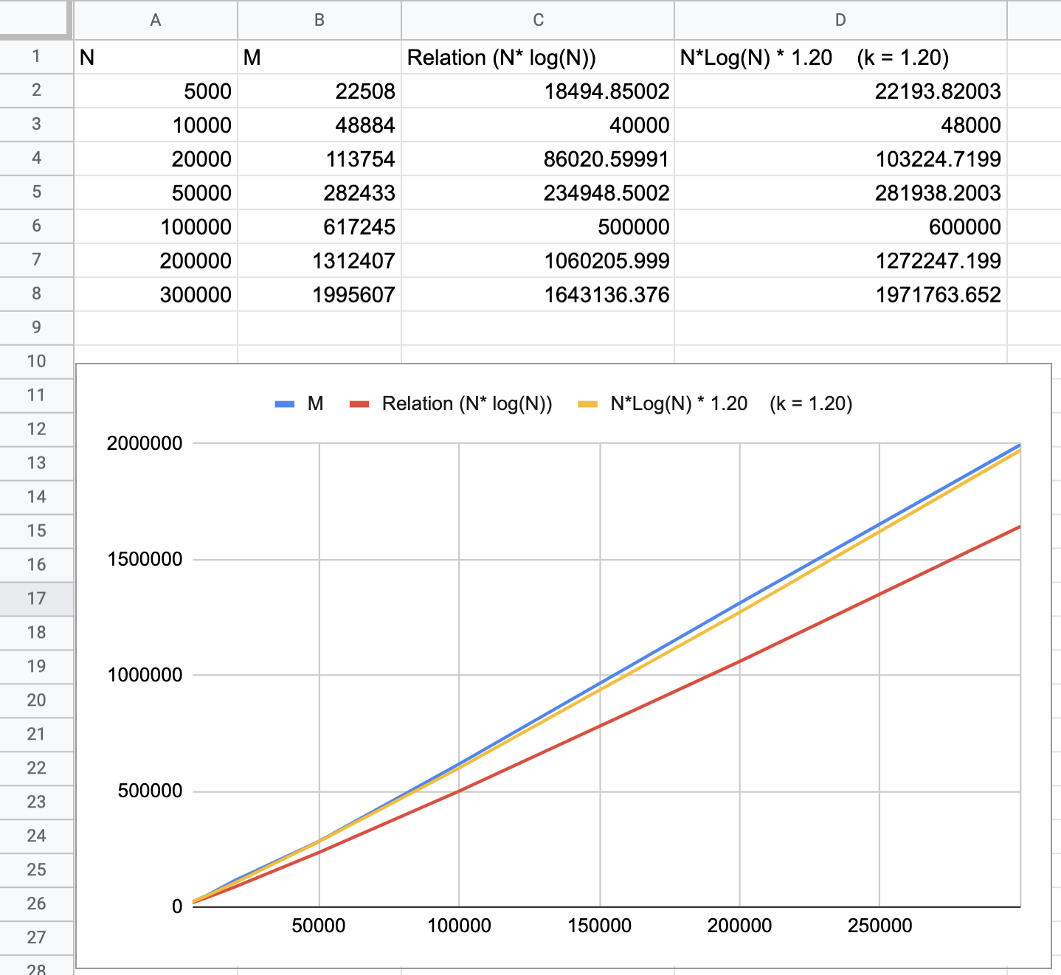

**N - >**

**After tying multiple values of N and as shown above. I got following relationship.**

**M = k * N * Log(N)**

**Where k is constant = ~ 1.20**