Abhishek Satbhai (001587689)

**Program Structures & Algorithms**

**Fall 2021**

**Assignment No. 5**

**Task:**

1. **Take cutoff in argument for command line and experiment and come up with good value for cutoff**
2. **Show performance of each thread working in parallel, show evidence to support your performance and attach output screenshot**
3. **Conclusion of assignments**

**Part 1.**

**Take cutoff in argument for command line and experiment and come up with good value for cutoff**

**Implemented Multiple thread for parallel sorting**

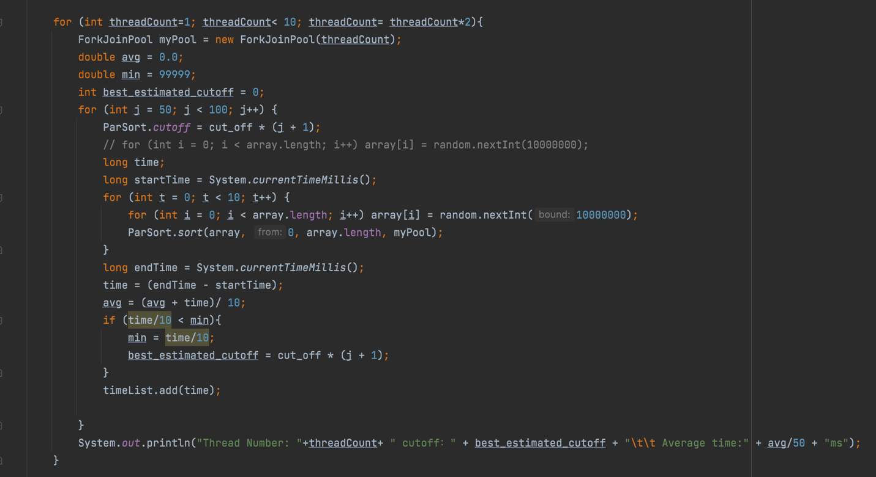

**Implemented ForkJoinPool “mypool” for sort function**

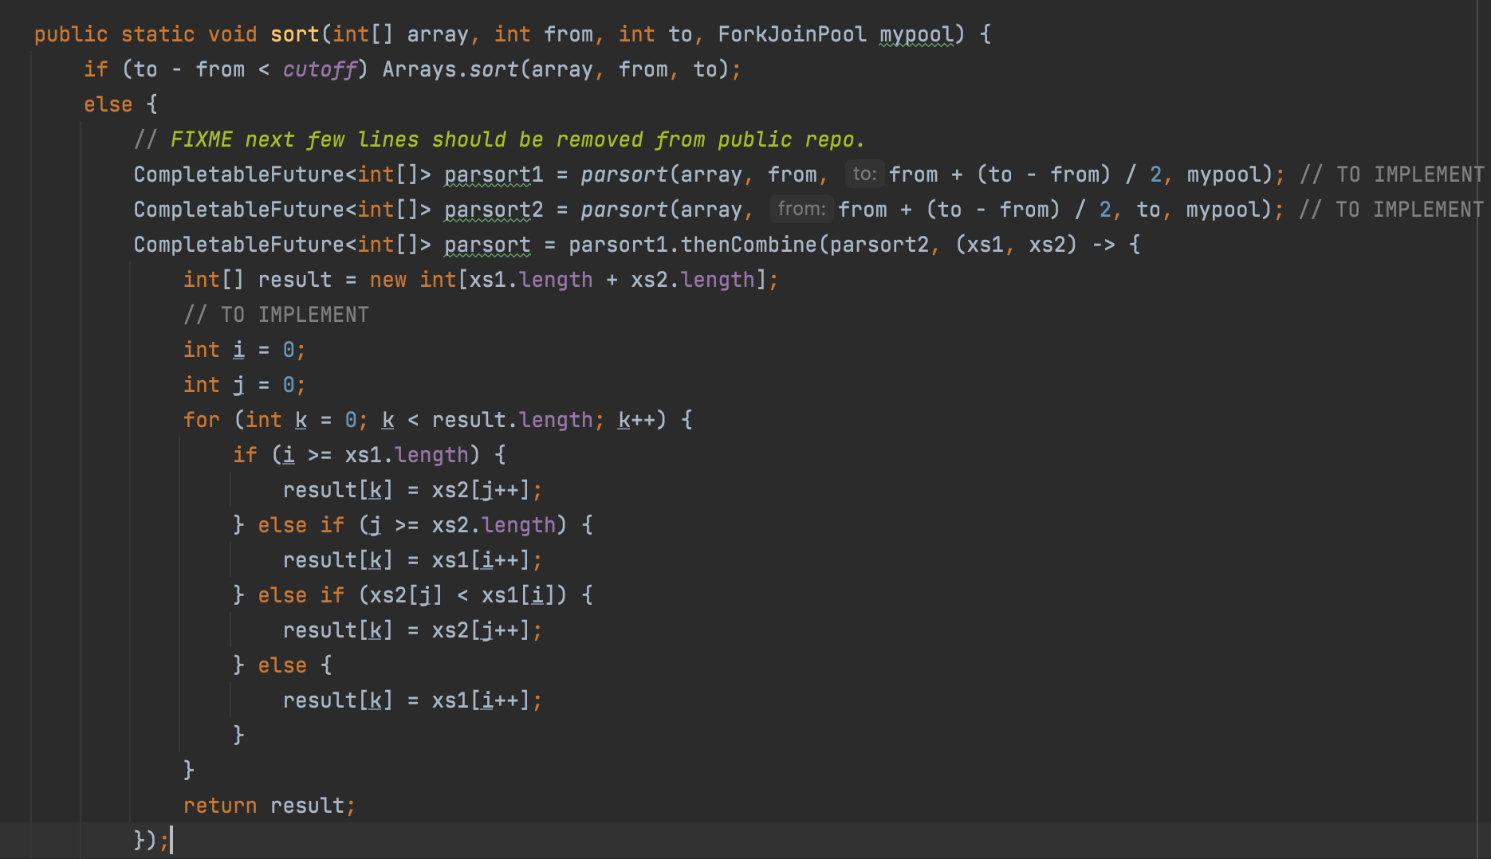

**Implemented Completable Future**

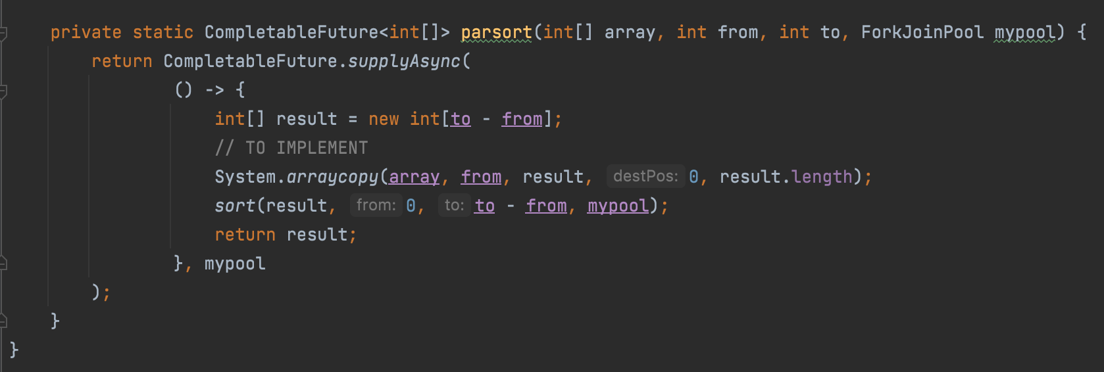

**Part 2 and 3 :**

**For Array size : 500000 with 4 Threads Graph of Performance:-**

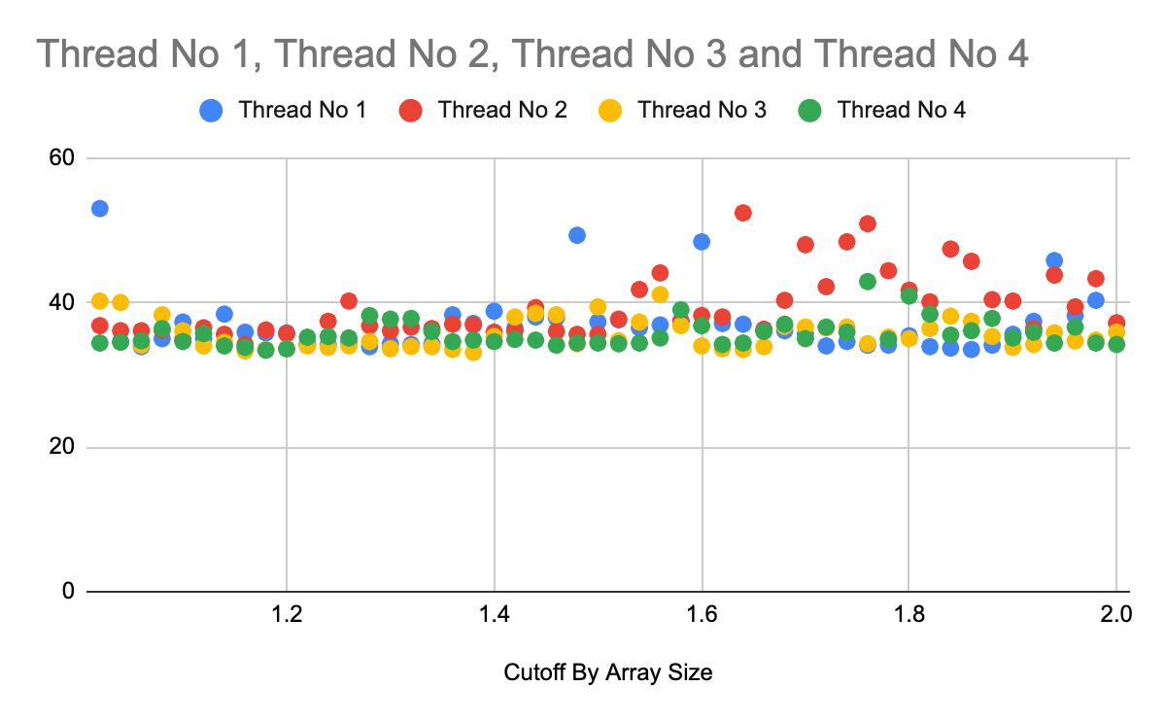

**Screenshot of output :-**

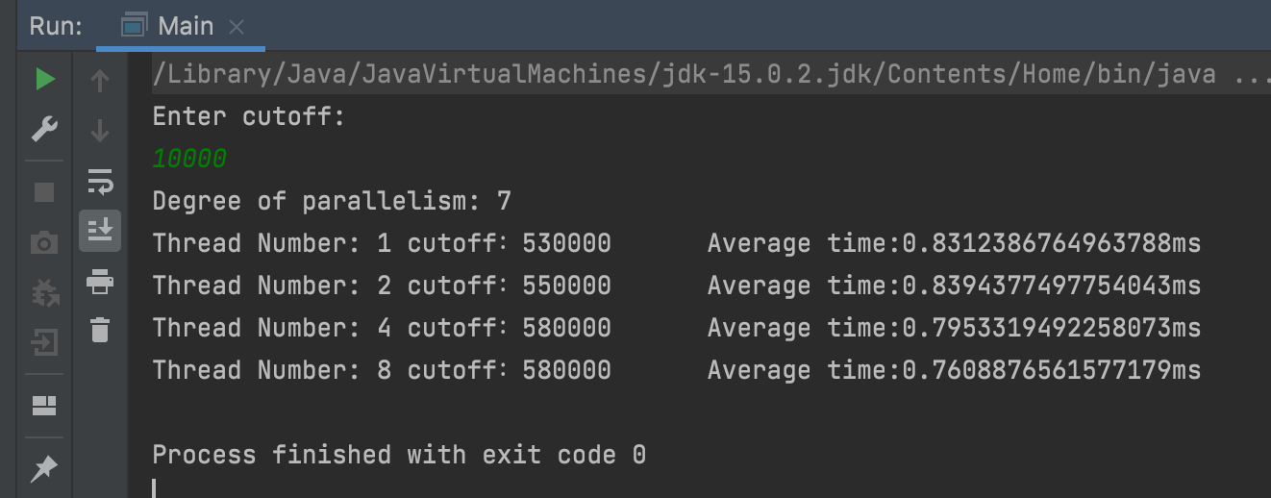

**Results. CSV :-**

|  |  |  |
| --- | --- | --- |
| Cut off by array size | Time (ms) | Threads |
| 1.02 | 53 | 0 |
| 1.04 | 34.6 | 0 |
| 1.06 | 33.9 | 0 |
| 1.08 | 35 | 0 |
| 1.1 | 37.3 | 0 |
| 1.12 | 35 | 0 |
| 1.14 | 38.4 | 0 |
| 1.16 | 35.9 | 0 |
| 1.18 | 35.8 | 0 |
| 1.2 | 35.8 | 0 |
| 1.22 | 34.3 | 0 |
| 1.24 | 34.2 | 0 |
| 1.26 | 34.5 | 0 |
| 1.28 | 33.9 | 0 |
| 1.3 | 34.3 | 0 |
| 1.32 | 34.2 | 0 |
| 1.34 | 34.3 | 0 |
| 1.36 | 38.3 | 0 |
| 1.38 | 37.1 | 0 |
| 1.4 | 38.8 | 0 |
| 1.42 | 36.5 | 0 |
| 1.44 | 38 | 0 |
| 1.46 | 37.9 | 0 |
| 1.48 | 49.3 | 0 |
| 1.5 | 37.3 | 0 |
| 1.52 | 37.6 | 0 |
| 1.54 | 36.5 | 0 |
| 1.56 | 36.9 | 0 |
| 1.58 | 37.5 | 0 |
| 1.6 | 48.4 | 0 |
| 1.62 | 37.1 | 0 |
| 1.64 | 37 | 0 |
| 1.66 | 36.1 | 0 |
| 1.68 | 36.1 | 0 |
| 1.7 | 35.7 | 0 |
| 1.72 | 34 | 0 |
| 1.74 | 34.6 | 0 |
| 1.76 | 34.1 | 0 |
| 1.78 | 34.1 | 0 |
| 1.8 | 35.4 | 0 |
| 1.82 | 33.9 | 0 |
| 1.84 | 33.7 | 0 |
| 1.86 | 33.5 | 0 |
| 1.88 | 34.1 | 0 |
| 1.9 | 35.6 | 0 |
| 1.92 | 37.4 | 0 |
| 1.94 | 45.8 | 0 |
| 1.96 | 38.2 | 0 |
| 1.98 | 40.3 | 0 |
| 2 | 37.1 | 0 |
| 1.02 | 36.8 | 1 |
| 1.04 | 36.1 | 1 |
| 1.06 | 36.1 | 1 |
| 1.08 | 36.2 | 1 |
| 1.1 | 34.9 | 1 |
| 1.12 | 36.5 | 1 |
| 1.14 | 35.6 | 1 |
| 1.16 | 34.2 | 1 |
| 1.18 | 36.2 | 1 |
| 1.2 | 35.7 | 1 |
| 1.22 | 34.1 | 1 |
| 1.24 | 37.4 | 1 |
| 1.26 | 40.2 | 1 |
| 1.28 | 36.8 | 1 |
| 1.3 | 36.1 | 1 |
| 1.32 | 36.6 | 1 |
| 1.34 | 36.4 | 1 |
| 1.36 | 37 | 1 |
| 1.38 | 36.9 | 1 |
| 1.4 | 35.9 | 1 |
| 1.42 | 36 | 1 |
| 1.44 | 39.3 | 1 |
| 1.46 | 36 | 1 |
| 1.48 | 35.6 | 1 |
| 1.5 | 35.6 | 1 |
| 1.52 | 37.7 | 1 |
| 1.54 | 41.8 | 1 |
| 1.56 | 44.1 | 1 |
| 1.58 | 37.4 | 1 |
| 1.6 | 38.2 | 1 |
| 1.62 | 38 | 1 |
| 1.64 | 52.4 | 1 |
| 1.66 | 36.3 | 1 |
| 1.68 | 40.3 | 1 |
| 1.7 | 48 | 1 |
| 1.72 | 42.2 | 1 |
| 1.74 | 48.4 | 1 |
| 1.76 | 50.9 | 1 |
| 1.78 | 44.4 | 1 |
| 1.8 | 41.7 | 1 |
| 1.82 | 40.1 | 1 |
| 1.84 | 47.4 | 1 |
| 1.86 | 45.7 | 1 |
| 1.88 | 40.4 | 1 |
| 1.9 | 40.2 | 1 |
| 1.92 | 36.4 | 1 |
| 1.94 | 43.8 | 1 |
| 1.96 | 39.4 | 1 |
| 1.98 | 43.3 | 1 |
| 2 | 37.2 | 1 |
| 1.02 | 40.2 | 2 |
| 1.04 | 40 | 2 |
| 1.06 | 34.1 | 2 |
| 1.08 | 38.3 | 2 |
| 1.1 | 36.1 | 2 |
| 1.12 | 34 | 2 |
| 1.14 | 34.5 | 2 |
| 1.16 | 33.3 | 2 |
| 1.18 | 33.5 | 2 |
| 1.2 | 33.6 | 2 |
| 1.22 | 34 | 2 |
| 1.24 | 33.8 | 2 |
| 1.26 | 34 | 2 |
| 1.28 | 34.6 | 2 |
| 1.3 | 33.6 | 2 |
| 1.32 | 33.9 | 2 |
| 1.34 | 33.9 | 2 |
| 1.36 | 33.5 | 2 |
| 1.38 | 33.1 | 2 |
| 1.4 | 35.3 | 2 |
| 1.42 | 38 | 2 |
| 1.44 | 38.5 | 2 |
| 1.46 | 38.3 | 2 |
| 1.48 | 34.3 | 2 |
| 1.5 | 39.4 | 2 |
| 1.52 | 34.7 | 2 |
| 1.54 | 37.3 | 2 |
| 1.56 | 41.1 | 2 |
| 1.58 | 36.8 | 2 |
| 1.6 | 34 | 2 |
| 1.62 | 33.6 | 2 |
| 1.64 | 33.5 | 2 |
| 1.66 | 33.9 | 2 |
| 1.68 | 36.7 | 2 |
| 1.7 | 36.6 | 2 |
| 1.72 | 36.5 | 2 |
| 1.74 | 36.6 | 2 |
| 1.76 | 34.3 | 2 |
| 1.78 | 35.2 | 2 |
| 1.8 | 35 | 2 |
| 1.82 | 36.4 | 2 |
| 1.84 | 38.1 | 2 |
| 1.86 | 37.4 | 2 |
| 1.88 | 35.3 | 2 |
| 1.9 | 33.8 | 2 |
| 1.92 | 34.2 | 2 |
| 1.94 | 35.8 | 2 |
| 1.96 | 34.7 | 2 |
| 1.98 | 34.8 | 2 |
| 2 | 35.9 | 2 |
| 1.02 | 34.4 | 3 |
| 1.04 | 34.5 | 3 |
| 1.06 | 34.7 | 3 |
| 1.08 | 36.4 | 3 |
| 1.1 | 34.6 | 3 |
| 1.12 | 35.7 | 3 |
| 1.14 | 34 | 3 |
| 1.16 | 33.8 | 3 |
| 1.18 | 33.4 | 3 |
| 1.2 | 33.6 | 3 |
| 1.22 | 35.2 | 3 |
| 1.24 | 35.3 | 3 |
| 1.26 | 35.1 | 3 |
| 1.28 | 38.2 | 3 |
| 1.3 | 37.7 | 3 |
| 1.32 | 37.8 | 3 |
| 1.34 | 36 | 3 |
| 1.36 | 34.6 | 3 |
| 1.38 | 34.8 | 3 |
| 1.4 | 34.6 | 3 |
| 1.42 | 34.9 | 3 |
| 1.44 | 34.8 | 3 |
| 1.46 | 34.1 | 3 |
| 1.48 | 34.4 | 3 |
| 1.5 | 34.4 | 3 |
| 1.52 | 34.3 | 3 |
| 1.54 | 34.4 | 3 |
| 1.56 | 35.1 | 3 |
| 1.58 | 39 | 3 |
| 1.6 | 36.8 | 3 |
| 1.62 | 34.2 | 3 |
| 1.64 | 34.4 | 3 |
| 1.66 | 36 | 3 |
| 1.68 | 37 | 3 |
| 1.7 | 35 | 3 |
| 1.72 | 36.6 | 3 |
| 1.74 | 35.9 | 3 |
| 1.76 | 42.9 | 3 |
| 1.78 | 34.9 | 3 |
| 1.8 | 40.9 | 3 |
| 1.82 | 38.4 | 3 |
| 1.84 | 35.5 | 3 |
| 1.86 | 36.1 | 3 |
| 1.88 | 37.8 | 3 |
| 1.9 | 35.1 | 3 |
| 1.92 | 35.9 | 3 |
| 1.94 | 34.4 | 3 |
| 1.96 | 36.6 | 3 |
| 1.98 | 34.4 | 3 |
| 2 | 34.2 | 3 |

**For Array Size 1000000 and 4 threads graph of performance:-**

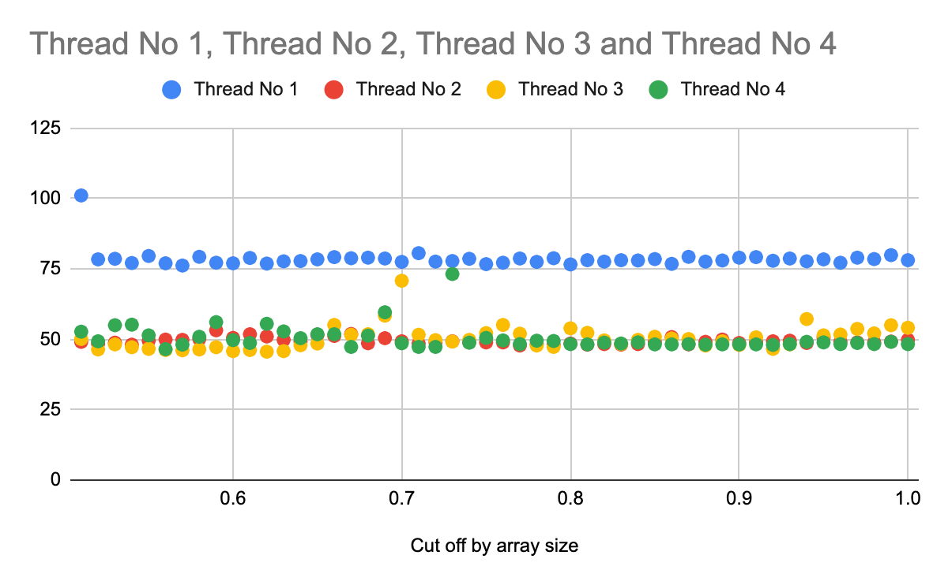

**Output:-**

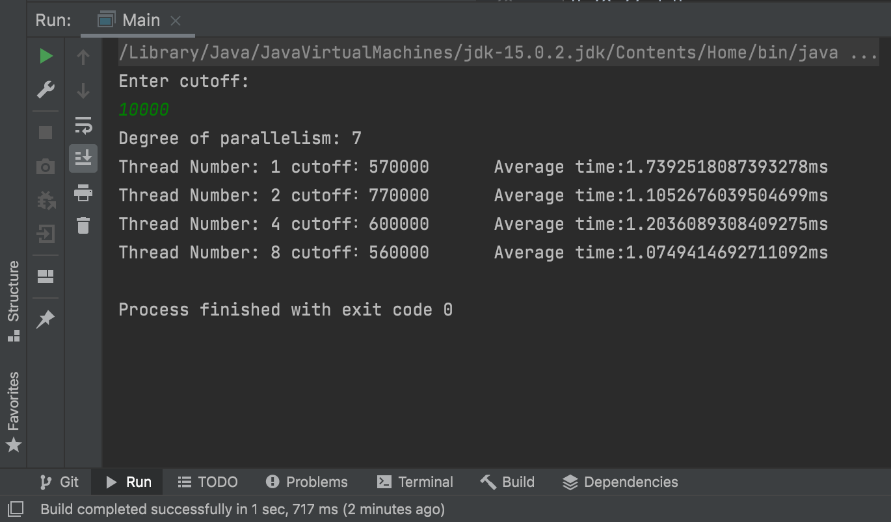

**Results Csv:**

|  |  |  |
| --- | --- | --- |
| Cut off by array size | Time (ms) | Threads |
| 0.51 | 101.1 | 0 |
| 0.52 | 78.4 | 0 |
| 0.53 | 78.6 | 0 |
| 0.54 | 77.1 | 0 |
| 0.55 | 79.6 | 0 |
| 0.56 | 77 | 0 |
| 0.57 | 76.2 | 0 |
| 0.58 | 79.3 | 0 |
| 0.59 | 77.2 | 0 |
| 0.6 | 77 | 0 |
| 0.61 | 78.9 | 0 |
| 0.62 | 76.9 | 0 |
| 0.63 | 77.7 | 0 |
| 0.64 | 77.8 | 0 |
| 0.65 | 78.4 | 0 |
| 0.66 | 79.2 | 0 |
| 0.67 | 78.8 | 0 |
| 0.68 | 79 | 0 |
| 0.69 | 78.7 | 0 |
| 0.7 | 77.5 | 0 |
| 0.71 | 80.6 | 0 |
| 0.72 | 77.6 | 0 |
| 0.73 | 77.8 | 0 |
| 0.74 | 78.6 | 0 |
| 0.75 | 76.7 | 0 |
| 0.76 | 77.2 | 0 |
| 0.77 | 78.7 | 0 |
| 0.78 | 77.5 | 0 |
| 0.79 | 78.8 | 0 |
| 0.8 | 76.6 | 0 |
| 0.81 | 78.1 | 0 |
| 0.82 | 77.6 | 0 |
| 0.83 | 78.1 | 0 |
| 0.84 | 78 | 0 |
| 0.85 | 78.5 | 0 |
| 0.86 | 76.8 | 0 |
| 0.87 | 79.3 | 0 |
| 0.88 | 77.6 | 0 |
| 0.89 | 78 | 0 |
| 0.9 | 79 | 0 |
| 0.91 | 79.2 | 0 |
| 0.92 | 77.9 | 0 |
| 0.93 | 78.7 | 0 |
| 0.94 | 77.7 | 0 |
| 0.95 | 78.4 | 0 |
| 0.96 | 77.2 | 0 |
| 0.97 | 79 | 0 |
| 0.98 | 78.5 | 0 |
| 0.99 | 79.9 | 0 |
| 1 | 78.1 | 0 |
| 0.51 | 49.1 | 1 |
| 0.52 | 48.4 | 1 |
| 0.53 | 48.8 | 1 |
| 0.54 | 48.1 | 1 |
| 0.55 | 49.5 | 1 |
| 0.56 | 49.9 | 1 |
| 0.57 | 49.8 | 1 |
| 0.58 | 50.1 | 1 |
| 0.59 | 53.2 | 1 |
| 0.6 | 50.5 | 1 |
| 0.61 | 51.8 | 1 |
| 0.62 | 51 | 1 |
| 0.63 | 49.8 | 1 |
| 0.64 | 49.2 | 1 |
| 0.65 | 51.5 | 1 |
| 0.66 | 51.2 | 1 |
| 0.67 | 51.9 | 1 |
| 0.68 | 48.6 | 1 |
| 0.69 | 50.4 | 1 |
| 0.7 | 49.3 | 1 |
| 0.71 | 48.5 | 1 |
| 0.72 | 48.9 | 1 |
| 0.73 | 49.3 | 1 |
| 0.74 | 48.9 | 1 |
| 0.75 | 48.9 | 1 |
| 0.76 | 48.9 | 1 |
| 0.77 | 47.8 | 1 |
| 0.78 | 48.3 | 1 |
| 0.79 | 48.2 | 1 |
| 0.8 | 48.5 | 1 |
| 0.81 | 48.1 | 1 |
| 0.82 | 48.3 | 1 |
| 0.83 | 48.1 | 1 |
| 0.84 | 48.3 | 1 |
| 0.85 | 49.1 | 1 |
| 0.86 | 50.8 | 1 |
| 0.87 | 48.2 | 1 |
| 0.88 | 49.1 | 1 |
| 0.89 | 49.9 | 1 |
| 0.9 | 48.7 | 1 |
| 0.91 | 49.1 | 1 |
| 0.92 | 49.3 | 1 |
| 0.93 | 49.5 | 1 |
| 0.94 | 48.7 | 1 |
| 0.95 | 50.6 | 1 |
| 0.96 | 49.2 | 1 |
| 0.97 | 48.9 | 1 |
| 0.98 | 48.9 | 1 |
| 0.99 | 49.2 | 1 |
| 1 | 49.8 | 1 |
| 0.51 | 50.1 | 2 |
| 0.52 | 46.4 | 2 |
| 0.53 | 48.2 | 2 |
| 0.54 | 47.2 | 2 |
| 0.55 | 46.6 | 2 |
| 0.56 | 46.2 | 2 |
| 0.57 | 46.1 | 2 |
| 0.58 | 46.4 | 2 |
| 0.59 | 47.2 | 2 |
| 0.6 | 45.8 | 2 |
| 0.61 | 46.2 | 2 |
| 0.62 | 45.6 | 2 |
| 0.63 | 45.8 | 2 |
| 0.64 | 47.9 | 2 |
| 0.65 | 48.5 | 2 |
| 0.66 | 55.1 | 2 |
| 0.67 | 51.6 | 2 |
| 0.68 | 51.8 | 2 |
| 0.69 | 58.4 | 2 |
| 0.7 | 70.8 | 2 |
| 0.71 | 51.6 | 2 |
| 0.72 | 49.7 | 2 |
| 0.73 | 49.2 | 2 |
| 0.74 | 49.8 | 2 |
| 0.75 | 52.2 | 2 |
| 0.76 | 55.1 | 2 |
| 0.77 | 52 | 2 |
| 0.78 | 47.8 | 2 |
| 0.79 | 47.3 | 2 |
| 0.8 | 53.9 | 2 |
| 0.81 | 52.3 | 2 |
| 0.82 | 49.6 | 2 |
| 0.83 | 48.3 | 2 |
| 0.84 | 49.8 | 2 |
| 0.85 | 50.9 | 2 |
| 0.86 | 50.3 | 2 |
| 0.87 | 50.1 | 2 |
| 0.88 | 47.8 | 2 |
| 0.89 | 49.3 | 2 |
| 0.9 | 48 | 2 |
| 0.91 | 50.7 | 2 |
| 0.92 | 46.6 | 2 |
| 0.93 | 48.2 | 2 |
| 0.94 | 57.2 | 2 |
| 0.95 | 51.4 | 2 |
| 0.96 | 51.7 | 2 |
| 0.97 | 53.7 | 2 |
| 0.98 | 52.1 | 2 |
| 0.99 | 55 | 2 |
| 1 | 54.1 | 2 |
| 0.51 | 52.7 | 3 |
| 0.52 | 49.3 | 3 |
| 0.53 | 55 | 3 |
| 0.54 | 55.2 | 3 |
| 0.55 | 51.4 | 3 |
| 0.56 | 46.5 | 3 |
| 0.57 | 48.1 | 3 |
| 0.58 | 50.9 | 3 |
| 0.59 | 56.1 | 3 |
| 0.6 | 49.7 | 3 |
| 0.61 | 48.7 | 3 |
| 0.62 | 55.5 | 3 |
| 0.63 | 52.8 | 3 |
| 0.64 | 50.4 | 3 |
| 0.65 | 51.8 | 3 |
| 0.66 | 51.8 | 3 |
| 0.67 | 47.3 | 3 |
| 0.68 | 51.3 | 3 |
| 0.69 | 59.6 | 3 |
| 0.7 | 48.6 | 3 |
| 0.71 | 47.3 | 3 |
| 0.72 | 47.3 | 3 |
| 0.73 | 73.2 | 3 |
| 0.74 | 48.8 | 3 |
| 0.75 | 50.5 | 3 |
| 0.76 | 49.6 | 3 |
| 0.77 | 48.3 | 3 |
| 0.78 | 49.5 | 3 |
| 0.79 | 49.4 | 3 |
| 0.8 | 48.3 | 3 |
| 0.81 | 48.2 | 3 |
| 0.82 | 48.8 | 3 |
| 0.83 | 48.5 | 3 |
| 0.84 | 48.9 | 3 |
| 0.85 | 48.2 | 3 |
| 0.86 | 48.2 | 3 |
| 0.87 | 48.3 | 3 |
| 0.88 | 48.1 | 3 |
| 0.89 | 48.2 | 3 |
| 0.9 | 48.2 | 3 |
| 0.91 | 48.2 | 3 |
| 0.92 | 48 | 3 |
| 0.93 | 48.3 | 3 |
| 0.94 | 49.1 | 3 |
| 0.95 | 48.9 | 3 |
| 0.96 | 48.3 | 3 |
| 0.97 | 48.7 | 3 |
| 0.98 | 48.3 | 3 |
| 0.99 | 49.1 | 3 |
| 1 | 48.3 | 3 |

**For array size 2000000 with 4 threads graph performance:-**

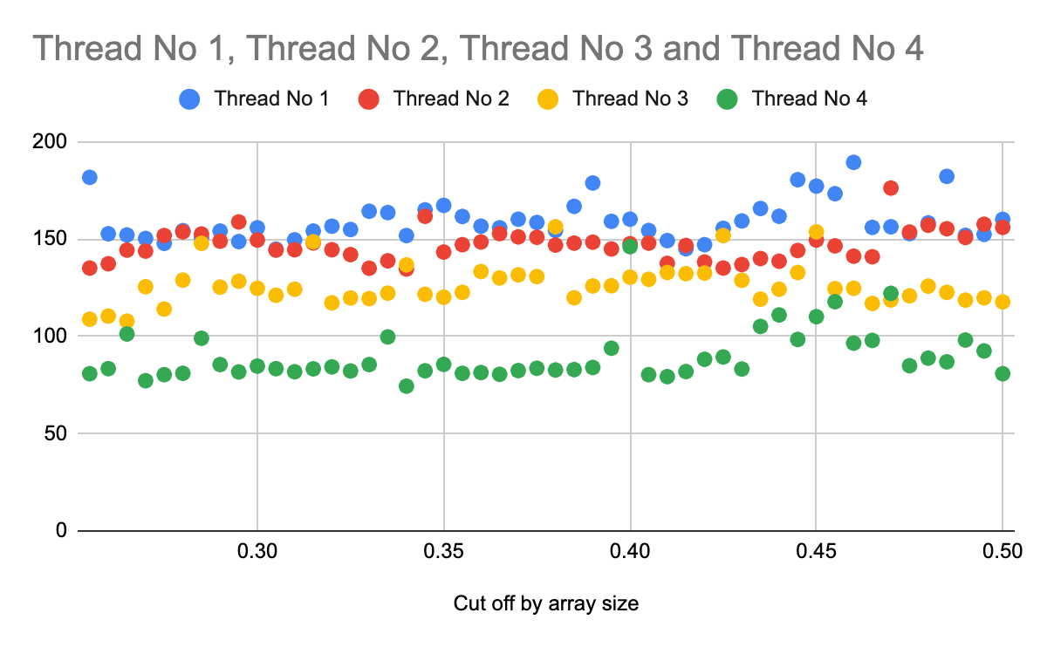

**Output:-**

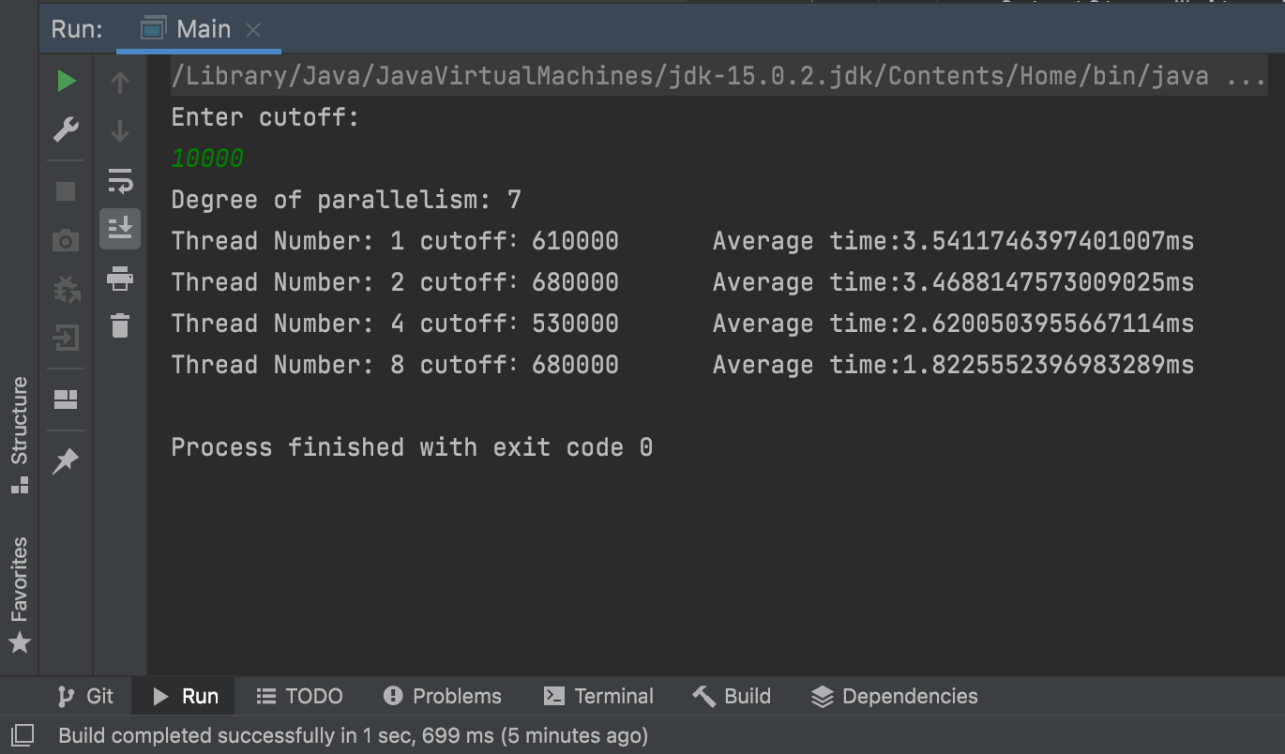

**Results csv:-**

|  |  |  |
| --- | --- | --- |
| Cut off by array size | Time (ms) | Threads |
| 0.255 | 181.7 | 0 |
| 0.26 | 152.7 | 0 |
| 0.265 | 152.1 | 0 |
| 0.27 | 150.3 | 0 |
| 0.275 | 147.8 | 0 |
| 0.28 | 154.3 | 0 |
| 0.285 | 150.6 | 0 |
| 0.29 | 154.1 | 0 |
| 0.295 | 148.7 | 0 |
| 0.3 | 155.8 | 0 |
| 0.305 | 144.8 | 0 |
| 0.31 | 149.6 | 0 |
| 0.315 | 154.1 | 0 |
| 0.32 | 156.6 | 0 |
| 0.325 | 154.9 | 0 |
| 0.33 | 164.3 | 0 |
| 0.335 | 163.6 | 0 |
| 0.34 | 151.8 | 0 |
| 0.345 | 165 | 0 |
| 0.35 | 167.3 | 0 |
| 0.355 | 161.6 | 0 |
| 0.36 | 156.6 | 0 |
| 0.365 | 155.8 | 0 |
| 0.37 | 160.2 | 0 |
| 0.375 | 158.5 | 0 |
| 0.38 | 154.4 | 0 |
| 0.385 | 166.8 | 0 |
| 0.39 | 178.8 | 0 |
| 0.395 | 159.1 | 0 |
| 0.4 | 160.2 | 0 |
| 0.405 | 154.4 | 0 |
| 0.41 | 149.2 | 0 |
| 0.415 | 145 | 0 |
| 0.42 | 147.1 | 0 |
| 0.425 | 155.5 | 0 |
| 0.43 | 159.3 | 0 |
| 0.435 | 165.7 | 0 |
| 0.44 | 161.7 | 0 |
| 0.445 | 180.5 | 0 |
| 0.45 | 177.2 | 0 |
| 0.455 | 173.3 | 0 |
| 0.46 | 189.4 | 0 |
| 0.465 | 156 | 0 |
| 0.47 | 156.3 | 0 |
| 0.475 | 152.8 | 0 |
| 0.48 | 158.3 | 0 |
| 0.485 | 182.2 | 0 |
| 0.49 | 151.9 | 0 |
| 0.495 | 152.4 | 0 |
| 0.5 | 160.1 | 0 |
| 0.255 | 135.1 | 1 |
| 0.26 | 137.3 | 1 |
| 0.265 | 144.3 | 1 |
| 0.27 | 143.8 | 1 |
| 0.275 | 151.8 | 1 |
| 0.28 | 153.7 | 1 |
| 0.285 | 152.6 | 1 |
| 0.29 | 148.9 | 1 |
| 0.295 | 158.8 | 1 |
| 0.3 | 149.5 | 1 |
| 0.305 | 144.3 | 1 |
| 0.31 | 144.5 | 1 |
| 0.315 | 148 | 1 |
| 0.32 | 144.5 | 1 |
| 0.325 | 142 | 1 |
| 0.33 | 135 | 1 |
| 0.335 | 138.8 | 1 |
| 0.34 | 134.6 | 1 |
| 0.345 | 161.7 | 1 |
| 0.35 | 143.3 | 1 |
| 0.355 | 147.1 | 1 |
| 0.36 | 148.5 | 1 |
| 0.365 | 152.8 | 1 |
| 0.37 | 151.1 | 1 |
| 0.375 | 150.9 | 1 |
| 0.38 | 146.9 | 1 |
| 0.385 | 147.9 | 1 |
| 0.39 | 148.4 | 1 |
| 0.395 | 144.9 | 1 |
| 0.4 | 147.6 | 1 |
| 0.405 | 147.9 | 1 |
| 0.41 | 137.5 | 1 |
| 0.415 | 146.7 | 1 |
| 0.42 | 138.2 | 1 |
| 0.425 | 135.1 | 1 |
| 0.43 | 136.9 | 1 |
| 0.435 | 140 | 1 |
| 0.44 | 138.6 | 1 |
| 0.445 | 144.1 | 1 |
| 0.45 | 149.5 | 1 |
| 0.455 | 146.5 | 1 |
| 0.46 | 141.2 | 1 |
| 0.465 | 140.9 | 1 |
| 0.47 | 176.2 | 1 |
| 0.475 | 153.6 | 1 |
| 0.48 | 157.1 | 1 |
| 0.485 | 155.3 | 1 |
| 0.49 | 150.8 | 1 |
| 0.495 | 157.6 | 1 |
| 0.5 | 156 | 1 |
| 0.255 | 108.8 | 2 |
| 0.26 | 110.4 | 2 |
| 0.265 | 107.8 | 2 |
| 0.27 | 125.5 | 2 |
| 0.275 | 114 | 2 |
| 0.28 | 128.9 | 2 |
| 0.285 | 147.8 | 2 |
| 0.29 | 125.3 | 2 |
| 0.295 | 128.3 | 2 |
| 0.3 | 124.7 | 2 |
| 0.305 | 121.1 | 2 |
| 0.31 | 124.2 | 2 |
| 0.315 | 148.6 | 2 |
| 0.32 | 117.2 | 2 |
| 0.325 | 119.7 | 2 |
| 0.33 | 119.4 | 2 |
| 0.335 | 122.2 | 2 |
| 0.34 | 136.7 | 2 |
| 0.345 | 121.6 | 2 |
| 0.35 | 120.1 | 2 |
| 0.355 | 122.6 | 2 |
| 0.36 | 133.3 | 2 |
| 0.365 | 130 | 2 |
| 0.37 | 131.6 | 2 |
| 0.375 | 130.7 | 2 |
| 0.38 | 156.3 | 2 |
| 0.385 | 119.8 | 2 |
| 0.39 | 125.9 | 2 |
| 0.395 | 126 | 2 |
| 0.4 | 130.4 | 2 |
| 0.405 | 129.3 | 2 |
| 0.41 | 132.8 | 2 |
| 0.415 | 132.2 | 2 |
| 0.42 | 132.5 | 2 |
| 0.425 | 151.8 | 2 |
| 0.43 | 128.8 | 2 |
| 0.435 | 119.1 | 2 |
| 0.44 | 124.2 | 2 |
| 0.445 | 132.8 | 2 |
| 0.45 | 153.7 | 2 |
| 0.455 | 124.5 | 2 |
| 0.46 | 124.7 | 2 |
| 0.465 | 116.9 | 2 |
| 0.47 | 118.7 | 2 |
| 0.475 | 120.8 | 2 |
| 0.48 | 125.8 | 2 |
| 0.485 | 122.6 | 2 |
| 0.49 | 118.6 | 2 |
| 0.495 | 119.8 | 2 |
| 0.5 | 117.7 | 2 |
| 0.255 | 80.8 | 3 |
| 0.26 | 83.4 | 3 |
| 0.265 | 101.2 | 3 |
| 0.27 | 77.2 | 3 |
| 0.275 | 80.3 | 3 |
| 0.28 | 81 | 3 |
| 0.285 | 99 | 3 |
| 0.29 | 85.5 | 3 |
| 0.295 | 81.7 | 3 |
| 0.3 | 84.7 | 3 |
| 0.305 | 83.4 | 3 |
| 0.31 | 81.8 | 3 |
| 0.315 | 83.3 | 3 |
| 0.32 | 84.3 | 3 |
| 0.325 | 82.2 | 3 |
| 0.33 | 85.5 | 3 |
| 0.335 | 99.7 | 3 |
| 0.34 | 74.4 | 3 |
| 0.345 | 82.3 | 3 |
| 0.35 | 85.6 | 3 |
| 0.355 | 81 | 3 |
| 0.36 | 81.4 | 3 |
| 0.365 | 80.5 | 3 |
| 0.37 | 82.4 | 3 |
| 0.375 | 83.6 | 3 |
| 0.38 | 82.7 | 3 |
| 0.385 | 82.9 | 3 |
| 0.39 | 84 | 3 |
| 0.395 | 93.9 | 3 |
| 0.4 | 146.1 | 3 |
| 0.405 | 80.3 | 3 |
| 0.41 | 79.3 | 3 |
| 0.415 | 81.9 | 3 |
| 0.42 | 88.2 | 3 |
| 0.425 | 89.4 | 3 |
| 0.43 | 83.2 | 3 |
| 0.435 | 105.1 | 3 |
| 0.44 | 111 | 3 |
| 0.445 | 98.4 | 3 |
| 0.45 | 110.1 | 3 |
| 0.455 | 117.8 | 3 |
| 0.46 | 96.5 | 3 |
| 0.465 | 97.9 | 3 |
| 0.47 | 122.1 | 3 |
| 0.475 | 84.9 | 3 |
| 0.48 | 88.8 | 3 |
| 0.485 | 86.9 | 3 |
| 0.49 | 98.1 | 3 |
| 0.495 | 92.5 | 3 |
| 0.5 | 80.8 | 3 |

**For array size 4000000, with 4 threads graphs performance :-**

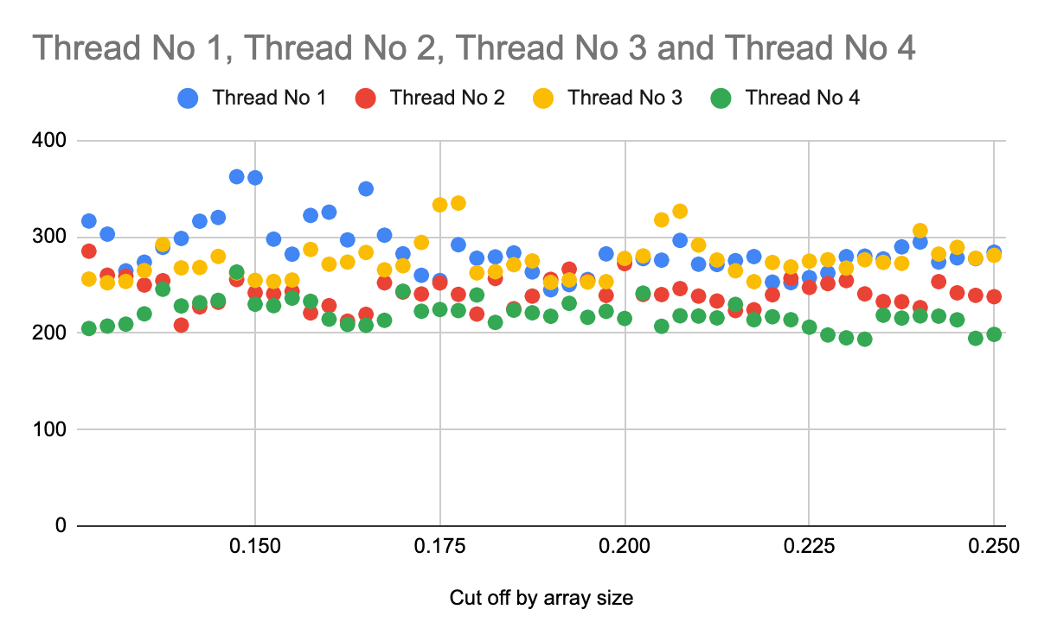

**Output result:-**

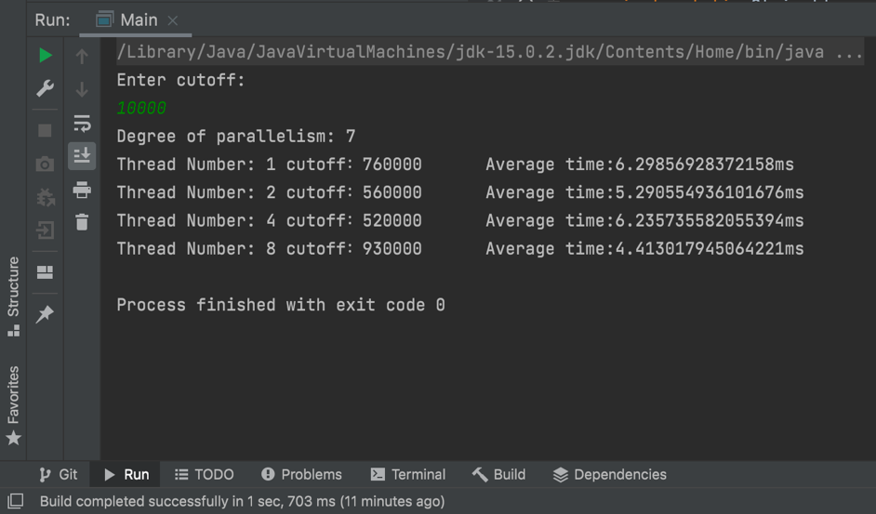

**Result csv:-**

|  |  |  |
| --- | --- | --- |
| Cut off by array size | Time (ms) | Threads |
| 0.1275 | 316.4 | 0 |
| 0.13 | 302.8 | 0 |
| 0.1325 | 264.7 | 0 |
| 0.135 | 273.7 | 0 |
| 0.1375 | 289.1 | 0 |
| 0.14 | 298.3 | 0 |
| 0.1425 | 316.2 | 0 |
| 0.145 | 320.1 | 0 |
| 0.1475 | 362.4 | 0 |
| 0.15 | 361.3 | 0 |
| 0.1525 | 297.6 | 0 |
| 0.155 | 282 | 0 |
| 0.1575 | 322.2 | 0 |
| 0.16 | 325.6 | 0 |
| 0.1625 | 296.8 | 0 |
| 0.165 | 349.8 | 0 |
| 0.1675 | 301.7 | 0 |
| 0.17 | 282.4 | 0 |
| 0.1725 | 260.1 | 0 |
| 0.175 | 254.7 | 0 |
| 0.1775 | 291.8 | 0 |
| 0.18 | 277.8 | 0 |
| 0.1825 | 279.2 | 0 |
| 0.185 | 283.3 | 0 |
| 0.1875 | 263.6 | 0 |
| 0.19 | 245.1 | 0 |
| 0.1925 | 250.4 | 0 |
| 0.195 | 255.7 | 0 |
| 0.1975 | 282.3 | 0 |
| 0.2 | 276.5 | 0 |
| 0.2025 | 277.4 | 0 |
| 0.205 | 275.8 | 0 |
| 0.2075 | 296.3 | 0 |
| 0.21 | 271.6 | 0 |
| 0.2125 | 271.3 | 0 |
| 0.215 | 275.3 | 0 |
| 0.2175 | 279.5 | 0 |
| 0.22 | 253 | 0 |
| 0.2225 | 252.5 | 0 |
| 0.225 | 257.7 | 0 |
| 0.2275 | 262.5 | 0 |
| 0.23 | 279.5 | 0 |
| 0.2325 | 280 | 0 |
| 0.235 | 277.1 | 0 |
| 0.2375 | 289.6 | 0 |
| 0.24 | 294.6 | 0 |
| 0.2425 | 273.8 | 0 |
| 0.245 | 278.2 | 0 |
| 0.2475 | 277.4 | 0 |
| 0.25 | 284.1 | 0 |
| 0.1275 | 285.1 | 1 |
| 0.13 | 260.2 | 1 |
| 0.1325 | 259.2 | 1 |
| 0.135 | 250 | 1 |
| 0.1375 | 254.5 | 1 |
| 0.14 | 208.4 | 1 |
| 0.1425 | 227.3 | 1 |
| 0.145 | 232.1 | 1 |
| 0.1475 | 255.7 | 1 |
| 0.15 | 242 | 1 |
| 0.1525 | 240.9 | 1 |
| 0.155 | 243.4 | 1 |
| 0.1575 | 221.1 | 1 |
| 0.16 | 228.6 | 1 |
| 0.1625 | 212.5 | 1 |
| 0.165 | 219.6 | 1 |
| 0.1675 | 252.3 | 1 |
| 0.17 | 242.7 | 1 |
| 0.1725 | 240.7 | 1 |
| 0.175 | 252.2 | 1 |
| 0.1775 | 240.3 | 1 |
| 0.18 | 219.9 | 1 |
| 0.1825 | 256.8 | 1 |
| 0.185 | 225.4 | 1 |
| 0.1875 | 238.5 | 1 |
| 0.19 | 255.9 | 1 |
| 0.1925 | 266.5 | 1 |
| 0.195 | 254.1 | 1 |
| 0.1975 | 239.2 | 1 |
| 0.2 | 272.2 | 1 |
| 0.2025 | 240.2 | 1 |
| 0.205 | 240.1 | 1 |
| 0.2075 | 246.3 | 1 |
| 0.21 | 238.5 | 1 |
| 0.2125 | 233.4 | 1 |
| 0.215 | 223.5 | 1 |
| 0.2175 | 224.3 | 1 |
| 0.22 | 239.9 | 1 |
| 0.2225 | 256.9 | 1 |
| 0.225 | 247.5 | 1 |
| 0.2275 | 251.5 | 1 |
| 0.23 | 254.6 | 1 |
| 0.2325 | 240.8 | 1 |
| 0.235 | 232.9 | 1 |
| 0.2375 | 232.7 | 1 |
| 0.24 | 226.6 | 1 |
| 0.2425 | 253.5 | 1 |
| 0.245 | 241.9 | 1 |
| 0.2475 | 239.3 | 1 |
| 0.25 | 237.9 | 1 |
| 0.1275 | 256.2 | 2 |
| 0.13 | 252.3 | 2 |
| 0.1325 | 253.7 | 2 |
| 0.135 | 265 | 2 |
| 0.1375 | 292.1 | 2 |
| 0.14 | 267.8 | 2 |
| 0.1425 | 268.2 | 2 |
| 0.145 | 279.7 | 2 |
| 0.1475 | 262.6 | 2 |
| 0.15 | 254.9 | 2 |
| 0.1525 | 253.8 | 2 |
| 0.155 | 255.2 | 2 |
| 0.1575 | 286.9 | 2 |
| 0.16 | 271.6 | 2 |
| 0.1625 | 273.8 | 2 |
| 0.165 | 283.8 | 2 |
| 0.1675 | 265.8 | 2 |
| 0.17 | 270 | 2 |
| 0.1725 | 294.2 | 2 |
| 0.175 | 333.2 | 2 |
| 0.1775 | 335 | 2 |
| 0.18 | 262.6 | 2 |
| 0.1825 | 263.8 | 2 |
| 0.185 | 271.1 | 2 |
| 0.1875 | 275 | 2 |
| 0.19 | 252.7 | 2 |
| 0.1925 | 255.3 | 2 |
| 0.195 | 253.1 | 2 |
| 0.1975 | 253.5 | 2 |
| 0.2 | 277.6 | 2 |
| 0.2025 | 280.2 | 2 |
| 0.205 | 317.6 | 2 |
| 0.2075 | 326.6 | 2 |
| 0.21 | 291.5 | 2 |
| 0.2125 | 276 | 2 |
| 0.215 | 264.8 | 2 |
| 0.2175 | 253.5 | 2 |
| 0.22 | 273.4 | 2 |
| 0.2225 | 268.8 | 2 |
| 0.225 | 274.8 | 2 |
| 0.2275 | 276.3 | 2 |
| 0.23 | 267.6 | 2 |
| 0.2325 | 276.2 | 2 |
| 0.235 | 273.5 | 2 |
| 0.2375 | 272.5 | 2 |
| 0.24 | 306.5 | 2 |
| 0.2425 | 282.1 | 2 |
| 0.245 | 289.1 | 2 |
| 0.2475 | 277.8 | 2 |
| 0.25 | 280.8 | 2 |
| 0.1275 | 204.9 | 3 |
| 0.13 | 207.4 | 3 |
| 0.1325 | 209.4 | 3 |
| 0.135 | 220.1 | 3 |
| 0.1375 | 245.6 | 3 |
| 0.14 | 228.3 | 3 |
| 0.1425 | 231.7 | 3 |
| 0.145 | 234.1 | 3 |
| 0.1475 | 263.5 | 3 |
| 0.15 | 230.1 | 3 |
| 0.1525 | 228.6 | 3 |
| 0.155 | 236.4 | 3 |
| 0.1575 | 233.1 | 3 |
| 0.16 | 214.6 | 3 |
| 0.1625 | 209.1 | 3 |
| 0.165 | 208.2 | 3 |
| 0.1675 | 213.4 | 3 |
| 0.17 | 243.6 | 3 |
| 0.1725 | 222.8 | 3 |
| 0.175 | 224.6 | 3 |
| 0.1775 | 223.5 | 3 |
| 0.18 | 239.7 | 3 |
| 0.1825 | 211.2 | 3 |
| 0.185 | 223.9 | 3 |
| 0.1875 | 221.2 | 3 |
| 0.19 | 217.6 | 3 |
| 0.1925 | 231 | 3 |
| 0.195 | 216.5 | 3 |
| 0.1975 | 222.7 | 3 |
| 0.2 | 215.3 | 3 |
| 0.2025 | 241.6 | 3 |
| 0.205 | 207.2 | 3 |
| 0.2075 | 218.1 | 3 |
| 0.21 | 217.8 | 3 |
| 0.2125 | 215.9 | 3 |
| 0.215 | 229.9 | 3 |
| 0.2175 | 214 | 3 |
| 0.22 | 217.1 | 3 |
| 0.2225 | 214 | 3 |
| 0.225 | 206.3 | 3 |
| 0.2275 | 198.2 | 3 |
| 0.23 | 195.2 | 3 |
| 0.2325 | 193.8 | 3 |
| 0.235 | 218.7 | 3 |
| 0.2375 | 215.7 | 3 |
| 0.24 | 218 | 3 |
| 0.2425 | 217.7 | 3 |
| 0.245 | 213.9 | 3 |
| 0.2475 | 194.7 | 3 |
| 0.25 | 198.8 | 3 |

**Conclusion:**

**From the graphs above we can say that, sorting with 4 threads is the fastest one and sorting with one thread is slowest.**

**This means that if we implement parallel sorting then performance of sorting program is improved as the number of threads increases and work is performed parallelly.**