### **Predicting Customer Churn in Telecom Industry**

Total number of churned customers and customer status

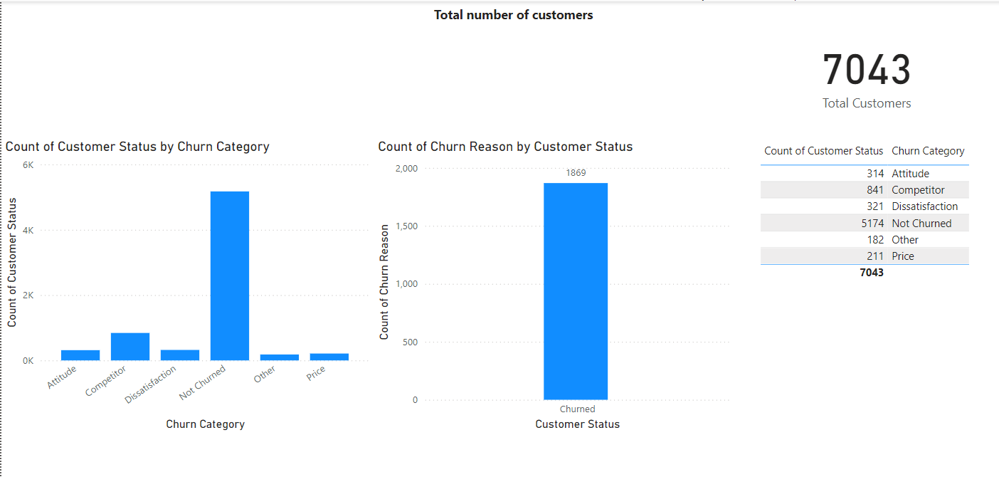

* In the chart we can see that there are **7043** total customers.
* There are **1869** churned customers
* There are 6 churned category which is shown in the table as well as in the chart

Find the average age of churned customers

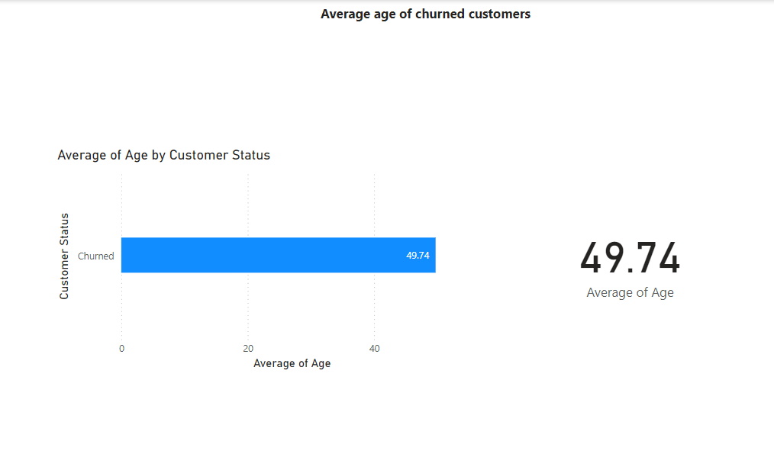

* From the chart we can see that average age of churned customer is **49**
* To show the average age filter has been used in customer status in the ‘filters’ area
* In the bar chart it is shown clearly the range
* In the card the exact number have been shown

Discover the most common contract types among churned customers

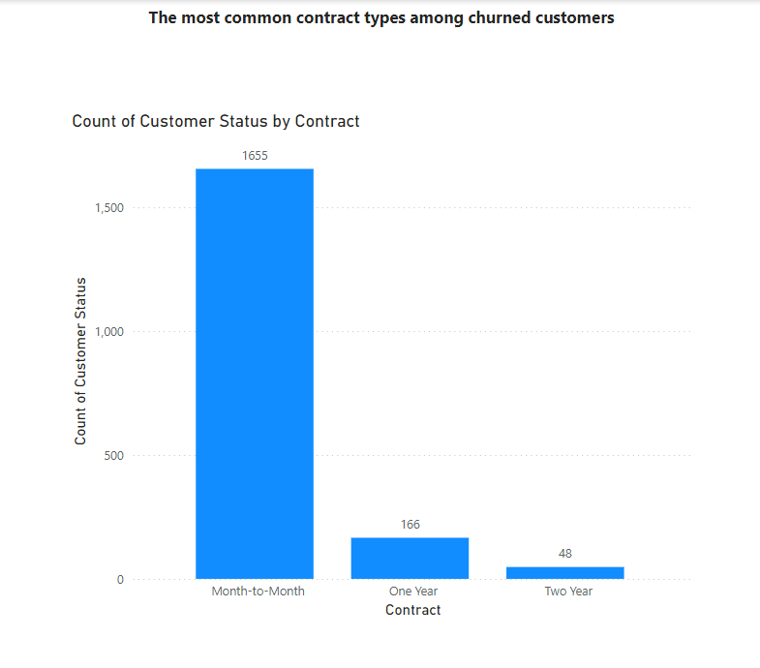

* From the chart we can clearly see that most of the churned customers like to opt for month-to-month contract compared to one year contract and Two-year contract
* Month-to-month contract contains **1655** churned customer
* To show churned customer, filter has been used in customer status column

Analyze the distribution of monthly charges among churned customers

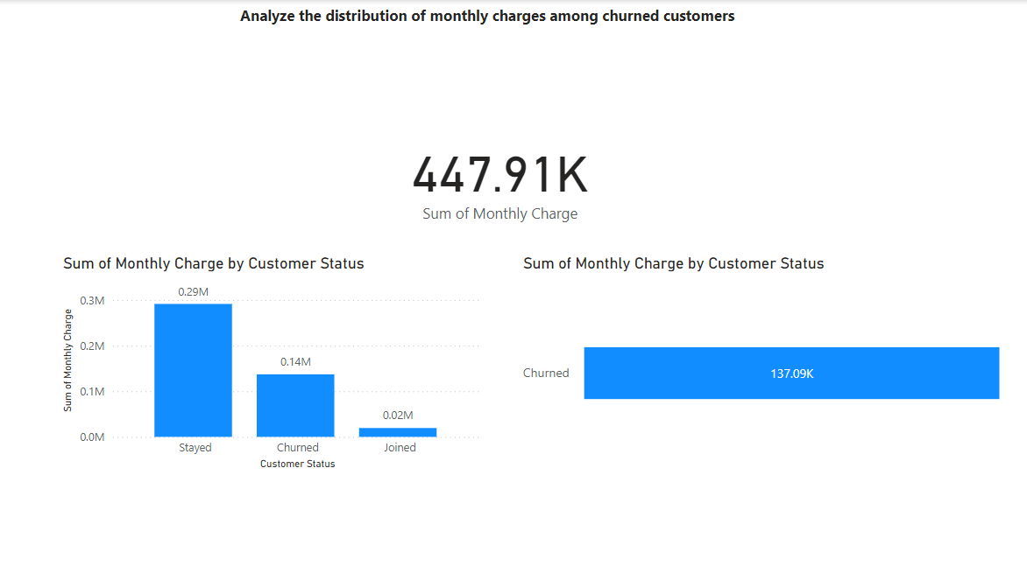

* In the chart we can see customer status with monthly charge
* Customer who stayed and their total monthly charges is **0.29M**
* And for churned customer is **137.09K**
* To show churned customers filter has been used in customer status column
* The card shows total monthly charges which is **447.91K**

Identify customers with high total charges who have churned

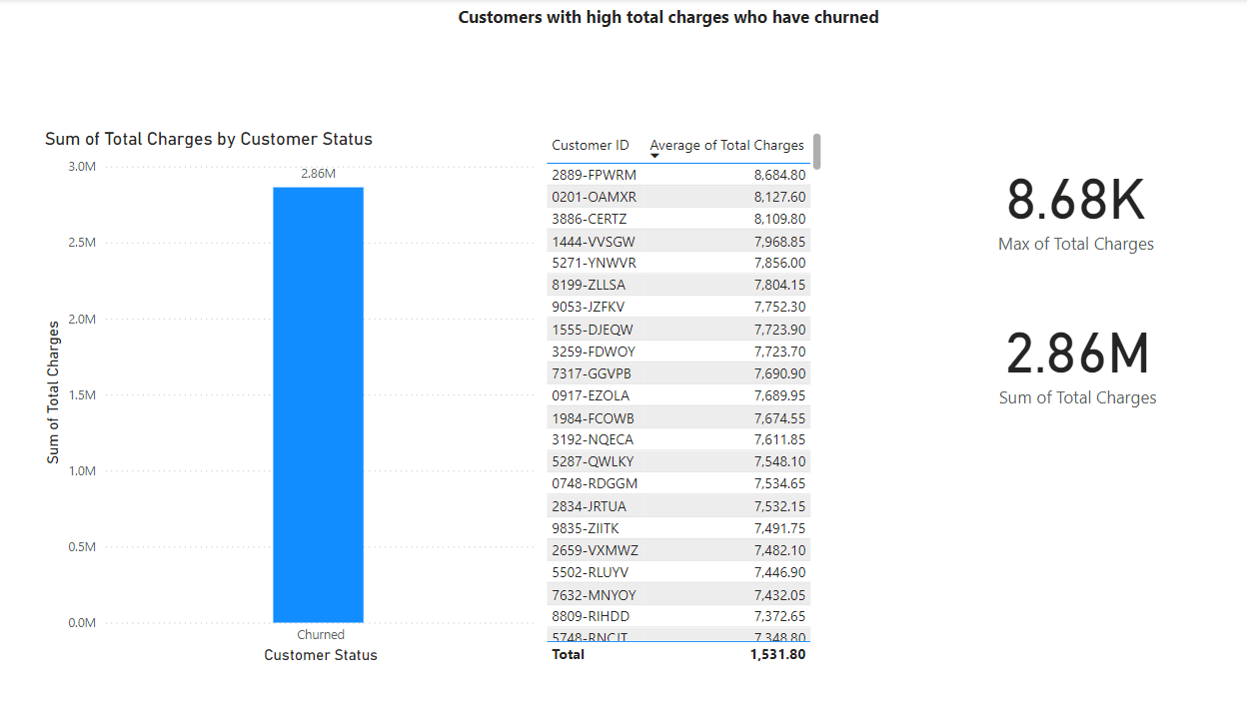

* To get the churned customer filter had been applied in customer status column to the page
* In the chart we can see sum of total charges of churned customer and the value has been shown in the card visualization (**2.86M**)
* In the table we can see the average total charges for each churned customer

Calculate the total charges distribution for churned and non-churned customers

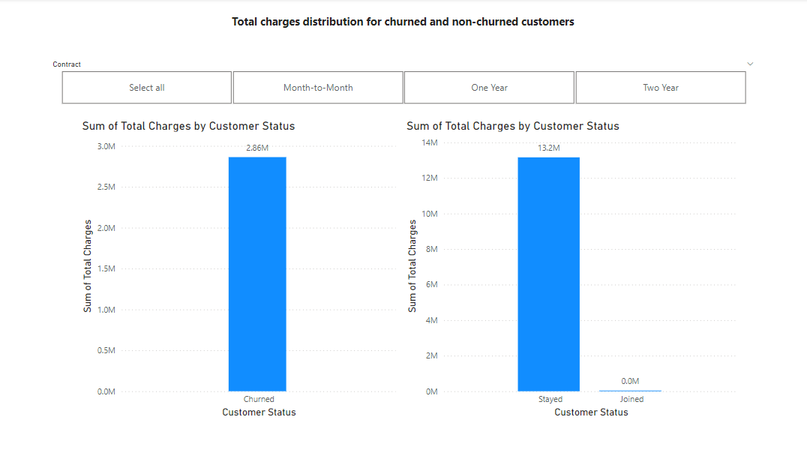

* In the chart we can see the sum total charges for churned and stayed customers
* Churned customers total charges are **2.86M** where as stayed customers total charges are **13.2M**
* Slicer has been used for contract to see the total charges for each contract separately

Calculate the average monthly charges for different contract types among churned customers

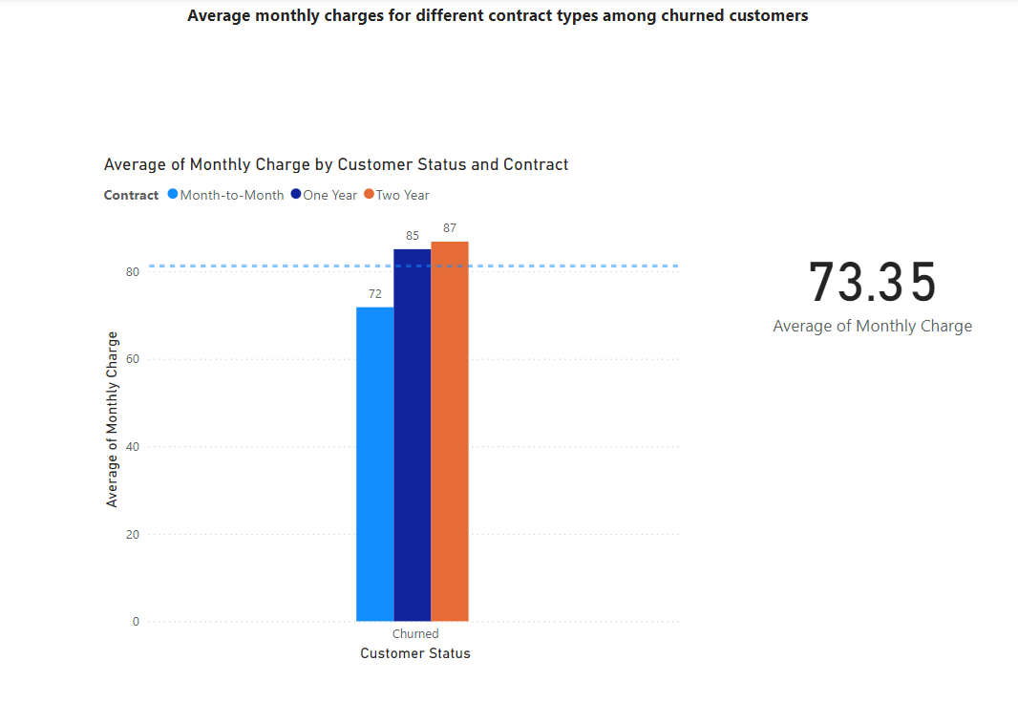

* In the chart, we can see that churned customer’s average monthly charges for the different contracts
* Two-year contracts are standing first in then one year followed by month-to-month
* Filter has been applied in the page to show only churned customers
* The average monthly charge for churned customer is **73.35**

Identify customers who have both online security and online backup services and have not churned

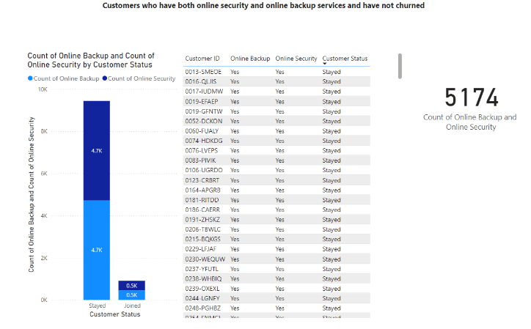

* In the table, we can see that customers who stayed and joined using both online backup and online security
* Filter had been applied for the table to show only stayed and joined customer using both online backup and online security
* In the chart, we can see the numbers of stayed and joined customer using both online backup and online security
* In the card visualization, we can see total number of stayed and joined customer using both online backup and online security

Determine the most common combinations of services among churned customers

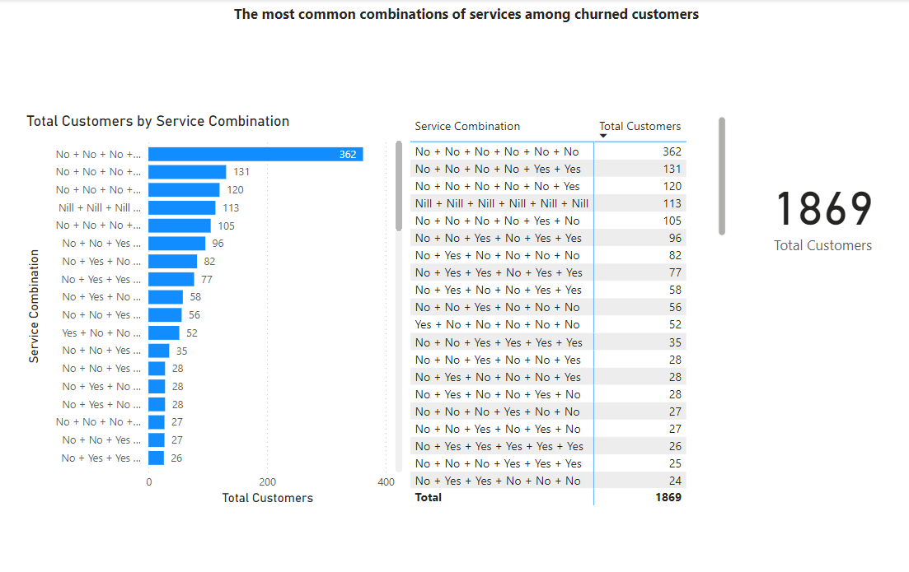

* The services are Online Security, Online Backup, Device Protection Plan, Premium Tech Support, Streaming TV, Streaming Movies.
* Using the modeling tool in Power BI, we have developed a combination to determine which services are used the most by customers. This will further help in enhancing those services that customers opt for the most.
* In the card visualization, we can see total number of churned customers who is using service combination which is **1869**

Identify the average total charges for customers grouped by gender and marital status

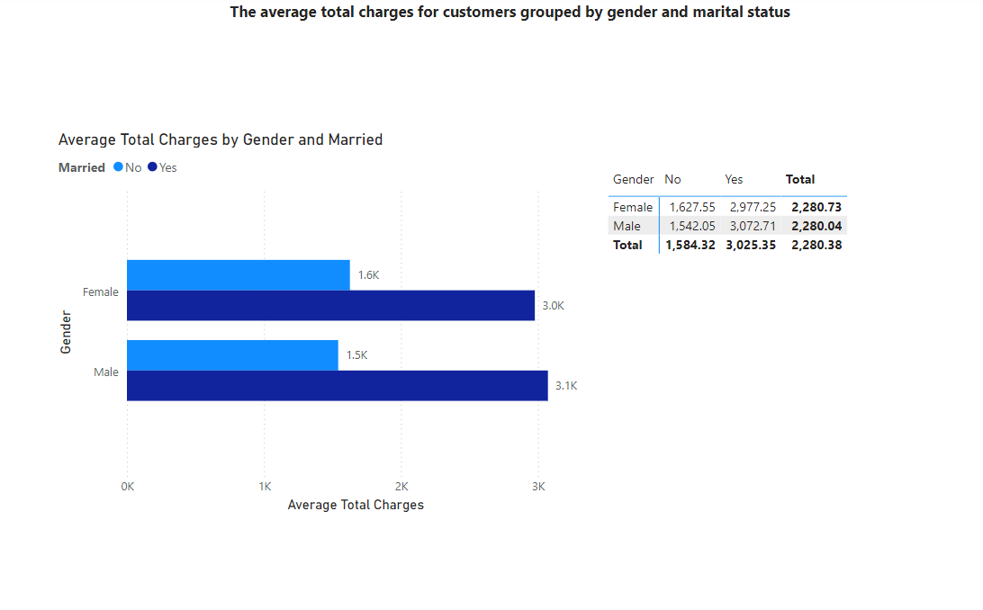

* In this chart, we can see average total charges for the male and female
* In the table, it is shown the exact numbers of those who are married and not married and their average total charges
* Married male having average of **3072.71** and married female average of **2977.25**

Calculate the average monthly charges for different age groups among churned customers

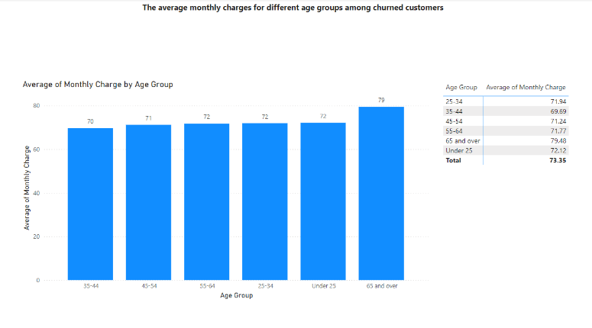

* In the chart, we can identify age group and average monthly charge
* Age group 65 and over have the highest average monthly charges followed by under 25 age group
* In this chart we can understand that age group of 65 and above are paying more for the monthly charges

Identify the contract types with the highest churn rate among senior citizens (age 65 and over)

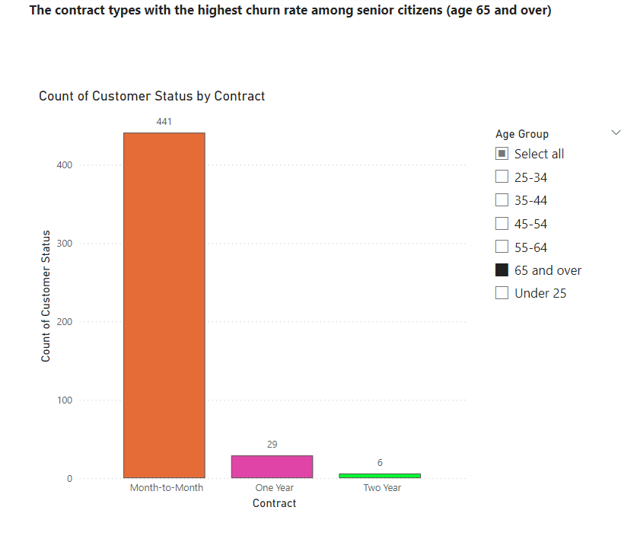

* In the chart, we can identify that month-to-month has the highest number of churned customers whose age group comes under 65 and over
* Slicer have been used to check for different age group

Calculate the average monthly charges for customers who have multiple lines and streaming TV

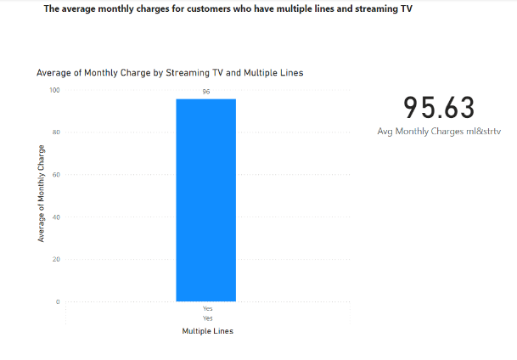

* In bar chart, we can identify that **95.63** average for month charges by streaming tv and multiple lines
* The customers who are using both streaming tv and multiple lines are shown in the bar chart
* The card visualization shows the average of streaming tv and multiple lines monthly charges

Identify the customers who have churned and used the most online services

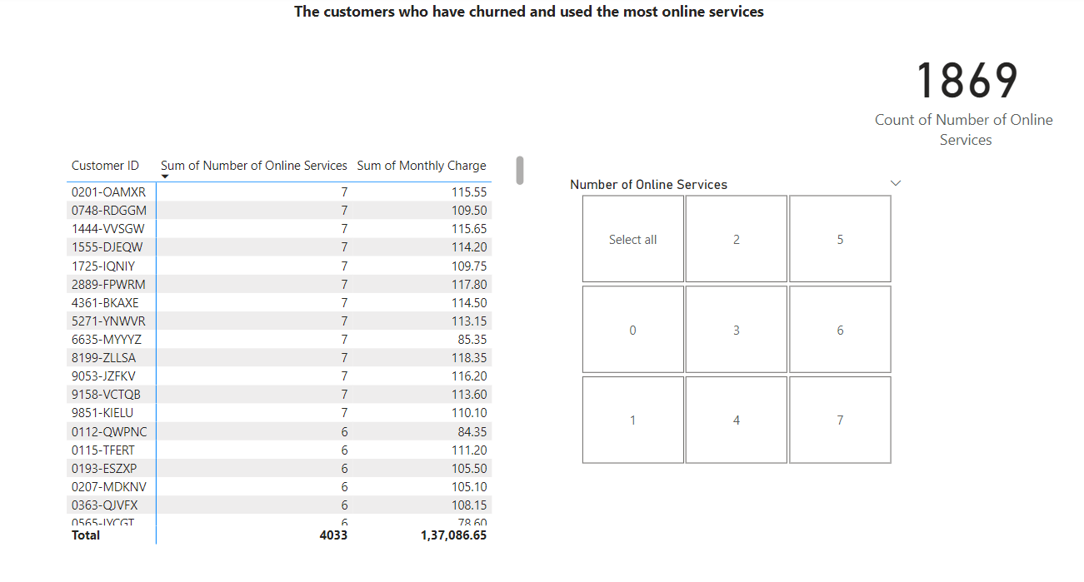

* The table will display a list of churned customers and the number of online services they were using.
* Customers who used many online services and still churned might indicate that there were issues with service quality, pricing, or other factors that led to their dissatisfaction.
* The slicer will help to segregate each online service individually.
* The card visualization shows the count of churned customer using online service.

Calculate the average age and total charges for customers with different combinations of streaming services

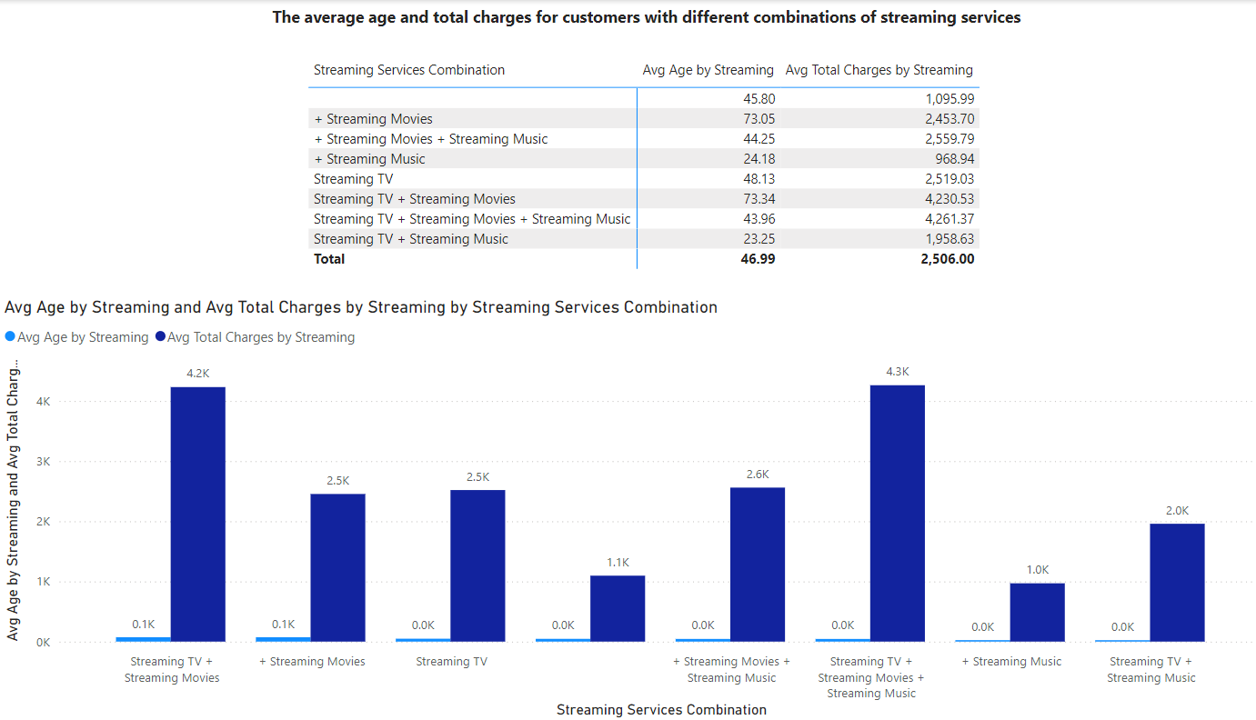

* The table will show the average age and average total charges for customers with different combinations of streaming services.
* You can easily compare how different combinations influence age and spending behaviour.
* The chart also shows the same thing as the table but in a bar chart

Identify the gender distribution among customers who have churned and are on yearly contracts

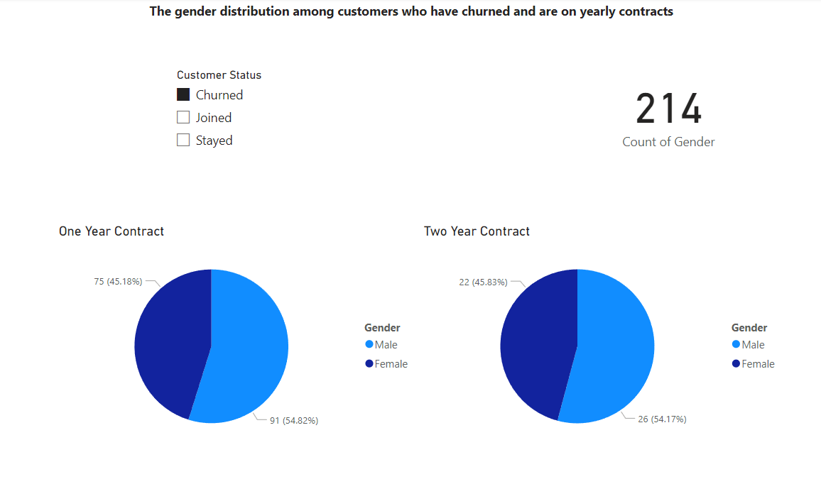

* The pie chart will display the percentage or count of male and female customers who have churned and were on yearly contracts.
* You can see which gender has a higher representation among this specific group.
* Understanding the gender distribution can help identify whether one gender is more likely to churn under yearly contracts. This could inform gender-specific retention strategies.

Calculate the average monthly charges and total charges for customers who have churned, grouped by contract type and internet service type

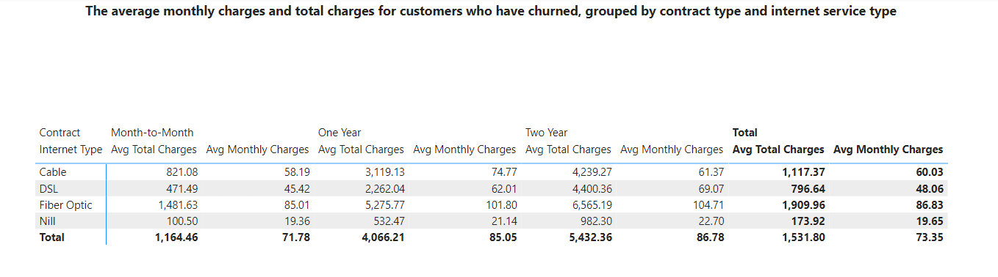

* The matrix will display the average monthly charges and total charges for churned customers, grouped by contract type and internet service type.
* Can identify how these averages vary across different contract and internet service combinations.
* Understanding the differences in charges across contract types and internet service types can provide insights into customer behavior and potential reasons for churn.

Find the customers who have churned and are not using online services, and their average total charges

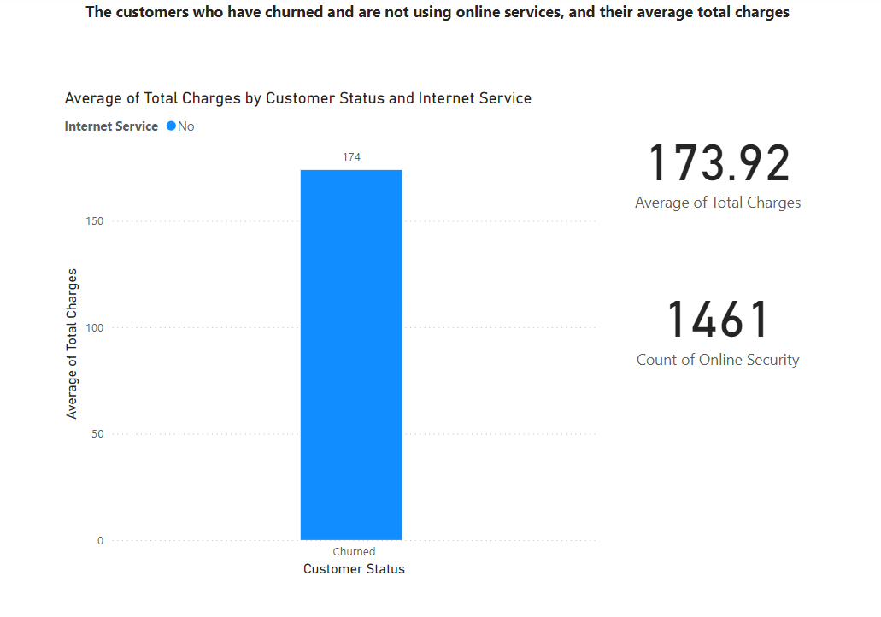

* The card will display the average total charges for the identified group.
* These customers, who aren't using any online services, might be low-engagement customers. Understanding their behavior could help in designing strategies to increase service adoption and reduce churn.
* These customers could be targeted for upselling online services, potentially increasing their engagement and satisfaction.

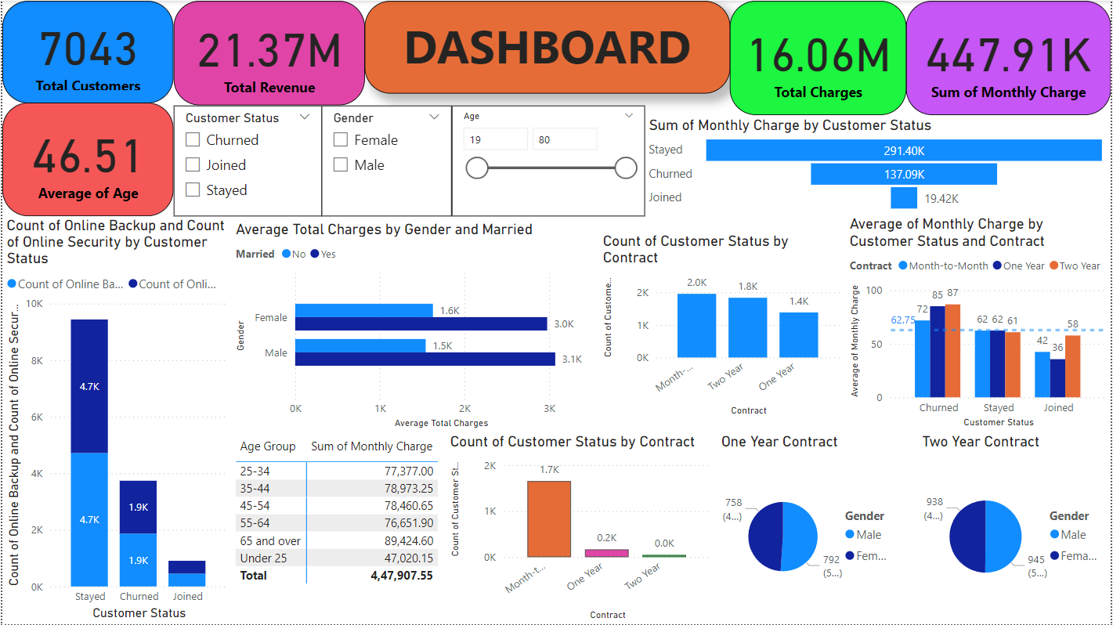

**SQL Queries**

use datachurn;

#7 Calculation of the total charges distribution for churned and non-churned customers

SELECT

Customer_status,

COUNT(*) AS CustomerCount,

AVG(Total_charges) AS Avg_Total_Charges,

MIN(Total_charges) AS Min_Total_Charges,

MAX(Total_charges) AS Max_Total_Charges,

SUM(Total_charges) AS Total_Sum_Charges

FROM

customer_churn

GROUP BY

Customer_status

ORDER BY

Customercount desc;

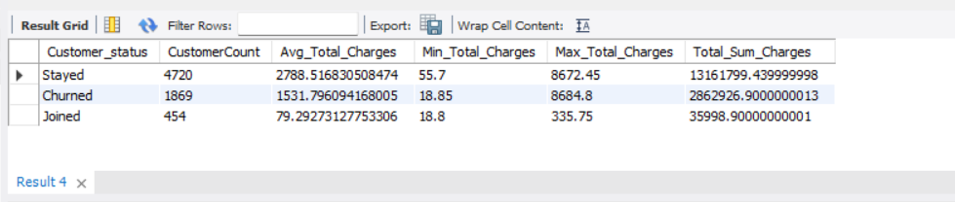

# 8 The average monthly charges for different contract types among churned customers

SELECT

Contract AS Contract_type_churned,

AVG(Monthly_charge) AS Avg_Monthly_Charges

FROM

customer_churn

WHERE

Customer_status = 'Churned'

GROUP BY

Contract

ORDER BY

Avg_Monthly_Charges desc;

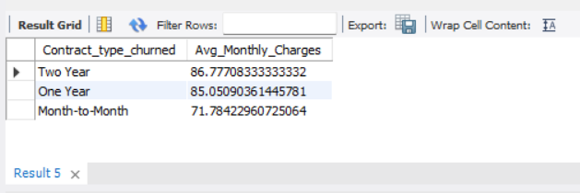

# 11 Identification of the average total charges for customers grouped by gender and marital status

SELECT

Gender,

Married,

AVG(Total_Charges) AS Average_Charges

FROM

customer_churn

GROUP BY Gender,Married;

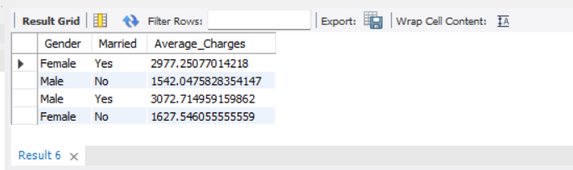

# 12 Calculation of the average monthly charges for different age groups among churned customers

SELECT

CASE

WHEN Age BETWEEN 0 AND 20 THEN '0-20'

WHEN Age BETWEEN 21 AND 30 THEN '21-30'

WHEN Age BETWEEN 31 AND 40 THEN '31-40'

WHEN Age BETWEEN 41 AND 50 THEN '41-50'

WHEN Age BETWEEN 51 AND 60 THEN '51-60'

WHEN Age BETWEEN 61 AND 70 THEN '61-70'

WHEN Age BETWEEN 71 AND 80 THEN '71-80'

ELSE '81-100'

END AS Age_Group,

AVG(Monthly_Charge) AS Average_Monthly_Charge

FROM

customer_churn

WHERE

Customer_Status = 'Churned'

GROUP BY

Age_Group

ORDER BY

Age_Group;

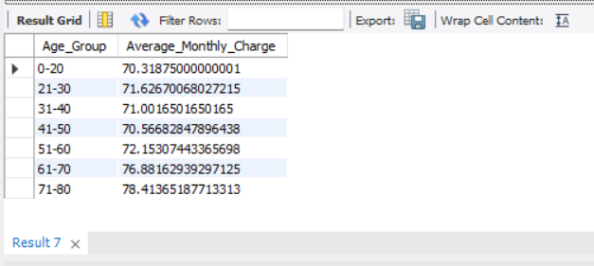

# 13 Determination of the average age and total charges for customers with multiple lines and online backup

SELECT

AVG(Age) AS Average_age,

AVG(Total_Charges) AS Average_Total_charges

FROM

customer_churn

WHERE

Multiple_Lines = 'Yes'

AND Online_Backup = 'Yes';

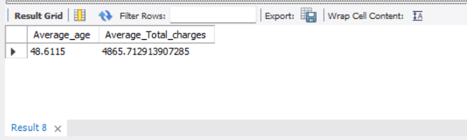

# 14 Identification of the contract types with the highest churn rate among senior citizens (age 65 and over)

SELECT

Contract,

COUNT(CASE WHEN Customer_Status = 'Churned' THEN 1 END) * 1.0 / COUNT(*) AS churn_rate

FROM

customer_churn

WHERE

age >= 65

GROUP BY

Contract

ORDER BY

churn_rate DESC;

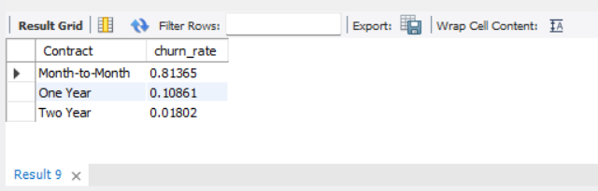

# 15 Calculation of the average monthly charges for customers who have multiple lines and streaming TV

SELECT

AVG(Monthly_Charge) AS Average_Monthly_Charge

FROM customer_churn

WHERE Multiple_Lines = 'Yes'

AND Streaming_TV = 'Yes';

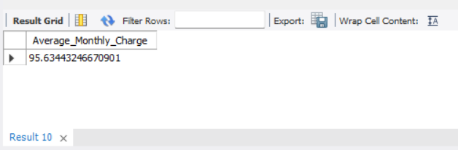

# 19 Calculation of the average monthly charges and total charges for customers who have churned, grouped by contract type and internet service type

SELECT

Contract, Internet_Type,

AVG(Monthly_Charge) AS Average_Monthly_Charge,

AVG(Total_Charges) AS Average_Total_Charges

FROM

customer_churn

WHERE

Customer_Status = 'Churned'

GROUP BY

Contract, Internet_Type;

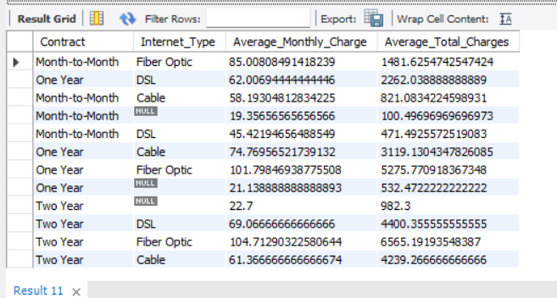

# 20 To Find the customers who have churned and are not using online services, and their average total charges

SELECT

AVG(Total_Charges) AS Average_Total_Charges

FROM

customer_churn

WHERE

Customer_Status = 'Churned'

AND Online_Security = 'No'

AND Online_Backup = 'No'

AND Device_Protection_Plan = 'No'

AND Premium_Tech_Support = 'No'

AND Streaming_TV = 'No'

AND Streaming_Movies = 'No'

AND Streaming_Music = 'No';

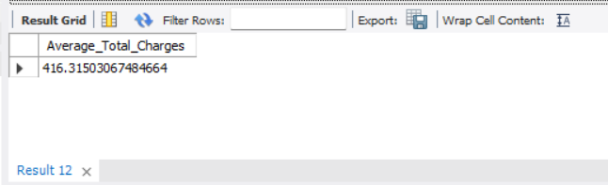

# 21 Calculation of the average monthly charges and total charges for customers who have churned, grouped by the number of dependents

SELECT

Number_of_Dependents,

AVG(Monthly_charge) AS Average_Monthly_Charge,

AVG(Total_Charges) AS Average_Total_Charges

FROM

customer_churn

WHERE

Customer_Status = 'Churned'

GROUP BY

Number_of_Dependents;

