
INDIAN INSTITUTE OF TECHNOLOGY ROORKEE

CSN-261 : Data Structures Laboratory

Assignment-2

Name : Abhishek Patil
Enr. No. : 18114003
E-mail : apatil@cs.iitr.ac.in

Problem 1 :
In this Problem, you have to implement a simple transposition cipher, where this cipher encrypts and decrypts a sequence of characters by dividing the sequence into blocks of size n, where n is specified by the encryption key. If the input text has a length that is not a multiple of n, the last block is padded with null characters ('\0'). In addition to n, the key also specifies two parameters a andb. For each block, the i-th output character, starting from 0 as usual, is set to the j-th input character, where j = (ai + b) mod n. For appropriate choices of a and b, this will reorder the characters in the block in a way that can be reversed by choosing a corresponding decryption key (n, a′, b′).
Algorithms Used :
Data Structure Used :
1.Cryptography
2.Array
Snapshots :
Encryption the input file
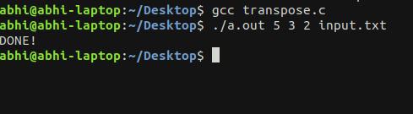

Decrypting the data with correct key

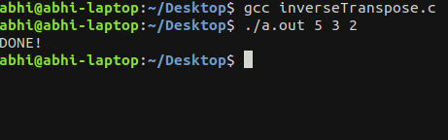

comparing the files

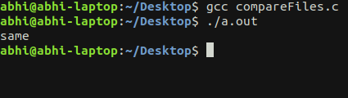

decrypting data with incorrect key
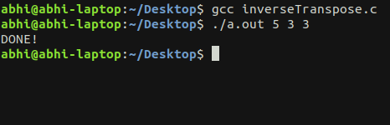

comparing the file again

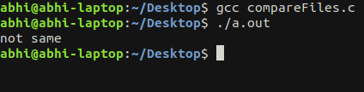

Problem 2 :
A region can be represented either by its interior or by its boundary. Here we represent the region by its interior using one of the most common methods called image array. In this case we have a collection of pixels. Since the number of elements in the array can be quite large, the main objective is to reduce its size by aggregating equal-valued pixels.
Data Structure Used :
1. Tree
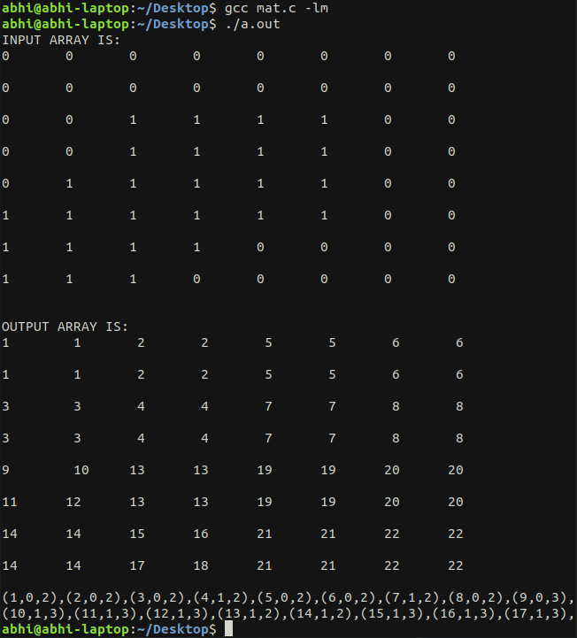
Snapshots :

