
INDIAN INSTITUTE OF TECHNOLOGY ROORKEE

CSN-261 : Data Structures Laboratory

Assignment-1

Name : Abhishek Patil
Enr. No. : 18114003
E-mail : apatil@cs.iitr.ac.in

Problem 1 :
Write a C program to create a student management system, where the students’ information are stored in a doubly circular linked list, as shown in Figure 1. The structure of each node from the list is shown in Figure 2. Initially, the circular doubly linked list is empty and the student personal data is entered from the filename “StudentData.xlsx” that contains the data of 13 students (name, D.O.B., address and phone no) in tabular form. The StudentData.xlsx file can be converted into a CSV file using Libreoffice or into any other file format readable from your C program. The program should have the following operations: insert, delete, search, modify, sort and print. While inserting, a unique roll number in the linked list is assigned to each student, where the starting roll number should be 101 and the list should always be in sorted according to their roll number (ascending order). However, when a deletion operation is performed, the roll number of the deleted student node is stored in a queue named unusedRollNo. These deleted roll numbers from the unusedRollNo queue will be allotted to the new students on next insertion operations.

Algorithms Used :
Data Structure Used :
1. Circular Linked List
2.Queue
3.Array

Snapshots :
Starting Program :

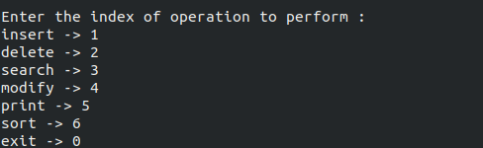

Inserting the data :

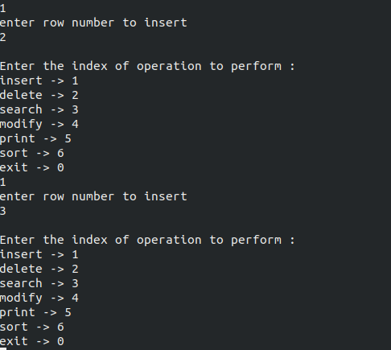

Printing data :

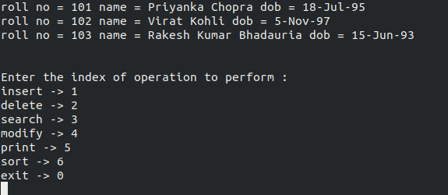

Searching the Data :

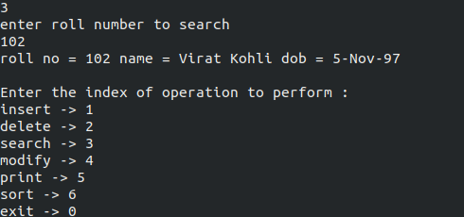

Modifying the data :

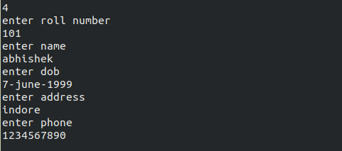

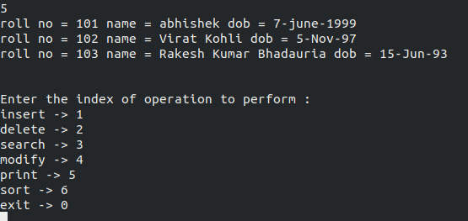
Printing Data after Modifying :

Deleting the Data :
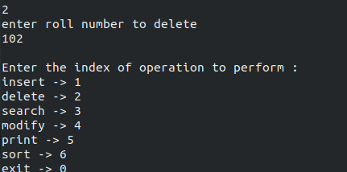

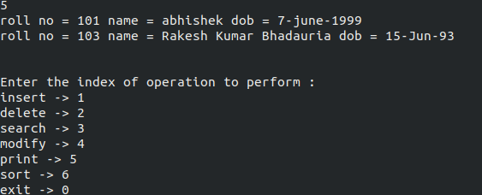

Sorting the Data :

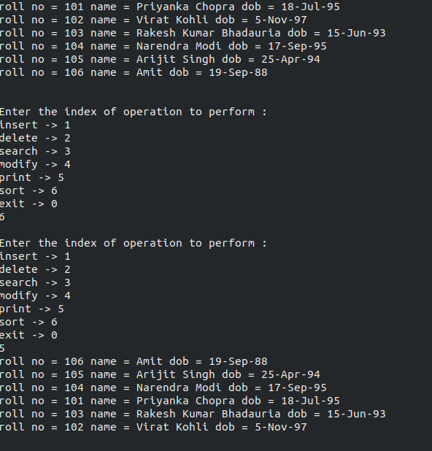

Terminating the Program :
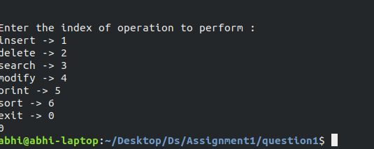

Problem 2 :
Write a C Program for resizeable deque using dynamic memory allocation, where a deque can perform the insertion and deletion operations at its both ends. The capacity of the deque depends on the number of elements currently stored in it, according to the following two rules:
● If an element is being inserted into a deque, when it is already full, then its capacity is doubled of its current size.
● After removing an element from a deque, if the number of elements are equal to half of the capacity of the deque, then its capacity is made half of its current size.

The program should have the following three functions: insert(), delete() and print(). The function print() should display the current size of the deque (capacity of deque) in terms of number of bytes.

Algorithms Used :
Data Structure Used :
1. Deque

Snapshots :
Starting of the program :
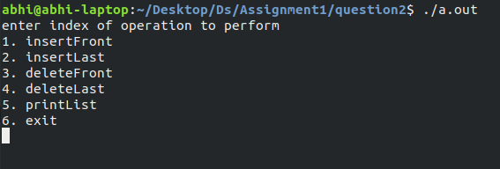
Inserting the data in deque :
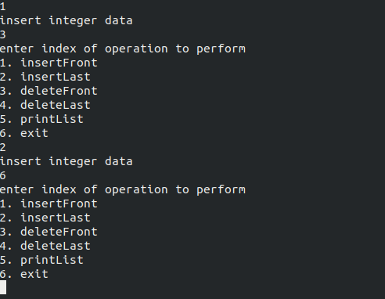

Printing the queue :

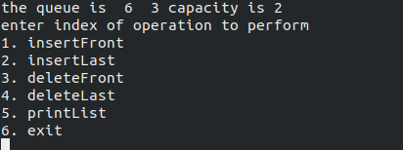

Inserting more data and printing the capacity of queue :
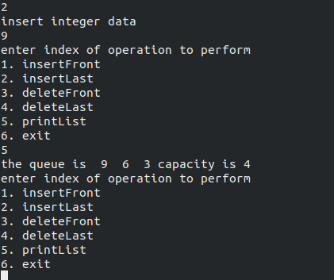

Inserting more data and printing out the doubled capacity :
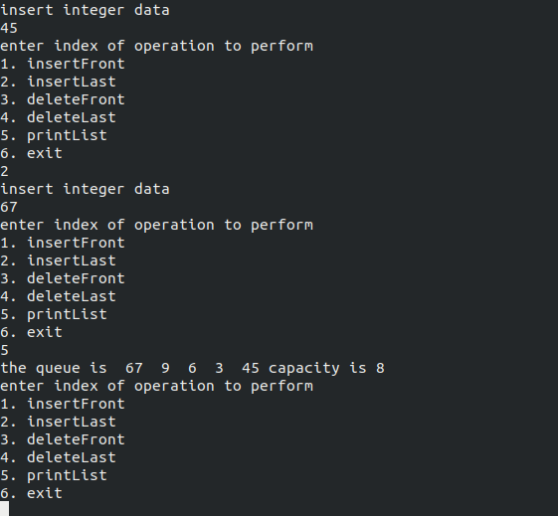

Deleting the data :
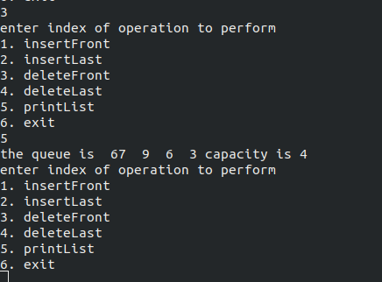

Terminating the program :

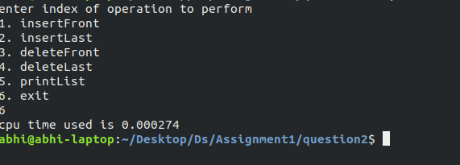

Problem 3 :
Given three 2D arrays (for red, green and blue color pixels) of a digital image. For a particular image pixel, the color shade of that pixel is Red if the pixel value at that position of the matrix corresponding to RED is greater than that of GREEN and BLUE. Same goes for GREEN and BLUE shades also. Write a C program that can perform following operations on the given image file:
● Remove all Red shades.
● Remove all Green shades.
● Remove all Blue shades.
● RedOnly: Preserve any red shades in the image, but remove all green and blue.
● GreenOnly: Preserve any green shades in the image, but remove all red and blue.
● BlueOnly: Preserve any blue shades in the image, but remove all red and green.
Write a function pixelValue() that has x and y as two parameters and displays the current pixel (RED, GREEN and BLUE) values of the input image at the point with coordinates (x, y), where x and y are the row and column numbers in that image file, respectively.

Algorithms Used :
Data Structure Used :
1. Array

Snapshots :
Starting of the program :

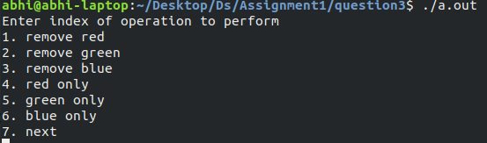

Running the operations on data :

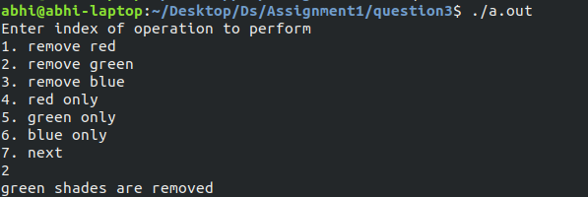

Running the operations on data :

Reading the pixel value and terminating the program :

