
INDIAN INSTITUTE OF TECHNOLOGY ROORKEE

CSN-261 : Data Structures Laboratory

Assignment-7

Name : Abhishek Patil
Enr. No. : 18114003
E-mail : apatil@cs.iitr.ac.in

Problem 1 :
Given: n 2D points and two orthogonal polygons.
Problem: Find the set of points lie inside the overlapping region (rectangular) of the two given orthogonal
polygons.
Write a program in Java to solve the above problem applying k-d tree data structure.

Algorithms Used :
Points to the left of this space are represented by the left subtree of that node and points to the right of the space are represented by the right subtree. We will soon be explaining the concept on how the space is divided and tree is formed.
If the root node is aligned in planeA, then the left subtree will contain all points whose coordinates in that plane are smaller than that of root node. Similarly, the right subtree will contain all points whose coordinates in that plane are greater-equal to that of root node.

Data Structure Used :
1. kd tree

Snapshots :

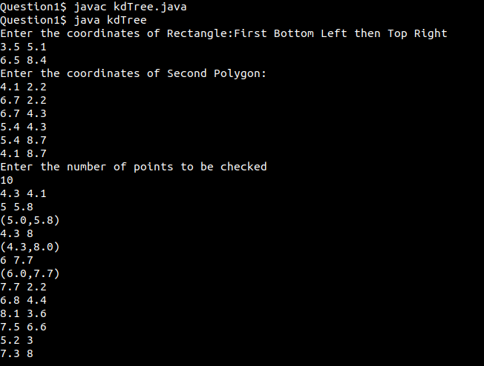

Problem 2 :
Given n values in an array and two index values, find the result of the following queries
1. minimum value
2. maximum value
3. sum
4. update by adding 4 with each element, within the given index range using Segment tree.

Algorithms Used :
Given a set I of intervals, or segments, a segment tree T for I is structured as follows:
- T is a binary tree.
- Its leaves correspond to the elementary intervals induced by the endpoints in I, in an ordered way: the leftmost leaf corresponds to the leftmost interval, and so on. The elementary interval corresponding to a leaf v is denoted Int(v).
- The internal nodes of T correspond to intervals that are the union of elementary intervals: the interval Int(N) corresponding to node N is the union of the intervals corresponding to the leaves of the tree rooted at N. That implies that Int(N) is the union of the intervals of its two children.
- Each node or leaf v in T stores the interval Int(v) and a set of intervals, in some data structure. This canonical subset of node v contains the intervals [x, x′] from I such that [x, x] contains Int(v) and does not contain Int(parent(v)). That is, each node in T stores the segments that span through its interval, but do not span through the interval of its parent.

Data Structure Used :
1. Segment tree
2. Heap

Snapshots :

