AI23521- BUILD AND DEPLOYMENT OF MACHINE LEARNING APPLICATIONS
EXP-6-CODE:

import numpy as np
import matplotlib.pyplot as plt
import seaborn as sns

import tensorflow as tf
from tensorflow import keras
from tensorflow.keras import layers
from tensorflow.keras.datasets import fashion_mnist

from sklearn.metrics import classification_report, confusion_matrix

tf.keras.utils.disable_interactive_logging()

print("Libraries Imported Successfully")
Libraries Imported Successfully
(x_train, y_train), (x_test, y_test) = fashion_mnist.load_data()

print("Training Data Shape:", x_train.shape)
print("Testing Data Shape :", x_test.shape)

class_names = [
"T-shirt/top",
"Trouser",
"Pullover",
"Dress",
"Coat",
"Sandal",
"Shirt",
"Sneaker",
"Bag",
"Ankle boot"
]
Training Data Shape: (60000, 28, 28)
Testing Data Shape : (10000, 28, 28)
# Flatten images 28x28 -> 784

x_train_fnn = x_train.reshape(-1, 784)
x_test_fnn = x_test.reshape(-1, 784)

# Normalize pixel values

x_train_fnn = x_train_fnn / 255.0
x_test_fnn = x_test_fnn / 255.0

print("FNN Training Shape:", x_train_fnn.shape)
print("FNN Testing Shape :", x_test_fnn.shape)
FNN Training Shape: (60000, 784)
FNN Testing Shape : (10000, 784)
model_fnn = keras.Sequential([

layers.Dense(128, activation="relu", input_shape=(784,)),

layers.Dropout(0.2),

layers.Dense(64, activation="relu"),

layers.Dense(10, activation="softmax")

])

model_fnn.compile(
optimizer="adam",
loss="sparse_categorical_crossentropy",
metrics=["accuracy"]
)

model_fnn.summary()
C:\Users\Lenovo\anaconda3\Lib\site-packages\keras\src\layers\core\dense.py:92: UserWarning: Do not pass an `input_shape`/`input_dim` argument to a layer. When using Sequential models, prefer using an `Input(shape)` object as the first layer in the model instead.
super().__init__(activity_regularizer=activity_regularizer, **kwargs)
history_fnn = model_fnn.fit(
x_train_fnn,
y_train,
epochs=10,
validation_split=0.1
)

loss_fnn, acc_fnn = model_fnn.evaluate(
x_test_fnn,
y_test
)

print("FNN Test Loss:", loss_fnn)
print("FNN Test Accuracy:", acc_fnn)
FNN Test Loss: 0.34095796942710876
FNN Test Accuracy: 0.8851000070571899
y_pred_fnn = np.argmax(
model_fnn.predict(x_test_fnn),
axis=1
)

print(classification_report(
y_test,
y_pred_fnn
))

cm_fnn = confusion_matrix(
y_test,
y_pred_fnn
)

plt.figure(figsize=(8,6))

sns.heatmap(
cm_fnn,
annot=True,
fmt="d",
cmap="Blues"
)

plt.title("FNN Confusion Matrix")
plt.xlabel("Predicted")
plt.ylabel("Actual")

plt.show()

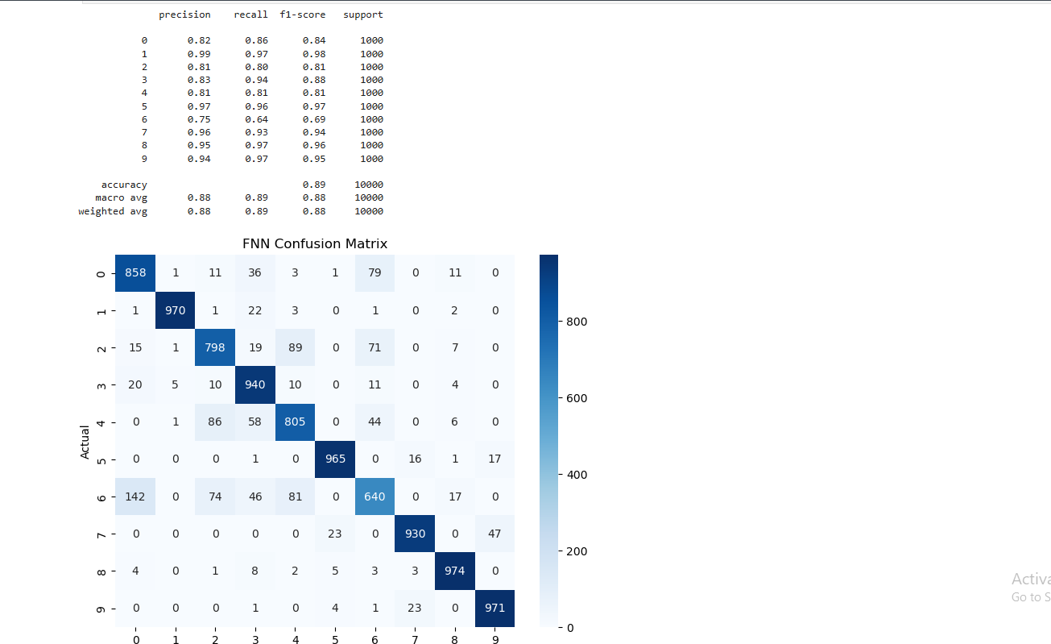
# Add channel dimension

x_train_cnn = x_train.reshape(
-1,28,28,1
)

x_test_cnn = x_test.reshape(
-1,28,28,1
)

# Normalize

x_train_cnn = x_train_cnn / 255.0

x_test_cnn = x_test_cnn / 255.0

print("CNN Training Shape:", x_train_cnn.shape)
print("CNN Testing Shape :", x_test_cnn.shape)
CNN Training Shape: (60000, 28, 28, 1)
CNN Testing Shape : (10000, 28, 28, 1)
model_cnn = keras.Sequential([

layers.Input(shape=(28,28,1)),

layers.Conv2D(
32,
(3,3),
activation="relu"
),

layers.MaxPooling2D(
(2,2)
),

layers.Conv2D(
64,
(3,3),
activation="relu"
),

layers.MaxPooling2D(
(2,2)
),

layers.Flatten(),

layers.Dense(
128,
activation="relu"
),

layers.Dropout(0.5),

layers.Dense(
10,
activation="softmax"
)
])

model_cnn.compile(
optimizer="adam",
loss="sparse_categorical_crossentropy",
metrics=["accuracy"]
)

model_cnn.summary()
history_cnn = model_cnn.fit(
x_train_cnn,
y_train,
epochs=10,
validation_split=0.1
)

loss_cnn, acc_cnn = model_cnn.evaluate(
x_test_cnn,
y_test
)

print("CNN Test Loss:", loss_cnn)
print("CNN Test Accuracy:", acc_cnn)
CNN Test Loss: 0.26358872652053833
CNN Test Accuracy: 0.9057000279426575
y_pred_cnn = np.argmax(
model_cnn.predict(x_test_cnn),
axis=1
)

print(classification_report(
y_test,
y_pred_cnn
))

cm_cnn = confusion_matrix(
y_test,
y_pred_cnn
)

plt.figure(figsize=(8,6))

sns.heatmap(
cm_cnn,
annot=True,
fmt="d",
cmap="Greens"
)

plt.title("CNN Confusion Matrix")
plt.xlabel("Predicted")
plt.ylabel("Actual")

plt.show()

# Sample Predictions

plt.figure(figsize=(10,10))

for i in range(25):

plt.subplot(5,5,i+1)

plt.imshow(
x_test[i],
cmap="gray"
)

plt.axis("off")

color = "green" if y_test[i]==y_pred_cnn[i] else "red"

plt.title(
class_names[y_pred_cnn[i]],
color=color,
fontsize=8
)

plt.tight_layout()
plt.show()
