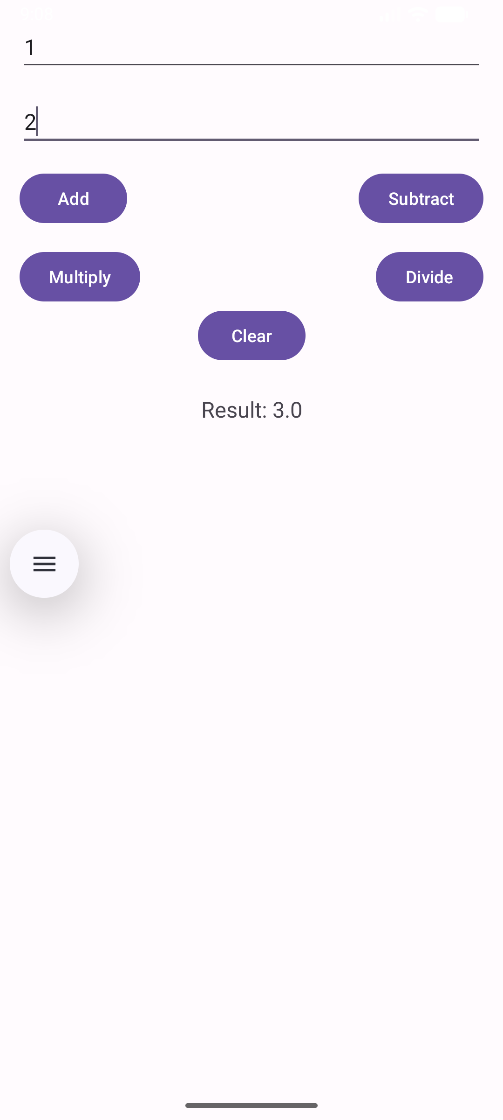
<?xml version="1.0" encoding="utf-8"?>
<androidx.constraintlayout.widget.ConstraintLayout xmlns:android="http://schemas.android.com/apk/res/android"
xmlns:app="http://schemas.android.com/apk/res-auto"
xmlns:tools="http://schemas.android.com/tools"
android:id="@+id/main"
android:layout_width="match_parent"
android:layout_height="match_parent"
tools:context=".MainActivity">
<EditText
android:id="@+id/editTextNumber1"
android:layout_width="0dp"
android:layout_height="wrap_content"
android:hint="Enter first number"
android:inputType="numberDecimal"
app:layout_constraintTop_toTopOf="parent"
app:layout_constraintStart_toStartOf="parent"
app:layout_constraintEnd_toEndOf="parent"
android:layout_margin="16dp"/>
<EditText
android:id="@+id/editTextNumber2"
android:layout_width="0dp"
android:layout_height="wrap_content"
android:hint="Enter second number"
android:inputType="numberDecimal"
app:layout_constraintTop_toBottomOf="@id/editTextNumber1"
app:layout_constraintStart_toStartOf="parent"
app:layout_constraintEnd_toEndOf="parent"
android:layout_margin="16dp"/>
<Button
android:id="@+id/buttonAdd"
android:layout_width="wrap_content"
android:layout_height="wrap_content"
android:text="Add"
app:layout_constraintTop_toBottomOf="@id/editTextNumber2"
app:layout_constraintStart_toStartOf="parent"
android:layout_margin="16dp"/>
<Button
android:id="@+id/buttonSubtract"
android:layout_width="wrap_content"
android:layout_height="wrap_content"
android:text="Subtract"
app:layout_constraintTop_toBottomOf="@id/editTextNumber2"
app:layout_constraintEnd_toEndOf="parent"
android:layout_margin="16dp"/>
<Button
android:id="@+id/buttonMultiply"
android:layout_width="wrap_content"
android:layout_height="wrap_content"
android:text="Multiply"
app:layout_constraintTop_toBottomOf="@id/buttonAdd"
app:layout_constraintStart_toStartOf="parent"
android:layout_margin="16dp"/>
<Button
android:id="@+id/buttonDivide"
android:layout_width="wrap_content"
android:layout_height="wrap_content"
android:text="Divide"
app:layout_constraintTop_toBottomOf="@id/buttonSubtract"
app:layout_constraintEnd_toEndOf="parent"
android:layout_margin="16dp"/>
<Button
android:id="@+id/buttonClear"
android:layout_width="wrap_content"
android:layout_height="wrap_content"
android:text="Clear"
app:layout_constraintTop_toBottomOf="@id/buttonMultiply"
app:layout_constraintStart_toStartOf="parent"
app:layout_constraintEnd_toEndOf="parent"/>
<TextView
android:id="@+id/textViewResult"
android:layout_width="wrap_content"
android:layout_height="wrap_content"
android:text="Result will appear here"
android:textSize="18sp"
app:layout_constraintTop_toBottomOf="@id/buttonClear"
app:layout_constraintStart_toStartOf="parent"
app:layout_constraintEnd_toEndOf="parent"
android:layout_marginTop="24dp"/>
</androidx.constraintlayout.widget.ConstraintLayout>

package com.example.calculatorapp;
import android.os.Bundle;
import android.widget.Button;
import android.widget.EditText;
import android.widget.TextView;
import androidx.appcompat.app.AppCompatActivity;
public class MainActivity extends AppCompatActivity {
private EditText editTextNumber1, editTextNumber2;
private Button buttonAdd, buttonSubtract, buttonMultiply, buttonDivide, buttonClear;
private TextView textViewResult;
@Override
protected void onCreate(Bundle savedInstanceState) {
super.onCreate(savedInstanceState);
setContentView(R.layout.activity_main);
// Link UI elements
editTextNumber1 = findViewById(R.id.editTextNumber1);
editTextNumber2 = findViewById(R.id.editTextNumber2);
buttonAdd = findViewById(R.id.buttonAdd);
buttonSubtract = findViewById(R.id.buttonSubtract);
buttonMultiply = findViewById(R.id.buttonMultiply);
buttonDivide = findViewById(R.id.buttonDivide);
buttonClear = findViewById(R.id.buttonClear);
textViewResult = findViewById(R.id.textViewResult);
// Button actions
buttonAdd.setOnClickListener(v -> calculate('+'));
buttonSubtract.setOnClickListener(v -> calculate('-'));
buttonMultiply.setOnClickListener(v -> calculate('*'));
buttonDivide.setOnClickListener(v -> calculate('/'));
buttonClear.setOnClickListener(v -> {
editTextNumber1.setText("");
editTextNumber2.setText("");
textViewResult.setText("Result will appear here");
});
}
private void calculate(char operator) {
String input1 = editTextNumber1.getText().toString();
String input2 = editTextNumber2.getText().toString();
if (input1.isEmpty() || input2.isEmpty()) {
textViewResult.setText("Please enter both numbers");
return;
}
try {
double num1 = Double.parseDouble(input1);
double num2 = Double.parseDouble(input2);
double result = 0;
switch (operator) {
case '+':
result = num1 + num2;
break;
case '-':
result = num1 - num2;
break;
case '*':
result = num1 * num2;
break;
case '/':
if (num2 == 0) {
textViewResult.setText("Cannot divide by zero");
return;
}
result = num1 / num2;
break;
}
textViewResult.setText("Result: " + result);
} catch (NumberFormatException e) {
textViewResult.setText("Invalid input");
}
}
}

