**NAME: FREDRICK KIMANI NJUGUNA**

**CP5503 ENTERPRISE DATABASE SYSTEMS ORACLE**

**ASSIGNMENT PART2 – TRIGGER**

**Task 1**

create or replace trigger TR_date_returned_chk

before update of date_returned on Loan

for each row

begin

if (:new.date_returned > sysdate) then

RAISE_APPLICATION_ERROR(-20000, 'date_returned cannot be greater than current date');

--error code must be between -20999 and 20000

--error message: must be a meaningful error message

end if;

end;

--set date returned -

**testing:**

--invalid

update loan

set date_returned = sysdate + 1

where loan_id = 6;

--valid

update loan

set date_returned = sysdate

where loan_id = 6;

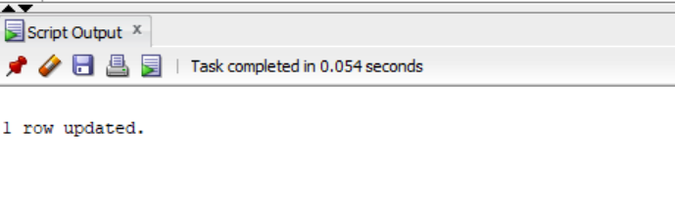

**Task 2**

**Code:**

create or replace FUNCTION FUNC_IS_AVAILABLE_COPY (

COPY_ID_P IN NUMBER)

RETURN NUMBER AS

is_available_var NUMBER;

loan_id_var NUMBER;

BEGIN

-- write a select ... into… statement to get a record from the Loan table having the given copy_id and

select loan_id into loan_id_var

from loan

where copy_id = copy_id_p

and date_returned is null;

--not available

is_available_var :=0;

RETURN is_available_var;

EXCEPTION

WHEN no_data_found THEN

RETURN is_available_var; -- it is 1 as defined

END FUNC_IS_AVAILABLE_COPY;

Testing:

Code:

select FUNC_is_available_copy(14) from dual; --not available

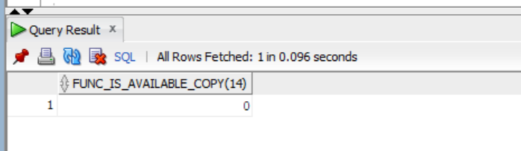

1 is available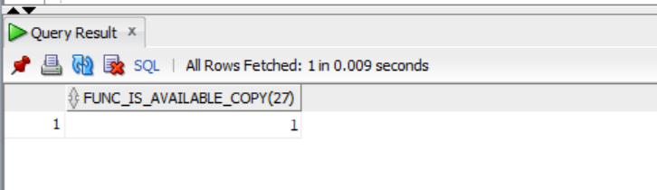

**TASK3**

insert into loan(loan_id, date_out, date_due, date_returned, borrower_id, copy_id)

values(loan_seq.nextval, sysdate, sysdate + 7, null, 5, 14);

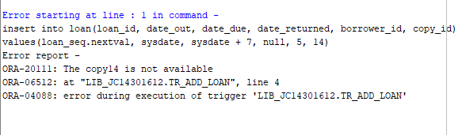

insert into loan(loan_id, date_out, date_due, date_returned, borrower_id, copy_id)

values(loan_seq.nextval, sysdate, sysdate + 7, null, 5, 27)

