Project - Name : Flipkart



About:
Flipkart Private Limited is an Indian e-commerce, one-stop fashion destination for anything and everything you need to look good.

Contents for Website:
- Navigation Bar:
- .navbar which consists
-.nav
-.nav-1 for Logo of Flipkart
-.nav-2 for Input tag and login button
-Ul for li a tags

- Main Page (Content ):
- Advertisement pages.
- Deals with discounts ( e.g Shoes,clothes,electrical-appliances,etc)
- Upcoming Sales.
-Discount tags available.
- Today’s deals
- Products with images.
-Products with highest ratings.

Special Css effects:
-Tranformations.
- Image size while hovering.

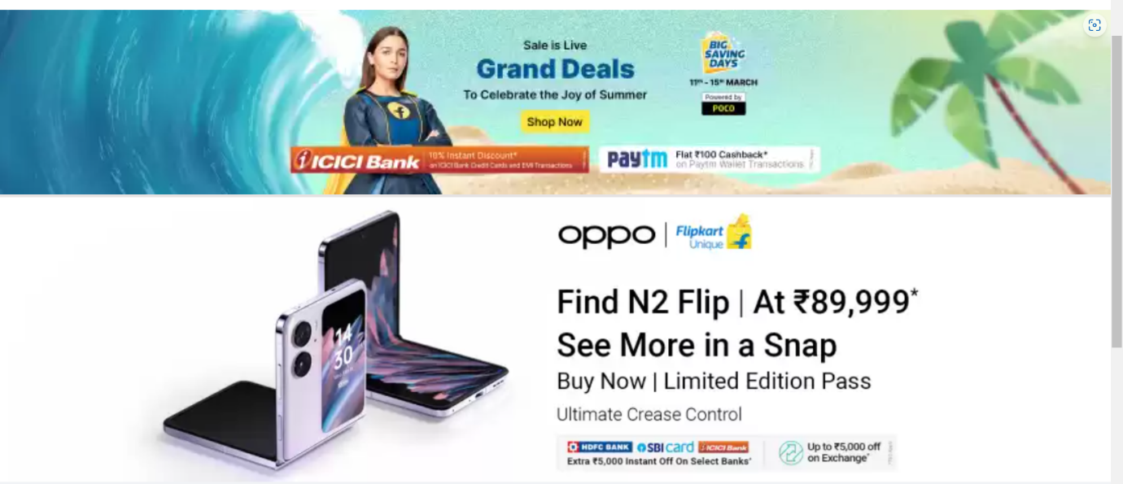

- Footer:
-.footer
-.footer-heading
- ul li tags with links
- address
-Ways to contact
-Payment Ways – Google pay , Paytm , Phone Pay,Credit Card,Debit Card,Net-Banking,etc
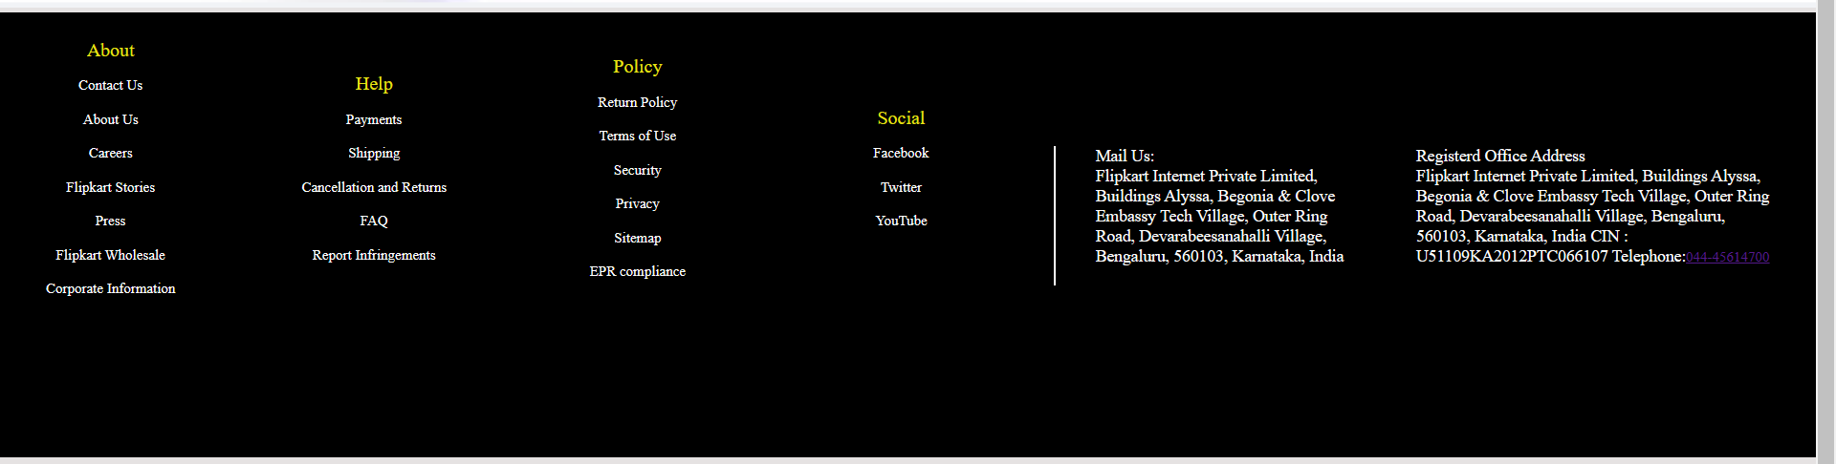

- Login Page:
-#customer-info
-Form consisting of Name,Email,Mobile-no,etc
-h2 heading tag
- Input tags
- Button .btn

