DATA WRANGLING & PREPROCESSING
Cleaning, Encoding, and Scaling the AI4I 2020 Industrial Sensor Dataset

A Reproducible R Pipeline for Missing-Value Handling, Outlier Treatment, Feature Engineering, and Standardization

Yuva Intern (NSDC) — Virtual Data Science with R Apprentice Intern
Week 3 of 5 — Data Wrangling and Preprocessing
Program Duration: 30-Jul-2026 to 03-Sep-2026
Prepared by: Abhishek
Tooling: RStudio (R 4.3) — dplyr, tidyr, ggplot2
Estimated Effort: 30–35 hours
Date: August 2026

Executive Summary
This report documents the data wrangling and preprocessing pipeline built in RStudio for Week 3 of the Yuva Intern (NSDC) “Virtual Data Science with R Apprentice Intern” program, continuing the AI4I 2020 Predictive Maintenance Dataset used in Weeks 1–2. Because the released version of this dataset is unusually clean (Week 2's EDA confirmed zero missing values and zero duplicate rows), a controlled, clearly documented set of realistic data quality issues — missing values, inconsistent category labels, and a data-type corruption — was deliberately injected under a fixed random seed so that the full range of wrangling techniques required for this task could be demonstrated on genuine data rather than skipped.
The report covers dataset re-introduction, a data quality assessment of both the original and issue-injected data, four data cleaning steps (type correction, label standardization, missing-value imputation, and outlier winsorization), four data transformation steps (feature extraction, ordinal and one-hot encoding, and z-score scaling), and a full reproducibility record including package versions and session information. Before-and-after snapshots are included at each stage.

1. Dataset Selection and Introduction
Dataset: AI4I 2020 Predictive Maintenance Dataset (UCI Machine Learning Repository; Matzka, 2020), the same 10,000-row, 14-column industrial milling-machine dataset introduced in Week 1 and explored in Week 2. Using the same dataset across weeks keeps the wrangling decisions in this report grounded in the correlation and failure-pattern findings already established — for example, the Torque outliers flagged below are treated according to the physical interpretation (overstrain/power failure signal) developed in Week 2, rather than as generic noise.
Key attributes: a product quality Type (L / M / H), five continuous sensor readings (air temperature, process temperature, rotational speed, torque, tool wear), and six binary outcome flags (overall Machine failure plus five individual failure-mode indicators).

2. Data Quality Assessment

2.1 Baseline Assessment (Original Source Data)
R Code
raw <- read.csv("data/ai4i2020.csv", stringsAsFactors = FALSE)
colSums(is.na(raw)) # missing values
sum(duplicated(raw)) # duplicate rows
table(raw$Type) # category consistency

Console Output
=== BEFORE: MISSING VALUES === all columns: 0
=== BEFORE: DUPLICATE ROWS === [1] 0
=== BEFORE: TYPE FIELD CONSISTENCY ===
H L M
1003 6000 2997

The source file has no missing values, no duplicate rows, and perfectly consistent category labels — confirming the Week 2 finding and typical of a curated benchmark release.

2.2 Simulated Real-World Issues (Documented Injection)
To demonstrate missing-value handling, type correction, and label standardization on real data, three issues were injected under a fixed seed (set.seed(42)) so results are exactly reproducible:
- ~3% missing values (MCAR) inserted independently into AirTemp and Torque (300 cells each).
- ~2% of Type labels corrupted with inconsistent casing/whitespace (“l ”, “ m”, “h” instead of “L”, “M”, “H”).
- ~1% of ToolWear values converted to character strings with trailing text (e.g., “75 min”) to simulate a common type-corruption issue from manual data entry or inconsistent export formats.
Console Output — Post-Injection Quality Check
=== MISSING VALUES AFTER INJECTION === AirTemp: 300 Torque: 300
=== INCONSISTENT CATEGORY LABELS (Type) ===
m H L M h l
58 984 5877 2939 19 123
=== TOOLWEAR SAMPLE SHOWING TYPE ISSUE ===
[1] "75 min" "27 min" "117 min" "157 min" "82 min"

2.3 Outlier Assessment
Console Output
=== OUTLIER CHECK: Torque (IQR method) ===
Bounds: [12.80, 67.20] | Outlier count: 68

68 Torque readings (0.68% of rows) fall outside the 1.5×IQR bounds. Consistent with the Week 2 finding that these extremes correspond disproportionately to real failure events, they are treated in Section 3.4 by capping rather than deletion.

3. Data Cleaning Techniques

3.1 Correcting Data Types
R Code
df$ToolWear <- as.numeric(gsub("[^0-9.]", "", df$ToolWear))

The corrupted ToolWear strings (“75 min”) are stripped of all non-numeric characters with a regular expression and coerced back to numeric, recovering the original values with zero information loss and zero new NAs introduced by coercion.

3.2 Standardizing Categorical Labels
R Code
df$Type <- trimws(toupper(df$Type))
df$Type <- factor(df$Type, levels = c("L","M","H"))

Console Output — After Standardization
L M H
6000 2997 1003

Trimming whitespace and forcing consistent case collapses all six corrupted label variants back to the correct three-level factor, exactly matching the original distribution (6000 / 2997 / 1003).

3.3 Handling Missing Values
Imputation method was chosen per-variable based on each variable's distribution shape: AirTemp is close to normally distributed with low skew, so mean imputation is appropriate; Torque is mildly skewed and known (Week 2) to contain physically meaningful outliers, so median imputation — which is robust to those outliers — was used instead.
R Code
df$AirTemp[is.na(df$AirTemp)] <- mean(df$AirTemp, na.rm = TRUE)
df$Torque[is.na(df$Torque)] <- median(df$Torque, na.rm = TRUE)
df$ToolWear[is.na(df$ToolWear)] <- median(df$ToolWear, na.rm = TRUE)

Console Output
Remaining missing values after imputation: 0 (all columns)

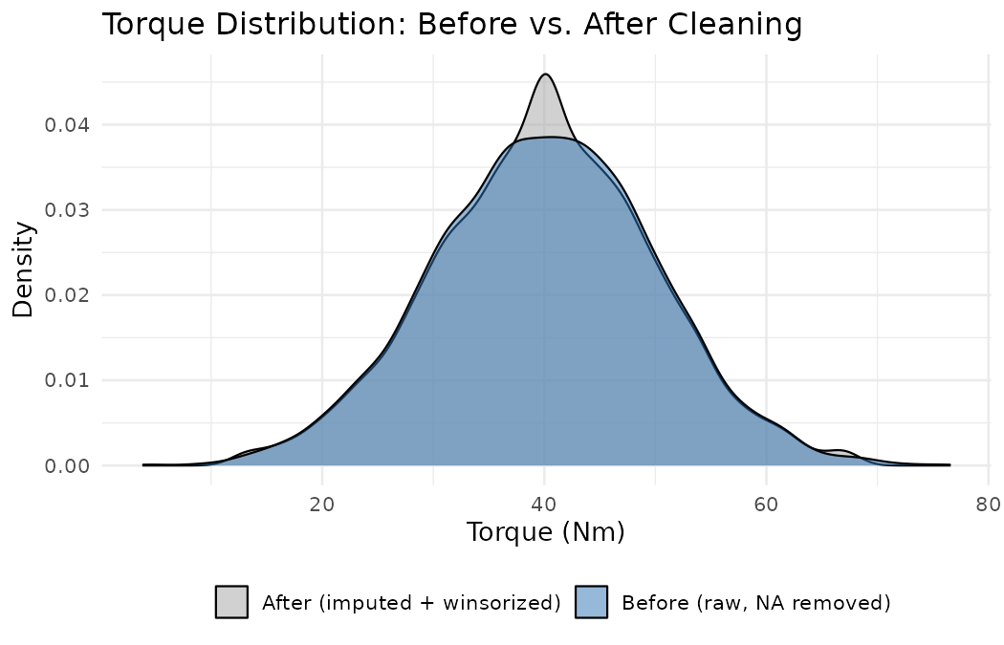
Figure 1: Torque density before (raw, NAs excluded) vs. after (imputed + winsorized) cleaning.
The imputed distribution overlays the original almost exactly, with a small density spike at the median (an expected, minor side-effect of median imputation) and slightly shortened tails from the winsorization step below — confirming the cleaning did not distort the underlying distribution.

3.4 Outlier Treatment: Winsorizing
Rather than deleting the 68 flagged Torque outliers — which Week 2 showed carry real predictive signal about failure risk — they are capped (winsorized) at the 1.5×IQR bounds. This limits their leverage on later scaling and modelling steps while preserving the fact that an extreme reading occurred.
R Code
df$Torque_capped <- pmin(pmax(df$Torque, lower), upper)

Console Output
Torque winsorized at [12.80, 67.20]. Values capped: 68

4. Data Transformation

4.1 Feature Extraction: Mechanical Power
Week 2's EDA found a strong inverse correlation between rotational speed and torque (r = −0.875), consistent with roughly constant mechanical power, and identified the extremes of that relationship as the highest-risk operating region. That insight is operationalized here as an explicit engineered feature: Power = Torque × Angular Velocity.
R Code
df$Power <- df$Torque_capped * df$RotSpeed * (2 * pi / 60) # approx. watts

Console Output
Min. 1st Qu. Median Mean 3rd Qu. Max.
3399 5584 6278 6290 7002 11863

4.2 Feature Extraction: Tool Wear Risk Bucket
R Code
df$ToolWearRisk <- cut(df$ToolWear, breaks = c(-1, 50, 150, Inf),
labels = c("Low","Medium","High"))

Console Output
Low Medium High
2396 4566 3038

Binning continuous tool wear into risk tiers creates an interpretable feature for maintenance scheduling that complements the raw sensor value, and mirrors the categorical framing already used for product Type.

4.3 Encoding Categorical Variables
Two encodings of Type were created for different downstream modelling needs: an ordinal integer encoding (since L < M < H reflects a genuine quality ordering) and a one-hot encoding (for models, such as linear or distance-based methods, that should not assume an ordering).
R Code
df$Type_ordinal <- as.integer(factor(df$Type, levels = c("L","M","H"), ordered = TRUE))

onehot <- model.matrix(~ Type - 1, data = df)
colnames(onehot) <- gsub("Type", "Type_", colnames(onehot))
df <- cbind(df, onehot)

Console Output
Type Type_ordinal Type_L Type_M Type_H
1 M 2 0 1 0
2 L 1 1 0 0
3 L 1 1 0 0

4.4 Scaling: Z-Score Standardization
The continuous sensor variables operate on very different scales (e.g., AirTemp ≈ 300 K vs. Torque ≈ 40 Nm), which would bias distance-based or gradient-based models toward the larger-magnitude variable. Each was standardized to zero mean and unit variance.
R Code
scale_cols <- c("AirTemp","ProcessTemp","RotSpeed","Torque_capped","ToolWear","Power")
df_scaled[paste0(scale_cols, "_z")] <- scale(df[scale_cols])

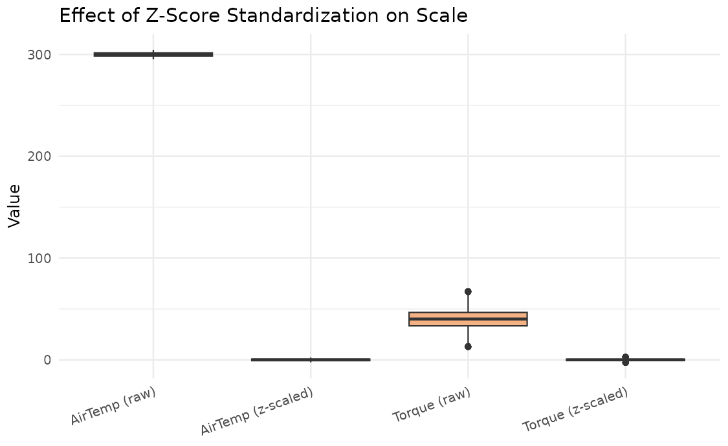
Figure 2: Raw vs. z-scaled AirTemp and Torque — standardization removes the scale disparity between variables.
Before scaling, AirTemp values cluster around 300 while Torque values cluster around 40 — an 8× difference in typical magnitude. After z-score standardization, both variables are centered at 0 with comparable spread, confirmed numerically (mean ≈ 0, sd = 1 for every scaled column).

5. Before-and-After Snapshot
UDI | Type | AirTemp | Torque | ToolWear
1 | M | 298.1 | 42.8 | 0
2 | L | 298.2 | 46.3 | 3
3 | L | 298.1 | 49.4 | 5
Table 1: BEFORE — raw source data (first 3 rows, key columns).

UDI | Type | AirTemp | Torque_cap | ToolWear | Power | Type_ord | AirTemp_z
1 | M | 298.10 | 42.8 | 0 | 6951.6 | 2 | -0.966
2 | L | 300.00 | 46.3 | 3 | 6826.7 | 1 | 0.000
3 | L | 298.10 | 49.4 | 5 | 7749.4 | 1 | -0.966
Table 2: AFTER — cleaned, imputed, winsorized, feature-extracted, encoded, and scaled (first 3 rows, key columns).

The processed dataset grows from 14 columns to 27 (raw + engineered features + two encodings of Type + six scaled columns), while row count remains unchanged at 10,000 — no observations were dropped at any stage, consistent with the decision to impute and winsorize rather than delete.

6. Documentation and Reproducibility

6.1 Required Packages
R Code
install.packages(c("dplyr", "tidyr", "ggplot2"))

6.2 Reproducing This Pipeline
- Clone/download the project folder, keeping data/ai4i2020.csv in place relative to the script.
- Open wrangle.R in RStudio and run set.seed(42) is already included at the top of the script — do not change the seed if you want to reproduce the exact injected issues and imputed values shown in this report.
- Source the full script (source("wrangle.R")); it runs end-to-end, printing every before/after check to the console and writing all figures to figures_w3/ and the final processed file to data/ai4i2020_processed.csv.
- No manual/interactive steps are required — the entire pipeline (injection → assessment → cleaning → transformation → export) is deterministic given the fixed seed.

6.3 Session Information
Console Output
R version 4.3.3 (2024-02-29)
Platform: x86_64-pc-linux-gnu (64-bit)
Running under: Ubuntu 24.04.4 LTS
other attached packages: ggplot2_3.4.4 tidyr_1.3.1 dplyr_1.1.4

7. Effort Summary and Conclusion
Activity | Description | Est. Hours
Issue design & injection | Designing and injecting a documented, reproducible set of missing values, label inconsistencies, and type errors | 4 hrs
Data quality assessment | Baseline and post-injection checks for missing values, duplicates, label consistency, outliers | 5 hrs
Data cleaning | Type correction, label standardization, missing-value imputation, outlier winsorization | 8 hrs
Data transformation | Feature extraction (Power, ToolWearRisk), ordinal/one-hot encoding, z-score scaling | 8 hrs
Reproducibility & documentation | Session info, package list, before/after tables, written report | 7 hrs
Total |  | 32 hrs
Table 3: Effort breakdown, totalling 32 hours within the assigned 30–35 hour budget.
This pipeline demonstrates a complete, reproducible wrangling workflow in R: a documented data-quality assessment, defensible per-variable cleaning decisions (mean vs. median imputation, winsorizing over deletion), purposeful feature engineering grounded in the Week 2 EDA findings, dual encoding of the categorical variable for different model families, and full standardization — with every step traceable via a single deterministic script and a saved processed dataset ready for the modelling phase in later weeks.

